# Creating roles

I will be creating two roles for this database the first role will be a sort of developer role this role will be able to read and write to the database because they will be considered a developer. The second role will be a worker role and they will only be allowed to use SELECT on views that the developer has created, the worker will not have anu access to the rest of the database.

# Creating the Developer Role

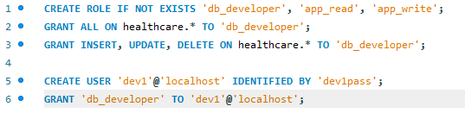

This is the code used to create a developer role that has the ability to read and write to the database. I then assign this role to have all access to the database. I then create a user for the developer call dev1pass, I then grant that user the db_developer role. Now as that user you will be able to create tables, queries, views etc.

# Creating the Worker Role

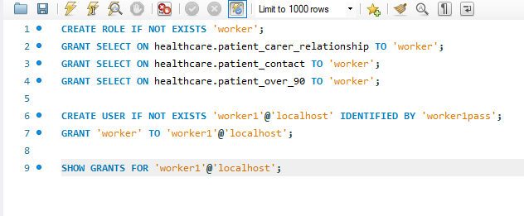

This code only allows the worker role to access the specified views and nothing else, I then created a user that has that role so whenever a worker uses the db they are only allowed to view the views that was set in the role.