|  |  |  |  |  |
| --- | --- | --- | --- | --- |
| Syntax Features | Source Code From | | | |
| In-class demos | Referenced PHP tutorials | Homework exercises or personal practice | Assessment |
| 1. PHP tags, escaping html, Instruction separation |  |  |  |  |
| 2. Variables: basic types, globals, scope, predefined variables, constants |  |  |  |  |
| 3. Namespaces, include, require |  |  |  |  |
| 4. Coding Conventions |  |  |  |  |
| 5. Arrays, foreach |  |  |  |  |
| 6. Selection |  |  |  |  |
| 7. Iteration |  |  |  |  |
| 8. Functions |  |  |  |  |
| 9. Strict types, type hinting, |  |  |  |  |
| 10. Classes, properties, constructors and destructors, visibility |  |  |  |  |
| 11. OO “tricks”: inheritance, static, abstract, interfaces |  |  |  |  |
| 12. Error handling, try, catch, throw, finally |  |  |  |  |
| 13. Cookies |  |  |  |  |
| 14. Sessions |  |  |  |  |
| 15. REST |  |  |  |  |
| 16. Passwords |  |  |  |  |
| 17. Regular expressions |  |  |  |  |
| 18. il8n |  |  |  |  |
| 19. String functions |  |  |  |  |
| 20. MySQL Improved Extension |  |  |  |  |

# PHP tags, escaping html, instruction separation

## 1.1 in class demo

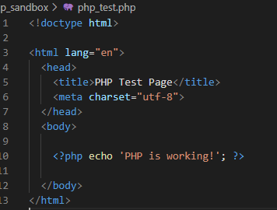

## Reference from the PHP documentation

<https://www.php.net/manual/en/language.basic-syntax.phptags.php>

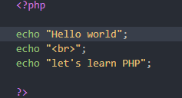

## Personal example of a short tag

# Variables: basic types, globals, scope, predefined variables, constants

## 2.1 In class String example

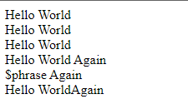

## Example from PHP documentation (integer)

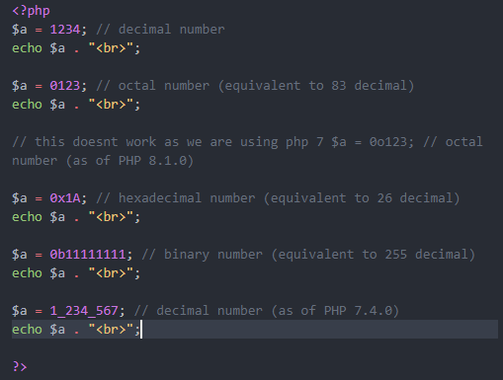

## 2.3 Personal example

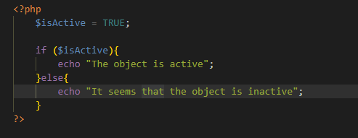

# 3.Namespaces, include, require

## 3.1 In class example

## 3.2 Example from PHP documentation

## 3.3 Personal example

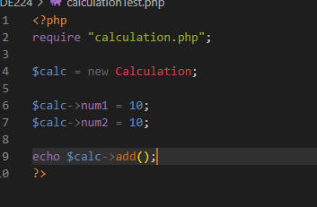

# 4 Coding conventions

## 4.1 In class example

## 4.2 PHP Documentation example

https://pear.php.net/manual/en/standards.control.php

## 4.3 Personal example



# 5 Arrays, Foreach

## 5.1 In class example

## 5.2 PHP Documentation example

<https://pear.php.net/manual/en/standards.arrays.php>

## 5.3 Personal example

# 6 Selection

## 6.1 In class example

## 6.2 PHP Documentation example

https://www.php.net/manual/en/control-structures.elseif.php

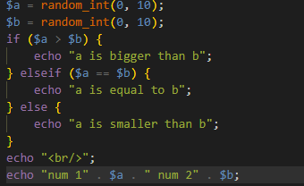

## 6.3 Personal example

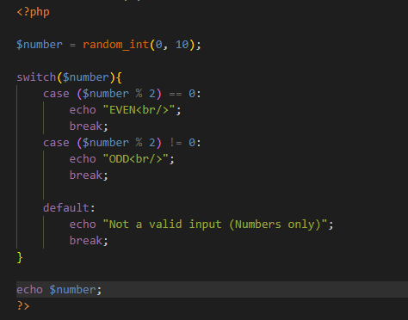

# 7 Iteration

## 7.1 In class example

## 7.2 PHP Documentation example

https://www.php.net/manual/en/control-structures.for.php

## 7.3 Personal example

# 8 Functions

## 8.1 In class example

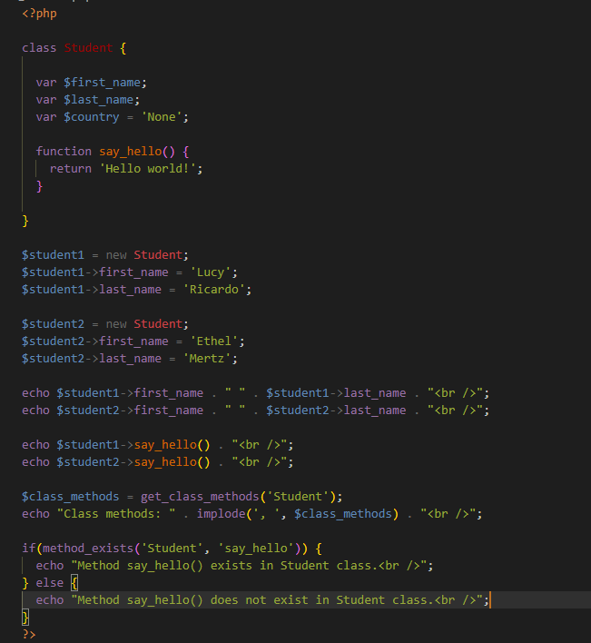

## 8.2 PHP Documentation example

## 8.3 Personal example

# 9 strict types, type hinting,

## 9.1 In class example

## 9.2 PHP Documentation example

## 9.3 Personal example

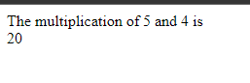

# 10 classes, properties, constructors and destructors, visibility

## 10.1 In class example

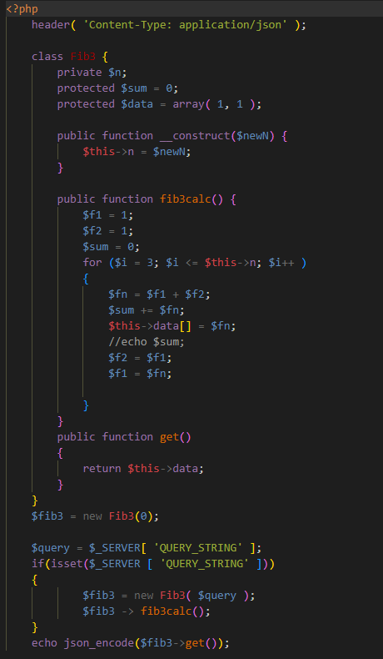

## 10.2 PHP Documentation example

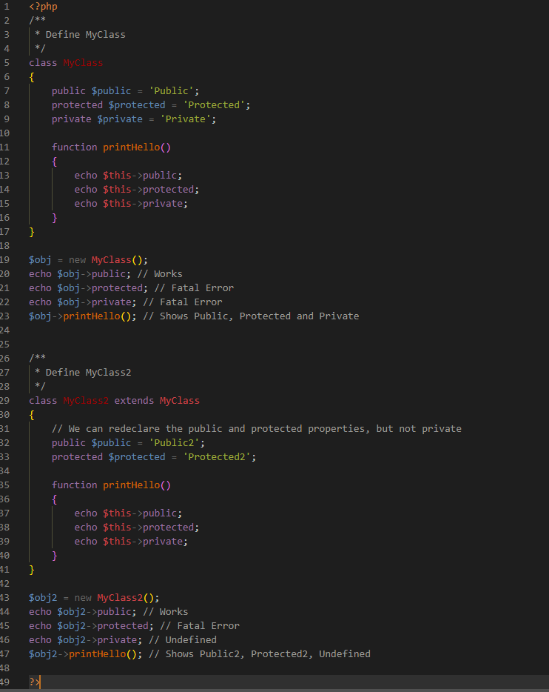

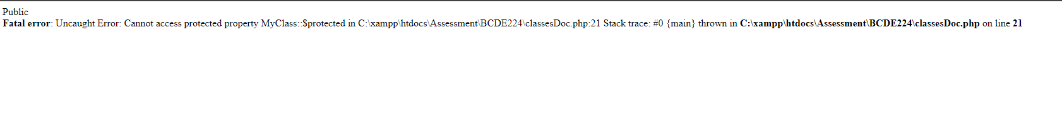

## 10.3 Personal example

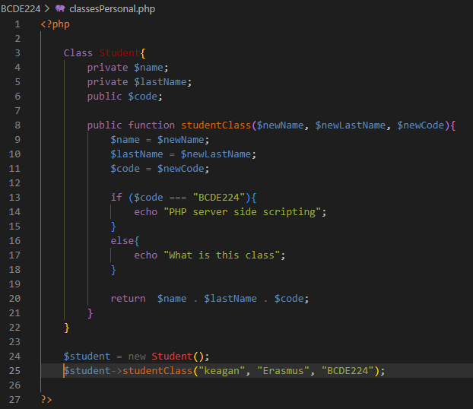

# 11 OO “tricks”: inheritance, static, abstract, interfaces

## 11.1 In class example

## 11.2 PHP Documentation example

## 11.3 Personal example

# 12 Error handling, try, catch, throw, finally

## 12.1 In class example

## 12.2 PHP Documentation example

## 12.3 Personal example

# 13 Cookies

## 13.1 In class example

## 13.2 PHP Documentation example

## 13.3 Personal example

# 14 Sessions

## 14.1 In class example

## 14.2 PHP Documentation example

## 14.3 Personal example