# Where:

This is the class diagram of the starting system that we made in DE101, in this iteration I will be taking this and modifying it to fit my new plan of creating the vending machine in Vue.js is

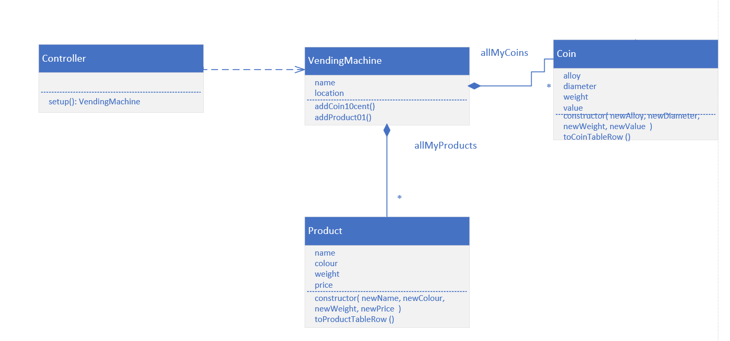  
this is the class diagram of the Vue.js system in this system we will be getting rid of the toTabeRow() functions as this will be handled buy Vue.js

# What:

## Goal:

The goal I had for this iteration was to get a basic understanding of Vue.js and to recreate my vending machine user interface that I had in my DE101 project, I also wanted to draw up a class diagram of the before and after of the project to show what I got rid of and what I kept while porting my project to Vue.js

## Planned tasks:

The Planned tasks I had for this iteration was to get my head around the basic syntax and structure of a Vue.js application, then when I had the basics down, I started recreating my DE101 vending machine project this time getting rid of the toString methods seeing as those weren’t needed in Vue.js, I wanted to get my product and coins showing so that I could see that it was working

* Get a basic understanding of Vue.js buy doing the box toy example
* Create the look of the vending machine
* Get the coins or products showing in a table

## Time estimates:

Before starting this iteration, I drew up a table of the estimated time each of these tasks would take, this was done to ensure that I only spend the right amount of time writing this program and document which was 4 hours in total.

* Get a basic understanding of Vue.js buy doing the box toy example(2hr) 4x 30-minute blocks
* Create the look of the vending machine (1hr) 2x 30-minute blocks
* Get the coins and products showing in a table (1hr)2x 30-minute blocks

## Planned product of each task:

Have a working toy box in Vue.js

Having something the resembles a vending machine

Have a table with coins in them or/

Have the products showing in the vending machine

## Record of actual time of each task:

|  |  |  |  |
| --- | --- | --- | --- |
| Task that needed to be done | Description of the task | Estimated time | Actual time it took |
| Basic understanding of Vue.js | Get basic knowledge of Vue by looking at box of toy and the Vue documentation | I estimated this would take 2 hours | This estimate was spot on it took me 2 hours to figure out the basic ins and outs of Vue |
| Create the look of the Vending machine | Get the general layout correct with ccs of the tables | I estimated this would take 1 hour | Writing the css and the table code took me about 1 and a half hours because I had forgotten how tables worked |
| Getting coins and products to show up in tables | Have the ability to see what coins and products are in the tables | I estimated this would take 1 hour | This step only took about 30 minutes because after getting the tables setup it was easy to add data to show up in said tables |

# How:

## Unit tests:

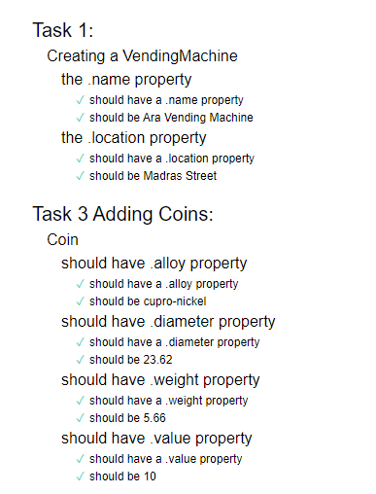

The way this feature will work in my final iteration is that I will be able to add products to the vending machine and add coins that I will be able to use as change when a customer buys a product this will work with a python back-end that will be in charge of all the logic of how the change gets calculated it will also be in charge of checking and validating if there are any products to be able to purchase, the Vue.js code will be in place so that we can visually see the products and the coins the Vue.js code will only be in charge of showing things in the browser it wont be doing any sort off logic as that will be handled by the python code

## Sequence Diagram:

This diagram describes the process of how the program will work when a customer approaches the vending machine, they will be able to see the products and add coins to buy said products then they will get change dispensed if they require any.

# Evaluation:

### Style:

### What happened vs what was planned:

When I started this project the plan was to have two class diagrams one of the DE101 vending machine and another of the new vending machine which showcases what has been changed when I converted it to Vue.js , I also wanted to have a working version of the DE101 vending machine but this time built in Vue.js, but in the end all I could get working were tables showing the coins and the products I will add the functionality of buying and receiving change in the next couple iterations, I also planned to do lint checking on my html and js code I thought that I would be able to pass all the tests in the allocated time we were given to finish this project but in the end I failed 4 of the lint tests these were due to the Vue.js function calls in the th tags and I wasn’t sure how I could fix those so that will have to be worked on in future iterations to make sure I am able to pass all checks

### Performance Review:

In this iteration I found that converting the display code from the DE101 vending machine to Vue.js was a really simple and effective thing to do I thought that using Vue.js worked well with what I was planning on doing, something that didn’t go too well when using Vue.js was doing lint checks I wasn’t sure how to fix some of the errors and I ran out of time when trying to fix them I didn’t want to spend extra time on them seeing as I didn’t write in my plan that I will be doing lint checking, for my next iterations I will spend the time to make sure I know how the linters work and make sure that I write the code as best I can so that I don’t waste my time and fail these checks again a, overall I think I did well in this iteration I was able to produce a MVP (minimum viable product) that I could’ve shown to a customer and that was also scalable to be worked on and improved, this MVP was able to prove that I can add coins to the vending machine and we could see this happening as I refreshed the browser the same thing goes for the products I was able to add multiple products in the table without changing my code too much

An example of my vending machine holding multiple coins and products

