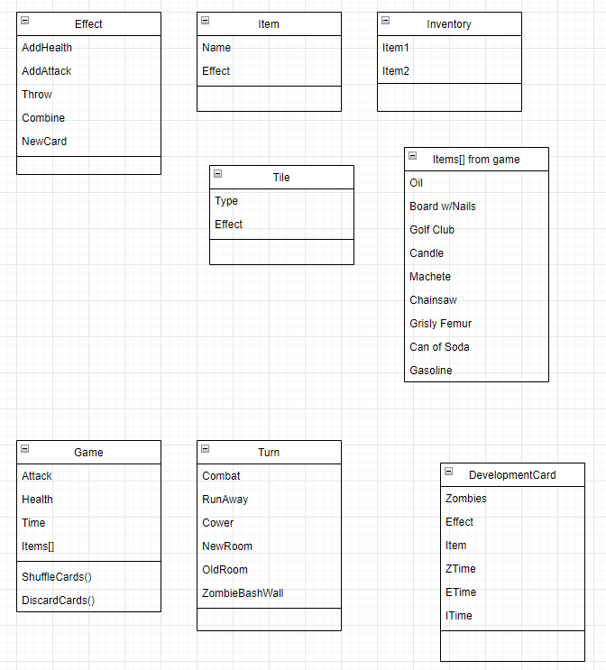

*\*Need to decide how we are going to handle placement of tiles; 3D array of tiles or something else\**

Game start:

* **Place Foyer tile**.
* “Set aside” Patio tile.
* **Shuffle** Development Cards.
* **Discard** top 2 cards.
* Starting **Attack 1.**
* Starting **Health 6**.
* Starting **Time 9pm.**

Turn:

* Choose exit; to go to **new room** or **visited room.**
  + If **new room**: draw and **place tile**.
* **Draw dev card.**
  + If **no cards left:** **TimePasses()** by 1 hour, **reshuffle deck**, **discard** top 2 cards.
    - If **item card** is last card drawn, first card from new deck is item found.
  + If card is **item:** draw new dev card to determine item or don’t draw.
    - You can choose to take item or not.
  + If card is **zombies:** Combat.
  + If card is **event:** Event.
* Follow instructions on tile if there is any.

Items:

* Only **2 items** in your inventory at once.
* You **must drop** one item to pick up another if you have 2 items.
* **Dropped items disappear** once you leave that tile.
* You can carry two weapons but only use one in combat.

Special Rooms:

* The **Zombie Totem** is in the **Evil Temple**.
* The **Zombie Totem** must be buried in the **Graveyard**.
* In either room, **draw and resolve dev card as normal**.
  + After this, **draw and resolve second card** to represent what happens as you are searching for the **Zombie Totem** or burying it.
  + If you are still alive: **Zombie Totem** has been found or buried.
* In **Storage** room, resolve dev card as normal, then you **may** draw another card to get that item.
* In **kitchen or garden**, if you didn’t run away from zombies, **add 1 health**.