# Sketchs

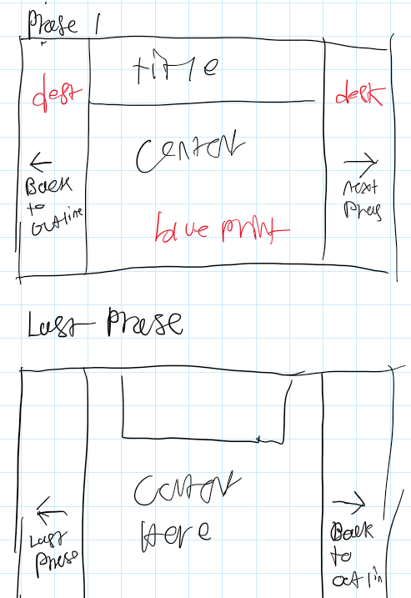

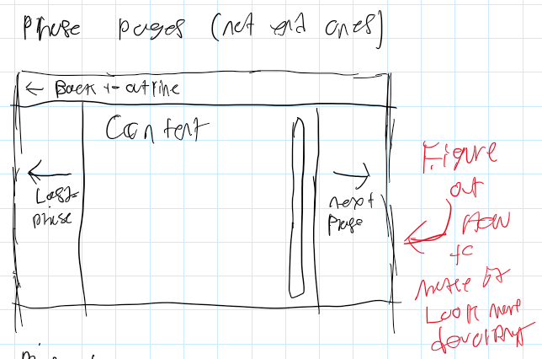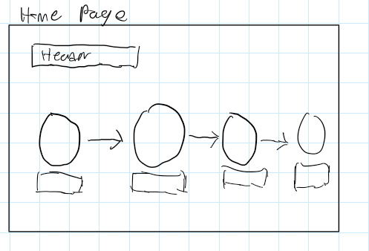

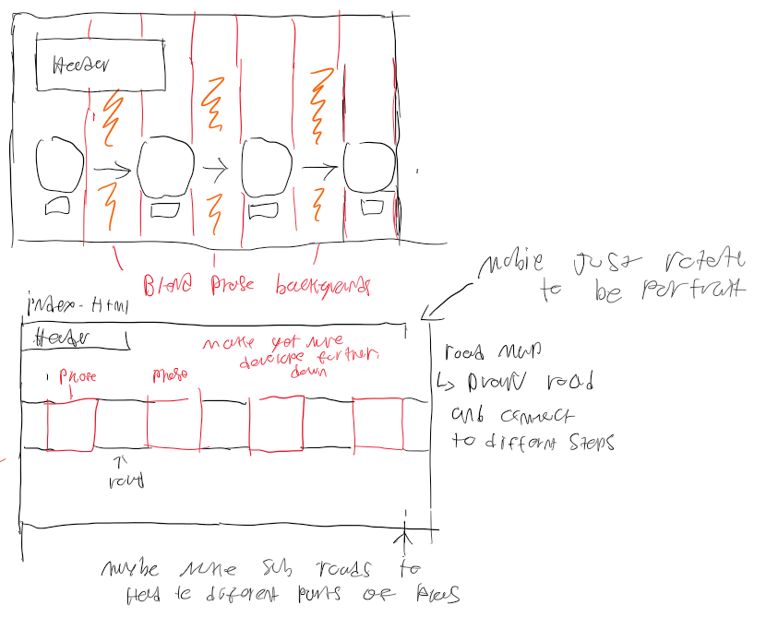

# Research

## Why I'm doing this topic

This topic interests me, and I've learned it from playing games like Cities Skylines and Sim City, where you manage and build a city. These games led me to want to learn more about how cities are planned, and I took Geography 2535: Introduction to Planning to learn more about urban and city planning. This site, as such, is about introducing the topic and then providing resources to look into it further if desired.

## The Basics

What is urban planning?

Urban or city planning is the process of designing and managing how physical, social and economic development occurs in a built environment like a city, town, etc. City planning attempts to predict and shape how a city will develop in the future, basing a lot of what is done or planned on a variety of aspects, such as:

* Anticipating how the city will look or function in the future.
* Assessing the current and potential needs in a city
* The change of demographics in a city over time and how a difference in age, race, etc, between now and then could impact the development.

The goal of city planning is to ensure that a city which is a continually evolving environment can develop in an organized and sustainable manner. Overtime shaping the patterns of community growth and the overall quality of life in a city

## The Planning Process

City planning follows a process that starts with nonspecific ideas and concepts based on research and data gathered, and these ideas slowly become more specific. Eventually, after many stages, a final detailed plan and policies are formed. The planning process can be organized into the following phases:

*Big Ideas (long-range planning):*

This phase is where planners research and gather data about the current state of an area, including things like population demographics, environmental conditions, existing city services, and infrastructure.

The data gathered, in conjunction with other planning documents, help form the overall vision for the area. This phase's resulting plans and policies are high-level but act as blueprints for refinement.

Some documents are also used in this phase to help in forming the plan for an area, such as:

* The official city plan or Municipal Development Plan

This formal document guides a city's long-term development, growth and policy decisions. This document is the overall vision of how the city should be developed and is meant to provide the framework for how developments within the city get designed, planned and developed.

* Inter-municipal Development Plans

These are documents made by a city in cooperation with neighbouring cities to determine how future growth and development in the areas between should be handled/carried out. This document ensures constant and continued cooperative growth and development between the cities/municipalities.

#### Refined plans

In this phase, more research reflects the overall vision for the area occurs. Data gathered here is then used to build on top of the high-level plans and policies from the last phase, resulting in more detailed plans and policies being created.

Some tools used in this phase include:

* Area Structure Plans

The purpose of this document is to provide a detailed framework for the development of a specific large area within a municipality. These documents designate a specific area's land usage, ultimately allowing planners to understand how an area will look when developed.

#### Detailed plans

This phase is where the final plan builds upon plans created in the last phase and forms a more detailed/focused plan. This plan is then reviewed and revised, eventually becoming the final plan or policy, which is very detailed and exact.

Tools and documents used in this phase include:

* Zoning bylaw

A law established which reflects the overall vision for an area. It regulates how the land of an area can be used, dictating what types of buildings can/can't be built in the area. These laws help guide the development of an area, ensuring the land is used well, and community needs are met.

* Development permits

Documents which grant permission to property owners or developers to develop an area. These documents ensure that new development follows plans, guidelines, and other documents for developing an area.

### Importance of urban planning

### more about urban planning

### Sources

* <https://www.reddeer.ca/media/reddeerca/business-in-red-deer/planning-and-development-of-property/planning/Planning-101.pdf>
* <http://www.urbanlearning.eu/toolbox/planning-process/>
* Geo 2535: Introduction to Planning