[UNIVERSITY NAME]
[COLLEGE / INSTITUTE NAME]
Department of [Computer Science and Engineering]

PROJECT BASED LEARNING (PBL) REPORT
on
Three-Address Code Generation for Conditional Statements, Loops and Branching Statements
A Translation Model with Short-Circuit Jumping Code, Control-Flow Graph Construction and Execution-Based Verification

Subject: Compiler Design ([Subject Code])
Submitted by  [Student Name]  Roll No.: [Roll Number]  Section / Semester: [Section]  Team members: [if any] | Submitted to  [Faculty Name]  [Designation]  Department of [CSE]
Academic Year [20XX – 20XX]

CERTIFICATE
This is to certify that the Project Based Learning (PBL) report entitled “Three-Address Code Generation for Conditional Statements, Loops and Branching Statements” has been carried out by [Student Name], Roll No. [Roll Number], in partial fulfilment of the requirements of the subject Compiler Design ([Subject Code]) of the B.Tech Computer Science and Engineering programme at [College / Institute Name] during the academic year [20XX – 20XX].
The work embodied in this report is original, and the report has not been submitted elsewhere for any other purpose.

Subject Teacher  [Faculty Name] | Head of Department  [HOD Name]
Date: [DD/MM/YYYY] Place: [Place]
DECLARATION
I hereby declare that this PBL report on “Three-Address Code Generation for Conditional Statements, Loops and Branching Statements” is the result of my own work carried out for the subject Compiler Design. The program, the diagrams and the test results presented in this report were produced by me, and the books and sources that I have used are listed in the References.

Signature: ______________________
Name: [Student Name]
Roll No.: [Roll Number]
Date: [DD/MM/YYYY]
ACKNOWLEDGEMENT
I express my sincere gratitude to [Faculty Name], subject teacher of Compiler Design, for the guidance, the useful discussions and the encouragement that made this project possible. I thank the Head of the Department, [HOD Name], and the management of [College / Institute Name] for providing the laboratory facilities and a supportive academic environment. I am also thankful to my classmates and family for their continuous support.
The textbook Compilers: Principles, Techniques, and Tools by Aho, Lam, Sethi and Ullman was the main reference for the theory used in this project.
ABSTRACT
Intermediate code generation is the phase of a compiler that links the language-dependent front end with the machine-dependent back end. Among all constructs of a programming language, those that change the flow of control – conditional statements, loops and branching statements – are the most difficult to translate, because they require labels and jumps whose targets are determined by the structure of the program, and because Boolean expressions must be evaluated lazily.
This project presents the design and implementation of a model that generates three-address code (TAC) for these constructs. A small C-like language with if, if-else, else-if, switch, while, do-while, for, break, continue and goto is defined; a lexer and a recursive-descent parser build an abstract syntax tree; and a TAC generator translates the tree into quadruples. Conditions are translated into jumping code using inherited true/false labels and fall-through, which gives short-circuit evaluation of && and || and compact code. A peephole pass removes redundant jumps and labels, and the final code is divided into basic blocks to produce the control-flow graph.
The model was tested with 19 programs (conditions, loops, nested loops, switch and goto) by executing the generated code on a TAC interpreter; all programs produced the expected results, and 7 kinds of erroneous programs were detected with line-numbered messages. The report describes the theory, the design with flowcharts, the implementation, the generated code with control-flow graphs, and the test results.
Keywords: Compiler Design, Intermediate Code, Three-Address Code, Quadruples, Short-Circuit Evaluation, Control-Flow Graph, Backpatching.
TABLE OF CONTENTS
1. Introduction 1
1.1 Background 1
1.2 Problem Statement 1
1.3 Objectives 1
1.4 Scope and Assumptions 2
1.5 Organisation of the Report 2
2. Theoretical Background 3
2.1 Phases of a Compiler and Intermediate Code 3
2.2 Three-Address Code 3
2.3 Representations of Three-Address Code 3
2.4 Translation of Control Flow 4
2.5 Basic Blocks and Control-Flow Graph 4
3. System Design 6
3.1 Source Language 6
3.2 Architecture of the Model 6
3.3 Overall Working 7
3.4 Data Structures 8
3.5 Translation Schemes 8
3.6 Jumping Code for Boolean Expressions 12
3.7 Peephole Clean-up 13
3.8 Error Handling 14
4. Implementation 15
4.1 Development Environment 15
4.2 Lexer and Parser 15
4.3 Jumping-Code Engine 15
4.4 Statement Translation 16
4.5 Clean-up and Control-Flow Graph 16
4.6 Using the Tool 17
5. Results and Analysis 18
5.1 Conditional Statements 18
5.2 Loops 19
5.3 Branching Statements 22
5.4 Verification by Execution 22
5.5 Error Detection 23
5.6 Effect of the Clean-up 24
5.7 Discussion 24
6. Applications, Limitations and Future Scope 26
6.1 Applications 26
6.2 Limitations 26
6.3 Future Scope 26
7. Conclusion 27
References 28
Appendix A: Complete Source Code (tac_generator.py) 29
Appendix B: Test Suite (test_tac_generator.py) 37
LIST OF FIGURES
Figure 2.1: Phases of a compiler (the phase studied in this project is highlighted) 3
Figure 3.1: Architecture of the proposed TAC generation model 7
Figure 3.2: Flowchart of the overall working of the translator 8
Figure 3.3: Flowchart of the code generated for if and if-else statements 10
Figure 3.4: Flowchart of the code generated for while and do-while loops 11
Figure 3.5: Flowchart of the code generated for a for loop 11
Figure 3.6: Flowchart of the code generated for a switch statement 12
Figure 3.7: Flowchart of the jumping-code algorithm cond(E, T, F) 13
Figure 5.1: Abstract syntax tree of the while-loop example 20
Figure 5.2: Control-flow graphs generated by the model: (a) while loop, (b) short-circuit condition, (c) nested loops with break and continue 21
Figure 5.3: Size of the generated code before and after the peephole clean-up 24
LIST OF TABLES
Table 2.1: Three-address instruction forms used in this project 3
Table 2.2: Quadruples, triples and indirect triples for x = a + b * c 4
Table 3.1: Modules of the system and their responsibilities 7
Table 3.2: Translation scheme for conditional, loop and branching statements 9
Table 3.3: Instructions emitted by jump_if(rel, a, b, T, F) 13
Table 3.4: Errors detected by the translator 14
Table 5.1: Quadruple table of the do-while example 20
Table 5.2: Results of the test programs 23
Table 5.3: Results of the error-detection tests 23

1. Introduction

1.1 Background
A compiler is a program that translates a source program written in a high-level language into an equivalent program in a target language. Modern compilers are organised as a sequence of phases: lexical analysis, syntax analysis, semantic analysis, intermediate code generation, code optimisation and target code generation. The first three phases form the front end and depend only on the source language, whereas the last two form the back end and depend on the target machine.
Between the two halves sits the intermediate representation (IR). Translating directly from the syntax tree to machine code would tie every source language to every machine. An IR breaks this dependence: a front end for each language and a back end for each machine can be combined freely. One of the most widely used linear IRs is Three-Address Code (TAC), in which every instruction has at most one operator on its right-hand side and at most three operands (addresses). Because of this restriction, TAC resembles the assembly language of an idealised machine while remaining independent of any real instruction set.

1.2 Problem Statement
Straight-line code such as assignments and arithmetic is translated into TAC almost mechanically. The difficult part is control flow. A conditional statement, a loop or a branching statement cannot be expressed by the sequential flow of TAC alone; it needs labels, conditional jumps and unconditional jumps whose targets may not yet be known at the moment the jump is generated. Boolean expressions add further difficulty because the operators && and || must be evaluated lazily (short-circuit evaluation) to preserve the meaning of the program.
The problem addressed in this project is therefore: to design and implement a model for generating Three-Address Code for conditional statements, loops and branching statements of a programming language.

1.3 Objectives
- To study the role of intermediate code and the forms of three-address instructions.
- To define a small C-like source language that contains conditional statements (if, if-else, else-if ladder, switch), loops (while, do-while, for) and branching statements (break, continue, goto with labels).
- To design a translation model based on inherited true/false labels and fall-through, that produces compact jumping code for Boolean conditions with short-circuit evaluation.
- To implement the complete pipeline (lexer, parser, TAC generator, peephole clean-up, basic-block and control-flow-graph builder) in Python.
- To verify the correctness of the generated code by executing it on a TAC interpreter and comparing the results with the expected values of test programs.

1.4 Scope and Assumptions
The implemented language supports only the data type int, a single global scope, arithmetic operators (+ - * / %), relational operators, the logical operators &&, || and !, and the control-flow statements listed above. Functions, arrays, pointers and floating-point types are outside the scope of this project, because they do not influence the translation of control flow. A variable that is declared without an initial value is treated as 0 by the interpreter. The output of the model is a list of quadruples that can be printed as readable TAC, converted into basic blocks, or executed.

1.5 Organisation of the Report
Chapter 2 reviews the theory of intermediate code, TAC representations and control-flow translation. Chapter 3 presents the design of the model: language grammar, architecture, translation schemes and flowcharts. Chapter 4 describes the implementation. Chapter 5 presents the generated code for sample programs, the control-flow graphs and the results of testing. Chapter 6 discusses applications, limitations and future scope, and Chapter 7 concludes the report.

2. Theoretical Background

2.1 Phases of a Compiler and Intermediate Code
Figure 2.1 shows the phases of a compiler. The intermediate code generator receives a syntax tree that has already been checked by the semantic analyser and produces a machine-independent instruction sequence. This sequence is then optimised and finally mapped to the instruction set of the target machine.
Figure 2.1: Phases of a compiler (the phase studied in this project is highlighted)
The main advantages of using an intermediate representation are (i) retargetability – a new back end can be attached to an existing front end, (ii) optimisation – many optimisations are easier on a simple linear code than on a tree or on machine code, and (iii) simplicity – the front end does not have to think about registers or addressing modes.

2.2 Three-Address Code
In three-address code there is at most one operator on the right side of an instruction, so a complex expression such as x = a + b * c is broken into t1 = b * c and x = a + t1, where t1 is a compiler-generated temporary. An address in TAC can be a source-program name, a constant, or a temporary. The instruction forms needed for control-flow translation are listed in Table 2.1.
Table 2.1: Three-address instruction forms used in this project
Form | Meaning | Used for
x = y op z | Binary operation (+, -, *, /, %) | Arithmetic expressions
x = -y | Unary minus | Negative operands
x = y | Copy | Assignments, constants
L: | Label (marks a position) | Targets of jumps
goto L | Unconditional jump | else-skip, loop back-edge, break, continue, goto
if x relop y goto L | Conditional jump (relop is <, >, <=, >=, ==, !=) | Conditions of if, loops and switch

2.3 Representations of Three-Address Code
Three-address instructions are stored in one of three ways. Quadruples have four fields (operator, argument 1, argument 2, result). Triples omit the result field and refer to a result by the position of the instruction that computes it. Indirect triples add a separate list of pointers to the triples so that instructions can be reordered without renumbering. Table 2.2 shows the three representations for the statement x = a + b * c.
Table 2.2: Quadruples, triples and indirect triples for x = a + b * c
# | Quadruples (op, a1, a2, result) | Triples (op, a1, a2) | Indirect triples (list of pointers)
0 | (*, b, c, t1) | (*, b, c) | → (0)
1 | (+, a, t1, t2) | (+, a, (0)) | → (1)
2 | (=, t2, -, x) | (=, x, (1)) | → (2)

This project uses quadruples. Control-flow translation and the peephole clean-up delete and move instructions, and because a quadruple names its own result no other instruction has to be renumbered after such a change. Labels are also stored as quadruples (operator label), which keeps the jump targets symbolic.

2.4 Translation of Control Flow
In jumping code a Boolean expression B is not evaluated to a value 0 or 1; instead, it is translated into jumps to one of two destinations, B.true and B.false. The code generator passes these two labels down the tree as inherited attributes. A special value, fall, means "do not emit a jump; simply continue with the next instruction". Using fall-through avoids many redundant goto instructions.
With short-circuit evaluation, B1 && B2 is translated by first testing B1; if B1 is false the whole expression is false and B2 is never evaluated, and B1 || B2 skips B2 as soon as B1 is true. This is not only an optimisation: in a condition like x != 0 && 10 / x > 1 it prevents a division by zero. The negation !B1 is handled without any code at all, by swapping the true and false labels of B1.
The alternative to inherited labels is backpatching (Aho et al.), where jumps are generated with empty targets that are recorded in lists and filled in later, which makes translation possible in a single pass of an LR parser. In this project the AST is already available, so the labels can be created and passed down directly; this is simpler and gives the same code.

2.5 Basic Blocks and Control-Flow Graph
A basic block is a maximal sequence of consecutive instructions with one entry (the first instruction) and one exit (the last instruction). The leaders that begin the blocks are found with three rules: (1) the first instruction of the program is a leader; (2) any instruction that is the target of a jump (a label) is a leader; (3) any instruction that immediately follows a jump is a leader. The control-flow graph (CFG) has the basic blocks as nodes and an edge from block A to block B if control can pass from the end of A to the start of B. The CFG is the starting point for almost every later optimisation and is used here to visualise the generated control flow.

3. System Design

3.1 Source Language
The model translates a small C-like language. Its grammar, written in EBNF, is given below. Terminals are shown in quotes; braces mean repetition and square brackets mean an optional part.
program = { stmt } ;
stmt = decl | assign ";" | block | ";"
| "if" "(" expr ")" stmt [ "else" stmt ]
| "while" "(" expr ")" stmt
| "do" stmt "while" "(" expr ")" ";"
| "for" "(" [assign] ";" [expr] ";" [assign] ")" stmt
| "switch" "(" expr ")" "{" { case_clause } "}"
| "break" ";" | "continue" ";" | "goto" ID ";"
| ID ":" stmt ;
decl = "int" ID ["=" expr] { "," ID ["=" expr] } ";" ;
assign = ID "=" expr ;
case_clause= ("case" ["-"] NUM | "default") ":" { stmt } ;
block = "{" { stmt } "}" ;
expr = expr ("||"|"&&"|"=="|"!="|"<"|">"|"<="|">="|"+"|"-"|"*"|"/"|"%") expr
| ("!" | "-") expr | NUM | ID | "(" expr ")" ;
Listing 3.1: Grammar of the source language
The ambiguity of the expression rule is resolved by operator precedence: || has the lowest precedence, then &&, then the equality and relational operators, then + and -, and finally *, / and %. The classical dangling-else ambiguity is resolved in the usual way by attaching each else to the nearest unmatched if.

3.2 Architecture of the Model
The architecture is shown in Figure 3.1. The source program is converted into tokens by the lexer and into an abstract syntax tree (AST) by a recursive-descent parser. The TAC generator walks the AST statement by statement. It consists of a statement translator, a jumping-code engine for Boolean expressions, a manager that hands out fresh temporaries and labels, and the semantic checks. The resulting raw TAC is simplified by the peephole clean-up and is then available in three forms: a quadruple table, a set of basic blocks with a control-flow graph, and as input to a TAC interpreter that is used for verification.
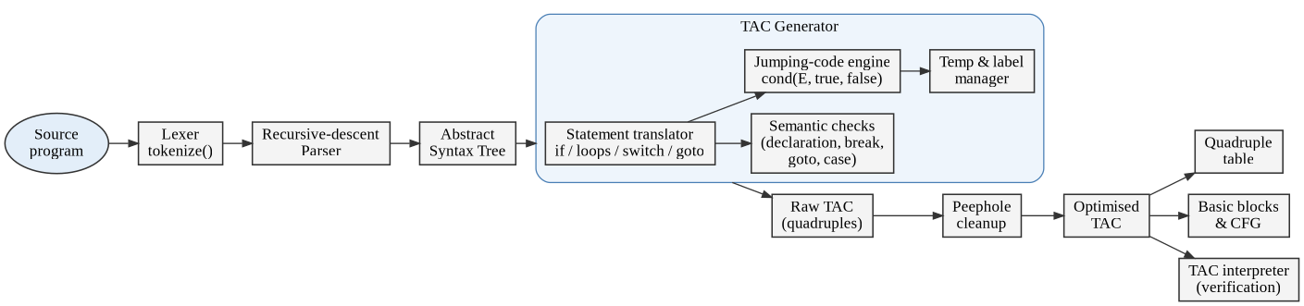
Figure 3.1: Architecture of the proposed TAC generation model
Table 3.1: Modules of the system and their responsibilities
Module | Responsibility | Main functions
Lexer | Converts characters into tokens, removes comments and white space, records line numbers. | tokenize()
Parser | Recursive-descent parser with precedence climbing for expressions; builds the AST. | Parser.stmt(), expr()
TAC generator | Translates statements and expressions into quadruples; creates temporaries and labels; performs semantic checks. | TACGenerator
Jumping-code engine | Translates Boolean expressions into conditional and unconditional jumps with fall-through. | cond(), jump_if()
Peephole clean-up | Removes jumps to the next instruction, merges condition-plus-goto pairs and deletes unused labels. | cleanup()
CFG builder | Finds leaders, forms basic blocks, adds edges and exports Graphviz DOT. | basic_blocks(), cfg_to_dot()
TAC interpreter | Executes the quadruples to verify that they behave like the source program. | run_tac()

3.3 Overall Working
The flowchart in Figure 3.2 shows the complete working of the translator. Errors can be detected in three places: the lexer reports illegal characters, the parser reports syntax errors, and the generator reports semantic errors (for example an undeclared variable). In every case a message with the line number is produced and translation stops.
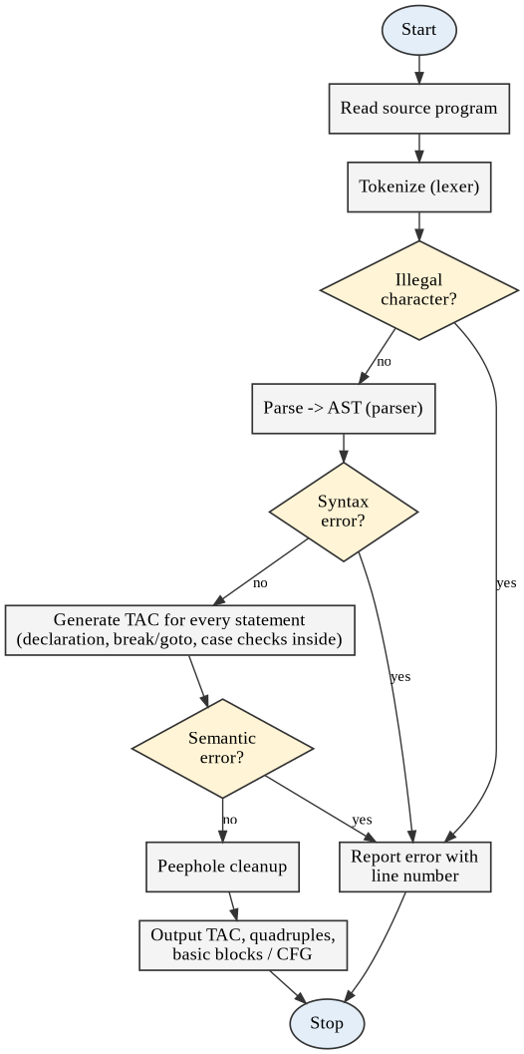
Figure 3.2: Flowchart of the overall working of the translator

3.4 Data Structures
- Token – kind, text and line number.
- AST node – a Python tuple whose first element is the node type, for example ("while", cond, body) or ("bin", "+", left, right).
- Quad – the four fields op, a1, a2 and res; conditional jumps use the operator names if<, if>=, if== and so on, with the target label in the result field.
- Counters for temporaries (t1, t2, ...) and labels (L1, L2, ...); user labels from goto statements keep their own names.
- break_stack and continue_stack – the innermost break and continue targets. A loop pushes both; a switch pushes only a break target, so that continue inside a switch correctly refers to the enclosing loop.

3.5 Translation Schemes
Table 3.2 gives the translation scheme of each construct. B.true and B.false are the inherited labels of the Boolean condition, fall denotes fall-through, and the notation ‖ means concatenation of code. Every new label is created with newlabel() and placed in the code with a label: instruction.
Table 3.2: Translation scheme for conditional, loop and branching statements
Construct | Generated code (inherited labels in brackets)
if (B) S1 | B.code (true = fall, false = L_false)  S1.code  L_false:
if (B) S1 else S2 | B.code (true = fall, false = L_else)  S1.code  goto L_end  L_else: S2.code  L_end:
while (B) S1 | L_begin:  B.code (true = fall, false = L_end)  S1.code  goto L_begin  L_end:
do S1 while (B) | L_begin: S1.code  L_cond:  B.code (true = L_begin, false = fall)  L_end:
for (I; C; U) S1 | I.code  L_begin:  C.code (true = fall, false = L_end)  S1.code  L_upd: U.code  goto L_begin  L_end:
switch (E) { case c1: S1 … default: Sd } | t = E.code  if t == c1 goto L1 … (one test per case)  goto L_default (or L_end if no default)  L1: S1.code … L_default: Sd.code  L_end:
break; continue; | goto break_stack.top  goto continue_stack.top (L_begin, L_cond or L_upd)
goto L; L: S | goto L  L: S.code

Conditional statements
For if (B) S1 the condition is translated with true = fall and false = L_false. Since the true case simply falls through into S1, only one conditional jump (on the negated relation) is needed. For if-else a goto L_end after S1 skips the else branch. An else-if ladder is nothing but an if-else whose else part is another if statement, so it needs no special rule. Figure 3.3 (a) and (b) show the control flow of the generated code.
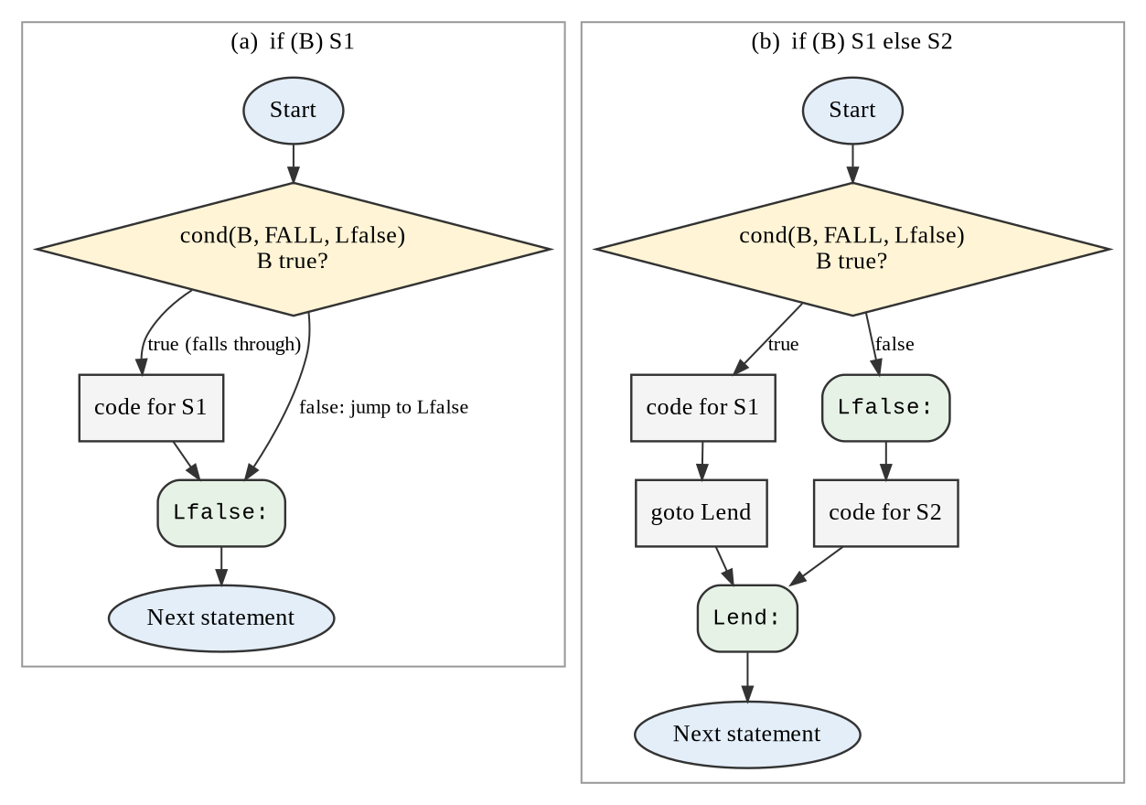
Figure 3.3: Flowchart of the code generated for if and if-else statements

Loops
The while loop places a label L_begin before the condition test, exits to L_end when the condition fails, and jumps back with goto L_begin after the body. The do-while loop executes its body first and tests at the bottom, so a single conditional jump back to L_begin (true = L_begin, false = fall) replaces the test-and-goto pair, saving one instruction per iteration. The for loop is translated like a while loop in which the update statement is placed in its own block L_upd; this label is the target of continue. Figures 3.4 and 3.5 show these three loops.
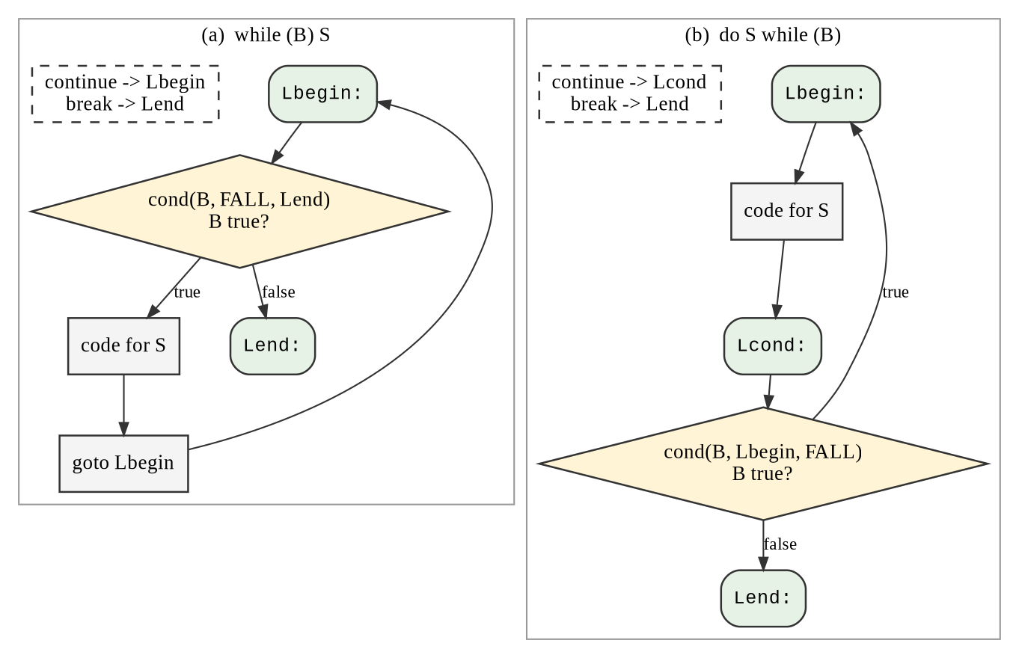
Figure 3.4: Flowchart of the code generated for while and do-while loops
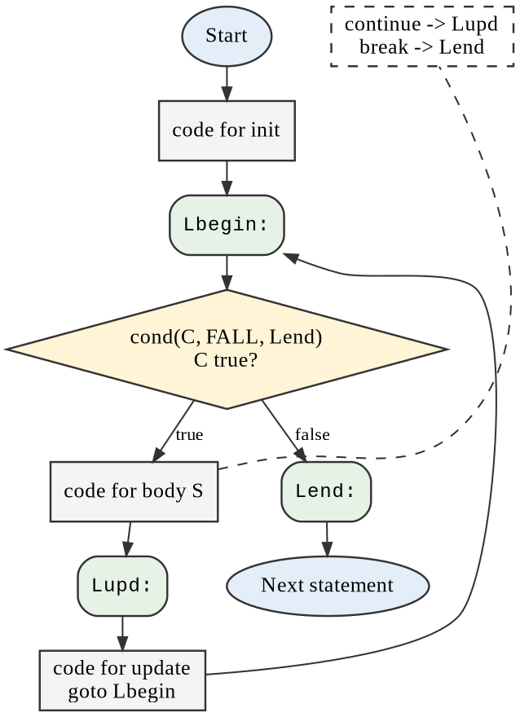
Figure 3.5: Flowchart of the code generated for a for loop

Branching statements
break and continue are translated into a goto to the label on top of the corresponding stack, which is why a single mechanism handles arbitrarily nested loops. A switch statement is translated into a sequence of equality tests that jump to the case labels, followed by a jump to the default label (or to the end if there is no default). The case bodies are placed one after the other in source order, so a case without break naturally falls through into the next case, exactly as in C. A goto to a user label is translated directly; all labels are collected in a first pass over the AST so that forward jumps can be checked. The control flow of the switch translation is shown in Figure 3.6.
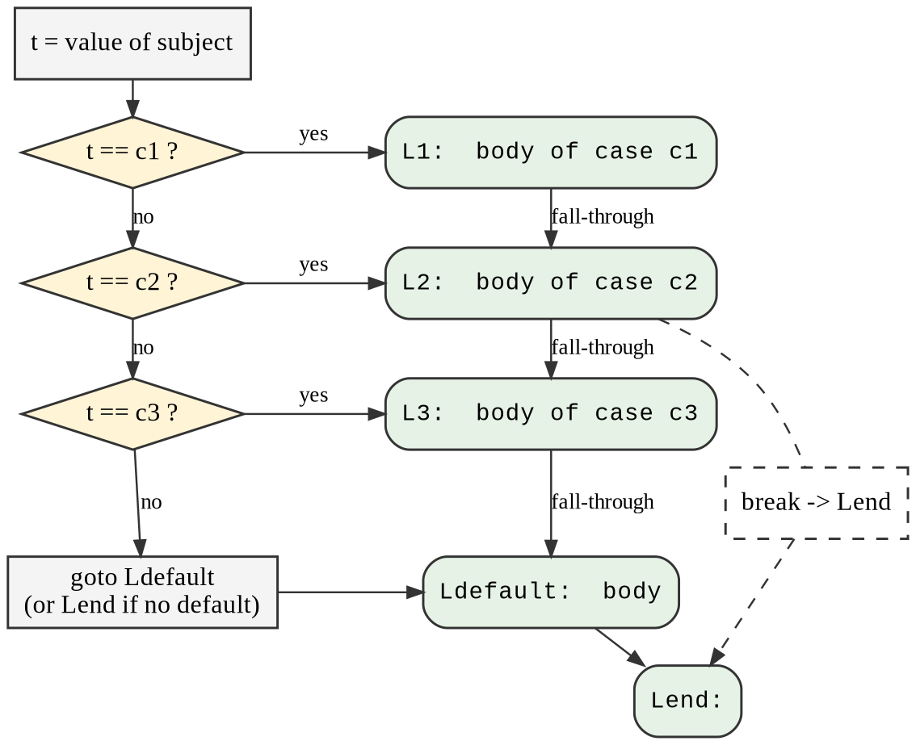
Figure 3.6: Flowchart of the code generated for a switch statement

3.6 Jumping Code for Boolean Expressions
The heart of the model is the function cond(E, T, F), which generates code that transfers control to label T when E is true and to label F when E is false; either label may be fall. Its algorithm is shown as a flowchart in Figure 3.7. For E1 && E2 the false label of E1 is F (or a new label if F is fall); for E1 || E2 the true label of E1 is T (or a new label if T is fall). For a relational test the function jump_if chooses between the three cases of Table 3.3.
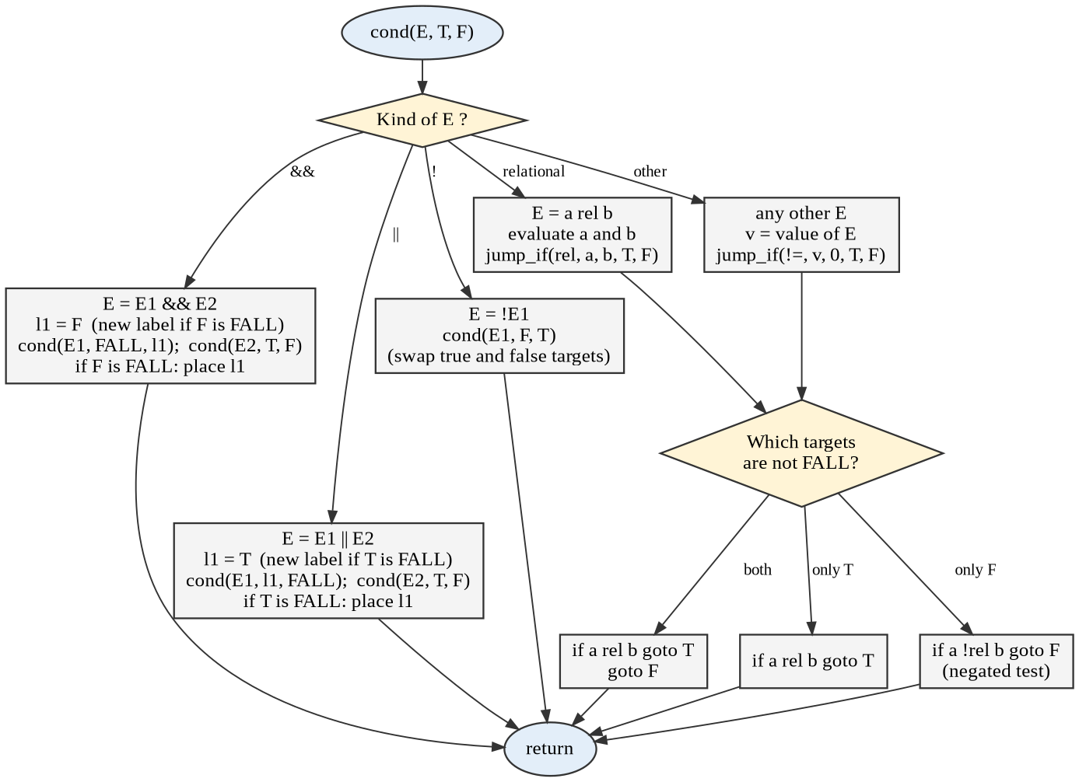
Figure 3.7: Flowchart of the jumping-code algorithm cond(E, T, F)
Table 3.3: Instructions emitted by jump_if(rel, a, b, T, F)
Targets | Emitted instructions | Example (a < b)
T and F both given | if a rel b goto T; goto F | if a < b goto T; goto F
only T given (F = fall) | if a rel b goto T | if a < b goto T
only F given (T = fall) | if a !rel b goto F (negated relation) | if a >= b goto F
both fall | nothing | —

When a relational or logical expression is used as a value (for example f = (a < b) && (c < d);) the generator calls cond with true = fall and false = L_false and then emits f = 1; goto L_end; L_false: f = 0; L_end:. Arithmetic operands are translated by a normal post-order traversal that allocates one temporary per operator; an assignment x = a + b * c writes the final addition directly into x instead of using one more temporary and a copy.

3.7 Peephole Clean-up
The generator is deliberately simple and may produce small redundancies, for example a goto to the label that follows it immediately. Three local rules remove them: (1) goto L directly followed by L: is deleted; (2) if c goto A; goto B; A: is replaced by if !c goto B; A:; (3) labels that no jump refers to are deleted. The rules are applied repeatedly until no further change is possible. They never change the meaning of the program; this is checked in the test-suite by running both the raw and the cleaned code.

3.8 Error Handling
Table 3.4: Errors detected by the translator
Error | Detected by | Message (example)
Illegal character | Lexer | line 1: illegal character '@'
Missing token / bad syntax | Parser | line 1: expected ')' but found 'a'
Undeclared variable | Generator | line 1: variable 'x' used before declaration
break / continue outside loop | Generator | line 1: 'break' outside loop or switch
goto undefined or duplicate label | Generator | line 1: goto to undefined label 'nowhere'
Duplicate case value | Generator | duplicate case value 1

4. Implementation

4.1 Development Environment
The model is implemented in Python 3 (about 450 lines in the single file tac_generator.py) and uses only the standard library. The unit tests use the unittest module, and the flowcharts, abstract syntax tree and control-flow graphs in this report were drawn with Graphviz from the DOT output of the program itself. The control-flow graphs are therefore generated from real compiler output and are not drawn by hand.

4.2 Lexer and Parser
The lexer is a single regular expression with named groups for comments, white space, numbers, identifiers and operators; keywords are recognised by looking up an identifier in a keyword set. The parser is a hand-written recursive-descent parser. One method exists for each statement type, and expressions are parsed with precedence climbing using the table of operator priorities. Each statement produces a tuple node of the AST, so the parser and the generator communicate only through plain data.

4.3 Jumping-Code Engine
Listing 4.1 shows the implementation of cond and jump_if. The code follows the flowchart of Figure 3.7 almost line by line. The dictionary NEGATE maps each relational operator to its opposite and is used when only the false target is given.
def cond(self, e, ltrue, lfalse):
"""Jumping code for a Boolean expression.
Control reaches ltrue / lfalse; FALL (None) means 'fall through'."""
kind = e[0]
if kind == "bin" and e[1] == "&&":
l1 = lfalse if lfalse is not FALL else self.label()
self.cond(e[2], FALL, l1)
self.cond(e[3], ltrue, lfalse)
if lfalse is FALL:
self.place(l1)
elif kind == "bin" and e[1] == "||":
l1 = ltrue if ltrue is not FALL else self.label()
self.cond(e[2], l1, FALL)
self.cond(e[3], ltrue, lfalse)
if ltrue is FALL:
self.place(l1)
elif kind == "un" and e[1] == "!":
self.cond(e[2], lfalse, ltrue)
elif kind == "bin" and e[1] in REL:
a, b = self.expr(e[2]), self.expr(e[3])
self.jump_if(e[1], a, b, ltrue, lfalse)
else: # any arithmetic value: true if != 0
a = self.expr(e)
self.jump_if("!=", a, "0", ltrue, lfalse)

def jump_if(self, rel, a, b, ltrue, lfalse):
if ltrue is not FALL and lfalse is not FALL:
self.emit("if" + rel, a, b, ltrue)
self.emit("goto", None, None, lfalse)
elif ltrue is not FALL:
self.emit("if" + rel, a, b, ltrue)
elif lfalse is not FALL:
self.emit("if" + NEGATE[rel], a, b, lfalse)
Listing 4.1: cond() and jump_if() – translation of Boolean expressions

4.4 Statement Translation
Each statement type has a method named s_<type>, which is found with getattr, so adding a new statement only requires adding one method. Listing 4.2 shows the translation of if-else and while, and Listing 4.3 the for statement. The helper loop_body (not shown) pushes the break and continue targets before the body is translated and pops them afterwards.
def s_if(self, s):
_, c, then, els = s
lfalse = self.label()
self.cond(c, FALL, lfalse)
self.stmt(then)
if els is None:
self.place(lfalse)
else:
lend = self.label()
self.emit("goto", None, None, lend)
self.place(lfalse)
self.stmt(els)
self.place(lend)

def s_while(self, s):
lbegin, lend = self.label(), self.label()
self.place(lbegin)
self.cond(s[1], FALL, lend)
self.loop_body(s[2], lend, lbegin)
self.emit("goto", None, None, lbegin)
self.place(lend)
Listing 4.2: Translation of if / if-else and while statements
def s_for(self, s):
_, init, c, upd, body = s
lbegin, lupd, lend = self.label(), self.label(), self.label()
if init:
self.stmt(init)
self.place(lbegin)
if c:
self.cond(c, FALL, lend)
self.loop_body(body, lend, lupd)
self.place(lupd)
if upd:
self.stmt(upd)
self.emit("goto", None, None, lbegin)
self.place(lend)
Listing 4.3: Translation of the for statement

4.5 Clean-up and Control-Flow Graph
Listing 4.4 shows the peephole clean-up. The helper labels_after collects all labels that follow position i, because several labels may stand together (for example at the end of nested loops). The leaders of the basic blocks are found in basic_blocks with the three rules of Section 2.5.
def cleanup(code):
"""Peephole clean-up of the raw code.
1. 'goto L' immediately followed by 'L:' -> delete the goto
2. 'if c goto A ; goto B ; A:' -> 'if !c goto B ; A:'
3. labels that no jump refers to -> delete the label
"""
code = list(code)

def labels_after(i):
out = set()
while i < len(code) and code[i].op == "label":
out.add(code[i].res)
i += 1
return out

changed = True
while changed:
changed = False
for i, q in enumerate(code):
if q.op == "goto" and q.res in labels_after(i + 1):
del code[i]
changed = True
break
if (q.is_cond() and i + 1 < len(code) and code[i + 1].op == "goto"
and q.res in labels_after(i + 2)):
q.op = "if" + NEGATE[q.op[2:]]
q.res = code[i + 1].res
del code[i + 1]
changed = True
break
used = {q.res for q in code if q.is_jump()}
return [q for q in code if q.op != "label" or q.res in used]
Listing 4.4: Peephole clean-up of the generated code

4.6 Using the Tool
The program is run from the command line as python tac_generator.py program.src. The option --raw disables the clean-up, --quads prints the quadruple table, --cfg prints the control-flow graph in DOT format and --run executes the generated code on the interpreter and prints the final values of all variables. The function compile_source(src, clean=True) can also be imported by other Python programs. The test-suite is run with python -m unittest test_tac_generator.

5. Results and Analysis
This chapter shows the code generated for typical programs. All listings in this chapter were produced by the implemented model and were then executed on the TAC interpreter; the final values are quoted from the interpreter.

5.1 Conditional Statements
Else-if ladder with short-circuit conditions. The condition marks >= 60 && attendance >= 75 is translated into two consecutive conditional jumps that both go to the same false label L3: if the first test fails, the second is never executed. Each relation is inverted (for example marks >= 60 becomes if marks < 60 goto L3) because the true case falls through. For marks = 72 and attendance = 80 the program sets grade = 2, as expected.
Source program | Generated three-address code (after cleanup)
int marks = 72, attendance = 80, grade = 0;  if (marks >= 90)  grade = 1;  else if (marks >= 60 && attendance >= 75)  grade = 2;  else  grade = 3; | marks = 72  attendance = 80  grade = 0  if marks < 90 goto L1  grade = 1  goto L2  L1:  if marks < 60 goto L3  if attendance < 75 goto L3  grade = 2  goto L4  L3:  grade = 3  L4:  L2:
Listing: Else-if ladder with short-circuit conditions – source and generated TAC
Short-circuit evaluation of && and ||. The condition a > 3 && b < 10 || c == 1 shows how && and || are combined. If a <= 3, control jumps to L3 and tests c == 1; if b < 10 holds, control jumps directly to the true branch L2 and the test of c is skipped. The corresponding control-flow graph is given in Figure 5.2 (b).
Source program | Generated three-address code (after cleanup)
int a = 5, b = 3, c = 0, r = 0;  if (a > 3 && b < 10 || c == 1)  r = a + b * 2;  else  r = -1; | a = 5  b = 3  c = 0  r = 0  if a <= 3 goto L3  if b < 10 goto L2  L3:  if c != 1 goto L1  L2:  t1 = b * 2  r = a + t1  goto L4  L1:  r = -1  L4:
Listing: Short-circuit evaluation of && and || – source and generated TAC

5.2 Loops
while loop. The loop body contains an if statement whose condition i % 2 == 0 needs a temporary t1 for the remainder. The structure of the output (label L1, exit test, body, back-edge) is exactly the template of Table 3.2. For the abstract syntax tree of this program see Figure 5.1 and for its control-flow graph Figure 5.2 (a). The interpreter obtains s = 30 (the sum of the even numbers up to 10).
Source program | Generated three-address code (after cleanup)
int i = 1, s = 0;  while (i <= 10) {  if (i % 2 == 0)  s = s + i;  i = i + 1;  } | i = 1  s = 0  L1:  if i > 10 goto L2  t1 = i % 2  if t1 != 0 goto L3  s = s + i  L3:  i = i + 1  goto L1  L2:
Listing: while loop with an if inside – source and generated TAC
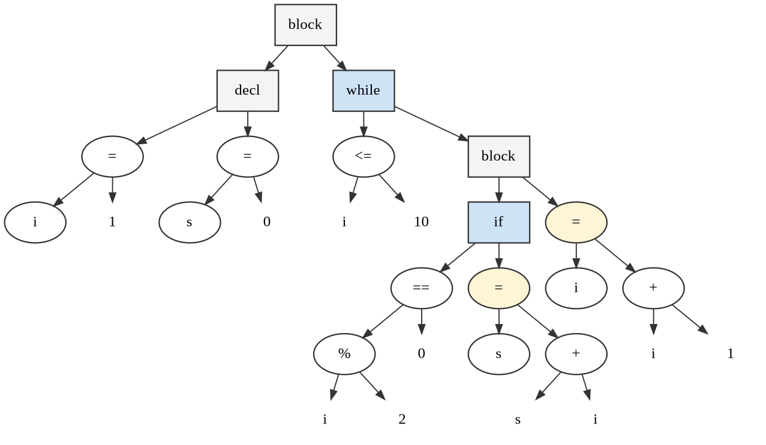
Figure 5.1: Abstract syntax tree of the while-loop example
do-while loop. Because the test is at the bottom of the loop, the cleaned code consists of just six instructions: the single conditional jump if n > 1 goto L1 both tests the condition and closes the loop. The raw code contains two more instructions (an unused end label and a jump), which the clean-up removes. The result is f = 120. Table 5.1 shows the same code in quadruple form.
Source program | Generated three-address code (after cleanup)
int n = 5, f = 1;  do {  f = f * n;  n = n - 1;  } while (n > 1); | n = 5  f = 1  L1:  f = f * n  n = n - 1  if n > 1 goto L1
Listing: do-while loop (factorial) – source and generated TAC
Table 5.1: Quadruple table of the do-while example
# | op | arg1 | arg2 | result
0 | = | 5 | - | n
1 | = | 1 | - | f
2 | label | - | - | L1
3 | * | f | n | f
4 | - | n | 1 | n
5 | if> | n | 1 | L1

Nested for loops with break and continue. The inner loop leaves with break (the jump goto L6), and continue in the outer loop jumps to the update label L2. The program counts the prime numbers up to 30 and the interpreter obtains count = 10, which is correct (2, 3, 5, 7, 11, 13, 17, 19, 23, 29). The control-flow graph of this program is Figure 5.2 (c).
Source program | Generated three-address code (after cleanup)
int n, i, count = 0, isp;  for (n = 2; n <= 30; n = n + 1) {  isp = 1;  for (i = 2; i * i <= n; i = i + 1) {  if (n % i == 0) { isp = 0; break; }  }  if (isp == 0) continue;  count = count + 1;  } | count = 0  n = 2  L1:  if n > 30 goto L3  isp = 1  i = 2  L4:  t1 = i * i  if t1 > n goto L6  t2 = n % i  if t2 != 0 goto L7  isp = 0  goto L6  L7:  i = i + 1  goto L4  L6:  if isp == 0 goto L2  count = count + 1  L2:  n = n + 1  goto L1  L3:
Listing: Nested for loops with break and continue – source and generated TAC
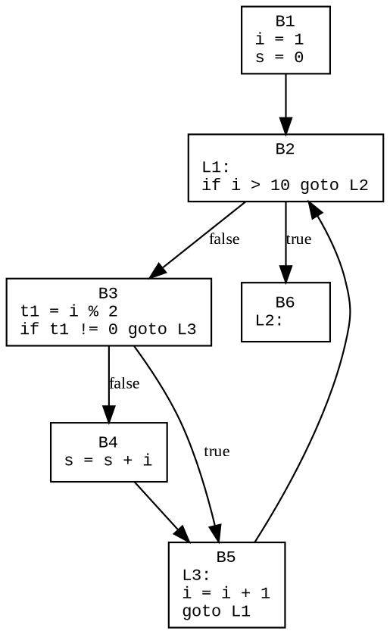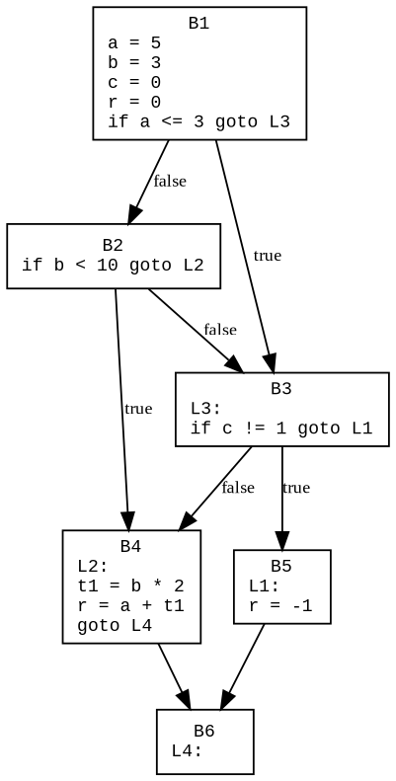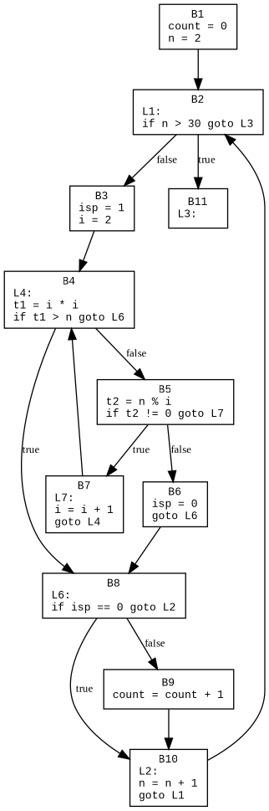
Figure 5.2: Control-flow graphs generated by the model: (a) while loop, (b) short-circuit condition, (c) nested loops with break and continue

5.3 Branching Statements
switch statement. The tests if x == 1 goto L2, if x == 2 goto L3 and if x == 3 goto L4 are followed by goto L5 for the default case. The case with value 2 has no break, so its body (L3) runs into the body of case 3 (L4); the result is r = 20 + 5 = 25, which shows that fall-through is preserved.
Source program | Generated three-address code (after cleanup)
int x = 2, r = 0;  switch (x) {  case 1: r = 10; break;  case 2: r = 20;  case 3: r = r + 5; break;  default: r = 99;  } | x = 2  r = 0  if x == 1 goto L2  if x == 2 goto L3  if x == 3 goto L4  goto L5  L2:  r = 10  goto L1  L3:  r = 20  L4:  r = r + 5  goto L1  L5:  r = 99  L1:
Listing: switch with fall-through and default – source and generated TAC
goto with labels. User labels keep their names (top, done). The generator emits the jump to done as a forward jump; the existence of the label was checked in the first pass. The loop built from goto computes the sum 1 + … + 5 = 15 and the last statement doubles it, so s = 30.
Source program | Generated three-address code (after cleanup)
int i = 1, s = 0;  top:  if (i > 5) goto done;  s = s + i;  i = i + 1;  goto top;  done:  s = s * 2; | i = 1  s = 0  top:  if i > 5 goto done  s = s + i  i = i + 1  goto top  done:  s = s * 2
Listing: goto and labelled statement – source and generated TAC

5.4 Verification by Execution
To verify the translation, 19 test programs were compiled both with and without clean-up and executed on the TAC interpreter. The final values of the observed variables were compared with the values expected from the meaning of the program. Table 5.2 summarises the result: 19 of 19 programs gave the expected values in both versions of the code.
Table 5.2: Results of the test programs
Test program | Expected values | Raw TAC | Clean TAC | Result
if without else | b = 1 | 5 | 5 | Pass
if-else (false branch) | b = 2 | 8 | 8 | Pass
else-if ladder | g = 3 | 18 | 18 | Pass
short-circuit && (no division by zero) | y = 2 | 10 | 10 | Pass
short-circuit || (right side skipped) | y = 1 | 11 | 11 | Pass
mixed && || | r = 1 | 11 | 11 | Pass
negation | r = 7 | 5 | 5 | Pass
Boolean used as a value | f = 1 | 12 | 12 | Pass
while loop (sum 1..10) | s = 55, i = 11 | 8 | 8 | Pass
do-while (5!) | f = 120 | 8 | 6 | Pass
for loop (sum of squares) | s = 55 | 10 | 9 | Pass
for with continue (odd sum) | s = 25 | 13 | 11 | Pass
nested loops + break (primes <= 30) | count = 10 | 25 | 23 | Pass
gcd(48,18) | a = 6 | 9 | 9 | Pass
Collatz steps for 27 | steps = 111 | 15 | 15 | Pass
switch with fall-through | r = 25 | 17 | 17 | Pass
switch default | r = 99 | 14 | 14 | Pass
goto and label | s = 30 | 11 | 9 | Pass
unary minus and precedence | r = 4 | 8 | 8 | Pass

Two tests demonstrate the short-circuit semantics directly. In the program if (x != 0 && 10 / x > 1) with x = 0 the division is never executed (the interpreter would raise a division-by-zero error if it were), and in if (x == 0 || 10 / x > 1) the right operand is likewise skipped. Both programs produce the correct result.

5.5 Error Detection
Seven erroneous programs were used to test the error handling. All 7 errors were detected, and each message contains the line number (Table 5.3).
Table 5.3: Results of the error-detection tests
Erroneous program | Message produced | Result
undeclared variable | line 1: variable 'x' used before declaration | Detected
break outside loop | line 1: 'break' outside loop or switch | Detected
continue outside loop | line 1: 'continue' outside loop | Detected
goto undefined label | line 1: goto to undefined label 'nowhere' | Detected
duplicate case | duplicate case value 1 | Detected
syntax error (missing paren) | line 1: expected ')' but found 'a' | Detected
illegal character | line 1: illegal character '@' | Detected

5.6 Effect of the Clean-up
Figure 5.3 compares the number of instructions (labels included) before and after the clean-up for each test program. In total the 19 programs contain 218 instructions before and 209 instructions after the clean-up, a reduction of 4.1%. The largest savings occur in loops (do-while, for, goto), where the generator leaves behind unused labels and jumps to the next instruction. Programs that were already compact, such as the plain if statements, are not changed, and no program becomes longer.
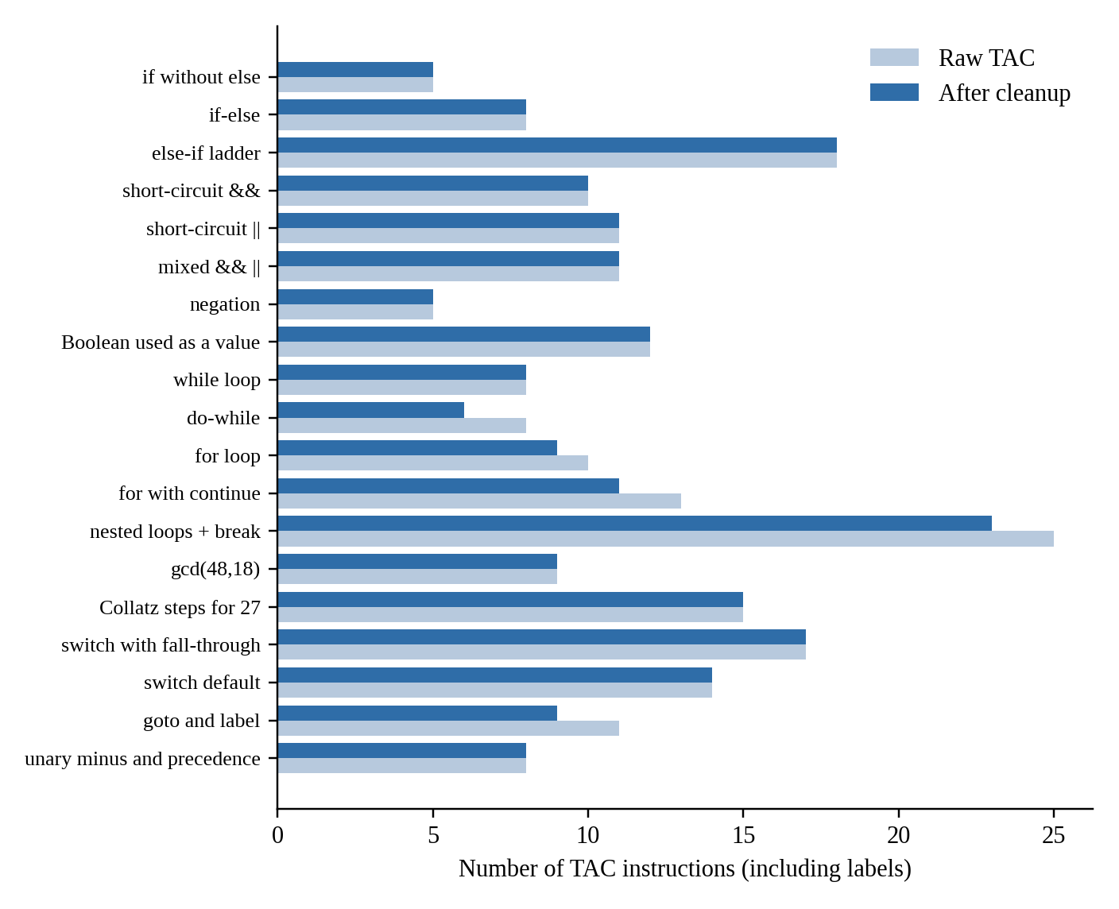
Figure 5.3: Size of the generated code before and after the peephole clean-up

5.7 Discussion
- Fall-through and inherited labels give compact code: an if statement with a relational condition needs only one conditional jump, and a do-while loop only one jump per iteration.
- Short-circuit evaluation is obtained without any special code – it is a consequence of the way the labels are passed to the operands of && and ||.
- A single pair of stacks is sufficient to translate break and continue in arbitrarily nested loops and switch statements.
- Because every program was executed after translation, the report does not rely on visual inspection alone to claim that the code is correct.

6. Applications, Limitations and Future Scope

6.1 Applications
- As the intermediate-code generation phase of a complete compiler for a C-like language; the quadruples can be passed to an optimiser or to a back end.
- As a teaching tool for the Compiler Design course: the readable output, quadruple table and CFG make the translation of control flow visible.
- As the basis for data-flow analyses and optimisations, which start from basic blocks and a control-flow graph.

6.2 Limitations
- Only the type int, a single scope and no functions, arrays or pointers are supported.
- The model generates a new temporary for every operator and does not reuse temporaries or perform common-subexpression elimination.
- The peephole clean-up is local; it does not remove unreachable code after a break, continue or goto.
- Constant conditions such as while (1) are not simplified.

6.3 Future Scope
- Add functions with parameters and return values, arrays and the type float, together with a type checker.
- Implement the backpatching variant for a bottom-up (LR) parser generated with a tool such as Yacc/Bison and compare it with the present approach.
- Add optimisations on the CFG: constant folding and propagation, dead-code elimination, common-subexpression elimination and loop-invariant code motion.
- Generate target code (for example for a simple register machine or x86-64) from the optimised TAC.

7. Conclusion
In this project a model for generating three-address code for the control-flow constructs of a programming language was designed and implemented. The model covers conditional statements (if, if-else, else-if ladders and switch), loops (while, do-while and for) and branching statements (break, continue and goto), and translates Boolean conditions into jumping code with short-circuit evaluation. The use of inherited true/false labels with fall-through produces compact code, and a small peephole clean-up removes the remaining redundant jumps and labels.
The implementation consists of a lexer, a recursive-descent parser, the TAC generator, a clean-up pass, a basic-block and CFG builder and a TAC interpreter. All 19 test programs gave the expected results on the interpreter, and all 7 erroneous programs were rejected with a meaningful message. The project has given practical experience with intermediate code, the treatment of Boolean expressions, and the relationship between source-level control structures and the control-flow graph, and it forms a good basis for the optimisation and code-generation phases of a compiler.

References
[1] A. V. Aho, M. S. Lam, R. Sethi and J. D. Ullman, Compilers: Principles, Techniques, and Tools, 2nd ed., Pearson Education, 2006. (Chapter 6: Intermediate-Code Generation.)
[2] K. D. Cooper and L. Torczon, Engineering a Compiler, 2nd ed., Morgan Kaufmann, 2011.
[3] A. W. Appel, Modern Compiler Implementation in C, Cambridge University Press, 1998.
[4] K. C. Louden, Compiler Construction: Principles and Practice, PWS Publishing, 1997.
[5] S. S. Muchnick, Advanced Compiler Design and Implementation, Morgan Kaufmann, 1997.
[6] Python Software Foundation, Python 3 Documentation, https://docs.python.org/3/
[7] Graphviz Project, Graphviz Documentation, https://graphviz.org/documentation/

Appendix A: Complete Source Code (tac_generator.py)
"""
tac_generator.py
Three-Address Code (TAC) generator for conditional statements, loops and
branching statements of a small C-like language.

Pipeline: source -> tokens -> AST -> TAC (quadruples) -> cleanup -> basic blocks / CFG

Usage: python tac_generator.py program.src [--raw] [--quads] [--cfg] [--run]
"""
import re
import sys

# ----------------------------------------------------------------------------
# 1. Lexical analysis
# ----------------------------------------------------------------------------
KEYWORDS = {"int", "if", "else", "while", "do", "for", "switch", "case",
"default", "break", "continue", "goto"}

TOKEN_RE = re.compile(r"""
(?P<COMMENT>//[^\n]*|/\*.*?\*/)
| (?P<WS>\s+)
| (?P<NUM>\d+)
| (?P<ID>[A-Za-z_]\w*)
| (?P<OP>==|!=|<=|>=|&&|\|\||[-+*/%<>=!(){};:,])
| (?P<BAD>.)
""", re.X | re.S)

class CompileError(Exception):
pass

class Token:
def __init__(self, kind, text, line):
self.kind, self.text, self.line = kind, text, line

def __repr__(self):
return f"Token({self.kind!r}, {self.text!r}, line {self.line})"

def tokenize(src):
tokens, line = [], 1
for m in TOKEN_RE.finditer(src):
kind, text = m.lastgroup, m.group()
if kind in ("WS", "COMMENT"):
pass
elif kind == "BAD":
raise CompileError(f"line {line}: illegal character {text!r}")
elif kind == "NUM":
tokens.append(Token("num", text, line))
elif kind == "ID":
tokens.append(Token(text if text in KEYWORDS else "id", text, line))
else:
tokens.append(Token(text, text, line))
line += text.count("\n")
tokens.append(Token("eof", "<eof>", line))
return tokens

# ----------------------------------------------------------------------------
# 2. Syntax analysis (recursive descent) -> AST made of tuples
# ----------------------------------------------------------------------------
PREC = {"||": 1, "&&": 2, "==": 3, "!=": 3, "<": 4, ">": 4, "<=": 4, ">=": 4,
"+": 5, "-": 5, "*": 6, "/": 6, "%": 6}

class Parser:
def __init__(self, tokens):
self.t, self.i = tokens, 0

def peek(self, k=0):
return self.t[min(self.i + k, len(self.t) - 1)]

def next(self):
tok = self.t[self.i]
self.i += 1
return tok

def expect(self, kind):
tok = self.peek()
if tok.kind != kind:
raise CompileError(f"line {tok.line}: expected '{kind}' but found '{tok.text}'")
return self.next()

def accept(self, kind):
return self.next() if self.peek().kind == kind else None

def program(self):
stmts = []
while self.peek().kind != "eof":
stmts.append(self.stmt())
return ("block", stmts)

def block(self):
self.expect("{")
stmts = []
while self.peek().kind not in ("}", "eof"):
stmts.append(self.stmt())
self.expect("}")
return ("block", stmts)

def stmt(self):
k = self.peek().kind
if k == "{":
return self.block()
if k == ";":
self.next()
return ("empty",)
if k == "int":
return self.decl()
if k == "if":
self.next(); self.expect("(")
cond = self.expr(); self.expect(")")
then = self.stmt()
els = self.stmt() if self.accept("else") else None
return ("if", cond, then, els)
if k == "while":
self.next(); self.expect("(")
cond = self.expr(); self.expect(")")
return ("while", cond, self.stmt())
if k == "do":
self.next()
body = self.stmt()
self.expect("while"); self.expect("(")
cond = self.expr(); self.expect(")"); self.expect(";")
return ("do", body, cond)
if k == "for":
return self.for_stmt()
if k == "switch":
return self.switch_stmt()
if k in ("break", "continue"):
tok = self.next(); self.expect(";")
return (k, tok.line)
if k == "goto":
self.next()
name = self.expect("id").text
self.expect(";")
return ("goto", name, self.t[self.i - 1].line)
if k == "id" and self.peek(1).kind == ":":
name = self.next().text; self.next()
return ("label", name, self.stmt())
if k == "id":
node = self.assign(); self.expect(";")
return node
tok = self.peek()
raise CompileError(f"line {tok.line}: unexpected token '{tok.text}'")

def decl(self):
self.expect("int")
items = []
while True:
name = self.expect("id").text
init = self.expr() if self.accept("=") else None
items.append((name, init))
if not self.accept(","):
break
self.expect(";")
return ("decl", items)

def assign(self):
tok = self.expect("id")
self.expect("=")
return ("assign", tok.text, self.expr(), tok.line)

def for_stmt(self):
self.expect("for"); self.expect("(")
init = None if self.peek().kind == ";" else self.assign()
self.expect(";")
cond = None if self.peek().kind == ";" else self.expr()
self.expect(";")
upd = None if self.peek().kind == ")" else self.assign()
self.expect(")")
return ("for", init, cond, upd, self.stmt())

def switch_stmt(self):
self.expect("switch"); self.expect("(")
subject = self.expr(); self.expect(")"); self.expect("{")
cases = []
while self.peek().kind in ("case", "default"):
if self.next().kind == "case":
neg = bool(self.accept("-"))
val = int(self.expect("num").text) * (-1 if neg else 1)
else:
val = None
self.expect(":")
body = []
while self.peek().kind not in ("case", "default", "}", "eof"):
body.append(self.stmt())
cases.append((val, body))
self.expect("}")
return ("switch", subject, cases)

def expr(self, minp=1):
left = self.unary()
while self.peek().kind in PREC and PREC[self.peek().kind] >= minp:
op = self.next().kind
right = self.expr(PREC[op] + 1)
left = ("bin", op, left, right)
return left

def unary(self):
if self.accept("!"):
return ("un", "!", self.unary())
if self.accept("-"):
e = self.unary()
return ("num", -e[1]) if e[0] == "num" else ("un", "-", e)
return self.primary()

def primary(self):
tok = self.next()
if tok.kind == "num":
return ("num", int(tok.text))
if tok.kind == "id":
return ("var", tok.text, tok.line)
if tok.kind == "(":
e = self.expr(); self.expect(")")
return e
raise CompileError(f"line {tok.line}: unexpected token '{tok.text}' in expression")

def parse(src):
return Parser(tokenize(src)).program()

# ----------------------------------------------------------------------------
# 3. Three-address code generation
# ----------------------------------------------------------------------------
ARITH = {"+", "-", "*", "/", "%"}
REL = {"<", ">", "<=", ">=", "==", "!="}
NEGATE = {"<": ">=", ">": "<=", "<=": ">", ">=": "<", "==": "!=", "!=": "=="}
FALL = None # "fall through to the next instruction" marker

class Quad:
"""Quadruple (op, arg1, arg2, result)."""
__slots__ = ("op", "a1", "a2", "res")

def __init__(self, op, a1=None, a2=None, res=None):
self.op, self.a1, self.a2, self.res = op, a1, a2, res

def is_cond(self):
return self.op.startswith("if")

def is_jump(self):
return self.op == "goto" or self.is_cond()

def row(self):
return tuple("-" if v is None else str(v) for v in (self.op, self.a1, self.a2, self.res))

def __str__(self):
o = self.op
if o == "label":
return f"{self.res}:"
if o == "goto":
return f" goto {self.res}"
if o.startswith("if"):
return f" if {self.a1} {o[2:]} {self.a2} goto {self.res}"
if o == "=":
return f" {self.res} = {self.a1}"
if o == "uminus":
return f" {self.res} = -{self.a1}"
return f" {self.res} = {self.a1} {o} {self.a2}"

class TACGenerator:
def __init__(self):
self.code, self.vars = [], set()
self.ntemp = self.nlabel = 0
self.break_stack, self.continue_stack = [], []
self.user_labels = set()

# ---- helpers ----
def temp(self):
self.ntemp += 1
return f"t{self.ntemp}"

def label(self):
self.nlabel += 1
return f"L{self.nlabel}"

def emit(self, op, a1=None, a2=None, res=None):
self.code.append(Quad(op, a1, a2, res))

def place(self, lab):
self.emit("label", res=lab)

def use(self, name, line=0):
if name not in self.vars:
raise CompileError(f"line {line}: variable '{name}' used before declaration")
return name

# ---- entry point ----
def generate(self, ast):
self.collect_labels(ast)
self.stmt(ast)
return self.code

def collect_labels(self, node):
if isinstance(node, tuple):
if node and node[0] == "label":
if node[1] in self.user_labels:
raise CompileError(f"duplicate label '{node[1]}'")
if re.fullmatch(r"L\d+", node[1]):
raise CompileError(f"label '{node[1]}' clashes with compiler-generated labels")
self.user_labels.add(node[1])
for child in node:
self.collect_labels(child)
elif isinstance(node, list):
for child in node:
self.collect_labels(child)

# ---- expressions ----
def expr(self, e, target=None):
"""Return the place (name or constant) that holds the value of e."""
kind = e[0]
if kind == "num":
return str(e[1])
if kind == "var":
return self.use(e[1], e[2])
if kind == "un" and e[1] == "-":
a = self.expr(e[2])
dest = target or self.temp()
self.emit("uminus", a, None, dest)
return dest
if kind == "bin" and e[1] in ARITH:
a, b = self.expr(e[2]), self.expr(e[3])
dest = target or self.temp()
self.emit(e[1], a, b, dest)
return dest
# relational / logical expression used as a value -> materialise 0 or 1
dest = target or self.temp()
lfalse, lend = self.label(), self.label()
self.cond(e, FALL, lfalse)
self.emit("=", "1", None, dest)
self.emit("goto", None, None, lend)
self.place(lfalse)
self.emit("=", "0", None, dest)
self.place(lend)
return dest

def cond(self, e, ltrue, lfalse):
"""Jumping code for a Boolean expression.
Control reaches ltrue / lfalse; FALL (None) means 'fall through'."""
kind = e[0]
if kind == "bin" and e[1] == "&&":
l1 = lfalse if lfalse is not FALL else self.label()
self.cond(e[2], FALL, l1)
self.cond(e[3], ltrue, lfalse)
if lfalse is FALL:
self.place(l1)
elif kind == "bin" and e[1] == "||":
l1 = ltrue if ltrue is not FALL else self.label()
self.cond(e[2], l1, FALL)
self.cond(e[3], ltrue, lfalse)
if ltrue is FALL:
self.place(l1)
elif kind == "un" and e[1] == "!":
self.cond(e[2], lfalse, ltrue)
elif kind == "bin" and e[1] in REL:
a, b = self.expr(e[2]), self.expr(e[3])
self.jump_if(e[1], a, b, ltrue, lfalse)
else: # any arithmetic value: true if != 0
a = self.expr(e)
self.jump_if("!=", a, "0", ltrue, lfalse)

def jump_if(self, rel, a, b, ltrue, lfalse):
if ltrue is not FALL and lfalse is not FALL:
self.emit("if" + rel, a, b, ltrue)
self.emit("goto", None, None, lfalse)
elif ltrue is not FALL:
self.emit("if" + rel, a, b, ltrue)
elif lfalse is not FALL:
self.emit("if" + NEGATE[rel], a, b, lfalse)

# ---- statements ----
def stmt(self, s):
getattr(self, "s_" + s[0])(s)

def s_empty(self, s):
pass

def s_block(self, s):
for child in s[1]:
self.stmt(child)

def s_decl(self, s):
for name, init in s[1]:
self.vars.add(name)
if init is not None:
self.assign_to(name, init)

def s_assign(self, s):
self.use(s[1], s[3])
self.assign_to(s[1], s[2])

def assign_to(self, name, e):
if e[0] in ("num", "var"):
self.emit("=", self.expr(e), None, name)
else:
res = self.expr(e, target=name)
if res != name:
self.emit("=", res, None, name)

def s_if(self, s):
_, c, then, els = s
lfalse = self.label()
self.cond(c, FALL, lfalse)
self.stmt(then)
if els is None:
self.place(lfalse)
else:
lend = self.label()
self.emit("goto", None, None, lend)
self.place(lfalse)
self.stmt(els)
self.place(lend)

def loop_body(self, body, lbreak, lcont):
self.break_stack.append(lbreak)
self.continue_stack.append(lcont)
self.stmt(body)
self.break_stack.pop()
self.continue_stack.pop()

def s_while(self, s):
lbegin, lend = self.label(), self.label()
self.place(lbegin)
self.cond(s[1], FALL, lend)
self.loop_body(s[2], lend, lbegin)
self.emit("goto", None, None, lbegin)
self.place(lend)

def s_do(self, s):
lbegin, lcond, lend = self.label(), self.label(), self.label()
self.place(lbegin)
self.loop_body(s[1], lend, lcond)
self.place(lcond)
self.cond(s[2], lbegin, FALL)
self.place(lend)

def s_for(self, s):
_, init, c, upd, body = s
lbegin, lupd, lend = self.label(), self.label(), self.label()
if init:
self.stmt(init)
self.place(lbegin)
if c:
self.cond(c, FALL, lend)
self.loop_body(body, lend, lupd)
self.place(lupd)
if upd:
self.stmt(upd)
self.emit("goto", None, None, lbegin)
self.place(lend)

def s_switch(self, s):
_, subject, cases = s
seen = set()
for val, _ in cases:
if val in seen:
raise CompileError(f"duplicate case value {val}" if val is not None
else "duplicate default label")
seen.add(val)
key = self.expr(subject)
lend = self.label()
labels = [self.label() for _ in cases]
ldefault = lend
for (val, _), lab in zip(cases, labels):
if val is None:
ldefault = lab
else:
self.emit("if==", key, str(val), lab)
self.emit("goto", None, None, ldefault)
self.break_stack.append(lend)
for (_, body), lab in zip(cases, labels):
self.place(lab)
for st in body:
self.stmt(st)
self.break_stack.pop()
self.place(lend)

def s_break(self, s):
if not self.break_stack:
raise CompileError(f"line {s[1]}: 'break' outside loop or switch")
self.emit("goto", None, None, self.break_stack[-1])

def s_continue(self, s):
if not self.continue_stack:
raise CompileError(f"line {s[1]}: 'continue' outside loop")
self.emit("goto", None, None, self.continue_stack[-1])

def s_goto(self, s):
if s[1] not in self.user_labels:
raise CompileError(f"line {s[2]}: goto to undefined label '{s[1]}'")
self.emit("goto", None, None, s[1])

def s_label(self, s):
self.place(s[1])
self.stmt(s[2])

# ----------------------------------------------------------------------------
# 4. Clean-up (peephole) and control-flow graph
# ----------------------------------------------------------------------------
def cleanup(code):
"""Peephole clean-up of the raw code.
1. 'goto L' immediately followed by 'L:' -> delete the goto
2. 'if c goto A ; goto B ; A:' -> 'if !c goto B ; A:'
3. labels that no jump refers to -> delete the label
"""
code = list(code)

def labels_after(i):
out = set()
while i < len(code) and code[i].op == "label":
out.add(code[i].res)
i += 1
return out

changed = True
while changed:
changed = False
for i, q in enumerate(code):
if q.op == "goto" and q.res in labels_after(i + 1):
del code[i]
changed = True
break
if (q.is_cond() and i + 1 < len(code) and code[i + 1].op == "goto"
and q.res in labels_after(i + 2)):
q.op = "if" + NEGATE[q.op[2:]]
q.res = code[i + 1].res
del code[i + 1]
changed = True
break
used = {q.res for q in code if q.is_jump()}
return [q for q in code if q.op != "label" or q.res in used]

def basic_blocks(code):
"""Return (blocks, edges); blocks are (start, end) index ranges."""
if not code:
return [], []
leaders = {0}
for i, q in enumerate(code):
if q.op == "label" and i > 0 and code[i - 1].op != "label":
leaders.add(i)
if q.is_jump() and i + 1 < len(code):
leaders.add(i + 1)
starts = sorted(leaders)
blocks = [(s, starts[k + 1] if k + 1 < len(starts) else len(code))
for k, s in enumerate(starts)]
block_of = {}
for b, (s, e) in enumerate(blocks):
for i in range(s, e):
block_of[i] = b
label_block = {q.res: block_of[i] for i, q in enumerate(code) if q.op == "label"}
edges = []
for b, (s, e) in enumerate(blocks):
last = code[e - 1]
if last.op == "goto":
edges.append((b, label_block[last.res], ""))
elif last.is_cond():
edges.append((b, label_block[last.res], "true"))
if b + 1 < len(blocks):
edges.append((b, b + 1, "false"))
elif b + 1 < len(blocks):
edges.append((b, b + 1, ""))
return blocks, edges

def cfg_to_dot(code, name="CFG"):
blocks, edges = basic_blocks(code)
out = [f'digraph {name} {{', 'node [shape=box, fontname="Liberation Mono", fontsize=10];',
'edge [fontname="Liberation Serif", fontsize=10];']
for b, (s, e) in enumerate(blocks):
text = "\\l".join(str(q).strip() for q in code[s:e]) + "\\l"
out.append(f'B{b + 1} [label="B{b + 1}\\n{text}"];')
for a, b, lab in edges:
out.append(f'B{a + 1} -> B{b + 1}' + (f' [label="{lab}"]' if lab else "") + ";")
out.append("}")
return "\n".join(out)

# ----------------------------------------------------------------------------
# 5. TAC interpreter (used to verify the generated code)
# ----------------------------------------------------------------------------
def run_tac(code, max_steps=1_000_000):
labels = {q.res: i for i, q in enumerate(code) if q.op == "label"}
env, pc, steps = {}, 0, 0

def val(x):
return int(x) if re.fullmatch(r"-?\d+", x) else env.get(x, 0)

def cdiv(a, b):
if b == 0:
raise ZeroDivisionError("division by zero in generated code")
q = abs(a) // abs(b)
return q if (a >= 0) == (b >= 0) else -q

while pc < len(code):
steps += 1
if steps > max_steps:
raise RuntimeError("step limit exceeded (possible infinite loop)")
q = code[pc]
pc += 1
if q.op == "label":
continue
if q.op == "goto":
pc = labels[q.res]
elif q.is_cond():
a, b, r = val(q.a1), val(q.a2), q.op[2:]
if {"<": a < b, ">": a > b, "<=": a <= b, ">=": a >= b,
"==": a == b, "!=": a != b}[r]:
pc = labels[q.res]
elif q.op == "=":
env[q.res] = val(q.a1)
elif q.op == "uminus":
env[q.res] = -val(q.a1)
else:
a, b = val(q.a1), val(q.a2)
env[q.res] = {"+": lambda: a + b, "-": lambda: a - b, "*": lambda: a * b,
"/": lambda: cdiv(a, b),
"%": lambda: a - b * cdiv(a, b)}[q.op]()
return {k: v for k, v in env.items() if not re.fullmatch(r"t\d+", k)}, steps

# ----------------------------------------------------------------------------
# 6. Public API and command line
# ----------------------------------------------------------------------------
def compile_source(src, clean=True):
gen = TACGenerator()
code = gen.generate(parse(src))
return cleanup(code) if clean else code

def format_quads(code):
rows = [("#", "op", "arg1", "arg2", "result")]
rows += [(str(i),) + q.row() for i, q in enumerate(code)]
w = [max(len(r[c]) for r in rows) for c in range(5)]
return "\n".join(" ".join(v.ljust(w[c]) for c, v in enumerate(r)) for r in rows)

def main(argv):
if len(argv) < 2:
print(__doc__)
return 1
try:
with open(argv[1]) as f:
src = f.read()
code = compile_source(src, clean="--raw" not in argv)
except (CompileError, OSError) as err:
print("error:", err)
return 1
print("\n".join(str(q) for q in code))
if "--quads" in argv:
print("\n" + format_quads(code))
if "--cfg" in argv:
print("\n" + cfg_to_dot(code))
if "--run" in argv:
env, steps = run_tac(code)
print(f"\nfinal values: {env} ({steps} TAC steps)")
return 0

if __name__ == "__main__":
sys.exit(main(sys.argv))

Appendix B: Test Suite (test_tac_generator.py)
import unittest
from tac_generator import compile_source, run_tac, CompileError

CASES = [
("if without else", "int a = 5, b = 0; if (a > 3) b = 1;", {"b": 1}),
("if-else (false branch)", "int a = 2, b = 0; if (a > 3) b = 1; else b = 2;", {"b": 2}),
("else-if ladder", """int m = 72, g = 0;
if (m >= 90) g = 1; else if (m >= 75) g = 2; else if (m >= 60) g = 3; else g = 4;""", {"g": 3}),
("short-circuit && (no division by zero)",
"int x = 0, y = 0; if (x != 0 && 10 / x > 1) y = 1; else y = 2;", {"y": 2}),
("short-circuit || (right side skipped)",
"int x = 0, y = 0; if (x == 0 || 10 / x > 1) y = 1; else y = 2;", {"y": 1}),
("mixed && ||", "int a = 5, b = 3, c = 0, r = 0; if (a > 3 && b < 10 || c == 1) r = 1;", {"r": 1}),
("negation", "int a = 4, r = 0; if (!(a < 3)) r = 7;", {"r": 7}),
("Boolean used as a value", "int a = 1, b = 2, c = 3, d = 4, f = 0; f = (a < b) && (c < d);", {"f": 1}),
("while loop (sum 1..10)", "int i = 1, s = 0; while (i <= 10) { s = s + i; i = i + 1; }", {"s": 55, "i": 11}),
("do-while (5!)", "int n = 5, f = 1; do { f = f * n; n = n - 1; } while (n > 1);", {"f": 120}),
("for loop (sum of squares)", "int i, s = 0; for (i = 1; i <= 5; i = i + 1) s = s + i * i;", {"s": 55}),
("for with continue (odd sum)", """int i, s = 0;
for (i = 1; i <= 9; i = i + 1) { if (i % 2 == 0) continue; s = s + i; }""", {"s": 25}),
("nested loops + break (primes <= 30)", """int n, i, count = 0, isp;
for (n = 2; n <= 30; n = n + 1) {
isp = 1;
for (i = 2; i * i <= n; i = i + 1) { if (n % i == 0) { isp = 0; break; } }
if (isp) count = count + 1;
}""", {"count": 10}),
("gcd(48,18)", "int a = 48, b = 18, t; while (b != 0) { t = a % b; a = b; b = t; }", {"a": 6}),
("Collatz steps for 27", """int n = 27, steps = 0;
while (n != 1) { if (n % 2 == 0) n = n / 2; else n = 3 * n + 1; steps = steps + 1; }""", {"steps": 111}),
("switch with fall-through", """int x = 2, r = 0;
switch (x) { case 1: r = 10; break; case 2: r = 20; case 3: r = r + 5; break; default: r = 99; }""", {"r": 25}),
("switch default", """int x = 7, r = 0;
switch (x) { case 1: r = 10; break; case 2: r = 20; break; default: r = 99; }""", {"r": 99}),
("goto and label", """int i = 1, s = 0;
top: if (i > 5) goto done; s = s + i; i = i + 1; goto top; done: s = s * 2;""", {"s": 30}),
("unary minus and precedence", "int a = 3, b = 4, r = 0; r = -a + b * 2 - (b - a);", {"r": 4}),
]

ERRORS = [
("undeclared variable", "x = 1;"),
("break outside loop", "int a; break;"),
("continue outside loop", "int a; continue;"),
("goto undefined label", "goto nowhere;"),
("duplicate case", "int a; switch (a) { case 1: a = 1; break; case 1: a = 2; }"),
("syntax error (missing paren)", "int a; if (a > 1 a = 2;"),
("illegal character", "int a; a = 3 @ 4;"),
]

class TACTests(unittest.TestCase):
def test_programs(self):
for name, src, expected in CASES:
for clean in (False, True):
with self.subTest(name=name, clean=clean):
env, _ = run_tac(compile_source(src, clean=clean))
for var, value in expected.items():
self.assertEqual(env[var], value)

def test_cleanup_never_grows_code(self):
for name, src, _ in CASES:
with self.subTest(name=name):
self.assertLessEqual(len(compile_source(src, True)), len(compile_source(src, False)))

def test_errors(self):
for name, src in ERRORS:
with self.subTest(name=name):
with self.assertRaises(CompileError):
compile_source(src)

if __name__ == "__main__":
unittest.main(verbosity=2)

