Health Assist Web Application Week 3 Technical Report

Prepared by TBIT Software Analysis Team

Authored by

Emmett Parker & Stephen Kean

05/04/2018

**Introduction:**

This report discusses the process under went for week 3 to meet the week 3 deliverables through a look at the current application more specifically the sign up, login, and profile pages and their related code as well as reasons for not meeting certain requirements.

Our GitHub code is on the branch Steve_Branch. The main branch hasn’t been updated or merged into yet.

Github: <https://github.com/KeanConfed/HealthAssist/tree/Steve_Branch>

**Signup.php**

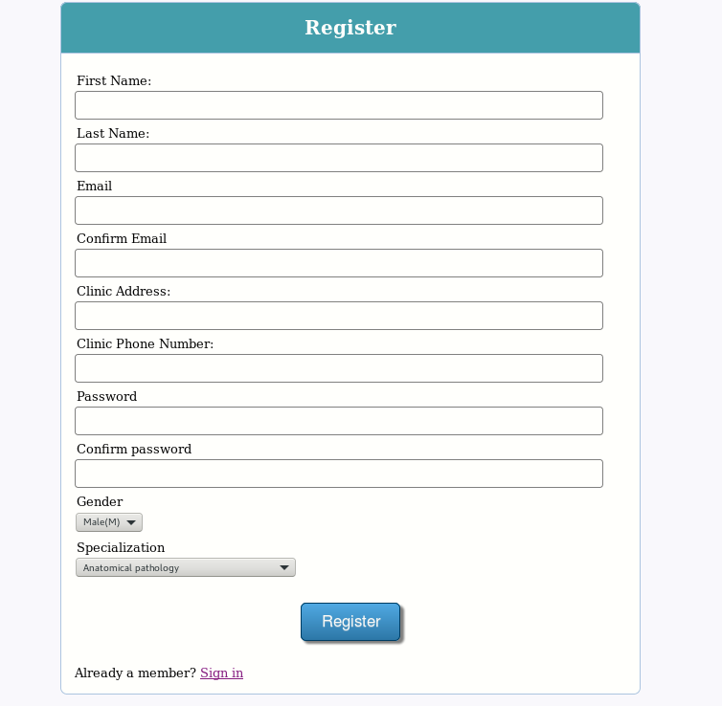

The signup page. Here a doctor can sign up to the system by entering all of their information and pressing the register button.

If a field is not filled in then the user won’t be able to continue until they are (a message will let the user know this)

If the email and confirm email inputs don’t match there will be a warning message and the user will be prevented from registering until they do. This is the same for password/confirm password

**Code for signup.php**

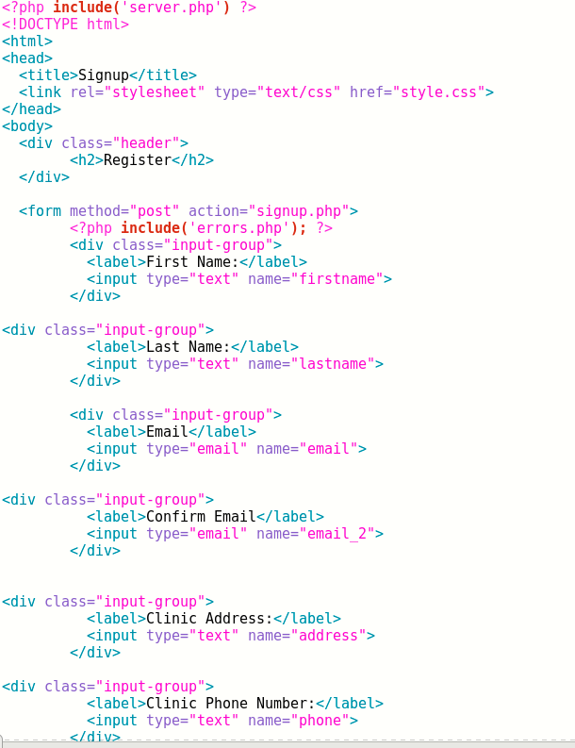

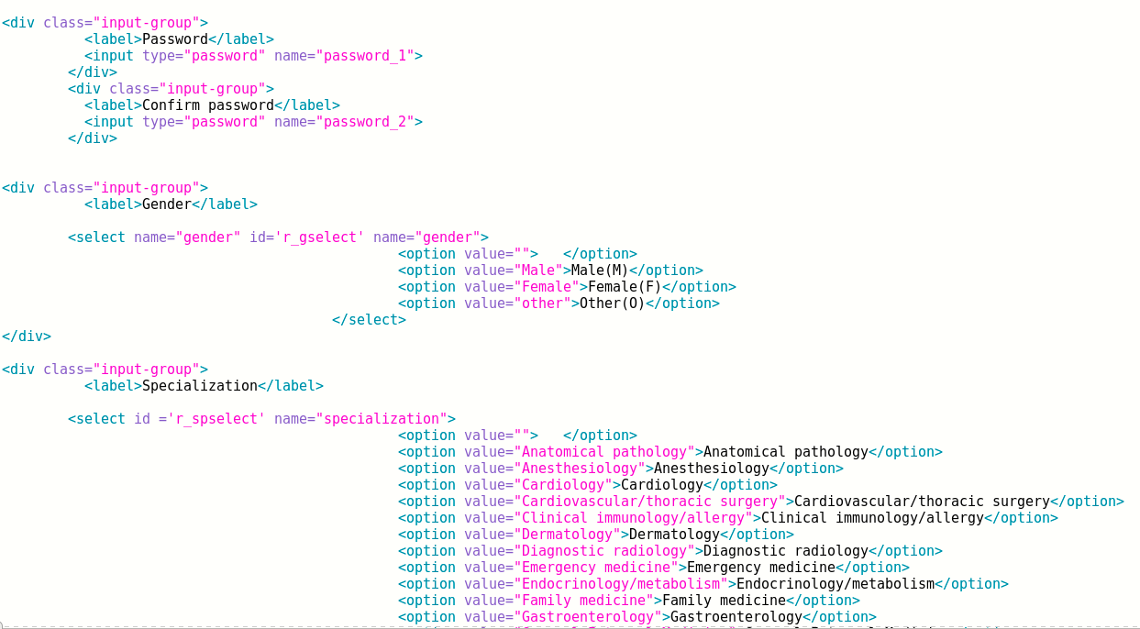

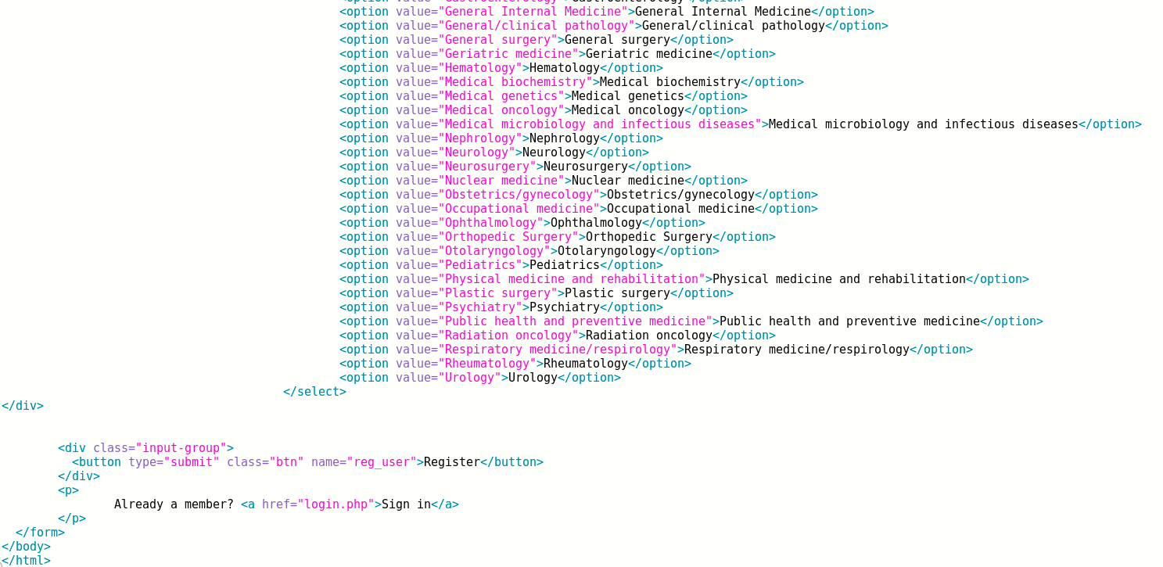

**Login.php**

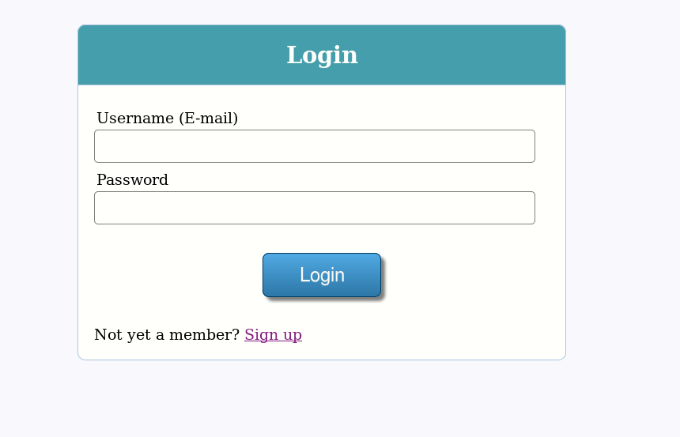

This is the Login page for registered users (doctors). Once a doctor is registered they can input their login information here and press the login button which will bring the user to the profile page.

If they aren’t registered they can select the sign up link to bring them to the signup page.

**Code for Login Page**

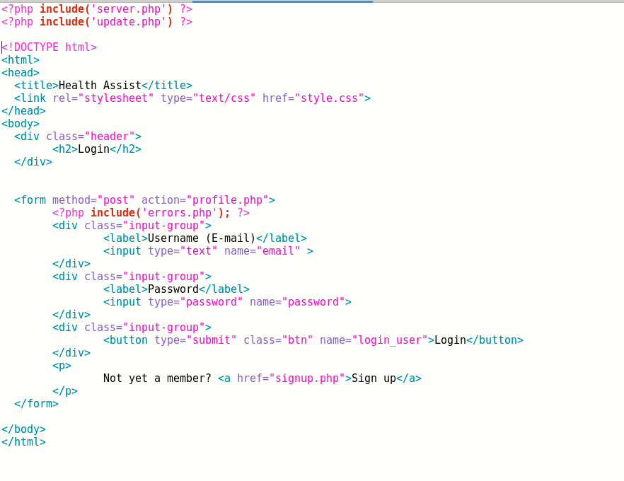

**Profile.php**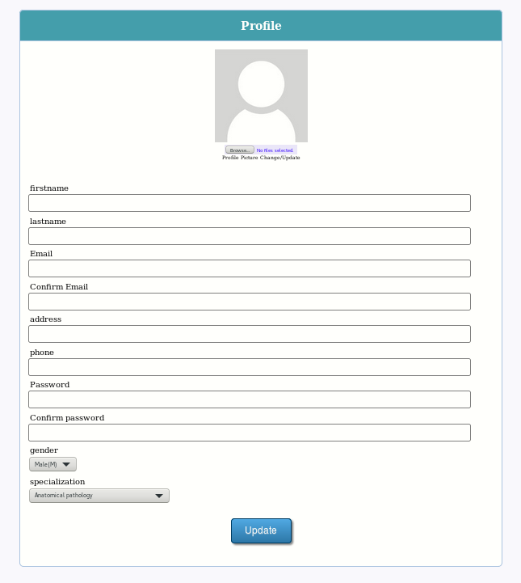

This is the profile page. Once a user registers they can log in which will send them to this page.

Here they can update their information and add a profile picture.

When the update button is pressed, the database will be updated with the corresponding information.

(Currently an image file can be uploaded to the profile, but it is unable to be saved in the database.)

**Code for profile.php**

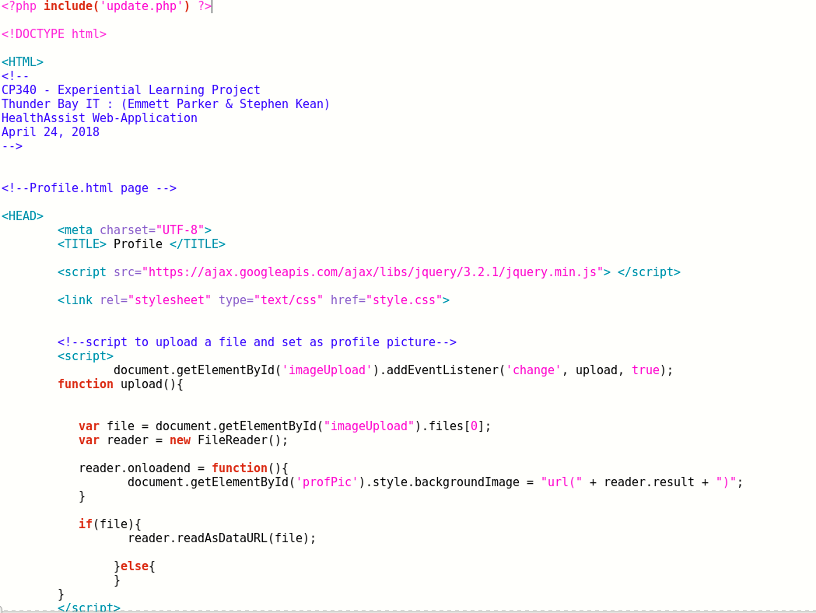

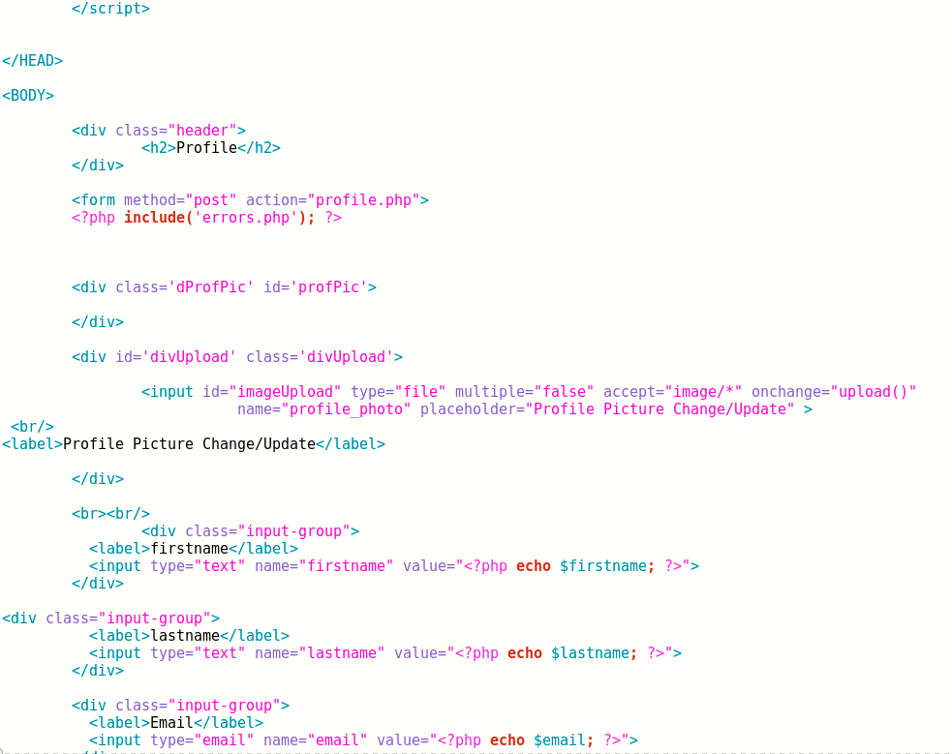

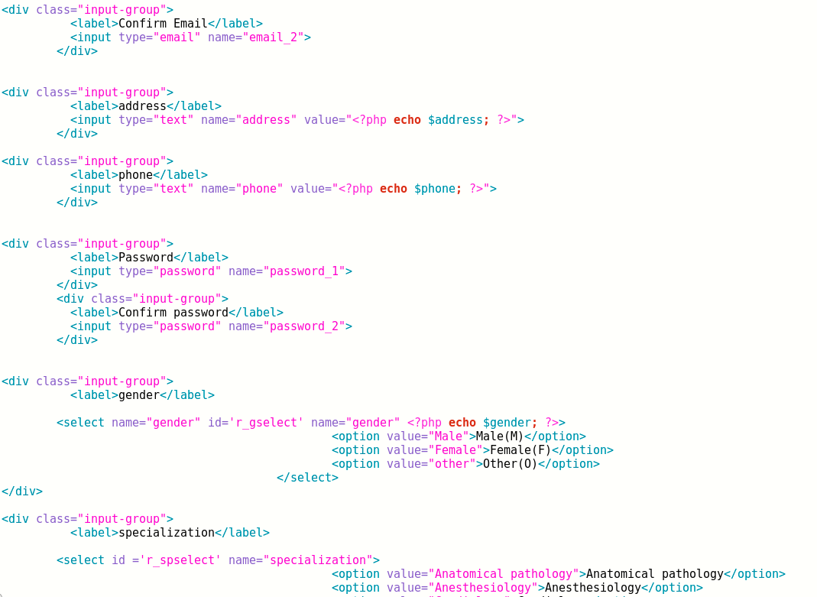

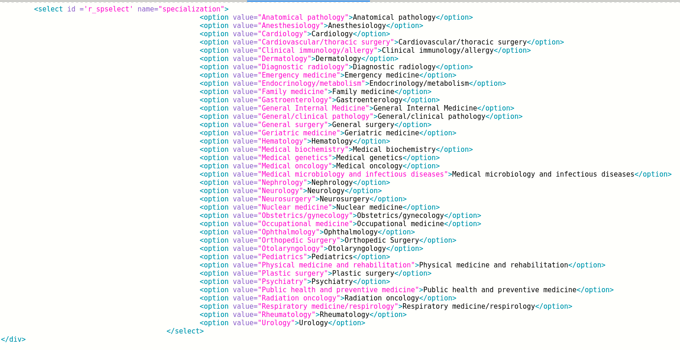

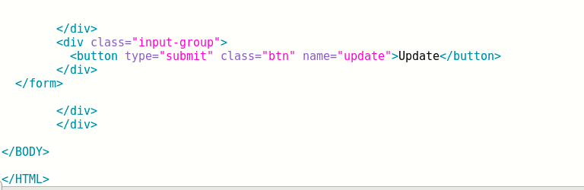

Code for server.php <- page used for registration and login

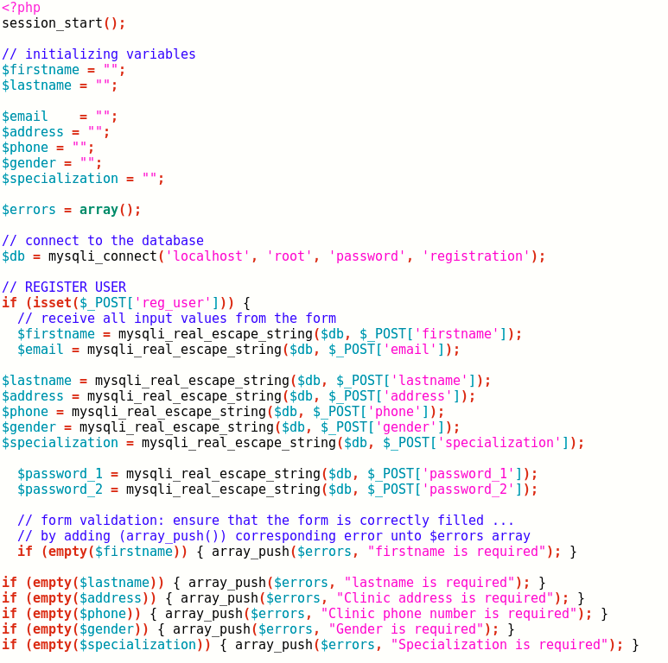

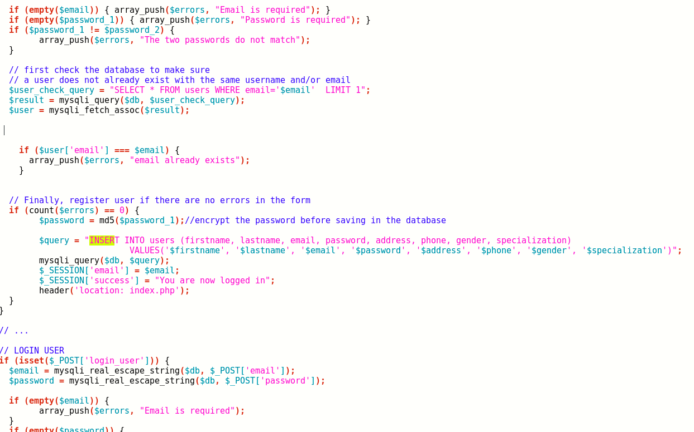

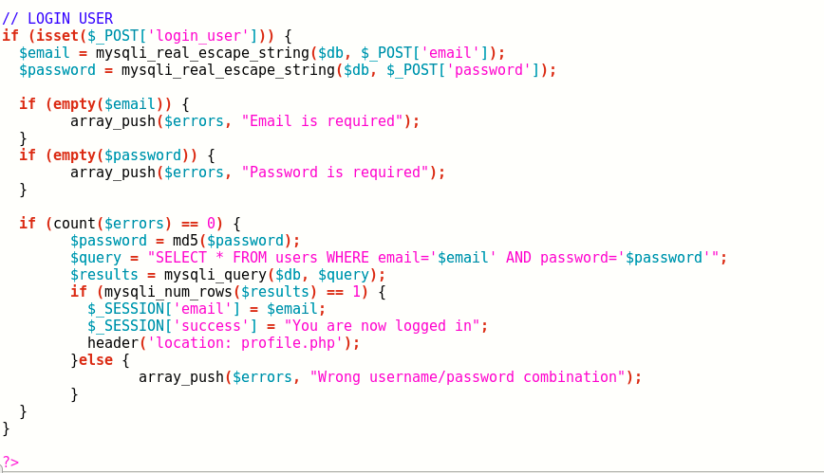

**Code for update.php** <- page used for updating profile

