**sdg-py**

A basic Calorie Tracker using Pycharms.

Project Overview This sdg-py project was created to fulfill academic requirements, and in accordance with Sustainable Development Goals #3.

**Features**

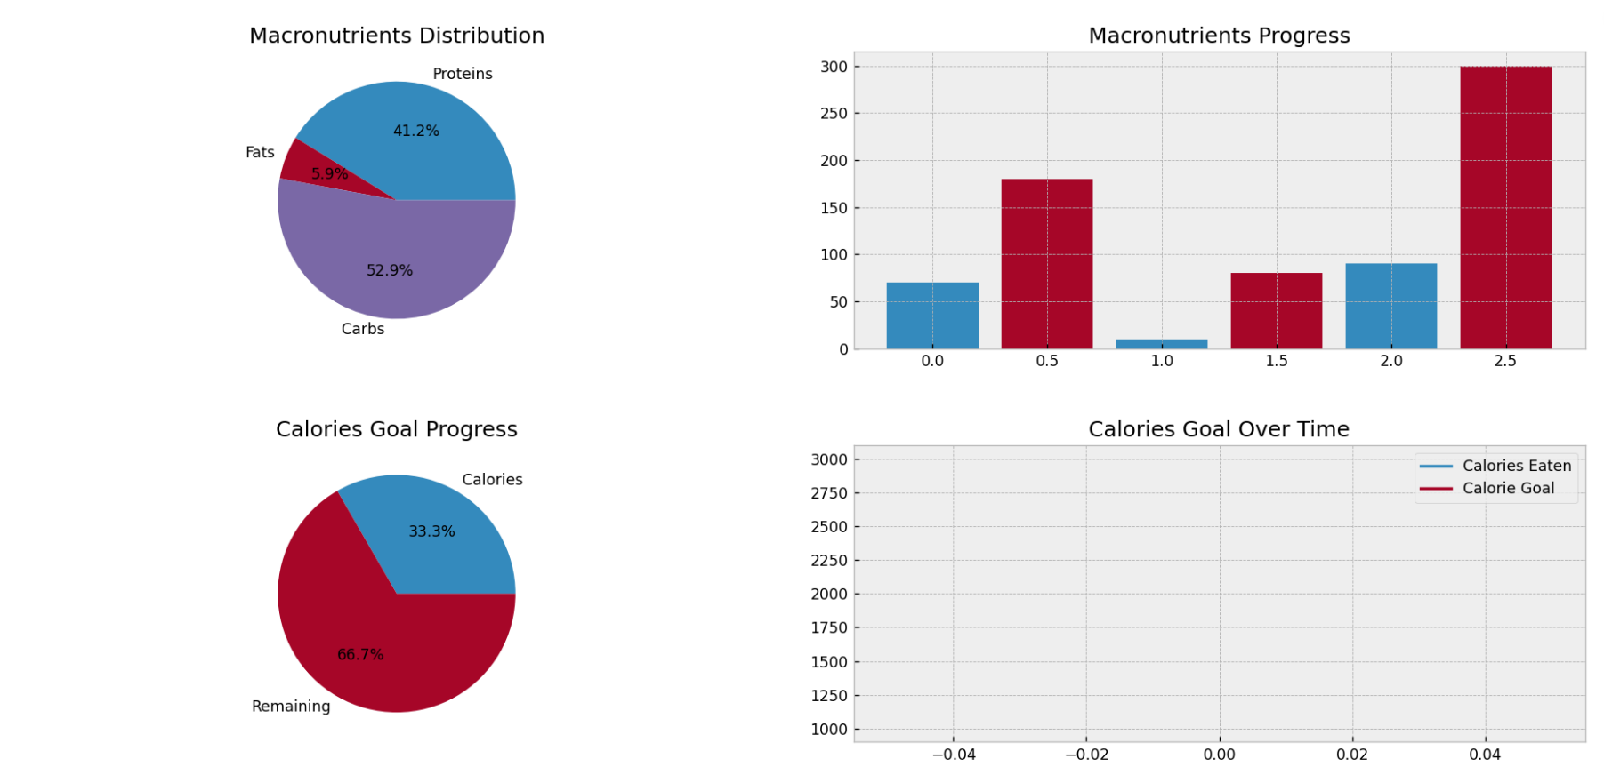

**Technologies Used**

• Python

• Pycharms