Lenaerts Kenneth, 1DAE03

**Game:** Cave Story+

**Release year:** November 22, 2011

**Link to demo film:** http://www.youtube.com/watch?v=ZWkdtvyDj28

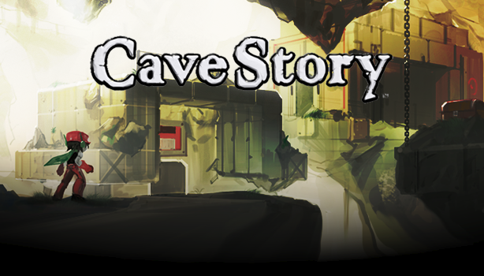**General game description:**

The game is focused around a small scout robot, Quote, who was giving the mission to eradicate the ‘Dark Power’. Together with his partner, Curly Brace, he was tasked to destroy the ‘Demon Crown’. They, however, lost a battle and were incapacitated.

Fast forward 10 years, Quote wakes up in a small cave and lost all his memories prior to today. Within minutes Quote gets involved in a conflict with ‘The Doctor’.

This is where the actual game starts, Quote allies himself with the resistance and puts a stop to the evil doings of The Doctor.

I will base myself on a level mid game. In doing so, I will have access to all the important game functions such as ‘Booster’ (Jetpack), a variety of ranged weapons and some complicated interactions which aren’t available in early game.

The game lacks a melee combat system, so my game will only feature shootable weapons.

**Game parts description:**

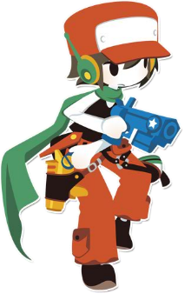**Player:**

The protagonist of the game is Quote, because he is a robot he is able to with withstand greater damages than a human being. He is capable of picking up health containers which increases his health points, making him even more durable.

Quote also makes use of a jetpack, which allows the player to maneuver in midair for a short period of time. After the times runs out, the jetpack will refill when in contact with the ground.

**Weapons:**

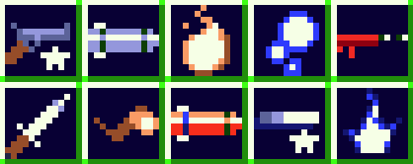Quote uses a mix of ranged weapons, his arsenal increases during the game. He owns weapons which don’t rely on ammo, as well as weapons which are tied to a limited ammo pool. As stated before, the original game doesn’t use melee weapons.

**Enemies:**

* My game will feature 1 flying type enemy

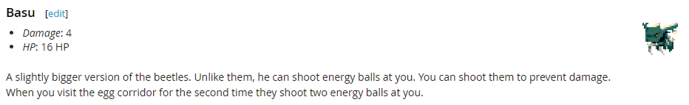

* 2 different ground types

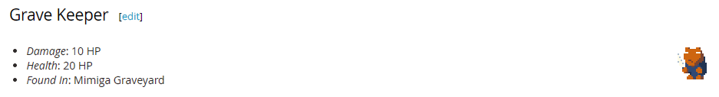

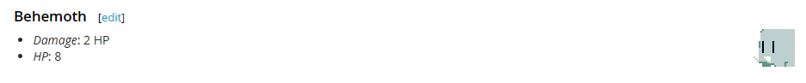

* And a boss.

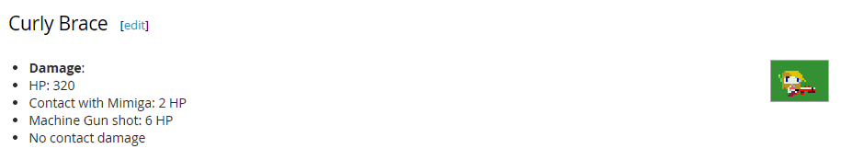

(Damage and HP of previously portrayed enemy are subject to change.)

**Pickups:**

The pickups include:

* ‘Hearts’, these will refill, or partly refill, Quote’s health points.
* ‘Energy Crystal’ will power up the currently equipped weapon, if enough of these crystals are collected the weapon will level-up; increasing its power and distance.
* ‘Ammo’, as the name states, are simple ammo items which will refill the ammo of the targeted weapon.
* ‘Heart Containers’, they increase the stamina of the Hero character.
* ‘Ammo Containers’, they increase the capacity of the ammo tied weapons.

**Interaction:**

The original game makes use of lots of interaction between both non-player characters and objects in order to proceed the game. A basic example would be hitting a switch to turn the power on, which as a result would open a door.  
Depending on how my level will be created, I will implement as much interaction without obstructing the gameplay.

**HUD:**

The GUI will remain as minimal as it is within the original game.

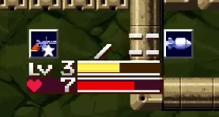

Featuring a graphical representation of the currently equipped weapon, as well as an XP bar for said weapon and a HP bar.

**Required Applied Physics functionality:**

**Force fields:**

I didn’t find any force fields in the original game (might have overlooked it, though). To compensate for this, I will have the Energy Crystals be drawn toward the Hero character in order to achieve a magnetic force.

**Triggers:**

Again, I couldn’t find a decent example of a trigger, I could only guess which ones were trigger within the game. I will implement triggers to start an elevator, engage the boss and triggers that affect other physics actors.

**Friction:**

Within the original game there is water and wind which causes the Hero to walk slower, hence friction. However, I haven’t encountered acceleration. This will be implemented by the use of ice or wind.

**Kinematic actor:**

There are kinematic actors in the game which moves, elevators for example. These will be implemented, as well as moving platforms.

**Physics Joints:**

No physics joints are found in Cave Story, so I’ll create a bridge between platforms and other joints depending on the level I haven’t yet created.

Lenaerts Kenneth, 1DAE03

**Game:** Cave Story+

**Release year:** November 22, 2011

**Link to demo film:** http://www.youtube.com/watch?v=ZWkdtvyDj28

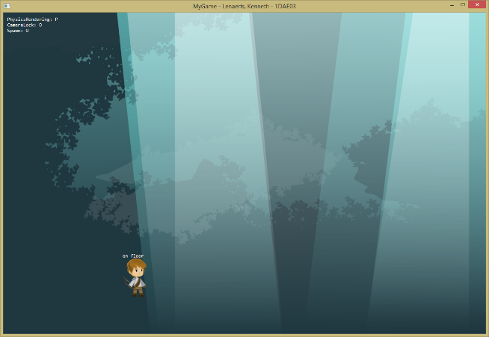**LOG:**

1. < 2015, April 10

* Camera Integration.
* The first level can be loaded.
* Hero is now able to jump.
* Hero is able to shoot arrows.
* Placeholder enemies are added.
* Basic hero animations are in place.

1. 2015, 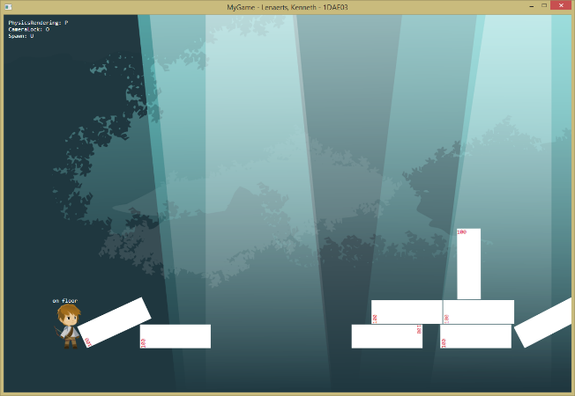April 10

* Arrows now damage enemies.
* Upon reaching 0 health, enemies will despawn.
* Enemy types are stores in a class list.
* Arrow types are stored in a class   
  list.
* Arrows despawn upon killing enemy type objects.

1. 2015, 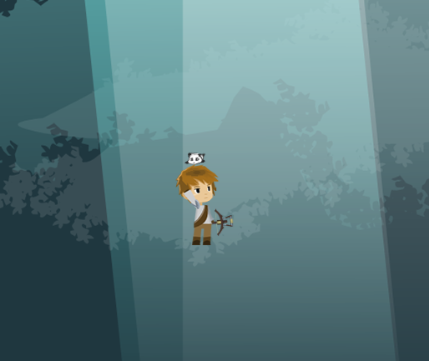April 11

* Implemented the right jump style
  + Hero now uses a Mario   
    style jump
  + Holding spacebar results  
    in a longer jump
* Updated Hero sprites
  + Less useless sprites
  + Hero now with companion
  + Easier to work with
* Code is now more maintainable   
  (still needs lots of improvement)
* Implemented a bitmap bank
  + All bitmaps now function through the bitmap bank

1. 2015, April 14
   * Implemented a Main Menu and an Exit state. Still both placeholders and need a huge artistic overhaul.
   * Implemented an IOManager class to handle all my reading and writing from external files.
   * Created a basic AI for 1 of my enemy classes: follows hero when in range, goes into an attack loop after in close proximity of hero character, deals damage to hero if struck by attack.
   * Hero now has a health stat. If health reaches 0: hero dies, Main Game gets popped off and the EXIT splash screen appears.
   * The game now waits for a key input when hero dies.
2. 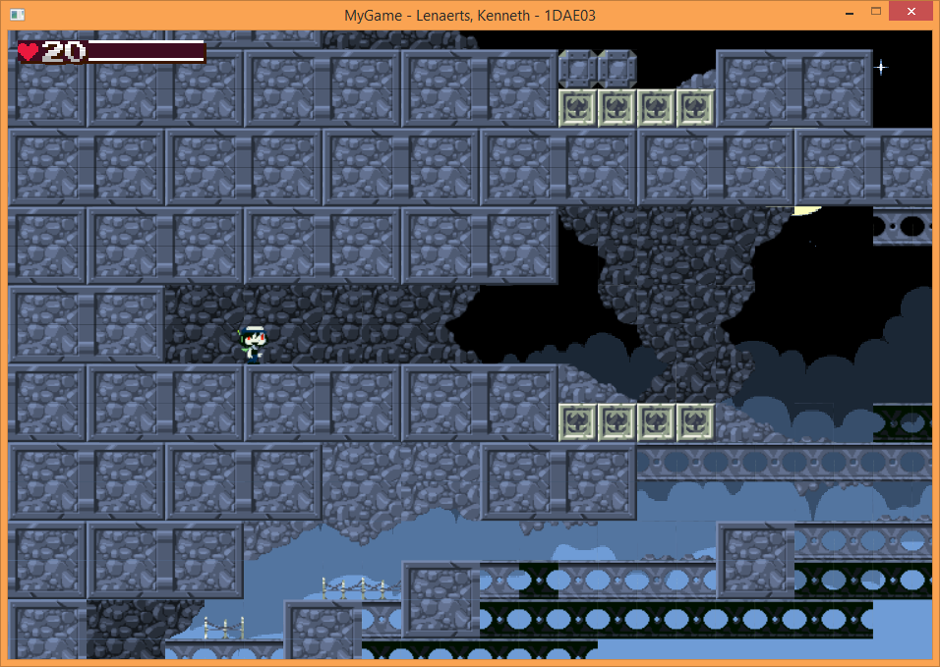2015, April 19
   * Created a tiled based level for my game, the coordinates for the tiles gets read from an external file.
   * Hero character now shoots upwards.
   * Implemented a pause state.
   * Implemented a HUD to represent the characters health, GUI will be updated when hero is able to carry weapons
   * Updated Camera class, fixed a bug where is did not follow the player when jumping / flying.