**I.**  **Introduction**

CPU Scheduling utilize the CPU for it allows a process to execute in the CPU while the other process is waiting to execute due to the unavailability of the resources it needs to be able to execute. Aside from utilizing the CPU, CPU Scheduling also makes the system efficient, fast and fair. This paper discuss the different kinds of CPU scheduling algorithms, such as; First-Come, First-Serve Scheduling, Shortest-Job-First Scheduling, Shortest-Remaining-Time-First Scheduling, Preemptive and Non-preemptive Priority Scheduling, and Round-Robin Scheduling. In every CPU scheduling algorithms, there will be three unique examples and answers will be provided in each CPU scheduling using the program that the authors have provided.

**II.** **CPU Scheduling Algorithms**

**A.**  **First-Come, First-Serve Scheduling**

First-Come, First-Serve Scheduling (FCFS) is similar to a FIFO Queue data structure, where the data element which is added to the queue first will also leave the queue first. In the FCFS scheduling, process who requested the CPU first is allocated and executed in the CPU first. FCFS is a non-preemptive CPU scheduling. A non-preemptive CPU scheduling is where the process will continue to execute in the CPU until the process is either terminates or change its state to waiting state. It is preemptive, otherwise.

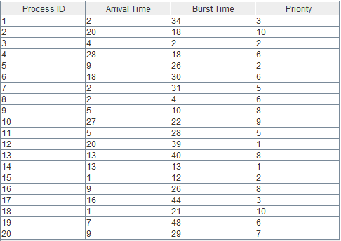

Table 1: Test Case No. 1 for FCFS Scheduling Algorithm.





Figure 1: Gannt Chart of Table 1.

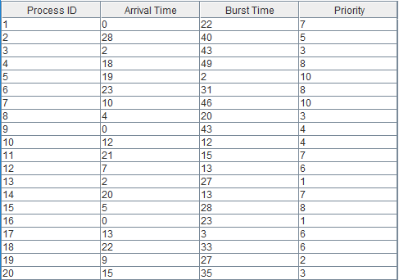

Table 2: Test Case No. 2 for FCFS Scheduling Algorithm.





Figure 2: Gannt Chart of Table 2.

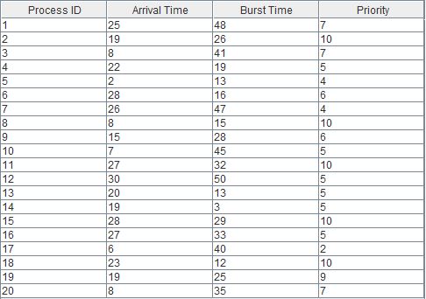

Table 3: Test Case No. 3 for FCFS Scheduling Algorithm.





Figure 3: Gannt Chart of Table 3.

**B.**  **Shortest-Job-First Scheduling**

Shortest-Job-First Scheduling (SJF) is a non-preemptive CPU scheduling algorithm that associates with the CPU burst time. Processes who have less burst time will execute first. If the two processes have the same burst time, then FCFS is used to figure out what process will execute first.

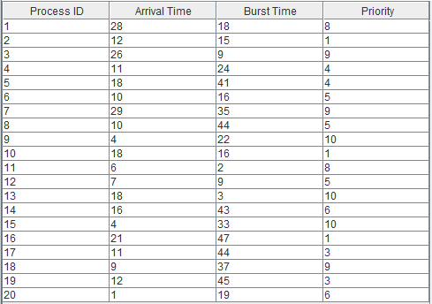

Table 4: Test Case No. 1 for SJF Scheduling Algorithm.

Figure 4: Gannt Chart of Table 4.



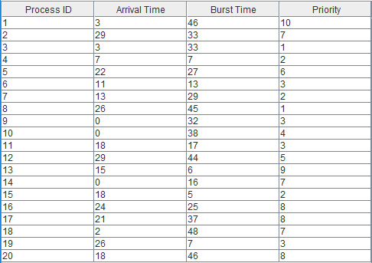

Table 5: Test Case No. 2 for SJF Scheduling Algorithm.





Figure 5: Gannt Chart of Table 5.

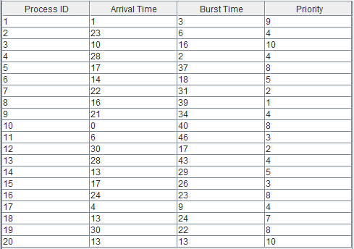

Table 6: Test Case No. 3 for SJF Scheduling Algorithm.



Figure 6: Gannt Chart of Table 6.

**C.**  **Shortest-Remaining-Time-First Scheduling**

Shortest-Remaining-Time-First Scheduling (SRTF) is a preemptive CPU scheduling algorithm version of SJF. The algorithm of SRTF is the same with the SJF, but if a new process arrives and its burst time is smaller than the existing process in the CPU, it will be preempt from its execution and the new process who has smaller burst time will execute first.

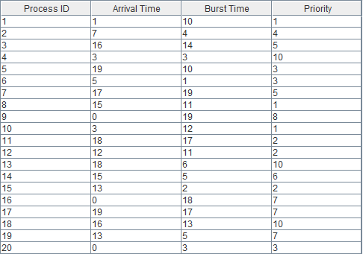

Table 7: Test Case No. 1 for SRTF Scheduling Algorithm.



Figure 7: Gannt Chart of Table 7.

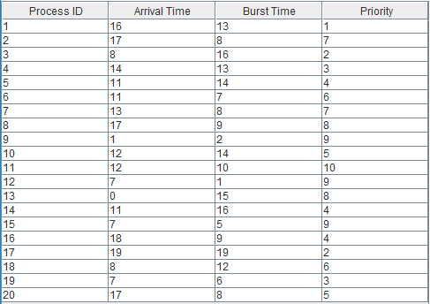

Table 8: Test Case No. 2 for SRTF Scheduling Algorithm.





Figure 8: Gannt Chart of Table 8.

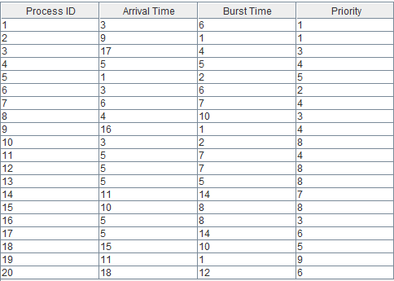

****Table 9: Test Case No. 3 for SRTF Scheduling Algorithm.

Figure 9: Gannt Chart of Table 9.

**D.**  **Priority Scheduling**

Priority Scheduling, where each process is assigned to a priority can be preemptive and non-preemptive. Non-preemptive priority will execute first the process who has the highest priority. If two processes have the same priority, the order of execution will be based in FCFS scheduling algorithm. On the other hand, Preemptive Priority Scheduling is the same with the Non-Preemptive Priority Scheduling but if a new process arrives and its priority is higher than the process that is currently executing in the CPU, the process will be preempt from its execution and the new process will execute first.

1. **Non-Preemptive Priority Scheduling**

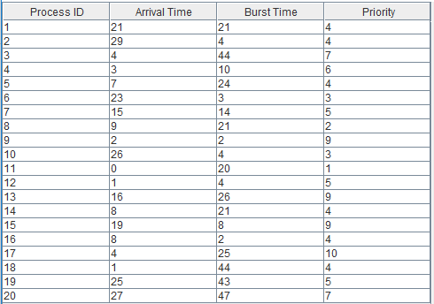

Table 10: Test Case No. 1 for Non-Preemptive Priority Scheduling Algorithm.



Figure 10: Gannt Chart of Table 10.

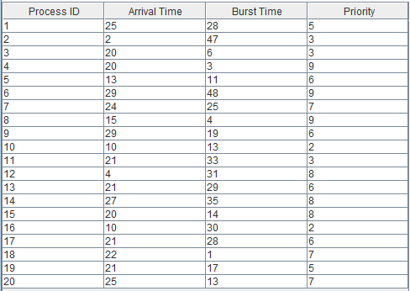

****Table 11: Test Case No. 2 for Non-Preemptive Priority Scheduling Algorithm.

Figure 11: Gannt Chart of Table 11.

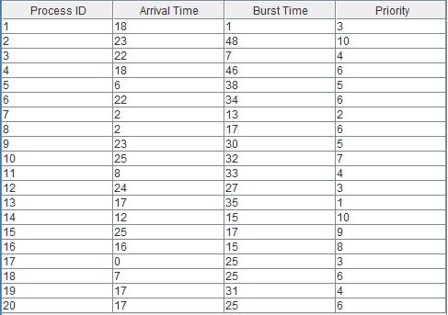

Table 12: Test Case No. 3 for Non-Preemptive Priority Scheduling Algorithm.

Figure 12: Gannt Chart of Table 12.



1. **Preemptive Priority Scheduling**

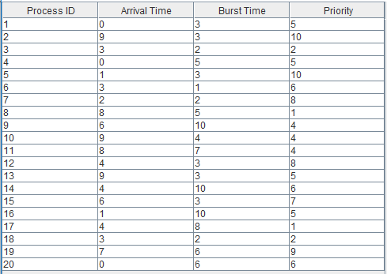

Table 13: Test Case No. 1 for Preemptive Priority Scheduling Algorithm.

Figure 13: Gannt Chart of Table 13.

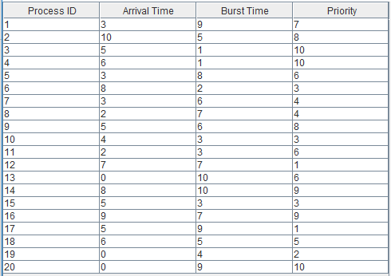

Table 14: Test Case No. 2 for Preemptive Priority Scheduling Algorithm.





Figure 14: Gannt Chart of Table 14.

Table 15: Test Case No. 3 for Preemptive Priority Scheduling Algorithm.

Figure 15: Gannt Chart of Table 15.



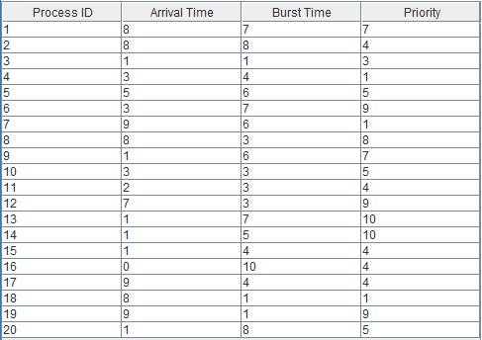

**E.**  **Round-Robin Scheduling**

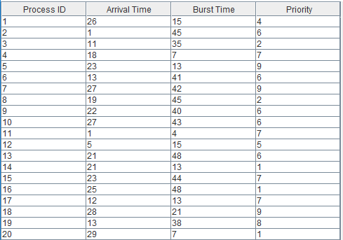The last CPU Scheduling algorithm is the Round-Robin Scheduling algorithm. The Round-Robin Scheduling algorithm has an allotted fixed time for execution. This allotted fixed time is called time quantum or time slice. This algorithm is similar to the FCFS but the process is preempted once it executes in the given time period.

Table 16: Test Case No. 1 for Round-Robin Scheduling Algorithm with a quantum of 5.

Figure 16: Gannt Chart of Table 16.



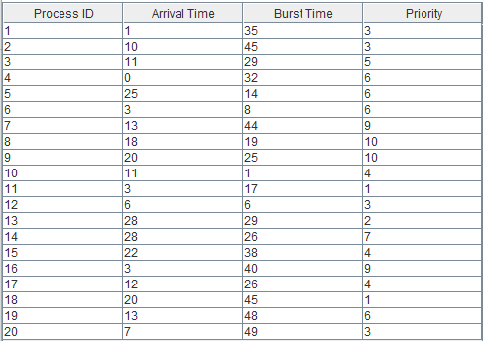

Table 17: Test Case No. 2 for Round-Robin Scheduling Algorithm with a quantum of 4.

****Figure 17: Gannt Chart of Table 17.

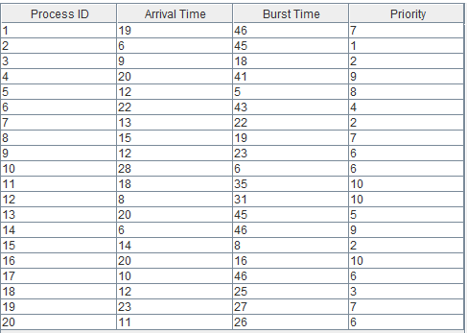

Table 18: Test Case No. 3 for Round-Robin Scheduling Algorithm with a quantum of 7.

Figure 18: Gannt Chart of Table 18.



**III.** **References**

<https://www.studytonight.com/operating-system/round-robin-scheduling>

<https://www.geeksforgeeks.org/program-priority-scheduling-set-1/>

[https://www.studytonight.com/operating-syshttps://www.studytonight.com/operating-](https://www.studytonight.com/operating-system/first-come-first-serve)

[system/shortest-job-first](https://www.studytonight.com/operating-system/first-come-first-serve)

[[http://operatingsystemfundas.blogspot.com/2012/05/post6.html](https://www.studytonight.com/operating-system/first-come-first-serve)](http://operatingsystemfundas.blogspot.com/2012/05/post6.html)

[https://t4tutorials.com/shortest-job-first-scheduling-sjf-process-scheduling-in-](https://t4tutorials.com/shortest-job-first-scheduling-sjf-process-scheduling-in-operating-systems/)

[operating-systems/](https://t4tutorials.com/shortest-job-first-scheduling-sjf-process-scheduling-in-operating-systems/)

[[http://www.personal.kent.edu/~rmuhamma/OpSystems/Myos/sjfSchedule.htm](https://www.studytonight.com/operating-system/first-come-first-serve)](http://www.personal.kent.edu/~rmuhamma/OpSystems/Myos/sjfSchedule.htm)

[tem/first-come-first-serve](https://www.studytonight.com/operating-system/first-come-first-serve)

[https://www.tutorialspoint.com/operating_system/os_process_scheduling_algorithms](https://www.tutorialspoint.com/operating_system/os_process_scheduling_algorithms.htm)

[.htm](https://www.tutorialspoint.com/operating_system/os_process_scheduling_algorithms.htm)

<https://www.studytonight.com/operating-system/cpu-scheduling>