arduino学习笔记15 - 12864液晶实验
12864是128*64点阵液晶模块的点阵数简称，业界约定俗成的简称。
控制芯片一般采用ST7920或者与之相兼容的。
数据总线采用8位并口与SPI串口方式。
12864液晶分带字库版本与不带字库版本。
字库版不需要用点阵生成器把汉字变成点阵后再输入，直接输入汉字内码即可显示出对应汉字，无字库版想要显示汉字，只能自己按照点阵方式驱动。
下图就是12864液晶实物。
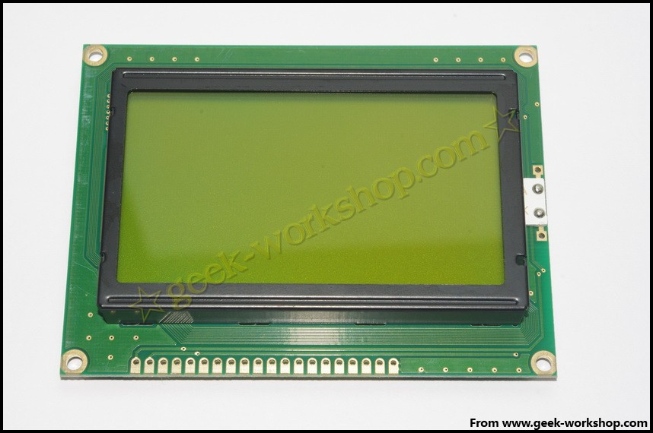
下图是arduino与12864液晶SPI连接方式的硬件连接图
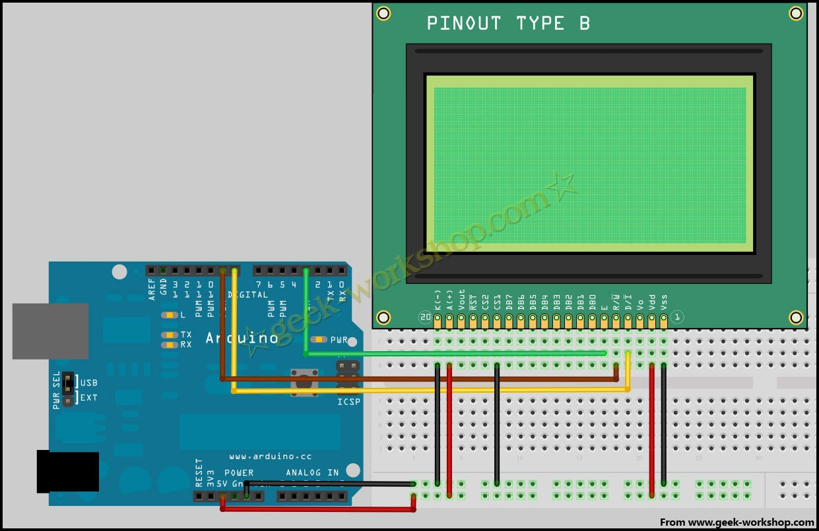
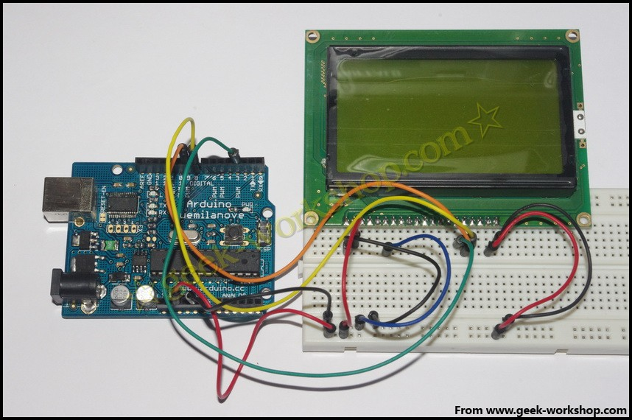
SPI连接方式驱动代码
/*
LCD Arduino
PIN1 = GND
PIN2 = 5V
RS(CS) = 8;
RW(SID)= 9;
EN(CLK) = 3;
PIN15 PSB = GND;
*/

#include "LCD12864RSPI.h"
#define AR_SIZE( a ) sizeof( a ) / sizeof( a[0] )

unsigned char show0[]={0xBC,0xAB,0xBF,0xCD,0xB9,0xA4,0xB7,0xBB};//极客工坊
unsigned char show1[]="geek-workshop";
unsigned char logo0[]={ //笑脸
0x00,0x00,0x00,0x00,0x00,0x00,0x00,0x00,
0x00,0x00,0x00,0x00,0x00,0x00,0x00,0x00,
0x00,0x00,0x00,0x00,0x00,0x00,0x00,0x00,
0x00,0x00,0x00,0x00,0x00,0x00,0x00,0x00,
0x00,0x00,0x00,0x00,0x00,0x00,0x01,0xFF,
0x80,0x00,0x00,0x00,0x00,0x00,0x00,0x00,
0x00,0x00,0x00,0x00,0x00,0x00,0x1F,0xFF,
0xF8,0x00,0x00,0x00,0x00,0x00,0x00,0x00,
0x00,0x00,0x00,0x00,0x00,0x00,0xFF,0xFF,
0xFF,0x00,0x00,0x00,0x00,0x00,0x00,0x00,
0x00,0x00,0x00,0x00,0x00,0x03,0xFE,0x00,
0x7F,0xC0,0x00,0x00,0x00,0x00,0x00,0x00,
0x00,0x00,0x00,0x00,0x00,0x0F,0xF0,0x00,
0x0F,0xF0,0x00,0x00,0x00,0x00,0x00,0x00,
0x00,0x00,0x00,0x00,0x00,0x1F,0x80,0x00,
0x01,0xF8,0x00,0x00,0x00,0x00,0x00,0x00,
0x00,0x00,0x00,0x00,0x00,0x3E,0x00,0x00,
0x00,0x7C,0x00,0x00,0x00,0x00,0x00,0x00,
0x00,0x00,0x00,0x00,0x00,0xF8,0x00,0x00,
0x00,0x1F,0x00,0x00,0x00,0x00,0x00,0x00,
0x00,0x00,0x00,0x00,0x01,0xF0,0x00,0x00,
0x00,0x0F,0x80,0x00,0x00,0x00,0x00,0x00,
0x00,0x00,0x00,0x00,0x03,0xE0,0x00,0x00,
0x00,0x07,0xC0,0x00,0x00,0x00,0x00,0x00,
0x00,0x00,0x00,0x00,0x07,0xC0,0x00,0x00,
0x00,0x01,0xE0,0x00,0x00,0x00,0x00,0x00,
0x00,0x00,0x00,0x00,0x07,0x80,0x00,0x00,
0x00,0x00,0xE0,0x00,0x00,0x00,0x00,0x00,
0x00,0x00,0x00,0x00,0x0F,0x00,0x00,0x00,
0x00,0x00,0xF0,0x00,0x00,0x00,0x00,0x00,
0x00,0x00,0x00,0x00,0x1E,0x00,0x00,0x00,
0x00,0x00,0x78,0x00,0x00,0x00,0x00,0x00,
0x00,0x00,0x00,0x00,0x3C,0x00,0x00,0x00,
0x00,0x00,0x3C,0x00,0x00,0x00,0x00,0x00,
0x00,0x00,0x00,0x00,0x38,0x00,0x40,0x00,
0x00,0x80,0x1C,0x00,0x00,0x00,0x00,0x00,
0x00,0x00,0x00,0x00,0x78,0x03,0xF8,0x00,
0x07,0xF0,0x1E,0x00,0x00,0x00,0x00,0x00,
0x00,0x00,0x00,0x00,0x70,0x07,0xFE,0x00,
0x0F,0xFC,0x0E,0x00,0x00,0x00,0x00,0x00,
0x00,0x00,0x00,0x00,0xF0,0x1F,0xBF,0x00,
0x3F,0x7E,0x0F,0x00,0x00,0x00,0x00,0x00,
0x00,0x00,0x00,0x00,0xE0,0x3E,0x0F,0x80,
0x7C,0x1F,0x07,0x00,0x00,0x00,0x00,0x00,
0x00,0x00,0x00,0x00,0xE0,0x7C,0x07,0xC0,
0xF8,0x0F,0x87,0x00,0x00,0x00,0x00,0x00,
0x00,0x00,0x00,0x01,0xE0,0xF8,0x01,0xE1,
0xF0,0x03,0xC3,0x80,0x00,0x00,0x00,0x00,
0x00,0x00,0x00,0x01,0xC0,0xF0,0x01,0xE1,
0xE0,0x03,0xC3,0x80,0x00,0x00,0x00,0x00,
0x00,0x00,0x00,0x01,0xC0,0xE0,0x00,0xE1,
0xC0,0x01,0xC3,0x80,0x00,0x00,0x00,0x00,
0x00,0x00,0x00,0x01,0xC0,0x00,0x00,0x00,
0x00,0x00,0x03,0x80,0x00,0x00,0x00,0x00,
0x00,0x00,0x00,0x03,0x80,0x00,0x00,0x00,
0x00,0x00,0x01,0xC0,0x00,0x00,0x00,0x00,
0x00,0x00,0x00,0x03,0x80,0x00,0x00,0x00,
0x00,0x00,0x01,0xC0,0x00,0x00,0x00,0x00,
0x00,0x00,0x00,0x03,0x80,0x00,0x00,0x00,
0x00,0x00,0x01,0xC0,0x00,0x00,0x00,0x00,
0x00,0x00,0x00,0x03,0x80,0x00,0x00,0x00,
0x00,0x00,0x01,0xC0,0x00,0x00,0x00,0x00,
0x00,0x00,0x00,0x03,0x80,0x00,0x00,0x00,
0x00,0x00,0x01,0xC0,0x00,0x00,0x00,0x00,
0x00,0x00,0x00,0x03,0x80,0x00,0x00,0x00,
0x00,0x00,0x01,0xC0,0x00,0x00,0x00,0x00,
0x00,0x00,0x00,0x03,0x80,0x00,0x00,0x00,
0x00,0x00,0x01,0xC0,0x00,0x00,0x00,0x00,
0x00,0x00,0x00,0x03,0x80,0x00,0x00,0x00,
0x00,0x00,0x01,0xC0,0x00,0x00,0x00,0x00,
0x00,0x00,0x00,0x03,0x80,0x00,0x00,0x00,
0x00,0x00,0x01,0xC0,0x00,0x00,0x00,0x00,
0x00,0x00,0x00,0x03,0x80,0x00,0x00,0x00,
0x00,0x00,0x01,0xC0,0x00,0x00,0x00,0x00,
0x00,0x00,0x00,0x01,0xC0,0x00,0x00,0x00,
0x00,0x00,0x01,0x80,0x00,0x00,0x00,0x00,
0x00,0x00,0x00,0x01,0xC0,0x00,0x00,0x00,
0x00,0x00,0x03,0x80,0x00,0x00,0x00,0x00,
0x00,0x00,0x00,0x01,0xC0,0x00,0x00,0x00,
0x00,0x00,0x03,0x80,0x00,0x00,0x00,0x00,
0x00,0x00,0x00,0x01,0xE0,0x00,0x00,0x00,
0x00,0x00,0x03,0x80,0x00,0x00,0x00,0x00,
0x00,0x00,0x00,0x00,0xE0,0x00,0x00,0x00,
0x00,0x00,0x07,0x00,0x00,0x00,0x00,0x00,
0x00,0x00,0x00,0x00,0xE0,0x00,0x00,0x00,
0x00,0x00,0x07,0x00,0x00,0x00,0x00,0x00,
0x00,0x00,0x00,0x00,0xF0,0x00,0x0C,0x00,
0x0C,0x00,0x0F,0x00,0x00,0x00,0x00,0x00,
0x00,0x00,0x00,0x00,0x70,0x00,0x1E,0x00,
0x1E,0x00,0x0E,0x00,0x00,0x00,0x00,0x00,
0x00,0x00,0x00,0x00,0x78,0x00,0x1F,0x00,
0x3E,0x00,0x1E,0x00,0x00,0x00,0x00,0x00,
0x00,0x00,0x00,0x00,0x38,0x00,0x07,0x80,
0xF8,0x00,0x1C,0x00,0x00,0x00,0x00,0x00,
0x00,0x00,0x00,0x00,0x3C,0x00,0x03,0xE1,
0xF0,0x00,0x3C,0x00,0x00,0x00,0x00,0x00,
0x00,0x00,0x00,0x00,0x1E,0x00,0x01,0xFF,
0xE0,0x00,0x78,0x00,0x00,0x00,0x00,0x00,
0x00,0x00,0x00,0x00,0x0F,0x00,0x00,0xFF,
0x80,0x00,0xF0,0x00,0x00,0x00,0x00,0x00,
0x00,0x00,0x00,0x00,0x07,0x00,0x00,0x3F,
0x00,0x00,0xF0,0x00,0x00,0x00,0x00,0x00,
0x00,0x00,0x00,0x00,0x07,0x80,0x00,0x00,
0x00,0x01,0xE0,0x00,0x00,0x00,0x00,0x00,
0x00,0x00,0x00,0x00,0x03,0xE0,0x00,0x00,
0x00,0x07,0xC0,0x00,0x00,0x00,0x00,0x00,
0x00,0x00,0x00,0x00,0x01,0xF0,0x00,0x00,
0x00,0x0F,0x80,0x00,0x00,0x00,0x00,0x00,
0x00,0x00,0x00,0x00,0x00,0xF8,0x00,0x00,
0x00,0x1F,0x00,0x00,0x00,0x00,0x00,0x00,
0x00,0x00,0x00,0x00,0x00,0x3E,0x00,0x00,
0x00,0x7E,0x00,0x00,0x00,0x00,0x00,0x00,
0x00,0x00,0x00,0x00,0x00,0x1F,0x80,0x00,
0x01,0xF8,0x00,0x00,0x00,0x00,0x00,0x00,
0x00,0x00,0x00,0x00,0x00,0x0F,0xE0,0x00,
0x07,0xF0,0x00,0x00,0x00,0x00,0x00,0x00,
0x00,0x00,0x00,0x00,0x00,0x03,0xFE,0x00,
0x3F,0xC0,0x00,0x00,0x00,0x00,0x00,0x00,
0x00,0x00,0x00,0x00,0x00,0x00,0xFF,0xFF,
0xFF,0x00,0x00,0x00,0x00,0x00,0x00,0x00,
0x00,0x00,0x00,0x00,0x00,0x00,0x1F,0xFF,
0xF8,0x00,0x00,0x00,0x00,0x00,0x00,0x00,
0x00,0x00,0x00,0x00,0x00,0x00,0x01,0xFF,
0x80,0x00,0x00,0x00,0x00,0x00,0x00,0x00,
0x00,0x00,0x00,0x00,0x00,0x00,0x00,0x00,
0x00,0x00,0x00,0x00,0x00,0x00,0x00,0x00,
0x00,0x00,0x00,0x00,0x00,0x00,0x00,0x00,
0x00,0x00,0x00,0x00,0x00,0x00,0x00,0x00
};

void setup()
{
LCDA.Initialise(); // 屏幕初始化
delay(100);
}

void loop()
{
LCDA.CLEAR();//清屏
delay(100);
LCDA.DisplayString(0,2,show0,AR_SIZE(show0));//第一行第三格开始，显示文字极客工坊
delay(100);
LCDA.DisplayString(2,1,show1,AR_SIZE(show1));;//第三行第二格开始，显示文字geek-workshop
delay(5000);
LCDA.CLEAR();//清屏
delay(100);
LCDA.DrawFullScreen(logo0);
delay(5000);
}

先来介绍一下怎样查找要输出地汉字的内码，打开汉字内码转换软件以后，点击转换就会显示出不同汉字对应的内码，比如"极"对应的内码是BCAB，那么给12864液晶发送的就是分为两段，0xBC与0xAB。这样就可以显示出极字了
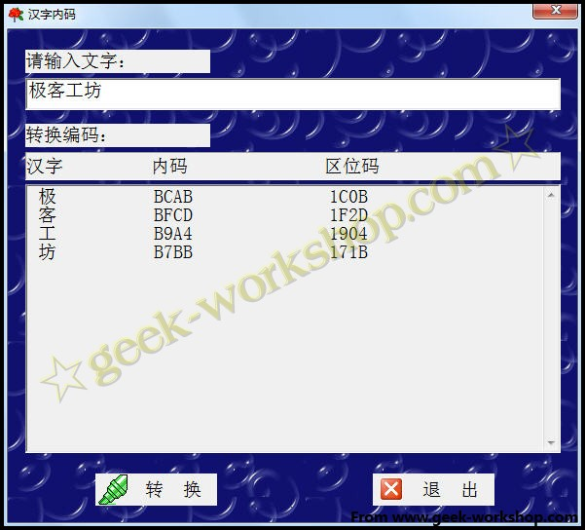

本次实验使用12864液晶显示了一个笑脸图片，怎样显示任意图片呢?
先打开photoshop，新建文档，大小为128*64，位图
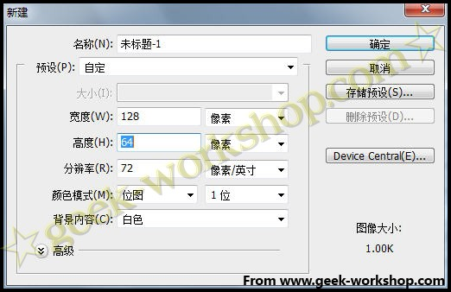

然后绘制出要现实的图案，比如这个笑脸，画好后保存。
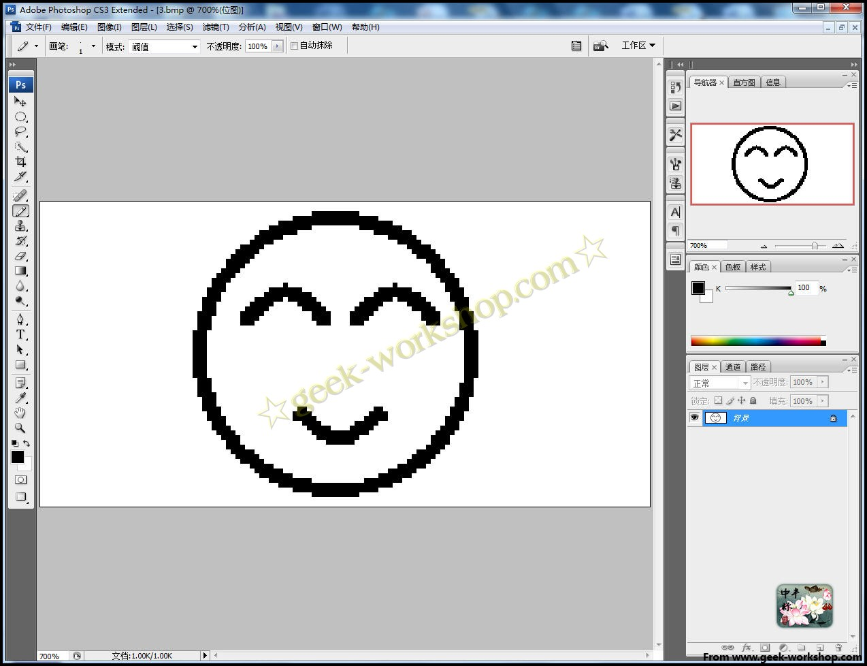

然后打开取字模软件，先设置参数，如下图，主要是设置输出为C语言，大小为128*64，设置好后点击参数确定。
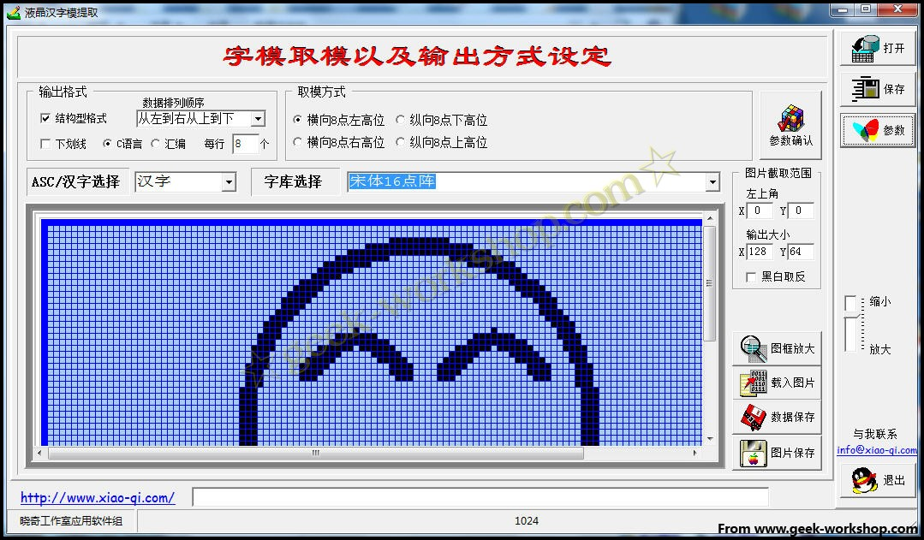

然后打开制作出来的图片，如果图片效果不是想要的白底黑字，参数里再重新设置下”黑白反取“
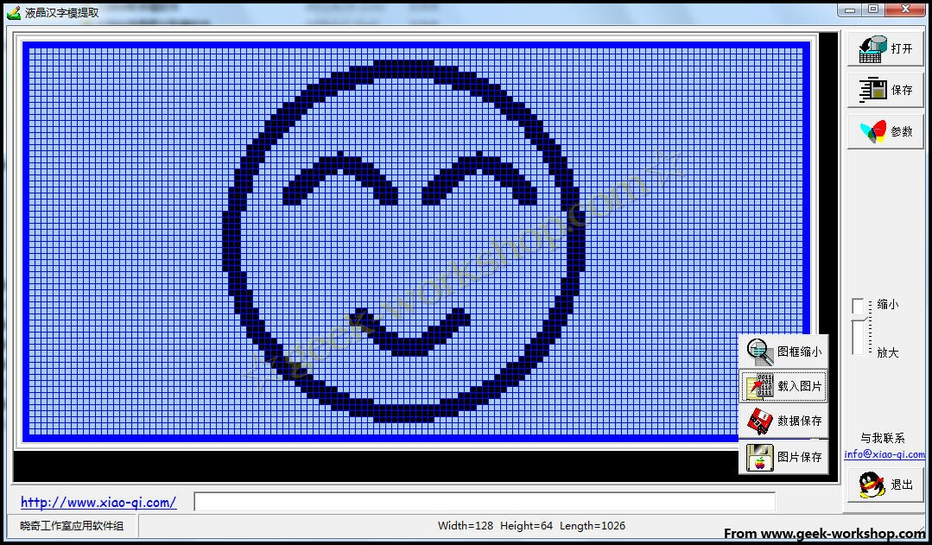

选择保存数据，跳出窗口，选择好路径进行保存。
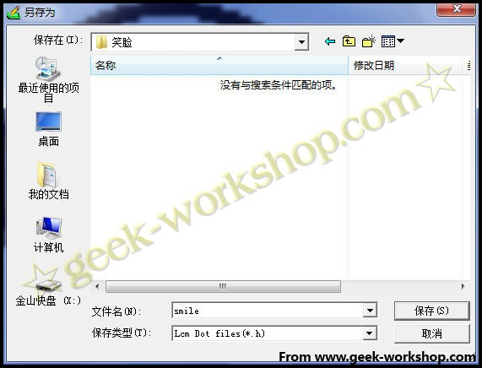

保存出来的smile.h就是包含图片代码的文件，我们打开看一下，{ }括号中的内容，就是我们需要的。
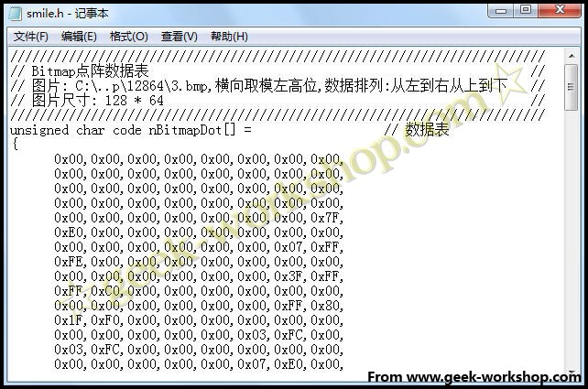

一般使用SPI接法后，就很少使用8位接法了，因为占用端口太多了，但是还是放出来供大家学习下。
先上硬件连接图
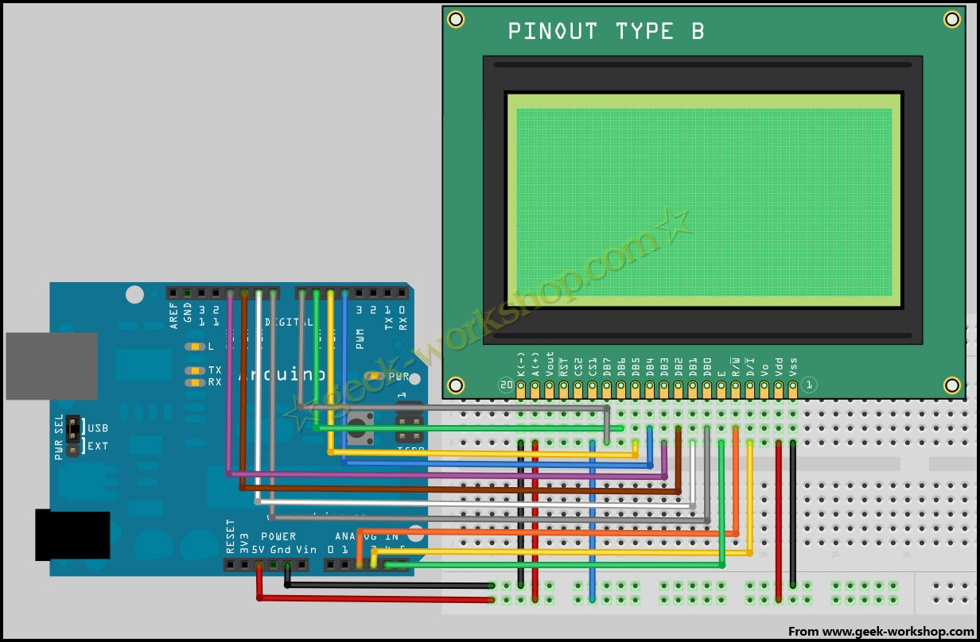

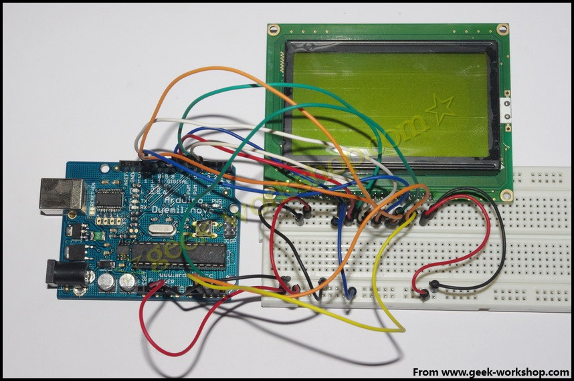

下面的是8位接法的代码，使用了库文件。

- /*
- LCD Arduino
- RS = 17; Analog Pin3
- RW = 16; Analog Pin2
- EN = 18; Analog Pin4
- D0 = 8;
- D1 = 9;
- D2 = 10;
- D3 = 11;
- D4 = 4;
- D5 = 5;
- D6 = 6;
- D7 = 7;
- PIN15 PSB = 5V;
- */
- #include "LCD12864R.h"
- #define AR_SIZE( a ) sizeof( a ) / sizeof( a[0] )
- unsigned char show0[]={0xBC,0xAB,0xBF,0xCD,0xB9,0xA4,0xB7,0xBB};//极客工坊
- unsigned char show1[]="geek-workshop";
- void setup()
- {
- LCDA.Initialise(); // 屏幕初始化
- delay(100);
- }
- void loop()
- {
- LCDA.CLEAR();//清屏
- delay(100);
- LCDA.DisplayString(0,2,show0,AR_SIZE(show0));//第一行第三格开始，显示文字极客工坊
- delay(100);
- LCDA.DisplayString(2,1,show1,AR_SIZE(show1));;//第三行第二格开始，显示文字geek-workshop
- while(1);
- }

