**Report**

Assignment 1

Keath Kor

103844324

COS10004-Computer Systems

Lab Session: 7

\

**Table of Contents**

1. Aim 2

2. Design Outline 2

**Implementing the start/stop button:** 2

**Implementing a single digit “Second” display:** 3

**Implementing the “Two-digit seconds” display** 3

**Implementing the “minutes” display** 4

**Implementing the “split” button** 4

3. Issues 5

4. Assumption 5

5. Final circuit (stopwatch) 5

# **Aim**

The aim and goal of this project was to create a fully functional digital stopwatch with splitting features. In order to create a functioning digital stop watch, functions such as splitters, start and stop time, and reset are needed. In addition, the stopwatch should have an elapsed time and a split time to display the time running on the stop watch. An LED display is also needed to show when the clock has started running and when it is not running.

# **Design Outline**

In order to construct this digital stopwatch, I have separated the circuit into 5 individual parts that have unique functions.

### **Implementing the start/stop button:**

* The start and stop button are wired up and connected to a T-Flip Flop to send a pulse to the “Clock Started” LED.
* When pressing on the start button, it sends a pulse to the T-Flip Flop, then sends another pulse from the T-Flip Flop to the LED, making it flash red.

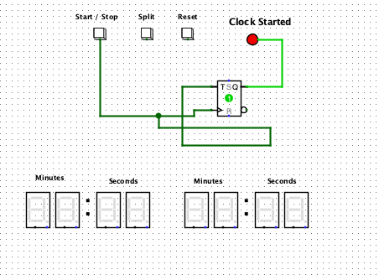

* When pressing on the stop button a second time, it then sends no pulse to the T-Flip Flop turning the LED off.

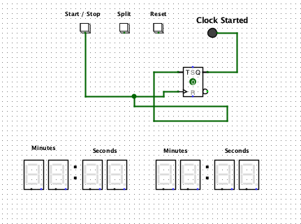

### **Implementing a single digit “Second” display:**

* The Start/Stop button connecting to the T-Flip Flop is then wired up to the 4 J-Flip Flops that are also connected to the clock, sending pulses.
* The J-Flip Flops are connected to the And gates, sending out signals to the D-Flip Flop that sends the output or signals using splitters to display single digit numbers on the Hex Digit Display.
* The third And gate on the far left resets the flip flops when it reaches 9 digits.

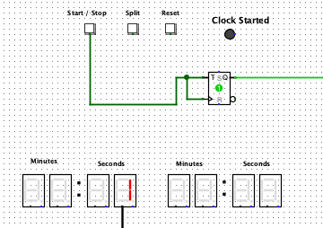 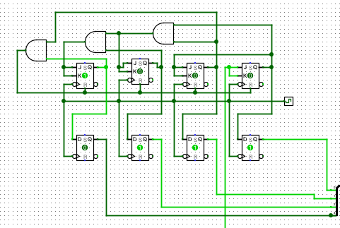

### **Implementing the “Two-digit seconds” display**

* The First Circuit is then connected to a second circuit using the And gate as well as a D-Flip Flop to delay and send out pulses to the second circuit.
* The Second Circuit consists of 3 And Gates, 3 J-Flip Flops, and 4 D-Flip Flops connecting to the splitter, sending pulses to the second second digit display in the Hex Digit Display output.
* The And gate on the far left resets the flip flops when the count reaches 5.

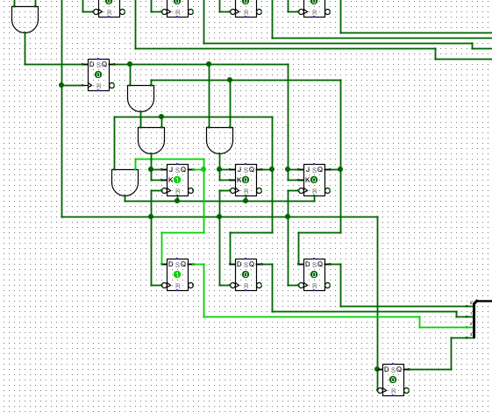

* Reset button was wired to the circuit to pause and set the time back to 00.

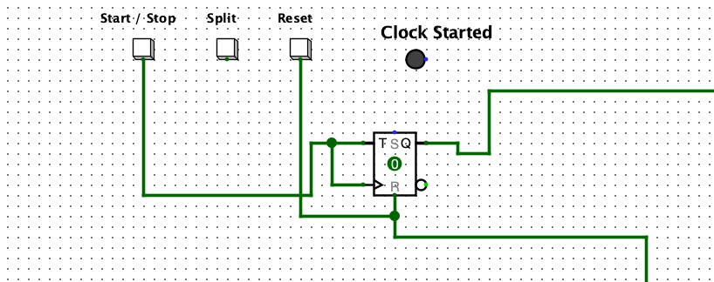

### **Implementing the “minutes” display**

* The second circuit is connected to a third circuit using a D-Flip Flop. The third circuit consists of 4 J-Flip Flops connecting to 7 D-Flip Flops along with 3 And gates in order to delay the pulse and output to the Hex Digit Display, displaying the first minute digit.
* The third circuit is connected to a fourth circuit using two And gates and a D-Flip Flop. The fourth circuit consists of 4 J-Flip Flops, 7 D-Flop Flops and 3 And gates, allowing the output of the second minute on the display.
* The And gates on circuit 3 and 4 on the far right resets the flip flops when the flip flops turn on and reach 9 digits.

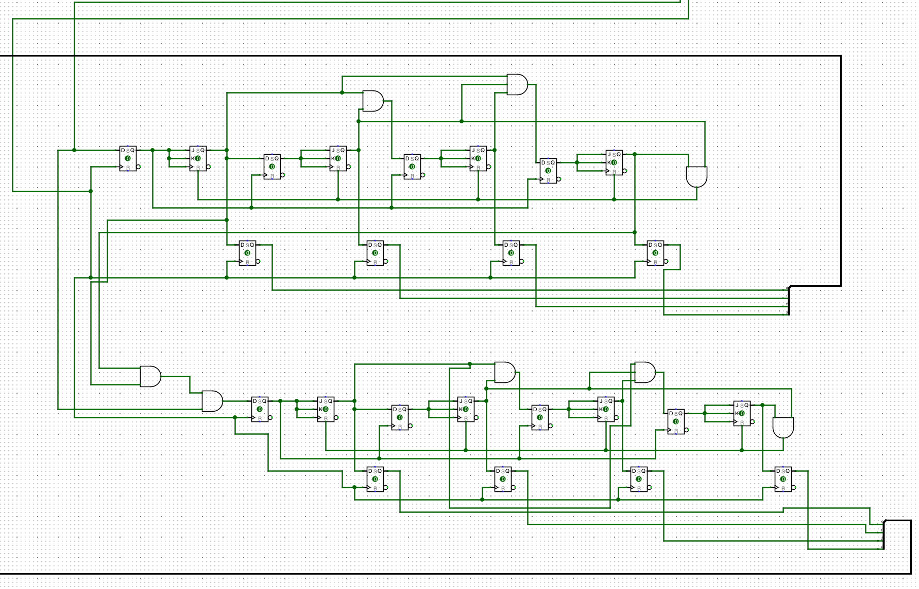

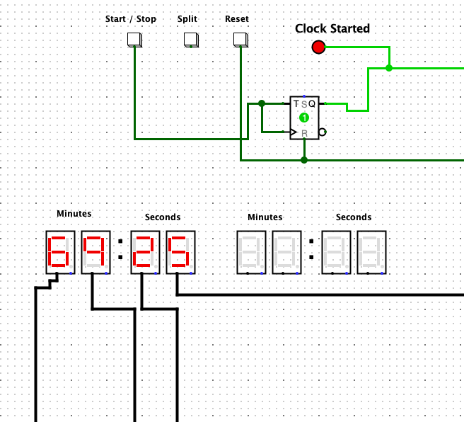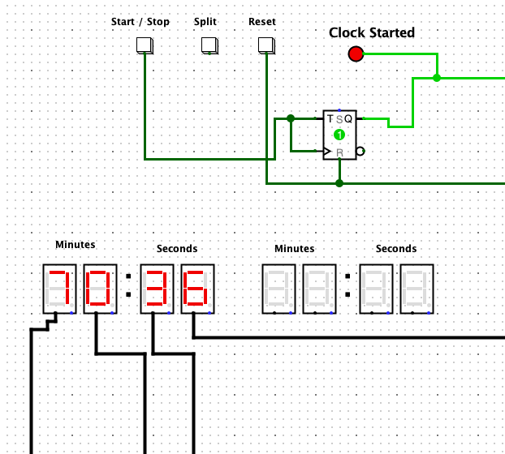

### **Implementing the “split” button**

* 16 D-Flip Flops were added by connecting to each of the Display D-flip flops on the original circuits outputting the display on the hex-digit display to illustrate the split time.
* Each time the split button is pressed the elapsed time will be saved to the split time.
* The reset button is connected to the D-Flip Flops, Each the reset button is pressed the split time also resets to 00:00.

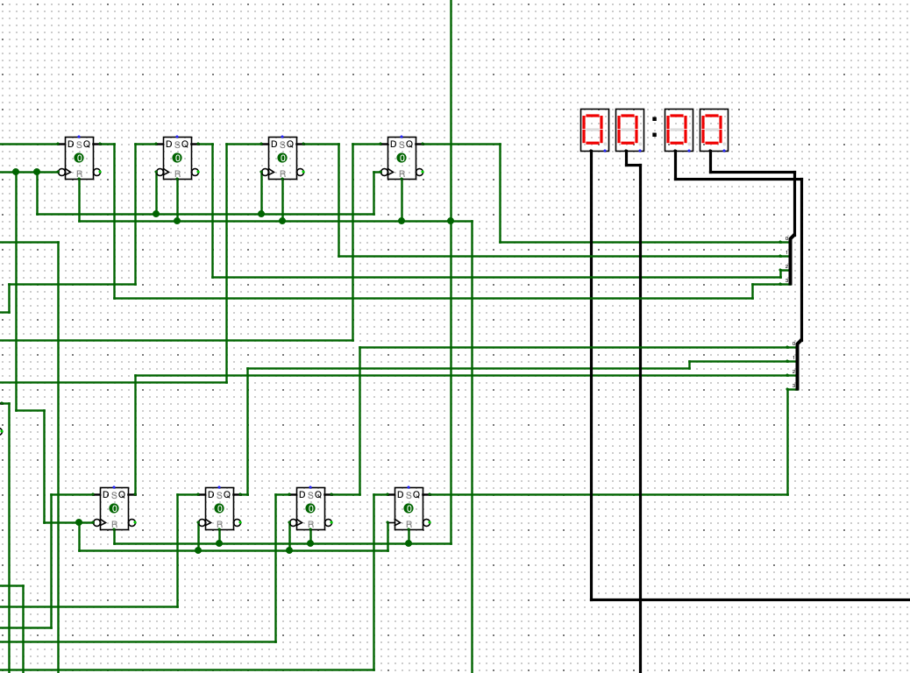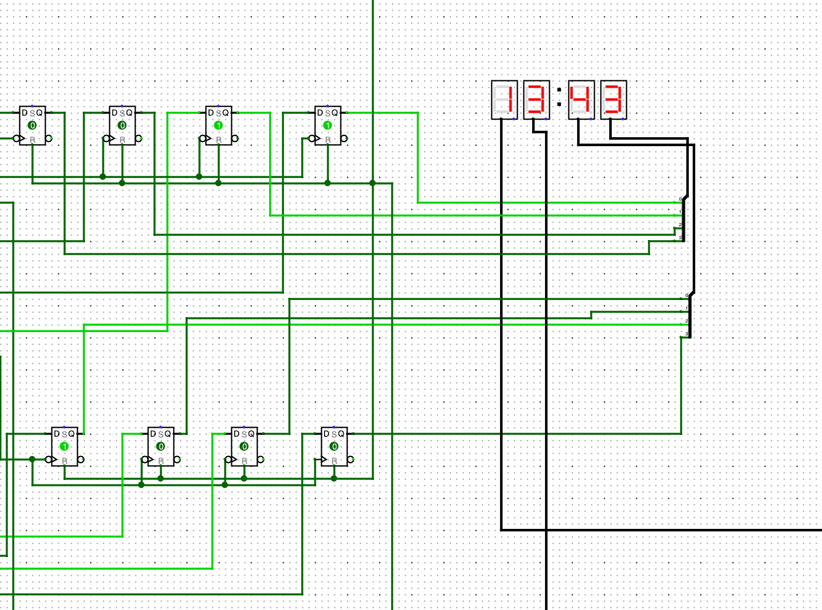

# **Issues**

* When the reset button is pressed, it resets both of the minutes and the seconds to 00:00 for a split second. However, it doesn’t display 00:00 and pauses.
* Stages 6, and 7 were not able to be completed due to the inability to wire and to store the pulses to the stacks.
* Stacks construction were unable to be completed as it is very complex.
* Reset button works correctly for the split time, however pauses the elapsed time.

# **Assumption**

* At first glance, the project seemed fairly straightforward due to only having to wire up ripple counters and connecting them from one circuit to another. However, the project was more complex due to having to construct other features and functions such as recording the split time, multi split display and one display for everything.
* Due to the inability to wire up the reset button to the circuits, the project became more complicated.

# **Final circuit (stopwatch)**

