Identification of Similar Differential Expression Genes between Schizophrenia and Autism Spectrum Disorder Patients

Introduction
Schizophrenia (SCZ) is a neuropsychiatric disorder characterized by hallucinations, delusions, speech, and motor behaviour abnormalities (Li & Teng, 2015). In addition to these symptoms, there is an eight-fold increased risk of suicide in SCZ patients with an attempted suicide rate of 40% (Li & Teng, 2015). It is no secret that there is a dramatic decline in the quality of life for people with SCZ and with an estimated total cost of over $60 billion as of 2002 and over $155 billion as of 2013, SCZ holds a significant burden on many individuals (Cloutier et al., 2016; Wu et al., 2005). Over the last decade, advancements in disease genomic research have led to many breakthroughs for SCZ mechanisms but still remains largely a mystery to the scientific community its full pathology (Bryois et al., 2018). One of these breakthroughs is the understanding that there is evidence that SCZ has a non-specific genetic component revealed by increased risk in siblings and phenotypic inheritance estimated to be around 60% (Bryois et al., 2018). From these findings, SCZ research has grown a community in observing other well-studied and genetic mental disorders and comparing them to SCZ patients. In these comparisons, similar regions of protein expression between the two disorders have suggested loci for future areas of research. These studies have revealed a polygenic base to SCZ and genomic similarity to disorders such as bipolar disorder (Purcell et al., 2009). The Major Histone Compatibility complex has been shown in many studies to be a target region for disease-causing variants (Purcell et al., 2009). This area of research is limited however due to the population-specific results and linkage equilibrium of the variants (Purcell et al., 2009). Bipolar disorder gene expression comparison studies also revealed similar levels of transcription of FK506 binding protein, prostaglandin E synthase 3 and BCL-2 associated anthogene 1 (Sinclair et al., 2013). These findings have set the groundwork for future studies, linking the expression of these genes to the disease pathology of neurological disorders such as SCZ. From the successes of these experiments, in this study, we want to expand these procedures to other well-studied mental disorders. Specifically, in this study, we are observing the similar differential RNA expression of SCZ patients and autism spectrum disorder (ASD) patients.
ASD is a neurological developmental disorder that is characterized by communication difficulties, repetitive behaviors and limited interests and a broad list of symptoms that affect all aspects of life (Rahman et al., 2020). ASD currently has no cure and a prevalence of around 1 in 54 children in the United States (Rahman et al., 2020). Similarly, to SCZ, ASD pathophysiology is suggested to be very complex, involving many pathways and genes in humans as well as being genetically heritable (Rahman et al., 2020). Due to ASD’s similarities to SCZ in terms of symptoms, genetic heritability, and complex cause, we chose to compare RNA sequencing data from patients with ASD with patients with SCZ to attempt to reveal any regions that could set the groundwork for future studies on SCZ mechanisms.

Objectives
In this study, our objective is to push the search for schizophrenia mechanisms using RNA sequencing data. Our study aims to reveal any similarities or differences between the transcriptome of individuals with SCZ and individuals with ASD in an attempt to reveal regions of potential common pathophysiology. These regions of potential pathophysiology will set up the groundwork for future studies, observing the direct mechanisms of these loci and their role in genetic mental disorders. The first task in this study is to curate a dataset of ASD and SCZ RNA sequencing data with control samples. To do so, we will look for publicly available datasets from previous studies with paired-end RNA sequences. For our controls, we will take an even split from both the ASD sample study and the SCZ sample study. Our observations will reveal any control bias from which study these samples stemmed. From this task, we will identify common regions of differential expression between ASD samples and SCZ samples that differ from our healthy control samples. Our results will lead to an output of gene candidates from SCZ research. We will observe these genes and look for patterns in gene types or general functions to assess their applicability as an SCZ mechanistic gene. From the successes in previous literature, we hypothesize that we will observe some similar regions of differential gene expression in these two diseased sample types that differ from our combined control. These regions should be related between SCZ and ASD, potentially in the major histone compatibility complex as discussed or in regions well studied in ASD research (Rahman et al., 2020).

Methods

Data Curation
Data was curated from two independent studies. SCZ samples come from a study on RNA-seq analysis of amygdala tissue samples of SCZ patients (Chang et al., 2017). ASD samples come from a study on the risk of autism at loci in the frontal cortex (Sun et al., 2019). Change et al. contains 22 SCZ patient samples and 24 non-psychiatric controls, while Sun et al. have 12 extreme autism gene expression cases and 12 controls (Chang et al., 2017; Sun et al., 2019). For this study, we randomly selected 3 SCZ samples, 3 ASD samples and 4 controls, 2 from Chang et al. and 2 from Sun et al. (Chang et al., 2017; Sun et al., 2019). The combined control group alleviates any bias in control selection and allows for the observation of said bias. A limitation in this study is the sampled tissue in the data collected from each. Amygdala and frontal cortex have very different roles and as such gene expression should be highly differentiated. This limitation can be alleviated with more available data such as data from the Common mind consortium which was not accessible for this study. This sample-based difference will be observed and acknowledged in the results of this study.

Sequence Alignment, Quality Control and Differential Gene Expression
Sequence paired-end reads were taken from the data curated from two studies with ASD, SCZ and control samples. These reads had their FASTQ files extracted with the FASTERQ tool in the advanced research computing cluster (ARC). The FASTQ files were aligned to the human reference sequence GRCh38 using Kallisto (Bray et al., 2016). This alignment was done using ARC as well. Each alignment and sequence were quality control checked with FastQC and visualized with MultiQC. After the alignments, differential expression analysis was done using SLEUTH. Kallisto output files as well as the reference transcriptome of human reference sequence GRCh38 were used in SLEUTH to do a gene-level analysis of the alignment. Analysis was done with transcripts per million and scaled reads per base pair in the genes from the reference transcriptome. PCA plots will be generated and the fold difference between SCZ and controls in the ASD samples will be calculated to find the genes that have similar expression differences to the controls. The false discovery rate will also be observed as a method of filtering through genes. Final output genes will be annotated manually for any observable patterns or relation to SCZ or mental disorders.

Results

Read Quality Control
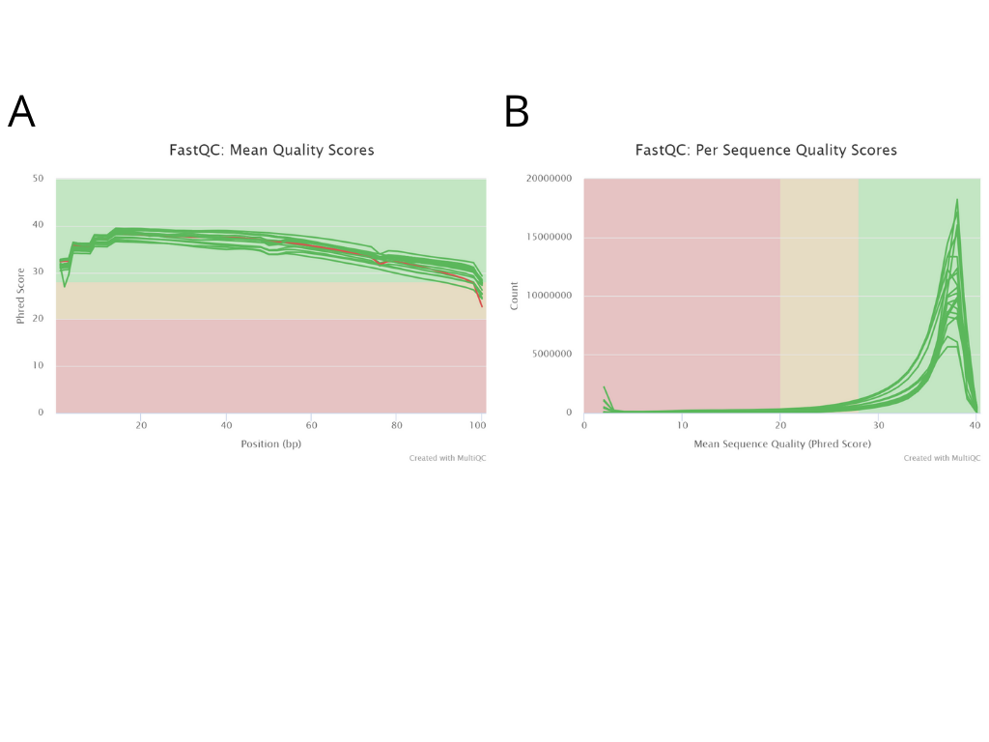
Figure 1: FASTQC quality scores of the 3 SCZ, 3 ASD and 4 Control samples. A) Mean quality scores for positions across the reads per sample. Quality is determined by the Phred Score of the base pair sequenced. B) Per Sequence Quality Scores for each sample. Mean quality score from each sample is plotted against the number of reads in the sample. For both A and B, the green highlighted area is a “successful” quality score, the yellow is an intermediate region and red is a “failed” quality score.
To verify the quality of the reads in our samples, we used the FastQC tool to determine read quality and MultiQC to visualize them. We see no failures in per sequence quality scores, while we observe a consistent decrease in read quality at the beginning and end of each read. This is expected due to sequencing limitations. We see one failure in sequence SRR5938456_1, a paired end read of an ASD sample. The mean quality across all reads of this sequence however passes the quality control check and remained in our dataset for analysis.

Principle Component Analysis (PCA)
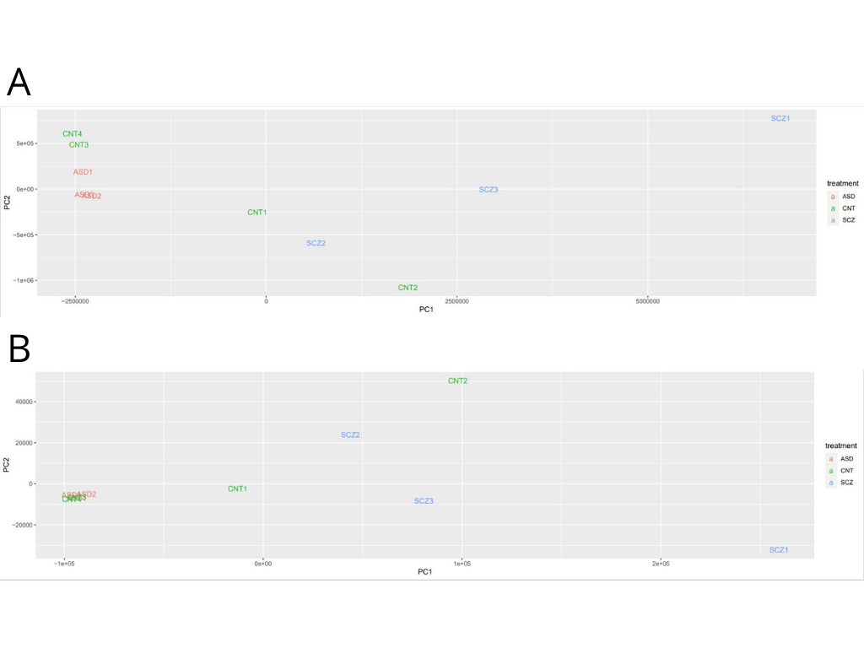
Figure 2: PCA plots for the 3 SCZ, 3 ASD and 4 Control samples. A) PCA clustering of samples in our dataset based on scaled reads per base pair. This clusters samples based on the number of reads that are mapped to each base pair across an entire gene. B) PCA clustering of samples in our dataset based on transcripts per million (TPM). This clusters sequences solely on the number of aligned reads to the reference genome (GRCh38). In both plots, red text indicates ASD samples, the green text indicates control samples and blue text indicates SCZ samples.
PCA clustering was done on our curated dataset to observe any clustering between the samples. We generated two PCA plots, one observing scaled reads per base pair on gene alignment and one observing TPM alignment. Both plots differed slightly, however general patterns remained similar. With Control sequences 1 and 2 clustering closer to SCZ samples and Control samples 3 and 4 clustering closer to ASD samples. This is due to the controls coming from their respective studies as well as the tissue samples taken from each of the studies (Amygdala for SCZ and prefrontal cortex for ASD). This limitation is apparent in these results and in future studies, gaining access to the Common Mind Consortium would broaden the available data for these analyses and remove the limitation of tissue-specific results. We also observe a clear separation of ASD and SCZ samples. With only 3 samples for each disorder, this finding is expected, however in future work including the entire sample set from both studies would result in more significant conclusions.

False Positive Discovery Rate (FDR) Filtering
Following sleuth analysis of gene-level alignment, the resulting output contained 18 381 genes comparable between ASD, SCZ and control samples. Filtering was done on these samples to remove samples with a substantial difference between SCZ and ASD samples, described as samples with a fold difference of between -1 and 1. This led to 208 gene entries which were then filtered for SCZ FDR. Typical studies use samples with an FDR of 0.05 or below, however, none of our samples after this filtering fit this criterion. A more relaxed FDR threshold of 0.1 was then applied to our filter and resulted in 4 remaining genes. We filtered our initial dataset one more time using SCZ FDR, and CNT FDR compared to the ASD samples. We used the traditional 0.05 FDR threshold which resulted in 6 output genes. The fold difference between ASD samples to both controls and SCZ samples varied in these 6 genes. The goal of this filtering is to observe what sequence-aligned genes resulted from traditional FDR filtering and why we observed differences from our first filtering. Both filtering results were outlined in Table 1.
Gene | LRT | Mean OBS | CNT Fold | CNT FDR | SCZ Fold | SCZ FDR
Filter 1
SHPK | 0.077 | 5.807 | 1.117 | 0.390 | 0.996 | 0.054
AMOTL2 | 0.100 | 5.405 | 1.065 | 0.436 | 0.960 | 0.067
ARRDC4 | 0.124 | 6.912 | 1.075 | 0.436 | 0.975 | 0.095
ACSL1 | 0.084 | 6.994 | 1.053 | 0.436 | 0.898 | 0.098
Filter 2
CHADL | 0.070 | 6.228 | 2.499 | 0.001 | 2.911 | 5.8x10⁻⁶
CMTM5 | 0.070 | 5.995 | 2.582 | 0.040 | 3.591 | 5.8x10⁻⁶
GJB1 | 0.070 | 6.153 | 1.788 | 0.040 | 2.108 | 2.52x10⁻⁴
TMEM98 | 0.070 | 6.095 | 1.935 | 0.023 | 2.597 | 5.8x10⁻⁰⁶
CRB2 | 0.070 | 6.218 | 1.815 | 0.040 | 2.119 | 2.35x10⁻⁴
CYB5R2 | 0.070 | 5.174 | 1.974 | 0.040 | 2.499 | 7.9x10⁻⁵
Table 1: Summary of the filtering steps after sleuth differential expression analysis. Filter 1 was done by filtering fold change of SCZ and Control samples to ASD samples for every aligned gene, then filtering by a 0.1 FDR. Filter 2 was done by filtering FDR of SCZ and Control samples to ASD samples by a threshold of 0.05 FDR.

Gene Annotation
The 4 genes resulting from filter 1 show no apparent relationship or pattern between each other. SHPK encodes for a carbohydrate kinase-like protein and is associated with cystine buildup or cystinosis. AMOTL2 encodes for the angiomotin protein that binds to angiostatin. This interaction regulates angiogenesis or blood vessel genesis and endothelial cell migration. AMOTL2 has disease association with meningioma which is cancer within the meninges. ARRDC4 is a gene that encodes for the Arrestin domain-containing protein 4 as an activator of ubiquitin ligase-substrate adaptor activity. ARRDC4 is associated with mitochondrial encephalomyopathy, lactic acidosis and stroke-like episodes (MELAS) and skeletal dysplasia disorders. MELAS has many symptoms involving muscle weakness and stroke-like symptoms. The ACSL1 gene encodes for a fatty-acid coenzyme A ligase family with a role in lipid biogenesis and fatty acid degradation. ACSL1 plays a role in obesity. Out of these genes, AMOTL2 and ARRDC4 genes seem to have a relationship to the nervous system.
From filter 2, we had 6 output genes that also showed no apparent relationship or pattern between each other. CHADL encodes for a chondroadherin-like protein that enables collagen and collagen fibril binding activity with no direct disease association. CMTM5 encodes for a chemokine-like factor superfamily member, associated with ovarian cyst formation and kidney diseases. The GJB1 gene encodes for a protein in the gap junction family, with disease association with a rare polyneuropathy disease. TMEM98 encodes for a transmembrane protein that is associated with Nanophthalmos eye disease. CRB2 encodes for a member of the Crumbs cell polarity complex family that has a role in early embryonic development, with disease association with cystic kidney diseases. CYB5R2 encodes for a flavoprotein pyridine nucleotide cytochrome reductase family protein with roles in cholesterol biosynthesis and fatty acid desaturation. CYB5R2 has disease association with blood disorders and cyanosis. Out of these output genes, GJB1 seems to be the only gene associated directly with the nervous system.

Conclusion
In this study, we observed the differential gene expression between SCZ and ASD patients with the objective of elucidation of potential areas of the genome that may contribute to the SCZ disease pathogenesis. The mechanism of SCZ is widely unknown in the scientific community and many studies have found success in revealing regions in the genome that may be associated with SCZ disease phenotype (Li & Teng, 2015). This was done through differential gene expression analysis of SCZ to other well-studied mental disorders such as bipolar disorder (Purcell et al., 2009). In this study, we aimed to observe the relationship between SCZ and ASD using similar methods as the SCZ and bipolar comparison study. We curated data from publicly available RNA sequencing datasets from previous studies. From each study, we created a subset of RNA sequencing data to use in this study. We used Kallisto to align to the GRCh38 human reference genome and used SLEUTH to do differential gene expression analysis. From this output, we filtered the aligned genes by their fold change and their FDR to the comparing the SCZ and control samples to the ASD samples. Our final output contained the genes outlined in Table 1. From these genes, we looked at their disease association manually and looked for any patterns in our fold change and FDR filtering and to mental disorders or the nervous system. We found that AMOTL2, ARRDC4 and GJB1 may be candidate genes as they pass the filters and have brain-related associations. These findings are limited however due to the amount of data we used in the study. Due to time, we took a small subset of the total dataset from both studies. In future studies, taking all the samples and looking at the results similarly as we did in this study would lead to more significant findings. Also, in the ASD and SCZ study that data was taken from samples of two different tissue types which leads to major inconsistencies in RNA expression between the two diseases. Access to larger databases, such as the Common Mind Consortium would allow for RNA sequencing data from more tissue types which can also be observed as a variable between the two disorders. From these findings, we failed to confirm our hypothesis and further consideration and time would be needed to correct limitations. SCZ is a major disorder that is largely impactful to society economically and socially and as such an understanding of its mechanisms is necessary to make advancements in treatment for individuals with this disorder (Cloutier et al., 2016; Wu et al., 2005).

References
Bray, N. L., Pimentel, H., Melsted, P., & Pachter, L. (2016). Near-optimal probabilistic RNA-seq quantification. Nature Biotechnology, 34(5). https://doi.org/10.1038/nbt.3519
Bryois, J., Garrett, M. E., Song, L., Safi, A., Giusti-Rodriguez, P., Johnson, G. D., Shieh, A. W., Buil, A., Fullard, J. F., Roussos, P., Sklar, P., Akbarian, S., Haroutunian, V., Stockmeier, C. A., Wray, G. A., White, K. P., Liu, C., Reddy, T. E., Ashley-Koch, A., … Crawford, G. E. (2018). Evaluation of chromatin accessibility in prefrontal cortex of individuals with schizophrenia. Nature Communications, 9(1). https://doi.org/10.1038/s41467-018-05379-y
Chang, X., Liu, Y., Hahn, C. G., Gur, R. E., Sleiman, P. M. A., & Hakonarson, H. (2017). RNA-seq analysis of amygdala tissue reveals characteristic expression profiles in schizophrenia. Translational Psychiatry, 7(8). https://doi.org/10.1038/tp.2017.154
Cloutier, M., Aigbogun, M. S., Guerin, A., Nitulescu, R., Ramanakumar, A. v., Kamat, S. A., DeLucia, M., Duffy, R., Legacy, S. N., Henderson, C., Francois, C., & Wu, E. (2016). The economic burden of schizophrenia in the United States in 2013. Journal of Clinical Psychiatry, 77(6). https://doi.org/10.4088/JCP.15m10278
Li, X., & Teng, S. (2015). RNA Sequencing in Schizophrenia. In Bioinformatics and Biology Insights (Vol. 9s1). https://doi.org/10.4137/BBI.S28992
Purcell, S. M., Wray, N. R., Stone, J. L., Visscher, P. M., O’Donovan, M. C., Sullivan, P. F., Ruderfer, D. M., McQuillin, A., Morris, D. W., Oĝdushlaine, C. T., Corvin, A., Holmans, P. A., Oĝdonovan, M. C., MacGregor, S., Gurling, H., Blackwood, D. H. R., Craddock, N. J., Gill, M., Hultman, C. M., … Sklar, P. (2009). Common polygenic variation contributes to risk of schizophrenia and bipolar disorder. Nature, 460(7256). https://doi.org/10.1038/nature08185
Rahman, M. R., Petralia, M. C., Ciurleo, R., Bramanti, A., Fagone, P., Shahjaman, M., Wu, L., Sun, Y., Turanli, B., Arga, K. Y., Islam, M. R., Islam, T., & Nicoletti, F. (2020). Comprehensive analysis of rna-seq gene expression profiling of brain transcriptomes reveals novel genes, regulators, and pathways in autism spectrum disorder. Brain Sciences, 10(10). https://doi.org/10.3390/brainsci10100747
Sinclair, D., Fillman, S. G., Webster, M. J., & Weickert, C. S. (2013). Dysregulation of glucocorticoid receptor co-factors FKBP5, BAG1 and PTGES3 in prefrontal cortex in psychotic illness. Scientific Reports, 3. https://doi.org/10.1038/srep03539
Sun, Y., Yao, X., March, M. E., Meng, X., Li, J., Wei, Z., Sleiman, P. M. A., Hakonarson, H., Xia, Q., & Li, J. (2019). Target genes of autism risk loci in brain frontal cortex. Frontiers in Genetics, 10(JUL). https://doi.org/10.3389/fgene.2019.00707
Wu, E. Q., Birnbaum, H. G., Shi, L., Ball, D. E., Kessler, R. C., Moulis, M., & Aggarwal, J. (2005). The economic burden of schizophrenia in the United States in 2002. Journal of Clinical Psychiatry, 66(9). https://doi.org/10.4088/JCP.v66n0906

