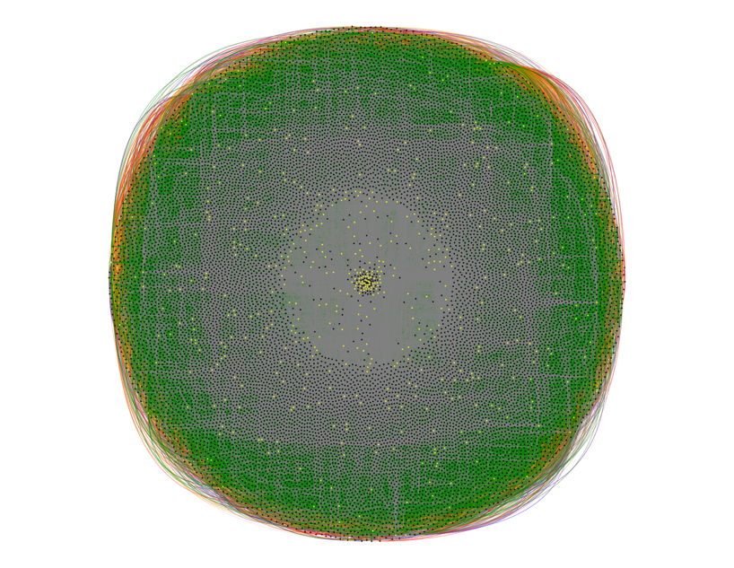

**PLaNet**

**PLaNet PLN Viewer:**

**Instruction Manual**

Table of Contents

Overview 2

Features 2

Displaying Phenotypic Linkage Networks 2

Select Different Phenotypic Linkage Networks and Sources 2

Search for Specific Genes in the Phenotypic Linkage Network 3

Gene Search 3

Selecting Gene Set 3

Upload List of Genes 4

Change Graph Layout and Save Plot 4

View Annotations and Associated Statistics 4

Examples 5

Citation and References 5

# Overview

# Features

## Displaying Phenotypic Linkage Networks

Fundamentally, PLaNet is purpose built to allow for the presentation of PLN data files as network graphs. Through the software package visNetwork, users are able to view PLN data files as a series of ‘nodes’ and ‘edges’, corresponding to ‘genes’ and ‘relationships’ respectively, that make up a network graph (Supp. Figure 1). As PLN files are often made up of thousands of genes and hundreds of thousands of relationships, PLaNet makes it easy to reduce the number of genes that are displayed to the viewer using the slider below the graph (Supp. Figure 1A). This allows for reduced amount of time required to plot the network graphs - as larger graphs are more computationally intensive to plot (such as Supp. Figure 1D) - as well as allowing a greater focus on specific subsets of the network. To further promote the ability to subset and refine a PLN graph to focus on certain genes or relationships, the visNetwork package allows for users to select genes by clicking them (Supp. Figure 1B) and highlighting only the direct relationships and directly associated genes, allowing greater focus on specific parts of the PLN graph. Moreover, visNetwork also allows users to zoom in and out of the displayed network graphs (Supp. Figure 1C) using their mouse scrolling wheel, enabling certain parts of the PLN graph to appear larger and in greater focus.

## Select Different Phenotypic Linkage Networks and Sources

Currently the PLaNet web app contains 3 pre-built example PLNs: a general PLN, a Type 2 Diabetes (T2D) or ‘Metabolic’ PLN and a nervous system PLN. Users are able to view each of these example PLNs by selecting for them in the app using the drop-down box (Supp. Figure 2A). As PLaNet undergoes further development and upgrades, more example PLNs will be included. As PLNs are built from multiple different functional datasets, or data ‘sources’, it is possible for users to subset the PLNs that are presented in the viewer to only include genes and relationships that originated from these datasets via the colour coded checkboxes (Supp. Figure 2B). Each dataset is colour coded, corresponding to the colour of the relationships in the PLN graph, allowing for easy differentiation between them in a full or partial PLN; users are able to view just one functional dataset within the viewer, such as the Gene Ontology Annotation Database (Supp. Figure 2C). Making the datasets easily distinguishable and separable enables the user to identify the most informative functional datasets for a particular PLN or sets of genes within that PLN.

## Search for Specific Genes in the Phenotypic Linkage Network

An important attribute for the PLaNet web app is the ability to interact and manipulate the PLN graphs that are presented, allowing the user to obtain more information from a PLN. A technique that allows users to interact with a PLN is to search for specific genes within a PLN and highlight them within the PLN graph, allowing greater focus on particular genes or modules. PLaNet contains three different methods for searching for genes within a PLN graph.

### Gene Search

The most direct method of accessing certain genes within the PLN viewer comes from the ‘Gene Search’ option (Supp. Figure 3A). By selecting the ‘Gene Search’ radio button in the ‘Gene Visualisation’ panel, users can enter an unlimited number of genes - comma separated - into the text box to visualise within the PLN.

### Selecting Gene Set

As part of the ‘Gene Visualisation’ section, PLaNet collates together multiple sets of genes associated with a condition (Supp. Table 1) from different sources. The GWAS gene set contains lists of genes from the EMBL-EBI Genome-Wide Association Study (GWAS) Catalog (<https://www.ebi.ac.uk/gwas/>), a curated collection of GWAS significant genes for a range of different conditions. For this we have selected 9 different informative gene sets (more to still be uploaded) that are able to be viewed within the selected PLN (Supp. Figure 3B) by selecting them within the drop-down box. As PLaNet develops, we will add more gene sets from different sources to enhance the gene visualisation feature. It is also possible to select multiple gene sets at the same time to view how they interact within the PLN (Supp. Figure 3C), allowing the user to view any significant associations between gene sets in order to see how they cluster within a PLN.

## Upload List of Genes

PLaNet also enables to user to upload their own list of genes from their local device to view within the PLN viewer (Figure 6D). These files can be in .txt or .csv format, in which the genes of interest must be separated by commas. This allows for greater customisability of the ‘Gene Visualisation’ feature whilst maintaining a user-friendly experience.

## Change Graph Layout and Save Plot

As part of the operation procedure for the PLaNet web app, the network graphs that are created by the PLN viewer can be used to produce informative figures for use in demonstration and publication. As the layout of each PLN graph is randomly generated, often their presentation can be undesirable to a user - not emphasising certain aspects of the PLN or being visually unappealing. To allow for controlled stochasticity of the resultant PLN graphs, users are able to control the seed number for the graph construction (Supp. Figure 4). This is achieved via two different methods, either randomly via the ‘Shuffle Network’ button, which randomly selects a seed number between 1-100, or entered manually by the user by selecting the ‘Advanced Options’ and entering the seed number in the text box. Once a desirable PLN graph has been constructed, the user is able to download the graph as a .png, .tiff or .pdf file using the ‘Download Plot’ feature.

## View Annotations and Associated Statistics

To avoid restricting PLaNet to just one purpose, allowing users to ascertain more information about the genes and PLNs they are presented with, the PLaNet web app contains a variety of annotations and statistics to accompany the PLN graphs. Each gene and relationship displayed in the PLN viewer is accompanied by extra information that can be accessed by selecting or hovering over a section of the PLN graph. For example, each gene-gene relationship can show the data source in which that association has arisen, as well as the size of the weighted relationship between them. Further developments updates to the PLaNet web app will expand further on these annotations, including information such as gene aliases, gene summaries and gene ontology analysis.

# Examples

# Citation and References