$Z$ = ${4x}_{1}$ + $5x_{2}$ (收益)

滿足農場資源限制式：

+ + = 7 (土地)

+ + =12 (工時)

+ + =15 (水量)

xj≥ 0, j= 1, 2, …, 5 (非負)

|  |  |  |  |  |  |  |  |
| --- | --- | --- | --- | --- | --- | --- | --- |
|  | $$x_{1}$$ | $$x_{2}$$ | $$x_{3}$$ | $$x_{4}$$ | $$x_{5}$$ | $$RHS$$ | 找min |
| $$Z$$ | -4 | -5 | 0 | 0 | 0 | 0 |  |
| $$x_{3}$$ | 1 | 1 | 1 | 0 | 0 | 7 | 7 |
| $$x_{4}$$ | 2 | 1 | 0 | 1 | 0 | 12 | 12 |
| $$x_{5}$$ | 1 | 3 | 0 | 0 | 1 | 15 | 5 |

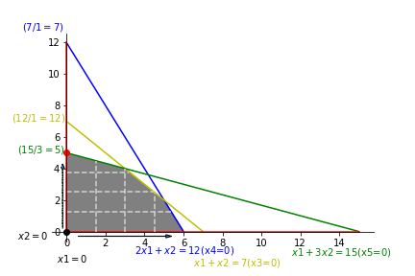

|  |  |  |  |  |  |  |  |
| --- | --- | --- | --- | --- | --- | --- | --- |
|  | $$x_{1}$$ | $$x_{2}$$ | $$x_{3}$$ | $$x_{4}$$ | $$x_{5}$$ | $$RHS$$ | 找min |
| $$Z$$ | $$-\frac{7}{3}$$ | 0 | 0 | 0 | $$\frac{5}{3}$$ | 25 |  |
| $$x_{3}$$ | $$\frac{2}{3}$$ | 0 | 1 | 0 | $$-\frac{1}{3}$$ | 2 | 3 |
| $$x_{4}$$ | $$\frac{5}{3}$$ | 0 | 0 | 1 | $$-\frac{1}{3}$$ | 7 | $$\frac{21}{3}$$ |
| $$x_{2}$$ | $$\frac{1}{3}$$ | 1 | 0 | 0 | $$\frac{1}{3}$$ | 5 | 15 |

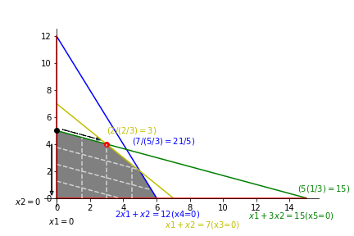

|  |  |  |  |  |  |  |  |
| --- | --- | --- | --- | --- | --- | --- | --- |
|  | $$x_{1}$$ | $$x_{2}$$ | $$x_{3}$$ | $$x_{4}$$ | $$x_{5}$$ | $$RHS$$ |  |
| $$Z$$ | 0 | 0 | $$\frac{7}{2}$$ | 0 | $$\frac{1}{2}$$ | 32 |  |
| $$x_{1}$$ | 1 | 0 | $$\frac{3}{2}$$ | 0 | $$-\frac{1}{2}$$ | 3 |  |
| $$x_{4}$$ | 0 | 0 | $$-\frac{5}{2}$$ | 1 | $$\frac{1}{2}$$ | 2 |  |
| $$x_{2}$$ | 0 | 1 | $$-\frac{1}{2}$$ | 0 | $$\frac{1}{2}$$ | 4 |  |

