|  |
| --- |
| KARNIVAL GAMES |
| Little Spy |
| **[2D Platformer – Assignment 02** |
| Version #1.0  All work Copyright © 2015 by Karnival Games.  All rights reserved. |
| **KEVIN LUU** |
|  |



|  |
| --- |
| October 26th 2015 |

**Table of Contents**

1. Game Overview
2. Game Settings
3. Moving Items
4. Sound and Art Direction

**Version History**

1. Final Version- Little Spy

[This is the body of your video game design document. You should add and delete sections as they pertain to your game’s design.]

1. **Game Overview**

The goal of the game is to reach the end of the level while collecting coins along the way. You will be facing off against simple enemies that will walk back and forth.

1. **Game Play Mechanics**

The character will have the ability to double jump. When jumping, if you land on an enemy, you will destroy it. There will be a separate scene that will inform the player of their remaining lives. When their lives are depleted, the player will then see a game over scene and that will end the game.

1. **Camera**

The camera will be isometric, looking at the player on a 2 dimensional plane.

1. **Controls**

The player will be using their default horizontal movement keys (A,D, Left Arrow Key, Right Arrow Key) to move side to side. The player will also have the space bar, which is capable of starting the level, and allow the player to jump and double jump.

1. **Interface Sketch**

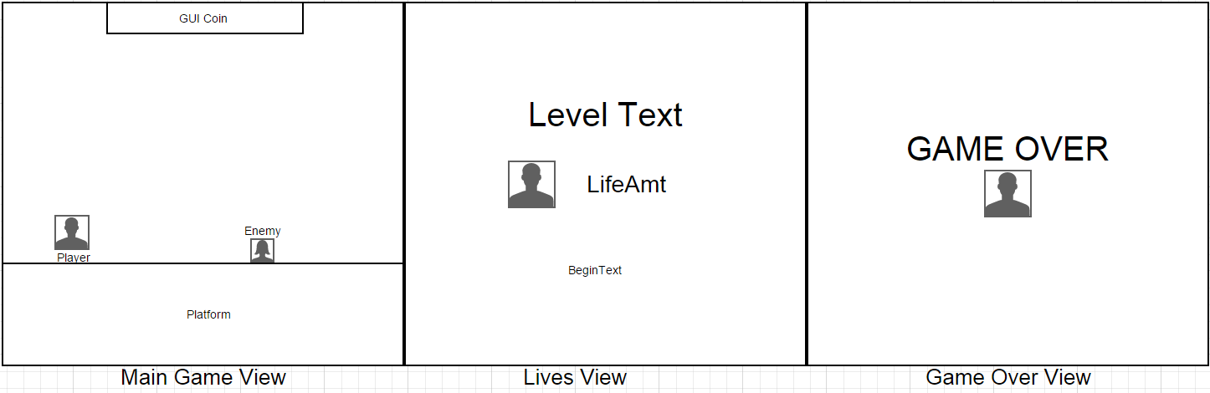

1. **Game World**

The Background is a plain sky blue colour. The ground is grass covered and has a few spike hazards around the map.

1. **Levels**

So far, there is only 1 level. However, more are planned to be added.

1. **Characters**

My character is a spy avatar, who wears a tuxedo. He is a bald character and is capable of jumping twice.

1. **Non-player Characters**

The enemies are animated block monsters that do not actively look for you. However, when they do touch you, you will die and lose a life. There is no boss monster yet in the game.

1. **Enemies**

The enemies are animated block monsters that do not actively look for you. However, when they do touch you, you will die and lose a life. There is no boss monster yet in the game.

1. **Script**

* DestroyByContact
* GameOverAndReset
* LifeController
* PlatformFall
* PlayerController
* SimpleEnemyController

1. **Scoring**

Everytime you come in contact with a coin, a sound will appear and you will receive 1 coin in your UI text.

1. **Sound Index**

* Darude Sandstorm 8 bit remix
* Ding
* The Price Is right losing horn

1. **Art / Multimedia Index**

* Gentleman Spy (Animated)
* Jellybot Enemies
* Platformer Assets Pack – Cam Tatz

1. **Design Notes**

-Animated characters

- Lives Scene

-Game over Scene

-Enemy Death animation

1. **Future Features**

* Life recovery items
* Increased level count
* Boss Battle
* Enemy Variety
* Cheat Codes