ScreenShots

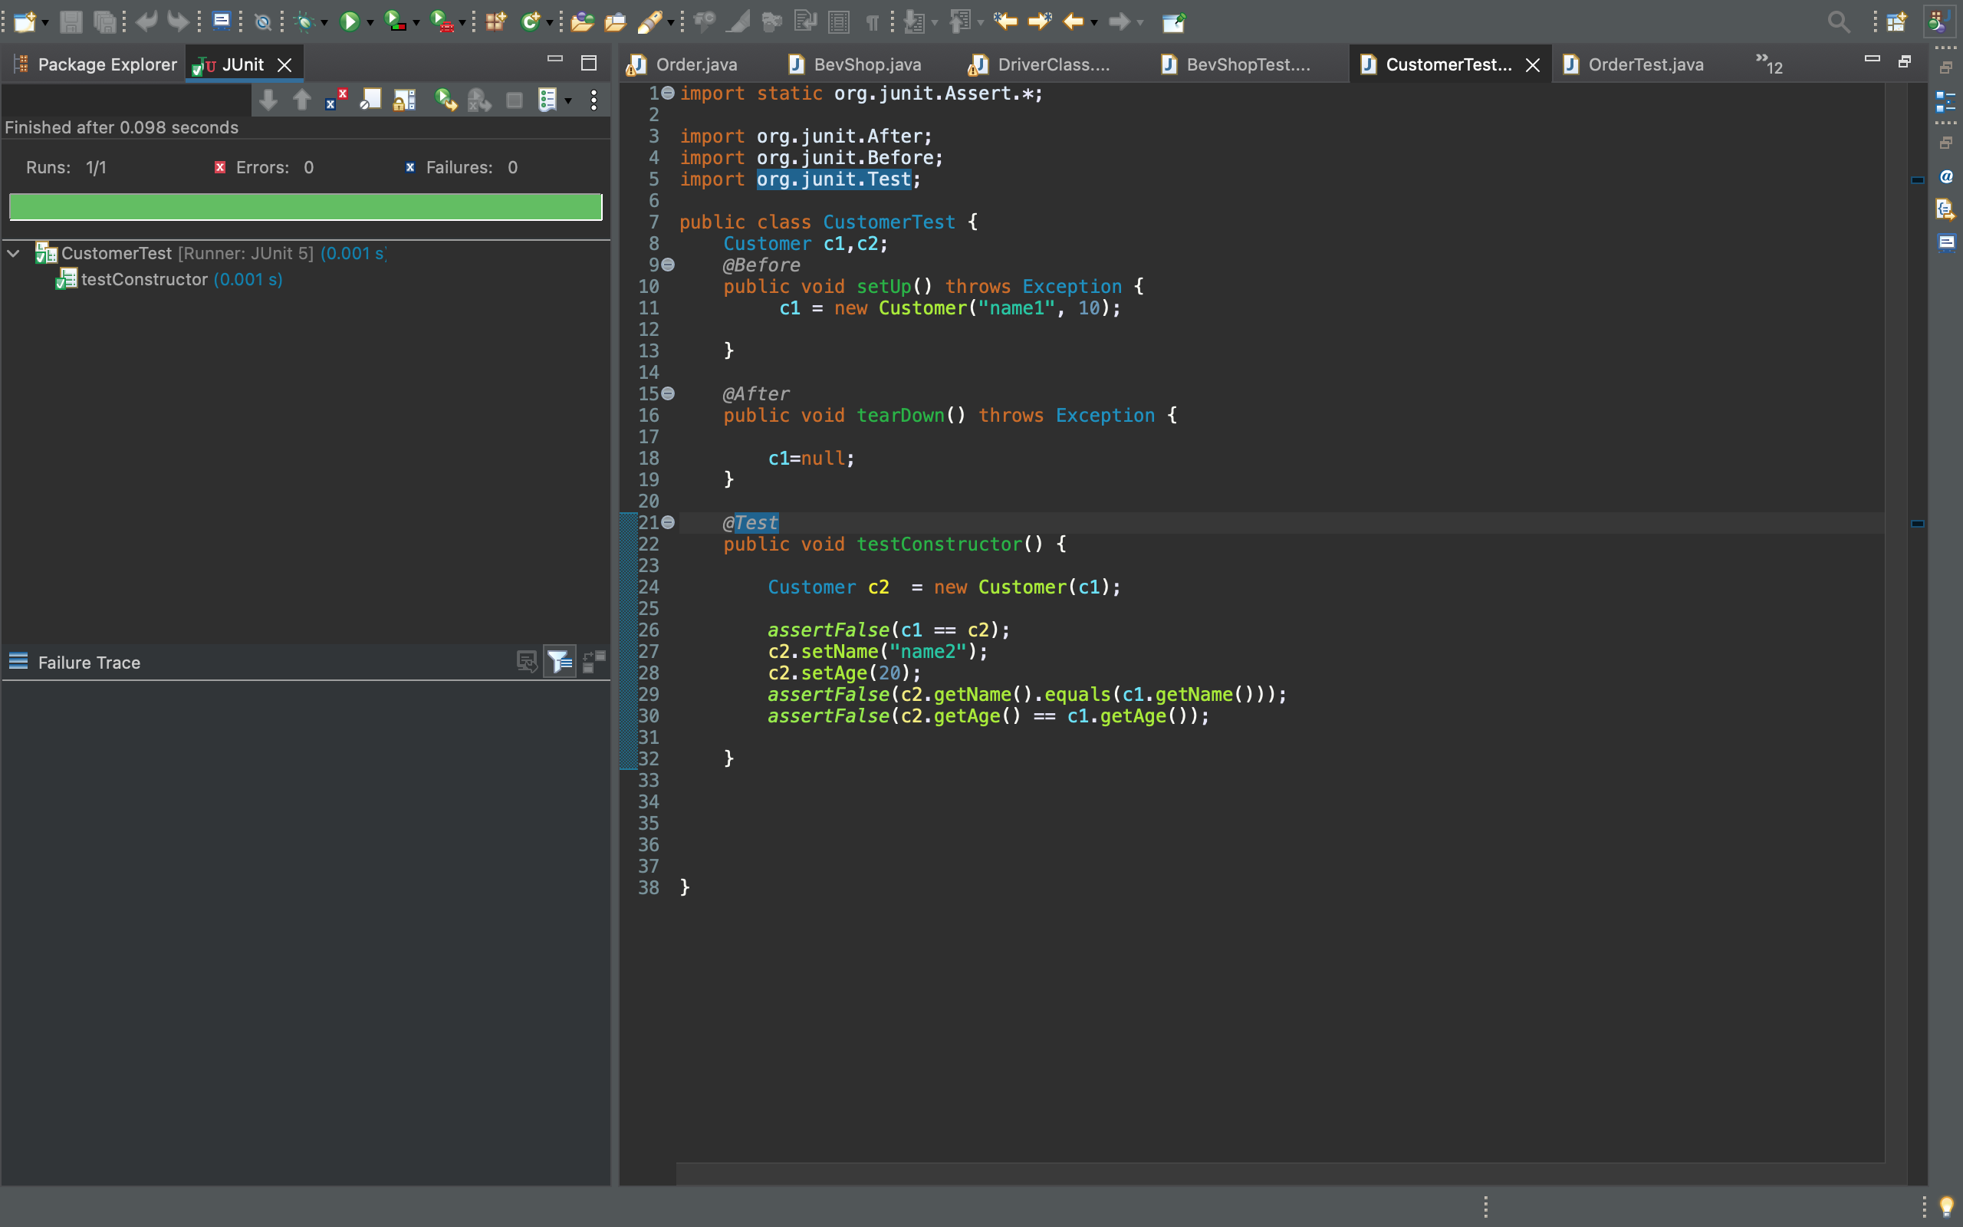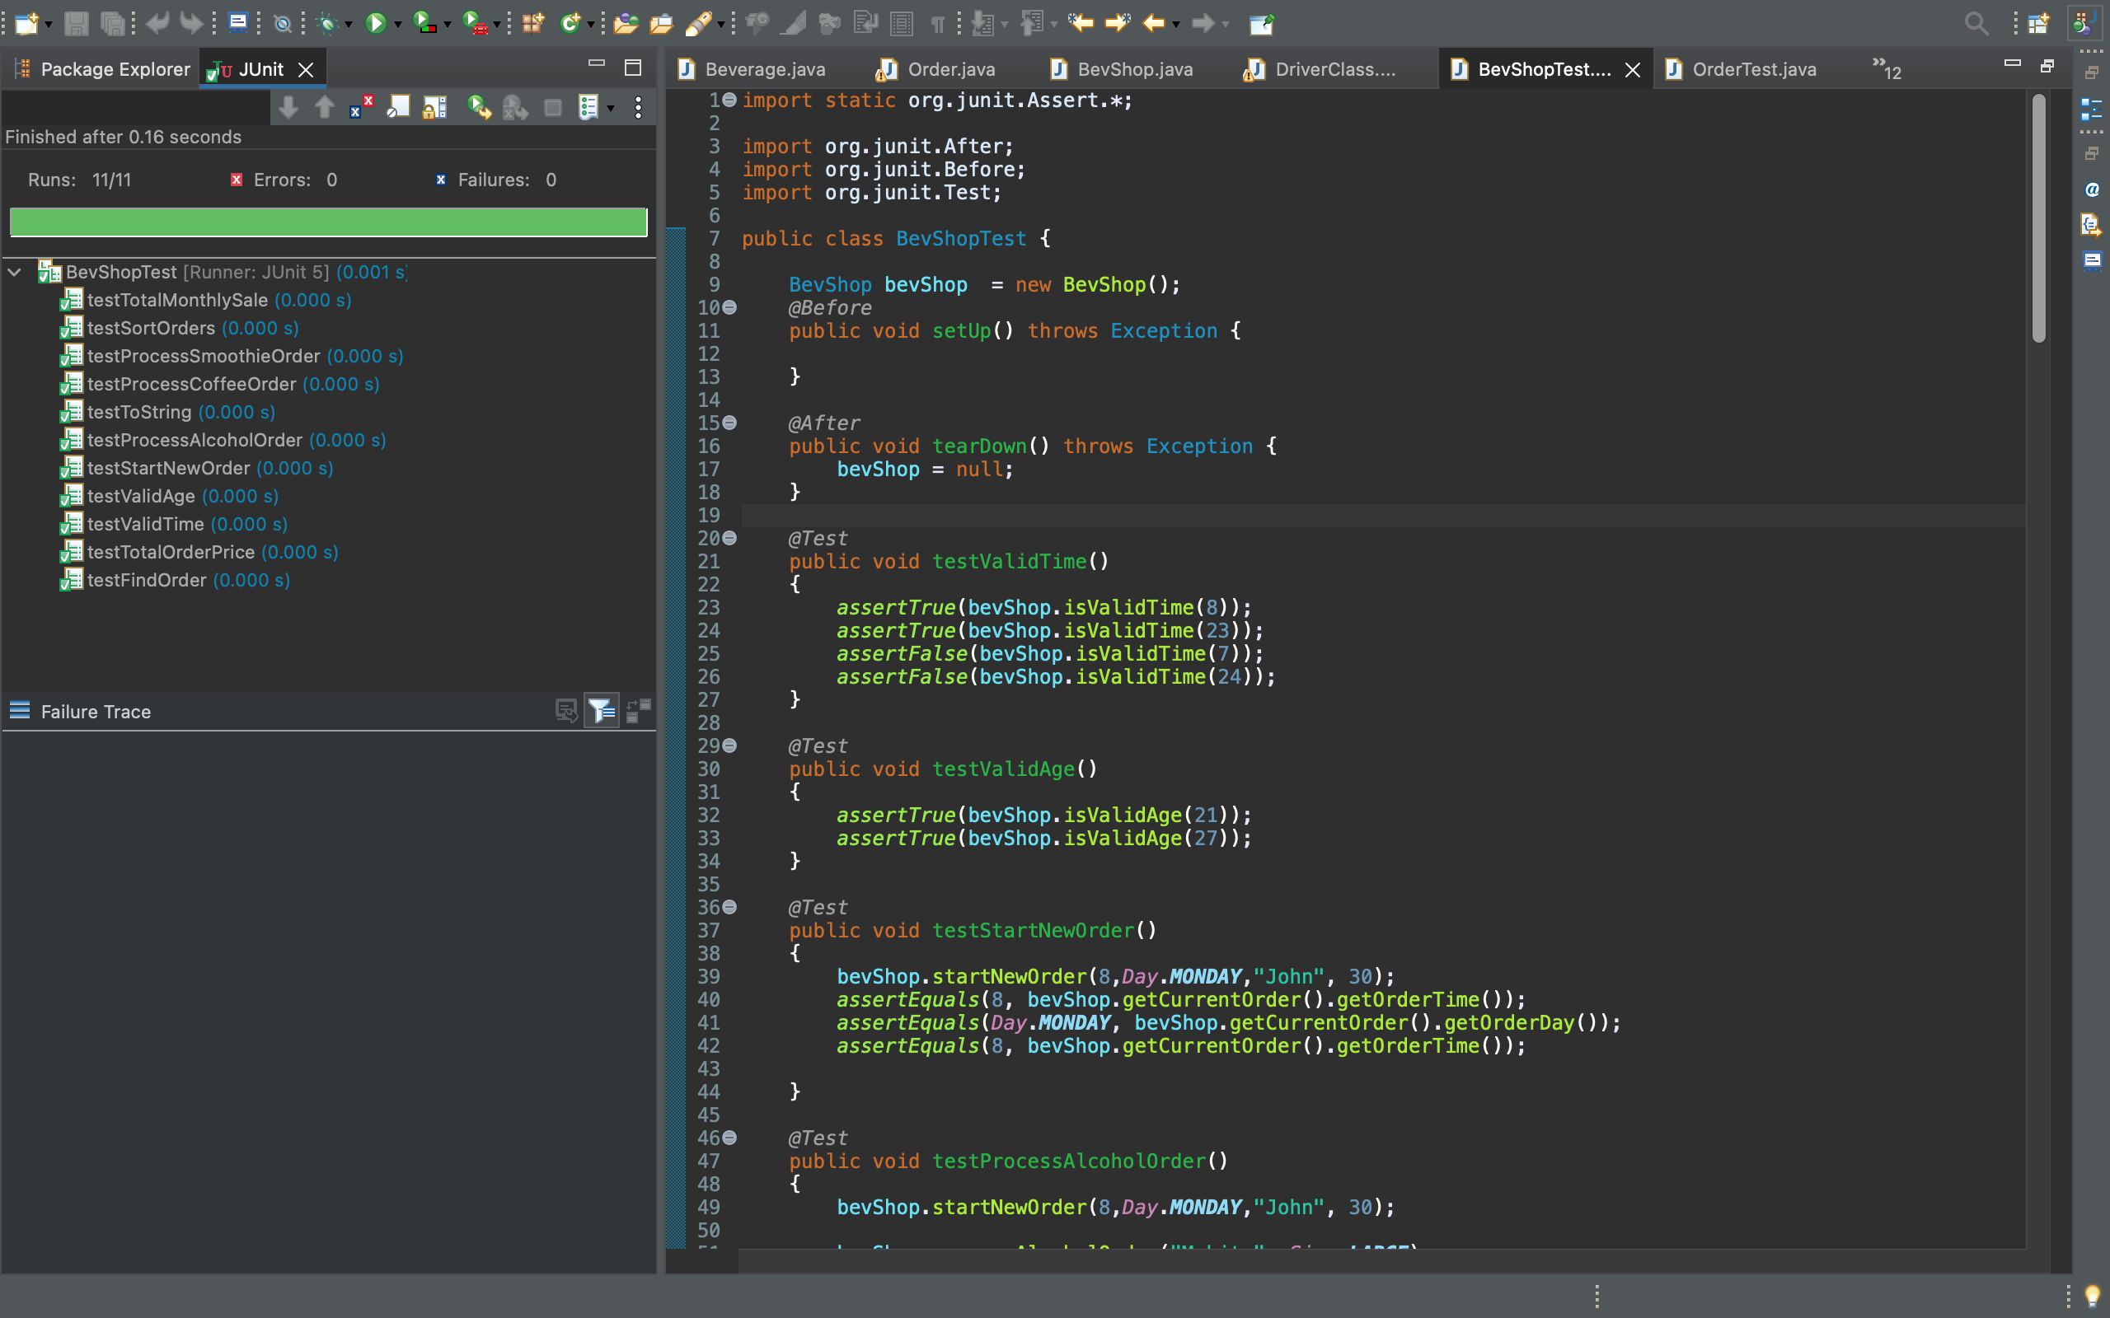

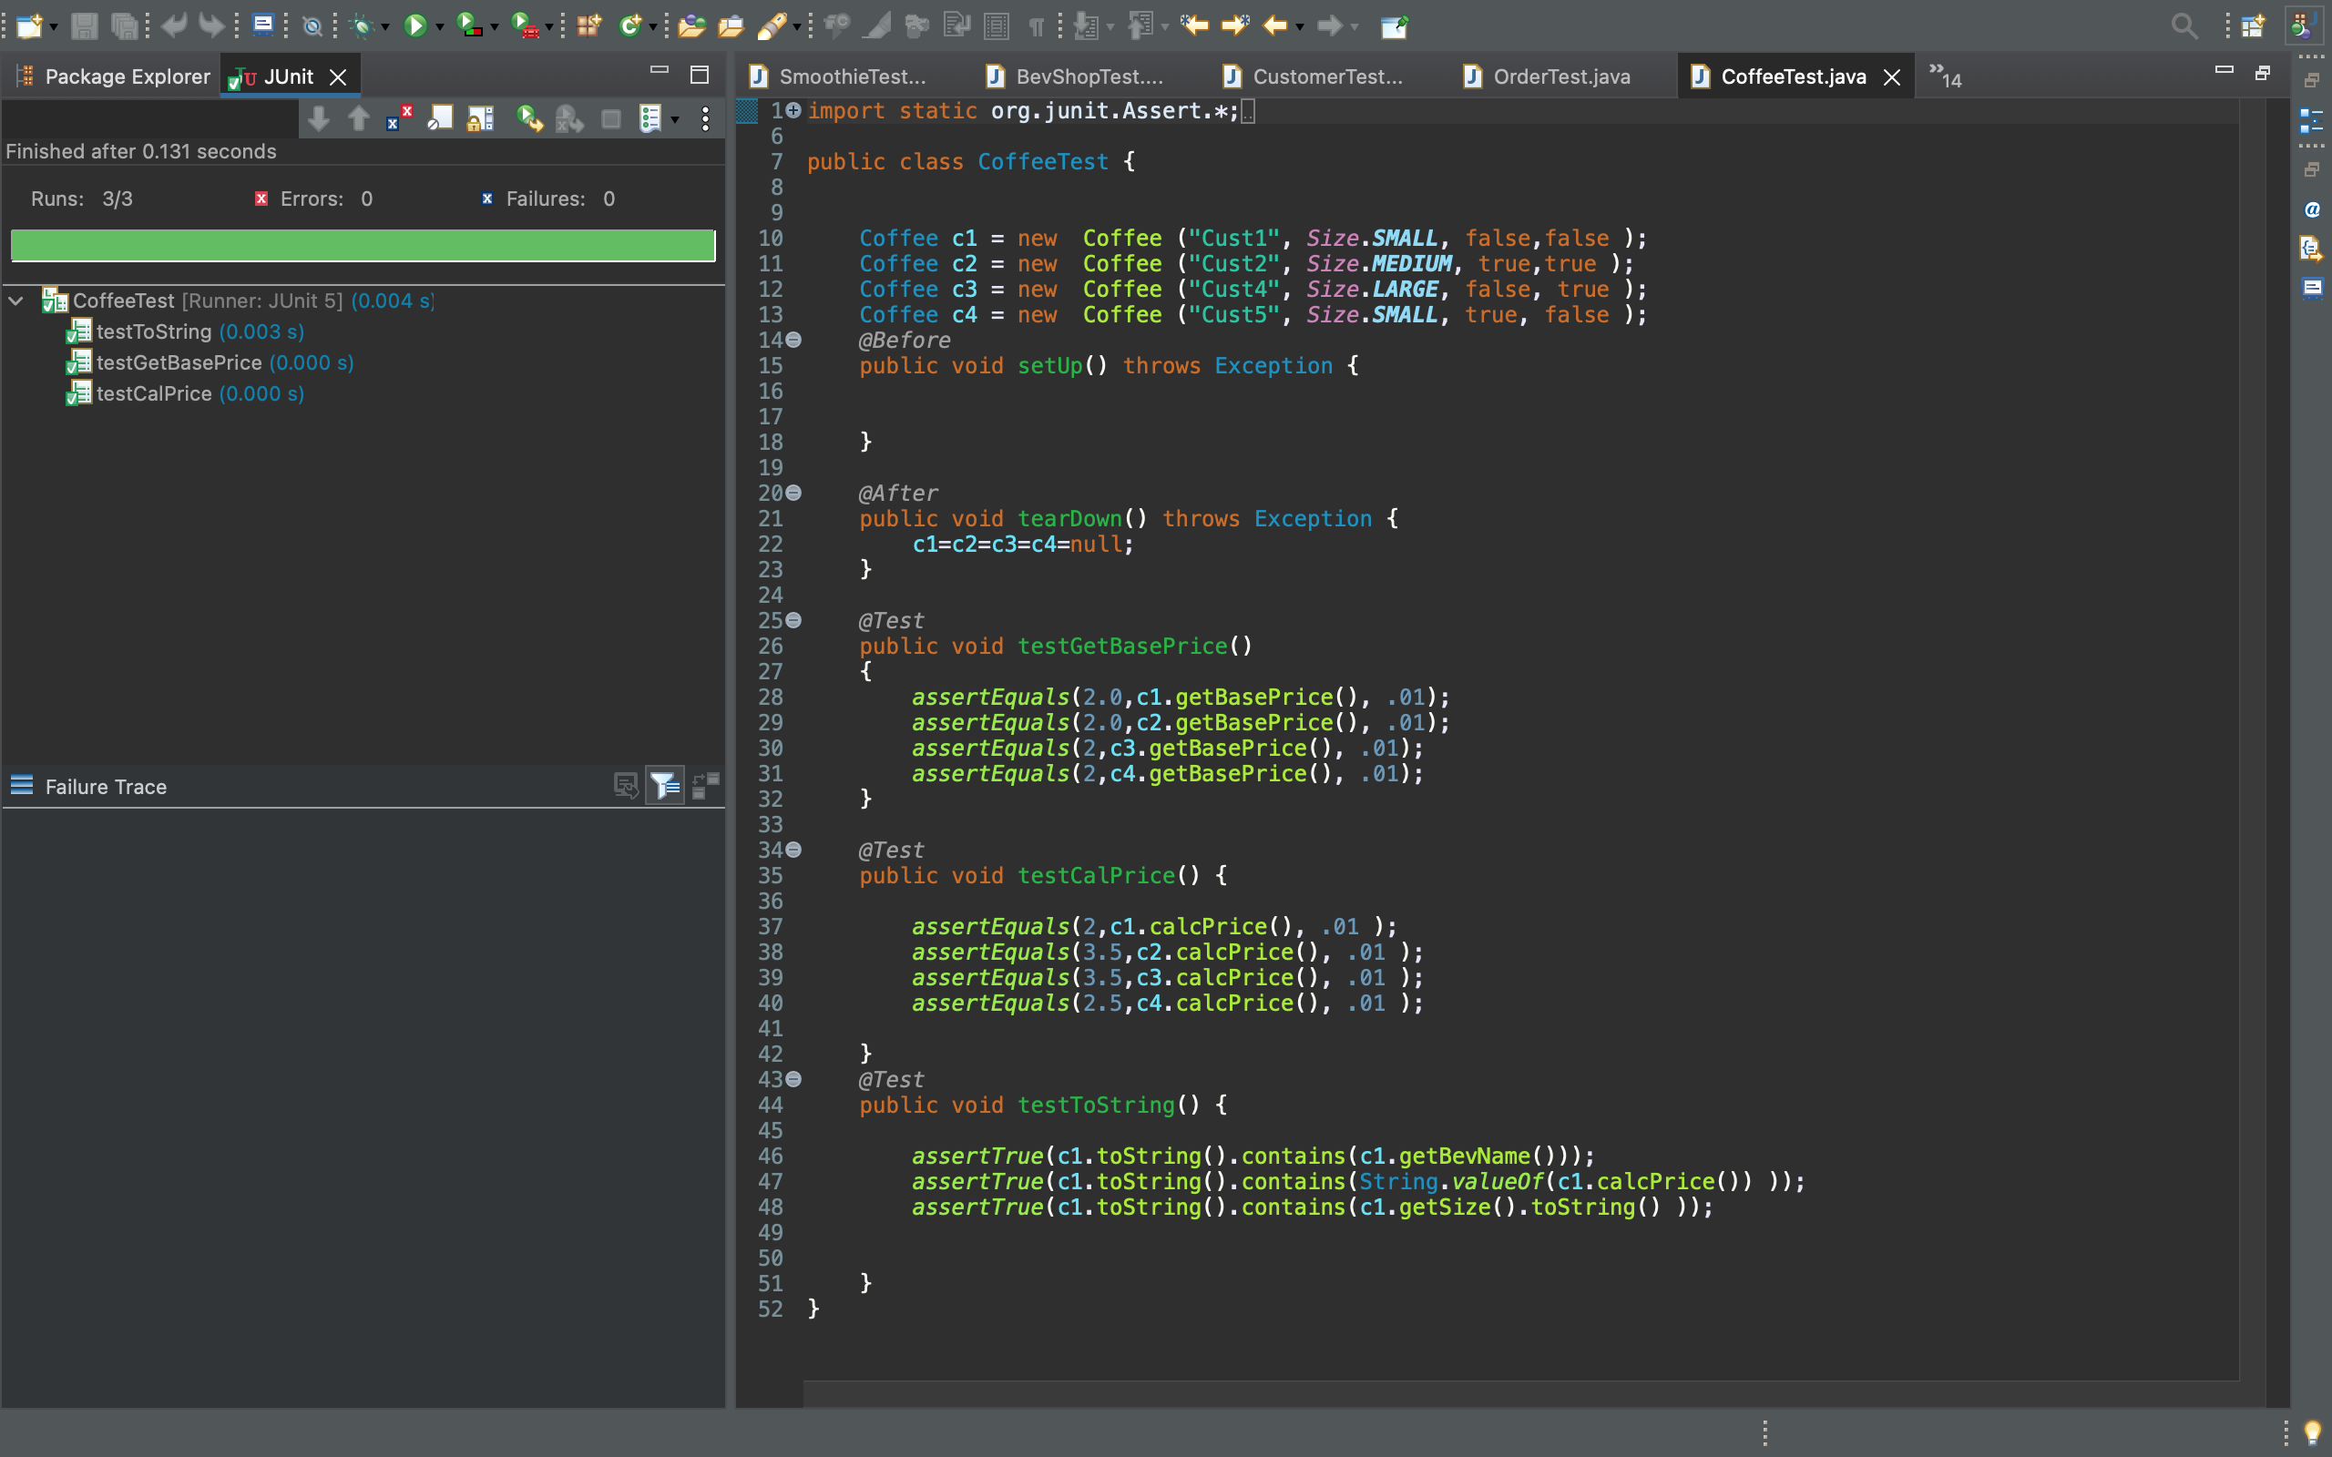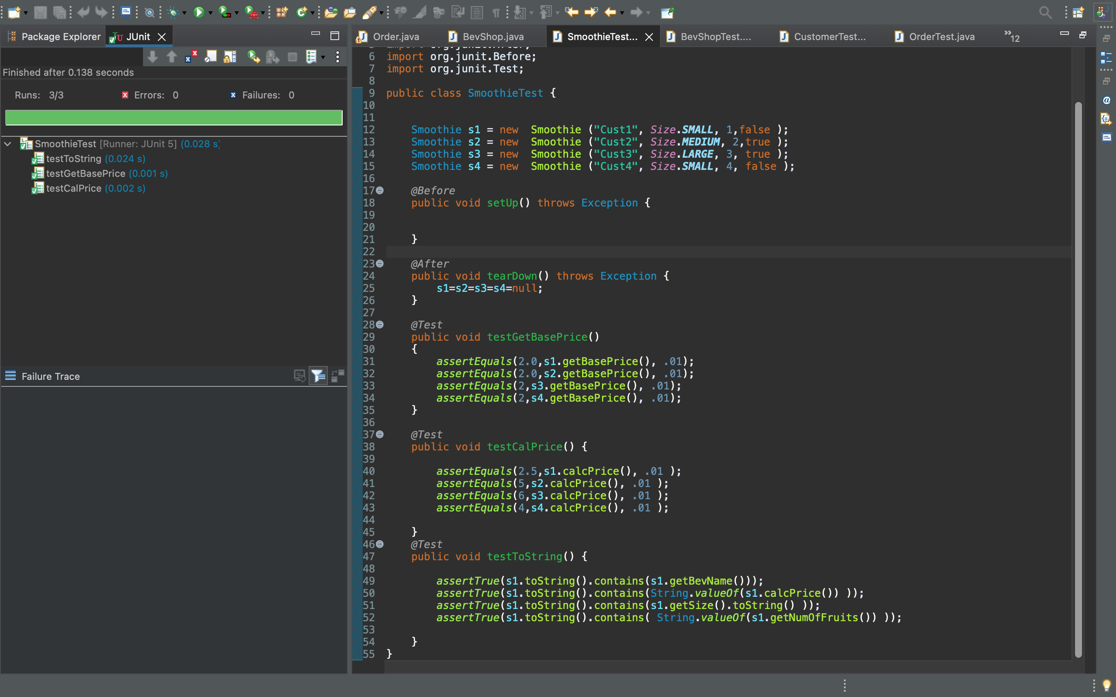

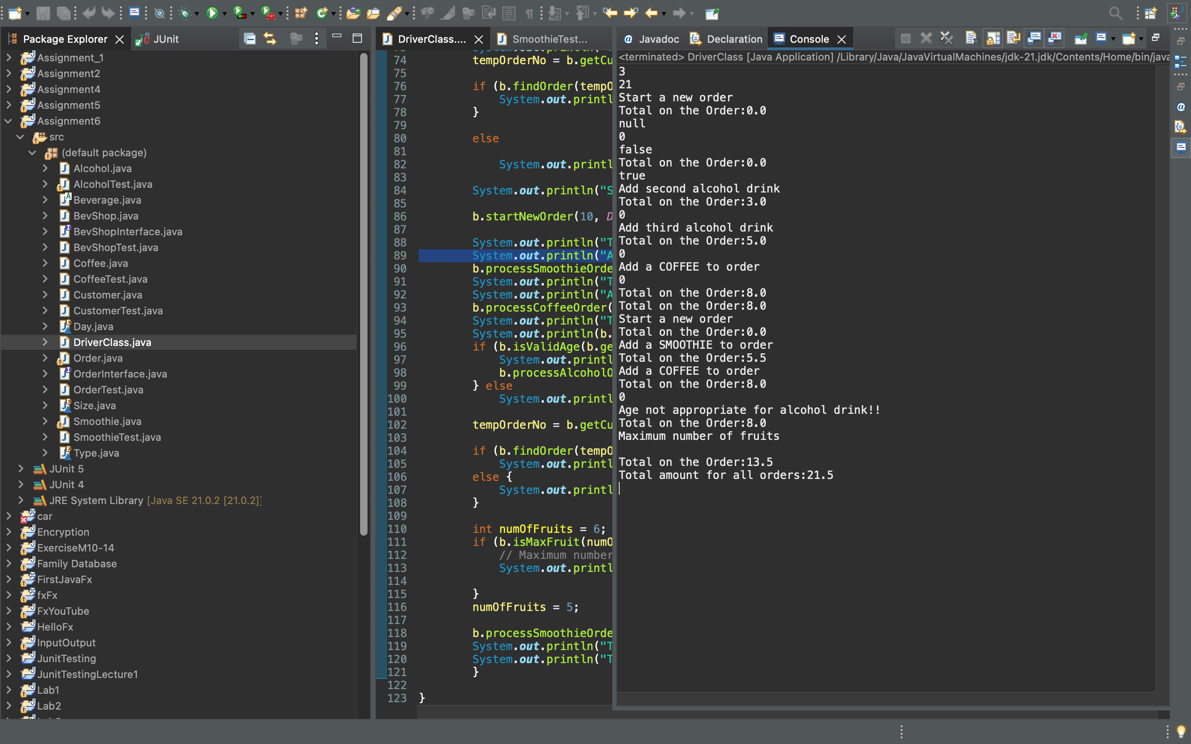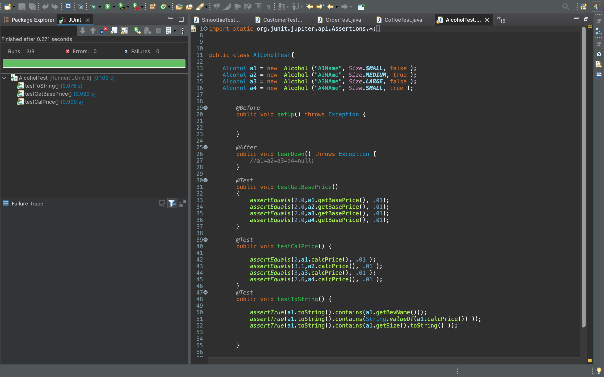

Lesson Learned

Working on this project, I learned how to integrate different Classes together to make up an application. I also washable to learn more on inheritance as well as sorting. This project was somehow hard considering the given amount of time to complete this project. I watched some YouTube videos to gain more understanding about abstract classes.

|  |  |  |  |
| --- | --- | --- | --- |
| **#** |  | **Y/N** | **Comments** |
|  | **Assignment files:** | ✅ |  |
|  | * FirstInitialLastName_ Assignment#_Moss.zip | ✅ |  |
|  | * FirstInitialLastName_Assignment#.docx/.pdf | ✅ |  |
|  | * Source java files | ✅ |  |
|  | **Program compiles** | ✅ |  |
|  | **Program runs with desired outputs related to a Test Plan** | ✅ |  |
|  | **Documentation file:** |  |  |
|  | * Comprehensive Test Plan | ✅ |  |
|  | * Screenshots related to the Test Plan | ✅ |  |
|  | * Screenshots of your GitHub account with submitted Assignment# (if required) | ✅ |  |
|  | * UML Diagram (if required) | ✅ |  |
|  | * Flowchart (if required) |  | **Not required** |
|  | * Lessons Learned | ✅ |  |
|  | * Checklist is completed and included in the Documentation | ✅ |  |