Group 31

Kehao Guo (kguo)

Kecheng Ye (kye)

Xiaojun Min (xmin2)

Each member contributes equally to this project.

Database Milestone 2

Task A: Draw an ER diagram

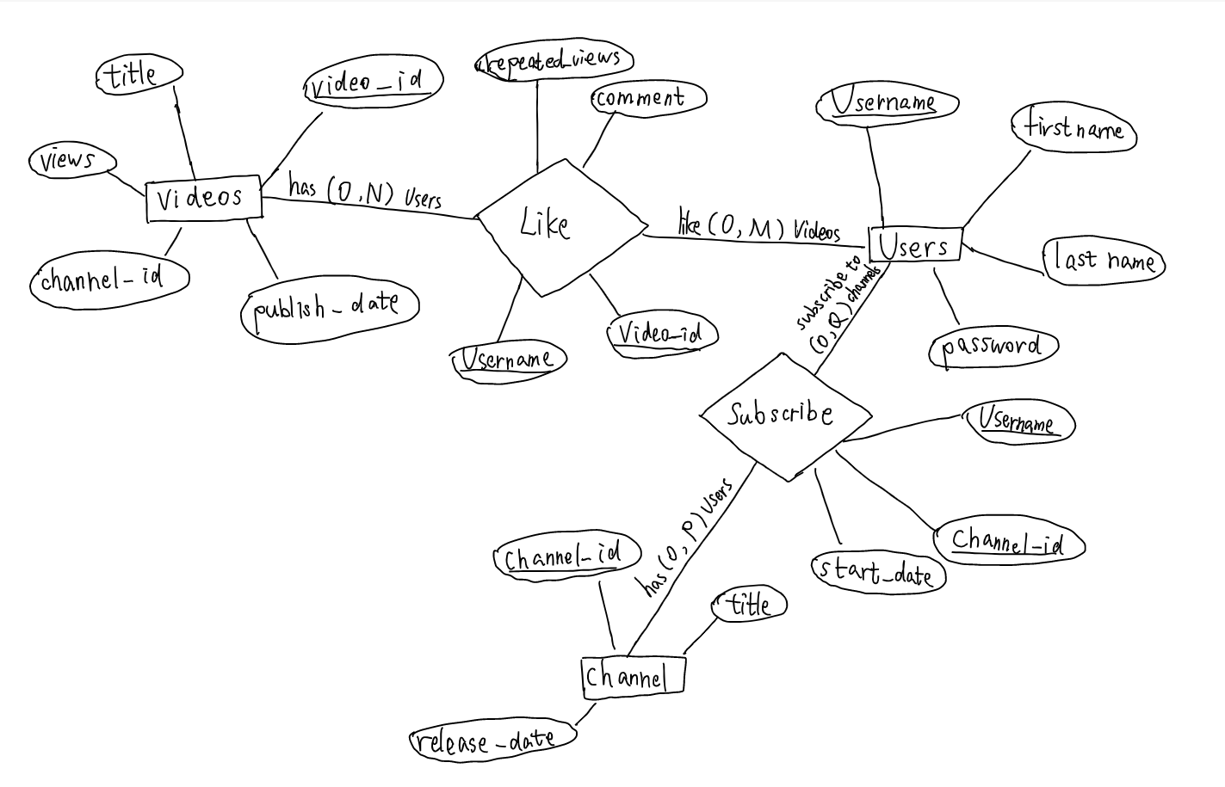

There is no weak entity/relationship.

There is no class hierarchy or total participation in our ER diagram.

We have state the (min,max) for each relationship entity on the graph.

Task B: Relational Database Design Using ER-to-Relational Mapping

1. ER-to-Relational Mapping Algorithm

Step 1: (The attribute that is underlined is the Primary Key attribute)

Step 2: Since we don’t have weak entities, we will skip this step

Step 3: Since we don’t have 1:1 Relation, we will skip this step

Step 4: Since we don’t have 1:N Relation, we will skip this step

Step 5: (The attribute that is underlined is the Primary Key attribute)

Step 6: Since we don’t have multivalued attributes in either entities or relations, we will skip this step

Step 7: Since we don’t have N-ary Relationship, we will skip this step

Step 8: Since we don’t have subclasses, we will skip this step

Step 9:

The mapping table is the following table:

2. Schema of your database

1. Videos

Video_id (INT): a unique identification code for a video. Value cannot be null. This is a primary key and it does not have default value.

Title (VARCHAR): name of the video. Default value can be “null”.

Channel_id (INT): ID of the channel which posted the video. This attribute serves as a **foreign key** which refers to the Channel_id of Channel table. This is a foreign key and it does not have default value.

Publish_date (DATE): date when the video was uploaded. Default value can be “null”.

Views (INT): number of times the video has been played by all users. Default value is 0.

This table’s primary key is **Video_id**

1. Users

Username (VARCHAR): a unique customized string used to identify a user and to log in to a user’s account. Value cannot be null. This is a primary key and it does not have default value.

First_name (VARCHAR): first name of the user. Default value can be “null”.

Last_name (VARCHAR): last name of the user. Default value can be “null”.

Password (VARCHAR): password for the user’s account. Default value can be “password”.

This table’s primary key is **Username**

1. Channel

Channel_id (INT): a unique identification code for a channel. Value cannot be null. This is a primary key and it does not have default value.

Title (VARCHAR): name of the channel. Default value can be “null”.

Release_date (DATE): the date when the channel was created. Default value can be “null”.

This table’s primary key is **Channel_id**

1. Subscribe

Username (VARCHAR): username of the user who subscribed to a channel. Value cannot be null. This attribute serves as a **foreign key** which refers to the Username of Users table. It does not have default value.

Channel_id (INT): ID of the channel that was subscribed. Value cannot be null. This attribute serves as a **foreign key** which refers to the Channel_id of Channel table. It does not have a default value.

Start_date (DATE): date when the subscription started. Default value can be “null”.

This table’s primary key is **{Username + Channel_id}**

1. Like

Username (VARCHAR): username of the user who liked the video. Value cannot be null. This attribute serves as a **foreign key** which refers to the Username of Users table. It does not have default value.

Video_id (INT): ID of the liked video. Value cannot be null. This attribute serves as a **foreign key** which refers to the Video_id of Videos table. It does not have default value.

Comment (VARCHAR): comment that the user who liked the video made about this video. Default value can be “null”.

Repeated_views (INT): number of times the user who liked the video has played the videos. Default value is 0.

This table’s primary key is **{Username + Video_id}**

For any potential violation caused by the foreign key violation, we will perform delete cascade operation. i.e., if a record in the parent table is deleted, then the corresponding records in the child table will automatically be deleted.

And except for the primary key of each table, our relation tables do not possess any other unique keys.