Multi-Object Spectroscopy with OSIRIS

**iconIndex**

* [General description](http://www.gtc.iac.es/instruments/osiris/osirisMOS.php#General)
* [MOS life cycle](http://www.gtc.iac.es/instruments/osiris/osirisMOS.php#Life_Cycle)
* [MOS mode practical limitations](http://www.gtc.iac.es/instruments/osiris/osirisMOS.php#Limitations)
* [Calibrating MOS observations](http://www.gtc.iac.es/instruments/osiris/osirisMOS.php#Calibrations)
* [Designing MOS masks](http://www.gtc.iac.es/instruments/osiris/osirisMOS.php#Designing)
* [The Mask Designer tool](http://www.gtc.iac.es/instruments/osiris/osirisMOS.php#MDtool)
  + [Starting up](http://www.gtc.iac.es/instruments/osiris/osirisMOS.php#Starting)
  + [Getting to know the MaskDesigner](http://www.gtc.iac.es/instruments/osiris/osirisMOS.php#Getting_to_know)
  + [The graphical user interface](http://www.gtc.iac.es/instruments/osiris/osirisMOS.php#GUI)
  + [Designing MOS masks step-by-step](http://www.gtc.iac.es/instruments/osiris/osirisMOS.php#Step_by_step)
    - [Example #1: Using a an OSIRIS pre-image](http://www.gtc.iac.es/instruments/osiris/osirisMOS.php#Ex1)
    - [Example #2: Using equatorial coordinates](http://www.gtc.iac.es/instruments/osiris/osirisMOS.php#Ex2)
* [Downloads](http://www.gtc.iac.es/instruments/osiris/osirisMOS.php#Downloads)

**iconGeneral description**

OSIRIS possesses significant spectroscopic multiplexing capability through the use of focal-plane multi-slit masks instead of a single long slit. Hence observing in MOS mode requires the design and construction of a physical mask that contains a number of small slits, or slitlets, where each slitlet produces the spectrum of a source in the field. By placing a mask with carefully designed and manufactured slits in the focal plane, spectra of several, including tens of objects can be observed at the same time.

**The effective available field for placing slitlets is about 7.5 by 6 arcmin** . At lower Resolutions (R=300, R=500) the spectrum fits well within the available detector area and hence it is possible to observe the complete spectral coverage, but within in a restricted region. Users can place their slitlets in this restricted FOV where all the spectra will provide the complete spectral coverage of the grism (see Table below). At higher resolutions (R=1000, 2000, and 2500), a spectra will cover the whole detector length. Therefore, the spectral coverage is dependent on the position of the slit in the FOV, and users should be aware of this when defining the observations. In any case, [The Mask Designer Tool](http://www.gtc.iac.es/instruments/osiris/osirisMOS.php#MDtool) will provide information about the spectral coverage associated with each defined slit for higher resolution grisms/VPHs.

|  |  |  |  |  |
| --- | --- | --- | --- | --- |
|  | **R300B** | **R300R** | **R500B** | **R500R** |
| **Effective FOV  (for complete spectral coverage)** | 7.5' x 2.8' | 7.5' x 3.4' | 7.5' x 1.3' | 7.5' x 1.6' |

Apart from the focal plane slit mask, spectral observations in MOS mode are no different from normal long-slit observations. In principle MOS mode can be used with all grisms. However, the projection of the spectrum onto the detector is displaced in the dispersion direction in accordance with the position of each specific slitlet. This implies that for slits close to the upper or lower boundary of the field part of the spectrum may be lost, and in the case of higher resolution grisms the spectral window that falls onto the detector is directly related to the slit position in the field. The Mask Designer tool that is described in detail further on assists the user in optimizing the design and produces a design file that is used for producing the mask.

The success of MOS observations depends critically on having accurate coordinates of the sources of interest, together with those of a number of appropriate stars in the field specially selected for alignment purposes: the fiducial stars. Intrinsic errors in coordinates, effects of proper motion, systematic differences between catalogues, and effects due to differential refraction by the atmosphere must be controlled for MOS observations to be successful. Users of MOS mode must pay special care to these aspects.

If the fiducial stars work well, alignment of a slit mask on the sky takes a similar amount of time as aligning a long-slit mask. Hence the overheads in MOS mode are similar to those for normal long-slit spectroscopy with OSIRIS.

For the design of slit masks a special software tool, the [OSIRIS Mask Designer Tool (MD)](http://www.gtc.iac.es/instruments/osiris/osirisMOS.php#MDtool), must be used. This tool allows the user to input a coordinate list (either equatorial coordinates or coordinates on the CCD pixel scale of OSIRIS) and to optimize the position of the slits. The Mask Designer shows where the spectrum will be projected onto the detector. It also avoids that spectra will overlap. This tool takes automatically care of field distortions when mapping coordinates into the focal plane of the telescope. More details are provided further down.

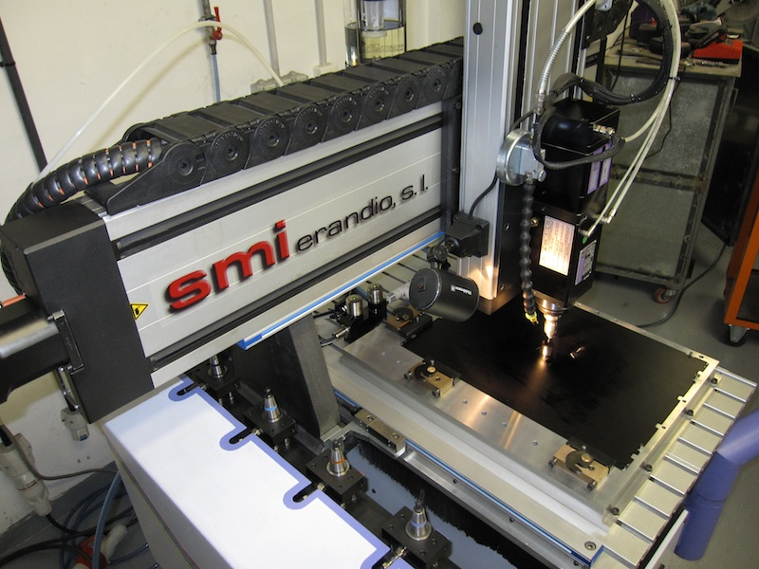

The MOS mask cutting machine at work.

[**Back to top**](http://www.gtc.iac.es/instruments/osiris/osirisMOS.php#top)

**iconMOS life cycle**

The complete process of planning and executing MOS observations becomes quite involved. In order to design a mask the PI must have a list of target coordinates, either from an existing catalogue with equatorial coordinates, or based on pixel coordinates from a Sloan r' band image taken previously with OSIRIS. Hence it may be necessary to first obtain this pre-image before the MOS observations can be planned. In the case of using external, non-OSIRIS, images it is strongly advised to check that the astrometric solution of such images is of sufficient accuracy (typically for good results one needs astrometry better than 0.2 arcseconds).

Once completed the design of a mask, or set of masks, the resulting design file(s) may be sent to the observatory where the masks will be produced on a dedicated machine. The observatory requires at least one full month to guarantee that the mask will be available in time. The produced masks, used or unused, will remain in the possession of the observatory and are available for later (re-)use.

At the time of taking the observations the mask(s) are installed in OSIRIS. Only a small number of masks can be installed at any one time. When the field is being acquired, the fiducial stars have the function of correctly aligning the mask with the projected star field. This alignment process again relies on information provided in the mask design file. When a good alignment is obtained the exposure can start.

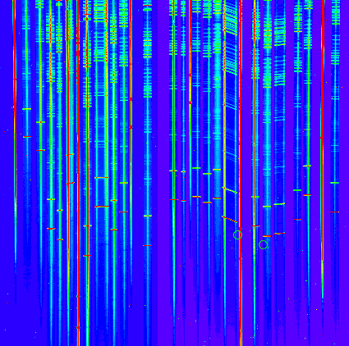

Example of a series of spectra taken with OSIRIS using a MOS mask.

[**Back to top**](http://www.gtc.iac.es/instruments/osiris/osirisMOS.php#top)

**iconMOS mode practical limitations**

As was indicated before, the successful use of MOS masks stands or falls with having accurate coordinates of a number of stars for aligning the mask on the sky, and of the science targets. Especially the positions of the fiducial stars are crucial, as any error in these stars will translate to a poor positioning of the whole mask. For the fiducial stars circular holes must be used on which the mask can be centered. **At least three fiducial stars are needed, but we strongly advice users to allow for more stars, for instance six**.

Special care should be taken with the proper motion of these stars, although often this is not known. This is one of the key reasons to define several fiducial stars so that one or two stars that happen to have a high proper motion can be identified and omitted when aligning the mask. Of course when the target pixel coordinates are used directly from an OSIRIS image, proper motion should not be a concern.

**Holes for the fiducial stars should have a diameter of no less than 4 arcseconds**. Also the brightness of fiducial stars is crucial. These stars should of course not be so bright that they saturate, and they should all have a similar brightness. A good choice is to have stars of about magnitude 18 in the r' band, but certainly not brighter than 17 as there will be a risk of saturation even with short exposure times. They should not differ by more than 2 magnitudes in brightness. Fainter stars can be used, but exposure times will increase and hence also the overheads in aligning the mask.

Furthermore, the fiducial stars should be well spread over the field and cover both CCDs. We advise to have alignment stars covering both CCDs and span a distance of at least 4 arcminutes.

**Slitlets for the science targets must not be narrower than 0.63 arcseconds**, and we advise users to design wider slits as this reduces the impact of any alignment error on the final signal-to-noise ratio of the spectra. The **accuracy in the slit positioning in OSIRIS MOS mode is 0.1 arcseconds (r.m.s),** hence this must be considered when defining the slit width for the corresponding scientific program. In order to fulfill the 10 % accuracy requirement in the slit positioning, the **use of 1.2 arcseconds slits is preferred**. Having wider slits gives also more flexibility with respect to the seeing conditions, and we strongly advice potential applicants to request reasonable seeing limits for their observation. For reasons of efficiency and cost, the observatory will not produce multiple masks for the same target fields (for instance identical masks but with different slit widths).

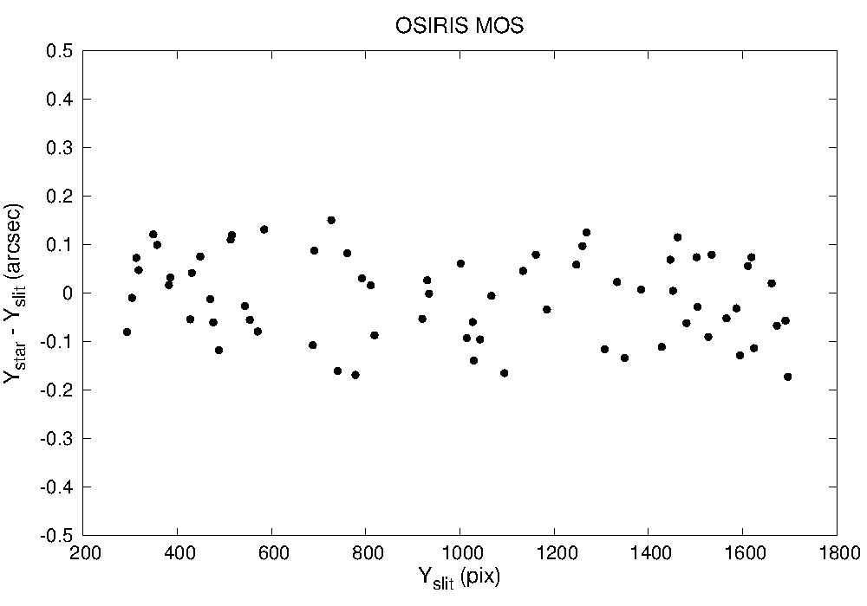

Differences in the slit positioning along OSIRIS FOV.

**Slits can be of any sensible length up to 24 arcseconds** and may by tilted relative to each other (for instance to position a slitlet along a certain orientation of a galaxy, or to get two nearby targets into one slitlet). Curved slits, however, are not (yet) admitted. Also, **the instrument field orientation must be such that the general slit orientation is either North-South, or East-West**.

Slits in OSIRIS run horizontally, along the detector x-axis, while the spectral direction is along the vertical axis on the OSIRIS detector. Hence users should be aware that the slit position angle differs by 90 degrees from the position angle for the MOS field that is specified in the observing block (as opposed to the standard long-slit mode where the slit PA is specified). In particular, **for a North-South orientation along the slits the position angle must be -90 deg, while for a East-West orientation along the slits, position angle should be 0 deg**. This orientation must also be taken into account when defining a preimaging for OSIRIS MOS observations, as **the preimage must be taken in exactly the same orientation as the final slit mask**.

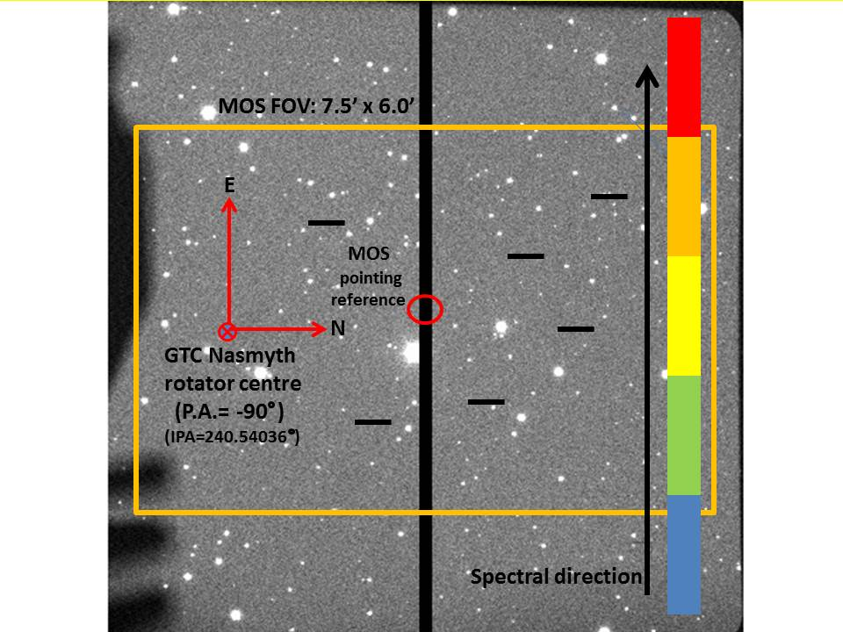

Example of one of the possible orientations supported in OSIRIS MOS observations, with slits oriented in North-South direction (that means a position angle of -90 deg in the sky).

**When designing masks based on OSIRIS images, only images taken in the Sloan r' band and with standard binning 2 x 2 may be used**.

Users may consider doing MOS spectroscopy with a grism in combination with a medium-band filter so that only a part of the spectrum will be shown. In that way more objects can be packed into a single mask. Please contact in advance with GTC staff if this observing mode is required.

[**Back to top**](http://www.gtc.iac.es/instruments/osiris/osirisMOS.php#top)

**iconCalibrating MOS observations**

Standard calibrations provided by the observatory for MOS data will be identical to those for normal spectroscopy (i.e. including a spectro-photometric standard star observed with the correct grism and a normal wide longslit). Any special night-time calibrations need to be defined in the phase-2 tool as observing blocks and the time will be charged to the observing program.

Accurate absolute flux calibration in MOS mode can be a difficult matter and must be planned with care. For specific calibrations each PI will have to define observing block specifically for the purpose of calibrating her/his science data.

[**Back to top**](http://www.gtc.iac.es/instruments/osiris/osirisMOS.php#top)

**iconDesigning MOS masks**

Designing OSIRIS MOS masks is not a very complex process in itself, thanks to the *Mask Designer* tool that helps the user in making the right choices. The process can however, be time consuming depending on the quality of information that one has available at the outset. There are a number of aspects in the design that require special attention.

From the outset one has to have clear whether the mask will be designed based on a set of accurate equatorial coordinates (coordinate design method), or on the basis of pixel coordinates taken from an OSIRIS image (pre-image design method). The necessary steps for both design methods will be described in detail in the next section.

When designing masks based on equatorial coordinates great care has to be taken with the quality of the coordinates, which is all-important for a correct design. The user should be aware of effects like intrinsic uncertainty of the coordinates, proper motions, and systematic differences between catalogues. Note also that only J2000 coordinates should be used.

In the case of designing a mask based on an image taken with OSIRIS (pre-imaging mode), one must have access to a suitable image of OSIRS taken in the Sloan r´ filter. Other filters may introduce unexpected field distortions. Images taken with the tunable filter, for instance, are not valid as input for designing MOS masks. The raw pre-image containing the two CCDs must first be converted into a single mosaic that contains the images of both CCDs, correctly positioned so that the pixel coordinates are continuous and geometrically correct. Also this step is described in detail in the following section.

When using a pre-image for the mask design, the OSIRIS image should be taken with the correct orientation and elevation, so that de design based on this image will reflect the reality at the moment of observing with the mask.

Before designing a mask, the user should consider the right orientation of the field in order to take into account the optimal angle of the slits projected onto the sky. This is important to reduce the effects of differential atmospheric refraction that may introduce important slit losses. This problem is exacerbated by the fact that currently the dome shutter cannot be fully opened and hence objects passing through the dome blind-spot cannot be observed in their optimal position. Moreover, although a mask design may be optimized for a certain hour angle of observation, there is no guarantee that the observation can be scheduled at exactly that hour angle.

Here follow some simple guidelines that will probably work well for most cases: For fields that are necessary to be observed close to the meridian (i.e., those using narrow slits) the slits are best oriented in the North-South direction. However, in order to increase the accessibility of the field in the observing queue, the slit orientation is best placed East-West, so that the field can be observed with the same mask both when the field is rising and when it is setting, since the slits will remain reasonably close to the parallactic angle, while when crossing the meridian atmospheric refraction is at its minimum and deviations from the parallactic angle will have little impact. Although other angles are in principle possible, **for the time being only slit orientations N-S or E-W will be accepted**.

A simple [calculator for atmospheric refraction and parallactic angles](http://gtc-phase2.gtc.iac.es/science/astroweb/atmosRefraction.php) is available [here](http://gtc-phase2.gtc.iac.es/science/astroweb/atmosRefraction.php).

For a more detailed description of the issue of the choice of slit angle we refer to [Szokoly, 2005, A&A 443, 703](http://www.gtc.iac.es/instruments/osiris/media/Szokoly2005.pdf) and [Sánchez-Janssen et al., 2014, A&A 556, A2](http://www.gtc.iac.es/instruments/osiris/media/SanchezJansen.pdf). Also, a detailed study on atmospheric refraction and its effects on spectroscopy can be found in [Filippenko, 1982, PASP 94, 715](http://www.gtc.iac.es/instruments/osiris/media/filippenko82.pdf).

[**Back to top**](http://www.gtc.iac.es/instruments/osiris/osirisMOS.php#top)

**iconThe Mask Designer tool**

Here follows a practical description of how the OSIRIS Mask Designer tool is used. In what follows we refer to MaskDesigner (MD) Version 3.25 (released December 2013). The MD was developed by Txinto Vaz Cedillo, based on previous work by J.I. González-Serrano and co-workers (2004, Experimental Astronomy 18, 65), with important input and invaluable assistance from Ángel Bongiovanni.

The [Mask Designer software](http://www.gtc.iac.es/instruments/osiris/osirisMOS.php#Downloads) can be downloaded [here](http://www.gtc.iac.es/instruments/osiris/osirisMOS.php#Downloads).

[**Back to top**](http://www.gtc.iac.es/instruments/osiris/osirisMOS.php#top)

**iconStarting up**

The MD software is written in JAVA and uses elements of the JSky project (see <http://archive.eso.org/cms/tools-documentation/jsky.html>). The MD tool runs locally on your machine and hence needs to be installed. You need to have the JAVA Runtime Environment Version 1.5.0 or later installed (see http://java.com/en/download/index.jsp).

First download the latest version from the GTC web site (see the OSIRIS instrument pages for the most recent location). Then unpack the compressed file by typing:

$ unzip maskDesigner_v325.zip (the filename may be different, depending on the version)

Within the directory structure you will find the java program MaskDesigner.jar that you can start by typing the command:

$ java -jar -Xmx256m MaskDesigner.jar

(Or simply just double-clicking on the file in your directory might start the program). To force use of the latest version of java on a typical Linux platform, one may type:

$ /usr/java/latest/bin/java -jar -Xmx256m MaskDesigner.jar

If you wish to start up the MaskDesigner software directly loading a specific mask design file one may pass that file at startup as given in the following example:

$ java -jar -Xmx256m MaskDesigner.jar ./projects/abell_2065_test.mdp

[**Back to top**](http://www.gtc.iac.es/instruments/osiris/osirisMOS.php#top)

**iconGetting to know the MaskDesigner**

Before starting work with the MaskDesigner (MD) it is useful to understand some basic principles of its function.

The main goal of the MD is to provide an interface and conversion between either the equatorial sky coordinate system (RA, DEC in J2000) or the OSIRIS detector pixel coordinate system (X,Y) and the coordinate system of the physical mask that must be produced. This requires a set of transformations and checks that the software takes care of in an automatic fashion based on the input given by the user. The above mentioned transformations include the geometric field distortions and corrections related to atmospheric refraction, the proper motions of objects, and precession. The software also ensures that there are no conflics between slitlets (i.e. overlapping spectra, manufacturing limitations), that the slits fall onto the mask, and that the spectrum is correctly projected onto the detector.

When designing a configuration of slitlets on the mask, the MD avoids conflicts that may occur when spectra from different slitlets overlap. It also shows how the spectra will be projected onto the detector. The user is informed of any conflicts that may occur (in the log window, through a pop-up window, and in the graphical displays of the mask design). Moreover, the user can add priorities to slitlets so that the MD software can give priority to the highest-priority slitlet and adjust the design accordingly.

The MD tool can be used to optimize and manage several masks at the same time, which might be useful in large projects. In fact, the MD tool resolves conflicts by automatically demote slitlets that are inconflict to secondary masks. However, we advice users to start with designing individual masks in order not to complicate the designs when dealing with complex arrangements. Moreover, the observatory only will accept design files for a **single mask** that each is **associated with specific observing block**.

Before starting with the design of an OSIRIS MOS mask the user must either have a set of accurate equatorial J2000 coordinates prepared, or a set of accurate x, y pixel coordinates based on an OSIRIS Sloan r’ band image (pre-image mode). When using an OSIRIS image, the MD can be used to interactively select the objects based on the image.

The MD allows the user to visualize the end result of the masks.

Mask designs can be stored and reloaded at a later moment. Slitlet details can be edited on-line for instance for making small adjustments. All details of a design are stored in an MDP file (Mask-Design-Project file). When a design is completed one must save the end result as a so-called MDF file (Mask-Design-File). This file will be used as input by the observatory to manufacture the mask accrding to the design.

[**Back to top**](http://www.gtc.iac.es/instruments/osiris/osirisMOS.php#top)

**iconThe graphical user interface**

After starting up the MD two windows appear: a log window and the main window that acts as the main interface with the user from where all actions are activated. The log file can be consulted at any time, but plays no active role during the design process.

The main window consists of the following areas indicated in next figure:

1. Pull-down menu options.
2. Box providing a listing of all the slitlets that have been defined.
3. Buttons for some specific actions.
4. Tick-boxes to select visualization options for the slit geometry.
5. Listing of the details of the slit size and orientations in three different coordinate systems: equatorial, pixel, and physical coordinates.
6. Box to set slit properties.
7. Box to define target details.

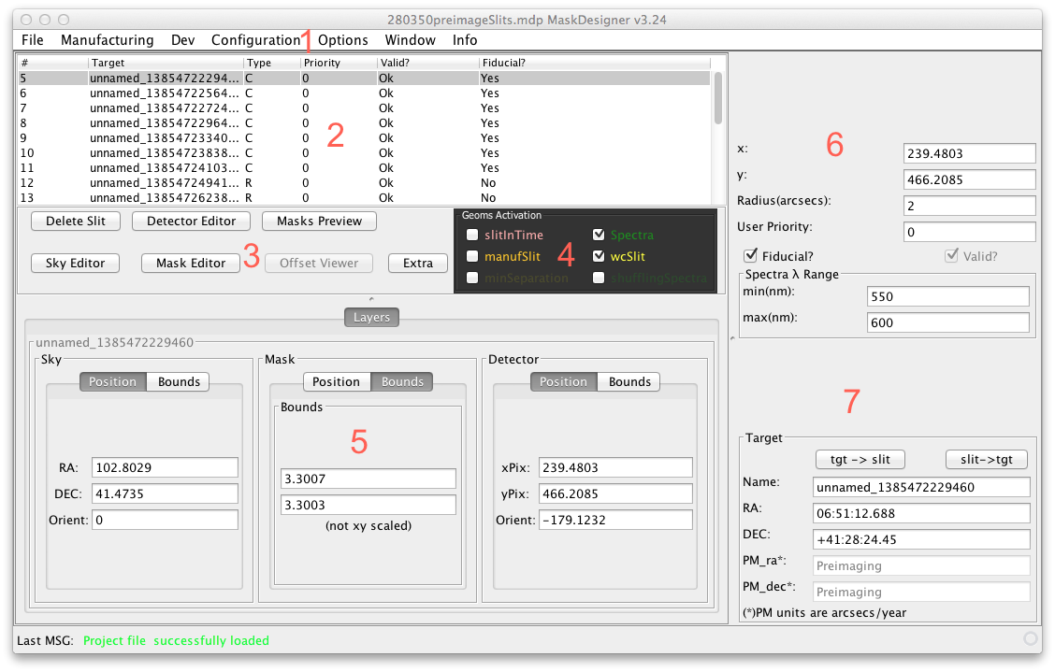

The principal panel of the Mask Designer tool.

Next we describe each point in somewhat more detail:

**Menu options**  
At the very top of the MD window one finds the usual pull-down menu options. Here one can save a project, load a previously defined project, configure the project, set default values for slits, or open specific windows etc. The configuration method is described later when specific examples are presented.

**Slitlet Listing**  
The top-left section of the window provides an overview of all the slitlets that have been defined. Each slit is given a unique number. The target names are copied from the input target list as provided by the user (and may be edited through the target information box). The listing also indicates the type of slitlet (i.e. “R” for a rectangular slitlet and “C” for circular), its priority, whether its current position is valid and does not conflict with other slitlets, and whether the slitlet pertains to a fiducial star.

By clicking on an entry in this list, that entry is highlighted and the information of this slitlet is given in other information boxes, and this slitlet is highlighted in the graphical mask representations.

**Action buttons**  
There are five action button. Three of them activate the main graphical representations of the current mask design: the *Detector Editor (DE)*, the *Mask Editor (ME)* *and the Sky Editor (SE)*, that allow the user to view the same slitlet configuration in the three different coordinate systems. The graphical display for these views employ the *JSKY* tool. The next figure shows as an example of the *Detector Editor* view. The green rectangular outline shows the OSIRIS detector, while the yellow box indicates the mask area that is availble for placing slitlets. Each of the visualization modes show these same outlines.

The visualization options maintain many of the facilities provided by *JSky*. For example, the Sky Editor may be used to load images or catalogues, either locally or remotely. The *Detector Editor* by default shows an engineering image that indicates the useful area of the OSIRIS field, but in case of designing a mask using an OSIRIS pre-image, this image will automatically be projected onto the *Detector Editor* view, as show in the following figure.

The *Mask Preview* button gives a view of what the physical mask will look like.

The fifth button *Delete Slit* deletes the selected slitlet that is highlighted in the list of slits.

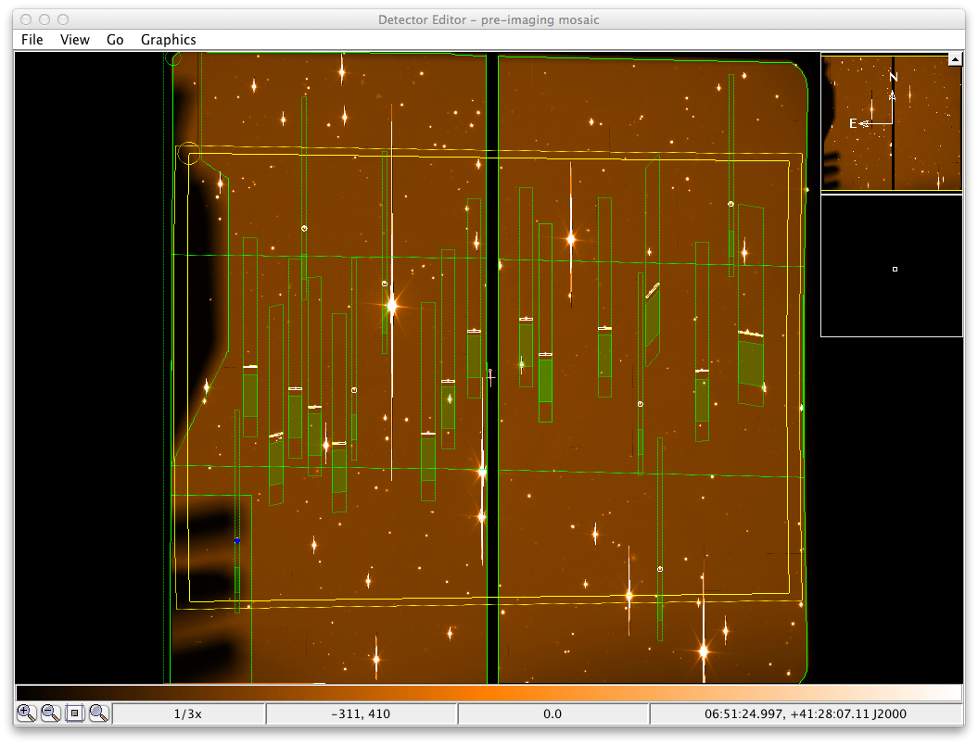

Example of the Detector Editor view.

**Slitlet geometry visualization**  
The abovementioned action buttons allow visualization of the geometry of the slitlets. The visualisation of different aspects of the geometry of the slitlets can be activated, or de-activated using a set of tick boxes labeled *Geoms Activation*.

* *spectra*: shows the projection of the spectra pertaining to the slitlets.
* *wcSlit*: shows possible errors that might occur in the production process of the slitlet according to the manufacturing tollerances of the cutting machine. It allows the user to assess whether there is risk of contamination by nearby targets.
* *slitInTime*: this options show the geometry of the slitlet taking into account the proper motion and atmospheric refraction. This geometry is the basis for the fabrication definition of the slitlet.
* *manufSlit*: slitlets, at the level of the manufacturing machine, are defined as (sets of) rectangles. However, the various transformations imply that switching between coordinate systems the rectangles will become distorted. This options allows the user to see the effects of such distortions and what shape will be sent to the manufacturing machine.
* *minSeparationSlit*: (not activated by default) shows the manufacturing safety margin around the slits.
* *shufflingSpectra*: (not activated by default) in case of shuffling spectra over the detector spectra are displaced over the detector by a certain number of lines before taking another exposure. This option will show where the spectra will fall in order to avoid overlapping the displaced spectra with the actual slitlet spectra. For mask design with many slits it is best to leave this option deactivated in order to improve speed and reduce memory requirements of the program.

**Slitlet details**  
Below the action buttons one finds a box that displays the details of the selected slitlet in three different coordinate systems: the equatorial “sky” coordinates, the physical “mask” coordinates, and the pixel “detector” coordinates. For each set of coordinates its position is shown, the orientation, as well as the range it spans. One can toggle between the two by selecting either “position” or “bounds”.

The position of each slitlet can be edited here in order to make small adjustments, but this should not normally be necessary.

**Slit properties**  
In the upper-right-hand corner of the MD window one finds further details of the slitlet. Apart from the RA and DEC coordinates, one can select or de-select fiducial objects and set the wavelength range that is relevant to this specific slitlet. Setting this overrides the default values that have been defined in the configuration panel (but only within the physical possibilities of the grisms).

**Target details**  
In this last box, at the bottom-right-hand corner of the window, one can edit details of the target that is associated with the slitlet. For instance, proper motion details can be entered here.

At the top of this target box one finds two buttons labeled *tgt -> slit* and *slit -> tgt*. These buttons can be used to quickly move the slit towards the target coordinates after editing those coordinates, and visa-versa.

**Mask editor and visualization windows**  
Three of the abovementioned action buttons open visualization windows where the mask design can be seen. Each slit that is defined is shown in these window, together with the associated band that will be occupied by the spectrum corresponding to the disperive element and wavelength range chosen.

The three windows provide a view of the slits in equatorial sky coordinates for the *Sky Editor*, in detector coordinates for the *Detector Editor*, and in physical mask coordinates for the *Mask Editor*. These windows are interactive to some extend. One can click on a slit upon which it will be highlighted as selected. At the same time on the main window that same slit will be selected and its properties can be selected. Changes in its proporties are instantly reflected in the visualization windows. Conflicting slitlets that are rejected are shown in red.

Through the *Detector Editor*, the *Sky Editor*, and the *Mask Editor* one can also define new slits by double-clicking on the location where you want the slit to be. However, it is advisable to prepare the target list using other tools such as IRAF and importing such list into the MaskDesigner. When using the MaskDesigner visualisation windows to define slits, one must be aware that the definition will be on the basis of the coordinate system relevant for the window (i.e. pixels coordinates for the *Detector Editor*)

**Log window**  
The log window essentially keeps a record of warnings and errors that might come up during the design of a MOS mask.

**Configuring the MD**  
Once a mask design has been initiated, some configuration parameters can be set. Under Options menu one can activate the Project Options window where some details and defaults for the current design can be set. It is useful to keep the default values and to enter the PI name. It is not required to fill in the observation ID as this will be defined by the observatory after the design has been submitted for manufacturing.

Further specific details related to the mask design must be set under Configuration and then selecting Config Obs. Here some basic configuration related to the OSIRIS instrument are set, such as the dispersing element, the detector binning factor, whether the mask design is based on an OSIRIS pre-image or uses a catalogue of equatorial coordinates, etcetera. Details on how this is used is explained in the examples that follow.

In the configuration panel the selected grism (and filter) combination set the spectral range of interest, while date is used to calculate effects of precession and proper motion, while the hour angle is used to calculate the effects of atmospheric refraction. In the case of using a pre-image, the relevant details are taken from this image itself.

The Offset entry allows the user to introduce an offset to the pointing coordinates in order to ensure that in the case of making a sky observation for calibration purposes with the same mask, that no stars by coincidence enter the slits.

When having made changes one has to click the button Commit changes to activate them. This causes to program to re-calculate the current design.

**Configuring the default slit shape**  
When designing a mask, the MD tool assumes a built-in default shape for the slitlets. This default is set in option Config default slits in section of Configuration. In this configuration panel you can set the default type of slitlet being either rectangular, circular, or curved. In this same panel the sizes and relevant wavelength range can be set. These default settings can be overruled for individual slits in the main panel.

**Configuring the spectral range**  
Each slitlet projects a spectrum onto the detector and obviously spectra from slitlets must not overlap or be projected outside the detector. The MaskDesigner tool is set up to detect and prevent overlapping spectra and allows the user to change the slit properties to avoid conflicts. The software also warns the user when spectra fall outside the detector. However, it could happen that the user is only interested in a limited part of the spectrum, in which case it may be acceptable when spectra partly overlap or are projected outside the detector, as long as the interested part remains detectable. Therefore the MD allows the user to specify for each slitlet the wavelength range of interest that the MD will use to detect any conflicts. This information can be set in the section labeled *Spectral Range*. If a same limited range is to be used for all slitlets, it is recommended to first set these default values for the whole project in the *Default slit configuration* window before importing coordinates or otherwise defining slitlets.

[**Back to top**](http://www.gtc.iac.es/instruments/osiris/osirisMOS.php#top)

**iconDesigning MOS masks step-by-step**

There are two distinct starting points when designing and OSIRIS MOS mask: (i) using target coordinates based on pixels of an OSIRIS r’ band image, or (ii) using target coordinates based on equatorial J2000 coordinates. The two options have a distinct treatment and are therefore described separately following specific examples.

[**Back to top**](http://www.gtc.iac.es/instruments/osiris/osirisMOS.php#top)

**iconExample #1: Using a an OSIRIS pre-image**

Using an image taken with OSIRIS as the basis for designing a mask is the easiest and hence prefered method to successfully obtain multiple-object spectra with OSIRIS. This so-called *pre-imaging mode* requires you to have access of an OSIRIS image of the field taken in the Sloan r’ filter and on which your targets can be identified. This image must have exactly the same position and orientation as will be used for the spectroscopic observations; this is essential since the field distortions for OSIRIS are significant and non-symmetric.

An OSIRIS image consists of a mosaic of two CCDs with a gap and a slight shift and rotation between them. In order to measure pixel coordinates first the two CCD images must be combined into a single frame where the pixel coordinates are continuous and geometrically correct by creating an image mosaic. This is accomplished using an IRAF task *mosaic_2x2_v2.cl* that has been written for this purpose and that is made available on the GTC web site.

The [mosaic script](http://www.gtc.iac.es/instruments/osiris/osirisMOS.php#Downloads) can be downloaded [here](http://www.gtc.iac.es/instruments/osiris/osirisMOS.php#Downloads).

It is used in the following way:

* Place the script *mosaic_2x2_v2.cl* into your data directory. Then open IRAF and go to the data directory.
* Load the task into IRAF by typing the following at the IRAF prompt:   
  task $mosaic=mosaic_2x2_v2.cl
* Run the task on your raw image by typing at the IRAF prompt:   
  mosaic 12345.fits where of course the FITS file name must indicate the filename of the input OSIRIS image.

The output file is called *OsirisMosaic.fits* and has a single layer containing the image of both CCDs. This is the FITS file you will be using to determine pixel coordinates of your targets. You can rename this file to anything you like.

From this mosaic FITS image use IRAF or any other tool to identify your targets and measure the targets centroid positions, for instance using the IRAF *imexam* routine with option “r”. (As an alternative, one can use the MaskDesigner tool itself to directly identify targets. This is described further down. However, the preferred and most secure method is what is described here).

Place these positions of all the targets in a text file (alternatively, you can use a spreadsheet tool such as EXCEL and save the file in CSV format) containing the following columns:

1. “img” to indicate pre-imaging-mode;
2. Centroid x-coordinate;
3. Centroid y-coordinate;
4. Proper motion in RA in arcsec/year (no effect in pre-imaging mode);
5. Proper motion in DEC in arcsec/year (no effect in pre-imaging mode);
6. Slit type “R” for rectangular and “C” for circular holes;
7. Angle of the slitlet in degrees;
8. “N” for normal slitlets and “F” for a fiducial alignment target;
9. Priority indication; integer value;
10. A target name (or any other relevant information).

Note that when designing masks using a pre-image the proper motion is ignored by the program. However, since the target files can be used for other future designs, we suggest to detail the proper motions, if they are known, for future reference.

Make sure that you have **at least 3 fiducials targets** (5 or 6 would be optimal), that the fiducials are not too bright nor too faint, as was described earlier, and that they are well distributed over the whole field of OSIRIS, as was described earlier in this document.



Example of a target input list based on detector pixel coordinates.

Now you are ready to start using the Mask Designer tool.

- To start the design, begin with opening a new project by selecting from File → New MDP.

- Setup the global parameters for the project by going to File → Configuration → Config Obs. Select the standard MOS mode, no filter, select the grism you want to use, and set binning to the standard 2x2 pixels (binning 1x1 is not accepted). In the observation details box you select below the question *Use Pre-imaging?*, the option *Use a pre-image* file and you identify the FITS file that must contain the moasic image that you prepared earlier. Ignore the *Telescope Offset* boxes. When you’re done, select Commit changes and save the MDP file.

- Next step is to set up the default slits and fiducial star holes. For that, go to File → Configuration → Config Default Slits where you can proceed to define rectangular slits, circular holes (used for the fiducial alignment stars), and curved slit. (Note that curved slits are not yet supported). For the rectangular holes you can specify the generic size, as well as the typical wavelength range of interest and their generic orientation. Note that in case the field orientation is set at 0 degrees, then the slit angle would normally be set at 90 degrees. These geometric details can later be tuned per slitlet, if necessary. The minimum supported slit width is 1.2 arcsec. Similarly, for circular apertures the diameter can be set. Normally circular apertures are used for the fiducial alignment stars in the field, and hence the tickbox *fiducial* should be activated. The minimum radius for fiducial holes is 2 arcsec. Just close the window after having edited your default values.

All the slits that will be defined now will take as default values of the parameters that you last selected. When you are interactively defining slitlets, to change, for instance, from defining fiducial holes to rectangular slitlets, you need to go back to the configuration panel and change the default to *rectangular*, with the appropriate sizes.

When having configured the setup, it is advised to save the project by selecting File → Save MDP and giving it an appropriate file name.

- Now it’s time lo load the list of coordinates by selecting File → Import targets and selecting the file you prepared. If the software has accepted your file you should see your list of slitlets appear in the table in the MaskDesigner window. The list will show which slitlets refer to fiducial objects or normal targets, and whether the MD software encounters any problems with the design (see the column labeled *valid*). The slitlets that are not considered valid will require further attention. Typical problems that are encountered are overlapping spectra with other slitlets, that the slitlet falls outside the mask, or that its spectral range falls outside the detector. The design can be tuned in order to reduce the conflicts, as will be shown in the next points. When you click on an entry in the list then the numbers in the other panels will display the details referring to the selected slitlet.

- The *Detector Editor* is the most suitable visualisation tool to verify and possibly change the design of the mask made in pre-imaging mode. The *Detector Editor* panel shows the layout of the mask design superimposed on the pre-image mosaic itself, in the pixel coordinate frame. Obviously the targets on the image should align well with the slitlets. Slitlets that for some reason are rejected by the MD tool show up in red.

When clicking on a slitlet in the image, that slitlet entry will be highlighted in the image, and it will be selected in the list of slitlets. Slitlets can also be indentified by their pixel coordinates.

The description of target selection so far has been based on the user having generated a target list prior to using the MaskDesigner tool. As an alternative, object coordinates can also be generated within the MaskDesigner software itself by going to the *Detector Editor* panel and double-clicking on the targets. This automatically centroids the target seen in the image and adds that target to the list with the attributes (slit size and shape, wavelength range, fiducial etc.) as they are set at that moment. This is a very quick and easy method. However, we advise users to generate their coordinate list with trusted and well-known tools such as IRAF.

- Editing the properties of a specific slitlet can simply be accomplished by changing any of the input boxes. First select a slitlet in the list so that its properties will show up and can be edited. For instance, the pixel coordinates may be altered, the slitlet might be given an angle, its size changed, or the wavelength range of interest adapted.

Slitlets may also be deleted from the list by activating the *Delete Slit* button. Or the priority of a slit may be altered so that it is given the approriate weight when the MD tool optimizes the mask design.

Priorities of slitlets are treated by the MD program in the following fashion: in case of conflict between slitlets, the slit with the lowest number remains in the primary mask design, while slits with a high priority index are automatically translated to a secondary mask.

- When you are done with your design, just save the Mask Design Project file by selecting File → Save MDP and giving it an appropriate file name. At a later stage you can reload this file and continue work where you left off.

It is important to note that since the pre-image design essentially deals with translating detector pixel coordinates to mask coordiantes, no account is made for atmospheric refraction. Nor is proper motion of the objects accounted for; the image is assumed to correctly represent the actual sky.

[**Back to top**](http://www.gtc.iac.es/instruments/osiris/osirisMOS.php#top)

**iconExample #2: Using equatorial coordinates**

This second example has much in common with the previous one, except for the initial coordinates provided for the slitlets. When you possess a set of accurate J2000 equatorial coordinates of your targets and fiducial stars you can input this list directly into the MaskDesigner tool and from there work to refine your mask design. The MD allows you, with its *Sky Editor* view to overlay your mask design on an image which has its astrometry well calibrated.

An important difference when working with equatorial coordinates as opposed to using a pre-image is that in translating the J2000 input coordinates on the sky to the mask coordinates, precession, atmospheric refraction and proper motion are taken into account.

Before starting the design of a mask one has to prepare a target list with accurate coordinates. This target list should include not only the science targets, but also the fiducial stars. Make sure that you have at least 3 fiducials (5 or 6 would be optimal), that the fiducials are not too bright nor too faint, as was described earlier, and that they are well distributed over the whole field of OSIRIS.

Place the coordinates of all the targets in a text file (alternatively, you can use a spreadsheet tool such as EXCEL and save the file in CSV format) containing the following columns:

1. “sky” or “skyDeg”, depending on the format of the coordinates (see next points);
2. Centroid RA coordinate (J2000). The format is either in hours HH:MM:SS.ssss or DDD.ddddddd, respectively, depending on the entry in the first point;
3. Centroid DEC coordinate (J2000). The format is either in hours +/-DD:MM:SS.sss or +/-DD.ddddddd, respectively, depending on the entry in the first point;
4. Proper motion in RA in arcsec/year;
5. Proper motion in DEC in arcsec/year;
6. Slit type “R” for rectangular and “C” for circular holes;
7. Angle of the slitlet in degrees;
8. “N” for normal slitlets and “F” for a fiducial alignment target;
9. Priority indication; integer value;
10. A target name (or any other relevant information).

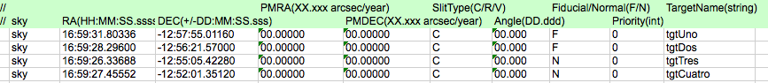

Example of a target input list based on equatorial coordinates.

In what follows the basic steps are described about what one needs to do with the MaskDesigner tool.

- To start the design, begin with opening a new project by selecting from the File → New MDP.

- Setup the global parameters for the project by going to File → Configuration → Config Obs. Select the standard MOS mode, no filter, select the grism you want to use, and set binning to the standard 2x2 pixels (binning 1x1 is not accepted). In the observation details box you select, below the question *Use Pre-imaging?*, the option *Don’t use it (catalog)*.

Fill in the correct RA, DEC and orientation that must correspond with the center of the OSIRIS field of view, i.e. corresponding to the center of the mask. An orientation angle of zero degrees will imply that North is at the top and East is towards the left of the *Sky Editor* and the *Detector Editor* views.

Although the MaskDesigner tool allows for the design at any orientation, GRANTECAN only accepts mask that are either oriented N-S or E-W. Our advice is that for fields to be observed close to the meridian without being affected by the dome shutter limitation (vignetting for elevations above 72 degrees) the slits are best oriented in the North-South direction. However, fields that pass close to the zenith and will be affected by the dome shutter, i.e. declinations between approximately 10 and 47 degrees, the slit orientation is best placed East-West, so that the field can be observed with the same mask both when the field is rising and when it is setting, since the slits will remain reasonably close to the parallactic angle.

In the Box labeled *Date System* fill in the optimal date and hour angle for the observation. These details are relevant to correct for precession, proper motions, and atmospheric refraction. Hence the MaskDesigner automatically corrects for these effects and ensures that the physical location of the slitlets will be correct. In case of doubt, selecting and hour angle of 0 is normally a good choice. (Note that the slit angle is defined in sky coordinates, independent of the instrument orientation).

Ignore the *Telescope Offset* boxes. When you’re done, hit Commit changes and save the MDP file.

- Next step is to set up the default slits and fiducial star holes. For that, go to File → Configuration → Config Default Slits where you can proceed to define rectangular slits, circular holes (used for the fiducial alignment stars), and curved slit. (Note that curved slits are not yet supported). For the rectangular holes you can specify the generic size, as well as the typical wavelength range of interest and their generic orientation. If the field orientation is set at 0 degrees, then the slit angle would normally be set at 90 degrees. These geometric details can later be tuned per slitlet, if necessary. The minimum supported slit width is 1.2 arcsec. Similarly, for circular apertures the diameter can be set. Normally circular apertures are used for the fiducial alignment stars in the field, and hence the tickbox fiducial should be activated. The minimum radius for fiducial holes is 2 arcsec. Just close the window after having edited your default values.

- Now it’s time lo load the list of coordinates by selecting File → Import targets and selecting the file you prepared. If the software has accepted your file you should see your list of slitlets appear in the table in the MaskDesigner window. The list will show which slitlets refer to fiducial objects or normal targets, and whether the MD software encounters any problems with the design (see the column labeled valid). The slitlets that are not considered valid will require further attention. Typical problems that are encountered are overlapping spectra with other slitlets, that the slitlet falls outside the mask, or that the spectral range falls outside the detector. The design can be tuned in order to reduce the conflicts, as will be shown in the next points. If you click on an entry in the list then the numbers in the other panels will display the details refering to the selected slitlet.

- The *Sky Editor* is the most suitable visualisation tool to verify the mask design as it projects the slitlets in the same equatorial coordinate frame as was used to define your targets. Slits and the spectral projection might look curved and distorted, which is due to the projection of rectangular outlines on the equatorial coordinate grid. The *Sky Editor* allows you to load images and catalogues. For instance, to overlay an image of the Digital Sky Survey, in the *Sky Editor* panel go to Catalog → Image Servers → Digitized Sky (Version II) at ESO and select the appropriate field (of course for this example you need to be connected to the internet in order to access the on-line catalogues). The DSS image will appear together with your design and if all is well your slitlets should align well with the targets in the image. Slitlets that for some reason are rejected by the MD tool show up in red.

- Editing the properties of a specific slitlet can simply be accomplished by changing any of the input boxes. First select a slitlet in the list. Its properties will then show up and can be edited. For instance, the coordinates may be altered, the slitlet might be given an angle, its size changed, or the wavelength range of interest adapted.

In the box labeled “Target” the proper motion of the target may be set or alterted. The MaskDesigner calculates the movement for the epoch 2000 coordinates to the observing date set in the configuration.

Slitlets may also be deleted from the list by activiting the *Delete Slit* button. Or the priority of a slit may be altered so that it is given the approriate weight when the MD tool optimizes the mask design.

- When you are done with your design, just save the Mask Design Project file by selecting File → Save MDP and giving it an appropriate file name. At a later stage you can reload this file and continue work where you left off.

[**Back to top**](http://www.gtc.iac.es/instruments/osiris/osirisMOS.php#top)

**iconDownloads**

This section contains download link for MOS-related tools.

-1- [Mosaic tool](http://www.gtc.iac.es/instruments/osiris/media/mosaic_v2.zip) (version 2, for observations from semester 2014A onwards) to create a single image for the two OSIRIS CCDs, that present the correct physical geometry.

-2- [Mask Designer tool](http://www.gtc.iac.es/instruments/osiris/media/maskDesigner_v325.zip) (version 3.25, for observations from semester 2014A onwards) to design a multi-object mask to be used with OSIRIS.

[**Back to top**](http://www.gtc.iac.es/instruments/osiris/osirisMOS.php#top)

*Last modified: 15 January 2016*

© **GRANTECAN S.A.** Cuesta de San José, s/n -  
38712 - Breña Baja - La Palma, España  
Teléfono: +34 922 425 720 | Fax: +34 922 425 725  
e-mail: gtc [at] gtc.iac.es

[Enlace al FEDER](http://ec.europa.eu/regional_policy/thefunds/regional/index_en.cfm)[Enlace al MEC](http://www.micinn.es/)[Enlace a Gobierno de Canarias](http://www.gobiernodecanarias.org/)[Enlace al IAC](http://www.iac.es/)[Enlace al IA - UNAM](http://www.astroscu.unam.mx/)[Enlace al INAOE](http://www.inaoep.mx/)[Enlace al UF](http://www.astro.ufl.edu/)

[aviso legal](http://www.gtc.iac.es/gtc/legal_es.php)