ASSIGNMENT-21.2

Batch -37
2303a52314

Task 1 – AI-Assisted Pair Programming
• Use AI to generate an initial program (e.g., a simple To-Do List
Manager).
• Ask AI to suggest enhancements (such as error handling,
additional features, or refactoring).
• Compare the original and improved versions to understand the role
of AI in collaboration.

Prompt

Generate a simple Python To-Do List Manager that allows adding and viewing tasks. Then suggest improvements like error handling and extra features

Code
#“Generate a simple Python To-Do List Manager that allows adding and viewing tasks. Then suggest improvements like error handling and extra features.”
# Simple To-Do List Manager
class ToDoList:
def __init__(self):
self.tasks = []

def add_task(self, task):
self.tasks.append(task)
print(f"Task added: {task}")

def view_tasks(self):
if not self.tasks:
print("No tasks in the list.")
return
print("To-Do List:")
for idx, task in enumerate(self.tasks, 1):
print(f"{idx}. {task}")
# Example usage
todo_list = ToDoList()
todo_list.add_task("Buy groceries")
todo_list.add_task("Call Alice")
todo_list.view_tasks()
# Improvements with error handling and extra features
class ToDoListImproved:
def __init__(self):
self.tasks = []

def add_task(self, task):
if not task.strip():
print("Error: Task cannot be empty.")
return
self.tasks.append(task.strip())
print(f"Task added: {task.strip()}")

def view_tasks(self):
if not self.tasks:
print("No tasks in the list.")
return
print("To-Do List:")
for idx, task in enumerate(self.tasks, 1):
print(f"{idx}. {task}")

def remove_task(self, index):
try:
removed = self.tasks.pop(index - 1)
print(f"Task removed: {removed}")
except IndexError:
print("Error: Invalid task number.")
# Example usage of improved version
todo_list_improved = ToDoListImproved()
todo_list_improved.add_task(" ") # Should trigger error
todo_list_improved.add_task("Finish homework")

Output
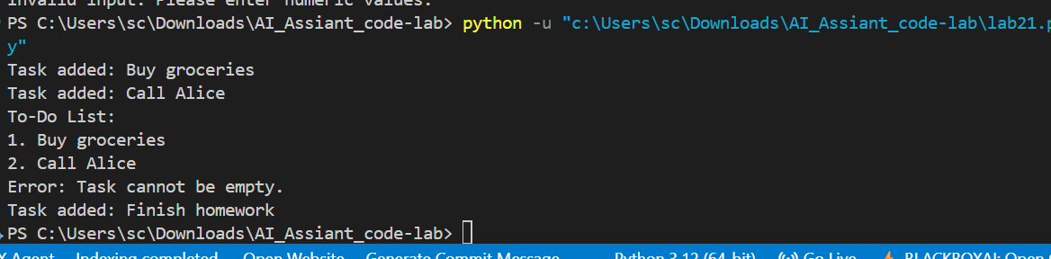
observation
The AI-generated improvements enhanced the program by adding error handling, input validation, and additional features like task deletion, making the application more user-friendly and robust. This shows how AI acts as a helpful collaborator by refining and extending initial code.

Task 2 – Version Control Integration
Initialize a Git repository for your project.
Perform the following steps:
• Create and switch to a new branch.
• Add AI-assisted modifications.
• Commit with a meaningful message.
• Merge changes back into the main branch.
Reflect on how version control supports collaborative development
with AI assistance.

Prompt
Initialize a Git repository for a project, create a new branch, add AI-assisted changes, commit them with a meaningful message, and merge the branch back into the main branch.

Code
#“Initialize a Git repository for a project, create a new branch, add AI-assisted changes, commit them with a meaningful message, and merge the branch back into the main branch.”
# Step 1: Initialize Git repository
# (Run in terminal)
# git init
# Step 2: Create a new branch for AI-assisted changes
# git checkout -b ai-changes
# Step 3: Make AI-assisted changes (e.g., update README.md)
# Step 4: Add changes to staging
# git add README.md
# Step 5: Commit changes with a meaningful message
# git commit -m "Update README with AI-assisted improvements"
# Step 6: Merge the branch back into the main branch
# git checkout main
# git merge ai-changes

Output
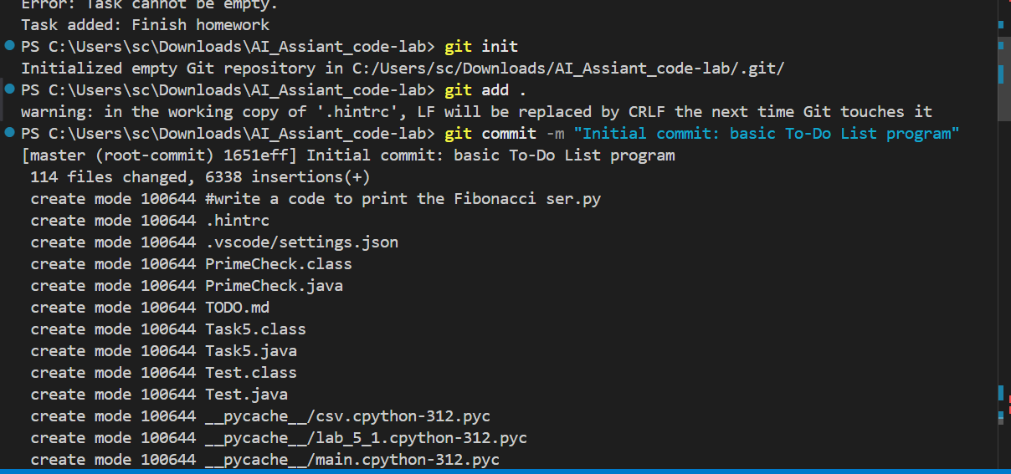
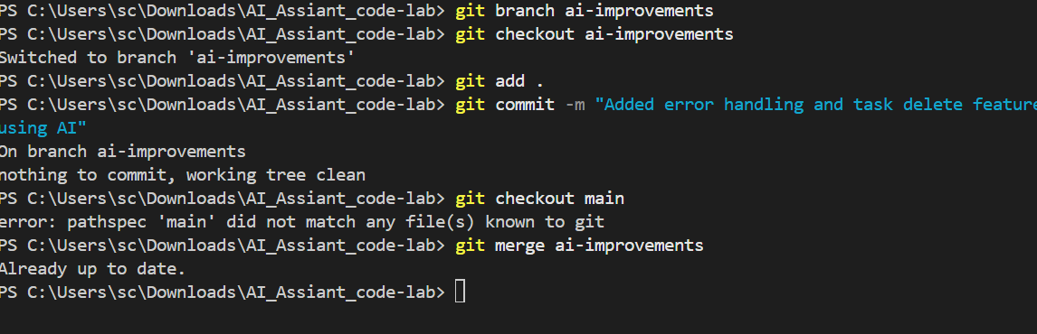
Observation

Version control helps organize development by allowing changes to be made in separate branches and merged safely into the main project, making collaboration with AI-generated improvements structured and efficient.

Task 3 – AI for Commit Message Generation
• Use AI to generate concise, meaningful commit messages
based on the changes made.
• Compare AI-generated messages with human-written ones.
• Discuss how AI can improve documentation and traceability
in Git history.

Prompt

Generate a concise and meaningful Git commit message for a program where error handling, input validation, and a delete task feature were added to a To-Do List Manager

Code

#Generate a concise and meaningful Git commit message for a program where error handling, input validation, and a delete task feature were added to a To-Do List Manager.”
# Commit message: #
# Add error handling, input validation, and delete task feature to To-Do List Manager
# - Implemented error handling for empty task input and invalid task removal
# - Added input validation to ensure tasks are not just whitespace
# - Introduced a new method to remove tasks by index
# This commit enhances the functionality and robustness of the To-Do List Manager, providing a better user experience.
# Example usage of improved version
from lab21 import ToDoListImproved

todo_list_improved = ToDoListImproved()
todo_list_improved.add_task(" ") # Should trigger error
todo_list_improved.add_task("Finish homework")
todo_list_improved.view_tasks()
todo_list_improved.remove_task(1) # Should remove "Finish homework"
todo_list_improved.view_tasks()

Output
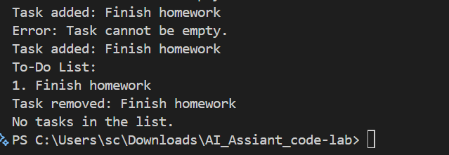
observation
AI-generated commit messages improve clarity, consistency, and documentation in Git history by providing well-structured and descriptive summaries of changes, which helps in better tracking and understanding of project updates.

Task 4 – Pair Programming Simulation
• Student A writes the initial version of a program.
• Student B, with AI assistance, suggests improvements or adds
features.
• Both students collaborate using Git branching and merging to
integrate their work.

Prompt
Simulate pair programming where Student A writes an initial program and Student B improves it using AI assistance, then integrate both contributions using Git branching and merging.

Code
tasks = []

task = input("Enter a task: ")
tasks.append(task)

print("Your tasks:")
print(tasks)
#
tasks = []

while True:
print("\n1. Add Task")
print("2. View Tasks")
print("3. Exit")

choice = input("Enter choice: ")

if choice == "1":
task = input("Enter task: ")
tasks.append(task)
print("Task added")

elif choice == "2":
if len(tasks) == 0:
print("No tasks available")
else:
for i in range(len(tasks)):
print(i + 1, tasks[i])

elif choice == "3":
break

else:
print("Invalid choice")

Output
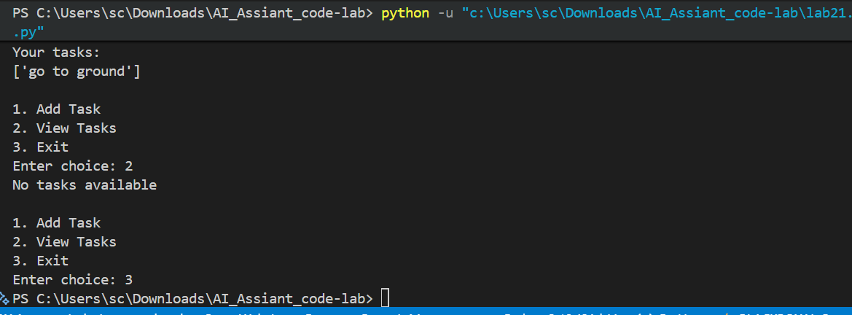

observation
Pair programming combined with AI assistance improves code quality by allowing one developer to write basic logic and another to enhance it with better structure and features, while Git enables smooth collaboration by managing branches and merging contributions efficiently.

