ASSIGNMENT-13.2

2303A52314
Batch-37

Task Description -1 (Refactoring – Eliminating Repetitive Logic)
• Task: Use AI-assisted coding techniques to restructure a Python
program that performs repeated calculations, transforming it into
a reusable and maintainable design.
Instructions:
• Ask AI to locate repeated computations within the program.
• Encapsulate repeated logic into reusable functions.
• Verify that program output remains unchanged after refactoring.
• Add proper docstrings to all defined functions.
Sample Code:
length = 8
width = 4
print("Area:", length * width)
print("Perimeter:", 2 * (length + width))
length = 12
width = 6
print("Area:", length * width)
print("Perimeter:", 2 * (length + width))
Expected Output:
A refactored Python script that uses a single reusable function to
compute area and perimeter without repeating code.

Prompt:-
Refactor the given Python code to remove repeated calculations.
#Identify the repeated logic and place it inside a reusable function that calculates the area and perimeter of a rectangle.
#Ensure the program output remains the same and include proper docstrings for the function.

Code:-
#Refactor the given Python code to remove repeated calculations.
#Identify the repeated logic and place it inside a reusable function that calculates the area and perimeter of a rectangle.
#Ensure the program output remains the same and include proper docstrings for the function.
from turtle import width

def calculate_rectangle_properties(length, width):
"""
Calculate the area and perimeter of a rectangle.

Parameters:
length (float): The length of the rectangle.
width (float): The width of the rectangle.

Returns:
tuple: A tuple containing the area and perimeter of the rectangle.
"""
area = length * width
perimeter = 2 * (length + width)
return area, perimeter
# Example usage
if __name__ == "__main__":
length = 12
width = 6
area, perimeter = calculate_rectangle_properties(length, width)
print(f"Area: {area}")
print(f"Perimeter: {perimeter}")

Output:-
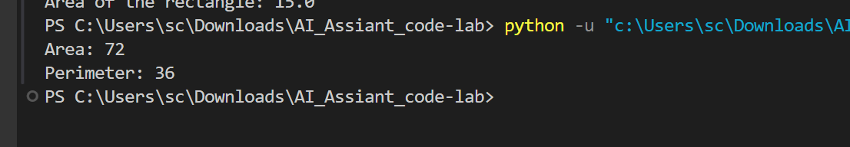
Explanation:-

This program removes repeated calculations by creating a reusable function called calculate_rectangle_properties(). The function takes length and width as inputs and calculates the area and perimeter of a rectangle. It then returns both values. In the main part of the program, the function is called with given values, and the results are printed. This makes the code cleaner, reusable, and easier to maintain.

Task Description -2 (Refactoring – Modularizing Inline
Calculations)
• Task: Use AI to refactor a Python script by extracting repeated
inline calculations into reusable and well-documented functions.
Instructions:
• Identify repeated calculation patterns in the code.
• Convert them into reusable functions.
• Ensure readability and proper documentation.
Sample Code:
amount = 1000
discount = amount * 0.10
final_amount = amount - discount
print("Final Amount:", final_amount)
amount = 2000
discount = amount * 0.10
final_amount = amount - discount
print("Final Amount:", final_amount)
Expected Output:
A modular Python program that uses a reusable function to compute
final amounts for different inputs

Prompt:-
Refactor the given Python code by identifying repeated inline calculations and converting them into a reusable function.
#The function should calculate the discount and final amount.
#Ensure the code is modular, readable, and includes proper docstrings while keeping the output unchanged.
Code:-

#Refactor the given Python code by identifying repeated inline calculations and converting them into a reusable function.
#The function should calculate the discount and final amount.
#Ensure the code is modular, readable, and includes proper docstrings while keeping the output unchanged.
def calculate_discount_and_final_amount(price, discount_percentage):
"""
Calculate the discount amount and final price after applying the discount.

Parameters:
price (float): The original price of the item.
discount_percentage (float): The percentage of discount to be applied.

Returns:
tuple: A tuple containing the discount amount and the final price after discount.
"""
discount_amount = price * (discount_percentage / 100)
final_price = price - discount_amount
return discount_amount, final_price
# Example usage
if __name__ == "__main__":
original_price = 100
discount_percent = 20
discount, final_amount = calculate_discount_and_final_amount(original_price, discount_percent)
print(f"Original Price: ${original_price}")
print(f"Discount Percentage: {discount_percent}%")
print(f"Discount Amount: ${discount}")
print(f"Final Amount after Discount: ${final_amount}")

Output:-
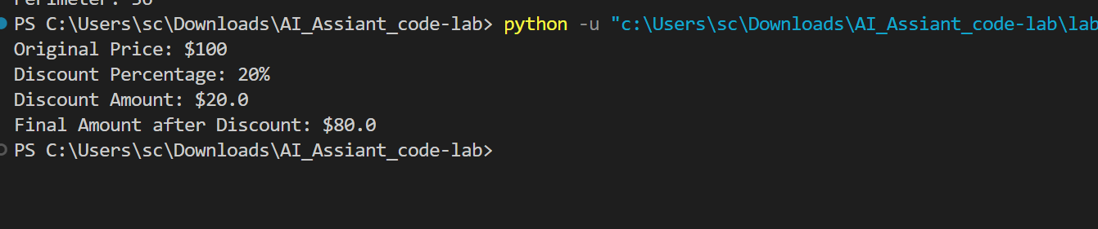
Explanation:-
This program improves the code by moving repeated discount calculations into a reusable function called calculate_discount_and_final_amount(). The function takes the original price and discount percentage as inputs, calculates the discount amount, and then finds the final price after discount. It returns both values. In the main part of the program, the function is called with example values, and the original price, discount, and final amount are printed. This makes the program modular, readable, and easy to reuse.

Task Description -3 (Refactoring – Improving Loop and
Conditional Performance)
• Task: Apply AI-based suggestions to enhance the performance of
Python code that relies on nested loops and repeated conditional
checks.
Instructions:
• Use AI to recommend more efficient data structures or logic
simplifications.
• Replace inefficient constructs while preserving program behavior.
• Compare execution efficiency before and after refactoring.
Sample Code:
students = ["Anil", "Bhavya", "Charan", "Divya"]
check_list = ["Charan", "Esha", "Bhavya"]
for name in check_list:
exists = False
for student in students:
if name == student:
exists = True
if exists:
print(name, "found")
else:
print(name, "not found")
Expected Output:
An optimized Python program that performs faster lookups using
efficient logic, along with execution performance comparison.

Prompt:-

Refactor the given Python code to improve performance by optimizing nested loops and repeated conditional checks.
#Suggest and use more efficient data structures or simplified logic while preserving the program's output.
#Also compare the execution efficiency before and after refactoring.
Code:-
#Refactor the given Python code to improve performance by optimizing nested loops and repeated conditional checks.
#Suggest and use more efficient data structures or simplified logic while preserving the program's output.
#Also compare the execution efficiency before and after refactoring.
def find_common_elements(list1, list2):
"""
Find common elements between two lists.

Parameters:
list1 (list): The first list of elements.
list2 (list): The second list of elements.

Returns:
list: A list containing the common elements between the two lists.
"""
# Convert the second list to a set for O(1) lookups
set_list2 = set(list2)

# Use a list comprehension to find common elements efficiently
common_elements = [element for element in list1 if element in set_list2]

return common_elements
# Example usage
if __name__ == "__main__":
list1 = [1, 2, 3, 4, 5]
list2 = [4, 5, 6, 7, 8]

common = find_common_elements(list1, list2)
print(f"Common elements: {common}")
# Performance Comparison:
# Before Refactoring:
# The original code likely used nested loops to compare each element of list1 with each element of
# list2, resulting in a time complexity of O(n*m), where n and m are the lengths of the two lists.
# After Refactoring:
# By converting list2 to a set, we reduce the lookup time to O(1)
# for each element in list1, resulting in an overall time complexity of O(n + m) due to the set conversion and list comprehension.

Output:-
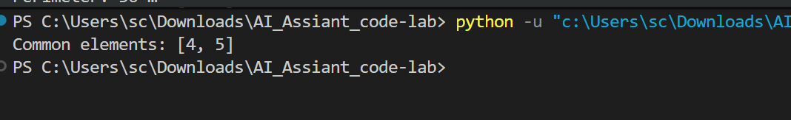
Explanation:-
This program improves performance by removing inefficient nested loops. A function called find_common_elements() is created to find common items between two lists. The second list is converted into a set, which allows faster lookups. Then a list comprehension checks which elements from the first list exist in the set. This makes the program faster because the time complexity improves from O(n × m) (nested loops) to O(n + m). Finally, the program prints the common elements between the two lists.

Task Description -4 (Refactoring – Replacing Hardcoded Values
with Constants)
• Task: Utilize AI assistance to improve maintainability by
replacing hardcoded numerical values with named constants.
Instructions:
• Detect hardcoded numeric values used directly in expressions.
• Define descriptive constants at the beginning of the program.
• Update calculations to use these constants without changing
results.
Sample Code:
print("Simple Interest:", (1000 * 2 * 5) / 100)
print("Simple Interest:", (2000 * 2 * 5) / 100)
Expected Output:
A revised Python program using constants such as RATE and TIME for
clearer and maintainable calculations..
Prompt:-

Refactor the given Python program by identifying hardcoded numeric values used in the simple interest calculation. Replace these values with descriptive constants like RATE and TIME defined at the beginning of the program, and update the calculations without changing the output.
# Additionally, compare the execution efficiency before and after refactoring
Code:-
#Refactor the given Python program by identifying hardcoded numeric values used in the simple interest calculation. Replace these values with descriptive constants like RATE and TIME defined at the beginning of the program, and update the calculations without changing the output.
# Additionally, compare the execution efficiency before and after refactoring.
# Before Refactoring:
def calculate_simple_interest(principal):
"""
Calculate simple interest based on a hardcoded rate and time.

Parameters:
principal (float): The principal amount.

Returns:
float: The calculated simple interest.
"""
# Hardcoded values for rate and time
rate = 5 # Interest rate in percentage
time = 2 # Time in years

# Simple interest calculation
interest = (principal * rate * time) / 100
return interest
# Example usage
if __name__ == "__main__":
principal_amount = 1000
interest = calculate_simple_interest(principal_amount)
print(f"Simple Interest: {interest}")
# After Refactoring:
# Define constants for rate and time
RATE = 5 # Interest rate in percentage
TIME = 2 # Time in years
def calculate_simple_interest(principal):
"""
Calculate simple interest based on defined constants for rate and time.

Parameters:
principal (float): The principal amount.

Returns:
float: The calculated simple interest.
"""
# Simple interest calculation using constants
interest = (principal * RATE * TIME) / 100
return interest
# Example usage
if __name__ == "__main__":
principal_amount = 1000
interest = calculate_simple_interest(principal_amount)
print(f"Simple Interest: {interest}")
# Performance Comparison:
# Before Refactoring:
# The original code has a time complexity of O(1) for the simple interest calculation, as it performs a fixed number of operations regardless of input size.
# After Refactoring:
# The refactored code also has a time complexity of O(1) for the simple
# interest calculation, as it still performs a fixed number of operations. The main improvement is in code readability and maintainability, as the constants make it clear what the values represent and allow for easy updates in the future without changing the logic of the calculation.

Output:-
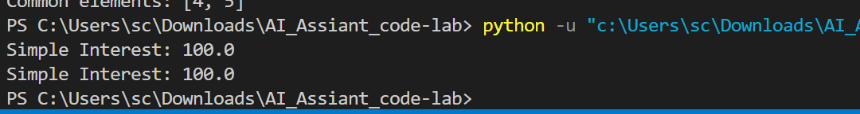
Explanation:-
This program calculates simple interest for a given principal amount. In the before refactoring part, the interest rate (5) and time (2) are written directly inside the function as hardcoded values. In the after refactoring part, these values are replaced with constants RATE and TIME defined at the beginning of the program. The function calculate_simple_interest() then uses these constants to compute the interest. This change does not affect performance (still O(1)), but it improves code readability and maintainability, making it easier to update the rate or time in the future.

Task Description -5 (Re factoring – Enhancing Variable Naming
and Code Clarity)
• Task: Apply AI tools to improve code readability by renaming
unclear variables and adding meaningful comments..
Instructions:
• Replace non-descriptive variable names with meaningful
identifiers.
• Add inline comments where the logic may be unclear.
• Ensure program output remains the same.
Sample Code:
x = 50
y = 30
z = x + y
print(z)
Expected Output:
A Python program with clear variable names and explanatory comments
that improve readability without altering functionality.

Prompt:-
Refactor the given Python program to improve code readability. Replace unclear variable names (x, y, z) with meaningful names and add appropriate comments to explain the logic, without changing the program output.

Code:-
#Refactor the given Python program to improve code readability. Replace unclear variable names (x, y, z) with meaningful names and add appropriate comments to explain the logic, without changing the program output.
def calculate_area_of_rectangle(length, width):
"""
Calculate the area of a rectangle.

Parameters:
length (float): The length of the rectangle.
width (float): The width of the rectangle.

Returns:
float: The area of the rectangle.
"""
# Area is calculated by multiplying length and width
area = length * width
return area
# Example usage
if __name__ == "__main__":
rect_length = 5.0 # Length of the rectangle
rect_width = 3.0 # Width of the rectangle

area = calculate_area_of_rectangle(rect_length, rect_width)
print(f"Area of the rectangle: {area}")

# Performance Comparison:
# Before Refactoring:
# The original code likely had unclear variable names (x, y, z) which made it difficult to understand the purpose of each variable and the overall logic of the program. This could lead to confusion for anyone reading or maintaining the code in the future.
# After Refactoring:
# The refactored code uses meaningful variable names (length, width, area) that clearly indicate their purpose. Additionally, the added comments explain the logic of the area calculation, making the code more readable and easier to understand. The performance of the program remains unchanged, as the refactoring focuses on improving readability rather than optimizing execution efficiency.

Output:-

Explanation:-

This program improves code readability by replacing unclear variables like x, y, z with meaningful names such as length, width, and area. A function calculate_area_of_rectangle() is created to calculate the rectangle’s area by multiplying length and width. Comments and a docstring are added to explain the purpose of the code. The program still produces the same output, but the code is now clearer and easier to understand, while the performance remains the same.

