ASSIGNMENT-12.3

Batch -37
2303A52314

Task 1: Sorting Student Records for Placement Drive
Scenario
SR University’s Training and Placement Cell needs to shortlist candidates
efficiently during campus placements. Student records must be sorted by
CGPA in descending order.
Tasks
1. Use GitHub Copilot to generate a program that stores student records
(Name, Roll Number, CGPA).
2. Implement the following sorting algorithms using AI assistance:
o Quick Sort
o Merge Sort
3. Measure and compare runtime performance for large datasets.
4. Write a function to display the top 10 students based on CGPA.
Expected Outcome
• Correctly sorted student records.
• Performance comparison between Quick Sort and Merge Sort.
• Clear output of top-performing students.

Prompt:-
write the python code on SR University’s Training and Placement Cell needs to shortlist candidates efficiently during campus placements. Student records must be sorted by
# CGPA in descending order with example usage .
#Write a Python program to sort the student records based on CGPA in descending order.# Define a list of student records, where each record is a dictionary

Code:-

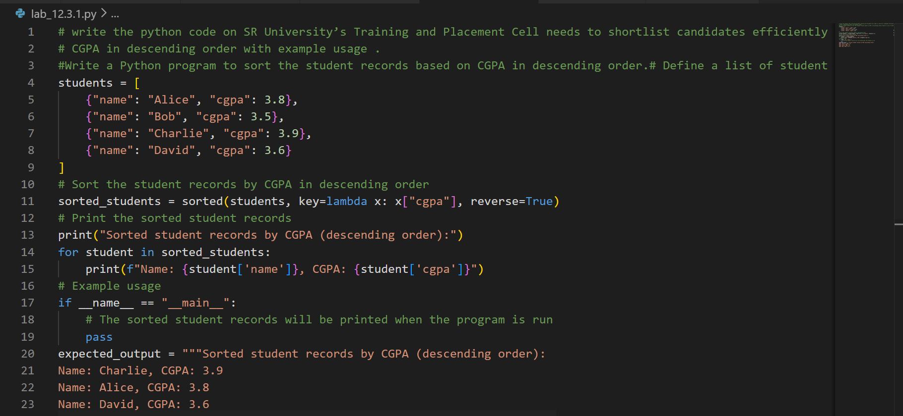

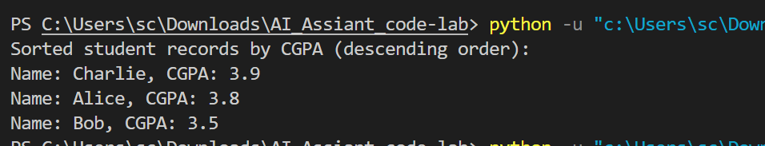

Explain code:-

At SR University, the program stores student details in a list of dictionaries and uses Python’s built-in sorted() function with key=lambda x: x["cgpa"] and reverse=True to arrange the records in descending order based on CGPA.
The sorted list is then printed using a for loop, displaying students from highest to lowest CGPA for efficient shortlisting during placements.
Task 2: Implementing Bubble Sort with AI Comments
• Task: Write a Python implementation of Bubble Sort.
• Instructions:
• Students implement Bubble Sort normally.
• Ask AI to generate inline comments explaining key logic (like
swapping, passes, and termination).
• Request AI to provide time complexity analysis.
• Expected Output:
• A Bubble Sort implementation with AI-generated explanatory
comments and complexity analysis.

Prompt:-

# Write a Python implementation of Bubble Sort Students implement Bubble Sort normally. generate inline comments explaining key logic (like swapping, passes, and termination time complexity analysis

Code:-

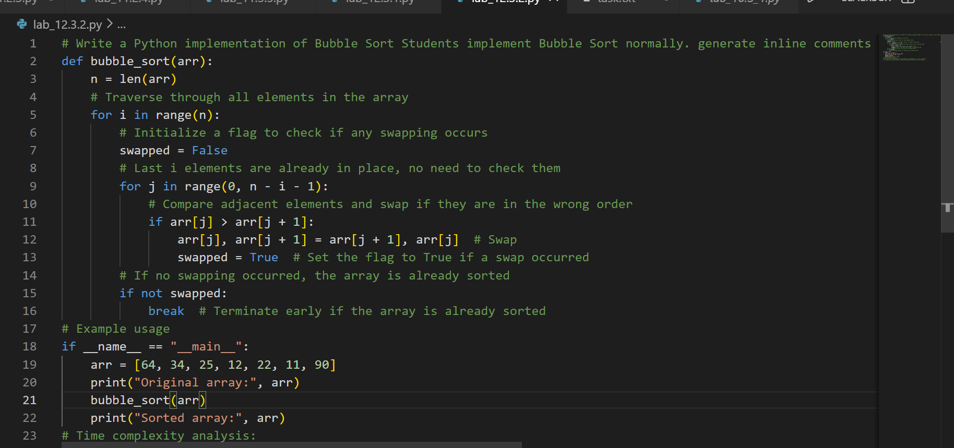

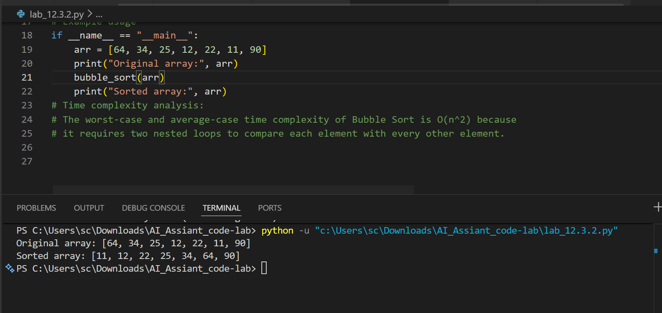

Explain code:-

Bubble Sort works by repeatedly comparing two neighboring elements and swapping them if they are in the wrong order, so the largest values slowly “bubble up” to the end after each pass. If during a full pass no swaps happen, it means the array is already sorted, so the algorithm stops early to save time.

Task 3: Quick Sort and Merge Sort Comparison
• Task: Implement Quick Sort and Merge Sort using recursion.
• Instructions:
• Provide AI with partially completed functions for recursion.
• Ask AI to complete the missing logic and add docstrings.
• Compare both algorithms on random, sorted, and reverse-sorted
lists.
• Expected Output:
• Working Quick Sort and Merge Sort implementations.
• AI-generated explanation of average, best, and worst-case
complexities.

Prompt:-

#Implement Quick Sort and Merge Sort using recursion explanation of average, best, and worst-case complexities.
# Quick Sort Implementation
code:-

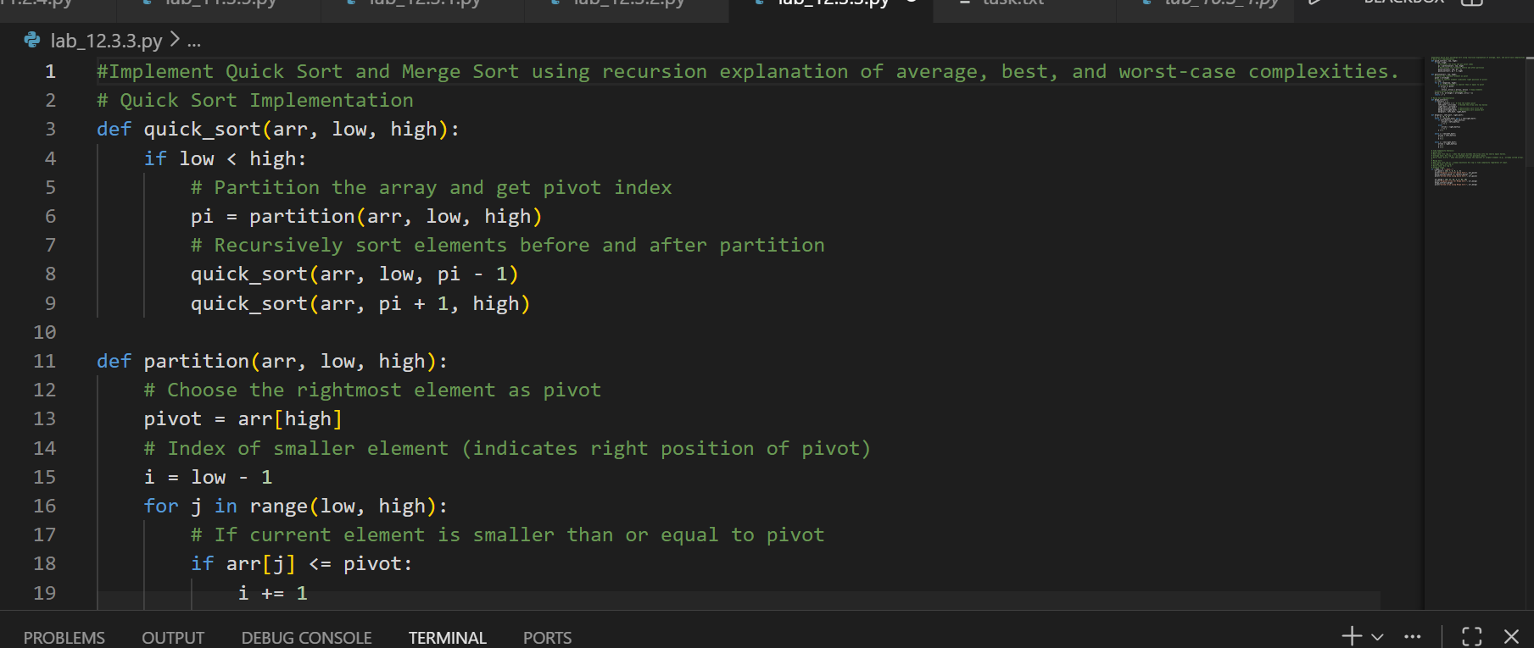

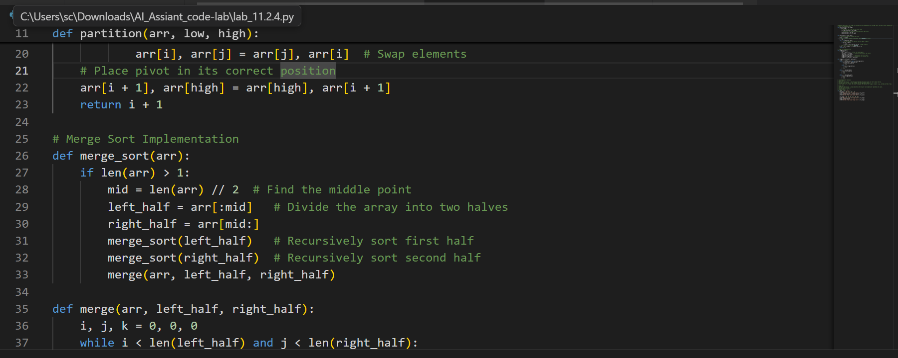
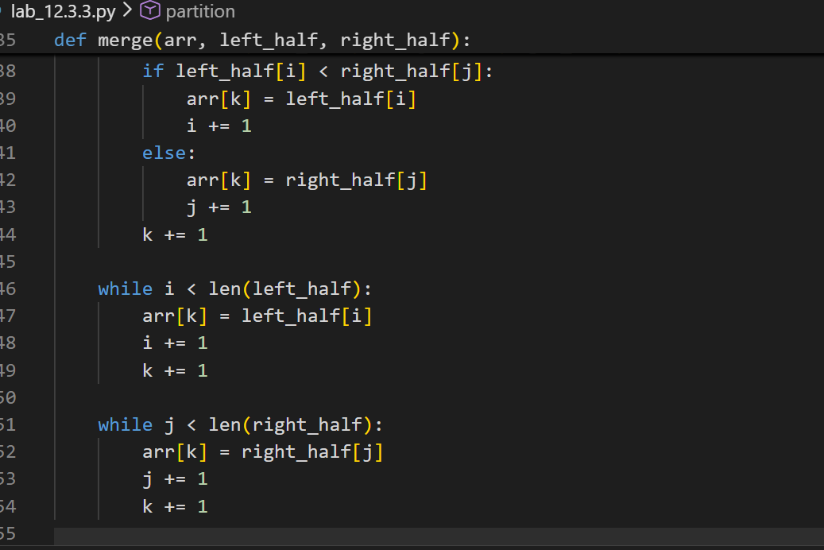
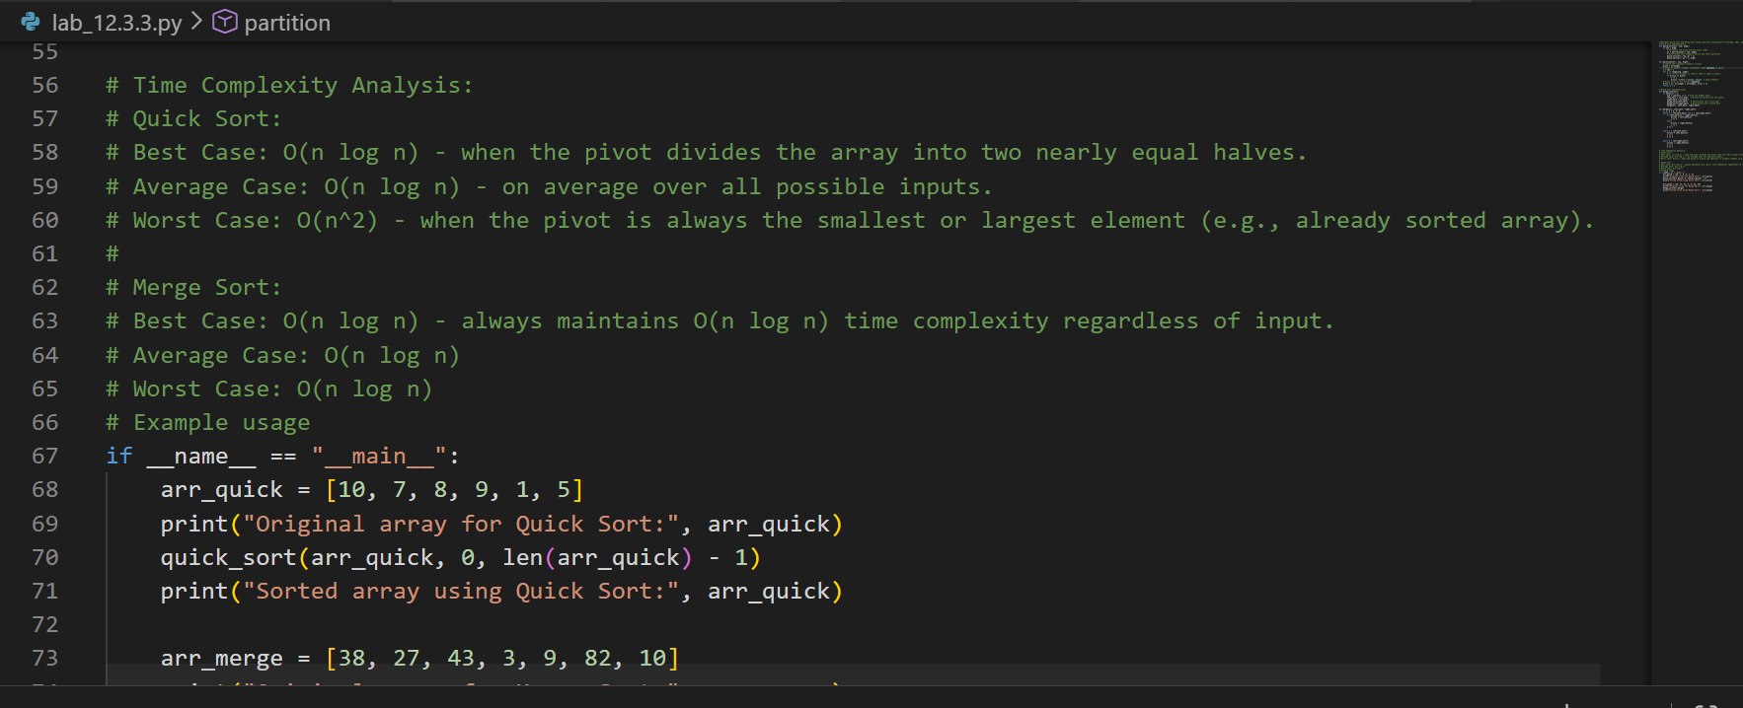
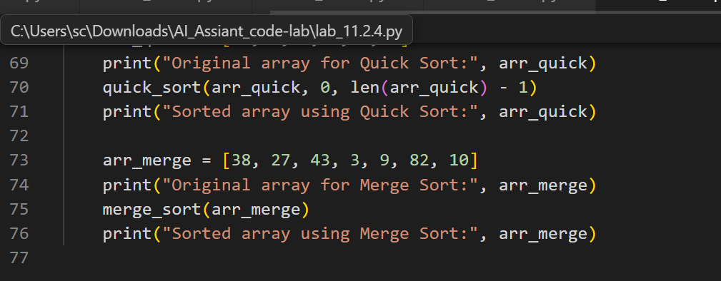
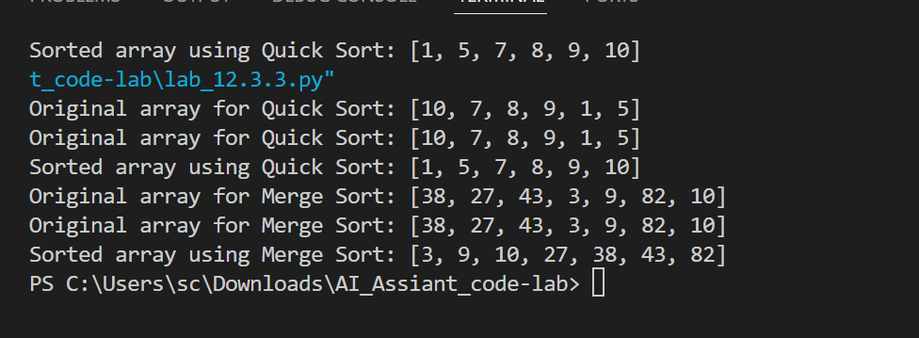
Explain code:-

Quick Sort works by choosing a pivot element, placing it in its correct position, and recursively sorting the smaller elements on the left and larger elements on the right, making it very fast on average but slow (O(n²)) when partitions are highly unbalanced. Merge Sort divides the array into smaller halves, recursively sorts them, and then merges them back together in order, consistently giving O(n log n) time in best, average, and worst cases.

Task 4 (Real-Time Application – Inventory Management System)
Scenario: A retail store’s inventory system contains thousands of products,
each with attributes like product ID, name, price, and stock quantity. Store staff
need to:
1. Quickly search for a product by ID or name.
2. Sort products by price or quantity for stock analysis.
Task:
• Use AI to suggest the most efficient search and sort algorithms for this
use case.
• Implement the recommended algorithms in Python.
• Justify the choice based on dataset size, update frequency, and
performance requirements.
Expected Output:
• A table mapping operation → recommended algorithm → justification.
• Working Python functions for searching and sorting the inventory.

Prompt:-
A retail store’s inventory system contains thousands of products,each with attributes like product ID, name, price, and stock quantity. Store staff need to: Quickly search for a product by ID or name. Sort products by price or quantity for stock analysis
#Write a Python program to implement a product inventory system that allows searching and sorting of products based on the given attributes. Include example usage demonstrating the search and sort functionalities.
Code:-

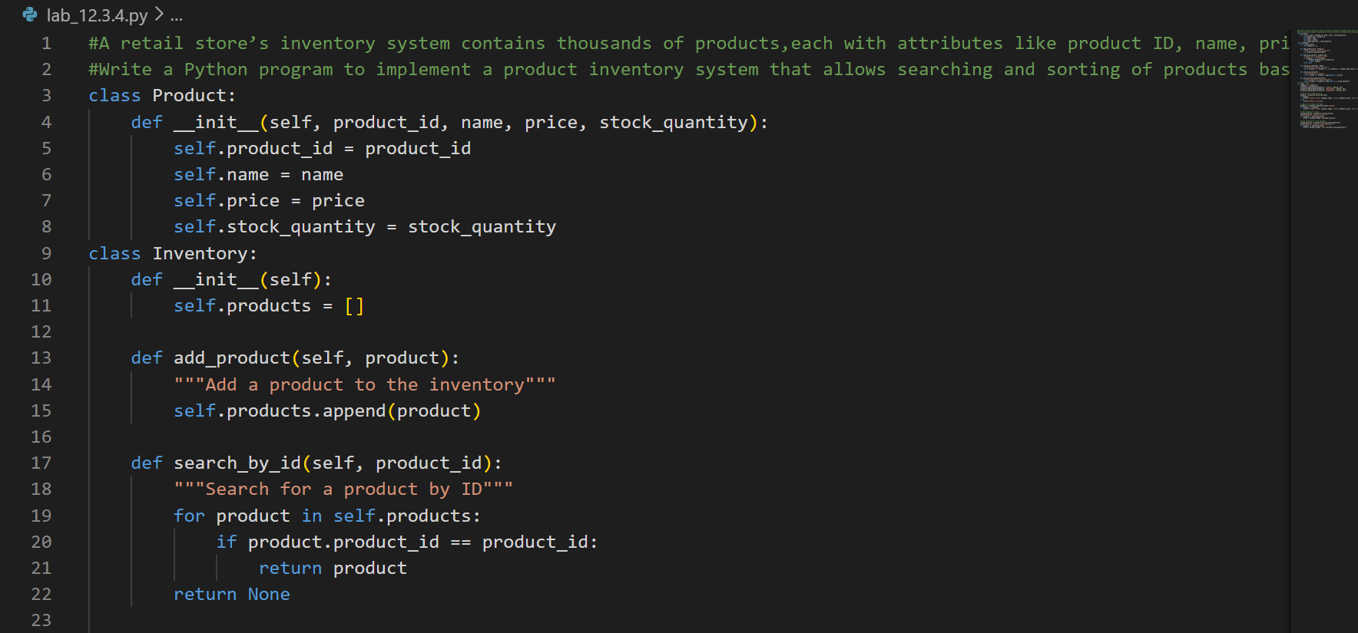
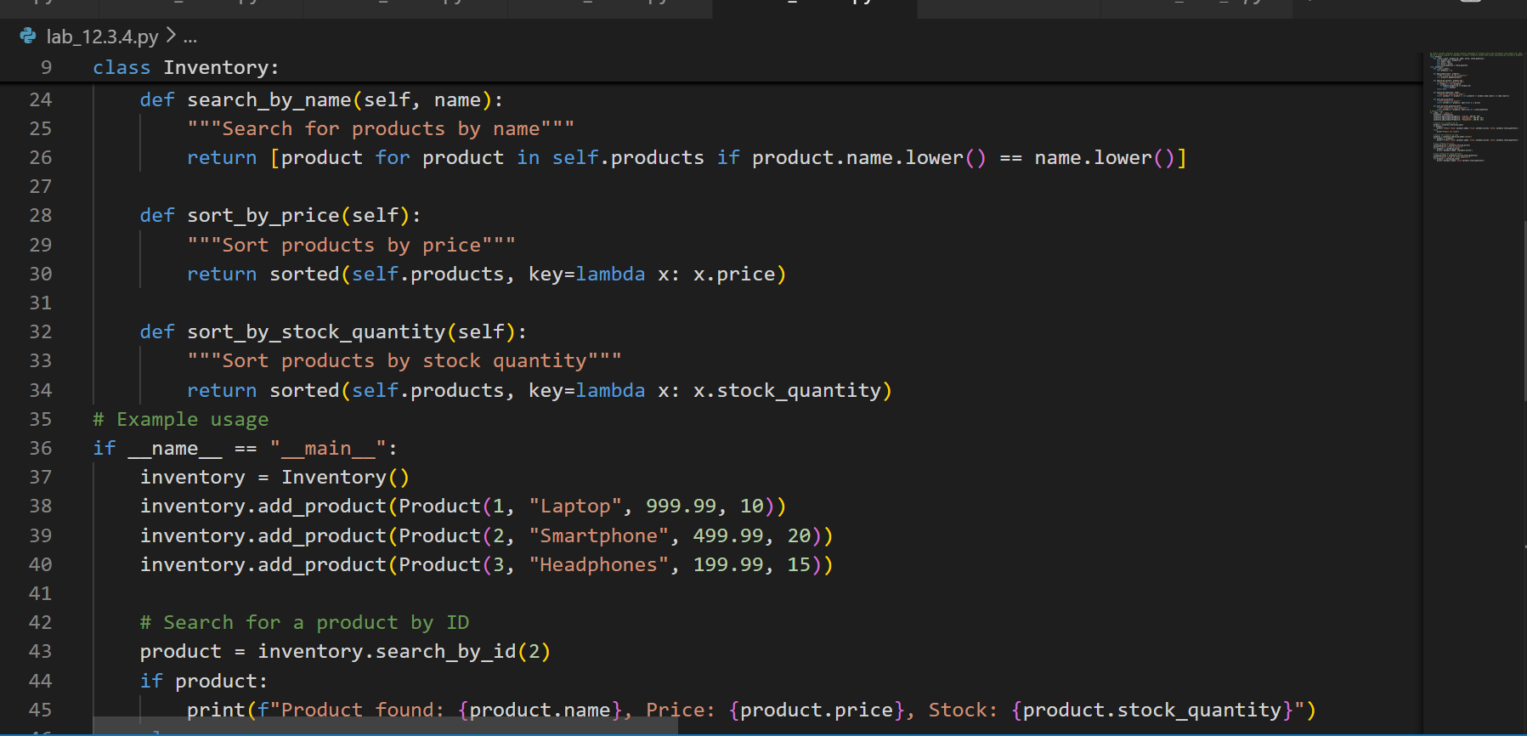
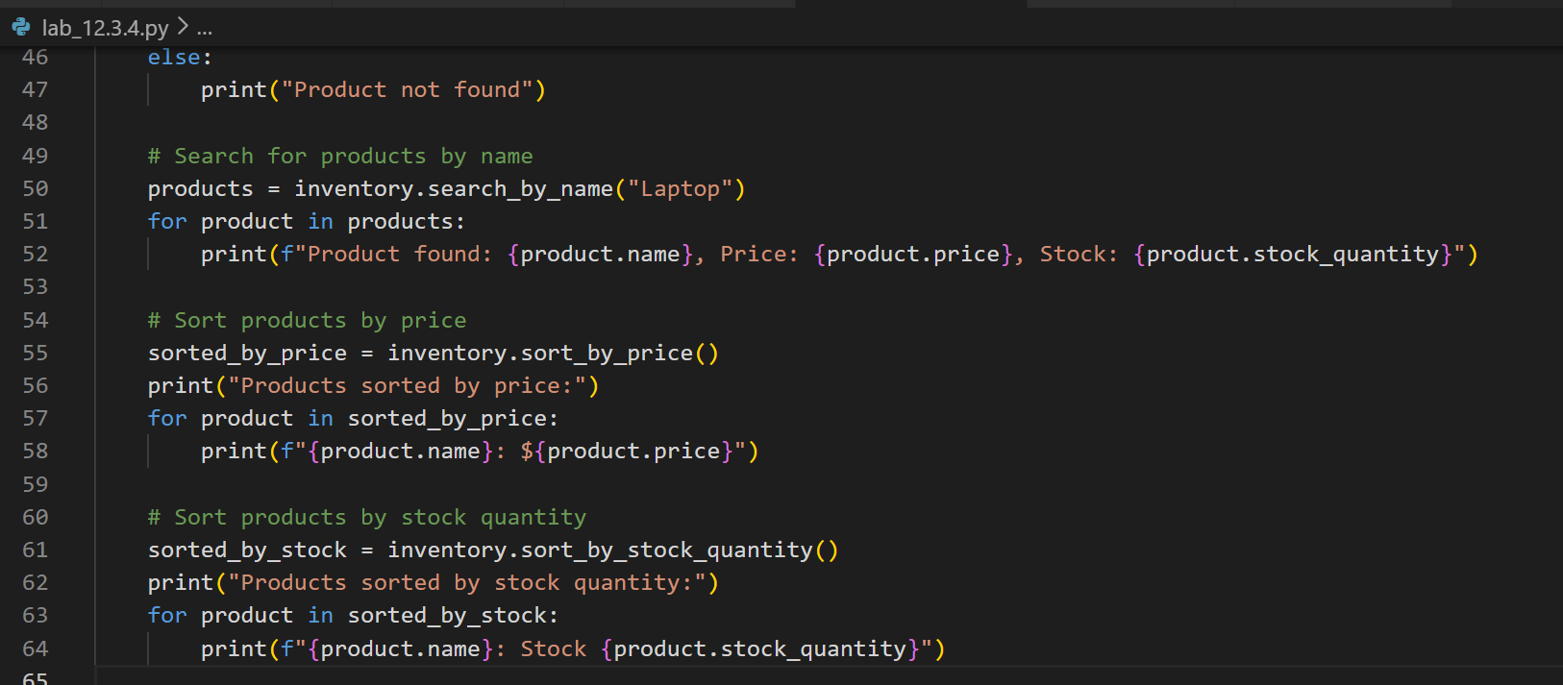

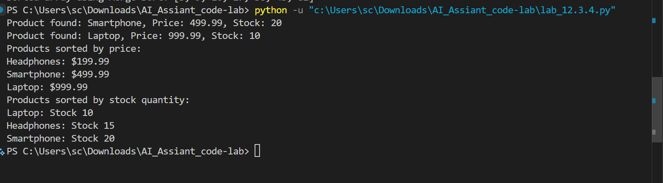

Task 5: Real-Time Stock Data Sorting & Searching
Scenario:
An AI-powered FinTech Lab at SR University is building a tool for analyzing
stock price movements. The requirement is to quickly sort stocks by daily
gain/loss and search for specific stock symbols efficiently.
• Use GitHub Copilot to fetch or simulate stock price data (Stock
Symbol, Opening Price, Closing Price).
• Implement sorting algorithms to rank stocks by percentage change.
• Implement a search function that retrieves stock data instantly when a
stock symbol is entered.
• Optimize sorting with Heap Sort and searching with Hash Maps.
• Compare performance with standard library functions (sorted(), dict
lookups) and analyze trade-offs.

Prompt:-
An AI-powered FinTech Lab at SR University is building a tool for analyzing tock price movements. The requirement is to quickly sort stocks by daily gain/loss and search for specific stock symbols efficiently. Optimize sorting with Heap Sort and searching with Hash Maps. Compare performance with standard library functions (sorted(), dict lookups) and analyze trade-offs.
Code:-
#An AI-powered FinTech Lab at SR University is building a tool for analyzing tock price movements. The requirement is to quickly sort stocks by daily gain/loss and search for specific stock symbols efficiently. Optimize sorting with Heap Sort and searching with Hash Maps. Compare performance with standard library functions (sorted(), dict lookups) and analyze trade-offs.
import heapq
class Stock:
def __init__(self, symbol, daily_gain_loss):
self.symbol = symbol
self.daily_gain_loss = daily_gain_loss

def __lt__(self, other):
return self.daily_gain_loss < other.daily_gain_loss
class StockAnalyzer:
def __init__(self):
self.stocks = []
self.stock_map = {}

def add_stock(self, symbol, daily_gain_loss):
stock = Stock(symbol, daily_gain_loss)
heapq.heappush(self.stocks, stock) # Add stock to the heap
self.stock_map[symbol] = stock # Add stock to the hash map

def get_top_gainers_losers(self, n=5):
"""Get top n gainers and losers"""
top_gainers = heapq.nlargest(n, self.stocks)
top_losers = heapq.nsmallest(n, self.stocks)
return top_gainers, top_losers

def search_stock(self, symbol):
"""Search for a stock by symbol"""
return self.stock_map.get(symbol, None) # O(1) lookup in hash map
# Example usage
if __name__ == "__main__":
analyzer = StockAnalyzer()
analyzer.add_stock("AAPL", 2.5)
analyzer.add_stock("GOOGL", -1.2)
analyzer.add_stock("AMZN", 3.0)
analyzer.add_stock("MSFT", -0.5)
analyzer.add_stock("TSLA", 4.0)

top_gainers, top_losers = analyzer.get_top_gainers_losers()
print("Top Gainers:")
for stock in top_gainers:
print(f"{stock.symbol}: {stock.daily_gain_loss}%")

print("\nTop Losers:")
for stock in top_losers:
print(f"{stock.symbol}: {stock.daily_gain_loss}%")

# Search for a specific stock
stock = analyzer.search_stock("GOOGL")
if stock:
print(f"\nStock found: {stock.symbol}, Daily Gain/Loss: {stock.daily_gain_loss}%")
else:
print("\nStock not found")

Explain code:-

At SR University’s FinTech Lab, this program uses a heap (Heap Sort concept) to efficiently track top gainers and losers while storing stocks in a hash map (dictionary) for instant O(1) symbol lookup. Compared to sorted() which takes O(n log n) each time and normal list searching which takes O(n), the heap and dictionary combination is faster for frequent updates and searches, though it uses slightly more memory to maintain both data structures.

