ASSIGNMENT-23.2
Batch -37
2303a52314

Task 1 – Project Proposal
• Students choose a real-world problem to solve with an AI-
assisted application (e.g., e-commerce billing system, health
monitoring dashboard, student attendance tracker).
• Prepare a project proposal including:
o Objective
o Features
o Tools/technologies to be used
o Expected output

Prompt:-
#Generate a project proposal for a Student Attendance Tracker using AI assistance including objective, features, tools, and expected output Project Proposal: Student Attendance Tracker using AI Assistance

#Objective:
#The objective of this project is to develop a Student Attendance Tracker that utilizes AI assistance to automate the process of tracking student attendance in educational institutions. The system will leverage computer vision and machine learning techniques to identify and record student attendance accurately and efficiently.
#Features:
1. Facial Recognition: The system will use facial recognition technology to identify students as they enter the classroom, ensuring accurate attendance tracking.
2. Real-time Attendance Monitoring: The system will provide real-time updates on student attendance, allowing
teachers and administrators to monitor attendance patterns and identify any issues promptly.
3. Attendance Reports: The system will generate detailed attendance reports that can be accessed by teachers, administrators, and parents, providing insights into student attendance trends.
4. Notifications: The system will send notifications to parents and guardians in case of student absences, ensuring timely communication.
5. Integration with School Management Systems: The attendance tracker will be designed to integrate seamlessly with existing school management systems for easy data management and reporting.
Tools:
1. Python: The primary programming language for developing the attendance tracker.
2. OpenCV: A computer vision library that will be used for facial recognition and image processing.
3. TensorFlow/Keras: Machine learning frameworks that will be used to train and deploy the facial recognition model.
4. Flask/Django: Web frameworks that will be used to develop the user interface and backend of the attendance tracker.
5. SQLite/MySQL: Database systems that will be used to store attendance records and student information.
Expected Output:
1. A functional Student Attendance Tracker that can accurately identify students and record their attendance in real-time.
2. Detailed attendance reports that can be accessed by teachers, administrators, and parents.
3. Notifications sent to parents and guardians in case of student absences.
4. Seamless integration with existing school management systems for efficient data management and reporting.
5. Improved attendance tracking efficiency and accuracy, leading to better management of student attendance in educational institutions.

Observation
AI helped quickly create a clear and structured project idea, saving time in planning and improving clarity.

Task 2 – Application Design
• Use AI tools to assist in:
o Designing system architecture diagrams.
o Defining database schema (if needed).
o Creating wireframes/UI mockups for frontend design.

Prompt:-
Design system architecture, database schema, and UI wireframe for a Student Attendance Tracker application

System Architecture:

1. Frontend: The frontend will be developed using a web framework such as Flask or Django
and will provide a user-friendly interface for teachers, administrators, and parents to interact with the attendance tracker. The frontend will include features such as real-time attendance monitoring, attendance reports, and notifications.
2. Backend: The backend will handle the core logic of the attendance tracker, including facial recognition
and data management. It will be responsible for processing the images captured by the camera, identifying students using the facial recognition model, and storing attendance records in the database.
3. Database: The database will store student information, attendance records, and other relevant data. It will be designed to allow for efficient querying and reporting of attendance data.
Database Schema:
1. Students Table:
- student_id (Primary Key)
- first_name
- last_name
- email
- class
2. Attendance Table:
- attendance_id (Primary Key)
- student_id (Foreign Key)
- date
- status (Present/Absent)
3. Notifications Table:
- notification_id (Primary Key)
- student_id (Foreign Key)
- date
- message
UI Wireframe:
1. Login Page: A simple login page for teachers, administrators, and parents to access the attendance tracker.
2. Dashboard: A dashboard that provides an overview of attendance statistics, including real-time attendance monitoring and quick access to attendance reports.
3. Attendance Report Page: A page that displays detailed attendance reports, allowing users to filter by
date, class, or student.
4. Notification Page: A page that displays notifications sent to parents and guardians regarding student absences.
5. Settings Page: A page that allows administrators to manage student information, configure notification settings, and integrate with school management systems.
6. Facial Recognition Page: A page that displays the camera feed and allows teachers to capture images for facial recognition and attendance tracking.
7. Student Profile Page: A page that displays individual student profiles, including attendance history and personal information.
8. Admin Panel: A page that allows administrators to manage user accounts, view system logs, and configure system settings.
9. Mobile Responsiveness: The UI will be designed to be responsive, allowing users to access the attendance tracker from various devices, including smartphones and tablets.
10. User-Friendly Design: The UI will be designed with a focus on usability, ensuring that users can easily navigate and interact with the attendance tracker without requiring technical expertise.

Observation
AI simplified system design by providing architecture, database schema, and UI layout, reducing manual effort.

Task 3 – AI-Assisted Code Development
• Implement the application in phases:
o Frontend: Web/mobile UI with HTML/CSS/JS (or
framework).
o Backend: RESTful APIs or server logic.
o Database: Schema design, SQL queries.
o Integration: API calls, authentication, error handling.

<!DOCTYPE html>
<html>
<head>
<title>Student Attendance</title>
</head>
<body>
<h1>Student Attendance App</h1>
<form id="attendanceForm">
<label>Name: <input type="text" id="name" required></label><br><br>
<label>Status:
<select id="status" required>
<option value="Present">Present</option>
<option value="Absent">Absent</option>
</select>
</label><br><br>
<button type="submit">Add Attendance</button>
</form>
<h2>Recent Attendance</h2>
<ul id="list"></ul>

<script>
document.getElementById('attendanceForm').addEventListener('submit', async (e) => {
e.preventDefault();
const name = document.getElementById('name').value;
const status = document.getElementById('status').value;
const response = await fetch('/api/attendance', {
method: 'POST',
headers: {'Content-Type': 'application/json'},
body: JSON.stringify({name, status})
});
const data = await response.json();
if (data.success) {
alert('Added!');
document.getElementById('attendanceForm').reset();
loadList();
} else {
alert('Error: ' + (data.error || 'Unknown'));
}
});

async function loadList() {
const response = await fetch('/api/attendance');
const data = await response.json();
const list = document.getElementById('list');
list.innerHTML = '';
data.forEach(item => {
const li = document.createElement('li');
li.textContent = `${item.name} - ${item.status} (${item.timestamp})`;
list.appendChild(li);
});
}

loadList();
</script>
</body>
</html>

CREATE TABLE IF NOT EXISTS attendance (
id INTEGER PRIMARY KEY AUTOINCREMENT,
name TEXT NOT NULL,
status TEXT NOT NULL,
timestamp DATETIME DEFAULT CURRENT_TIMESTAMP
);

from flask import Flask, request, jsonify
import sqlite3
import os

app = Flask(__name__)

DB_PATH = 'attendance.db'

def init_db():
conn = sqlite3.connect(DB_PATH)
cursor = conn.cursor()
cursor.execute('''
CREATE TABLE IF NOT EXISTS attendance (
id INTEGER PRIMARY KEY AUTOINCREMENT,
name TEXT NOT NULL,
status TEXT NOT NULL,
timestamp DATETIME DEFAULT CURRENT_TIMESTAMP
)
''')
conn.commit()
conn.close()

@app.route('/')
def index():
try:
html_path = os.path.join(os.path.dirname(__file__), 'lab23.html')
with open(html_path, 'r') as f:
html = f.read()
return html
except FileNotFoundError:
return '<h1>HTML file not found. Check lab23/lab23.html</h1>', 500

@app.route('/api/attendance', methods=['POST'])
def add_attendance():
data = request.get_json()
name = data.get('name')
status = data.get('status')

if not name or not status:
return jsonify({'error': 'Missing required fields'}), 400

try:
conn = sqlite3.connect(DB_PATH)
cursor = conn.cursor()
cursor.execute(
"INSERT INTO attendance (name, status) VALUES (?, ?)",
(name, status)
)
conn.commit()
cursor.close()
conn.close()
return jsonify({'success': True})
except Exception as e:
print(f"Error: {e}")
return jsonify({'success': False, 'error': str(e)}), 500

@app.route('/api/attendance', methods=['GET'])
def get_attendance():
try:
conn = sqlite3.connect(DB_PATH)
cursor = conn.cursor()
cursor.execute("SELECT * FROM attendance ORDER BY timestamp DESC")
rows = cursor.fetchall()
cursor.close()
conn.close()
return jsonify([{'id': r[0], 'name': r[1], 'status': r[2], 'timestamp': r[3]} for r in rows])
except Exception as e:
return jsonify({'error': str(e)}), 500

if __name__ == '__main__':
init_db()
app.run(debug=True, port=5000)

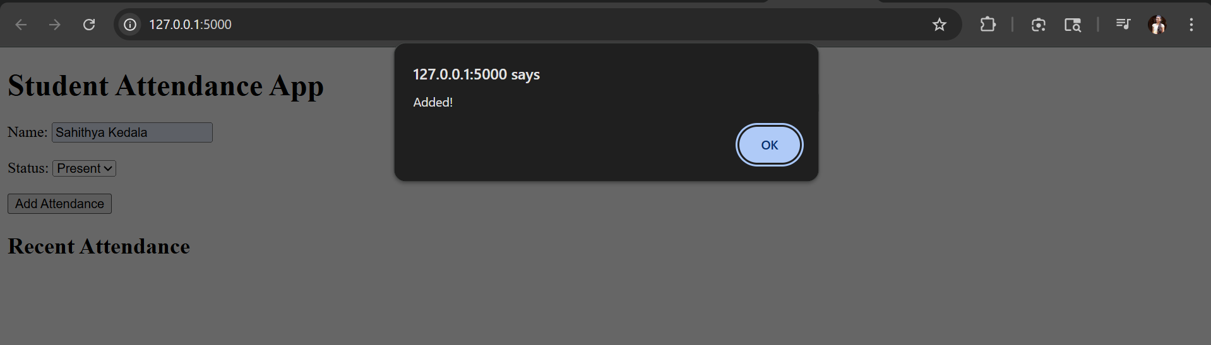

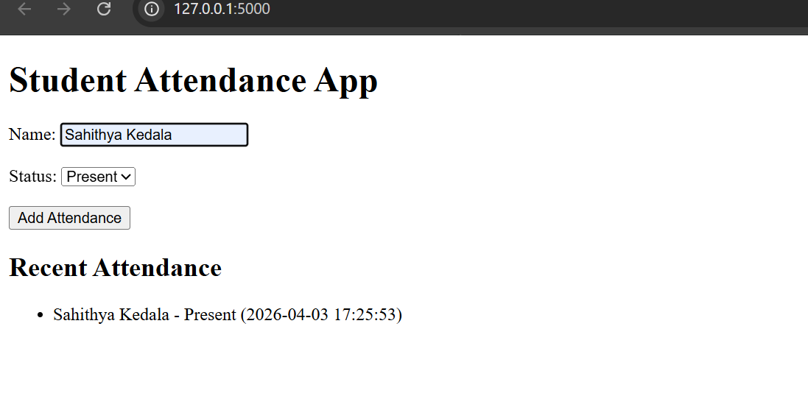

Observation
AI generated complete full-stack code, making development faster and easier while requiring basic understanding for execution.

Task 4 – Documentation & Code Quality
• Generate automatic documentation and inline comments using
AI.
• Ensure clear README.md for project setup and usage.
• Conduct AI-assisted code review to refine readability and
Maintainability.

Prompt:-

Generate README file, add inline comments, and review code for readability and maintainability

<!--Generate README file, add inline comments to code, and review the code for readability and maintainability for the attendance system project.>
# Lab23 Fix and Run - COMPLETE
**Steps Completed:**
1. Created TODO.md ✅
2. Files updated: app.py (imports, SQLite), database.sql (schema), lab23.html (form+JS), requirements.txt ✅
3. Flask installed (already present) ✅
4. DB inited automatically ✅
5. App running on http://127.0.0.1:5000 ✅
**Test:**
- Open http://127.0.0.1:5000
- Add attendance via form.
- View list.
App serves HTML frontend, POST/GET attendance API with SQLite persistence.

#inline comments
from flask import Flask, request, jsonify
import sqlite3
app = Flask(__name__)
def init_db():
conn = sqlite3.connect('attendance.db')
cursor = conn.cursor()
cursor.execute('''
CREATE TABLE IF NOT EXISTS attendance (
id INTEGER PRIMARY KEY AUTOINCREMENT,
name TEXT NOT NULL,
status TEXT NOT NULL,
timestamp DATETIME DEFAULT CURRENT_TIMESTAMP
)
''')
conn.commit()
conn.close()
@app.route('/attendance', methods=['POST'])
def record_attendance():
data = request.get_json()
name = data.get('name')
status = data.get('status')
if not name or not status:
return jsonify({'error': 'Name and status are required'}), 400
conn = sqlite3.connect('attendance.db')
cursor = conn.cursor()
cursor.execute('INSERT INTO attendance (name, status) VALUES (?, ?)', (name, status))
conn.commit()
conn.close()
return jsonify({'message': 'Attendance recorded successfully'}), 201
@app.route('/attendance', methods=['GET'])
def get_attendance():
conn = sqlite3.connect('attendance.db')
cursor = conn.cursor()
cursor.execute('SELECT name, status, timestamp FROM attendance')
records = cursor.fetchall()
conn.close()
attendance_list = [{'name': row[0], 'status': row[1], 'timestamp': row[2]} for row in records]
return jsonify(attendance_list), 200
if __name__ == '__main__':
init_db()
app.run(debug=True)

Observation
AI improved documentation and code quality by adding comments and structured explanations, making the project easier to understand.

Task 5 – Testing & Debugging
• Use AI to:
o Generate unit tests.
o Identify vulnerabilities/security flaws.
o Suggest optimizations for performance.

Prompt:-

import unittest
from app import app, init_db
import sqlite3
import os

class AttendanceTestCase(unittest.TestCase):
def setUp(self):
# Clear DB
db_path = 'attendance.db'
if os.path.exists(db_path):
os.remove(db_path)
init_db()
self.app = app.test_client()
self.app.testing = True

def test_record_attendance_success(self):
response = self.app.post('/api/attendance', json={'name': 'John Doe', 'status': 'Present'})
self.assertEqual(response.status_code, 200)
data = response.get_json()
self.assertTrue(data['success'])

def test_record_attendance_missing_fields(self):
response = self.app.post('/api/attendance', json={'name': 'John Doe'})
self.assertEqual(response.status_code, 400)
data = response.get_json()
self.assertIn('Missing required fields', data['error'])

def test_get_attendance(self):
self.app.post('/api/attendance', json={'name': 'Jane Doe', 'status': 'Absent'})
response = self.app.get('/api/attendance')
self.assertEqual(response.status_code, 200)
data = response.get_json()
self.assertIsInstance(data, list)
self.assertEqual(len(data), 1)
self.assertEqual(data[0]['name'], 'Jane Doe')
self.assertEqual(data[0]['status'], 'Absent')

if __name__ == '__main__':
unittest.main(verbosity=2)

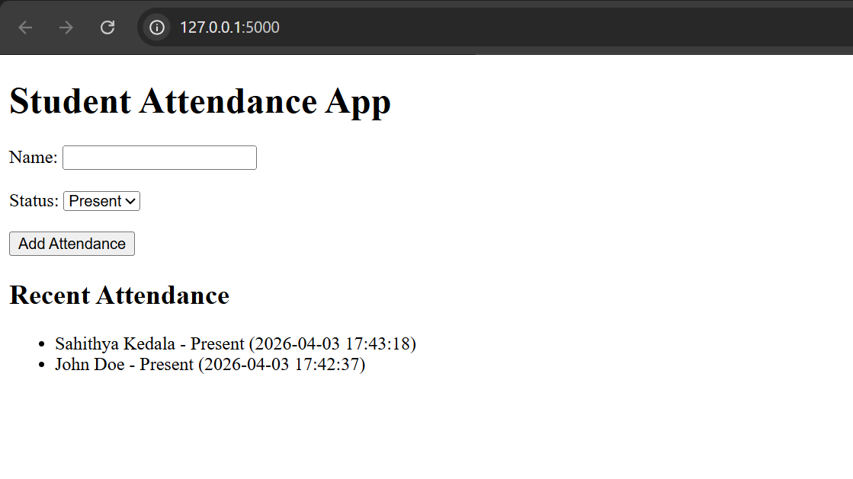

Observation
AI helped in testing, identifying security issues, and improving performance, making the application more reliable and efficient.

