ASSIGNMENT-22.3

Batch-37
2303A52314

Task 1 – Bias Detection in AI Suggestions (Alternative Example)
Example Scenario:
Ask AI to generate a resume shortlisting algorithm multiple times.
• Change prompt wording (e.g., “select best candidate” vs “ensure
diversity”).
• Compare outputs and logic.
Discussion Points:
• Does the AI favor certain qualifications, backgrounds, or
experiences?
• How could biased shortlisting algorithms affect equal
employment opportunities?

Prompt
Generate a Python algorithm to shortlist the best candidate based on qualifications and experience
Code
#Generate a Python algorithm to shortlist the best candidate based on qualifications and experience
class Candidate:
def __init__(self, name, qualifications, experience):
self.name = name
self.qualifications = qualifications
self.experience = experience
def shortlist_candidates(candidates):
shortlisted = []
for candidate in candidates:
if candidate.qualifications >= 3 and candidate.experience >= 5:
shortlisted.append(candidate)
return shortlisted
# Example usage
candidates = [
Candidate("Alice", 4, 6),
Candidate("Bob", 2, 4),
Candidate("Charlie", 3, 5),
Candidate("David", 1, 2)
]
best_candidates = shortlist_candidates(candidates)
for candidate in best_candidates:
print(f"Shortlisted Candidate: {candidate.name}, Qualifications: {candidate.qualifications}, Experience: {candidate.experience} years")

Output
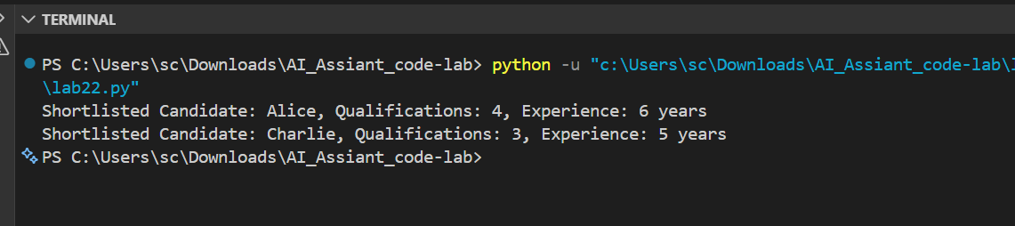
observation
AI-generated shortlisting algorithms can show bias depending on prompt wording, which may lead to unfair hiring and reduced equal employment opportunities.

Task 2 – Privacy and Sensitive Data Handling (Alternative
Example)
Example Scenario:
Ask AI to write code for processing student academic records (roll
number, marks, email).
Discussion Points:
• How should student identity data be masked or encrypted?
• What privacy laws (e.g., FERPA, GDPR-like principles) are
relevant?
• What ethical responsibility does the programmer have when
using AI-generated code?

Prompt
Write Python code to process student records (roll number, marks, email).”

Code
#Write Python code to process student records (roll number, marks, email).”
class Student:
def __init__(self, roll_number, marks, email):
self.roll_number = roll_number
self.marks = marks
self.email = email
def process_student_records(students):
for student in students:
print(f"Roll Number: {student.roll_number}, Marks: {student.marks}, Email: {student.email}")
# Example usage
students = [
Student(1, 85, "xyz123@.com"),
Student(2, 90, "abc456@.com"),
Student(3, 78, "def789@.com")
]
process_student_records(students)

Output
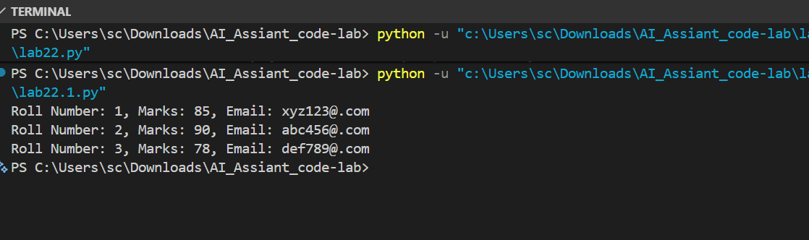
Observation
AI-generated code may expose sensitive student data if not handled properly, so developers must ensure data masking, encryption, and follow privacy principles.

Task 3 – AI-Generated Security Risks (Alternative Example)
Example Scenario:
Use AI to generate a payment processing script for an online shopping
system.
Student Tasks:
• Identify risks such as:
o Plain-text card data storage
o Missing input validation
• Propose ethical coding standards to prevent financial fraud and
Misuse.

Prompt
Generate Python code for payment processing system.
Code
#Generate Python code for payment processing system.”
class PaymentProcessor:
def process_payment(self, amount, payment_method):
if payment_method == "credit_card":
return self.process_credit_card_payment(amount)
elif payment_method == "paypal":
return self.process_paypal_payment(amount)
else:
raise ValueError("Unsupported payment method")
def process_credit_card_payment(self, amount):
# Simulate credit card payment processing
print(f"Processing credit card payment of ${amount}")
return True
def process_paypal_payment(self, amount):
# Simulate PayPal payment processing
print(f"Processing PayPal payment of ${amount}")
return True
# Example usage
payment_processor = PaymentProcessor()
payment_processor.process_payment(100, "credit_card")
payment_processor.process_payment(50, "paypal")

Output
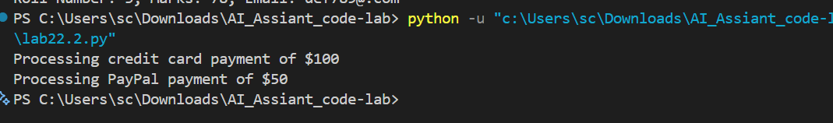
Observation
AI-generated payment code can contain security flaws like lack of validation and plain-text data handling, which can lead to financial fraud if not corrected.

Task 4 – Accountability in Human–AI Collaboration (Alternative
Example)
Scenario:
AI generates code for an autonomous traffic signal control system.
Discussion Questions:
• If a software error causes accidents, who is accountable?
• Should responsibility lie with:
o AI tool developers
o Software engineers
o Government authorities deploying the system?
Students submit a short reflection on accountability.

Prompt
Generate code for autonomous traffic signal control.

Code
#“Generate code for autonomous traffic signal control.”
class TrafficSignalController:
def __init__(self):
self.signal_state = "RED"
def change_signal(self):
if self.signal_state == "RED":
self.signal_state = "GREEN"
elif self.signal_state == "GREEN":
self.signal_state = "YELLOW"
elif self.signal_state == "YELLOW":
self.signal_state = "RED"
def get_signal_state(self):
return self.signal_state
# Example usage
traffic_signal_controller = TrafficSignalController()
for _ in range(6):
print(f"Current Signal State: {traffic_signal_controller.get_signal_state()}")
traffic_signal_controller.change_signal()

Output
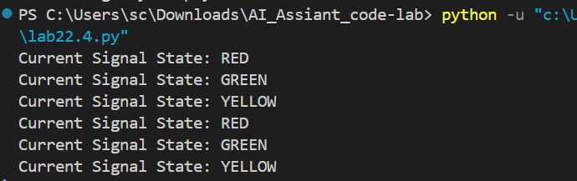
Observation
In AI-assisted systems, responsibility for errors lies mainly with human developers and deploying authorities, as AI is only a tool and not accountable.

Task 5 – Limitations of AI in Critical Systems (Alternative
Example)
Example Scenario:
Ask AI to generate code for an aircraft maintenance fault detection
system.
Discussion Points:
• Can AI-generated code be trusted without expert validation?
• What human oversight is essential in aviation software?
• How should safety-critical code be reviewed and certified?

Prompt
Generate code for aircraft fault detection system
Code
#Generate code for aircraft fault detection system
class AircraftFaultDetectionSystem:
def __init__(self):
self.faults = []
def detect_fault(self, sensor_data):
if sensor_data["engine_temperature"] > 100:
self.faults.append("Engine Overheating")
if sensor_data["oil_pressure"] < 20:
self.faults.append("Low Oil Pressure")
if sensor_data["altitude"] < 1000:
self.faults.append("Low Altitude")
def get_faults(self):
return self.faults
# Example usage
fault_detection_system = AircraftFaultDetectionSystem()
sensor_data = {
"engine_temperature": 110,
"oil_pressure": 15,
"altitude": 800
}
fault_detection_system.detect_fault(sensor_data)
detected_faults = fault_detection_system.get_faults()
print("Detected Faults:")
for fault in detected_faults:
print(fault)

Output
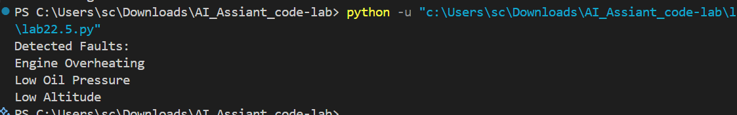
Observation

AI-generated code cannot be fully trusted in safety-critical systems without expert validation, testing, and strict human oversight.

Task 6 – Ethical Use of AI-Generated Code (Alternative Example)
Example Scenario:
Students analyze cases where AI-generated code is used in academic
assignments or startups.
Discussion Points:
• Risks of submitting AI code without understanding it
• Copyright and license violations
Best practices:
o Proper citation
o Manual verification
o Ethical reuse of AI outputs

Prompt
Generate Python code for a basic student management system. Then explain the code step-by-step so that a beginner can understand it.

Code
#Generate Python code for a basic student management system. Then explain the code step-by-step so that a beginner can understand it.”
class Student:
def __init__(self, name, age, grade):
self.name = name
self.age = age
self.grade = grade
class StudentManagementSystem:
def __init__(self):
self.students = []
def add_student(self, student):
self.students.append(student)
def display_students(self):
for student in self.students:
print(f"Name: {student.name}, Age: {student.age}, Grade: {student.grade}")
# Example usage
student_management_system = StudentManagementSystem()
student1 = Student("Alice", 20, "A")
student2 = Student("Bob", 22, "B")
student_management_system.add_student(student1)
student_management_system.add_student(student2)
student_management_system.display_students()
# Step-by-step explanation:
# 1. We define a class called `Student` which has an `__init__` method. This method is a constructor that initializes the attributes of the student, such as `name`, `age`, and `grade`.
# 2. We then define another class called `StudentManagementSystem` which has its own `__init__` method that initializes an empty list called `students` to store the student objects.
# 3. The `StudentManagementSystem` class has a method called `add_student` which takes a student object as an argument and appends it to the `students` list.
# 4. Another method in the `StudentManagementSystem` class is `display_students`, which iterates through the `students` list and prints out the details of each student in a formatted string.
# 5. Finally, we create an instance of the `StudentManagementSystem` class and create two student objects with their respective details. We add these student objects to the management system and call the `display_students` method to print out the information of all the students in the system.

Output
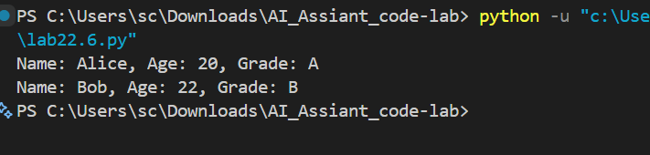
observation
Using AI-generated code without understanding or proper citation can lead to academic dishonesty and legal issues, so ethical reuse and verification are necessary.

