ASSIGNMENT-2.2

Batch-37
2303A52314

Question:-

Lab 2: Exploring Additional AI Coding Tools beyond Copilot – Gemini (Colab) and Cursor AI

Task 1: Cleaning Sensor Data
❖ Scenario:
❖ You are cleaning IoT sensor data where negative values are invalid.
❖ Task:
Use Gemini in Colab to generate a function that filters out all negative
numbers from a list.
❖ Expected Output:
➢ Before/after list
➢ Screenshot of Colab execution

Prompt:-

Given a list of numbers, separate them into two new lists: one for negative numbers and another for non-negative numbers. Then, print the original list, the negative numbers, and the non-negative numbers.

Code:-

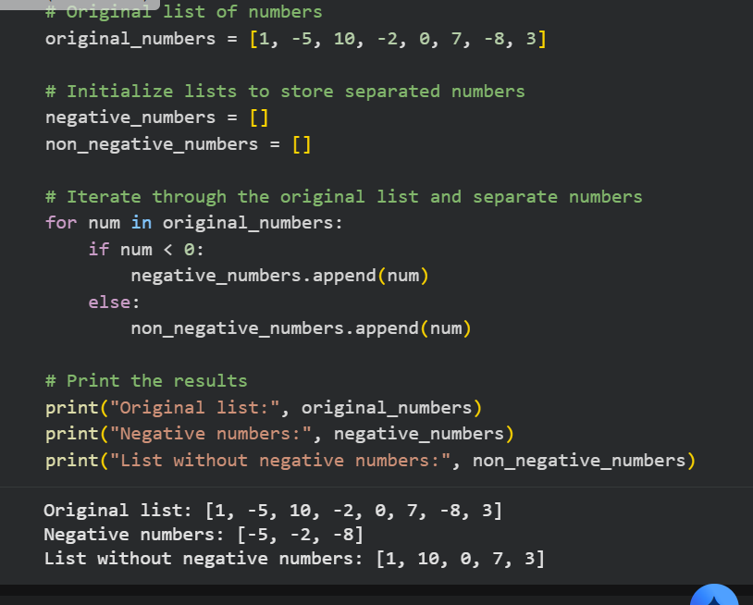

Explain code:-

This program starts with a list of numbers.
It goes through each number one by one and checks whether it is negative or not.
If the number is less than zero, it is added to the negative numbers list.
If the number is zero or greater, it is added to the non-negative numbers list.
In the end, the program displays the original list, the list of negative numbers, and the list of non-negative numbers.

Question-2:

Task 2: String Character Analysis
❖ Scenario:
You are building a text-analysis feature.
❖ Task:
Use Gemini to generate a Python function that counts vowels, consonants,
and digits in a string.
❖ Expected Output:
➢ Working function
➢ Sample inputs and outputs

Prompt:-

Create a Python function that counts the number of vowels, consonants, and digits in a given string. Afterwards, show how to use this function with an example string and print all the resulting counts.

code:-

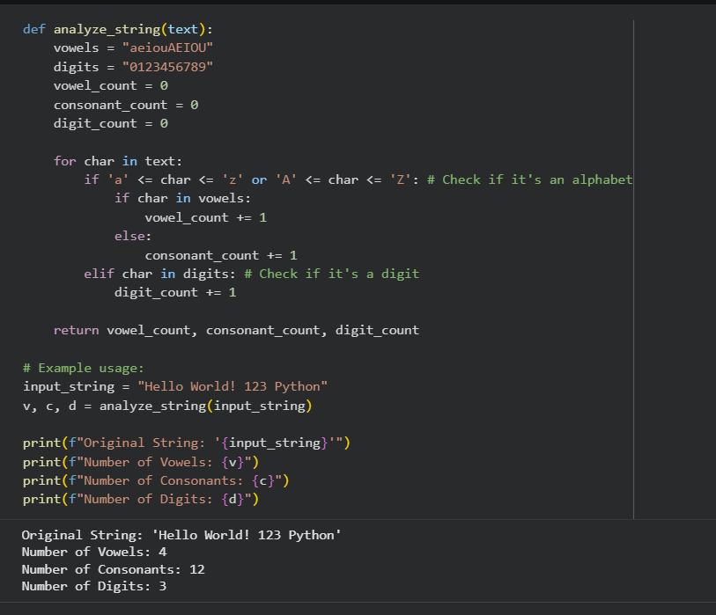

Explain code:-

This program has a function named analyze_string that takes a string as input.
It checks each character in the string one by one.
If the character is a vowel, it increases the vowel count.
If it is a consonant, it increases the consonant count.
If it is a digit (number), it increases the digit count.
After checking all characters, the function gives back the total number of vowels, consonants, and digits.
The example shows how the function is used with the text "Hello World! 123 Python" and prints the final counts.

Question-3:-

Task 3: Palindrome Check – Tool Comparison
❖ Scenario:
You must decide which AI tool is clearer for string logic.
❖ Task:
Generate a palindrome-checking function using Gemini and Copilot, then
compare the results.
❖ Expected Output:
➢ Side-by-side code comparison
➢ Observations on clarity and structure

Prompt:-

Write a Python program using a function to check whether the given text is a palindrome or not.
The program should take input from the user and display an appropriate message based on the result.

Code:-
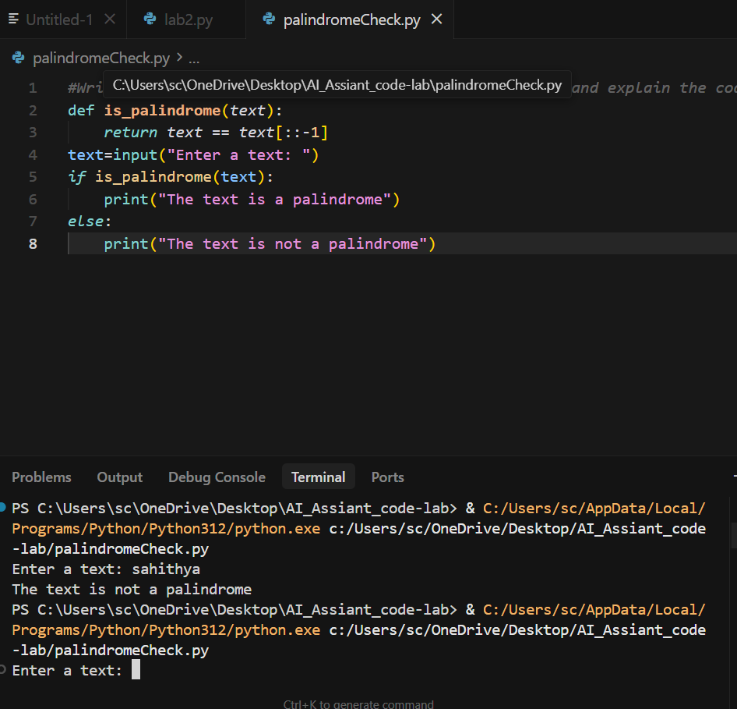

Explain Code:-

This program defines a function called is_palindromei that checks whether a given text reads the same forwards and backwards.
It does this by comparing the original text with its reversed version.
The program then asks the user to enter a text.
If the function returns true, it prints that the text is a palindrome; otherwise, it prints that the text is not a palindrome.

Question –4:-
Task 4: Code Explanation Using AI
❖ Scenario:
You are reviewing unfamiliar code written by another developer.
❖ Task:
Ask Gemini to explain a Python function (prime check OR palindrome
check) line by line.
❖ Expected Output:
➢ Code snippet
➢ AI explanation
➢ Student comments on understanding

Prompt:-
Write a Python program using a function to check whether a given number is a prime number or not.
The program should test the function with sample numbers and display the results.

Code:-

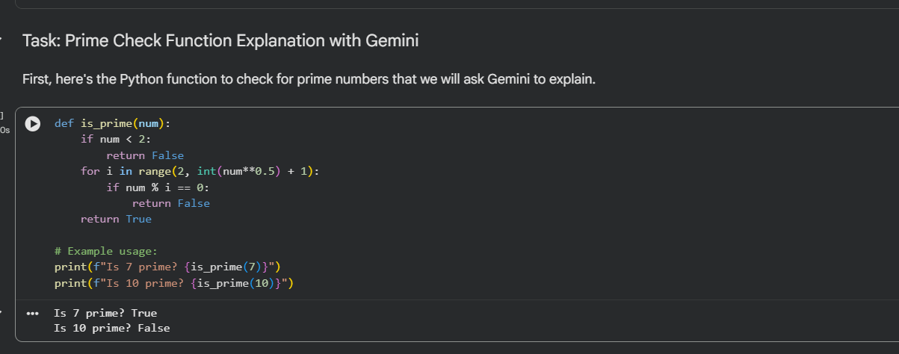

Explain Code:-

This code defines a function called is_prime that checks whether a number is prime or not.
It first rules out numbers less than 2, then checks if the number is divisible by any value up to its square root; if it is, the function returns false, otherwise it returns true and the example prints the results for 7 and 10.

