ASSIGNMENT-11.2

Batch -37
2303A52314

Task Description -1 – (Stack Using AI Guidance)
• Task: With the help of AI, design and implement a Stack data
structure supporting basic stack operations.
Expected Output:
• A Python Stack class supporting push, pop, peek, and empty-
check operations with proper documentation.

Prompt ➖
generate python code basic stack operations using data structure list and give output

Code:-
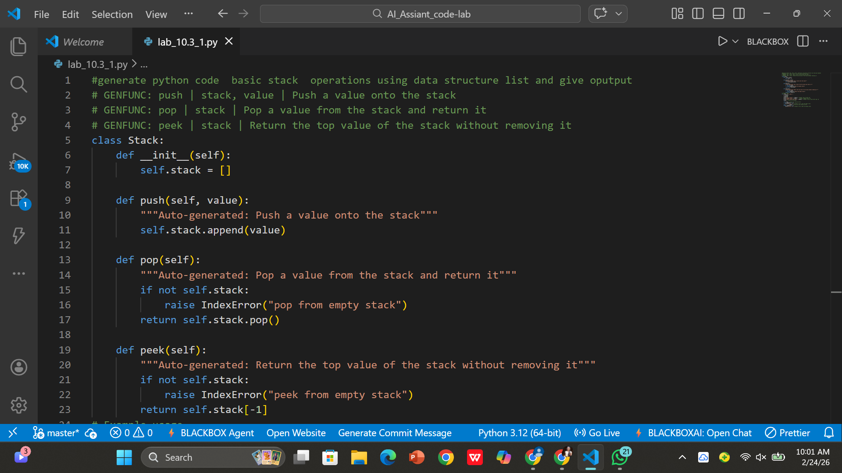

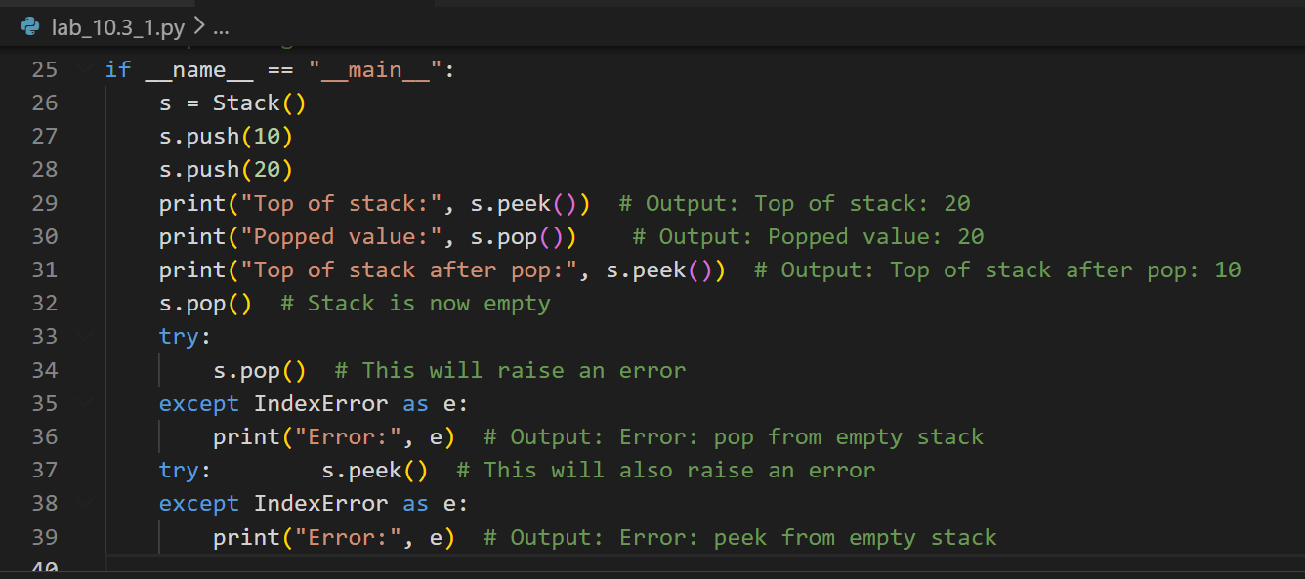

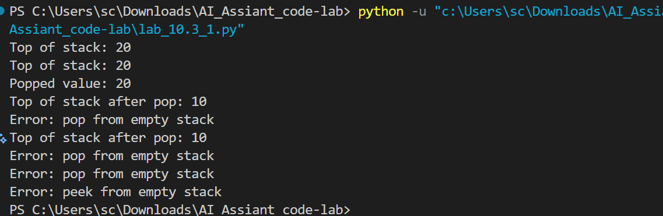

Explain code:-

This code defines a Stack class that uses a Python list to implement basic stack operations: push() adds an element to the top, pop() removes and returns the top element (raising an error if empty), and peek() returns the top element without removing it. In the example usage, elements are pushed and removed to demonstrate normal behavior, and try-except blocks are used to handle errors when attempting to pop or peek from an empty stack.

Task Description -2 – (Queue Design)
• Task:Use AI assistance to create a Queue data structure
following FIFO principles
Expected Output:
• A complete Queue implementation including enqueue, dequeue,
front element access, and size calculation

Prompt:-

create a Queue data structure following FIFO principles

Code:-

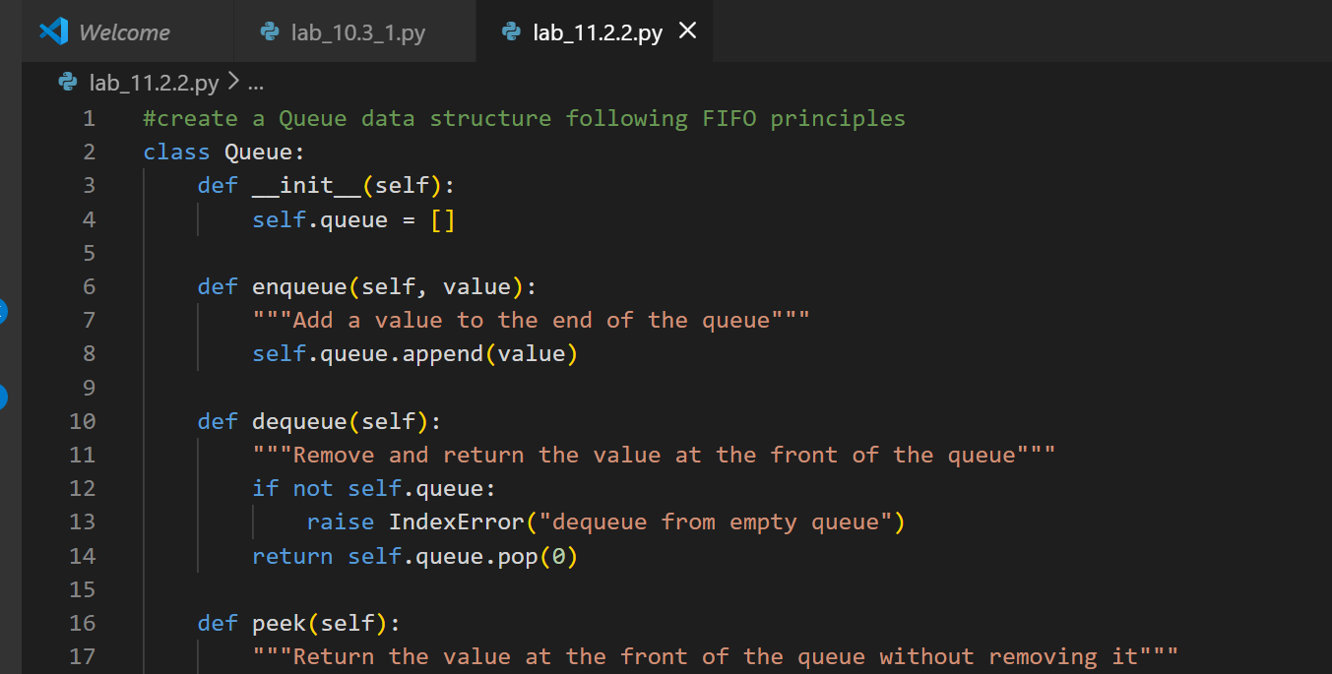

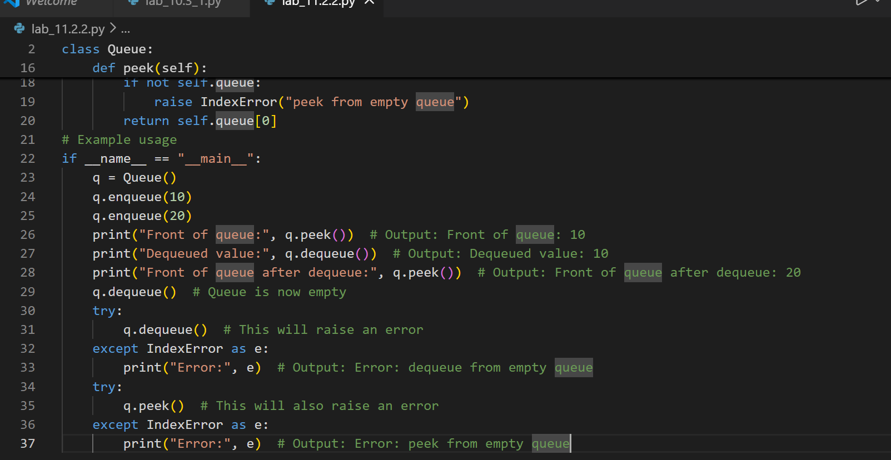

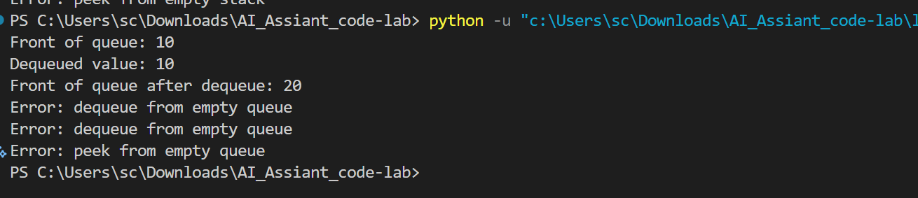

Explain code:-

This code defines a Queue class that follows the FIFO (First In, First Out) principle using a Python list.
- The __init__ method initializes an empty list called queue to store elements.
- The enqueue(value) method adds a new element to the end of the queue using append().
- The dequeue() method removes and returns the first element (front of the queue) using pop(0), and raises an error if the queue is empty.
- The peek() method returns the front element without removing it, and also raises an error if the queue is empty.

Task Description -3 –(Singly Linked List Construction)
• Task: Utilize AI to build a singly linked list supporting insertion
and traversal.
Expected Output:
• Correctly functioning linked list with node creation, insertion
logic, and display functionality.

Prompt:-
Build a singly linked list supporting insertion and traversal.
Code:-

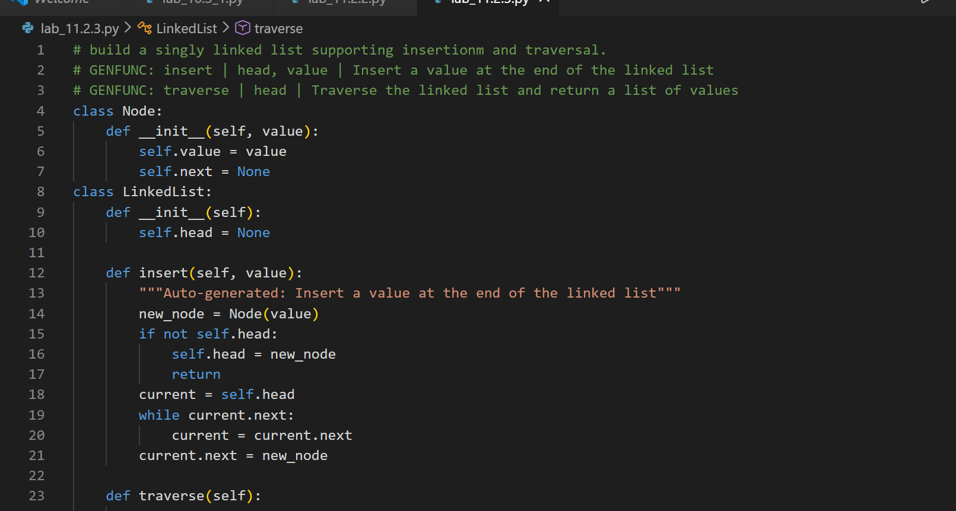

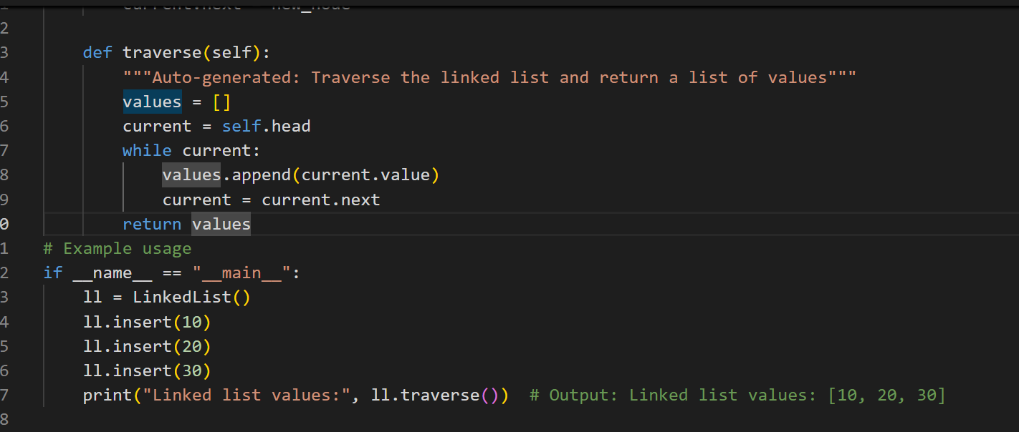

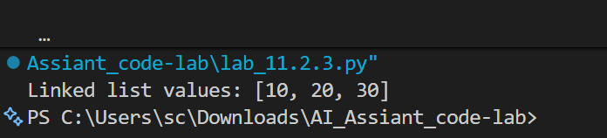
Explain code:-
This code creates a singly linked list using two classes: Node and LinkedList. The Node class stores a value and a reference (next) to the next node, while the LinkedList class manages the list through a head pointer that points to the first node.
The insert() method adds a new node at the end of the list by traversing until it finds the last node and linking the new node there, and the traverse() method moves through each node from the head to the end, collects their values in a list, and returns them.

Task Description -4 – (Binary Search Tree Operations)
• Task: Implement a Binary Search Tree with AI support focusing
on insertion and traversal.
Expected Output:
• BST program with correct node insertion and in-order traversal
Output.
Prompt:-
Implement a Binary Search Tree and focusing on insertion and traversal.

Code:-

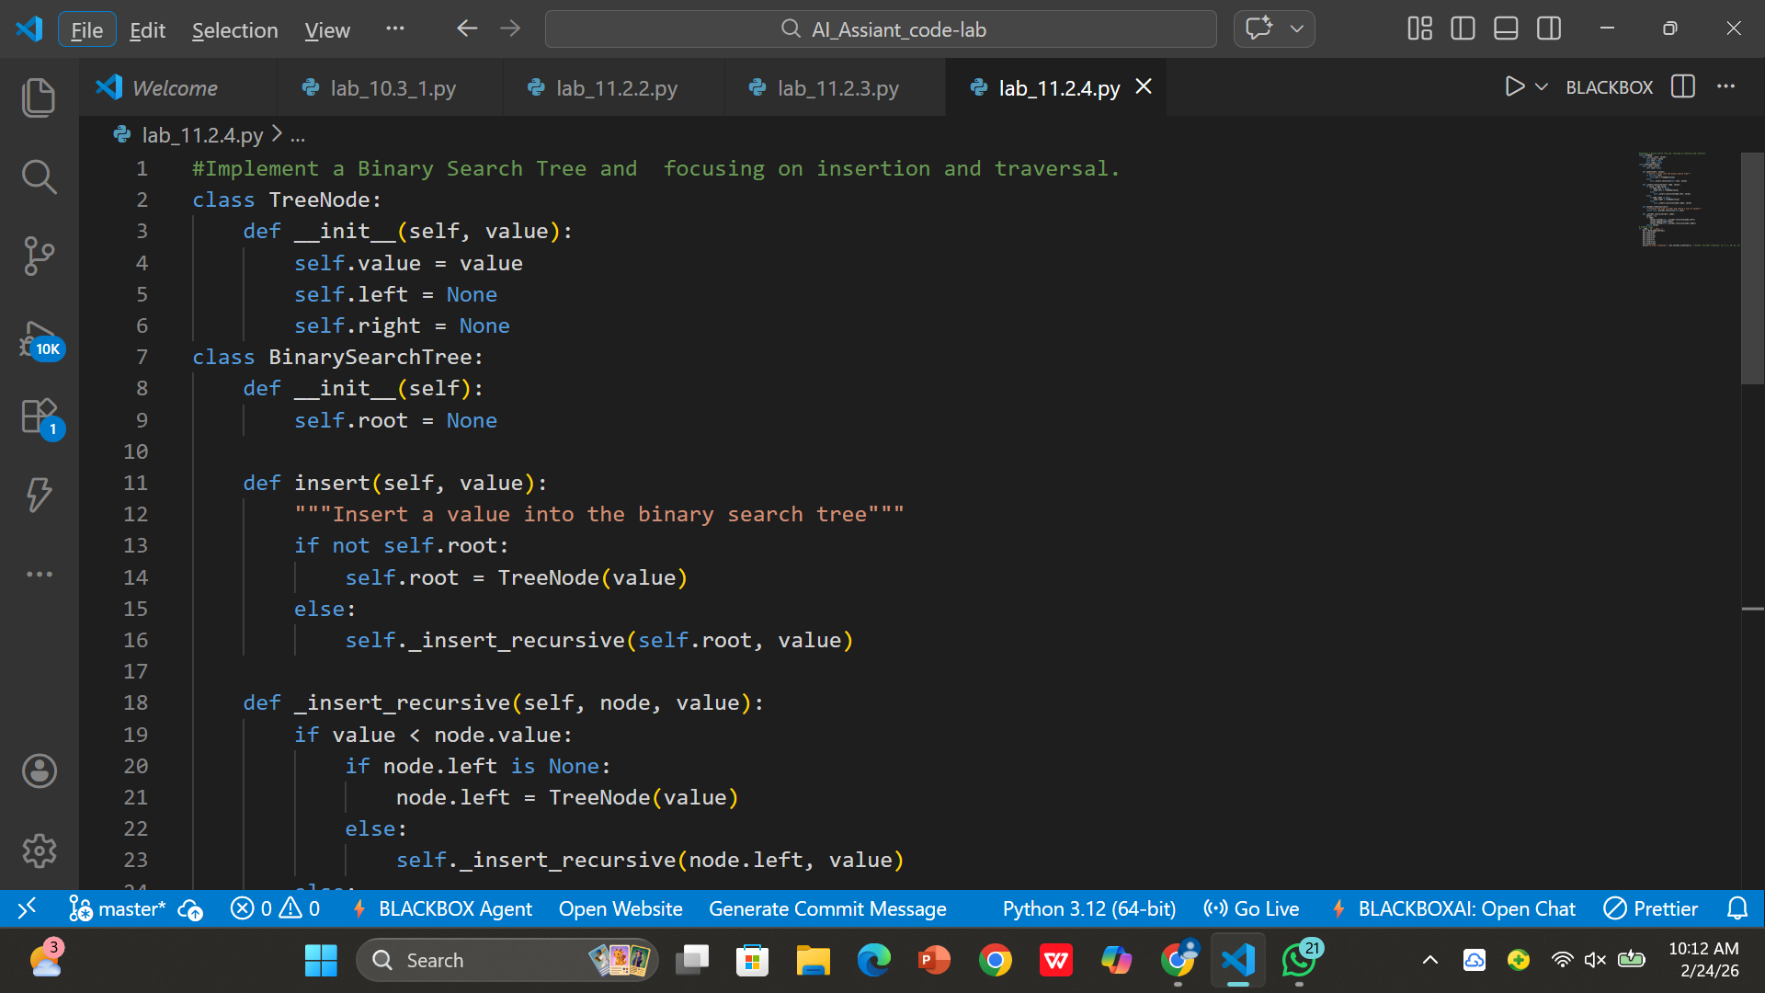

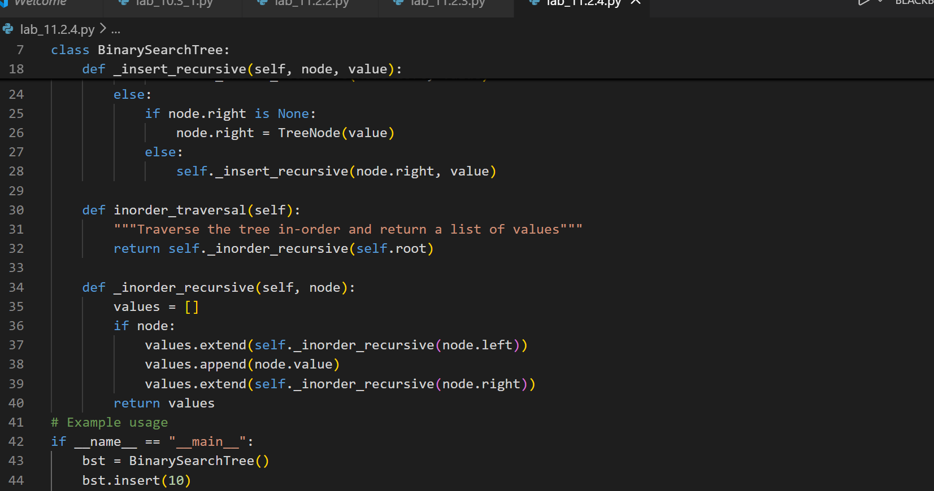

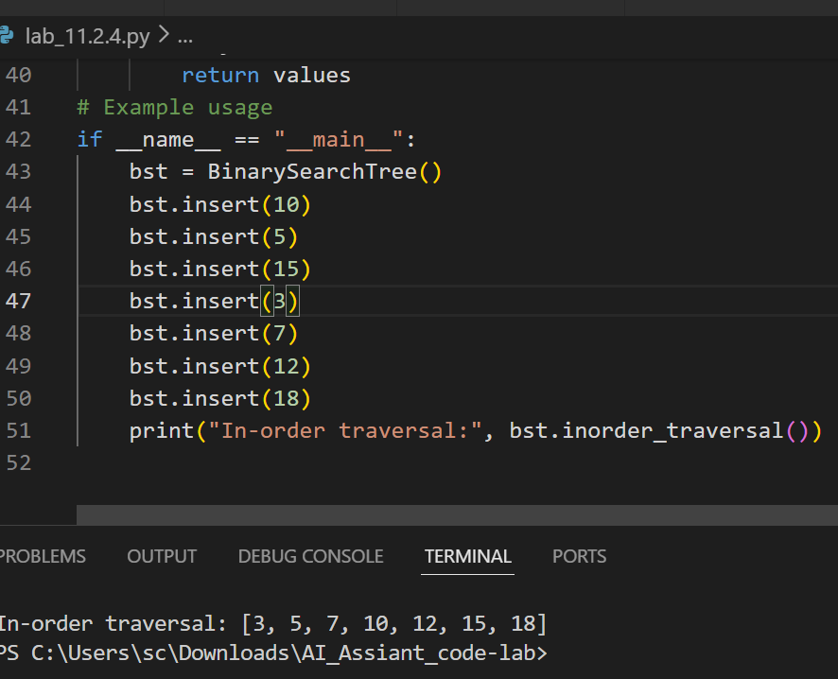

Explain code:-
This code implements a Binary Search Tree (BST) using two classes: TreeNode and BinarySearchTree. The TreeNode class stores a value and two references (left and right), while the BinarySearchTree class manages the tree with a root node.
The insert() method adds values following BST rules (smaller values go to the left subtree, larger values go to the right subtree) using a recursive helper method _insert_recursive(). The inorder_traversal() method performs an in-order traversal (left → root → right) using _inorder_recursive(), which returns the values in sorted order, as shown in the output [3, 5, 7, 10, 12, 15, 18].

Task Description -5 – (Hash Table Implementation)
• Task: Create a hash table using AI with collision handling
Expected Output:
• Hash table supporting insert, search, and delete using chaining
or open

Prompt:-
Create a hash table with collision handling using chaining. Implement the following operations:

Code:-

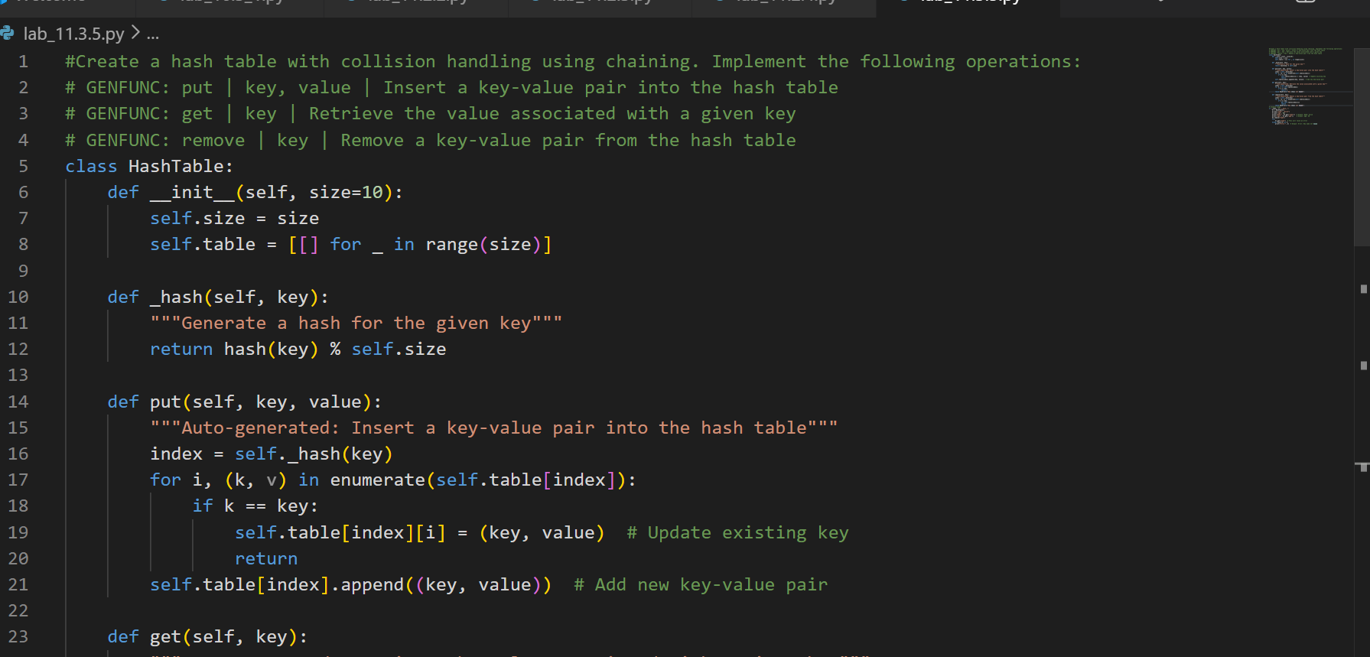
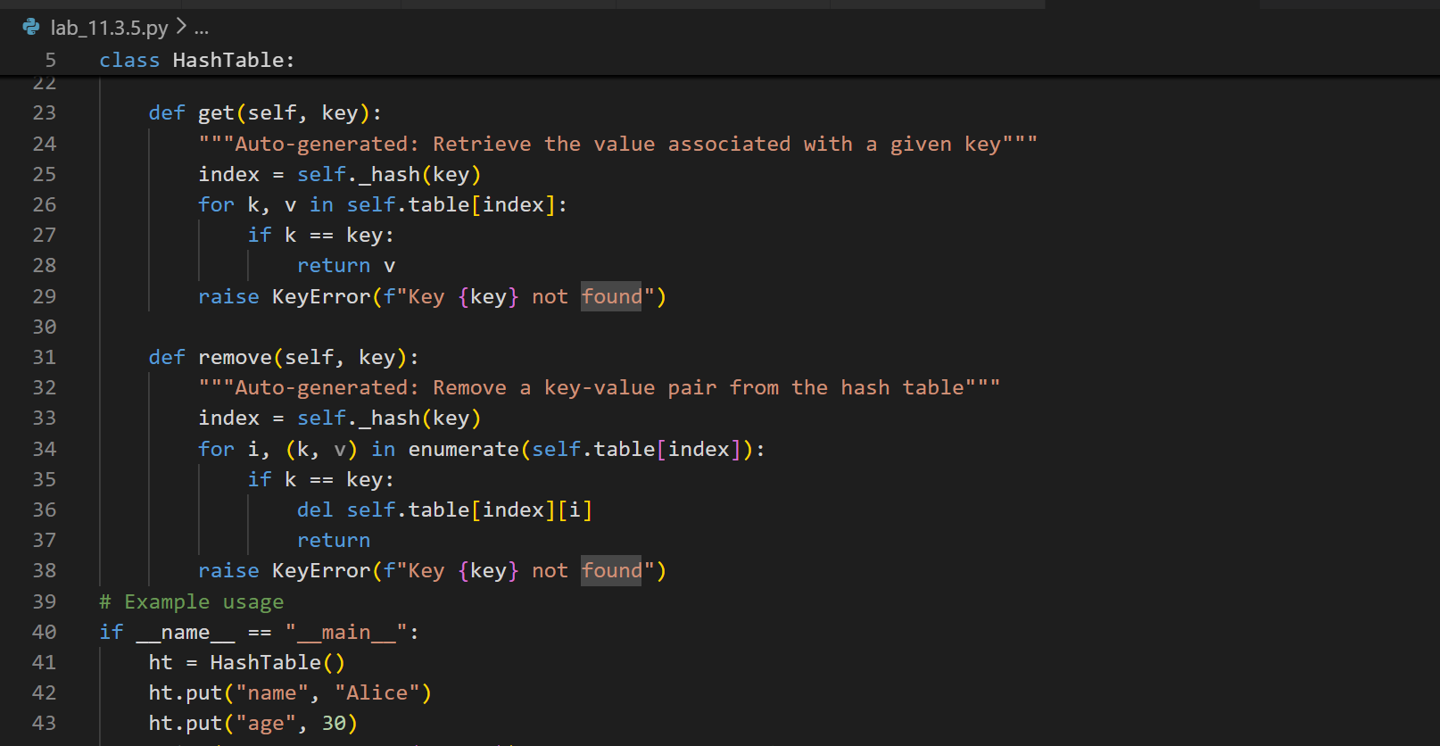
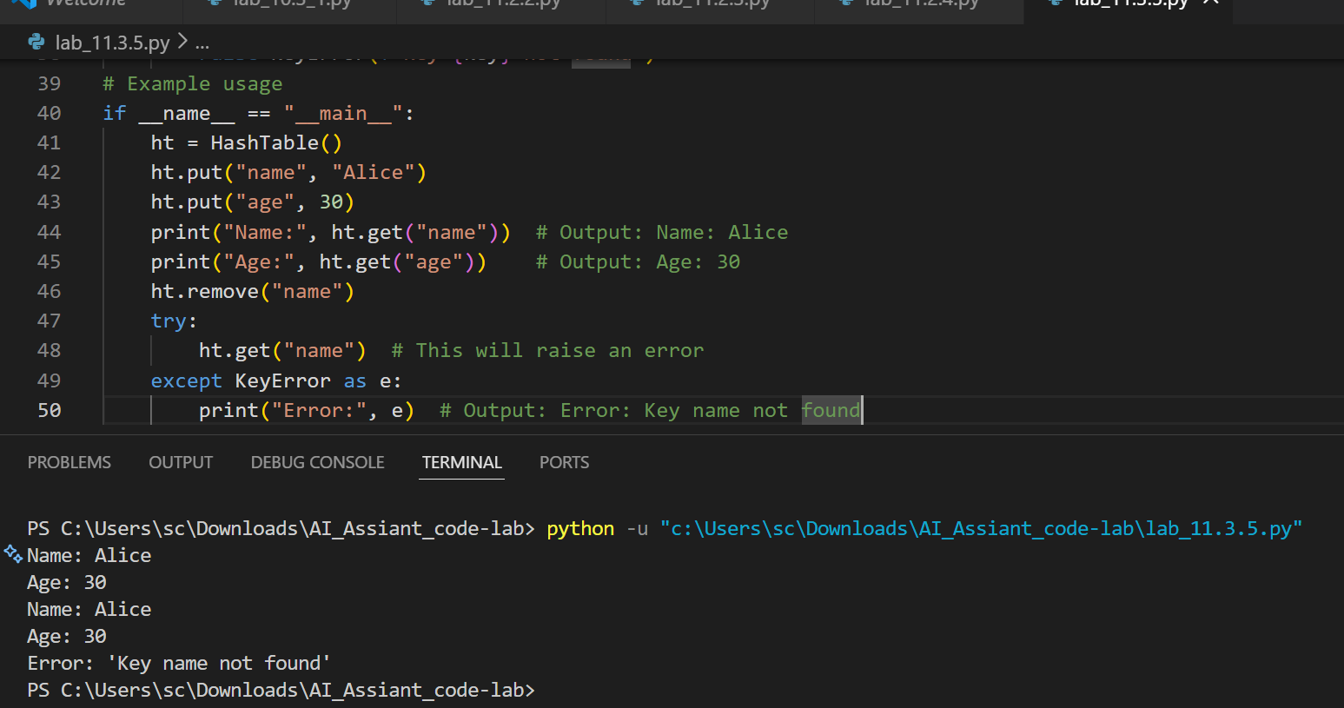

Explain code:-

This code implements a hash table using chaining to handle collisions. The HashTable class creates a fixed-size list where each index stores a sub-list (bucket), and the _hash() method calculates an index for a key using Python’s built-in hash() function with modulo operation.
The put() method inserts or updates key-value pairs in the correct bucket, the get() method searches the bucket to retrieve a value for a given key (raising KeyError if not found), and the remove() method deletes a key-value pair from the bucket. In the example, keys "name" and "age" are inserted and retrieved successfully, and attempting to access a removed key raises an error.

