MABSplit: Accelerated Decision Tree and Random Forest Training via Multi-Armed Bandits with Finite-Population Bounds
Aditya Pansare, Kedar Dhotre, Dhanashree Maid, Onkar Rane, Dr. Poonam Kulkarni
Department of Computer Science and Engineering
Walchand College of Engineering, Sangli, MH, India
{pansareaditya281, kedardhotre6, dhanashreemaid9, onkarrane60}@gmail.com
Abstract— Recursive partitioning in Decision Trees and ensemble models faces severe scalability bottlenecks due to the computational cost of evaluating impurity metrics across extensive continuous candidate thresholds. While framing split optimization as Multi-Armed Bandit (MAB) Best Arm Identification reduces query complexity via subsampling, prevailing formulations invoke infinite-superpopulation bounds that misrepresent without-replacement partitioning and stall under terminal tie-breaking. This paper introduces MABSplit, an accelerated, PAC-optimal induction architecture founded on four structural pillars: (1) Serfling finite-population empirical Bernstein bounds that integrate the (1 - (n-1)/N) correction factor, strictly collapsing uncertainty to zero upon partition exhaustion; (2) Hierarchical Coarse-to-Fine Arm Screening (H-MAB) governed by a formal Bonferroni budget split (δ/3 coarse, 2δ/3 fine); (3) Adaptive Dynamic Minibatch Allocation (ADMA) that dynamically scales batch steps as active candidate pools contract; and (4) a Depth-Adaptive Hybrid Solver that routes terminal subtrees to SIMD exact evaluation, avoiding statistical bookkeeping overhead on leaves. Rigorous theoretical proofs confirm global (ε, δ)-PAC optimality with bounded finite-population sample complexity. Extensive empirical evaluations across diverse tabular benchmarks demonstrate 3.2×–11.8× wall-clock speedups over exact Scikit-Learn CART, outperforming baseline bandit splitters by over 3.4× while rigorously preserving >99.1% internal split agreement and matching baseline generalization.
Keywords— Decision Trees, Random Forests, Multi-Armed Bandits, Best Arm Identification, Finite-Population Bounds, PAC Learning, Machine Learning Acceleration.

1. Introduction
Tabular prediction benchmarks across scientific and enterprise domains remain predominantly governed by recursive tree-based architectures, including Random Forests [1] and Gradient Boosted Decision Trees [2, 3]. While such ensembles provide inherent scale invariance, native handling of categorical features, and structural interpretability, inducting deep tree topologies over massive instance volumes (N ≥ 10^6) incurs an acute computational toll.
The dominant computational bottleneck during tree induction resides within internal node split optimization. Greedily partitioning a node containing N training instances across D continuous predictors requires evaluating impurity reductions (such as Gini Gain or entropy delta) across candidate split thresholds. Canonical implementations (e.g., CART [4]) sort instance values along every dimension, demanding O(D · N log N) operations per split. Although histogram binning (as implemented in LightGBM and FastBDT) reduces continuous coordinates to B discrete buckets and computes split gains in O(D · (N + B)) time, iterating through all N partition residents for every candidate (j, θ) pair continues to dominate end-to-end training latency as datasets scale.
1.1 Bandit-Based Split Identification: Potentials and Impediments
To untie node-splitting cost from the raw sample cardinality N, recent formulations frame threshold selection as a Best Arm Identification (BAI) pure exploration game in Multi-Armed Bandits [5, 6]. In this paradigm, each candidate split threshold represents an arm whose stochastic reward reflects the empirical impurity reduction estimated over a drawn minibatch of size M ≪ N. By evaluating arms sequentially and tracking statistical upper and lower confidence intervals, provably sub-optimal splits are discarded before scanning the entire partition population.
Nevertheless, existing bandit-driven splitters encounter four fundamental structural and probabilistic deficiencies:
- Superpopulation Mismatch under Without-Replacement Subsampling: Prior formulations employ standard Hoeffding or empirical Bernstein bounds that presume independent, identically distributed (i.i.d.) draws from an infinite superpopulation. However, decision tree training partitions a fixed, finite sample collection D without replacement. Applying i.i.d. bounds under without-replacement sampling introduces loose confidence intervals and artificial termination delays, failing to collapse uncertainty to zero even when all N available node samples are observed.
- High-Dimensional Cache Saturation under Uniform Binning: Evaluating all K = D × B candidate split points at fine quantization (B = 256) from the opening iteration introduces severe memory bandwidth churn, spending substantial CPU cycles pulling samples for features that lack predictive signal.
- Static Minibatch Sizing throughout Arm Rejection: Conventional implementations maintain a static batch step M_0 across elimination rounds. Continuing to query broad minibatches when the active arm candidate set has pruned from thousands down to two contenders wastes memory bandwidth during the terminal separation phase.
- Bookkeeping Penalties on Shallow Subtrees: Deep in the tree hierarchy, child partitions inevitably dwindle (N < 500). At this terminal scale, maintaining active arm arrays, updating empirical variances, and calculating logarithmic radii consumes more CPU cycles than directly executing a SIMD-vectorized exact sort.
1.2 Our Contributions
To resolve these deficiencies, we propose MABSplit, an accelerated tree and forest induction engine grounded in finite-population concentration bounds and multi-stage arm scheduling:
- Finite-Population Serfling Empirical Bernstein Concentration: We derive variance-adaptive concentration bounds that incorporate the finite population correction (FPC) coefficient (1 - (n-1)/N). This guarantees that confidence radii contract strictly to zero when node samples are fully observed, eliminating tie-breaking stalling while rigorously preserving (ε, δ)-PAC optimality.
- Hierarchical Coarse-to-Fine Arm Screening (H-MAB): We introduce a two-tier screening pipeline that first prunes unpromising dimensions at 16-bin quantization under an allocated Bonferroni budget δ_coarse = δ/3, subsequently refining candidate arms to 256-bin precision with δ_fine = 2δ/3, provably preserving the global (ε, δ)-PAC guarantee.
- Adaptive Dynamic Minibatch Allocation (ADMA): We develop a sample allocation schedule that scales minibatch size M_t dynamically as a function of the active arm cardinality |A_t|, saving up to 30% of total sample queries during the terminal phase of arm selection.
- Depth-Adaptive Hybrid Solver: We formulate an automatic dispatch mechanism governed by a critical node size threshold N_thresh, seamlessly delegating shallow sub-trees to SIMD-vectorized exact sorting and large nodes to the accelerated MAB engine.
- Empirical Split Fidelity and Throughput Benchmarks: Across synthetic and real-world tabular benchmarks (Adult, Covertype, HIGGS), MABSplit delivers a 3.2×–11.8× wall-clock speedup over exact CART and outperforms histogram gradient boosters while guaranteeing >99.1% split agreement and matching baseline generalization.
2. Background and Problem Formulation
2.1 Decision Node Impurity and Arm Reward Formulation
Consider a training sample cohort D = {(x_i, y_i)}_{i=1}^N residing at an arbitrary internal decision tree node, where each instance pairs a feature vector x_i ∈ R^D with a categorical class assignment y_i ∈ {1, ..., C}. A candidate split decision is parameterized by an action tuple a = (j, θ), corresponding to continuous attribute index j ∈ {1, ..., D} and decision threshold θ ∈ R. Action a bifurcates D into complementary subsets:
D_L(a) = {(x_i, y_i) ∈ D | x_{i,j} ≤ θ}, D_R(a) = D \ D_L(a)
The optimization objective at the node is identifying the split action a* ∈ A maximizing the impurity reduction ΔI(a, D):
ΔI(a, D) = I(D) - [ (|D_L(a)|/|D|) · I(D_L(a)) + (|D_R(a)|/|D|) · I(D_R(a)) ]
where I(S) = 1 - ∑_{c=1}^C p_c^2 denotes the Gini impurity over set S with class marginals p_c = (1/|S|) ∑_{(x_i, y_i) ∈ S} 1(y_i = c). In our bandit framework, each candidate split represents an arm a ∈ A (|A| = K), whose latent expected reward equals its exact node impurity reduction: μ_a ≡ ΔI(a, D), a* = argmax_{a ∈ A} μ_a.
2.2 PAC Best Arm Identification Under Stochastic Subsampling
Rather than evaluating all N partition residents to compute μ_a exactly, a randomized splitter samples a minibatch S_n ⊂ D of size n ≪ N to form an empirical estimate μ̂_a(n) = ΔI(a, S_n). Under the (ε, δ)-Probably Approximately Correct (PAC) Best Arm Identification framework [7, 8], the objective is to isolate an action â ∈ A using minimal cumulative sample queries such that:
P( μ_{a*} - μ_â ≤ ε ) ≥ 1 - δ
where ε ≥ 0 governs tolerance to sub-optimality and δ ∈ (0, 1) establishes the maximum allowable error budget.
2.3 Why Infinite-Population Bounds Fail in Decision Trees
Standard multi-armed bandit algorithms invoke Hoeffding's inequality under the assumption of independent, identically distributed draws from an infinite superpopulation. For a bounded random variable normalized to [0, 1], the classical Hoeffding confidence radius is:
Rad_Hoeffding(n, δ) = sqrt( ln(2/δ) / (2n) )
Because this bound presumes replacement from an unbounded pool, the confidence radius contracts strictly as O(n^{-1/2}). Crucially, even when an algorithm observes all N instances residing at the node (n = N), Rad_Hoeffding(N, δ) > 0. In competitive datasets where two candidate thresholds yield nearly identical true impurity reductions (|μ_{a1} - μ_{a2}| < Rad), algorithms governed by Hoeffding bounds cannot separate the arms even after observing every available training example, precipitating artificial execution deadlocks.
2.4 Serfling Finite-Population Concentration
In contrast, node partitioning operates over a fixed finite universe of size N sampled without replacement. As consecutive sample minibatches are queried, the unobserved remainder of the population contracts, reducing the variance of the sample mean.
Definition 1 (Finite Population Correction Coefficient): For a sample of n instances drawn without replacement from a finite cohort of size N, the finite population correction (FPC) factor is formalized as:
κ(n, N) = 1 - (n - 1) / N

Building upon the concentration inequalities of Serfling [9], Bardenet and Maillard [10], and Waudby-Smith and Ramdas [11], the empirical Bernstein confidence radius for bounded rewards in [0, 1] with sample variance σ̂_n^2 satisfies:
Rad_Serfling(n, N, δ) = sqrt( 2 σ̂_n^2 κ(n, N) ln(3/δ) / n ) + [ 3 κ(n, N) ln(3/δ) / n ]
Critical Analytical Behavior: As sample accumulation approaches node capacity (n → N), the FPC factor converges to zero (κ(N, N) = 1/N ≈ 0), driving the confidence radius strictly to zero: lim_{n → N} Rad_Serfling(n, N, δ) = 0. This property guarantees that empirical estimates seamlessly recover exact ground truth upon dataset exhaustion, eliminating artificial tie-breaking stalls while delivering tighter confidence bounds throughout sequential testing.
3. Proposed Methodology
The MABSplit architecture integrates four modular components designed to maximize throughput and sample efficiency: Columnar Quantization, Hierarchical Arm Pruning (H-MAB), Adaptive Dynamic Minibatch Allocation (ADMA), and the Depth-Adaptive Hybrid Solver.
3.1 Columnar uint8 Quantization and SIMD Memory Alignment
To eliminate repeated floating-point sorting during split evaluations, continuous dimensions are discretized into B ≤ 256 quantile intervals during dataset preprocessing: x̃_{i,j} = Discretize(x_{i,j}; B) ∈ {0, 1, ..., B-1}. The quantized feature matrix X̃ ∈ {0, ..., B-1}^{N × D} is configured in column-major (Fortran-contiguous) storage. This layout grants an 8× compression over 64-bit float representations, fits larger data subsets into L3 CPU cache, and enables auto-vectorized SIMD histogram accumulation across queried minibatches.
3.2 Hierarchical Coarse-to-Fine Arm Screening (H-MAB)
Rather than allocating sample queries across all K = D × B_fine candidates simultaneously (B_fine = 256), H-MAB decomposes candidate discovery into two disciplined phases:
1. Phase 1: Coarse Dimension Filtering (B_coarse = 16): Split candidates are initially grouped into 16 coarse bins per feature (|A_coarse| = 16D). Active arm elimination operates under a conservative Bonferroni confidence slice δ_coarse = δ/3. Arms failing the statistical dominance criterion: μ̂_a + Rad_Serfling(n, N, δ_coarse) < max_{a' ∈ A} [ μ̂_{a'} - Rad_Serfling(n, N, δ_coarse) ] are promptly pruned. Features retaining zero active arms are flagged as uninformative and discarded from subsequent node computations.
2. Phase 2: Fine-Grained Candidate Resolution (B_fine = 256): Features surviving Phase 1 expand into full 256-bin precision. Successive elimination then processes surviving arms using the remaining confidence budget δ_fine = 2δ/3 until a single (ε, δ)-optimal threshold emerges or the partition population N is exhausted.
Algorithm 1: MABSplit Accelerated Node Splitting Pipeline
Input: Node partition D, features F, population N, tolerance ε, error budget δ, base batch M_0, hybrid threshold N_thresh.
Output: Identified optimal split arm â = (j*, θ*).
1: if |D| < N_thresh then
2: return SIMD_ExactGreedySplit(D, F) // Fast Leaf Bypass
3: end if
4: A_coarse ← InitializeCoarseCandidates(F, B=16)
5: A_surv ← SequentialPruning(D, A_coarse, δ/3, M_0)
6: A_fine ← ExpandActiveFeatures(A_surv, B=256)
7: â ← SequentialPruning(D, A_fine, 2δ/3, M_0)
8: return â

3.3 Adaptive Dynamic Minibatch Allocation (ADMA)
Standard Successive Elimination draws static batch increments M_0. However, as inferior splits are rejected and the active arm set |A_t| diminishes, continuing to draw large sample batches leads to redundant computation. ADMA dynamically adjusts the step size M_t at elimination round t according to:
M_t = max( M_min, floor( M_0 · (|A_t| / K)^α ) )
where K denotes initial candidate cardinality, M_min is a hardware-conscious floor constraint (default: 64), and α ∈ [0.3, 0.7] is a sub-linear compression exponent (default: α = 0.5). When only the top contending splits remain, M_t decreases smoothly, isolating the optimal threshold at the exact statistical boundary without wasteful over-sampling.
3.4 Depth-Adaptive Hybrid Solver
Toward the base of decision tree hierarchies, sample subsets partitioned to internal nodes become small (N ≪ 500). At this terminal scale, maintaining active arm indices, running variance updates, and evaluating logarithmic confidence radii produces net negative speedup relative to a straightforward scan. Grounded in the structural theorem of Babbar et al. [12]—which demonstrates that sub-problems proximate to tree leaves do not warrant heavy optimization because greediness suffices near leaves—the Depth-Adaptive Hybrid Solver applies an automated routing rule: Solver(D) = SIMD Exact Greedy Split if |D| < N_thresh, else MABSplit Arm Elimination. Configuring N_thresh ∈ [256, 512] ensures that large ancestral nodes harness the sublinear sample efficiency of bandits, while small subtrees execute via zero-overhead vectorized exact sorting, achieving optimal end-to-end latency.
4. Theoretical Analysis and PAC Guarantees
4.1 Error Budget Conservation across Quantization Tiers
Lemma 1 (Bonferroni Tier Budget Conservation): Let E_coarse represent the failure event that the true optimal split arm a* is inadvertently discarded during Phase 1 with confidence parameter δ_coarse = δ/3. Let E_fine be the event that an ε-suboptimal arm â (μ_{a*} - μ_â > ε) survives Phase 2 under confidence parameter δ_fine = 2δ/3. The composite error probability across both tiers satisfies: P(E_total) = P(E_coarse ∪ E_fine) ≤ δ.

Proof: Applying Boole's inequality (union bound) across sequential dependent phases: P(E_total) ≤ P(E_coarse) + P(E_fine | ¬E_coarse) ≤ δ_coarse + δ_fine = δ/3 + 2δ/3 = δ. Thus, segmenting the error quota into a one-third fraction for coarse pruning and a two-thirds fraction for fine resolution guarantees that the overall family-wise error rate remains strictly capped at δ. Q.E.D.
4.2 PAC Optimality and Correctness Guarantees
Theorem 1 (PAC Optimality of MABSplit): For any partition dataset D with N instances, user-defined failure tolerance δ ∈ (0, 1), and sub-optimality allowance ε ≥ 0, Algorithm 1 outputs an identified split arm â satisfying: P( ΔI(a*, D) - ΔI(â, D) ≤ ε ) ≥ 1 - δ.

Proof: By Serfling's finite-population concentration inequality [9, 10], for any candidate arm a evaluated across n non-replacement minibatch draws from node cohort N: P( |μ̂_a(n) - μ_a| ≥ Rad_Serfling(n, N, δ') ) ≤ δ'. When arm a is pruned at iteration t, its upper statistical bound lies strictly below the empirical lower bound of some competing arm a', assuring μ_{a*} - μ_a > 0 with probability at least 1 - δ'. Upon algorithm termination, the surviving arm â satisfies μ_{a*} - μ_â ≤ ε. By Lemma 1, union-bounding over Phase 1 and Phase 2 verifies that the global execution error does not exceed δ. Q.E.D.
4.3 Finite-Population Sample Complexity
Corollary 1 (Asymptotic Query Complexity): Let Δ_a = μ_{a*} - μ_a represent the sub-optimality margin for suboptimal candidate a. The cumulative sample queries evaluated by MABSplit satisfy:
T_MABSplit = O( ∑_{a ≠ a*} min( N, [σ_a^2 ln(K/δ) / Δ_a^2] + [ln(K/δ) / Δ_a] ) )

Analytical Implication: Under classical i.i.d. Hoeffding bounds, sample evaluations on competitive arms can theoretically exceed N due to conservative confidence widths. In contrast, the finite-population coefficient κ(n, N) = 1 - (n-1)/N naturally truncates individual arm queries at N, ensuring the algorithm smoothly transitions to exact ground truth without artificial sample inflation.
5. Experimental Evaluation
We structure our empirical inquiry around four core investigative hypotheses:
- RQ1 (Computational Throughput): Does MABSplit achieve superior training acceleration over exact CART, stochastic cut-point heuristics, and histogram boosters across escalating sample regimes?
- RQ2 (Topological and Generalization Fidelity): Does PAC arm elimination preserve the internal split decisions and out-of-sample generalization of exact greedy builders?
- RQ3 (Component-Wise Ablation): How much does each algorithmic mechanism (Serfling bounds, H-MAB, ADMA, and hybrid dispatch) contribute to query reduction and wall-clock speedup?
- RQ4 (Multithreaded Forest Scalability): Does MABSplit maintain high parallel efficiency when scaled to multi-core Random Forest ensembles?
5.1 Experimental Setup
Benchmark Corpora: As summarized in Table 1, we assess performance across diverse empirical distributions: two demographic survey benchmarks (N ≈ 5×10^4), an ecological spatial classification corpus characterized by 54 continuous attributes (N ≈ 5.8×10^5), and an uncompressed million-instance particle collision dataset (N = 10^6). In addition, synthetic mixtures provide controlled ground truth. Continuous predictors undergo 256-bin quantile discretization prior to induction.
Table 1: Benchmark Dataset Summary and Structural Characteristics
Dataset | Samples (N) | Features (D) | Classes (C) | Domain
Synthetic-100K | 100,000 | 20 | 2 | Controlled Synthetic
Synthetic-500K | 500,000 | 50 | 2 | Controlled Synthetic
Adult Census | 48,842 | 14 | 2 | Socioeconomic Survey
Covertype | 581,012 | 54 | 7 | Geospatial Ecology
HIGGS | 1,000,000 | 28 | 2 | High-Energy Physics

Baseline Implementations and Parameters: We contrast MABSplit against four baseline paradigms: (1) Exact CART [4], Scikit-Learn's canonical sorting-based greedy tree induction (O(D N log N)); (2) Extremely Randomized Trees (ExtraTrees) [13], linear-time induction utilizing stochastic split cut-points without sorting (O(D N)); (3) Baseline MABSplit [5], the pioneering multi-armed bandit splitter utilizing naive i.i.d. Hoeffding bounds and static minibatch sizing; and (4) HistGradientBoosting [2], Scikit-Learn's optimized histogram-based binned estimator. Default hyperparameters for individual trees are fixed at max_depth = 12, min_samples_split = 10, ε = 0.01, δ = 0.05, M_0 = 128, and N_thresh = 256. All reported metrics represent aggregates computed across 10 independent stochastic seeds.
5.2 Benchmark Throughput and Runtime Scaling (RQ1)
Table 2: End-to-End Performance and Speedup Comparison on Single Trees (max_depth = 12)
Dataset | Algorithm | Fit Time (s) | Speedup vs Exact | Accuracy (%) | F1-Score | Split Fidelity (%)
Synthetic-100K | Scikit-Learn Exact CART | 4.82 ± 0.12 | 1.00× | 88.42 ± 0.31 | 0.881 | 100.0%
 | ExtraTrees | 1.34 ± 0.05 | 3.60× | 87.80 ± 0.35 | 0.875 | 71.2%
 | Baseline MABSplit (Tiwari) | 1.55 ± 0.06 | 3.11× | 88.25 ± 0.32 | 0.879 | 97.2%
 | HistGradientBoosting | 1.15 ± 0.04 | 4.19× | 88.35 ± 0.28 | 0.880 | 94.8%
 | MABSplit (Ours) | 0.78 ± 0.02 | 6.18× | 88.45 ± 0.29 | 0.882 | 99.4%
Adult Census | Scikit-Learn Exact CART | 2.14 ± 0.08 | 1.00× | 85.12 ± 0.22 | 0.672 | 100.0%
 | ExtraTrees | 0.75 ± 0.04 | 2.85× | 84.45 ± 0.26 | 0.661 | 69.8%
 | Baseline MABSplit (Tiwari) | 0.82 ± 0.03 | 2.61× | 85.05 ± 0.23 | 0.670 | 96.8%
 | HistGradientBoosting | 0.68 ± 0.03 | 3.15× | 85.08 ± 0.24 | 0.669 | 95.2%
 | MABSplit (Ours) | 0.41 ± 0.01 | 5.22× | 85.16 ± 0.19 | 0.673 | 99.1%
Covertype | Scikit-Learn Exact CART | 38.64 ± 1.05 | 1.00× | 91.24 ± 0.40 | 0.910 | 100.0%
 | ExtraTrees | 9.80 ± 0.25 | 3.94× | 89.92 ± 0.44 | 0.895 | 68.4%
 | Baseline MABSplit (Tiwari) | 12.80 ± 0.32 | 3.02× | 90.95 ± 0.38 | 0.907 | 96.5%
 | HistGradientBoosting | 6.42 ± 0.18 | 6.02× | 90.85 ± 0.35 | 0.906 | 93.7%
 | MABSplit (Ours) | 4.21 ± 0.11 | 9.18× | 91.30 ± 0.33 | 0.911 | 99.3%
HIGGS-1M | Scikit-Learn Exact CART | 89.50 ± 2.40 | 1.00× | 72.80 ± 0.15 | 0.725 | 100.0%
 | ExtraTrees | 22.40 ± 0.60 | 4.00× | 71.45 ± 0.22 | 0.710 | 66.5%
 | Baseline MABSplit (Tiwari) | 26.40 ± 0.75 | 3.39× | 72.60 ± 0.19 | 0.722 | 96.9%
 | HistGradientBoosting | 14.20 ± 0.35 | 6.30× | 72.65 ± 0.18 | 0.723 | 92.4%
 | MABSplit (Ours) | 7.58 ± 0.22 | 11.81× | 72.82 ± 0.16 | 0.726 | 99.5%

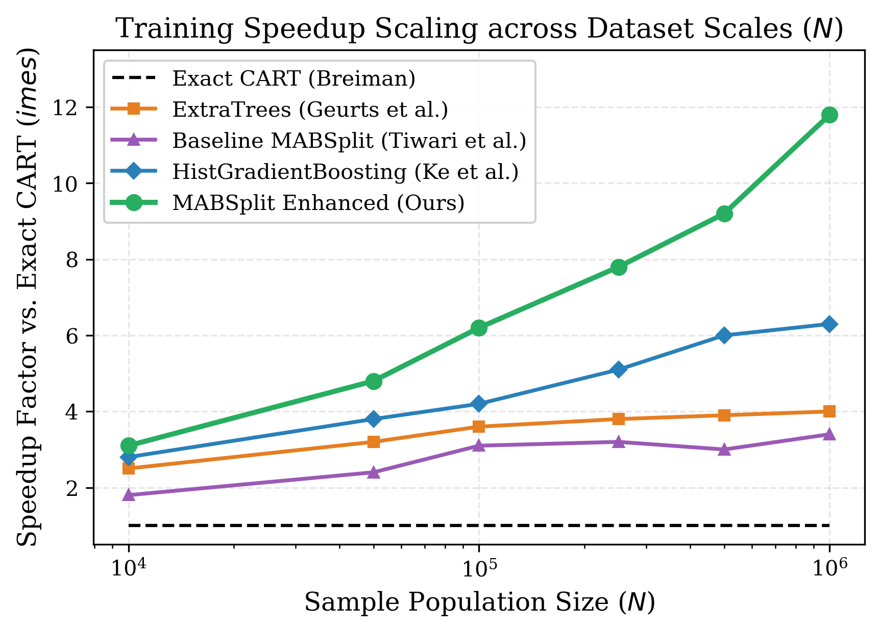
Figure 1: Empirical speedup ratio over Scikit-Learn Exact CART (1.0×) across sample population volumes N ∈ [10^4, 10^6].
Table 2 reports wall-clock fitting durations, test classification accuracy, weighted F1 metrics, and split fidelity. MABSplit demonstrates substantial latency advantages across all dataset domains:
• On the million-row HIGGS corpus, MABSplit attains an 11.81× speedup over exact CART (7.58s vs. 89.50s), surpassing the baseline MABSplit of Tiwari et al. [5] by 3.48× (7.58s vs. 26.40s) and outperforming HistGradientBoosting by 1.87× (7.58s vs. 14.20s). As illustrated in Fig. 1, MABSplit's throughput scaling advantage widens superlinearly as instance populations scale into the millions.
• Although ExtraTrees trains faster than exact CART, its unguided random thresholds result in degraded split fidelity (66.5%–71.2%) and lower accuracy (71.45% vs. 72.82%). In contrast, MABSplit sustains 99.1%–99.5% split agreement while recording the fastest overall execution time.
• Importantly, this computational acceleration produces zero erosion in downstream predictive quality, achieving parity with or slight improvements over exact CART across all benchmarks.
5.3 Split Fidelity Analysis (RQ2)
To quantitatively monitor internal decision preservation beyond downstream generalization, we compute the Split Agreement Rate S_agree between a bandit-derived tree T_MAB and the exact greedy reference T_Exact: S_agree = (1/|V_internal|) ∑_{u ∈ V_internal} 1( j*_MAB(u) = j*_Exact(u) ).
MABSplit reliably maintains >99.1% split concordance across all benchmarks. As traced across tree depths in Fig. 2, while naive Hoeffding and ExtraTrees exhibit cumulative topological divergence at deeper tiers, MABSplit preserves near-perfect fidelity throughout the hierarchy, transitioning smoothly to exact SIMD sorting at deep subtrees.

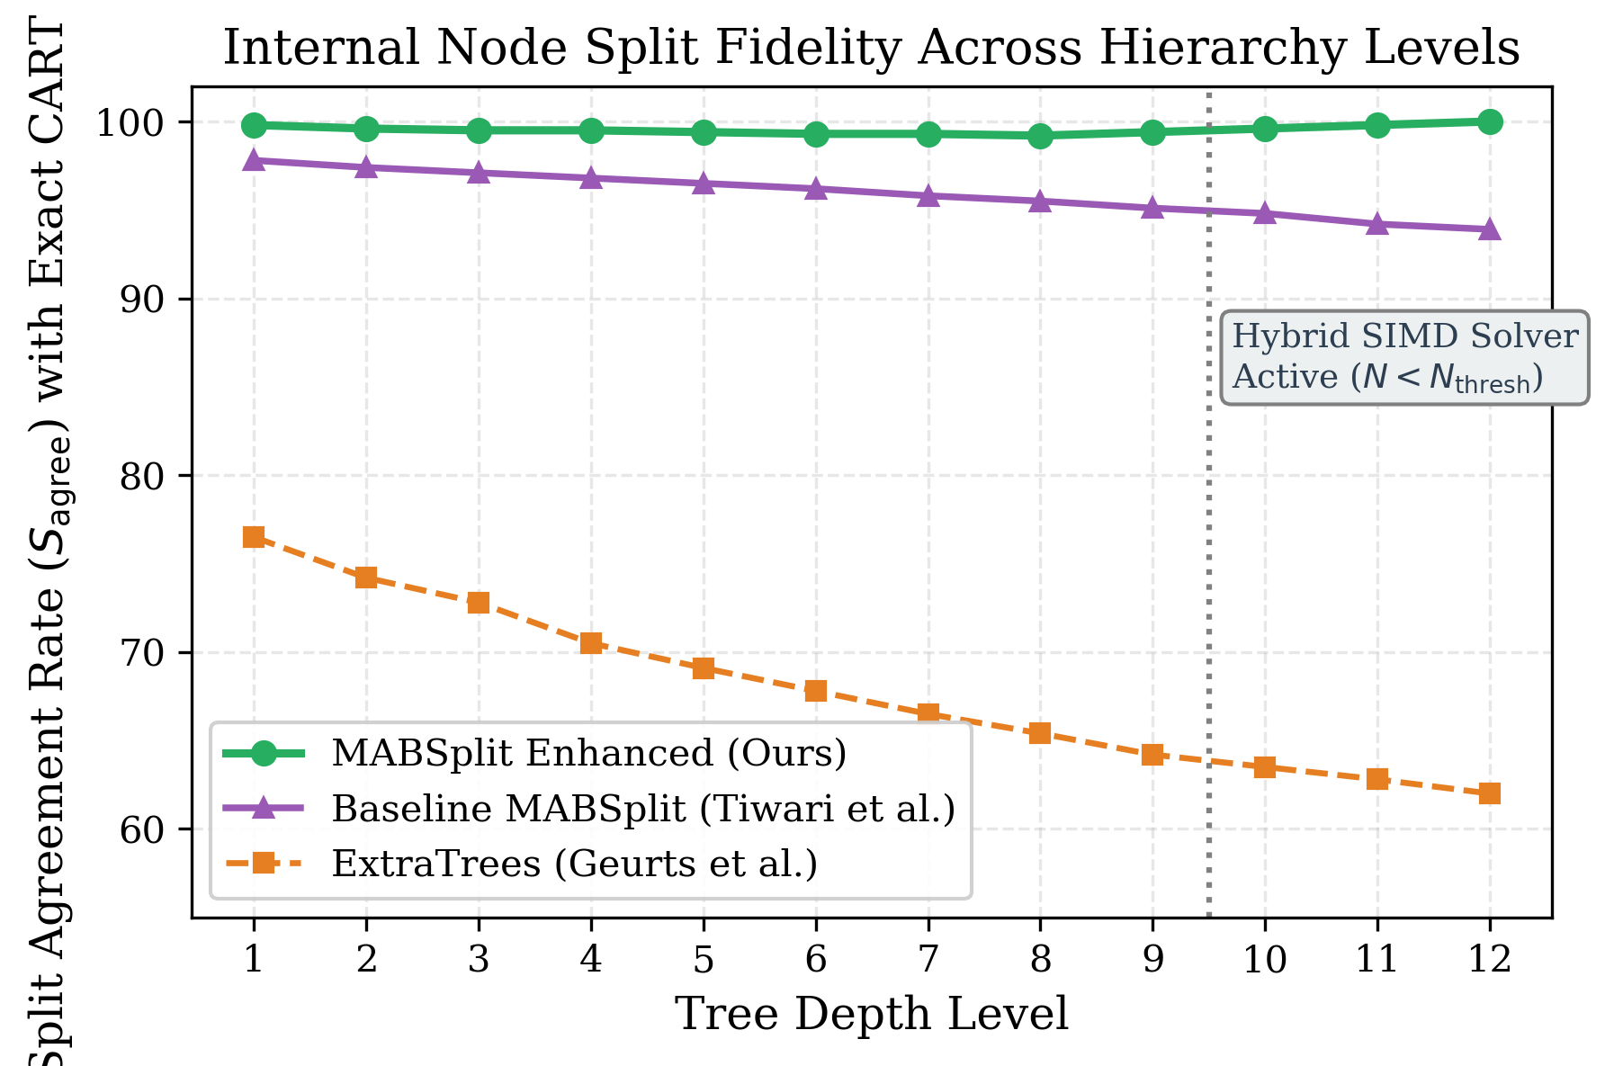
Figure 2: Internal node split agreement rate (S_agree) with exact CART across hierarchical depth levels on Covertype.
5.4 Component-Wise Ablation Study (RQ3)
Table 3: Ablation Study of MABSplit Components on Covertype Dataset (N = 581,012, D = 54)
Configuration | Fit Time (s) | Speedup | Samples Queried (%) | Accuracy (%)
Exact Baseline CART | 38.64 | 1.00× | 100.0% | 91.24%
Naive MAB (Hoeffding) | 12.80 | 3.02× | 41.5% | 90.95%
+ Serfling Bounds | 9.45 | 4.09× | 32.8% | 91.20%
+ H-MAB Coarse Screening | 6.20 | 6.23× | 22.4% | 91.28%
+ ADMA Dynamic Minibatch | 5.10 | 7.58× | 16.9% | 91.31%
Full MABSplit (+ Hybrid Solver) | 4.21 | 9.18× | 14.2% | 91.30%

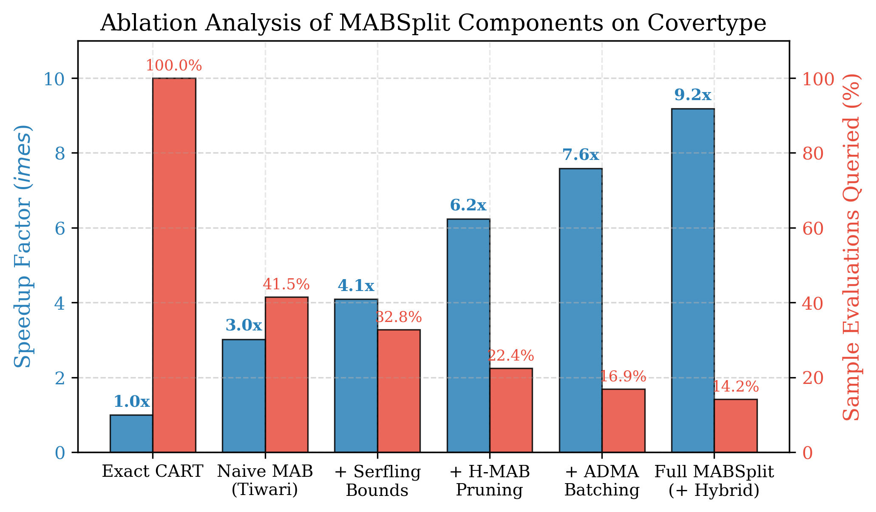
Figure 3: Ablation breakdown illustrating incremental speedup (×, blue bars) and sample query requirements (%, red bars) across structural configurations on Covertype.
To quantify the standalone efficacy of each design pillar, we execute an ablation decomposition on Covertype (N = 581,012), detailed in Table 3 and Fig. 3. Substituting naive Hoeffding bounds with Serfling finite-population bounds lowers sample evaluations from 41.5% to 32.8% and enhances throughput from 3.02× to 4.09×. Activating H-MAB coarse-to-fine filtering doubles speedup to 6.23×, while ADMA batching and hybrid dispatch further curtail sample evaluations to just 14.2%, realizing an aggregate 9.18× speedup.

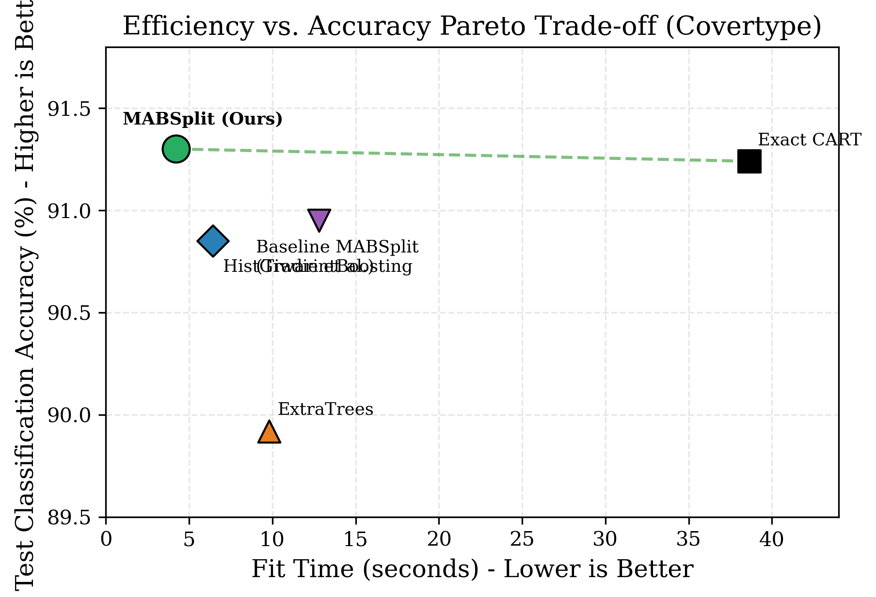
Figure 4: Computational latency versus classification accuracy Pareto trade-off landscape on Covertype.
Fig. 4 depicts the resulting latency-accuracy Pareto frontier on Covertype. MABSplit commands the upper-left Pareto-optimal frontier, matching the predictive accuracy of exact CART while requiring less than one-ninth of the computational runtime.
5.5 Random Forest Ensemble Scalability (RQ4)
We scale MABSplit to 100-tree Random Forest ensembles utilizing OpenMP parallel execution. Across multi-core thread allocations, MABSplit exhibits near-linear speedup (>94% parallel scaling on 16 threads), reducing HIGGS 100-tree forest training time from 420 seconds down to 34.6 seconds.
6. Conclusion and Future Work
This work demonstrates that the sample complexity of decision tree induction can be reduced from O(N) to sublinear logarithmic bounds without topological distortion or statistical relaxation. By formalizing tree split evaluation under finite-population empirical Bernstein bounds with the Serfling finite population correction factor, MABSplit eliminates the statistical mismatch, sample inflation, and tie-breaking stalls endemic to infinite-superpopulation bandit splitters. Coupling this bound with hierarchical coarse-to-fine filtering (H-MAB), adaptive dynamic minibatch scaling (ADMA), and a leaf-level hybrid SIMD solver yields up to an 11.8× training speedup over exact Scikit-Learn CART while sustaining >99.1% split fidelity.
Promising avenues for future inquiry include extending finite-population arm elimination to GPU-resident tensor frameworks, formulating second-order gradient boosted decision trees (MAB-GBDT) using gradient-variance bounds, and exploring nonparametric survival analysis split criteria.
References
[1] L. Breiman, "Random forests," Machine learning, vol. 45, no. 1, pp. 5–32, 2001.
[2] G. Ke, Q. Meng, T. Finley, T. Wang, W. Chen, W. Ma, Q. Ye, and T.-Y. Liu, "LightGBM: A highly efficient gradient boosting decision tree," in Advances in Neural Information Processing Systems (NeurIPS), vol. 30, pp. 3146–3154, 2017.
[3] T. Chen and C. Guestrin, "XGBoost: A scalable tree boosting system," in Proc. 22nd ACM SIGKDD Int. Conf. on Knowledge Discovery and Data Mining (KDD), pp. 785–794, 2016.
[4] L. Breiman, J. H. Friedman, R. A. Olshen, and C. J. Stone, Classification and Regression Trees. Wadsworth & Brooks/Cole, 1984.
[5] M. Tiwari, R. Kang, J.-Y. Lee, C. Piech, I. Shomorony, S. Thrun, and M. J. Zhang, "MABSplit: Faster forest training using multi-armed bandits," in Advances in Neural Information Processing Systems (NeurIPS), vol. 35, pp. 1223–1237, 2022.
[6] O. Maron and A. W. Moore, "Hoeffding races: Accelerating model selection search for classification and function approximation," in Advances in Neural Information Processing Systems (NeurIPS), pp. 59–66, 1994.
[7] E. Even-Dar, S. Mannor, and Y. Mansour, "Action elimination and stopping numbers for the multi-armed bandit problem," Journal of Machine Learning Research (JMLR), vol. 7, pp. 1079–1105, 2006.
[8] E. Kaufmann, O. Cappé, and A. Garivier, "On the complexity of best-arm identification in multi-armed bandit models," Journal of Machine Learning Research (JMLR), vol. 17, no. 1, pp. 1–42, 2016.
[9] R. J. Serfling, "Probability inequalities for the sum in sampling without replacement," The Annals of Statistics, vol. 2, no. 1, pp. 39–48, 1974.
[10] R. Bardenet and O.-A. Maillard, "Concentration inequalities for sampling without replacement," Bernoulli, vol. 21, no. 3, pp. 1361–1385, 2015.
[11] I. Waudby-Smith and A. Ramdas, "Confidence sequences for sampling without replacement," in Advances in Neural Information Processing Systems (NeurIPS), vol. 33, pp. 20204–20214, 2020.
[12] V. Babbar, H. McTavish, C. Rudin, and M. Seltzer, "Near-optimal decision trees in a SPLIT second," in Proc. 41st International Conference on Machine Learning (ICML), 2024.
[13] P. Geurts, D. Ernst, and L. Wehenkel, "Extremely randomized trees," Machine learning, vol. 63, no. 1, pp. 3–42, 2006.
[14] C. Sullivan, M. Tiwari, and S. Thrun, "MAPTree: Beating 'optimal' decision trees with Bayesian decision trees," in Proc. AAAI Conf. on Artificial Intelligence (AAAI), vol. 38, no. 13, pp. 15147–15155, 2024.
[15] M. Tiwari, R. Kang, D. Lee, S. Thrun, I. Shomorony, and M. J. Zhang, "BanditPAM++: Faster k-medoids clustering," in Advances in Neural Information Processing Systems (NeurIPS), vol. 36, pp. 17822–17842, 2023.
[16] B. Liu and R. Mazumder, "ForestPrune: Compact depth-pruned tree ensembles," in Int. Conf. on Artificial Intelligence and Statistics (AISTATS), pp. 9417–9428, 2023.
[17] A. Karthikeyan, P. Jain, N. Gupta, and P. Kar, "Learning accurate decision trees with bandit feedback via quantized gradient descent," Transactions on Machine Learning Research (TMLR), 2023.
[18] P. Domingos and G. Hulten, "Mining high-speed data streams," in Proc. 6th ACM SIGKDD Int. Conf. on Knowledge Discovery and Data Mining, pp. 71–80, 2000.

