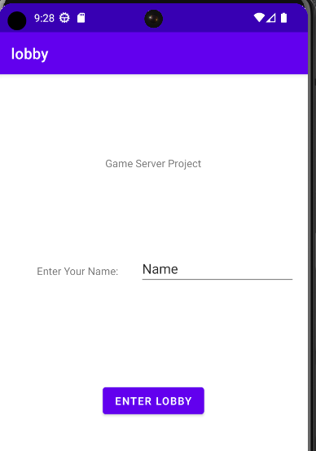Starter window.

Enter Lobby button – switches to the game lobby

Window with the inserted name.

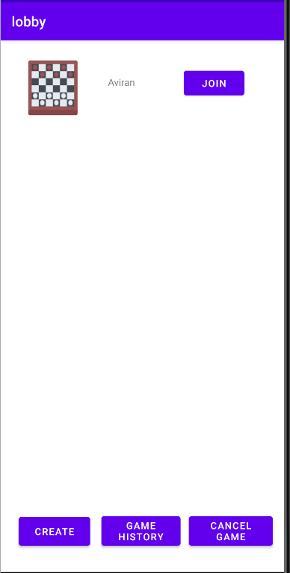Lobby window.

Create button – creates a game in lobby

Game History button – Switches to game history View

Cancel game button – Cancels the created game in Lobby if created

Join button – Joins the selected game in lobby.

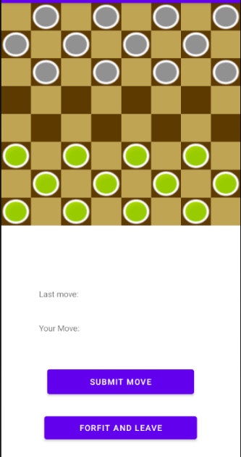Game window.

Click on the board to select a move, the selected move will show on “your move”. The last move played will show under “Last move”.

Submit button – submit a move and updated the server with the selected move.

Forfeit button – Forfeits and leaves the game window into the lobby.

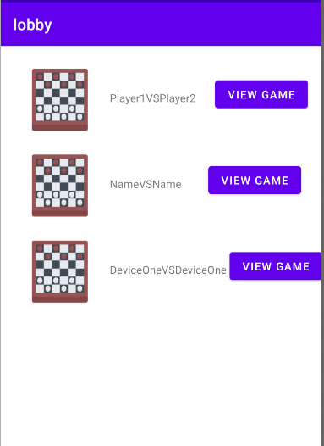Game history view

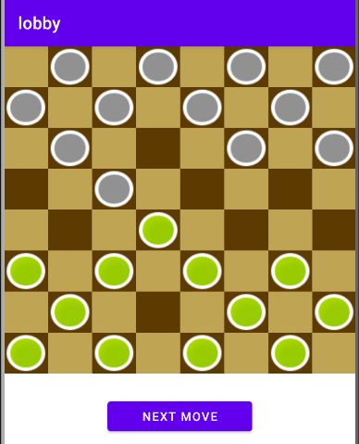View game Button – open game window to inspect and review the selected game in menu.

Game review window

Next move Button – displays the next move played in the selected game.