Histogram for all variables in a dataset mtcars. Write a program to create histograms for all columns

install.packages("purrr")

library(purrr)

install.packages("tidyr")

library(tidyr)

library(ggplot2)

mtcars%>%

keep(is.numeric)%>%

gather() %>%

ggplot(aes(value))+

facet_wrap(~key, scales = "free")+

geom_histogram()

hist(mtcars1$mpg) – Repeat this command for each variable after $ sign, to create histrogram of each variable

p <- ggplot(data = mtcars, aes(x=variable, y=value)) +

geom_boxplot(aes(fill=Label))

p + facet_wrap( ~ variable, scales="free")

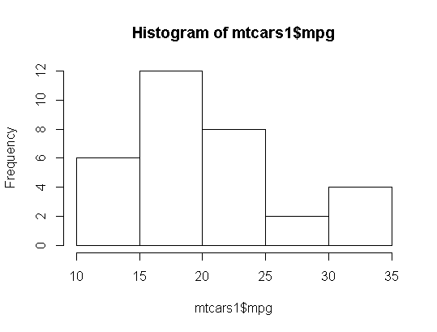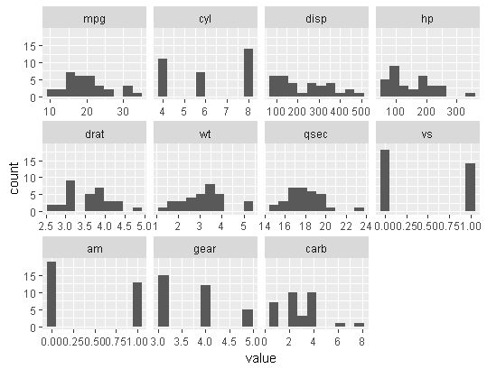

mtcars1

library(reshape)

head(melt(mtcars))

library(ggplot2)

ggplot(data=melt(mtcars1), mapping = aes(x=value))+

geom_histogram(bins = 10)+ facet_wrap(~variable, scales = 'free_x')

View(mtcars1)