**CC Endsem - PYQ(2024, 2023, 2022)**

**UNIT 3**

**Q1. What is virtualization? What is Type 1 Hypervisor and Type 2 Hypervisor? [6]**

**=>**

**1. Virtualization:**

Virtualization is a technique of creating a **virtual version** of physical components like servers, storage devices, networks, or operating systems. It allows multiple **virtual machines (VMs)** with different operating systems to run on a single physical machine by **abstracting hardware resources**.

* Each VM operates independently as if it were a separate physical machine.
* Virtualization improves **resource utilization**, **scalability**, **fault isolation**, and **cost efficiency**.
* It is the backbone of **cloud computing** as it enables on-demand resource provisioning.

**2. Hypervisor:**

A **hypervisor** is a software layer that enables virtualization. It sits between the hardware and virtual machines and is responsible for **allocating resources** (CPU, memory, storage) to each VM.

There are **two types** of hypervisors:

**3. Type 1 Hypervisor (Bare-Metal Hypervisor):**

* Installed **directly on the physical hardware** without any host OS.
* Offers **direct access to hardware**, which leads to **better performance**, **efficiency**, and **low latency**.
* Typically used in **enterprise data centers and cloud environments**.
* **Secure and stable** as it has fewer layers between hardware and VM.

**Examples:**  
VMware ESXi, Microsoft Hyper-V (Server Core), Citrix XenServer, KVM.

**4. Type 2 Hypervisor (Hosted Hypervisor):**

* Installed **on top of an existing operating system** (host OS).
* Relies on the host OS to interact with hardware resources.
* Slightly **lower performance** compared to Type 1 due to overhead from host OS.
* Easier to set up and use for **developers, testers, and personal users**.

**Examples:**  
VMware Workstation, Oracle VirtualBox, Parallels Desktop.

**5. Key Differences:**

| **Feature** | **Type 1 Hypervisor** | **Type 2 Hypervisor** |
| --- | --- | --- |
| Installed on | Physical hardware (bare metal) | Host operating system |
| Performance | High (no OS overhead) | Moderate (host OS overhead) |
| Use case | Data centers, production | Testing, personal use |
| Examples | VMware ESXi, Xen, Hyper-V | VirtualBox, VMware Workstation |

**Conclusion:**

Virtualization, enabled through hypervisors, is essential in modern computing. **Type 1 hypervisors** are suited for **enterprise-grade and production systems**, while **Type 2 hypervisors** are better for **development, testing, and learning purposes**.

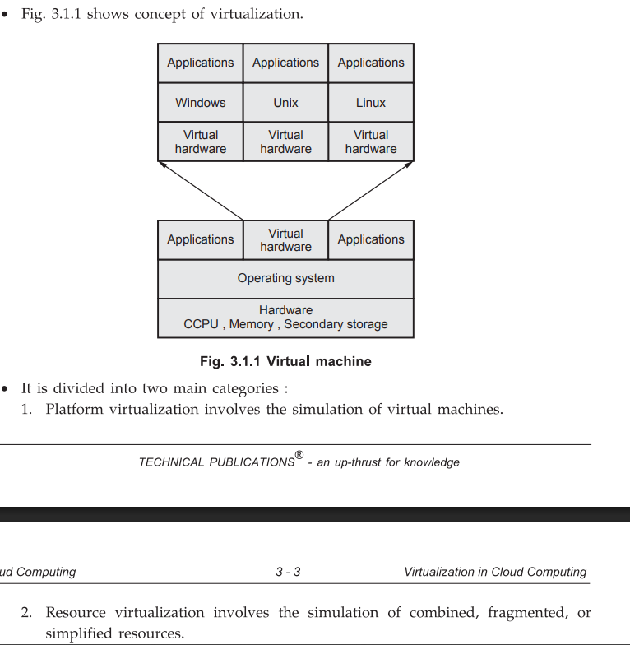

**Q2. Explain Virtual clustering in detail? [6]**

**=>**

### 1. Definition of Virtual Clustering:

Virtual clustering refers to the creation of a **cluster of virtual machines (VMs)** on top of physical servers using virtualization technology. Each virtual node (VM) in the cluster appears as a separate system but shares the underlying physical infrastructure.

It enables **resource sharing**, **load balancing**, **high availability**, and **scalability** in cloud environments.

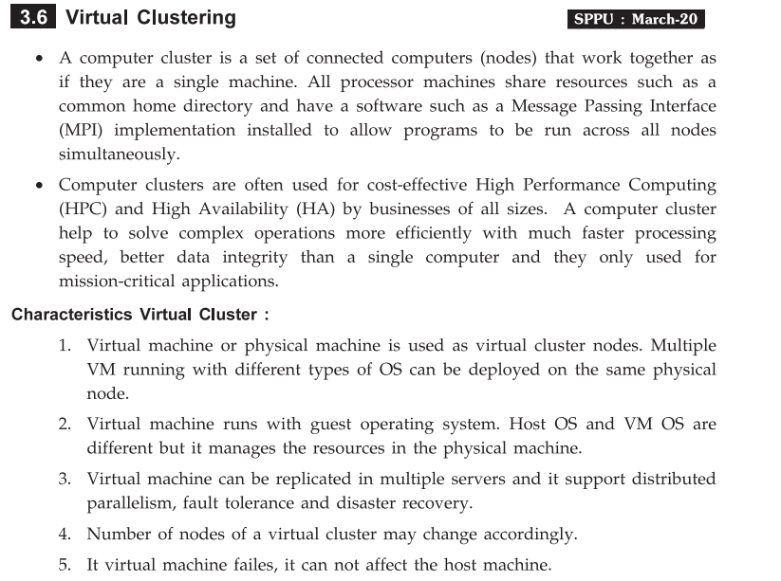

**2. Purpose of Virtual Clustering:**

* To **combine the computing power** of multiple VMs to work as a single logical unit.
* To support **parallel processing**, **distributed computing**, and **fault tolerance**.
* To **simulate a real cluster** for testing, research, or development.
* To **optimize physical resource usage** by running multiple clusters on fewer physical machines.

**3. Components of a Virtual Cluster:**

1. **Physical Machines (Hosts):**
   * Provide CPU, memory, storage, and network resources.
   * Run the **hypervisor** to host VMs.
2. **Hypervisor:**
   * Manages the creation and execution of VMs (e.g., VMware ESXi, KVM).
3. **Virtual Machines (VMs):**
   * Act as **cluster nodes** with their own operating systems and applications.
4. **Virtual Network:**
   * Connects all VMs to form a communication channel within the cluster.

**4. Working of Virtual Clustering:**

* Multiple VMs are created using a hypervisor on one or more physical servers.
* These VMs are configured to **cooperate** and work together as a cluster.
* Tasks such as data processing or application hosting are **distributed** among VMs.
* **Middleware software** like Apache Hadoop, Spark, or MPI can be used to coordinate the distributed operations.
* If a VM fails, another VM can take over, ensuring **fault tolerance and high availability**.

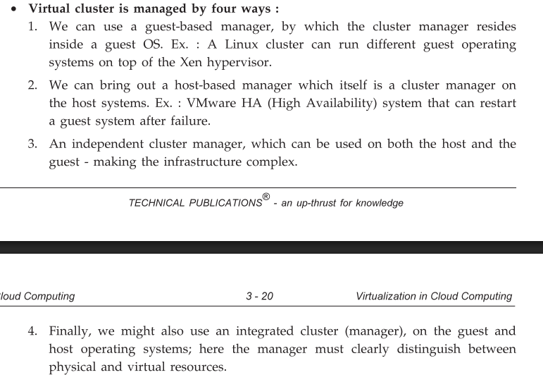

**5. Advantages of Virtual Clustering:**

* **Efficient resource utilization**
* **Cost-effective** (no need for separate physical machines)
* **Flexible and scalable**
* **Easy to manage and reconfigure**
* **Supports fault-tolerant systems**

**6. Example Use Case:**

In a Hadoop-based Big Data system, a virtual cluster may consist of:

* One VM as the **NameNode**
* Multiple VMs as **DataNodes**  
  All running on virtualized infrastructure but acting as a real distributed system.

**Conclusion:**

Virtual clustering plays a critical role in cloud computing by enabling multiple VMs to collaborate as a logical cluster. It helps in achieving **better performance**, **resource management**, and **service reliability** without requiring a large number of physical machines.

**Q3. Explain Virtualization in grid computing? [6]**

**=>**

**1. Introduction:**

**Grid computing** is a distributed computing model where resources like CPU, storage, and applications are shared across multiple administrative domains to solve large-scale problems.

**Virtualization** in grid computing enhances flexibility, scalability, and efficient resource utilization by abstracting physical resources into virtual units.

**2. Role of Virtualization in Grid Computing:**

Virtualization introduces a **layer of abstraction** between physical hardware and grid applications, allowing the dynamic creation and management of **Virtual Machines (VMs)** or **virtual resources**.

**3. Key Benefits of Virtualization in Grid Computing:**

1. **Resource Abstraction:**
   * Virtualization hides hardware complexity and presents resources in a standard, uniform format.
2. **Isolation:**
   * VMs are isolated from each other, ensuring security and fault isolation in a multi-user grid environment.
3. **Dynamic Resource Allocation:**
   * VMs can be created, resized, or destroyed on demand, allowing **efficient scheduling** of grid tasks.
4. **Portability and Flexibility:**
   * Virtual environments can be moved across physical machines without affecting execution.
5. **Improved Utilization:**
   * Multiple virtual grid nodes can run on fewer physical systems, reducing cost.

**4. How Virtualization Enhances Grid Computing:**

* **Grid middleware** (like Globus Toolkit) can manage VMs as grid nodes.
* VMs can be used to **simulate grid nodes** for testing before real deployment.
* Virtualization supports **load balancing**, **fault tolerance**, and **energy efficiency**.
* It enables **on-demand provisioning** of computing environments.

**5. Example Scenario:**

In a scientific research project using grid computing:

* Researchers can deploy **pre-configured VMs** across a grid.
* These VMs perform simulations in parallel, and results are gathered centrally.
* If one VM fails, another can quickly be launched to continue processing.

**6. Technologies Used:**

* **Hypervisors:** VMware, Xen, KVM
* **Virtualization platforms:** OpenStack, VirtualBox
* **Grid middleware with virtualization support:** Globus Toolkit, UNICORE

**Conclusion:**

Virtualization plays a vital role in grid computing by providing **flexible**, **scalable**, and **efficient** resource management. It simplifies grid infrastructure management and improves the performance and reliability of distributed computing environments.

**Q4. Explain Virtualization Application and Pitfalls of Virtualization? [6]**

**=>**

**1. Applications of Virtualization:**

1. **Server Consolidation:**
   * Multiple servers are virtualized and run on a single physical machine, reducing hardware and energy costs.
2. **Cloud Computing:**
   * Virtualization is the foundation of cloud services (IaaS, PaaS, SaaS). It allows dynamic provisioning of resources on-demand.
3. **Testing and Development Environments:**
   * Developers use virtual machines to test applications in different OS environments without needing multiple physical systems.
4. **Disaster Recovery:**
   * VMs can be backed up and restored easily, ensuring quick disaster recovery and business continuity.
5. **Legacy System Support:**
   * Old software can run on VMs with outdated OS versions, even if not supported on modern hardware.
6. **Desktop Virtualization (VDI):**
   * Users can access virtual desktops remotely, improving security and management.

**2. Pitfalls of Virtualization:**

1. **Performance Overhead:**
   * Virtualization adds a software layer (hypervisor), which may cause slight performance degradation compared to native hardware.
2. **Security Risks:**
   * If a hypervisor is compromised, all VMs on that host can be at risk (single point of failure).
3. **Complex Management:**
   * Managing multiple virtual machines and ensuring their resource allocation can be challenging without proper tools.
4. **Licensing Issues:**
   * Licensing virtual environments can be complicated, especially with proprietary software.
5. **Resource Contention:**
   * Multiple VMs may compete for limited physical resources (CPU, RAM), causing bottlenecks.
6. **Not Ideal for High-Performance Applications:**
   * Applications requiring real-time processing or high I/O performance may not work efficiently in virtualized environments.

**Conclusion:**

Virtualization has a wide range of applications across IT infrastructure, cloud computing, and software development. However, it must be implemented carefully to avoid performance, security, and management-related pitfalls.

**Q5. Explain Network and Storage Virtualization? [6]**

**=>**

**1. Network Virtualization:**

**Definition:**  
Network virtualization is the process of combining hardware (like switches, routers) and software network resources into a **single, software-based virtual network**. It allows multiple virtual networks to operate independently on the same physical network infrastructure.

**Key Features:**

* **Logical separation** of network traffic.
* **Improved network management** and scalability.
* **Isolation and security** between virtual networks.

**Components:**

* **Virtual LANs (VLANs)**
* **Virtual Private Networks (VPNs)**
* **Software-Defined Networking (SDN)**
* **Virtual switches and routers**

**Benefits:**

* Easy network provisioning and management
* Faster deployment of services
* Better resource utilization and isolation

**Example:**  
Using SDN, a network admin can configure a virtual firewall, load balancer, and switch, all without changing the physical network layout.

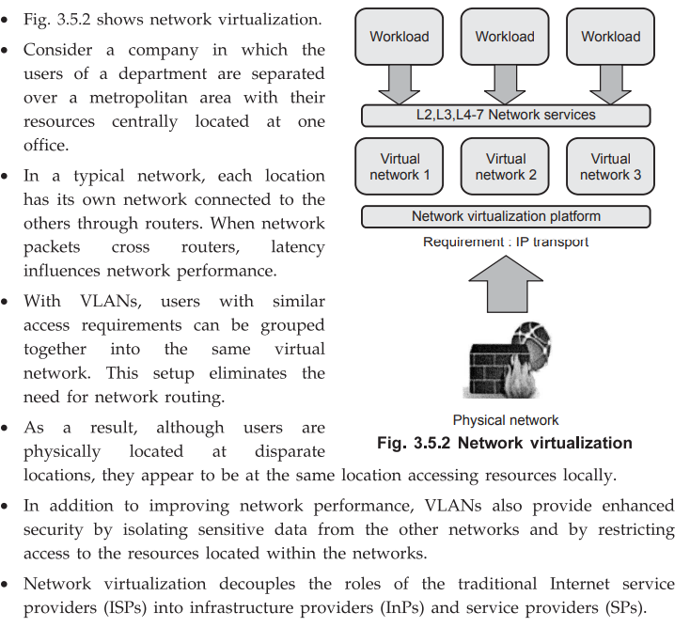

**2. Storage Virtualization:**

**Definition:**  
Storage virtualization is the pooling of physical storage from multiple devices into a **single virtual storage unit** that appears as one storage system to users and applications.

**Types:**

1. **Block-level Virtualization:** Virtualizes storage at block level (used in SANs).
2. **File-level Virtualization:** Abstracts and manages files (used in NAS).

**Components:**

* Storage devices (HDDs, SSDs)
* Virtual storage controller or software layer
* SAN (Storage Area Network) or NAS (Network Attached Storage)

**Benefits:**

* Centralized storage management
* Simplified backup and recovery
* Increased storage utilization and flexibility
* Scalability and fault tolerance

**Example:**  
In a virtualized storage system, data from multiple disks is combined into one virtual volume that can be resized or migrated without affecting users.

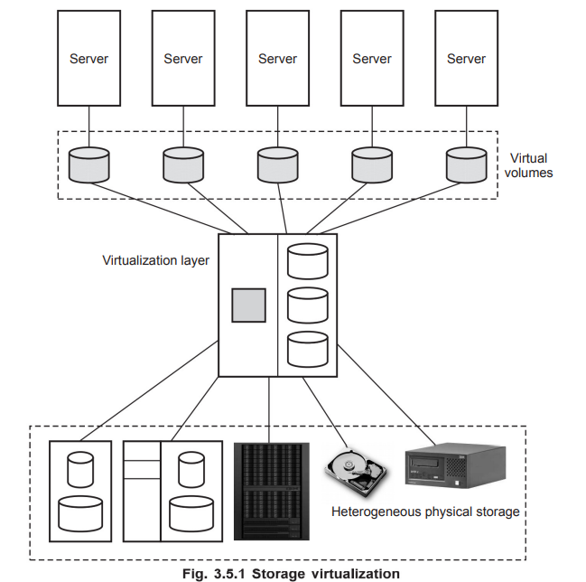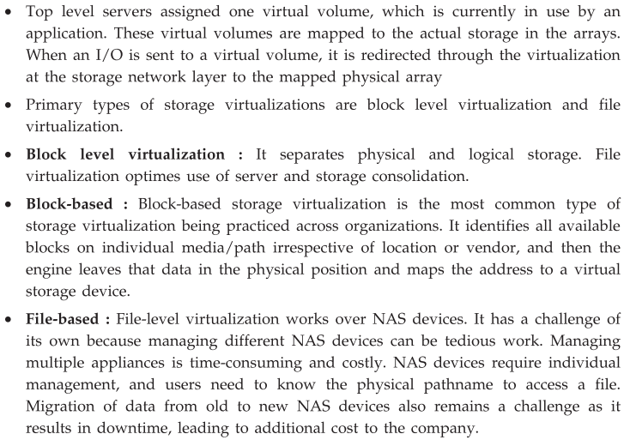

**Conclusion:**

Both **network** and **storage virtualization** abstract physical infrastructure to provide flexible, scalable, and efficient management. These technologies are fundamental to **cloud computing and virtualized data centers**, enabling better resource allocation, isolation, and control.

**Q6. Explain virtual machine migration technique in detail? [6]**

**=>**

### ****1. Definition:****

**Virtual Machine Migration** is the process of **moving a running virtual machine (VM)** from one physical host to another without disrupting the services running inside the VM. It is widely used in **cloud computing and virtualized data centers** for **load balancing, maintenance, fault tolerance, and energy management**.

### ****2. Types of VM Migration:****

#### a) **Cold Migration:**

* The VM is **shut down** before migrating.
* Migration occurs offline.
* **Simple but causes downtime.**
* Suitable for non-critical applications.

#### b) **Live Migration:**

* VM is migrated while it is **still running**.
* Minimal or no downtime.
* Common in **high-availability systems**.

#### c) **Hot Migration:**

* Similar to live migration, but **includes active I/O and memory transfers**.
* Slightly higher complexity than live migration.

### ****3. Live Migration Process (Steps):****

1. **Pre-Migration:**
   * Destination host is selected and verified.
2. **Memory Transfer:**
   * VM’s memory pages are copied from source to destination **while the VM is running**.
   * Modified pages are tracked.
3. **Stop-and-Copy:**
   * VM is paused briefly.
   * Remaining memory and CPU state are transferred.
4. **Resume:**
   * VM is resumed on the destination host.
   * Execution continues with minimal service disruption.

### ****4. Benefits of VM Migration:****

* **Load Balancing:** Migrate VMs to underutilized hosts.
* **Hardware Maintenance:** VMs can be moved to allow hardware upgrades.
* **Power Management:** Idle servers can be powered off.
* **Fault Tolerance:** VMs moved from failing hosts to healthy ones.

### ****5. Challenges:****

* **Migration Time:** Must be fast to avoid delays.
* **Network Overhead:** Large memory transfers consume bandwidth.
* **Security Risks:** Data may be exposed during transfer.
* **Resource Availability:** Target host must have sufficient capacity.

### ****Conclusion:****

Virtual machine migration is a key technique in managing virtualized environments. It enhances **resource optimization, service availability**, and **infrastructure flexibility** with minimal disruption to users.

**Q8. Describe the importance of hypervisor in cloud computing? Differentiate Type I and Type 2 hypervisor? [8]**

**=>**

### ****Q8. Describe the Importance of Hypervisor in Cloud Computing. Differentiate between Type 1 and Type 2 Hypervisor. [8 Marks]****

### ****1. Importance of Hypervisor in Cloud Computing:****

A **hypervisor**, also known as a **Virtual Machine Monitor (VMM)**, is a software layer that allows multiple **virtual machines (VMs)** to run on a single physical hardware system. It manages **CPU, memory, storage**, and **network resources** for each VM.

In **cloud computing**, hypervisors are the **core enablers of virtualization**, which is essential for building **Infrastructure as a Service (IaaS)** platforms like Amazon EC2, Microsoft Azure, etc.

#### **Key Roles and Importance:**

1. **Resource Isolation:**
   * Each VM is isolated, preventing interference and ensuring security.
2. **Efficient Resource Utilization:**
   * Allows better usage of CPU, RAM, and storage by sharing them among VMs.
3. **Multi-tenancy Support:**
   * Enables multiple users (tenants) to share the same physical server with complete isolation.
4. **Dynamic Resource Allocation:**
   * Hypervisors dynamically allocate resources based on demand, optimizing performance.
5. **Fault Tolerance and High Availability:**
   * Enables VM migration and replication to ensure continuity in case of failures.
6. **Cost Efficiency:**
   * Reduces the need for dedicated hardware, lowering operational and capital costs.
7. **Rapid Provisioning:**
   * New VMs can be created and deployed within minutes, enabling scalability.
8. **Security and Control:**
   * Hypervisors enforce access control, firewalls, and monitoring at the VM level.

### ****2. Types of Hypervisors:****

Hypervisors are broadly classified into two types based on how they interact with hardware:

### ****Type 1 Hypervisor (Bare-Metal Hypervisor):****

#### **Definition:**

A Type 1 hypervisor runs **directly on the physical hardware** without needing a host operating system.

#### **Features:**

* High performance due to direct access to hardware.
* Used in **enterprise and data center environments**.
* More secure and stable as there's no host OS.

#### **Examples:**

VMware ESXi, Microsoft Hyper-V (Server Core), Citrix XenServer, KVM.

### ****Type 2 Hypervisor (Hosted Hypervisor):****

#### **Definition:**

A Type 2 hypervisor runs **on top of an existing operating system** (host OS).

#### **Features:**

* Easier to install and use.
* Suitable for **personal use, testing, and development**.
* Slightly lower performance due to additional OS layer.

#### **Examples:**

VMware Workstation, Oracle VirtualBox, Parallels Desktop.

### ****3. Comparison Table:****

| **Feature** | **Type 1 Hypervisor** | **Type 2 Hypervisor** |
| --- | --- | --- |
| Installation | Directly on hardware | On top of host operating system |
| Performance | High | Moderate (host OS overhead) |
| Use Case | Enterprise, cloud infrastructure | Personal, development, testing |
| Resource Access | Direct hardware access | Via host OS |
| Security | High | Moderate |
| Example | VMware ESXi, Hyper-V, Xen | VirtualBox, VMware Workstation |

### ****Conclusion:****

The **hypervisor is critical in cloud computing** as it forms the foundation of virtualization, allowing resource sharing, scalability, and efficient cloud service delivery. Understanding the **differences between Type 1 and Type 2 hypervisors** is essential for choosing the right virtualization technology based on performance and use-case requirements.

**Q9. Compare grid computing and cloud computing? [9]**

**=>**

Grid Computing and Cloud Computing are both **distributed computing models**, but they differ in architecture, resource management, service models, and purpose.

**✅ Comparison Table:**

| **Point of Comparison** | **Grid Computing** | **Cloud Computing** |
| --- | --- | --- |
| **1. Definition** | Uses a network of distributed computers to solve a single task collaboratively. | Provides on-demand computing services (compute, storage, network) over the web. |
| **2. Purpose** | Designed for **scientific research and large-scale computation**. | Designed for **commercial and general-purpose applications**. |
| **3. Resource Ownership** | Resources are owned by **different organizations** across locations. | Resources are **centrally managed** by cloud providers. |
| **4. Resource Allocation** | Static or manually configured resource allocation. | Dynamic resource provisioning based on user demand. |
| **5. Virtualization Support** | Minimal or no virtualization. | Extensive use of **virtualization** for resource abstraction. |
| **6. Service Models** | Not service-oriented; mostly task or job-based. | Offers **IaaS, PaaS, SaaS** service models. |
| **7. Accessibility** | Requires predefined access or collaboration agreements. | Publicly accessible over the **internet**. |
| **8. Cost Model** | Often **free or non-commercial** (research-focused). | Pay-as-you-go model based on **usage and subscription**. |
| **9. Scalability** | Limited scalability depending on physical grid nodes. | High scalability with elastic resource provisioning. |
| **10. Fault Tolerance** | Less automated fault recovery; handled manually or via job resubmission. | Built-in **auto-recovery, redundancy,** and **failover** mechanisms. |
| **11. Latency** | May have **high latency** due to distributed nature. | Low latency due to **centralized and optimized** infrastructure. |
| **12. Example Technologies** | Globus Toolkit, BOINC, Condor | AWS, Microsoft Azure, Google Cloud |
| **13. Application Type** | Scientific simulations, climate modeling, drug discovery. | Web hosting, data storage, enterprise applications, mobile apps. |
| **14. Control and Customization** | Controlled by users or organizations collaboratively. | Controlled by **cloud service providers** with limited user-level access. |

**✅ Conclusion:**

* **Grid computing** is best suited for **scientific and research-based parallel tasks**, using distributed resources.
* **Cloud computing** is ideal for **scalable, flexible, and cost-effective** services for individuals and enterprises.

**Q10. Define virtualizations? Describe the advantages and disadvantages of Virtualization? [8]**

**=>**

**1. Definition of Virtualization:**

**Virtualization** is the process of creating a **virtual version** of physical resources such as servers, storage devices, networks, or even entire operating systems. It allows multiple virtual machines (VMs) to run on a single physical machine, each with its own OS and applications.

**Key Concept:**  
It abstracts hardware resources and delivers them as **logical units** to users.

**2. Advantages of Virtualization:**

1. **Efficient Resource Utilization:**
   * Maximizes use of CPU, RAM, and storage by sharing them among multiple VMs.
2. **Cost Saving:**
   * Reduces hardware, energy, and maintenance costs by consolidating servers.
3. **Isolation and Security:**
   * Each VM is isolated, reducing the risk of interference and improving security.
4. **Flexibility and Scalability:**
   * Resources can be easily scaled up or down based on demand.
5. **Quick Deployment and Provisioning:**
   * VMs can be created and deployed in minutes, speeding up development and testing.
6. **Disaster Recovery and Backup:**
   * VMs can be easily backed up and restored, improving business continuity.
7. **Cross-platform Support:**
   * Allows running different operating systems on the same hardware.
8. **Supports Legacy Applications:**
   * Older applications can run in virtual environments without modifying hardware.

**3. Disadvantages of Virtualization:**

1. **Performance Overhead:**
   * Slight reduction in performance compared to native hardware due to hypervisor layer.
2. **High Initial Setup Cost:**
   * Initial investment in virtualization infrastructure can be expensive.
3. **Complex Management:**
   * Managing multiple VMs, networks, and storage needs skilled administrators and proper tools.
4. **Single Point of Failure:**
   * If the physical host fails, all hosted VMs may become unavailable unless redundancy is in place.
5. **Security Risks:**
   * A breach in the hypervisor can potentially affect all VMs on the host.
6. **Software Licensing Issues:**
   * Managing licenses in virtual environments can be complex and costly.
7. **Not Ideal for Heavy I/O Applications:**
   * Virtualization may not perform well with applications requiring high disk or network throughput.

**Conclusion:**

Virtualization plays a vital role in **modern IT infrastructure and cloud computing**, offering significant benefits like cost savings, flexibility, and scalability. However, careful planning is required to mitigate performance, management, and security challenges.

**Q11. Describe CPU, Network and Storage Virtualization? [9]**

**=>**

### 1. CPU Virtualization:

**Definition:**  
CPU virtualization allows multiple operating systems and applications to share the physical CPU of a host machine as if each has its own dedicated CPU.

**How it Works:**

* The **hypervisor** intercepts and manages CPU instructions between the guest OS and the physical CPU.
* Each VM gets a **virtual CPU (vCPU)**, mapped to the host’s physical CPU cores.

**Types:**

* **Full Virtualization:** Guest OS doesn’t require modification.
* **Paravirtualization:** Guest OS is aware it is virtualized and cooperates with the hypervisor.

**Advantages:**

* Efficient CPU usage
* Supports multi-tasking and multi-tenancy
* Load balancing between VMs

**Example:**  
Running 4 VMs on a quad-core processor using scheduling.

**2. Network Virtualization:**

**Definition:**  
Network virtualization combines physical and software-based networking resources into one **logical, manageable network**.

**Components:**

* **Virtual switches**
* **Virtual routers**
* **VLANs (Virtual LANs)**
* **VPNs (Virtual Private Networks)**
* **SDN (Software Defined Networking)**

**How it Works:**

* Abstracts and segments the physical network for multiple tenants or purposes.
* Each VM is connected to a **virtual network** independent of the underlying hardware.

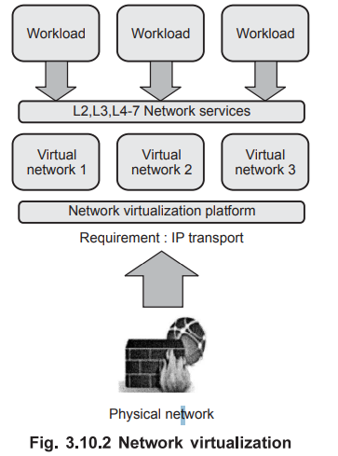

**Advantages:**

* Improved network scalability
* Better isolation and security
* Easy provisioning and management

**Example:**  
A data center hosting multiple clients with logically separated networks using VLANs and SDN.

**3. Storage Virtualization:**

**Definition:**  
Storage virtualization abstracts multiple physical storage devices and presents them as a **single virtual storage unit**.

**Types:**

* **Block-level virtualization:** Used in SAN (Storage Area Network)
* **File-level virtualization:** Used in NAS (Network Attached Storage)

**How it Works:**

* A **virtualization layer or controller** maps virtual storage volumes to physical disks.
* Users interact with logical storage, not the actual hardware.



**Advantages:**

* Centralized storage management
* Simplified backup and recovery
* Scalable and efficient use of storage

**Example:**  
Multiple physical disks pooled into one logical drive accessible by VMs in a cloud environment.

**Conclusion:**

**CPU, Network, and Storage Virtualization** are core technologies in virtualization and cloud computing. They allow flexible, secure, and efficient use of computing resources while reducing costs and improving system scalability and reliability.

**Q12. Draw and Explain the Virtualization Architecture in detail? [8]**

**=>**

### ✅ ****1. Definition:****

**Virtualization Architecture** refers to the structural design that enables virtualization of physical resources such as CPU, memory, storage, and network through a layer called the **hypervisor**. This architecture allows **multiple virtual machines (VMs)** to run on a single physical machine.

### ✅ ****2. Diagram of Virtualization Architecture:****

pgsql

CopyEdit

+----------------------------+

| Virtual Machines |

| +-----+ +-----+ +-----+ |

| | VM1 | | VM2 | | VM3 | |

| +-----+ +-----+ +-----+ |

+------------|---------------+

|

+----------------+

| Hypervisor |

| (VMM Layer) |

+----------------+

|

+-------------------------------+

| Physical Hardware Layer |

| CPU | Memory | Storage | NIC |

+-------------------------------+

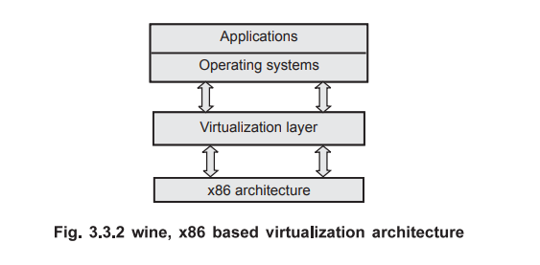

### ✅ ****3. Layers of Virtualization Architecture:****

#### **a) Virtual Machine Layer:**

* Consists of **multiple VMs** running simultaneously.
* Each VM has its own **guest operating system** and applications.
* Operates as if on independent physical hardware.

#### **b) Hypervisor Layer:**

* The core component that **manages virtualization**.
* It sits between hardware and VMs.
* Allocates and monitors **hardware resources** to each VM.
* Types:
  + **Type 1 (Bare Metal)**: Runs directly on hardware.
  + **Type 2 (Hosted)**: Runs on a host operating system.

#### **c) Physical Hardware Layer:**

* Includes **CPU, RAM, disk, and network interfaces**.
* These resources are abstracted and distributed by the hypervisor to different VMs.

### ✅ ****4. Functions of Virtualization Architecture:****

1. **Resource Management:**  
   Allocates CPU, memory, storage dynamically to VMs.
2. **Isolation:**  
   Ensures that one VM does not interfere with others.
3. **Security:**  
   Provides boundaries between VMs to prevent data breaches.
4. **Portability:**  
   VMs can be moved or copied easily across systems.
5. **Efficiency:**  
   Optimizes hardware usage and reduces power and hardware costs.
6. **Fault Tolerance & High Availability:**  
   Enables VM migration and recovery from hardware failure.

### ✅ ****5. Conclusion:****

Virtualization architecture is essential for **cloud computing, data centers**, and **enterprise IT environments**. It allows better **resource utilization**, **cost-efficiency**, and **scalability**, while also enabling isolation, security, and flexibility in system operations.

**Q13. Define Virtualization? Explain different types of Virtualizations? [9]**

**=>**

### ✅ ****1. Definition of Virtualization:****

**Virtualization** is a technology that allows creation of a **virtual (rather than actual) version** of hardware platforms, operating systems, storage devices, or network resources.  
It enables multiple virtual environments to run on a single physical system by **abstracting physical hardware** and delivering resources logically.

**Key Goal:** Improve **resource utilization, scalability, isolation, and flexibility**.

### ✅ ****2. Types of Virtualization:****

#### **a) Hardware Virtualization (CPU Virtualization):**

* **Definition:** Creation of virtual machines (VMs) that simulate physical computers.
* **Done Using:** A hypervisor (Type 1 or Type 2).
* **Use:** Allows running multiple OSes on a single machine.
* **Example:** VMware ESXi, Microsoft Hyper-V.

#### **b) Operating System Virtualization:**

* **Definition:** Multiple isolated user-space instances run on a single OS kernel.
* **Known As:** Containers or containerization.
* **Use:** Lightweight and fast deployments.
* **Tools:** Docker, LXC (Linux Containers).
* **Example:** Running multiple isolated applications in Docker containers.

#### **c) Network Virtualization:**

* **Definition:** Combines hardware and software network resources into a single virtual network.
* **Use:** Enables efficient, flexible, and secure communication between VMs.
* **Components:** Virtual switches, routers, VLANs, SDN (Software-Defined Networking).
* **Example:** Virtual LAN in cloud data centers.

#### **d) Storage Virtualization:**

* **Definition:** Pooling of physical storage from multiple devices into a single, logical storage resource.
* **Use:** Centralized management and efficient storage utilization.
* **Types:** Block-level and file-level storage virtualization.
* **Example:** SAN (Storage Area Network), NAS (Network Attached Storage).

#### **e) Desktop Virtualization:**

* **Definition:** User desktops are hosted on a centralized server instead of local machines.
* **Use:** Remote access, centralized management, and cost savings.
* **Example:** Virtual Desktop Infrastructure (VDI) like Citrix, VMware Horizon.

#### **f) Application Virtualization:**

* **Definition:** Applications run in isolated virtual environments, separate from the underlying OS.
* **Use:** Avoid software conflicts and ensure app portability.
* **Example:** Microsoft App-V, Turbo.net

#### **g) Server Virtualization:**

* **Definition:** Dividing a single physical server into multiple logical servers (VMs).
* **Use:** Better server utilization and isolation.
* **Example:** Hosting multiple services like email, web, and databases on one server.

### ✅ ****3. Conclusion:****

Virtualization is a **key enabling technology** for cloud computing, offering major benefits like **cost efficiency, scalability, and flexibility**. The different types of virtualization cater to **different layers** of IT infrastructure—from hardware to applications—making systems more **modular, efficient, and secure**.

**Q14. Differentiate between Virtualization in Grid and Virtualization in Cloud [8]**

**=>**

Virtualization is used in **both Grid and Cloud Computing**, but the **purpose, implementation, and management** of virtualization differ in both environments.

**✅ Comparison Table:**

| **Point of Difference** | **Virtualization in Grid Computing** | **Virtualization in Cloud Computing** |
| --- | --- | --- |
| **1. Purpose** | Resource sharing across multiple organizations for **scientific tasks**. | Resource pooling to deliver **on-demand services** to users and businesses. |
| **2. Resource Ownership** | Resources are **distributed and owned** by different entities. | Resources are **centralized and managed** by cloud providers. |
| **3. Virtualization Role** | Optional; traditional grids may not use virtualization. | **Core technology** used to enable cloud services. |
| **4. Management** | Decentralized resource management. | Centralized and automated management using virtualization tools. |
| **5. Scalability** | Limited scalability; depends on participating nodes. | Highly scalable; resources are added dynamically through virtualization. |
| **6. Resource Provisioning** | Static or semi-dynamic. | **Dynamic provisioning** of virtual machines and services. |
| **7. Security and Isolation** | Less emphasis on VM isolation; shared trust model. | Strong isolation between users via **VMs and containers**. |
| **8. Examples of Virtualization Tools** | Globus Toolkit with Condor/GridFTP. | VMware, Hyper-V, KVM, Docker in AWS, Azure, GCP. |
| **9. Usage of VMs** | Not common or widespread. | Extensive use of **VMs and virtual networks/storage**. |
| **10. Application Focus** | Scientific computing, research simulations, academic environments. | Web hosting, business apps, storage, data analytics, AI/ML workloads. |

**✅ Conclusion:**

* **Grid virtualization** is used to enable distributed computing across collaborative domains with optional VM usage.
* **Cloud virtualization** is essential for offering flexible, scalable, and isolated services using virtual machines and containers.

**Q15. Differentiate between full and para virtualization? [8]**

**=>**

**✅ Comparison Table:**

| **Point of Difference** | **Full Virtualization** | **Para Virtualization** |
| --- | --- | --- |
| **1. Definition** | Guest OS is **completely unaware** it's being virtualized. | Guest OS is **aware** of virtualization and modified to support it. |
| **2. OS Modification** | **No modification** needed in guest OS. | **Guest OS must be modified** to interact with hypervisor. |
| **3. Hypervisor Role** | Uses **binary translation** to trap and emulate privileged operations. | Uses **hypercalls** from guest OS to hypervisor for privileged tasks. |
| **4. Performance** | **Lower performance** due to emulation overhead. | **Better performance** due to direct communication with hypervisor. |
| **5. Compatibility** | Can run **any standard OS**, including Windows and Linux. | Only works with **open-source or modified OS** like modified Linux. |
| **6. Complexity** | More complex hypervisor needed to emulate hardware. | Simpler hypervisor design. |
| **7. Examples** | VMware Workstation, VirtualBox, Microsoft Virtual PC. | Xen Hypervisor, VMware ESXi with modified OS. |
| **8. Hardware Support Requirement** | May not require hardware-assisted virtualization (older models). | Often used where **hardware support is limited or unavailable**. |
| **9. Security and Isolation** | Strong isolation between VMs due to full abstraction. | Slightly weaker isolation since guest OS knows it's virtualized. |
| **10. Resource Utilization** | Less efficient use of system resources. | More efficient and optimized resource utilization. |

**✅ Conclusion:**

* **Full Virtualization** is best when you want to run unmodified, commercial OSes with strong isolation, even at some performance cost.
* **Para Virtualization** offers better speed and efficiency but requires modification of the guest OS, making it suitable for open-source or customized environments.

**Q16. Explain the functionality of hypervisor? What is type l and type 2 hypervisor? [9]**

**=>**

### ✅ ****1. Definition of Hypervisor:****

A **Hypervisor** (also called **Virtual Machine Monitor - VMM**) is a software layer that enables **virtualization**. It allows multiple **virtual machines (VMs)** to run on a **single physical hardware system** by abstracting and managing the underlying hardware resources like CPU, memory, storage, and I/O devices.

### ✅ ****2. Functionality of Hypervisor:****

1. **Resource Allocation:**
   * Allocates physical hardware resources (CPU, RAM, storage, etc.) to VMs as needed.
2. **Isolation:**
   * Ensures that each VM runs independently without interfering with others.
3. **Hardware Abstraction:**
   * Hides the complexity of the hardware from the guest OS and applications.
4. **Monitoring and Management:**
   * Monitors VM performance and health.
   * Manages starting, stopping, and migration of VMs.
5. **Security Enforcement:**
   * Provides secure boundaries between VMs.
   * Prevents unauthorized access between VMs.
6. **Live Migration Support:**
   * Enables VMs to be moved across physical machines with minimal downtime.
7. **Fault Isolation:**
   * Faults in one VM do not affect the operation of others.

### ✅ ****3. Types of Hypervisors:****

#### **A. Type 1 Hypervisor (Bare Metal):**

**Definition:**  
Runs **directly on the physical hardware** of the host machine without a host operating system.

**Characteristics:**

* High performance and efficiency.
* Used in enterprise data centers and servers.
* Requires dedicated hardware.

**Examples:**

* VMware ESXi
* Microsoft Hyper-V (Server Core)
* Xen
* KVM

**Advantages:**

* Better performance
* Strong security and isolation
* Direct access to hardware

#### **B. Type 2 Hypervisor (Hosted):**

**Definition:**  
Runs **on top of a host operating system** and uses the OS to interact with hardware.

**Characteristics:**

* Easier to install and use.
* Common in desktop/laptop environments for development/testing.

**Examples:**

* Oracle VirtualBox
* VMware Workstation
* Parallels Desktop
* QEMU (in user mode)

**Advantages:**

* User-friendly
* Great for personal or educational use
* Compatible with host OS features

### ✅ ****4. Comparison Table:****

| **Feature** | **Type 1 Hypervisor** | **Type 2 Hypervisor** |
| --- | --- | --- |
| Host OS | No (runs on hardware directly) | Yes (runs over host OS) |
| Performance | High | Moderate to low |
| Use Case | Enterprise, data centers | Personal, testing, development |
| Resource Access | Direct | Indirect (via host OS) |
| Examples | VMware ESXi, KVM | VirtualBox, VMware Workstation |

### ✅ ****5. Conclusion:****

The **hypervisor is the foundation of virtualization** technology. It allows efficient use of hardware, better system isolation, and flexible deployment. Understanding **Type 1 and Type 2 hypervisors** helps in selecting the right virtualization model for different environments—enterprise or personal.

**UNIT 4**

**Q1. What is AWS? What are the services provided by AWS? [6]**

**=>**

### ✅ ****1. What is AWS?****

**Amazon Web Services (AWS)** is a **cloud computing platform** provided by **Amazon** that offers a **broad set of on-demand services** such as computing power, storage, databases, networking, machine learning, and more.  
It operates on a **pay-as-you-go** pricing model and enables **scalable, secure, and cost-effective** infrastructure for businesses and developers.

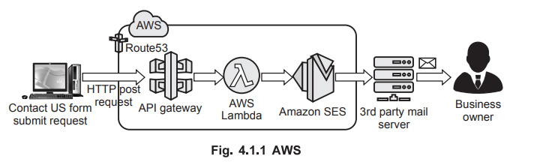

### ✅ ****2. Key Features of AWS:****

* Global infrastructure with **Availability Zones** and **Regions**.
* Highly **scalable**, **flexible**, and **secure**.
* Supports multiple **deployment models**: Public, Private, Hybrid Cloud.
* Used for **web hosting, app development, big data, AI/ML**, etc.

### ✅ ****3. Major Services Provided by AWS:****

#### **A. Compute Services:**

* **Amazon EC2 (Elastic Compute Cloud):** Virtual servers to run applications.
* **AWS Lambda:** Serverless compute service to run code without provisioning servers.
* **Elastic Beanstalk:** Platform as a Service (PaaS) for deploying applications.

#### **B. Storage Services:**

* **Amazon S3 (Simple Storage Service):** Object storage for files, backups, etc.
* **Amazon EBS (Elastic Block Store):** Persistent block-level storage for EC2.
* **Amazon Glacier:** Archival storage with long-term data retention.

#### **C. Database Services:**

* **Amazon RDS (Relational Database Service):** Managed databases like MySQL, PostgreSQL.
* **Amazon DynamoDB:** NoSQL database service.
* **Amazon Aurora:** High-performance relational database.

#### **D. Networking Services:**

* **Amazon VPC (Virtual Private Cloud):** Isolated cloud network environment.
* **Route 53:** Scalable DNS and domain name service.
* **Elastic Load Balancing (ELB):** Distributes traffic among instances.

#### **E. Security and Identity Services:**

* **IAM (Identity and Access Management):** Secure access control to AWS resources.
* **AWS Shield & WAF:** Protection against DDoS and web attacks.

#### **F. Other Services:**

* **CloudWatch:** Monitoring and logging service.
* **SNS/SQS:** Messaging and notification services.
* **AWS CloudFormation:** Infrastructure as Code (IaC) tool.

### ✅ ****4. Conclusion:****

AWS is the **most widely adopted cloud platform**, offering over **200 fully featured services**. It supports **startups, enterprises, and governments** in building highly reliable and scalable applications in the cloud.

**Q2. Explain amazon S3 and Amazon EC2? [6]**

**=>**

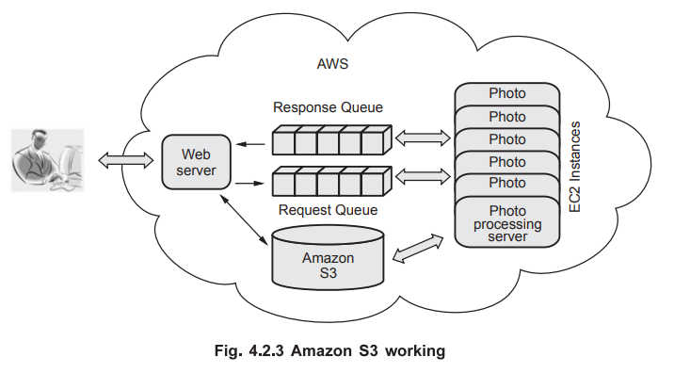

**✅ 1. Amazon EC2 (Elastic Compute Cloud):**

**Definition:**  
Amazon EC2 is a **web service** that provides **resizable compute capacity** (i.e., virtual machines) in the cloud. It allows users to **launch, configure, and manage virtual servers**, known as **instances**, on-demand.

**Key Features:**

* **Scalable:** Easily scale compute capacity up or down.
* **Flexible:** Choose instance types based on CPU, memory, and storage needs.
* **Customizable:** Install any OS and software.
* **Secure:** Integrated with AWS Identity and Access Management (IAM).
* **Elastic IPs:** Assign static IP addresses to instances.
* **Load Balancing & Auto Scaling:** Handle high traffic and maintain availability.

**Use Cases:**

* Hosting web applications and APIs.
* Running batch processing jobs.
* Development and testing environments.

**✅ 2. Amazon S3 (Simple Storage Service):**

**Definition:**  
Amazon S3 is a **scalable object storage service** used to **store and retrieve any amount of data** at any time from anywhere on the web.

**Key Features:**

* **Storage Classes:** Offers Standard, Infrequent Access, Glacier (for archiving).
* **Durability:** 99.999999999% (11 9s) durability for stored data.
* **Scalable:** Automatically scales storage needs.
* **Secure:** Supports encryption, access control policies, and IAM.
* **Versioning:** Maintains versions of files for recovery.
* **Data Lifecycle Policies:** Automatically transition or delete objects.

**Use Cases:**

* Backup and restore.
* Storing media files (images, videos).
* Hosting static websites.
* Big data analytics.

**✅ Conclusion:**

* **Amazon EC2** provides **compute power** (virtual servers), while
* **Amazon S3** offers **scalable cloud storage**.  
  Together, they form the backbone for hosting, computing, and storing data in the AWS Cloud.

**Q3. Explain SQL Azure in detail? [5]**

**=>**

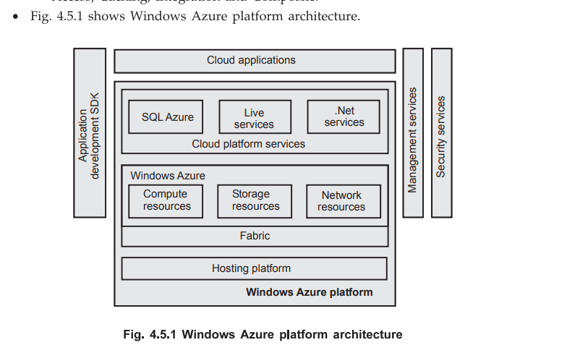

**✅ 1. What is SQL Azure?**

**SQL Azure** (now called **Azure SQL Database**) is a **cloud-based relational database service** provided by **Microsoft Azure**.  
It is built on Microsoft SQL Server technology and offers **Database-as-a-Service (DBaaS)** in the Azure cloud.

**✅ 2. Key Features of SQL Azure:**

1. **Fully Managed Database:**
   * Microsoft handles patching, backups, and updates automatically.
   * No need for users to manage underlying infrastructure.
2. **High Availability and Scalability:**
   * Built-in **redundancy** and **failover support**.
   * Supports **horizontal and vertical scaling**.
3. **Familiar Tools and Languages:**
   * Supports **T-SQL**, SQL Server Management Studio (SSMS), and Azure Data Studio.
4. **Advanced Security:**
   * **Encryption at rest and in transit**.
   * Integrated with **Azure Active Directory** and supports firewalls and auditing.
5. **Backup and Restore:**
   * Automated backups and **point-in-time restore** features.
6. **Elastic Pools:**
   * Multiple databases share resources like CPU and memory for cost savings.

**✅ 3. Benefits of Using SQL Azure:**

* **No hardware management** required.
* **Pay-as-you-go pricing**.
* **Global accessibility** via the internet.
* **Integration with other Azure services** like Power BI, Azure Functions, and App Services.

**✅ 4. Use Cases:**

* Hosting **web applications** with a cloud database backend.
* **Business analytics** and reporting.
* Running **OLTP (Online Transaction Processing)** workloads.

**✅ Conclusion:**

SQL Azure is a **reliable, scalable, and secure** cloud-based database solution ideal for modern applications. It eliminates the burden of infrastructure management while providing the **power of SQL Server** in the cloud.

**Q4. Explain Google App Engine with its installation steps? [6]**

**=>**

### ****Q4. Explain Google App Engine with its Installation Steps. [6 Marks]****

### ✅ ****1. What is Google App Engine (GAE)?****

**Google App Engine (GAE)** is a **Platform-as-a-Service (PaaS)** provided by **Google Cloud Platform (GCP)**. It allows developers to **build, deploy, and scale** web applications and APIs without managing the underlying infrastructure.

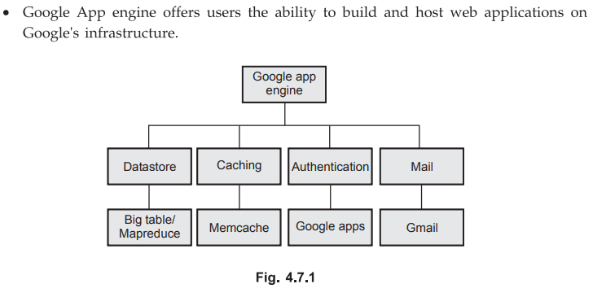

### ✅ ****2. Key Features of Google App Engine:****

* **Fully Managed Platform:** Handles server provisioning, scaling, and load balancing.
* **Supports Multiple Languages:** Python, Java, Go, PHP, Node.js, Ruby, .NET, etc.
* **Auto Scaling:** Automatically adjusts resources based on traffic.
* **Integrated Services:** Works with Google Cloud Datastore, Firestore, Cloud SQL, etc.
* **Built-in Monitoring:** Stackdriver for logging and monitoring.

### ✅ ****3. Installation and Setup Steps:****

#### **Step 1: Install Python or Preferred Runtime**

* Download and install Python (if using Python-based GAE project).
* For other languages, install appropriate runtime (Java, Node.js, etc.).

#### **Step 2: Install Google Cloud SDK**

* Visit: https://cloud.google.com/sdk
* Download and install the **Google Cloud SDK** for your OS.
* After installation, initialize SDK using command:

csharp

CopyEdit

gcloud init

#### **Step 3: Set Up Google Cloud Project**

* Go to **Google Cloud Console**: https://console.cloud.google.com
* Create a **new project**.
* Enable **App Engine API** for the project.

#### **Step 4: Create App Engine Application**

* Run the command in terminal:

lua

CopyEdit

gcloud app create

* Select your **project ID** and **preferred region**.

#### **Step 5: Develop Your Application**

* Write your app code in the preferred language.
* Include app.yaml configuration file.

#### **Step 6: Deploy the Application**

* In the project directory, deploy your app using:

nginx

CopyEdit

gcloud app deploy

### ✅ ****4. Conclusion:****

Google App Engine enables developers to **quickly deploy web apps** without worrying about infrastructure. With its **auto-scaling**, **multi-language support**, and **managed environment**, it's ideal for modern cloud-native applications.

**Q5. Draw and explain Architecture of Amazon Dynamo? [6]**

**=>**

### ✅ ****1. What is Amazon Dynamo?****

**Amazon Dynamo** is a **highly available**, **scalable**, and **eventually consistent** distributed **NoSQL key-value store** designed by Amazon to meet the needs of large-scale services like shopping carts, session management, etc.

Note: Dynamo is the **research paper system** that inspired **Amazon DynamoDB**, but Dynamo itself is a foundational distributed system.

### ✅ ****2. Architecture of Amazon Dynamo (Diagram):****

+------------------------+

| Application Layer |

+-----------+------------+

|

+----v----+

| Client |

+----+----+

|

+-------------+-------------+

| |

+-----v-----+ +-----v-----+

| Coordinator Node (DHT) | Partition |

+-----------+---------------+ Ring |

| (Consistent Hashing)

+-----------+-----------+-----------+-----------+

| | | | |

+---v--+ +--v---+ +--v---+ +--v---+ +--v---+

|Node1 | |Node2 | |Node3 | |Node4 | |Node5 |

+------+ +------+ +------+ +------+ +------+

| | | | |

+---v--+ +--v---+ +--v---+ +--v---+ +--v---+

|Replica| |Replica| |Replica| |Replica| |Replica|

| Data | | Data | | Data | | Data | | Data |

+-------+ +-------+ +-------+ +-------+ +-------+

### ✅ ****3. Key Components of Dynamo Architecture:****

#### **A. Distributed Hash Table (DHT):**

* Dynamo uses **consistent hashing** to distribute data across nodes.
* Each node is assigned a range of hash values and is responsible for storing data within that range.

#### **B. Coordinator Node:**

* The node that receives the client request becomes the **coordinator**.
* It routes the request to the correct node(s) based on the key.

#### **C. Data Partitioning:**

* Data is partitioned using consistent hashing into a **circular ring**.
* This ensures uniform data distribution and supports scalability.

#### **D. Replication:**

* Each data item is **replicated to N nodes** for fault tolerance.
* Replication uses the concept of **virtual nodes** to improve load balancing.

#### **E. Quorum-based Reads/Writes:**

* Uses parameters **R** (read quorum) and **W** (write quorum).
* Guarantees availability and eventual consistency.

#### **F. Vector Clocks:**

* Used for **version control** and resolving conflicts during concurrent updates.

#### **G. Gossip Protocol:**

* Nodes communicate periodically to exchange membership and health information.

### ✅ ****4. Conclusion:****

Amazon Dynamo provides a **fault-tolerant, highly available, decentralized** storage system for distributed applications. Its design principles—**consistent hashing, replication, versioning**, and **eventual consistency**—make it a foundation for modern NoSQL databases like **DynamoDB**.

**Q6. Differentiate between Dynamo DB and Amazon S3? [5]**

**=>**

**✅ Q6. Differentiate between DynamoDB and Amazon S3 [5 Marks]**

| **Point** | **DynamoDB** | **Amazon S3** |
| --- | --- | --- |
| **1. Service Type** | NoSQL Database Service (Key-Value & Document) | Object Storage Service |
| **2. Data Model** | Stores structured data in **tables** with items and attributes | Stores **unstructured data** as objects (files, images, videos, etc.) |
| **3. Access Method** | Accessed via **queries and API calls** to fetch items by keys | Accessed via **URLs or API calls** using object key (path) |
| **4. Use Case** | Ideal for **real-time data**, like user profiles, session data | Ideal for **static content**, backups, media files, big data, etc. |
| **5. Performance** | Supports **low-latency reads/writes**, millisecond performance | Optimized for **high throughput** and large file storage |
| **6. Scalability** | Automatically scales throughput and storage | Automatically scales to store unlimited data |
| **7. Data Consistency** | Offers **eventual or strong consistency** options | Offers **eventual consistency** by default, strong for new uploads |
| **8. Cost Model** | Charged based on **read/write units and storage** | Charged based on **storage size**, requests, and data transfer |

**✅ Summary:**

* **DynamoDB** is best suited for **structured, low-latency database workloads**.
* **Amazon S3** is best for **mass storage of unstructured data** like media files, backups, and logs.

**Q7. Draw & explain the working of Amazon simple storage service(S3)? [9]**

**=>**

### ****1. Introduction:****

Amazon Simple Storage Service (Amazon S3) is a **cloud-based object storage service** offered by AWS. It provides **secure, scalable, durable**, and **highly available** storage for a wide range of data types such as documents, images, videos, backups, logs, etc.

### ****2. Labeled Diagram:****

sql

CopyEdit

+-------------------------+

| Client / User |

+-----------+-------------+

|

REST API / SDK

|

+-----------v------------+

| Amazon S3 |

+-----------+------------+

|

+-----------+-------------+--------------+------------+

| | | |

+------v-----+ +----v------+ +------v-----+ +-----v------+

| Bucket A | | Bucket B | ... | Bucket N | | Bucket M |

+------+-----+ +----+-------+ +------+-----+ +-----+-----+

| | | |

+------v--+ +----v---+ +-----v--+ +----v---+

| Object | | Object | | Object | | Object |

| + Meta | | + Meta | | + Meta | | + Meta |

+---------+ +--------+ +--------+ +--------+

### ****3. Key Concepts:****

* **Buckets:**  
  Containers for storing objects. Each S3 bucket has a **unique name** and resides in a **specific AWS region**.
* **Objects:**  
  The actual data stored, along with metadata. Every object is stored in a bucket and identified by a **key** (unique name).
* **Keys:**  
  Unique identifiers for objects within a bucket.

### ****4. Working of Amazon S3:****

#### **Step 1: Bucket Creation**

* Users create a bucket using the AWS Console, CLI, or API.
* A bucket is like a folder in the cloud and acts as the root directory.

#### **Step 2: Uploading Objects**

* Users upload files (objects) to buckets using PUT operations.
* Each object gets a **key** and can store metadata (e.g., file type, permissions).

#### **Step 3: Data Storage**

* Amazon S3 **replicates data across multiple availability zones** to ensure high durability (99.999999999%).

#### **Step 4: Access and Retrieval**

* Users access objects using the object’s URL or by API calls (GET).
* Fine-grained **access control** is supported through:
  + Bucket policies
  + IAM roles and policies
  + Access Control Lists (ACLs)

#### **Step 5: Lifecycle Management**

* Define lifecycle rules to automatically transition data to:
  + **S3 Standard-IA** (Infrequent Access)
  + **S3 Glacier** (archival)
  + Or delete data after a specified time

### ****5. Features:****

* **Durability:** 11 nines (99.999999999%) durability
* **Scalability:** Automatically handles any amount of data
* **Security:** Supports encryption at rest and in transit
* **Versioning:** Maintain multiple versions of an object
* **Cost-efficient:** Tiered storage classes for cost optimization
* **Static Website Hosting:** S3 can host static web pages directly

### ****6. Conclusion:****

Amazon S3 is a robust object storage solution that provides secure, reliable, and scalable storage. It is widely used for backup, disaster recovery, content distribution, and big data storage in cloud environments.

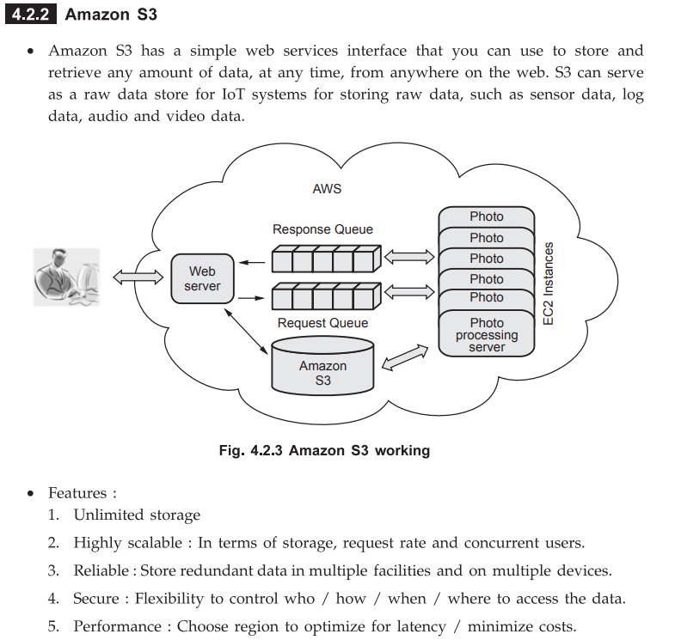

**Q8. Describe the different steps for configuring Amazon EC2 VM instance? [8]**

**=>**

### Introduction:

Amazon EC2 (Elastic Compute Cloud) is a web service that provides **resizable virtual machines (instances)** in the cloud. It allows users to launch and manage VMs with various OS and software configurations.

**✅ Steps to Configure an Amazon EC2 VM Instance:**

**1. Sign In to AWS Management Console**

* Open <https://aws.amazon.com>
* Log in with your AWS account credentials.

**2. Launch Instance (EC2 Dashboard)**

* Go to **EC2 Dashboard** under "Compute Services".
* Click on **“Launch Instance”** to start creating a new virtual machine.

**3. Choose an Amazon Machine Image (AMI)**

* Select a pre-configured **AMI**:
  + Example: Amazon Linux, Ubuntu, Red Hat, Windows Server
* AMI includes OS and software packages.

**4. Choose an Instance Type**

* Select the **instance type** based on required CPU, RAM, and storage.
  + Example: t2.micro (free-tier eligible), m5.large, etc.

**5. Configure Instance Details**

* Set number of instances
* Choose network (VPC) and subnet
* Enable Auto-assign Public IP
* Configure IAM roles (optional)
* Set shutdown behavior (Stop/Terminate)

**6. Add Storage**

* Allocate **Elastic Block Store (EBS)** volumes.
* You can modify root volume size or add additional volumes.

**7. Add Tags**

* Create **key-value pairs** to identify and manage your instance.
  + Example: Key = Name, Value = MyEC2Instance

**8. Configure Security Group**

* Security group acts as a **virtual firewall**.
* Add rules to allow **SSH (port 22)**, HTTP (port 80), etc.
* For Linux: open port 22 for SSH  
  For Windows: open port 3389 for RDP

**9. Review and Launch**

* Review all configuration settings.
* Click **“Launch”**.

**10. Select or Create Key Pair**

* Choose an existing key pair or create a new one.
* Download the .pem file – required for SSH/RDP access.

**11. Access the Instance**

* For Linux: Use terminal with SSH  
  ssh -i keypair.pem ec2-user@public-ip
* For Windows: Use RDP with administrator credentials

**✅ Conclusion:**

Configuring an Amazon EC2 instance involves selecting an AMI, instance type, storage, security settings, and launching the VM. EC2 offers a flexible and scalable compute environment for deploying applications in the cloud.

**Q9. Enlist an applications of cloud computing in different Area? Describe any two applications? [8]**

**=>**

**1. Applications of Cloud Computing in Different Areas:**

| **Domain** | **Application** |
| --- | --- |
| Education | Online learning platforms, virtual labs, content sharing |
| Healthcare | Electronic health records, telemedicine, data analysis |
| Banking & Finance | Online banking, fraud detection, risk management |
| E-commerce | Scalable hosting, inventory tracking, personalized recommendations |
| Software Development | CI/CD pipelines, cloud IDEs, testing environments |
| Entertainment | Streaming services, gaming, media storage |
| Government | e-Governance, digital identity, data storage |
| Disaster Recovery | Cloud-based backup and quick recovery solutions |
| AI/ML | On-demand compute power for training models |
| Data Storage | Scalable storage services like S3, Google Cloud Storage |

**2. Describe Any Two Applications:**

**A. Healthcare**

* **Purpose:**  
  Store and manage large-scale patient data securely.
* **Use Cases:**
  + Maintain Electronic Health Records (EHR).
  + Enable telemedicine services via video consultation.
  + Support AI tools for diagnosis, treatment predictions.
* **Benefits:**
  + High data availability and disaster recovery.
  + Real-time patient data access.
  + Secure data sharing among doctors and hospitals.
* **Examples:**
  + AWS HealthLake
  + Microsoft Azure for Healthcare

**B. Education**

* **Purpose:**  
  Deliver digital learning platforms and collaboration tools.
* **Use Cases:**
  + Host virtual classes, exams, and assignments.
  + Use Learning Management Systems (LMS) like Moodle, Google Classroom.
  + Real-time student-teacher interaction using cloud apps.
* **Benefits:**
  + Remote learning from any location.
  + Cost-saving on physical infrastructure.
  + Scalable resources for students and institutions.
* **Examples:**
  + Google Workspace for Education
  + AWS Educate, Microsoft Teams

**✅ Conclusion:**

Cloud computing has become an essential backbone across industries like **healthcare, education, finance, and entertainment** by providing on-demand, scalable, and cost-efficient resources with high availability and flexibility.

**Q10. Identify the different components of AWS? [9]**

**=>**

**✅ Introduction:**

Amazon Web Services (AWS) is a comprehensive and widely adopted cloud platform that offers over 200 fully featured services from data centers globally. These services can be grouped into major components based on functionality.

**✅ Main Components of AWS:**

**1. Compute Services**

* **Amazon EC2 (Elastic Compute Cloud):**  
  Provides scalable virtual servers.
* **AWS Lambda:**  
  Serverless computing that runs code in response to events.
* **Auto Scaling:**  
  Automatically adjusts compute capacity based on demand.
* **Elastic Beanstalk:**  
  Platform-as-a-Service (PaaS) for deploying and managing applications.

**2. Storage Services**

* **Amazon S3 (Simple Storage Service):**  
  Object-based storage service.
* **Amazon EBS (Elastic Block Store):**  
  Block storage for use with EC2 instances.
* **Amazon Glacier:**  
  Archival storage for long-term backups.

**3. Database Services**

* **Amazon RDS (Relational Database Service):**  
  Managed relational databases (MySQL, PostgreSQL, etc.).
* **Amazon DynamoDB:**  
  Managed NoSQL key-value and document database.
* **Amazon Redshift:**  
  Data warehouse service for analytics.

**4. Networking & Content Delivery**

* **Amazon VPC (Virtual Private Cloud):**  
  Private network within AWS.
* **Amazon Route 53:**  
  Scalable Domain Name System (DNS) service.
* **Amazon CloudFront:**  
  Content Delivery Network (CDN) for faster content delivery.

**5. Security & Identity Services**

* **AWS IAM (Identity and Access Management):**  
  Controls access to AWS resources securely.
* **AWS KMS (Key Management Service):**  
  Manages encryption keys.

**6. Monitoring & Management Tools**

* **Amazon CloudWatch:**  
  Monitors AWS resources and applications.
* **AWS CloudTrail:**  
  Tracks user activity and API usage.
* **AWS Config:**  
  Monitors and audits resource configurations.

**7. Developer Tools**

* **AWS CodeCommit:**  
  Source control service (like Git).
* **AWS CodeDeploy:**  
  Automates application deployments.
* **AWS CodePipeline:**  
  CI/CD workflow service.

**8. Application Integration**

* **Amazon SQS (Simple Queue Service):**  
  Message queuing for decoupling services.
* **Amazon SNS (Simple Notification Service):**  
  Sends notifications to users and systems.
* **AWS Step Functions:**  
  Orchestrates workflows using visual workflows.

**9. Analytics and AI/ML Services**

* **Amazon Athena:**  
  Query service for S3 data using SQL.
* **Amazon SageMaker:**  
  Builds, trains, and deploys machine learning models.
* **Amazon QuickSight:**  
  Business Intelligence (BI) tool.

**✅ Conclusion:**

AWS offers a wide range of components grouped under **Compute, Storage, Database, Networking, Security, Developer Tools, Monitoring, and AI/ML**. Together, these services provide a complete cloud solution for building scalable and secure applications.

**Q11. Enlist an applications of cloud computing in different Area? Describe any two applications? [9]**

**=>**

**1. Applications of Cloud Computing in Different Areas:**

Cloud computing is used across many domains. Some key application areas include:

| **Sr. No** | **Application Area** | **Use Case Examples** |
| --- | --- | --- |
| 1 | **Education** | Online classes, learning management systems (LMS) |
| 2 | **Healthcare** | Electronic health records, telemedicine |
| 3 | **Banking & Finance** | Online banking, fraud detection |
| 4 | **E-commerce** | Product recommendations, inventory management |
| 5 | **Entertainment** | Video streaming, gaming platforms |
| 6 | **Software Development** | DevOps, CI/CD, cloud-based IDEs |
| 7 | **Government** | E-governance, public service portals |
| 8 | **Artificial Intelligence** | AI model training, analytics |
| 9 | **Backup & Recovery** | Cloud-based data backup, disaster recovery |

**2. Describe Any Two Applications:**

**A. Cloud Computing in Education:**

* **Purpose:** To provide digital learning environments and remote access to educational content.
* **Use Cases:**
  + Virtual classrooms and online examinations.
  + Learning Management Systems (LMS) like Moodle, Google Classroom.
* **Benefits:**
  + Reduces infrastructure cost.
  + Enables access to education from anywhere, anytime.
  + Enhances collaboration between students and teachers.
* **Examples:**
  + Google Workspace for Education
  + Microsoft Teams for Education

**B. Cloud Computing in Healthcare:**

* **Purpose:** To manage healthcare data securely and enable remote health services.
* **Use Cases:**
  + Electronic Health Records (EHR).
  + Remote patient monitoring and telemedicine.
  + AI-based diagnostics and treatment suggestions.
* **Benefits:**
  + Real-time data access by healthcare professionals.
  + Secure storage and data privacy.
  + Cost-effective and scalable healthcare IT infrastructure.
* **Examples:**
  + AWS HealthLake
  + Microsoft Cloud for Healthcare

**✅ Conclusion:**

Cloud computing applications span across critical sectors like **education, healthcare, banking, and more**, offering benefits like scalability, remote accessibility, cost savings, and improved efficiency.

**Q13. What are the components of Microsoft Azure? Explain briefly? [9]**

**=>**

### ✅ ****1. Introduction:****

**Microsoft Azure** is a cloud computing platform provided by Microsoft that offers a wide range of services for building, deploying, and managing applications through Microsoft's global network of data centers. It supports **IaaS, PaaS, and SaaS** models.

### ✅ ****2. Key Components of Microsoft Azure:****

Below are the major components, each with a short description:

#### **1. Compute Services**

* **Azure Virtual Machines:**  
  Provides scalable compute capacity in the cloud with OS options (Windows/Linux).
* **Azure App Services:**  
  PaaS for hosting web apps, REST APIs, and mobile backends.
* **Azure Kubernetes Service (AKS):**  
  Manages containerized applications using Kubernetes.
* **Azure Functions:**  
  Serverless compute service that runs code in response to triggers/events.

#### **2. Storage Services**

* **Azure Blob Storage:**  
  Object storage for unstructured data like images, videos, and backups.
* **Azure Queue Storage:**  
  Messaging service for decoupling applications.
* **Azure Disk Storage:**  
  High-performance SSD/HDD for VM use.

#### **3. Networking Services**

* **Azure Virtual Network (VNet):**  
  Private networks with IP addressing, routing, and security.
* **Azure Load Balancer:**  
  Distributes incoming network traffic.
* **Azure DNS & Traffic Manager:**  
  Provides name resolution and geographic traffic routing.

#### **4. Database Services**

* **Azure SQL Database:**  
  Managed relational database as a service.
* **Cosmos DB:**  
  Globally distributed NoSQL database.
* **Azure Database for MySQL/PostgreSQL:**  
  Fully managed open-source databases.

#### **5. Identity & Access Management**

* **Azure Active Directory (AAD):**  
  Identity and access control service (SSO, MFA, RBAC).
* **Role-Based Access Control (RBAC):**  
  Manages user permissions over Azure resources.

#### **6. AI and Machine Learning**

* **Azure Machine Learning Studio:**  
  Platform for building and deploying ML models.
* **Azure Cognitive Services:**  
  APIs for vision, speech, language, and decision-making.

#### **7. Developer Tools and DevOps**

* **Azure DevOps Services:**  
  CI/CD pipelines, repo hosting, project boards.
* **Azure SDKs & APIs:**  
  Development kits for integrating Azure with apps.

#### **8. Monitoring and Management**

* **Azure Monitor:**  
  Collects metrics and logs for performance monitoring.
* **Azure Resource Manager (ARM):**  
  Management layer for deploying and managing resources.

#### **9. Security & Compliance**

* **Azure Security Center:**  
  Threat detection, security recommendations.
* **Azure Policy & Blueprints:**  
  Governance tools for regulatory compliance.

### ✅ ****3. Conclusion:****

Microsoft Azure provides a **comprehensive suite of cloud services** for compute, storage, networking, AI, DevOps, and security. Its modular architecture allows organizations to build and scale secure applications effectively in the cloud.

**Q14. How cloud computing can be used for business and consumer applications like ERP or CRM? [8]**

**=>**

### ✅ 1. ****Introduction to Cloud Computing in Business Applications:****

Cloud computing enables businesses to run software like **ERP (Enterprise Resource Planning)** and **CRM (Customer Relationship Management)** without the need to maintain physical infrastructure or local installations.

These applications are hosted on cloud platforms and accessed over the internet using the **Software as a Service (SaaS)** model.

### ✅ 2. ****Cloud-Based ERP (Enterprise Resource Planning):****

#### ➤ What is ERP?

ERP is an integrated system used by businesses to manage core processes like finance, HR, supply chain, and manufacturing.

#### ➤ How Cloud Helps ERP:

* Hosted on platforms like AWS, Azure, or Oracle Cloud.
* Enables centralized data access for all departments.
* Real-time data analytics and reporting.
* Automatic software updates and maintenance.

#### ➤ Benefits:

* **Cost-effective:** No upfront infrastructure costs.
* **Scalable:** Resources can be added as business grows.
* **Accessible:** Employees can access ERP from anywhere.

#### ➤ Examples:

* SAP S/4HANA Cloud
* Oracle ERP Cloud
* Microsoft Dynamics 365 for Finance and Operations

### ✅ 3. ****Cloud-Based CRM (Customer Relationship Management):****

#### ➤ What is CRM?

CRM helps manage customer data, sales, marketing campaigns, and customer interactions.

#### ➤ How Cloud Helps CRM:

* Cloud CRM stores data centrally and gives sales/marketing teams real-time access.
* Integration with emails, social media, and other tools.
* Offers AI-powered insights for customer behavior.

#### ➤ Benefits:

* **Improved Customer Relationships**
* **Mobile Accessibility**
* **Data Security and Backup**

#### ➤ Examples:

* Salesforce CRM
* Zoho CRM
* Microsoft Dynamics 365 for Sales

### ✅ 4. ****Conclusion:****

Cloud computing makes **ERP and CRM systems more accessible, scalable, and cost-efficient** for both large and small businesses. It reduces IT burden, improves real-time collaboration, and increases productivity, ultimately supporting business growth and customer satisfaction.

**Q15. Describe the Amazon Database Services? [8]**

**=>**

### ✅ ****1. Introduction:****

Amazon Web Services (AWS) offers a wide range of **fully managed database services** designed for different types of applications—relational, non-relational, key-value, document, in-memory, graph, and time series.

These services are **scalable**, **secure**, **cost-effective**, and **highly available**, eliminating the need for manual database setup, patching, and backups.

### ✅ ****2. Key Amazon Database Services:****

#### **A. Amazon RDS (Relational Database Service):**

* A fully managed service for relational databases.
* Supports **MySQL, PostgreSQL, MariaDB, Oracle, and Microsoft SQL Server**.
* Features: automated backups, patching, replication, monitoring.
* Use Case: ERP, CRM, and e-commerce applications.

#### **B. Amazon Aurora:**

* A high-performance, MySQL- and PostgreSQL-compatible **relational database**.
* Up to **5x faster** than standard MySQL and **3x faster** than PostgreSQL.
* Highly available with auto-scaling and fault tolerance.
* Use Case: Enterprise-grade applications needing high throughput.

#### **C. Amazon DynamoDB:**

* A **NoSQL key-value and document database**.
* Fully managed, serverless, and supports **millisecond latency**.
* Use Case: Gaming, IoT, mobile, and real-time apps.

#### **D. Amazon ElastiCache:**

* In-memory caching service using **Redis** or **Memcached**.
* Reduces database load and speeds up application performance.
* Use Case: Session management, real-time analytics.

#### **E. Amazon Redshift:**

* A **data warehousing** service used for **analytical queries** on large datasets.
* Supports **SQL-based queries** and integrates with BI tools.
* Use Case: Business Intelligence, reporting, data analytics.

#### **F. Amazon Neptune:**

* Fully managed **graph database**.
* Supports **RDF and Property Graph** models.
* Use Case: Social networks, fraud detection, recommendation engines.

#### **G. Amazon Timestream:**

* Purpose-built **time series database**.
* Optimized for storing and analyzing time-stamped data.
* Use Case: IoT sensor data, operational metrics.

#### **H. Amazon DocumentDB:**

* Fully managed **document database service**, compatible with MongoDB.
* Use Case: JSON-based applications, content management systems.

### ✅ ****3. Features of AWS Database Services:****

* **Fully Managed:** AWS handles maintenance, backups, patching.
* **Scalable:** Auto-scaling based on demand.
* **Secure:** Encryption at rest and in transit, IAM integration.
* **High Availability:** Multi-AZ deployments and automatic failover.
* **Monitoring:** Integrated with Amazon CloudWatch for insights.

### ✅ ****4. Conclusion:****

Amazon provides a **comprehensive set of database services** tailored to various application needs. These services simplify database management and offer high performance, security, and reliability for modern cloud-native applications.

**Q16. Explain Google Cloud Applications in detail? [9]**

**=>**

**✅ 1. Introduction:**

**Google Cloud Platform (GCP)** is a suite of cloud services offered by Google. It provides infrastructure, platform, and software services used to **build, deploy, and scale applications**, websites, and services.

Google Cloud is used across industries like finance, healthcare, retail, education, and media.

**✅ 2. Common Applications of Google Cloud:**

**🔹 A. Application Development**

* GCP provides tools like **App Engine**, **Cloud Functions**, and **Cloud Run**.
* Supports multiple programming languages like Java, Python, Node.js.
* **Use Case:** Building scalable web/mobile applications with serverless architecture.

**🔹 B. Data Storage and Databases**

* Offers multiple data storage options:
  + **Cloud Storage** (object storage)
  + **Cloud SQL** (relational DB)
  + **Firestore & Bigtable** (NoSQL)
* **Use Case:** Store large volumes of structured/unstructured data with high availability.

**🔹 C. Big Data and Analytics**

* Tools like **BigQuery**, **Dataflow**, and **Dataproc** help process and analyze large datasets.
* **Use Case:** Real-time analytics, business intelligence, and reporting dashboards.

**🔹 D. Machine Learning and AI**

* Provides **AI Platform**, **Vertex AI**, and **pre-trained models** like Vision, NLP, and Speech APIs.
* **Use Case:** Build and deploy ML models, chatbots, image classification, and speech recognition.

**🔹 E. Networking**

* Services like **Cloud CDN**, **VPC**, and **Cloud Load Balancing**.
* Ensures fast, secure, and reliable content delivery.
* **Use Case:** Hosting global applications with low-latency access.

**🔹 F. DevOps and CI/CD**

* Tools: **Cloud Build**, **Cloud Source Repositories**, **Cloud Deploy**.
* Supports continuous integration and delivery (CI/CD).
* **Use Case:** Automate build, test, and deployment workflows.

**🔹 G. Internet of Things (IoT)**

* GCP provides **Cloud IoT Core** for managing IoT devices securely.
* **Use Case:** Collect, process, and analyze sensor data from distributed devices.

**🔹 H. Security and Identity**

* Features: **IAM (Identity and Access Management)**, **Cloud Armor**, and **DLP APIs**.
* **Use Case:** Control access, protect data, and maintain compliance standards.

**🔹 I. Productivity and Collaboration**

* Integrates with **Google Workspace (Gmail, Drive, Docs, Sheets)** for business communication and file sharing.
* **Use Case:** Enhance collaboration and document management in organizations.

**✅ 3. Conclusion:**

Google Cloud offers a **comprehensive set of cloud-based solutions** for application development, AI, big data, DevOps, and storage. Its global infrastructure, scalability, and security make it a reliable choice for businesses and developers.

**Q17. Enlist the different services offered by Amazon web Service? Explain it? [8]**

**=>**

### ✅ ****1. Introduction:****

**Amazon Web Services (AWS)** is a comprehensive and widely adopted **cloud computing platform** offered by Amazon. It provides **on-demand cloud services** such as computing power, storage, networking, databases, analytics, machine learning, and more on a pay-as-you-go model.

### ✅ ****2. Services Offered by AWS:****

Here are the major categories of AWS services with brief explanations:

#### 🔹 A. **Compute Services:**

These services provide virtual servers and serverless computing.

* **Amazon EC2 (Elastic Compute Cloud):** Virtual servers to run applications.
* **AWS Lambda:** Serverless computing to run code without provisioning servers.
* **Amazon Elastic Beanstalk:** Auto-deploy and scale web apps.
* **Amazon Lightsail:** Easy-to-use VPS for smaller applications.

#### 🔹 B. **Storage Services:**

AWS provides scalable, durable, and secure storage.

* **Amazon S3 (Simple Storage Service):** Object storage for files, media, backups.
* **Amazon EBS (Elastic Block Store):** Block storage for EC2 instances.
* **Amazon Glacier:** Low-cost storage for data archiving and backups.

#### 🔹 C. **Database Services:**

Fully managed databases for structured and unstructured data.

* **Amazon RDS (Relational Database Service):** Supports MySQL, PostgreSQL, Oracle, etc.
* **Amazon DynamoDB:** NoSQL key-value and document database.
* **Amazon Redshift:** Data warehousing for big data analytics.
* **Amazon Aurora:** High-performance relational DB.

#### 🔹 D. **Networking & Content Delivery:**

* **Amazon VPC (Virtual Private Cloud):** Isolated network environments.
* **Amazon CloudFront:** Content Delivery Network (CDN) to deliver content globally.
* **Elastic Load Balancer (ELB):** Distributes incoming traffic across EC2 instances.

#### 🔹 E. **Security & Identity Services:**

* **AWS Identity and Access Management (IAM):** Manage user access and permissions.
* **AWS Key Management Service (KMS):** Create and manage cryptographic keys.
* **AWS Shield & WAF:** Protection against DDoS and web attacks.

#### 🔹 F. **Analytics Services:**

* **Amazon Kinesis:** Real-time data streaming and analytics.
* **Amazon EMR (Elastic MapReduce):** Big data processing using Hadoop.
* **Amazon Athena:** Interactive SQL queries on S3 data.
* **Amazon QuickSight:** Business intelligence and visualization.

#### 🔹 G. **Machine Learning & AI:**

* **Amazon SageMaker:** Build, train, and deploy ML models.
* **Amazon Rekognition:** Image and video analysis.
* **Amazon Polly:** Text-to-speech service.
* **Amazon Lex:** Build chatbots using voice and text.

#### 🔹 H. **Developer & DevOps Tools:**

* **AWS CodeCommit:** Source code repository.
* **AWS CodeBuild, CodeDeploy, CodePipeline:** CI/CD automation tools.
* **AWS Cloud9:** Cloud-based IDE.

### ✅ ****3. Conclusion:****

AWS offers a wide range of cloud services that support businesses in **computing, storage, networking, database management, security, machine learning, and more**. These services allow organizations to **scale quickly, reduce costs**, and deliver applications with high performance and reliability.

**Q18. Discuss Amazon Dynamo Database Service in detail? [9]**

**=>**

**✅ 1. Introduction:**

**Amazon DynamoDB** is a **fully managed NoSQL database service** offered by AWS. It delivers **high availability, scalability, and low-latency performance**. It is suitable for applications that need consistent, single-digit millisecond response times at any scale.

It was inspired by the design of the original **Amazon Dynamo** system.

**✅ 2. Key Features of Amazon DynamoDB:**

* **Fully Managed:** No need to manage servers or infrastructure.
* **NoSQL Model:** Key-value and document data models.
* **High Performance:** Delivers consistent, fast response times.
* **Scalable:** Scales horizontally to handle millions of requests per second.
* **Durability:** Data is automatically replicated across multiple Availability Zones.
* **Integrated Security:** Supports encryption at rest and in transit.

**✅ 3. Data Model:**

* **Tables:** Collection of items.
* **Items:** Individual records (like rows in RDBMS).
* **Attributes:** Fields or columns in each item.
* **Primary Key:** Uniquely identifies each item. Two types:
  + **Partition key only** (simple key)
  + **Partition key + sort key** (composite key)

**✅ 4. Architecture Overview:**

* **Partitioning:** Data is split across partitions using the hash of the partition key.
* **Replication:** Data is replicated across 3 Availability Zones for durability.
* **DynamoDB Streams:** Captures changes in table data for real-time applications.
* **Auto Scaling:** Automatically adjusts capacity based on traffic patterns.

**✅ 5. Read and Write Operations:**

* **Read Types:**
  + **Eventually consistent** (default)
  + **Strongly consistent** (optional)
* **Write Operations:**
  + PutItem, UpdateItem, DeleteItem
  + Uses conditional writes for concurrency control.

**✅ 6. Pricing Models:**

* **On-Demand Mode:** Pay per request.
* **Provisioned Mode:** Pre-define read/write capacity.
* **Free Tier Available:** Up to 25 GB of storage and 200 million requests/month.

**✅ 7. Use Cases of DynamoDB:**

* Real-time bidding platforms
* Gaming leaderboards
* Shopping cart applications
* IoT and sensor data storage
* Session management

**✅ 8. Advantages:**

* Serverless with no operational overhead
* Automatically scales with traffic
* High fault tolerance and availability
* Integrated with other AWS services (Lambda, S3, etc.)

**✅ 9. Conclusion:**

Amazon DynamoDB is a powerful, highly available NoSQL database designed for **modern applications** that require **low-latency, scalable, and reliable data access**. It supports real-time data processing and is ideal for applications with dynamic or unpredictable workloads.

**Q19. Explain Microsoft Windows Azure Platform? [8]**

**=>**

**✅ 1. Introduction:**

Microsoft **Azure** is a **cloud computing platform** and **Infrastructure-as-a-Service (IaaS)** + **Platform-as-a-Service (PaaS)** offering by Microsoft. It provides a wide range of **cloud services** including **compute, storage, networking, databases, AI, IoT**, and **DevOps**.

It allows users to **build, deploy, and manage applications** through Microsoft-managed data centers.

**✅ 2. Key Features of Microsoft Azure:**

* **On-Demand Resources:** Compute and storage can be provisioned and scaled easily.
* **Global Reach:** Data centers across the globe.
* **Security:** Multi-layered security across physical data centers, infrastructure, and operations.
* **Integration:** Works seamlessly with Microsoft tools like Windows Server, Active Directory, SQL Server, .NET, etc.

**✅ 3. Main Components / Services of Azure:**

**A. Compute Services:**

* **Azure Virtual Machines:** IaaS to run VMs on demand.
* **App Services:** PaaS to host web apps and APIs.
* **Azure Functions:** Serverless compute service.
* **Azure Kubernetes Service (AKS):** Container orchestration.

**B. Storage Services:**

* **Blob Storage:** Unstructured data like media, documents.
* **Queue Storage:** Messaging between components.
* **Table Storage:** NoSQL key-value store.
* **Disk Storage:** Persistent disks for VMs.

**C. Networking:**

* **Virtual Network (VNet):** Isolated network for services.
* **Azure Load Balancer:** Traffic distribution.
* **VPN Gateway:** Secure connections to on-premises.
* **Azure DNS:** Domain management.

**D. Database Services:**

* **Azure SQL Database:** Fully managed relational DB.
* **Cosmos DB:** Global distributed NoSQL DB.
* **Azure Database for MySQL/PostgreSQL**

**E. AI and Analytics:**

* **Azure Machine Learning**
* **HDInsight** (Big Data processing)
* **Stream Analytics**

**F. DevOps and Management:**

* **Azure DevOps:** CI/CD pipelines.
* **Azure Monitor, Azure Log Analytics** for system monitoring.

**✅ 4. Azure Deployment Models:**

* **Public Cloud:** Services available over the internet.
* **Private Cloud:** Dedicated for one organization.
* **Hybrid Cloud:** Combination of on-premises and Azure.

**✅ 5. Advantages of Azure:**

* Highly scalable and flexible.
* Pay-as-you-go pricing.
* Integration with existing Microsoft technologies.
* Supports multiple programming languages (Java, Python, .NET, Node.js).
* High availability with 99.95% uptime SLA.

**✅ 6. Conclusion:**

Microsoft Azure is a robust and versatile **cloud platform** offering a wide range of **services and tools** for building, deploying, and managing modern applications. It is widely used by enterprises for **scalable, secure, and flexible** cloud solutions.

**Q20. Elaborate the unique features Google App Engine with suitable example? [9]**

**=>**

**✅ 1. Introduction:**

**Google App Engine (GAE)** is a **Platform-as-a-Service (PaaS)** offered by **Google Cloud Platform (GCP)**. It allows developers to build and deploy applications without managing the underlying infrastructure. GAE automatically handles **scaling, load balancing, monitoring, and patching**.

**✅ 2. Unique Features of Google App Engine:**

**1. Fully Managed Platform:**

* No need to manage servers, OS, or infrastructure.
* Google manages scaling, updates, and availability.

**2. Automatic Scaling:**

* Automatically increases or decreases the number of instances based on incoming traffic.
* Ideal for applications with unpredictable load.

**3. Multiple Language Support:**

* Supports **Java, Python, PHP, Node.js, Go, Ruby, .NET**, and more.
* Custom runtimes supported using Docker containers.

**4. Integrated Development Tools:**

* Integrated with tools like **Cloud SDK**, **Cloud Shell**, and **Google Cloud Console**.
* Easy deployment using CLI or CI/CD.

**5. Versioning and Traffic Splitting:**

* Supports **multiple versions** of an app.
* Traffic can be split between different versions for testing.

**6. Built-in Services:**

* Includes **Datastore**, **Memcache**, **Cloud SQL**, **Cloud Storage**, **Task Queues**, and **Cron Jobs**.
* Easily integrates with other **GCP services**.

**7. Security and Compliance:**

* Built-in security features.
* Identity and Access Management (IAM) integration.
* Compliant with industry standards like ISO, SOC, and GDPR.

**8. Pay-as-you-go Pricing:**

* Charges based on the resources used (compute time, storage, etc.).
* Offers a **free tier** for small applications.

**9. High Availability and Fault Tolerance:**

* Deployed across multiple **Google data centers**.
* Provides automatic failover and health monitoring.

**✅ 3. Example Use Case:**

Suppose you want to deploy a **Python web application** (e.g., an online polling app):

* Create an app.yaml configuration file.
* Use Google Cloud SDK to deploy:

bash

CopyEdit

gcloud app deploy

* GAE will:
  + Automatically provision servers.
  + Route incoming requests.
  + Scale instances up/down.
  + Manage logs and metrics.

**✅ 4. Conclusion:**

**Google App Engine** is ideal for developers who want to **focus on writing code** without worrying about managing servers. Its **scalability, integrated tools, and flexible deployment options** make it a powerful platform for modern cloud-native applications.

**UNIT 5**

**Q1. What is role of Confidentiality, Integrity and Availability in Cloud Computing? [6]**

**=>**

### ✅ 1. Introduction:

In **cloud computing**, the **CIA Triad** — **Confidentiality, Integrity, and Availability** — forms the **core of cloud security** principles. These three aspects ensure **data protection**, **system reliability**, and **user trust** when data is stored, processed, and accessed over the cloud.

### ✅ 2. Role of CIA in Cloud Computing:

#### ✅ A. **Confidentiality**

**Definition:**  
Ensures that **data is protected from unauthorized access**.

**Role in Cloud Computing:**

* Prevents sensitive cloud data (user data, credentials, etc.) from being exposed.
* Uses **encryption**, **access control**, and **identity management**.
* Ensures that only **authorized users** or services can access the data.

**Example:**  
Encryption of data stored in **Amazon S3** or during transfer using **SSL/TLS**.

#### ✅ B. **Integrity**

**Definition:**  
Ensures that **data is accurate and unaltered** during storage or transmission.

**Role in Cloud Computing:**

* Detects **unauthorized data modifications** or corruption.
* Uses **checksums**, **hash functions (SHA256)**, **digital signatures**.
* Maintains **trustworthiness** of stored and processed data.

**Example:**  
Storing data in **Google Cloud Storage** with **MD5 checksum** validation.

#### ✅ C. **Availability**

**Definition:**  
Ensures that **authorized users can access the data and services** when needed.

**Role in Cloud Computing:**

* Guarantees **continuous access** even during failures.
* Uses **load balancing**, **redundancy**, **failover systems**, **auto-scaling**.
* Provides **uptime guarantees (SLA)** such as 99.9% or higher.

**Example:**  
AWS EC2 auto-scaling ensures application availability during traffic spikes.

### ✅ 3. Conclusion:

The **CIA triad** plays a critical role in building **secure, reliable, and trustworthy** cloud environments. Implementing **Confidentiality**, **Integrity**, and **Availability** helps in protecting cloud infrastructure and user data against threats, ensuring **secure service delivery**.

**Q2. Explain types of Risks in Cloud Computing? [6]**

**=>**

### ✅ 1. Introduction:

Cloud computing introduces several **security, operational, and compliance risks** due to **data being stored, processed, and transmitted over shared infrastructure**. Understanding these risks is crucial to implementing proper mitigation strategies.

### ✅ 2. Types of Risks in Cloud Computing:

#### ✅ A. **Data Breach Risk**

* Unauthorized access to sensitive data stored in the cloud.
* Can occur due to weak authentication, misconfigured storage (e.g., open S3 buckets).
* Leads to loss of confidentiality and regulatory penalties.

#### ✅ B. **Data Loss Risk**

* Permanent loss of data due to hardware failure, accidental deletion, or malware.
* If proper backups are not maintained, recovery may not be possible.
* Affects data availability and integrity.

#### ✅ C. **Insecure APIs**

* Cloud services are accessed through APIs.
* Poorly designed APIs can be exploited by attackers.
* Leads to data leakage, service disruptions, or unauthorized operations.

#### ✅ D. **Account Hijacking**

* Occurs when an attacker gains access to cloud account credentials.
* Can result in full control of resources, data theft, or abuse of services.
* Causes financial and reputational damage.

#### ✅ E. **Insider Threats**

* Malicious or careless insiders (employees or vendors) may misuse access.
* Hard to detect, as insiders have legitimate access.
* Threatens confidentiality, integrity, and availability.

#### ✅ F. **Compliance and Legal Risks**

* Cloud providers may store data in different geographical regions.
* May lead to non-compliance with **data protection laws** (like GDPR, HIPAA).
* Legal issues arise if data is accessed by foreign governments or third parties.

### ✅ 3. Conclusion:

Cloud computing offers flexibility and scalability, but it also brings **various security and legal risks**. Organizations must implement **security controls, encryption, access management, and regular audits** to minimize these risks and protect cloud assets.

**Q3. Explain the secure cloud software testing? [6]**

**=>**

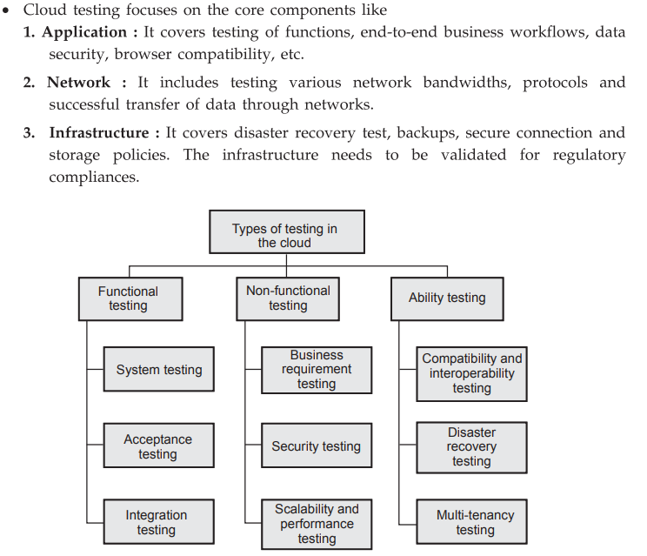

### ✅ 1. Introduction:

**Secure cloud software testing** refers to the process of verifying cloud-based applications and services for **security vulnerabilities, data protection, access control, and compliance issues**. It ensures that cloud software remains secure against internal and external threats.

### ✅ 2. Objectives of Secure Cloud Software Testing:

* Identify **vulnerabilities** in cloud-based applications.
* Ensure **data confidentiality, integrity, and availability**.
* Validate **access control** and **authentication mechanisms**.
* Ensure **compliance** with security standards and policies.

### ✅ 3. Key Aspects of Secure Cloud Testing:

#### ✅ A. **Security Functional Testing**

* Verifies whether security features (e.g., authentication, encryption, firewall) work as intended.
* Tests include login, session management, and access control.

#### ✅ B. **Vulnerability Scanning**

* Automated tools scan cloud applications and infrastructure for known vulnerabilities.
* Examples: SQL injection, cross-site scripting (XSS), misconfigured storage, open ports.

#### ✅ C. **Penetration Testing**

* Simulates real-world attacks to assess how well the cloud system can withstand hacking attempts.
* Must follow cloud provider's policies (e.g., AWS requires approval for penetration tests).

#### ✅ D. **Data Security Testing**

* Ensures data is **encrypted at rest and in transit**.
* Tests backup, recovery, and secure deletion processes.

#### ✅ E. **Compliance Testing**

* Checks that applications comply with regulatory standards (e.g., GDPR, HIPAA).
* Ensures security controls are in place as per industry norms.

#### ✅ F. **Access Control Testing**

* Verifies **role-based access control (RBAC)**.
* Ensures that users and services only have access to what they are authorized for.

### ✅ 4. Tools Used:

* **OWASP ZAP**, **Burp Suite**, **Nessus**, **Astra**, **Nmap**, etc.

### ✅ 5. Conclusion:

Secure cloud software testing is essential for protecting cloud applications from evolving threats. It involves **systematic testing of vulnerabilities, security mechanisms, and compliance standards** to ensure secure and reliable cloud service delivery.

**Q4. Compare server side and client-side encryption? [6]**

**=>**

**✅ 1. Introduction:**

**Encryption** is the process of converting data into a secure format to prevent unauthorized access. In cloud computing, **server-side** and **client-side** encryption are two major techniques used to secure data during storage or transfer.

**✅ 2. Comparison between Server-side and Client-side Encryption:**

| **Aspect** | **Server-side Encryption (SSE)** | **Client-side Encryption (CSE)** |
| --- | --- | --- |
| **Definition** | Data is encrypted by the **cloud provider** after it is uploaded. | Data is encrypted **by the client** before uploading to the cloud. |
| **Encryption Location** | Performed **at the server** (cloud side). | Performed **on the client device** before transmission. |
| **Key Management** | Managed by the **cloud provider** (e.g., AWS KMS). | Managed by the **client/user**. |
| **Security Control** | Less control by user; trusted to provider. | Full control over encryption and keys remains with the user. |
| **Performance** | Better for performance and ease of use. | More secure but adds overhead on client side. |
| **Data Visibility** | Cloud provider may have access to unencrypted data temporarily. | Cloud provider **never** sees unencrypted data. |
| **Use Case** | Suitable for general cloud storage (e.g., AWS S3). | Suitable for high-security needs (e.g., medical or financial data). |

**✅ 3. Conclusion:**

* **Server-side encryption** is convenient and efficient, suitable for regular cloud users.
* **Client-side encryption** offers greater security and privacy, especially when handling sensitive or confidential data.

Organizations can choose either or both depending on their **security policies and compliance requirements**.

**Q5. Short note & State the use of Content Level Security (CLS)? [9]**

**=>**

**✅ 1. Introduction:**

**Content Level Security (CLS)** is a method of securing the **actual content or data** stored, transmitted, or processed in a cloud environment, rather than just securing the channel or storage medium. It focuses on **protecting data itself** regardless of where it is stored or how it is transmitted.

**✅ 2. What is Content Level Security?**

* CLS ensures that **data remains confidential and protected** even if an attacker gains access to the storage or communication channels.
* It uses **encryption, digital signatures, and content tagging** to secure individual files, messages, or data objects.
* Security is embedded **directly into the content**.

**✅ 3. Key Features of CLS:**

* **End-to-End Security:** Data is encrypted from the source and decrypted only by the intended recipient.
* **Independent of Infrastructure:** Security does not rely solely on secure networks or storage.
* **Granular Control:** Allows fine-grained access control at the file or document level.
* **Audit and Monitoring:** Provides tracking of who accessed what data and when.

**✅ 4. Techniques Used in CLS:**

* **Encryption:** Content is encrypted using symmetric or asymmetric cryptography.
* **Digital Signatures:** Ensure authenticity and integrity of the content.
* **Watermarking or Metadata Tagging:** For ownership identification and access policies.
* **Rights Management Systems (DRM):** Control actions like view, copy, or edit.

**✅ 5. Use of Content Level Security:**

| **Use Case / Application Area** | **Explanation** |
| --- | --- |
| **Email and Messaging Security** | Encrypts content of messages to prevent unauthorized reading. |
| **Document Security** | Protects sensitive files like legal, healthcare, or financial documents. |
| **Cloud Storage Protection** | Ensures that files uploaded to services like Google Drive, Dropbox remain encrypted and secure. |
| **Data Sharing with Third Parties** | Enables secure content sharing with contractors, clients, or partners. |
| **Mobile and Remote Access** | Protects data accessed from untrusted networks or mobile devices. |

**✅ 6. Conclusion:**

**Content Level Security (CLS)** plays a critical role in **data-centric security approaches**, ensuring protection of sensitive data **regardless of the platform or channel**. It is essential for **confidentiality, data integrity, compliance**, and **user access control** in modern cloud-based environments.

**Q6. What are the different types of testing in cloud computing? Explain briefly? [9]**

**=>**

### ✅ 1. Introduction:

**Cloud testing** refers to testing cloud-based applications or using cloud resources to perform software testing. It helps verify performance, functionality, security, and reliability of cloud-hosted systems.

There are several types of testing in cloud computing to ensure **quality assurance** of cloud services.

### ✅ 2. Types of Testing in Cloud Computing:

| **Type of Testing** | **Description** |
| --- | --- |
| **1. Functional Testing** | Validates whether the cloud application works as expected according to requirements. Tests UI, APIs, input/output, etc. |
| **2. Performance Testing** | Evaluates the system’s response time, speed, scalability, and stability under various workloads. Includes load and stress testing. |
| **3. Load Testing** | Checks how the cloud system behaves under expected or peak load conditions. Ensures the application can handle user traffic. |
| **4. Stress Testing** | Tests system under extreme conditions to find its breaking point and ensure recovery without data loss. |
| **5. Compatibility Testing** | Ensures cloud services are compatible across different browsers, devices, operating systems, and networks. |
| **6. Security Testing** | Identifies security loopholes like unauthorized access, data breaches, or encryption flaws in cloud services. |
| **7. Scalability Testing** | Verifies if the application can scale up or down in response to workload changes, as cloud systems are expected to be elastic. |
| **8. Disaster Recovery Testing** | Validates the backup, restore, and failover capabilities to ensure business continuity during outages. |
| **9. Multi-Tenancy Testing** | Ensures proper data isolation and performance in a multi-user (multi-tenant) environment common in cloud platforms. |

### ✅ 3. Conclusion:

Cloud testing helps ensure that cloud applications are **efficient, secure, scalable, and compatible**. It enables better **cost-efficiency**, **resource optimization**, and **real-time test environments**, making it essential in modern software delivery practices.

**Q7. Analyze the different types of security risk involved in cloud computing? [9]**

**=>**

**✅ 1. Introduction:**

Cloud computing provides flexibility, scalability, and cost-efficiency. However, due to its distributed and shared nature, it introduces several **security risks** that can compromise **data confidentiality, integrity, and availability (CIA)**.

**✅ 2. Different Types of Security Risks in Cloud Computing:**

| **Security Risk** | **Explanation** |
| --- | --- |
| **1. Data Breach** | Unauthorized access to sensitive user data due to weak access controls or insecure APIs. |
| **2. Data Loss** | Permanent loss of data due to hardware failure, accidental deletion, or attacks without proper backup mechanisms. |
| **3. Insecure APIs** | Cloud services expose APIs; if not secured, attackers can exploit them to access data or services. |
| **4. Account Hijacking** | Attackers gain control of user credentials and misuse resources or steal data. Phishing and credential reuse are common causes. |
| **5. Insider Threats** | Employees or contractors with legitimate access may misuse data or cause intentional harm. |
| **6. Denial of Service (DoS) Attacks** | Attackers overwhelm cloud services, making them unavailable to genuine users. Affects availability. |
| **7. Insufficient Identity & Access Management (IAM)** | Poor control over user roles and privileges may allow unauthorized data access. |
| **8. Shared Technology Vulnerabilities** | Multi-tenancy and shared infrastructure (e.g., hypervisors, storage) can lead to cross-tenant data leaks if not properly isolated. |
| **9. Compliance Violations** | Data stored in the cloud may violate laws like GDPR, HIPAA if cloud providers don’t follow proper standards. |
| **10. Data Location and Jurisdiction Issues** | Data may reside in different countries with different laws, affecting privacy and regulatory compliance. |

**✅ 3. Mitigation Measures (Optional but Value-Adding):**

* Use of strong encryption for data at rest and in transit.
* Regular security audits and compliance checks.
* Proper IAM (multi-factor authentication, least privilege).
* Data backup and disaster recovery planning.
* Monitoring and intrusion detection systems.

**✅ 4. Conclusion:**

Understanding and managing **security risks in cloud computing** is critical to maintain **trust, data privacy, and business continuity**. Organizations must implement **robust security frameworks** to protect cloud-based resources from these evolving threats.

**Q8. What are the security issues of cloud computing identified by cloud security alliance (CSA)? Explain any three in detail? [9]**

**=>**

### ✅ 1. Introduction:

The **Cloud Security Alliance (CSA)** is a non-profit organization that identifies key security challenges in cloud computing. CSA published the **“Top Threats to Cloud Computing”** report to help organizations understand risks and adopt proper countermeasures.

### ✅ 2. Security Issues Identified by CSA:

Here are the **top security issues** (also called the "Treacherous 12"):

1. Data Breaches
2. Weak Identity & Access Management
3. Insecure Interfaces and APIs
4. System Vulnerabilities
5. Account Hijacking
6. Malicious Insiders
7. Advanced Persistent Threats (APTs)
8. Data Loss
9. Insufficient Due Diligence
10. Abuse of Cloud Services
11. Denial of Service (DoS)
12. Shared Technology Issues

### ✅ 3. Explanation of Any Three (In Detail):

#### 🔹 A. Data Breaches:

* **Definition:** Unauthorized access or disclosure of sensitive information like customer records or intellectual property.
* **Causes:** Weak authentication, misconfigurations, insecure APIs.
* **Impact:** Financial loss, brand damage, legal penalties.
* **Mitigation:** Encryption, access control, regular audits.

#### 🔹 B. Insecure Interfaces and APIs:

* **Definition:** APIs are the gateways to interact with cloud services. If not secured, they can be exploited.
* **Risks:** Exposure of credentials, data tampering, service hijacking.
* **Example:** Improperly authenticated REST APIs may allow attackers to access internal systems.
* **Mitigation:** Use of secure tokens, HTTPS, rate-limiting, and security testing of APIs.

#### 🔹 C. Account Hijacking:

* **Definition:** Attackers gain unauthorized access to cloud accounts using stolen credentials.
* **Methods:** Phishing, password reuse, keylogging.
* **Consequences:** Data theft, service manipulation, launching further attacks.
* **Mitigation:** Multi-factor authentication (MFA), monitoring, strong password policies.

### ✅ 4. Conclusion:

The CSA highlights major threats in cloud computing to guide organizations in building a secure cloud environment. Addressing issues like **data breaches, API security, and account hijacking** is essential to protect cloud-based resources and maintain trust.

**Q9. How Trusted Cloud Computing can be used to manage the risk and security in a cloud? [9]**

**=>**

### ✅ 1. Introduction:

**Trusted Cloud Computing (TCC)** refers to building a **secure and reliable cloud environment** where both service providers and users can trust the system to behave as expected, even in the presence of threats.

TCC combines **security technologies, protocols, policies, and governance** to reduce **risks and vulnerabilities** in cloud computing.

### ✅ 2. Objectives of Trusted Cloud Computing:

* Ensure **Confidentiality, Integrity, and Availability (CIA)**
* Establish **trust between cloud provider and users**
* Prevent unauthorized access and data leakage
* Provide **secure execution environments**

### ✅ 3. Key Components of Trusted Cloud Computing:

| **Component** | **Function** |
| --- | --- |
| **Trusted Platform Module (TPM)** | Provides hardware-based encryption, secure key storage, and system integrity checks. |
| **Virtual Trusted Platform (vTPM)** | A software version of TPM used in virtual environments. |
| **Secure Boot & Remote Attestation** | Ensures cloud systems boot securely and can prove their integrity. |
| **Policy Enforcement Point (PEP)** | Enforces access control policies for cloud resources. |
| **Identity & Access Management (IAM)** | Ensures only authorized users can access data and services. |

### ✅ 4. How TCC Helps Manage Risks and Security:

#### 🔹 A. **Trusted Hardware and Secure Booting**

* TCC ensures that the cloud system boots from **authenticated and verified software** only.
* Protects against **malware, rootkits, and boot-level attacks**.

#### 🔹 B. **Data Confidentiality and Integrity**

* TCC uses **encryption (at rest and in transit)** to secure data.
* **Access controls and audit logs** prevent unauthorized access and ensure traceability.

#### 🔹 C. **Isolation and Secure Multi-Tenancy**

* Ensures that data and execution environments of different users are **isolated** from each other.
* Prevents **data leakage** between tenants in shared infrastructure.

#### 🔹 D. **Remote Attestation**

* Allows cloud users to **verify the integrity** of the cloud environment before trusting it with sensitive data or computation.

#### 🔹 E. **Compliance and Governance**

* Trusted clouds help meet **regulatory requirements** (like GDPR, HIPAA).
* Policies can be enforced at all levels (data, application, network).

### ✅ 5. Conclusion:

**Trusted Cloud Computing** plays a vital role in **reducing security risks** and building **confidence** in cloud adoption. By combining hardware trust, encryption, secure policies, and access control, TCC enables organizations to **safely migrate and manage** critical workloads in the cloud.

**Q10. Explain the six step risk management processes? [9]**

**=>**

### ✅ 1. Introduction:

**Risk management** in cloud computing is the process of identifying, analyzing, evaluating, and addressing potential threats to cloud infrastructure, data, and services. A systematic **six-step process** ensures secure and reliable cloud usage.

### ✅ 2. Six-Step Risk Management Process:

#### 🔹 Step 1: **Categorize the Information System**

* Define and classify **data and resources** based on their **impact level** (low, moderate, high).
* Helps understand **what is at risk** and **how critical** the system is.
* Example: Financial records = high-impact system.

#### 🔹 Step 2: **Select Security Controls**

* Choose appropriate **security measures** (technical, administrative, physical) to protect the system.
* Refer to **security frameworks** (e.g., NIST SP 800-53, ISO 27001).
* Controls include: Firewalls, access control, encryption, etc.

#### 🔹 Step 3: **Implement Security Controls**

* Deploy the **selected controls** within the cloud infrastructure.
* Configure cloud services with proper **security settings**.
* Ensure secure coding practices and system hardening.

#### 🔹 Step 4: **Assess Security Controls**

* Evaluate the **effectiveness** of implemented controls.
* Perform **security testing, audits, and vulnerability scans**.
* Identify any weaknesses or misconfigurations.

#### 🔹 Step 5: **Authorize the Information System**

* Based on the risk assessment and control testing, **senior management decides** whether the system is **secure enough to operate**.
* A formal **Authorization to Operate (ATO)** is issued.
* Accepts residual risk after mitigation.

#### 🔹 Step 6: **Monitor Security Controls**

* Continuously **track and monitor** the environment for threats.
* Use tools like **SIEM, IDS/IPS, cloud monitoring dashboards**.
* Perform regular updates, audits, and incident response.

### ✅ 3. Diagram (Optional for Revision):

scss

CopyEdit

[1] Categorize → [2] Select Controls → [3] Implement →

[4] Assess → [5] Authorize → [6] Monitor (loop)

### ✅ 4. Conclusion:

The six-step risk management process ensures that **cloud systems remain secure and compliant** by regularly assessing and responding to security threats. This proactive approach helps organizations **protect data, maintain trust, and reduce vulnerabilities**.

**Q11. Describe how to perform Secure Cloud Software Testing? [9]**

**=>**



### ✅ 1. Introduction:

**Secure Cloud Software Testing** refers to the process of validating the **security, performance, and functionality** of applications deployed on cloud environments, ensuring **confidentiality, integrity, and availability (CIA)** of data and services.

This testing ensures cloud applications are **resilient against vulnerabilities**, even when accessed over public networks or from shared infrastructures.

### ✅ 2. Steps to Perform Secure Cloud Software Testing:

#### 🔹 Step 1: **Understand the Cloud Deployment Model**

* Identify the cloud model: **Public, Private, Hybrid, or Community**.
* Know where the application is hosted and the **level of control** the tester has.

#### 🔹 Step 2: **Define Security Requirements**

* Set clear **security goals**: data protection, access control, encryption.
* Compliance with standards like **ISO 27001, GDPR, HIPAA**.
* Identify **sensitive data and critical components**.

#### 🔹 Step 3: **Identify Security Threats and Risks**

* Conduct **threat modeling** using STRIDE (Spoofing, Tampering, Repudiation, etc.).
* Consider risks like **data leakage, insecure APIs, weak authentication**, etc.

#### 🔹 Step 4: **Plan Security Test Cases**

* Prepare detailed test cases for:
  + **Authentication and authorization**
  + **Session management**
  + **Data encryption (in transit and at rest)**
  + **Input validation**
  + **Access control policies**
* Use **OWASP Top 10** as a reference for common cloud application vulnerabilities.

#### 🔹 Step 5: **Perform Various Security Tests**

| **Test Type** | **Purpose** |
| --- | --- |
| **Vulnerability Scanning** | Identify known flaws and misconfigurations. |
| **Penetration Testing** | Simulate real attacks to find weak points. |
| **Configuration Testing** | Check cloud infrastructure settings. |
| **Data Integrity Testing** | Ensure data is not altered in transit/storage. |
| **API Security Testing** | Validate secure API usage and authorization. |

#### 🔹 Step 6: **Use Cloud Testing Tools**

* Tools like **Nessus, Metasploit, OWASP ZAP, Burp Suite**, and **Cloud-specific tools** (e.g., AWS Inspector, Azure Security Center) can be used for scanning and testing.

#### 🔹 Step 7: **Analyze and Report**

* Document test findings.
* Rate vulnerabilities based on **severity (High/Medium/Low)**.
* Provide recommendations for **mitigation and remediation**.

#### 🔹 Step 8: **Retest and Continuous Monitoring**

* After fixing issues, **retest the system**.
* Set up **continuous monitoring** for real-time alerts and proactive security.

### ✅ 3. Conclusion:

Secure cloud software testing is **crucial for protecting cloud applications** from evolving cyber threats. A structured testing approach involving **threat modeling, vulnerability analysis, and continuous monitoring** helps ensure **robust and secure cloud deployments**.

**Q12. Discuss the various Cloud Security Services with its necessity? [9]**

**=>**

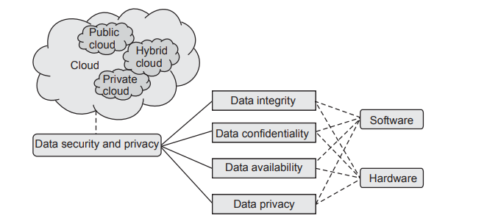

### ✅ 1. Introduction:

**Cloud Security Services** are tools and mechanisms designed to protect **data, applications, and infrastructure** in the cloud. These services help ensure **Confidentiality, Integrity, and Availability (CIA)** while enabling secure use of cloud resources.

Cloud security is essential due to **multi-tenancy, shared resources, remote access, and third-party control** in cloud environments.

### ✅ 2. Major Cloud Security Services:

#### 🔹 1. **Identity and Access Management (IAM)**

* **Purpose**: Ensures that only **authorized users** have access to cloud resources.
* **Functions**:
  + User authentication (MFA, password policies)
  + Role-based access control (RBAC)
  + Policy enforcement
* **Necessity**: Prevents **unauthorized access** and **internal data misuse**.

#### 🔹 2. **Data Encryption Services**

* **Purpose**: Protects data during **transit and at rest**.
* **Functions**:
  + Encrypt files, databases, and communications (SSL/TLS)
  + Key Management Systems (KMS)
* **Necessity**: Ensures **data confidentiality** and **prevents data leakage**.

#### 🔹 3. **Firewall and Network Security**

* **Purpose**: Protects the cloud network from **unauthorized traffic and attacks**.
* **Functions**:
  + Web Application Firewalls (WAF)
  + Network segmentation
  + Intrusion Detection and Prevention Systems (IDS/IPS)
* **Necessity**: Blocks **malicious traffic**, **DDoS**, and **zero-day threats**.

#### 🔹 4. **Security Information and Event Management (SIEM)**

* **Purpose**: Provides **real-time analysis** of security alerts and logs.
* **Functions**:
  + Collect and analyze logs from various sources
  + Detect anomalies and generate alerts
* **Necessity**: Helps in **incident detection, forensics, and response**.

#### 🔹 5. **Endpoint and Malware Protection**

* **Purpose**: Protects devices and servers from **malicious software**.
* **Functions**:
  + Antivirus, anti-malware, EDR (Endpoint Detection and Response)
* **Necessity**: Prevents **data theft, ransomware, and malicious code execution**.

#### 🔹 6. **Backup and Disaster Recovery Services**

* **Purpose**: Ensures **business continuity** in case of failures or attacks.
* **Functions**:
  + Automatic data backups
  + Replication across regions
* **Necessity**: Provides **data recovery** in case of accidental loss or cyberattacks.

#### 🔹 7. **Compliance and Governance Tools**

* **Purpose**: Ensures adherence to **legal and regulatory standards**.
* **Functions**:
  + GDPR, HIPAA, ISO 27001 compliance monitoring
  + Security policy enforcement
* **Necessity**: Avoids **legal penalties** and builds **customer trust**.

### ✅ 3. Importance / Necessity of Cloud Security Services:

| **Reason** | **Explanation** |
| --- | --- |
| Shared Infrastructure | Multi-tenancy increases exposure to threats |
| Remote Access | Needs strict control and identity verification |
| Compliance Requirements | Must meet industry standards (e.g., GDPR) |
| Dynamic & Scalable Environments | Require auto-scaled security measures |
| Constant Threat Landscape | Cloud is a target for cyberattacks |

### ✅ 4. Conclusion:

Cloud security services are **essential for building a trusted and resilient cloud infrastructure**. They safeguard **data, users, and workloads** from threats while ensuring compliance and availability of services in dynamic cloud environments.

**Q13. What are different risks in cloud computing and how to mange them?[9]**

**=>**

### ✅ 1. Introduction:

Cloud computing offers many benefits like scalability and cost-efficiency but also introduces several **risks** due to its distributed, multi-tenant, and remote-access nature. Understanding these risks and managing them is essential to ensure secure cloud adoption.

### ✅ 2. Different Risks in Cloud Computing:

#### 🔹 1. **Data Breach**

* Unauthorized access to sensitive data stored in the cloud.
* Can happen due to weak access controls or vulnerabilities.

#### 🔹 2. **Data Loss**

* Permanent loss of data caused by accidental deletion, disasters, or malicious attacks.

#### 🔹 3. **Insider Threats**

* Malicious or careless actions by employees or cloud provider insiders.

#### 🔹 4. **Account Hijacking**

* Attackers gain control over user accounts via phishing, credential theft, or weak passwords.

#### 🔹 5. **Insecure APIs**

* Vulnerabilities in cloud service APIs can lead to unauthorized access or data leakage.

#### 🔹 6. **Denial of Service (DoS) Attacks**

* Overloading cloud services to make them unavailable to legitimate users.

#### 🔹 7. **Compliance and Legal Risks**

* Failing to comply with laws and regulations regarding data privacy and security.

#### 🔹 8. **Lack of Control and Visibility**

* Users have limited control over infrastructure and visibility into security policies.

#### 🔹 9. **Shared Technology Vulnerabilities**

* Multi-tenancy means shared hardware or software vulnerabilities can be exploited.

### ✅ 3. How to Manage These Risks:

#### 🔹 1. **Data Encryption**

* Encrypt sensitive data at rest and in transit to protect confidentiality.

#### 🔹 2. **Strong Identity and Access Management (IAM)**

* Use Multi-Factor Authentication (MFA), least privilege principle, and role-based access.

#### 🔹 3. **Regular Security Audits and Monitoring**

* Continuous monitoring with tools like SIEM to detect suspicious activity.

#### 🔹 4. **Backup and Disaster Recovery**

* Maintain regular backups and implement disaster recovery plans to prevent data loss.

#### 🔹 5. **Secure APIs**

* Implement strict authentication and input validation for APIs.

#### 🔹 6. **Security Awareness Training**

* Educate employees and users about phishing, social engineering, and safe practices.

#### 🔹 7. **Use Trusted Cloud Providers**

* Choose providers with strong security certifications (ISO 27001, SOC 2).

#### 🔹 8. **Compliance Management**

* Ensure cloud deployments meet regulatory requirements through regular compliance checks.

#### 🔹 9. **Network Security Measures**

* Use firewalls, intrusion detection systems, and DDoS protection services.

### ✅ 4. Conclusion:

Cloud computing risks can affect data confidentiality, integrity, and availability but can be effectively managed by adopting a **comprehensive security strategy** combining encryption, access control, monitoring, and compliance. Proactive risk management ensures secure and reliable cloud use.

**Q14. Explain security authorization challenges in cloud computing? [9]**

**=>**

### 1. Introduction:

**Authorization** in cloud computing is the process of granting or denying specific access rights to users or systems over cloud resources after authentication. It ensures users access only what they are permitted to.

In cloud environments, authorization faces unique challenges due to **multi-tenancy, dynamic resource allocation, and distributed nature** of cloud services.

### 2. Key Security Authorization Challenges in Cloud Computing:

#### 🔹 1. **Complex Access Control Management**

* Managing access rights for a large number of users, devices, and applications is complex.
* Dynamic cloud environments require frequent updates in permissions.
* Risk of **over-privileged accounts** causing security vulnerabilities.

#### 🔹 2. **Multi-Tenancy and Data Isolation**

* Cloud resources are shared among multiple tenants.
* Ensuring strict **authorization boundaries** to prevent unauthorized cross-tenant data access is challenging.
* Requires fine-grained authorization mechanisms.

#### 🔹 3. **Dynamic and Scalable Environments**

* Cloud resources can scale up or down dynamically.
* Authorization systems must adapt in real-time to changing resource states and user roles.
* Maintaining consistent policies in such environments is difficult.

#### 🔹 4. **Federated and Cross-Domain Access**

* Cloud users often need access across multiple domains or cloud providers.
* Managing authorization in a federated environment with **different policies and standards** is complicated.
* Requires **interoperability** between diverse identity and access management systems.

#### 🔹 5. **Insufficient or Inconsistent Policy Enforcement**

* Authorization policies might not be uniformly enforced across all cloud services.
* Inconsistent policies lead to security loopholes and unauthorized access.

#### 🔹 6. **Lack of Visibility and Auditing**

* Difficulty in tracking and auditing who accessed what and when.
* Lack of detailed logs affects the ability to detect and respond to unauthorized access.

#### 🔹 7. **Privilege Escalation Attacks**

* Attackers exploiting flaws to gain higher privileges.
* Requires robust mechanisms to detect and prevent escalation.

#### 🔹 8. **Managing Temporary and Guest Access**

* Granting temporary access to contractors or partners is tricky.
* Ensuring automatic revocation after expiry is essential but often neglected.

### 3. Solutions to Overcome Authorization Challenges:

* Implement **Role-Based Access Control (RBAC)** and **Attribute-Based Access Control (ABAC)** for fine-grained policies.
* Use **Federated Identity Management** for cross-domain access.
* Enforce **least privilege principle** to minimize risk.
* Employ continuous **monitoring and auditing** for access patterns.
* Automate **access provisioning and de-provisioning** with lifecycle management.
* Use **multi-factor authentication (MFA)** alongside authorization.

### 4. Conclusion:

Authorization in cloud computing is critical but challenging due to dynamic, multi-tenant, and distributed cloud nature. Addressing these challenges requires robust, scalable, and adaptive authorization frameworks combined with strong policy enforcement and monitoring to secure cloud environments effectively.

**UNIT 6**

**Q1. Explain the mobile cloud computing? [6]**

**=>**

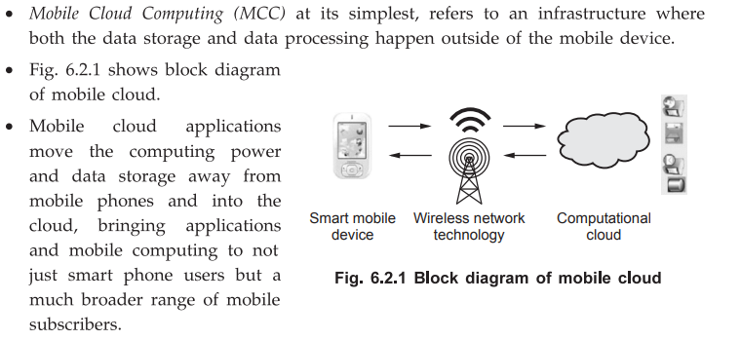

**1. Introduction:**

**Mobile Cloud Computing (MCC)** is the combination of mobile computing and cloud computing to provide rich computational resources to mobile users through internet and cloud services. It enables mobile devices to use cloud infrastructure and applications for better performance, storage, and processing capabilities.

**2. Definition:**

MCC is defined as a model where **mobile devices access cloud services and resources remotely via wireless networks** to overcome their inherent limitations like limited battery, processing power, and storage.

**3. Architecture of MCC:**

* **Mobile Devices:** Smartphones, tablets with limited resources.
* **Wireless Network:** 3G, 4G, 5G, Wi-Fi connects mobile devices to cloud.
* **Cloud Infrastructure:** Provides storage, processing power, applications hosted remotely.
* **Cloud Services:** Platforms, software, infrastructure as a service accessible via the cloud.

**4. Key Features:**

* **On-demand resource provisioning:** Access to virtually unlimited resources.
* **Elasticity:** Scalability based on demand.
* **Mobility support:** Users can access services anytime, anywhere.
* **Cost efficiency:** Reduces mobile device costs by offloading tasks.
* **Improved battery life:** Offloads heavy computation to cloud.

**5. Benefits of MCC:**

* Overcomes mobile device limitations (CPU, storage).
* Enhances application performance and availability.
* Supports resource-intensive applications like video streaming, gaming.
* Enables easy data sharing and synchronization.

**6. Conclusion:**

Mobile Cloud Computing enables mobile devices to leverage cloud computing power, improving functionality and user experience despite hardware constraints, making it essential for modern mobile applications.

**Q2. Explain docker with its Architecture? [6]**

**=>**

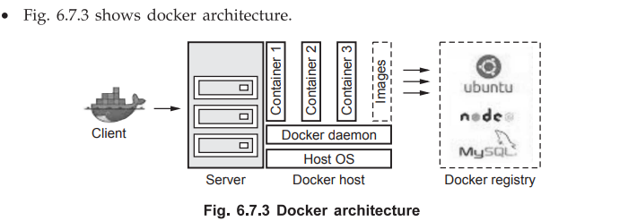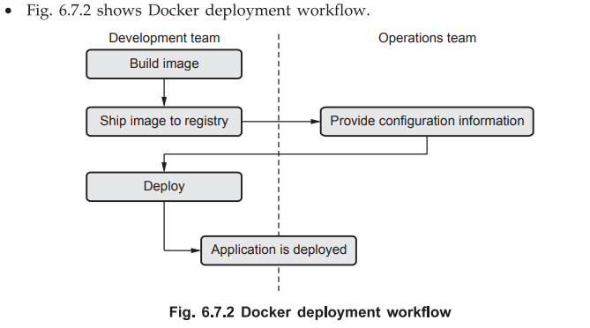

### 1. Introduction:

**Docker** is an open-source platform that automates the deployment, scaling, and management of applications inside lightweight, portable containers. Containers package an application and its dependencies, ensuring consistent behavior across environments.

### 2. What is Docker?

* Docker enables **containerization**, which isolates applications in containers that share the OS kernel but run independently.
* It is faster and more resource-efficient than traditional virtual machines.

### 3. Docker Architecture Components:

#### 🔹 1. **Docker Client:**

* Command-line interface (CLI) tool that users interact with.
* Sends commands to Docker Daemon (Docker Engine) via REST API.

#### 🔹 2. **Docker Daemon (Docker Engine):**

* Runs on the host machine.
* Responsible for building, running, and managing containers.
* Listens for Docker API requests from the client.

#### 🔹 3. **Docker Images:**

* Read-only templates that contain the application code, runtime, libraries, and dependencies.
* Used to create Docker containers.
* Built using Dockerfiles.

#### 🔹 4. **Docker Containers:**

* Runtime instances of Docker images.
* Lightweight, isolated environments running applications.
* Containers share the host OS kernel but have their own filesystem and processes.

#### 🔹 5. **Docker Registry:**

* Storage and distribution system for Docker images.
* Public registry example: Docker Hub.
* Users push and pull images to/from the registry.

### 4. How Docker Works:

* User issues commands via Docker Client.
* Docker Client communicates with Docker Daemon.
* Docker Daemon builds or runs containers using Docker images.
* Docker Daemon pulls images from the Docker Registry if not available locally.

### 5. Conclusion:

Docker architecture efficiently supports container lifecycle management by separating the client interface, daemon, images, containers, and registries, enabling developers to build, ship, and run applications consistently across environments.

**Q3. Explain the application of IOT and cloud in your home? [5]**

**=>**

### 1. Introduction:

**Internet of Things (IoT)** refers to the network of interconnected smart devices that collect and exchange data. When integrated with **Cloud Computing**, these devices leverage cloud infrastructure for data storage, processing, and remote access, making home automation more intelligent, efficient, and user-friendly.

### 2. Applications of IoT and Cloud in Home:

#### 🔹 1. **Smart Home Automation**

* IoT devices such as smart bulbs, smart thermostats, smart plugs, and smart appliances are connected to the internet.
* These devices can be controlled remotely via mobile apps or voice assistants.
* Cloud platforms store user preferences, automate schedules, and enable device synchronization.
* Example: Turning off/on lights or adjusting thermostat temperature remotely.

#### 🔹 2. **Home Security and Surveillance**

* IoT-enabled smart cameras, motion sensors, door/window sensors continuously monitor the home environment.
* Data and video footage are streamed and stored securely on the cloud.
* Cloud-based analytics detect unusual activity and send real-time alerts and notifications to the homeowner’s mobile device.
* Enables live remote viewing and recorded playback from anywhere.

#### 🔹 3. **Energy Management and Monitoring**

* IoT smart meters and energy monitoring devices track electricity, water, and gas consumption in real-time.
* Cloud platforms analyze usage patterns to identify wastage and suggest energy-saving strategies.
* Automation of appliances reduces energy consumption, for example, automatically switching off unused devices.
* Helps in reducing utility bills and promoting eco-friendly habits.

#### 🔹 4. **Voice-Controlled Assistants**

* Devices like Amazon Echo (Alexa), Google Home, or Apple HomePod use cloud-based AI and natural language processing.
* These devices act as hubs controlling other IoT gadgets via voice commands.
* Cloud integration allows continuous software updates, access to vast knowledge bases, and personalized user experience.
* Example: Voice commands to play music, control lighting, or check the weather.

#### 🔹 5. **Remote Health Monitoring**

* IoT health devices such as smart blood pressure monitors, glucose meters, and fitness trackers collect vital health data.
* Data is uploaded to cloud servers for storage and analysis.
* Cloud-based health applications provide alerts for abnormal readings, track health trends, and enable remote consultations with doctors.
* Enhances health management especially for elderly or chronic patients.

### 3. Benefits of IoT and Cloud in Home:

* **Convenience:** Remote control of devices anytime and anywhere.
* **Security:** Continuous monitoring with instant alerts.
* **Efficiency:** Better resource management with real-time data.
* **Scalability:** Easy to add new devices without infrastructure changes.
* **Cost Saving:** Optimized energy usage lowers bills.

**Q4. What is Energy aware cloud computing? Explain in details? [6]**

**=>**

### Q4. What is Energy Aware Cloud Computing? Explain in Detail? [6 Marks]

### 1. Introduction:

**Energy Aware Cloud Computing** refers to designing, managing, and operating cloud data centers and services with the primary goal of reducing energy consumption while maintaining performance and quality of service. It focuses on making cloud infrastructure more energy-efficient to lower operational costs and reduce environmental impact.

### 2. Why Energy Awareness is Important in Cloud Computing?

* Cloud data centers consume huge amounts of electrical energy due to servers, cooling systems, and network devices.
* Rising energy costs increase cloud service expenses.
* High energy consumption contributes to carbon emissions and environmental pollution.
* Energy efficient cloud computing supports sustainability and green IT initiatives.

### 3. Key Concepts of Energy Aware Cloud Computing:

#### 🔹 a) **Energy Efficient Resource Management**

* Dynamically allocating resources (CPU, memory, storage) based on workload demand.
* Turning off or putting idle servers into low-power sleep mode to save energy.
* Virtualization helps consolidate multiple virtual machines on fewer physical servers.

#### 🔹 b) **Energy Aware Scheduling**

* Scheduling cloud workloads and tasks considering energy consumption.
* Optimizing job assignments to servers with better energy profiles.
* Using algorithms that balance performance and energy use.

#### 🔹 c) **Energy Monitoring and Measurement**

* Continuous monitoring of energy usage by servers and devices.
* Using sensors and software tools to collect real-time energy consumption data.
* Analyzing data to identify energy inefficiencies.

### 4. Techniques Used in Energy Aware Cloud Computing:

* **Dynamic Voltage and Frequency Scaling (DVFS):** Adjusts CPU voltage and frequency based on workload to save energy.
* **Load Balancing:** Distributes workload evenly to avoid overloading some servers while others remain underutilized.
* **Virtual Machine (VM) Migration:** Moves VMs from lightly loaded servers to fewer machines, turning off unused servers.
* **Cooling Optimization:** Using smart cooling techniques like free cooling or liquid cooling to reduce power consumption of cooling systems.

### 5. Benefits of Energy Aware Cloud Computing:

* Reduces operational costs of cloud providers.
* Prolongs hardware lifespan by avoiding overheating.
* Supports environmental sustainability by lowering carbon footprint.
* Improves cloud service provider competitiveness through energy savings.

### 6. Conclusion:

Energy Aware Cloud Computing is essential to create sustainable, cost-effective cloud infrastructure. By adopting energy-efficient resource management, scheduling, and advanced techniques, cloud providers can reduce energy consumption while delivering reliable and scalable services.

**Q5. Explain container & Kubernetes in detail? [6]**

**=>**

### ****1. What is a Container?****

A **container** is a lightweight, portable, and self-sufficient software package that includes the application code, runtime, system tools, libraries, and dependencies required to run the application.

It uses **OS-level virtualization** to isolate the application from the host system and other containers.

#### 🔹 Key Features of Containers:

* Lightweight and fast to start.
* Portable across environments (dev, test, prod).
* Consistent behavior regardless of where it runs.
* Uses fewer resources than virtual machines.

#### 🔹 Popular Container Technology:

* **Docker** is the most widely used container platform.

### ****2. Benefits of Containers:****

* **Isolation:** Each container runs independently.
* **Portability:** Works the same across different OS and cloud platforms.
* **Resource Efficiency:** Shares the host OS kernel.
* **Scalability:** Supports rapid scaling of microservices.

### ****3. What is Kubernetes?****

**Kubernetes (K8s)** is an open-source **container orchestration** platform developed by Google. It is used to **automate the deployment, scaling, and management of containerized applications**.

Kubernetes ensures containers run in a **desired state**, restarts failed containers, and balances load across multiple containers.

### ****4. Key Components of Kubernetes:****

| **Component** | **Description** |
| --- | --- |
| **Pod** | Smallest unit in Kubernetes that can contain one or more containers. |
| **Node** | A machine (VM or physical) that runs pods. |
| **Cluster** | A set of nodes managed by Kubernetes. |
| **Master Node** | Controls and manages the Kubernetes cluster using the API server and scheduler. |
| **Kubelet** | Agent running on each node that ensures containers are running. |
| **Kube-proxy** | Manages network rules for communication between pods. |
| **Controller** | Monitors cluster state and makes changes to maintain desired configuration. |
| **Scheduler** | Assigns pods to nodes based on resource availability. |

### ****5. Advantages of Kubernetes:****

* **Auto-scaling:** Adds/removes containers based on load.
* **Self-healing:** Automatically restarts failed containers.
* **Rolling Updates:** Updates containers with zero downtime.
* **Load Balancing:** Distributes traffic to healthy containers.
* **Storage Orchestration:** Mounts local or cloud storage as needed.

### ****6. Conclusion:****

**Containers** package applications with all dependencies, and **Kubernetes** manages and orchestrates these containers at scale. Together, they provide a powerful, scalable, and efficient way to deploy and manage cloud-native applications in modern DevOps environments.

**Q6. Explain Distributed cloud computing? [5]**

**=>**

**1. Definition:**

**Distributed Cloud Computing** refers to a cloud computing model in which **computing resources, storage, and services are distributed across multiple physical locations** but are managed centrally by a public or private cloud provider.

The goal is to bring cloud services **closer to the end users** for improved performance, lower latency, and regulatory compliance.

**2. Key Characteristics:**

* **Decentralized Infrastructure:** Resources are spread across data centers or edge locations.
* **Centralized Management:** Single control plane to manage distributed resources.
* **Low Latency:** Processing occurs closer to the data source or user.
* **Fault Tolerance:** Improved reliability through geographic redundancy.
* **Compliance:** Data can be stored in specific regions for legal requirements.

**3. Types of Distributed Cloud:**

| **Type** | **Description** |
| --- | --- |
| **Public-resource cloud** | Uses geographically distributed public cloud resources. |
| **Edge cloud** | Cloud services run at edge locations (near users/devices). |
| **Hybrid cloud** | Combines on-premises infrastructure with distributed public cloud services. |

**4. Benefits of Distributed Cloud Computing:**

* **Improved Performance:** Less delay as services are closer to the user.
* **Better Compliance:** Meets regional data regulations.
* **Scalability:** Easy to expand across multiple locations.
* **Resilience:** Distributed setup avoids single points of failure.

**5. Real-life Use Cases:**

* **Content delivery networks (CDNs)**
* **IoT and smart city applications**
* **Gaming platforms with global user base**
* **Healthcare data processing close to hospitals**

**6. Conclusion:**

Distributed Cloud Computing is a powerful evolution of traditional cloud computing. It combines the scalability and flexibility of cloud services with the performance and compliance advantages of localized processing.

**Q7. Draw & Explain client - server architecture of docker? [9]**

**=>**

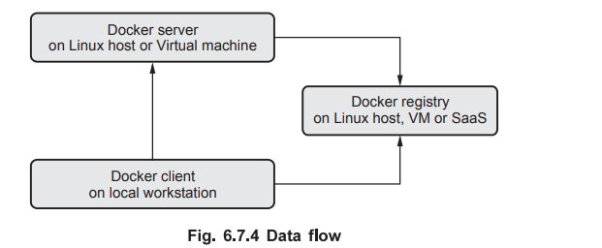

### ✅ ****1. Introduction:****

**Docker** uses a **client-server architecture** where the **Docker client** communicates with the **Docker daemon (server)** to build, run, and manage containers.

The communication usually happens via **REST APIs**, **UNIX socket**, or **network interface (TCP socket)**.

### ✅ ****2. Diagram: Docker Client-Server Architecture****

sql

CopyEdit

+---------------------+

| Docker Client |

+---------+-----------+

|

REST API / CLI Commands

|

+---------------+------------------+

| Docker Daemon |

| (dockerd - runs in system) |

+---------------+------------------+

|

+-------------------+--------------------+

| | |

+------------+ +------------+ +------------+

| Dockerfile | | Docker Hub | | Containers |

| (Images) | | (Registry) | | (Running) |

+------------+ +------------+ +------------+

### ✅ ****3. Components Explanation:****

#### 🔹 **A. Docker Client (**docker**)**

* It is the primary **user interface**.
* Sends commands to the Docker Daemon via **Docker CLI or REST API**.
* Examples: docker build, docker run, docker push.

#### 🔹 **B. Docker Daemon (**dockerd**)**

* **Runs on host system**, listens to client requests.
* Manages Docker **containers**, **images**, **volumes**, and **networks**.
* Performs building, running, and distribution of containers.

#### 🔹 **C. Docker Images**

* A read-only **template** with instructions to create a container.
* Created using **Dockerfiles**.
* Stored locally or in remote **registries**.

#### 🔹 **D. Docker Hub (or Private Registry)**

* A cloud-based or on-premises **image repository**.
* Allows sharing of container images.
* Docker client can **pull/push** images from/to this registry.

#### 🔹 **E. Docker Containers**

* **Running instances** of Docker images.
* They include the application and all its dependencies.
* Containers are isolated from the host and other containers.

### ✅ ****4. Working Flow:****

1. **User runs a command** via Docker CLI (e.g., docker run ubuntu).
2. **Client sends request** to Docker daemon.
3. Daemon checks if **image exists** locally; if not, pulls from Docker Hub.
4. **Daemon creates a container** from the image.
5. Container runs in an isolated environment on the host system.

### ✅ ****5. Conclusion:****

Docker's client-server architecture separates **user interaction (client)** from **execution and management (daemon)**, enabling **automation**, **remote deployment**, and **efficient management** of containerized applications.

**Q8. Explain Multimedia Cloud in detail? [9]**

**=>**

**✅ 1. Introduction to Multimedia Cloud:**

**Multimedia Cloud Computing** refers to the integration of **multimedia data processing** (such as video, audio, images) with **cloud computing infrastructure**.

It enables **storage, processing, streaming, and delivery** of multimedia content over the cloud with scalability, availability, and cost-effectiveness.

**✅ 2. Definition:**

A **Multimedia Cloud** is a cloud-based framework that supports **multimedia services** such as **media storage, encoding, transcoding, indexing, streaming, and content delivery**.

**✅ 3. Key Components of Multimedia Cloud:**

| **Component** | **Description** |
| --- | --- |
| **Multimedia Data Center** | Stores and processes large volumes of media files. |
| **Transcoding Engine** | Converts media files into different formats/resolutions. |
| **Content Delivery Network (CDN)** | Delivers multimedia to users from geographically distributed servers. |
| **Streaming Server** | Handles real-time streaming (live or on-demand). |
| **Media Indexing** | Extracts metadata (e.g., tags, titles) for search and retrieval. |

**✅ 4. Architecture of Multimedia Cloud:**

pgsql

CopyEdit

+---------------------------------------------------------+

| Multimedia Cloud Users |

+---------------------------+-----------------------------+

|

v

+------------------ Cloud Interface ------------------+

|

+------------------ Service Layer ------------------+

| Video On Demand | Live Streaming | Audio Services |

+--------------------------------------------------+

|

+------------------ Cloud Infrastructure ------------------+

| Storage | Transcoding | Streaming | CDN | Indexing |

+----------------------------------------------------------+

|

+---- Cloud Data Center ----+

**✅ 5. Features of Multimedia Cloud:**

* **Scalable Storage:** Stores huge multimedia content efficiently.
* **Dynamic Transcoding:** Supports multiple formats (MP4, AVI, etc.).
* **High Availability:** Ensures 24x7 access to content.
* **Adaptive Streaming:** Adjusts video quality based on bandwidth.
* **Cross-Platform Access:** Accessible via mobile, desktop, smart TV, etc.

**✅ 6. Applications of Multimedia Cloud:**

* **Video-on-Demand platforms** (e.g., YouTube, Netflix)
* **Live broadcasting** (e.g., sports, webinars)
* **E-learning platforms** (multimedia lectures)
* **Online music services** (e.g., Spotify, Gaana)
* **Video conferencing** (e.g., Zoom, Google Meet)

**✅ 7. Benefits:**

* Reduces cost of infrastructure
* Fast content delivery worldwide
* Flexibility to handle variable user loads
* Supports various devices and networks

**✅ 8. Challenges:**

* Bandwidth and latency issues
* Ensuring data security and content privacy
* Efficient multimedia indexing and retrieval
* Quality of Service (QoS) maintenance

**Q9. Differentiate between Distributed Cloud Computing Vs Edge Computing? [9]**

**=>**

### ✅ ****1. Introduction****

Both **Distributed Cloud Computing** and **Edge Computing** are modern approaches to computing that aim to reduce latency and improve performance. However, they differ in architecture, deployment, control, and purpose.

### ✅ ****2. Key Differences:****

| **Point of Comparison** | **Distributed Cloud Computing** | **Edge Computing** |
| --- | --- | --- |
| **Definition** | Extension of public cloud services to multiple locations, managed centrally by the provider. | Computing performed near the source of data (e.g., IoT devices), minimizing latency. |
| **Architecture** | Cloud resources are deployed at geographically distributed locations, but controlled by cloud. | Processing happens at or near the data source, often at the "edge" of the network. |
| **Data Processing Location** | At distributed cloud data centers across regions. | At edge devices, local servers, or gateways. |
| **Latency** | Lower latency than central cloud, but higher than edge. | Extremely low latency due to proximity to users/devices. |
| **Control & Management** | Managed by a central cloud provider (e.g., AWS Outposts, Azure Arc). | Decentralized; managed locally or by on-premise systems. |
| **Use Cases** | Multi-region applications, hybrid cloud, regulatory compliance, high availability. | Real-time applications like autonomous vehicles, industrial IoT, AR/VR, smart homes. |
| **Scalability** | Highly scalable; follows traditional cloud model with regional extension. | Limited scalability compared to cloud; depends on edge device capacity. |
| **Security** | Cloud-level security controls and compliance. | Requires strong device-level security; more vulnerable to physical and network attacks. |
| **Examples** | Google Distributed Cloud, AWS Local Zones, Azure Stack. | Smart cameras, wearable health monitors, smart factories, edge gateways. |

### ✅ ****3. Summary:****

* **Distributed Cloud** brings **cloud infrastructure closer** to users for performance and compliance, but still centrally managed.
* **Edge Computing** brings **compute power closer to data sources**, enabling real-time processing with ultra-low latency.

### ✅ ****4. Diagram (Textual Representation)****

#### a. **Distributed Cloud:**

sql

CopyEdit

+-------------------+

| Central Cloud |

| Management System |

+--------+----------+

|

+--------------+----------------+

| | |

+-----v-----+ +----v----+ +-----v-----+

| Cloud DC1 | | Cloud DC2| | Cloud DC3 |

| (Region 1)| | (Region 2)| | (Region 3)|

+-----------+ +----------+ +-----------+

#### b. **Edge Computing:**

lua

CopyEdit

+-------------------+

| Cloud (Optional) |

+---------+---------+

|

+----v----+

| Gateway |

+----+----+

|

+-----------------+-----------------+

| | |

+----v----+ +----v----+ +----v----+

| Edge Dev| | Edge Dev| | Edge Dev|

| (IoT) | | (CCTV) | | (AR) |

+---------+ +---------+ +---------+

### ✅ ****5. Conclusion:****

Both technologies enhance modern computing. **Distributed Cloud** ensures **global consistency and scalability**, while **Edge Computing** provides **localized, fast decision-making**. Their adoption depends on application requirements like latency, bandwidth, and control.

**Q10. Describe the concept of DevOps in detail? [9]**

**=>**

**✅ 1. Introduction:**

**DevOps** is a combination of **Development (Dev)** and **Operations (Ops)**. It is a set of practices, cultural philosophies, and tools designed to **increase an organization’s ability to deliver applications and services faster and more reliably**.

DevOps bridges the gap between software development teams and IT operations, improving collaboration and automation throughout the software lifecycle.

**✅ 2. Key Objectives of DevOps:**

* **Faster Software Delivery:** Automate and streamline development, testing, and deployment.
* **Improved Collaboration:** Break silos between development, operations, and other teams.
* **Continuous Integration and Continuous Delivery (CI/CD):** Ensure code changes are integrated, tested, and deployed frequently.
* **Quality and Reliability:** Detect and fix bugs early, improving software quality.
* **Scalability and Stability:** Automate infrastructure provisioning and monitoring for better stability.

**✅ 3. Components of DevOps:**

| **Component** | **Description** |
| --- | --- |
| **Continuous Integration (CI)** | Developers frequently merge code changes into a shared repository; automated builds and tests run to detect problems early. |
| **Continuous Delivery (CD)** | Automates software release processes to deploy code changes to production or staging environments quickly and safely. |
| **Infrastructure as Code (IaC)** | Managing infrastructure through code and automation instead of manual setup (e.g., using Terraform, Ansible). |
| **Monitoring and Logging** | Continuous monitoring of applications and infrastructure for performance and issues using tools like Prometheus, ELK stack. |
| **Collaboration and Communication** | Tools and practices that enable teams to communicate effectively (e.g., Slack, Jira). |

**✅ 4. DevOps Lifecycle Stages:**

1. **Plan:** Define features, requirements, and tasks.
2. **Develop:** Write and commit code.
3. **Build:** Compile and package the application.
4. **Test:** Automated and manual testing to ensure quality.
5. **Release:** Deploy to production or staging.
6. **Deploy:** Automated deployment with rollback options.
7. **Operate:** Monitor and manage applications in production.
8. **Monitor:** Collect feedback and metrics for continuous improvement.

**✅ 5. Tools Used in DevOps:**

* **Version Control:** Git, GitHub, GitLab
* **CI/CD:** Jenkins, CircleCI, Travis CI
* **Configuration Management:** Ansible, Puppet, Chef
* **Containerization:** Docker, Kubernetes
* **Monitoring:** Nagios, Prometheus, ELK Stack
* **Collaboration:** Slack, Jira, Confluence

**✅ 6. Benefits of DevOps:**

* Faster delivery of features and bug fixes
* Improved collaboration and communication among teams
* Enhanced software quality and reliability
* Reduced deployment failures and downtime
* Better customer satisfaction

**Q13. What do you mean by IoT Cloud? And how IoT cloud can be used in home automation? [9]**

**=>**

### ****1. Meaning of IoT Cloud****

* **IoT Cloud** is a specialized cloud computing platform designed to support the unique requirements of Internet of Things (IoT) ecosystems.
* It provides a **centralized infrastructure** that facilitates the storage, processing, and analysis of the massive volumes of data generated by connected IoT devices and sensors.
* IoT Cloud platforms offer **device management, data analytics, real-time monitoring, and security services** tailored specifically for IoT use cases.
* Unlike traditional cloud services, IoT cloud platforms focus on **handling device heterogeneity, intermittent connectivity, and event-driven data flows**.
* Examples of popular IoT cloud platforms include **Amazon AWS IoT, Microsoft Azure IoT Hub, Google Cloud IoT Core, IBM Watson IoT**.

### ****2. Key Features and Functionalities of IoT Cloud****

| **Feature** | **Explanation** |
| --- | --- |
| **Device Connectivity** | Enables secure and scalable connection of millions of IoT devices through protocols like MQTT, CoAP, HTTP. |
| **Device Management** | Allows remote onboarding, configuration, firmware updates, and health monitoring of devices. |
| **Data Storage & Analytics** | Collects, stores, and processes large-scale sensor data to extract actionable insights using cloud analytics tools and AI. |
| **Scalability** | Automatically scales resources to handle growing number of devices and data streams without downtime. |
| **Security** | Ensures authentication, authorization, encryption of data in transit and at rest, and threat detection. |
| **Real-time Processing** | Supports event-driven computing to trigger immediate actions based on sensor data or user commands. |
| **APIs and SDKs** | Provides developers with software tools to build, customize, and integrate IoT solutions efficiently. |

### ****3. IoT Cloud Architecture Overview****

* The architecture typically includes the following layers:
  + **Device Layer:** Sensors, actuators, and smart devices deployed in the environment.
  + **Network Layer:** Communication protocols and connectivity (Wi-Fi, cellular, Zigbee, LoRaWAN).
  + **IoT Cloud Platform Layer:** Core cloud services for device management, data ingestion, storage, processing, and analytics.
  + **Application Layer:** User-facing applications for control, monitoring, and automation.

### ****4. Use of IoT Cloud in Home Automation****

Home Automation refers to **automating household appliances and systems** to improve comfort, energy efficiency, and security. IoT Cloud enables this by connecting smart devices in the home to centralized cloud platforms.

#### **How IoT Cloud Supports Home Automation:**

* **Device Connectivity and Integration:**
  + Connects various smart home devices such as smart lights, thermostats, door locks, security cameras, smoke detectors, and appliances.
  + Supports interoperability among different manufacturers via standardized protocols.
* **Remote Monitoring and Control:**
  + Homeowners can monitor home devices remotely through mobile apps or web dashboards connected to the IoT cloud.
  + Enables turning devices on/off, adjusting settings, and receiving status updates from anywhere with internet access.
* **Data Collection and Analytics:**
  + IoT cloud collects sensor data like temperature, humidity, motion, light intensity.
  + Performs analytics to optimize device operation (e.g., turning heating off when room reaches set temperature).
* **Automation and Scheduling:**
  + Users can define automation rules or schedules through cloud applications (e.g., turn lights on at sunset, lock doors at night).
  + AI and machine learning algorithms in cloud analyze patterns and automate repetitive tasks without user intervention.
* **Real-time Alerts and Notifications:**
  + IoT cloud platforms send instant alerts for unusual activities like unauthorized access, smoke detection, or water leakage.
  + Enables quick response to emergencies improving home security and safety.
* **Voice Assistant Integration:**
  + IoT cloud enables integration with voice-controlled smart assistants such as Amazon Alexa or Google Assistant.
  + Users can issue voice commands to control smart home devices seamlessly.

### ****5. Example of IoT Cloud in Home Automation****

* **Smart Thermostat:** The thermostat senses room temperature and sends data to the IoT cloud.
* The cloud analyzes weather forecasts and occupancy patterns.
* It adjusts the temperature automatically for energy saving and comfort.
* The user can override settings remotely via a smartphone app.
* The system sends alerts if abnormal temperature changes or system faults are detected.

### ****6. Benefits of Using IoT Cloud in Home Automation****

* **Convenience:** Centralized control over all home devices accessible remotely.
* **Energy Efficiency:** Automated adjustments reduce wastage of electricity and water.
* **Improved Security:** Continuous monitoring with real-time alerts enhances safety.
* **Scalability:** Easily add or remove devices without infrastructure changes.
* **Cost Savings:** Optimized use of resources reduces utility bills.
* **Customization:** Personalized automation tailored to user habits and preferences.

### ****7. Challenges****

* **Data Privacy and Security:** Protecting sensitive data from unauthorized access.
* **Interoperability:** Integrating devices from different vendors with varying standards.
* **Reliability:** Dependence on stable internet connectivity and cloud uptime.

### ****8. Conclusion****

IoT Cloud acts as the **backbone of modern smart homes**, providing a scalable, secure, and intelligent platform to connect, manage, and automate home devices. It enhances convenience, comfort, energy efficiency, and security, making home automation accessible and effective.

**Q14. Explain architecture and working of Kubernetes. [9]**

**=>**

### 1. Introduction

* **Kubernetes** is an open-source container orchestration platform used to automate deployment, scaling, and management of containerized applications.
* It helps in managing clusters of containers efficiently by handling tasks like load balancing, resource allocation, scaling, and self-healing.

### 2. Kubernetes Architecture Overview

Kubernetes architecture follows a **master-worker (control plane-node)** model with the following components:

#### **A. Control Plane (Master Node)**

Responsible for managing the entire cluster and maintaining its desired state.

* **API Server (kube-apiserver):**
  + Acts as the frontend for Kubernetes control plane.
  + Exposes REST API for communication with users, CLI, and other components.
  + Validates and configures data for API objects (pods, services, replication controllers).
* **Scheduler (kube-scheduler):**
  + Assigns newly created pods to worker nodes based on resource availability, constraints, and policies.
* **Controller Manager (kube-controller-manager):**
  + Runs various controller processes (Node Controller, Replication Controller, Endpoint Controller).
  + Ensures cluster is in desired state by monitoring and making adjustments (e.g., scaling pods, maintaining node health).
* **etcd:**
  + Distributed key-value store used to persist all cluster data and configurations.
  + Acts as the source of truth for Kubernetes cluster state.

#### **B. Worker Nodes (Minions)**

Responsible for running the containerized applications and reporting back to the control plane.

* **Kubelet:**
  + An agent running on each worker node.
  + Ensures containers described in PodSpecs are running and healthy.
  + Communicates with the API server to receive instructions.
* **Kube-proxy:**
  + Network proxy running on each node.
  + Manages network rules to enable communication between pods and services inside and outside the cluster.
* **Container Runtime:**
  + Software responsible for running containers on the node (e.g., Docker, containerd).

### 3. Kubernetes Objects

* **Pods:** The smallest deployable units consisting of one or more containers.
* **Services:** Abstracts a set of pods and provides a stable IP address and DNS.
* **ReplicaSets:** Ensure specified number of pod replicas are running.
* **Deployments:** Manage ReplicaSets and provide declarative updates.

### 4. Working of Kubernetes

1. **User Interaction:**
   * User interacts with the cluster using kubectl (Kubernetes CLI) or REST API.
   * User submits the desired state (e.g., deploy 3 replicas of a web app) via API Server.
2. **Scheduling:**
   * API Server forwards pod creation request to Scheduler.
   * Scheduler finds an appropriate worker node based on resource availability and constraints.
3. **Pod Creation:**
   * Scheduler assigns pod to the selected node.
   * Kubelet on that node receives pod specs from API server.
   * Kubelet pulls container images from the registry and starts containers using container runtime.
4. **Networking:**
   * Kube-proxy sets up networking rules so pods can communicate internally and externally.
   * Services provide load balancing and stable access to pods.
5. **Monitoring and Self-Healing:**
   * Controller Manager constantly monitors pods and nodes.
   * If a pod or node fails, it reschedules pods to maintain the desired state.
6. **Scaling:**
   * Users can scale up/down deployments using API.
   * Kubernetes automatically schedules or terminates pods accordingly.

### Diagram of Kubernetes Architecture

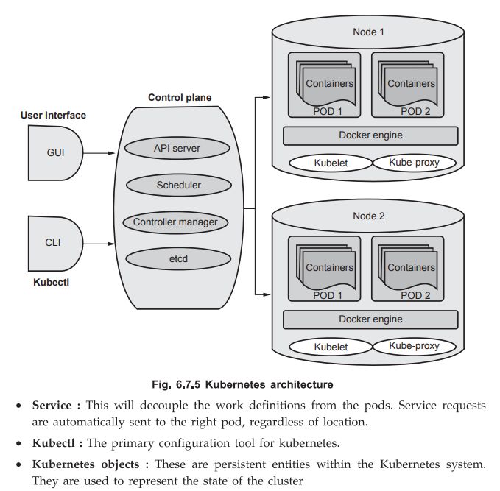

pgsql

CopyEdit

+-----------------------------+

| Control Plane |

| |

| +---------+ +------------+|

| | API | | Scheduler ||

| | Server | +------------+|

| +---------+ +------------+|

| |Controller Manager |

| +--------------------------|

| | etcd (Key-Value Store) |

+-----------------------------+

| |

+---------+ +---------+

| |

+------------------+ +------------------+

| Worker Node 1 | | Worker Node 2 |

| +--------------+ | | +--------------+ |

| | Kubelet | | | | Kubelet | |

| | Kube-proxy | | | | Kube-proxy | |

| | Container | | | | Container | |

| | Runtime | | | | Runtime | |

| +--------------+ | | +--------------+ |

+------------------+ +------------------+

### 6. Summary

* Kubernetes automates container management via a **master-worker** architecture.
* The **control plane** manages cluster state; worker nodes run application containers.
* Core components like **API Server, Scheduler, Controller Manager, Kubelet, and Kube-proxy** coordinate container lifecycle, networking, and scaling.
* Kubernetes provides self-healing, load balancing, and scalability, making it ideal for modern cloud-native applications.

**Q15. What are the future trends in cloud computing? Explain in brief? [9]**

**=>**

Cloud computing is rapidly evolving, and several emerging trends are shaping its future. These trends focus on enhancing performance, security, automation, and integration with new technologies.

**1. Multi-Cloud and Hybrid Cloud Solutions**

* Organizations are adopting **multi-cloud** strategies to use multiple cloud providers simultaneously, improving reliability, avoiding vendor lock-in, and optimizing costs.
* **Hybrid cloud** combines private and public clouds, allowing sensitive data to remain on-premises while leveraging public cloud scalability.
* This trend promotes flexibility, business continuity, and better workload management.

**2. Edge Computing and Fog Computing**

* With IoT and 5G proliferation, **edge computing** processes data closer to the source, reducing latency and bandwidth use.
* **Fog computing** extends cloud services to the network edge, supporting real-time analytics.
* These approaches complement cloud computing by enabling faster decision-making and efficient handling of massive data.

**3. Serverless Computing**

* Also known as **Function as a Service (FaaS)**, serverless computing allows developers to run code without managing servers.
* It offers automatic scaling, pay-per-use billing, and simplifies deployment.
* This trend accelerates application development and reduces infrastructure costs.

**4. Artificial Intelligence (AI) and Machine Learning (ML) Integration**

* Cloud providers increasingly embed **AI and ML services** into their platforms.
* These services enable predictive analytics, automation, natural language processing, and intelligent decision-making.
* The integration supports smarter cloud applications and business processes.

**5. Cloud Security Enhancements**

* Security remains a top priority with advancements in **Zero Trust models, AI-powered threat detection, and enhanced encryption techniques**.
* Cloud providers are focusing on securing multi-cloud environments, identity management, and compliance.
* This ensures data protection and regulatory adherence in a complex cloud ecosystem.

**6. Quantum Computing and Cloud**

* Quantum computing is expected to revolutionize data processing.
* Cloud providers are beginning to offer **quantum computing as a service** to provide access to quantum processors.
* This will enable solving complex problems in cryptography, optimization, and simulation faster than classical computers.

**7. Containers and Kubernetes Growth**

* Containers and orchestration tools like **Kubernetes** will dominate for application deployment.
* They offer portability, scalability, and efficient resource utilization.
* Their integration with cloud-native services will continue to grow.

**8. Green Cloud Computing**

* With increasing environmental concerns, **energy-efficient and sustainable cloud computing** is gaining importance.
* Providers are investing in renewable energy-powered data centers and optimizing resource usage.
* This trend supports corporate social responsibility and reduces carbon footprint.

**9. Cloud Automation and DevOps**

* Automation in cloud management through **Infrastructure as Code (IaC), continuous integration/continuous deployment (CI/CD), and AI-driven automation** is rising.
* DevOps practices will further streamline development, testing, and deployment in cloud environments.

**Conclusion**

The future of cloud computing is characterized by **flexibility, intelligence, security, and sustainability**. Innovations like multi-cloud strategies, edge computing, AI integration, and quantum computing will shape next-generation cloud services, empowering businesses to be more agile and competitive.

**Q16. Discuss Energy Aware Cloud Computing with suitable example? [9]**

**=>**

### 1. Introduction

Energy Aware Cloud Computing is an approach in cloud computing that focuses on optimizing energy consumption in cloud data centers and computing resources while ensuring efficient performance and meeting user demands. It aims to reduce the overall carbon footprint and operational costs associated with running large-scale cloud infrastructures.

Cloud data centers consume a significant portion of global electricity due to servers, cooling systems, networking devices, and storage units. Energy Aware Cloud Computing promotes techniques and strategies to minimize this energy consumption sustainably.

### 2. Importance of Energy Awareness in Cloud Computing

* **High Energy Consumption:** Cloud data centers consume huge amounts of energy; a single large data center may consume tens of megawatts of power.
* **Environmental Impact:** Energy usage contributes to greenhouse gas emissions and global warming if derived from fossil fuels.
* **Cost Reduction:** Energy costs can be 30-50% of total data center operating costs.
* **Regulatory Compliance:** Many countries enforce energy efficiency and environmental regulations.
* **Sustainability Goals:** Organizations aim to reduce their carbon footprint and promote green IT.

### 3. Energy Consumption in Cloud Data Centers

Energy consumption in data centers is primarily due to:

* **Servers and Computing Devices:** CPUs, GPUs, RAM, and disks consume power even when idle.
* **Cooling Systems:** Cooling accounts for nearly 30-50% of data center energy usage.
* **Networking Equipment:** Switches, routers, and other communication devices also consume power.
* **Power Supply Losses:** Energy loss in power distribution and conversion.

### 4. Key Techniques for Energy Aware Cloud Computing

#### a) **Energy Efficient Hardware**

* Use of low-power CPUs and GPUs.
* Energy Star certified servers.
* Use of solid-state drives (SSD) instead of traditional HDDs.
* Efficient power supplies and cooling systems.

#### b) **Virtualization and Server Consolidation**

* Consolidate multiple virtual machines on fewer physical servers.
* Shut down or put idle servers into low power or sleep mode.
* Improves server utilization and reduces the number of active servers.

#### c) **Dynamic Voltage and Frequency Scaling (DVFS)**

* Adjust CPU voltage and frequency based on workload demand.
* Reduces power usage during low CPU utilization without impacting performance.

#### d) **Energy-Aware Workload Scheduling**

* Allocate workloads to servers in a way that minimizes energy consumption.
* Use scheduling algorithms that consider power efficiency.
* For example, batch non-critical tasks during off-peak hours or when renewable energy is abundant.

#### e) **Thermal-Aware Resource Management**

* Distribute workloads to reduce hotspots inside data centers.
* Prevent overheating, which lowers cooling energy requirements.

#### f) **Use of Renewable Energy Sources**

* Integration of solar, wind, or hydroelectric power in data centers.
* Google and Microsoft operate data centers powered by renewable energy to reduce carbon footprint.

### 5. Energy Aware Cloud Computing Workflow (Brief)

1. **Monitoring:** Real-time measurement of power usage across servers and network devices.
2. **Analysis:** Analyze energy consumption patterns using software tools.
3. **Optimization:** Use algorithms to optimize resource allocation dynamically.
4. **Control:** Implement control mechanisms like DVFS or server power states.
5. **Feedback:** Continuously monitor and adjust based on performance and energy metrics.

### 6. Example: Google’s Energy Aware Data Centers

* Google uses AI and machine learning to optimize data center energy use.
* The AI controls cooling systems and workload distribution to reduce energy consumption.
* Achieved a **40% reduction** in energy usage for cooling.
* Google invests heavily in renewable energy and operates data centers with near-zero carbon footprint.

### 7. Benefits of Energy Aware Cloud Computing

* **Cost Savings:** Lower electricity bills reduce operational expenses.
* **Environmental Impact:** Reduced CO2 emissions promote sustainability.
* **Improved Hardware Longevity:** Less heat generation reduces hardware wear and tear.
* **Compliance:** Helps meet governmental regulations and corporate social responsibility.
* **Better Resource Utilization:** Efficient use of computing resources increases overall system performance.

### 8. Challenges in Energy Aware Cloud Computing

* **Balancing Performance vs. Energy Savings:** Reducing energy should not degrade QoS or SLA adherence.
* **Complexity:** Implementing dynamic, real-time energy management algorithms is complex.
* **Heterogeneous Environments:** Diverse hardware and workloads complicate energy optimization.
* **Initial Investment:** Energy-efficient hardware and renewable energy setups require higher initial costs.
* **Measurement Accuracy:** Accurately measuring power consumption in real-time is difficult.

### 9. Conclusion

Energy Aware Cloud Computing is essential for creating sustainable and cost-effective cloud environments. It incorporates hardware innovations, virtualization, smart scheduling, and renewable energy use to reduce energy consumption without sacrificing service quality. As cloud adoption grows, energy-aware practices will become a standard requirement to meet environmental and economic goals.

**Q17. Explain with example, working of Docker? [9]**

**=>**

**1. Introduction to Docker**

Docker is an open-source containerization platform that enables developers to package applications and their dependencies into lightweight, portable containers. Containers run consistently across different environments, solving the “works on my machine” problem.

**2. Key Concepts**

* **Container:** A lightweight, standalone executable package including application code, runtime, libraries, and settings.
* **Image:** A read-only template used to create containers. It contains the application and dependencies.
* **Docker Engine:** The core software that builds, runs, and manages Docker containers.
* **Docker Hub:** A cloud-based registry to store and share Docker images.

**3. Working of Docker**

Docker uses client-server architecture:

* **Docker Client:** The command-line interface (CLI) used by users to interact with Docker.
* **Docker Daemon:** Runs on the host machine, manages containers, images, networks, and storage.
* **REST API:** Used for communication between client and daemon.

**4. Docker Workflow (Step-by-step)**

1. **Write a Dockerfile:**

A text file that contains instructions to build a Docker image. For example, to create a Node.js app container:

dockerfile

CopyEdit

FROM node:14

WORKDIR /app

COPY package*.json ./

RUN npm install

COPY . .

EXPOSE 3000

CMD ["node", "app.js"]

1. **Build Docker Image:**

Use command:

perl

CopyEdit

docker build -t my-node-app .

This creates an image named my-node-app.

1. **Run Docker Container:**

Start a container from the image:

arduino

CopyEdit

docker run -d -p 3000:3000 my-node-app

This runs the container in detached mode (-d) and maps port 3000 of container to host port 3000.

1. **Docker Engine:**

The Docker daemon manages container lifecycle — creation, starting, stopping, and deleting containers.

1. **Container Execution:**

The container runs the app isolated with all dependencies, ensuring consistent behavior across environments.

**5. Example: Simple Web Server in Docker**

* Create a Dockerfile to set up an Nginx web server:

dockerfile

CopyEdit

FROM nginx:latest

COPY ./html /usr/share/nginx/html

* Build and run:

perl

CopyEdit

docker build -t my-web-server .

docker run -d -p 80:80 my-web-server

* Now accessing http://localhost in the browser shows the website served from the container.

**6. Advantages of Docker**

* Lightweight and fast compared to virtual machines.
* Portability across different platforms.
* Easy to scale applications via containers.
* Supports microservices architecture.
* Efficient resource utilization.

**7. Summary**

Docker packages applications with dependencies into containers that run consistently everywhere. The workflow involves writing a Dockerfile, building an image, and running containers managed by the Docker engine. This containerization streamlines deployment, scalability, and environment consistency.



**Q18. How the Cloud and IoT together works for Home Automation? [9]**

**=>**

**1. Introduction**

* **Home Automation** refers to the automatic and remote control of household devices like lights, fans, security cameras, thermostats, and appliances.
* **IoT (Internet of Things)** enables physical devices to connect to the internet, communicate, and be controlled remotely.
* **Cloud Computing** provides scalable computing resources, storage, and services over the internet.
* When combined, **Cloud and IoT** create a smart, connected home system that is accessible anytime, anywhere.

**2. Components of IoT-Cloud Home Automation System**

* **IoT Devices:** Sensors (temperature, motion, humidity), actuators (motors, switches), smart appliances.
* **Gateway:** Connects IoT devices to the internet, aggregates data, and forwards it to the cloud.
* **Cloud Platform:** Provides data storage, processing power, analytics, control logic, and user interface.
* **User Interface:** Mobile apps or web portals for users to monitor and control devices remotely.
* **Communication Protocols:** MQTT, HTTP, CoAP for data transmission between devices and cloud.

**3. Working of Cloud and IoT in Home Automation**

**Step-by-step process:**

1. **Data Collection:** IoT sensors in home collect data — e.g., temperature, motion, door status.
2. **Data Transmission:** Sensors send data via local gateway or directly over Wi-Fi/Cellular to the cloud platform using secure protocols.
3. **Data Processing and Storage:** Cloud servers receive data, process it in real-time or batch, and store it securely.
4. **Decision Making & Automation:**
   * Cloud runs automation rules or AI algorithms to analyze sensor data.
   * For example, if temperature crosses a threshold, cloud triggers commands to smart thermostat to adjust HVAC.
5. **Control Commands:** Cloud sends control signals back to IoT actuators/devices.
6. **User Interaction:**
   * Users access mobile or web apps connected to the cloud.
   * They can monitor home status, receive alerts, and manually control devices from anywhere.
7. **Feedback Loop:** Device status updates are sent back to the cloud and reflected on user interfaces.

**4. Example Scenario**

* A motion sensor detects movement in the living room.
* Sensor sends alert data to the cloud.
* Cloud processes alert and triggers smart lights to turn on.
* User receives notification on the smartphone app.
* User can override or automate actions using cloud-based settings.

**5. Benefits of Cloud-IoT Home Automation**

* **Remote Accessibility:** Control devices from any location.
* **Scalability:** Cloud can handle many devices and data streams.
* **Data Analytics:** Cloud analyzes usage patterns for energy savings.
* **Cost Efficiency:** Minimal local hardware; pay-as-you-go cloud services.
* **Integration:** Connect multiple smart devices and third-party services.
* **Security:** Cloud provides centralized security management.

**6. Challenges**

* **Data Privacy:** Sensitive data must be protected.
* **Network Dependence:** Requires reliable internet connectivity.
* **Latency:** Real-time control requires low latency communication.