Manual Lathe Extension

Kedar More*1,Vaibhavi Patil*2

*Roll no. s-201536,301537*

1Department of Mechanical

2 Department of Electronics and Telecommunication

*Fr. Conceicao Rodrigues College of Engineering, Mumbai University*

*Sector-9A, Vashi, Navi Mumbai, India*

1kedarmore5050@gmail.com

2vaibhaviapatil1997@gmail.com

***Abstract—* This abstract discusses an enhancement in conventional lathe machine. Now-a-days amongst many products which are manufactured using modern technology which is a communion of computer software, hardware and firmware, the lathe machine plays a vital role in this manufacturing sector. Hence, researchers are trying out new enhancements in the conventional lathe machine. The latest amongst these developments is the use of the Computer Numeric Control for automation of the manual lathe machines, which are termed as Computer Numeric Control lathe machines. Although, these lathe machines provide desired accuracy and efficiency but they require a huge capital. Also, due to modernized industrialization, replacing the manual lathe machines with more efficient Computer Numeric Control lathe machines cannot be affordable to all the small scale and medium industries. In this dilemma, the designing of an extension for manual lathe can enhance its existing properties. This extension will have almost all the characteristics of a Computer Numeric Control machine. Hence, this project is an attempt to equip the conventional lathe machine with a controlling device i.e. a microcontroller to control the motor movement.**

**Keywords—** ***CNC, Lathe.***

# INTRODUCTION

Lathe is machine used to produce objects with axial symmetry which is achieved by operations like turning, tapering, facing, parting, grinding, drilling, boring, knurling. An operator has to rotate the two wheels in order to change the position of the tool and move it to the desired location. The wheels have some graduation marks which indicate the distance of the traveled path according to its revolution.

In early 1960s, CNC lathes where introduced as improved productivity and precision type lathe machines with computer numeric control(CNC). Now, the latest machinery of CNC milling machines and lathes employ microprocessors in order to read the user created G and M codes. The calculations for generating a pre-defined path for the tool are done based on these codes.

So, this shows that the CNC lathe machines have various benefits over manual lathe machines including the improved efficiency, accuracy, reliability and also reduced human labor. On the other hand, the conventional fully human operated lathe machines are completely discarded in the advent of installation of “CNC” lathe machines to design more finished products.

So, our aim is to design an extension for the conventional lathe machines whose functionality will be the same as that of CNC. This part will be similar to the cross slide or dead end, which can be removed. Thus, without hindering the normal manual lathe this extension can be used as a CNC. Still one can get back to the conventional manual lathe as this extension is detachable.

# II. SYSTEM OVERVIEW

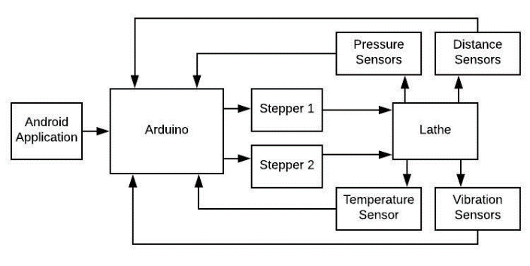

Fig3.1 Block diagram

# III.WORKING

The Working of this extension can be divided into following sections:

1. *Android application:*

An android application is provided to the workers. They have to draw the side view of the required part in that application and Press “SEND”.

1. *Communication via Bluetooth.*

The communication between the Arduino and User application is done via Bluetooth. In, the android application when the worker clicks on “SEND” button after drawing the side view, appropriate dimensions of the diameters at specific interval of length of workpiece are send to the controller in form of an array.

1. *Shaping Action.*

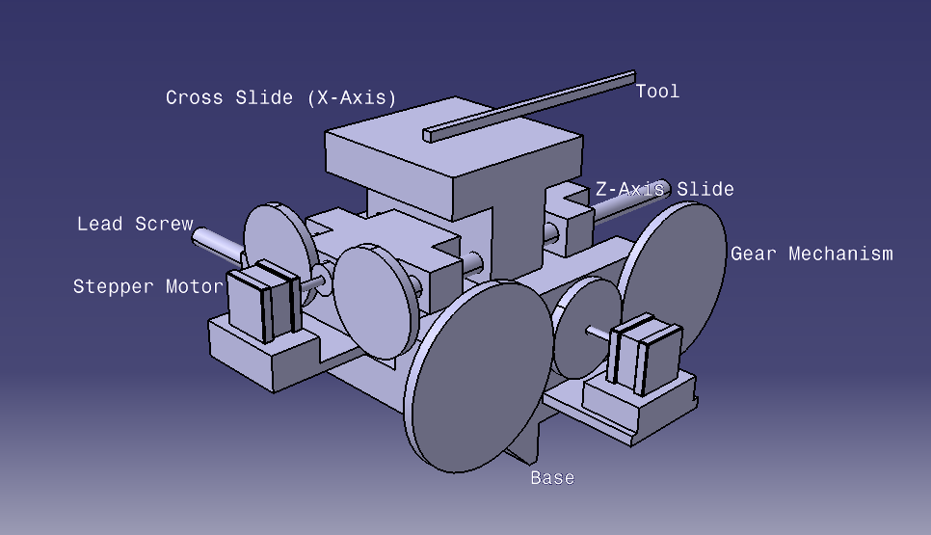

Fig 4.1 Catia model

The controller used is Arduino mega 2560. The controller understands the shape of desired object based on the array received from the application. The cutting algorithm fed to the Arduino controls the motion of the two stepper motors for the desired cut. Now, according to the received array the cutting algorithm starts the cut. For every job, the controller will first perform a “rough cut” and then later it will go for a “finished cut”. The type of cut varies according to shape or inclination of the job. Hence, manufacturing of different jobs may involve different types of cuts. As the entire array is first analyzed by the controller, and then based on the type of cuts, their position and number, the controller decides which cut to be performed first. Hence, the cuts are performed in the most appropriate order.

1. *Coding algorithm:*

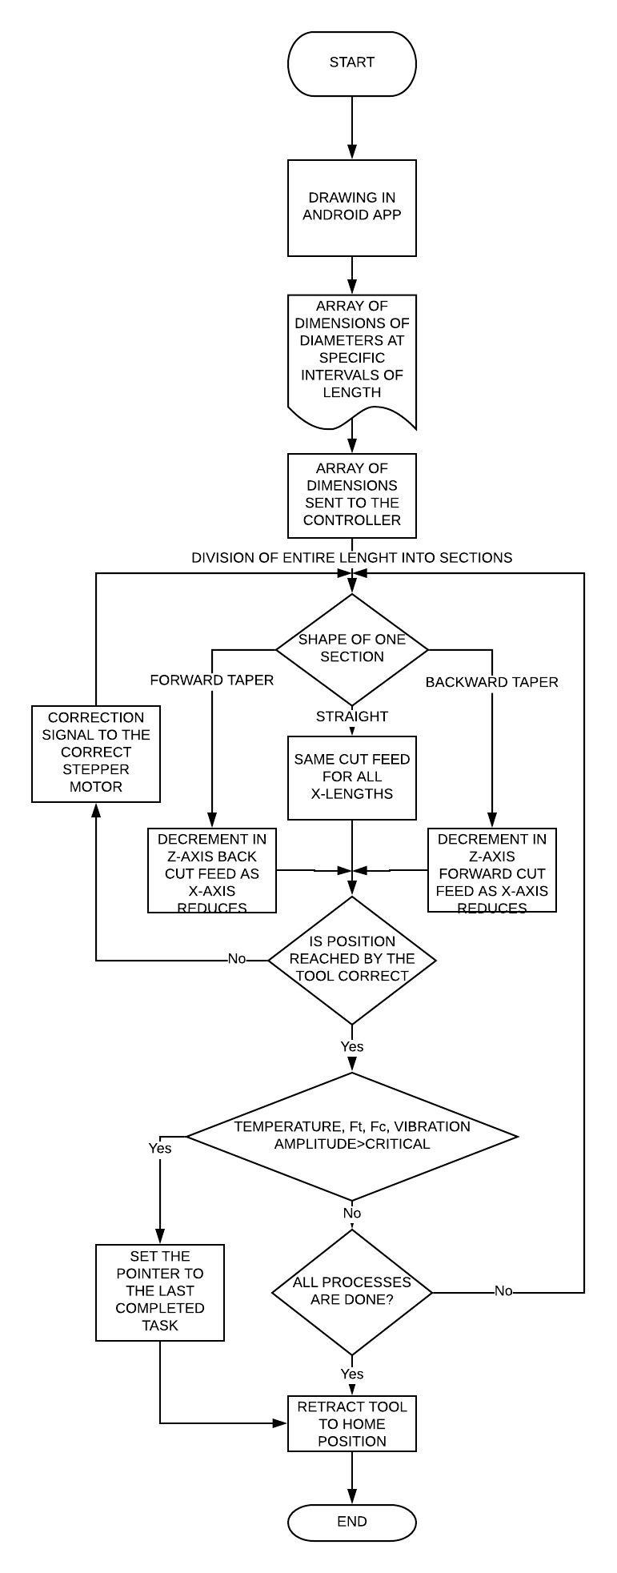

Fig 4.3 Flow Chart part2

1. *Simulation*

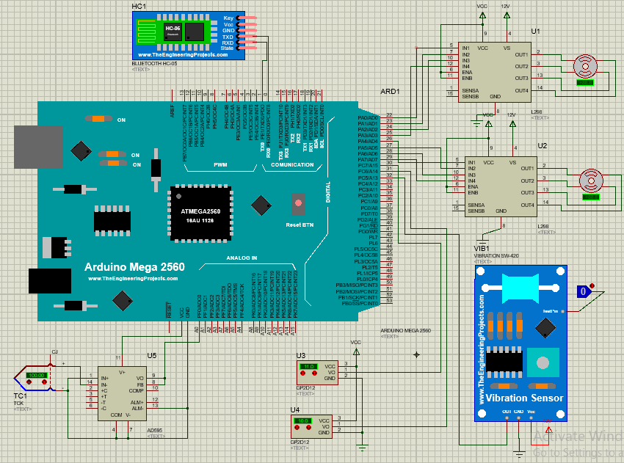

Fig 4.4 Proteus simulation

V. FEEDBACK CONTROL

Stepper Motors provide very accurate angle of rotation as codded. This in turn move the lead screws precisely to the required position. But if the motor goes haywire then the tool may move much deeper into the work piece than expected. This can cause severe damage to the Extension and also some fragile parts may break. In order to avoid this feedback control becomes mandatory. Two Sharp Distance IR distance sensors are used to keep a track on the two axes of motion i.e. track of movement of the tool. These sensors work on the principle of transmitting and receiving IR light. They are placed such that they can track the motion of the flat surface in front of them. Hence, they the actual distance travelled by the tool.

The error of the stepper motor can be observed by the IR sensors and if necessary be rectified by commanding the stepper motor accordingly.

VI. SAFETY PRECAUTIONS

There are two major forces acting on the tool tip namely Ft - Thrust Force and Fc - Cutting Force. If they exceed a certain critical limit, then tool edge may get blunt rapidly. The forces exceed the limit if the feed rate or the depth of cut is more than the specifications. For measurement of these perpendicular force two strain gauges are used.

While cutting operations friction is always present. Friction between the tool and the workpiece leads to high heat release. This may increase the temperature of the workpiece above the fusing point. It causes a small amount of molten metal to accumulate on the tool tip making it blunt. Thus, a check on rise in temperature is also necessary in cutting operations. For this a K Type Thermocouple is attached and the temperature of the tool is checked continuously.

The main motor on the lathe which rotates the spindle is heavy duty, high torque motor. During its operation high amount of vibrations are created which travel through the gear box the whole machine. This may cause the surface of the machined workpiece to be uneven. Complete removal of these vibrations is not possible but can stop the operation when they cross a threshold value. Then if the problem is analyzed and solved the operation may resume. For this a vibrometer is mounted on a location far from supporting structure where the maximum amplitude of vibration will be recorded.

VII. ADVANTAGES

1. No skilled labor needed
2. Direct connection to the design engineer can be established
3. Basic drawing of the part in needed.
4. Manual lathe can be obtained by detaching the extension
5. Can produce the same quality for all work parts as produced by CNC lathe machines.
6. Better dimensional accuracy than manual lathe which gives exact and correct dimensions.

VIII. CONCLUSION

Using this extension, we are reducing the work of the laborer as well as giving the design engineers a clear path to the machine itself. Here, the worker is just needs to load and unload the work piece, whereas uploading the file into the controller can be done by the engineer in the office. This also assures reduction in amount of paper work including the hard copy of drawing files. The extension will have lesser cost than the full functional CNC, hence introduction of this extension can prove a boom to small scale industries. Additionally, the wastage of metal or internal mechanism of old lathe is also avoided by using the same spindle provided in the old machine. In this way, the functionality of manual lathe will always sustain in this world of automation.

REFERENCES

[1] Review on Advance Automation of Conventional Lathe Machine

[2] In 2013, M. Moses & Dr. Denis Ashok M. Tech, Mechatronic from School of Mechanical and Building Science, VIT University, Vellore, India 978-1-4673-6150-7/13/$31.00 ©2013 IEEE

[3] We have also used following links,

http://en.wikipedia.org/wiki/Lathe