Exercise 1.

(a) Give a definition for a complete planning algorithm.

An algorithm is said to be complete if it computes a path to the goal if it exists in finite amount of time or returns failure if the path does not exist.

(b) Give a definition for an optimal planning algorithm.

(c) Recall the wave-front planner from Lecture 8. Is it a complete planner? Is it an optimal planner?

Exercise 2.

Exercise 3.

(a) Plot the paths generated by the planner. (Assume the robot transverses the adjacent cells using a line that connects their centers.)

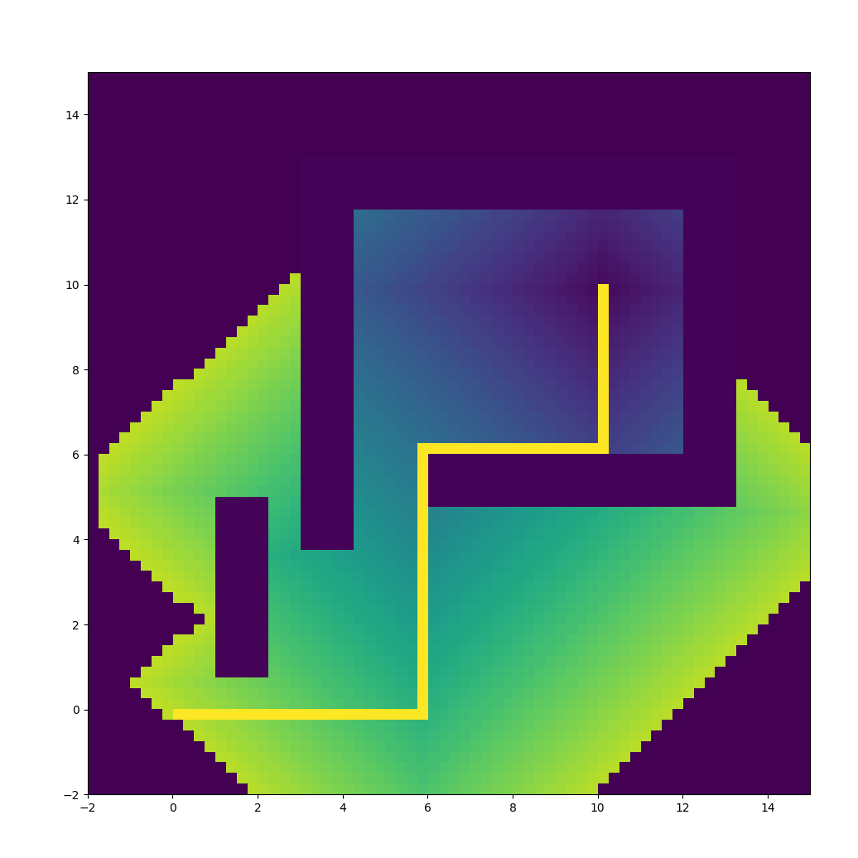

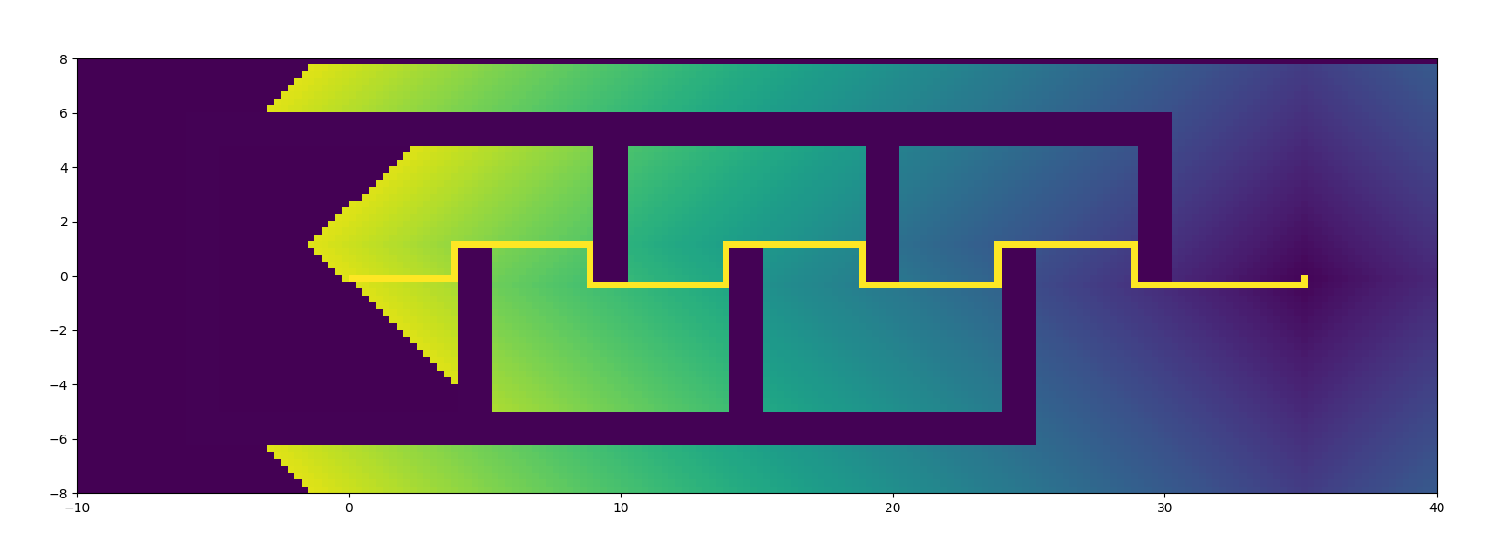

(b) What are the lengths of the paths?

Workspace 1: 20 units

Workspace 2: 44 units

(c) Would you expect the path lengths to get smaller as the grid size gets smaller?

No, as the

(d) How does this wave-front planner perform in comparison to the gradient descent planner in Exercise 2 part (b)?

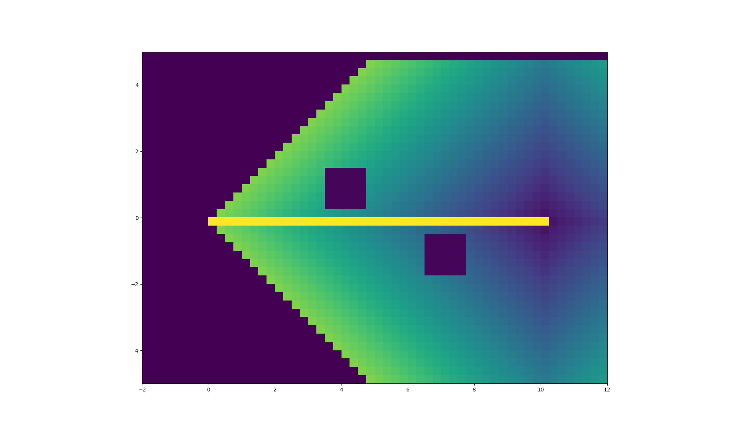

Length of the path is 10 units.

Time taken is

Exercise 4.

