**Manage EMPLOYEE, SCHEDULE and CUSTOMERS**

**Application DOCUMENTATION**

Purpose of the document

Describe the main features of application and its workflow.

This document is the property of the KingPins FEC LLC.

Document history

|  |  |  |  |
| --- | --- | --- | --- |
| **Version** | **Date** | **Drafter** | **Description** |
| 1.0 | 01/13/2017 | Kedar Ram | Initial Draft |
|  |  |  |  |
|  |  |  |  |
|  |  |  |  |

Validation

|  |  |  |
| --- | --- | --- |
|  | **Validator** | **Date** |
|  | Kedar Ram | 01/17/2017 |
|  |  |  |

Contents

[**Purpose of the document**](#_gjdgxs)

[**Document history**](#_30j0zll)

**Distribution**

[**Validation**](#_1fob9te)

[**1.** **Icons Used in the Manual**](#_3znysh7)

[**2.** **Presentation of the Solution**](#_tyjcwt)

[2.1 Brief description](#_3dy6vkm)

[2.2 Project players](#_1t3h5sf)

[2.3 Support](#_4d34og8)

[2.4 History of the Solution](#_2s8eyo1)

[**3.** **Connecting to the Application**](#_17dp8vu)

[3.1 Address](#_3rdcrjn)

[3.2 Authentication](#_26in1rg)

[**4.** **Structuring of the Application**](#_lnxbz9)

[4.1 Layout](#_35nkun2)

[4.2 Menus](#_1ksv4uv)

[4.3 Functionalities](#_44sinio)

[4.3.1 Functionalities Presented/Described](#_2jxsxqh)

[4.3.2 Functionalities not Presented/not Described](#_z337ya)

[**5.** **Function Component / Screen Login**](#_3j2qqm3)

[5.1 Screenshot](#_1y810tw)

[5.2 Descriptions of fields, content](#_4i7ojhp)

[5.3 Description of actions](#_2xcytpi)

[5.4 Sequence of screens](#_1ci93xb)

[**6.** **Function Component / Screen Employee Manager**](#_2bn6wsx)

[6.1 Screenshot](#_qsh70q)

[6.2 Descriptions of fields, content](#_3as4poj)

[6.3 Description of actions](#_1pxezwc)

[6.4 Sequence of screens](#_49x2ik5)

**7.** [**Function Component / Screen Customer Manager**](#_3j2qqm3)

7.1 [Screenshot](#_1y810tw)

7.[2 Descriptions of fields, content](#_4i7ojhp)

7[.3 Description of actions](#_2xcytpi)

7[.4 Sequence of screens](#_1ci93xb)

**8**[**.** **Function Component / Screen Schedule Manager**](#_2bn6wsx)

8[.1 Screenshot](#_qsh70q)

8[.2 Descriptions of fields, content](#_3as4poj)

8[.3 Description of actions](#_1pxezwc)

8[.4 Sequence of screens](#_49x2ik5)

9[**.** **Appendices**](#_2p2csry)

[7.1 Appendix 1](#_147n2zr)

7.2 Appendix 2

# Icons Used in the Document

Throughout this document, the pictograms below are used to underline points or important notions

|  |  |
| --- | --- |
| icono2 | Important information |
| policeman_usa_on | Actions reserved for the …. **Manager** |
| businessman2_on | Actions reserved for the … **Employee** |

# Presentation of the Solution

## 2.1 Brief description

* + **The application allows employees to login, manage their profile, request changes to schedule for upcoming weeks along with managing customer entry and exit along with printable reports.**

## 2.2 Project players

* + **Kedar Ram – Developer and Documentation**

## 2.3 Support

* + **Email** [**kingpins.adm@gmail.com**](mailto:kingpins.adm@gmail.com) **for all support questions.**

## 2.4 History of the Solution

**This is our first major coding application. We picked the simplest development software to work on the project. After a couple of weeks into the project my partner quit, I took on all components to complete the project.**

**Solution to the application was broken down into multiple components**

1. **Login**
2. **Employee Management**
3. **Customer Management**
4. **Scheduling**

**Some of the reference materials used to develop the application include:**

* **Udemy**
* **Code Academy PHP, MYSQL**
* **PHP W3school**
* **Youtube videos**
* **stackoverflow.com**
* **google**

**Software used to develop on Windows.**

* **WAMPSERVER x64 – PHP 5.6.25, Apache 2.4.23 and MYSQL 5.7.14 => environment**
* **Bootstrap 3.3.7 => fancy header**
* **PHPMailer 5.2.19 => mail when password is forgotten**
* **JQuery 1.11.3, 1.11.4 => javascript**
* **Visual Studio Code 1.7.2 => Colorful editor**

icono2 One needs to install WAMPSERVER x64 version 3.0.6

And upload the database scripts to populate seed data to begin using the application.

See Appendix 1 for details on installation/deployment.

**Component Login:**

**Mock view was made up on what fields we would require in a form and database.**

**This was translated into table and test data.**

**With the Login the Forgot Password link was incorporated. This required email to send out, A gmail account was setup to be used for this purpose and PHPMailer code was added to send out email.**

**Reset-Password was added as a feature to allow users the ability to set their own password instead of default.**

**Component Employee Management:**

**This was broken down into Manager vs Employee.**

**An Employee would be able to see their profile and edit some parts of it.**

**While a Manager would be able edit his/her own and search any employees to edit.**

**Manager will also be able to create new employees and list all of them to print.**

**Component Customer Management:**

**Both Employee and Manager will be able to create a new customer as they register to play with the current enter time. As the customer leaves (maybe Driver's license is taken from the customer as they enter and returned as they leave to note their exit), the company employee or manager would be able to look up a customer and mark them as exit complete.**

**(What hasn’t been coded: Automated clean up at the end of day of any open customers that were not marked as exit complete.)**

**Reporting of customers for a specific date and start and end time was added and this report can be printed using standard browser print settings.**

**Component Scheduling:**

**Manager would be able to view schedule changes, approve schedule change request, move employees between groups to ensure there are enough employees per Group.**

**We decide to follow a fixed group for shift schedule. Employees are assigned a default group when created, they can request to move to a different group for a week. The request can be approved by the manager.**

**Each employee would be able to view their schedule on login with their group for the week highlighted.**

# **3**. Connecting to the Application

## 3.1 Address

* + **http://localhost/KingPins**

## 3.2 Authentication

* + **Authentication to the application requires UserName and Password.**
  + **Forgot Password will prompt for Email and UserName and provide default password via email.**
  + **Reset-Password post login can be used to set up a new password.**

# 4. Structuring of the Application

## 4.1 Layout

* + **The top header displays the home page, logo and main menu applicable to the user of the application.**
  + **All processing and forms are displayed below the header.**

## 4.2 Menus

* + **Home -> About**
  + **Home -> Contact**
  + **Home -> Login**
  + **Employee Home -> Home (personal schedule)**
  + **Employee Home -> Reset Password**
  + **Employee Home -> Edit Personal Profile**
  + **Employee Home -> Schedule Manager -> Request Schedule Change**
  + **Employee Home -> Schedule Manager -> Delete Requested Change**
  + **Employee Home -> Customer Manager**
  + **Employee Home -> Customer Manager -> Create Customer**
  + **Employee Home -> Customer Manager -> Search Customer**
  + **Employee Home -> Customer Manager -> Search Customer ->List All Customers -> Print**
  + **Employee Home -> Customer Manager -> Search -> Exit/Close Customer**
  + **Employee Home -> Customer Manager -> Customer Report Form**
  + **Employee Home -> Customer Manager -> Customer Report Form -> Report**
  + **Employee Home -> Logout**
  + **Manager Home -> Home(personal schedule)**
  + **Manager Home -> Home (personal schedule)**
  + **Manager Home -> Reset Password**
  + **Manager Home -> Edit Personal Profile**
  + **Manager Home -> Employee Manager -> Create Employee**
  + **Manager Home -> Employee Manager -> Search and Edit Employee**
  + **Manager Home -> Employee Manager -> List All Employees -> Print**
  + **Manager Home -> Schedule Manager**
  + **Manager Home -> Schedule Manager -> Personal Schedule Change Request**
  + **Manager Home -> Schedule Manager -> Manager initiated Schedule Change**
  + **Manager Home -> Schedule Manager -> Approve Employee Schedule Change**
  + **Manager Home -> Schedule Manager -> Delete (mark as Delete) Schedule Change Request**
  + **Manager Home -> Schedule Manager -> Scheduling**
  + **Manager Home -> Customer Manager**
  + **Manager Home -> Customer Manager -> Create Customer**
  + **Manager Home -> Customer Manager -> Search Customer**
  + **Manager Home -> Customer Manager -> Search -> List All Customers**
  + **Manager Home -> Customer Manager -> Search -> Exit/Close Customer**
  + **Manager Home -> Customer Manager -> Customer Report Form**
  + **Manager Home -> Customer Manager -> Customer Report Form -> Report**
  + **Manager Home -> Schedule Manager**
  + **Manager Home -> Logout**

## 4.3 Functionalities

### 4.3.1 Functionalities Presented/Described

**Component: Login**

1. Login using UserName and Password
   1. If the user name and/or password is valid - display error
   2. If forgot password - click on link to new screen that prompt for email address and username and reset password to default password. It emails the user that they can login using default password.
2. After successful login, depending on the type of employee, they are led to new menu screen.
3. Both employee and manager have the ability to Reset their password with required fields
   1. If username is not valid - display error
   2. If new password and confirm password do not match - display error.

**Component: Employee Manager**

Employee:

1. Edit their profile
   1. The employee is allowed to change their username, email and phone number.
   2. If username is already in use - display error (has to be unique)
   3. If email is already in use - display error (has to be unique)
   4. phone number should be in right format xxx-xxx-xxxx - else display error.

Manager:

1. Edit their profile
   1. The employee is allowed to change their username, email and phone number.
   2. If username is already in use - display error (has to be unique)
   3. If email is already in use - display error (has to be unique)
   4. phone number should be in right format xxx-xxx-xxxx - else display error.
2. Create Employee
   1. If required fields are not populated - display error
   2. If required fields like username, firstname do not meet required length - display error
3. Search and Edit Employee
   1. Search for an employee
   2. Search using username - need to be exact match - display error if not match
   3. Search using firstname and lastname - need to be exact match - display error if not match
   4. Search using firstname - need to be exact match - display error if not match
   5. Search using lastname - need to be exact match - display error if not match
   6. List all employees - link provides list of all employees on the screen with print option.

**Component: Customer Manager**

For Both Employee and Manager:

1. Create a Customer
   1. Required field phone number - It has to be unique (as long as there is only one customer group in the center, example: a customer can come in and leave and come in again )
2. Search a Customer
   1. Search using phone number
   2. Search using customer first name and or last name.
   3. List all customers.
3. Report on Customer
   1. Search using a date, start time and end time
   2. If start and end time is not provided, use default start as 00:00 and end as 23:59
   3. Report will be listed in a new page that can be printed using browser print option.

**Component: Scheduling**

### 4.3.2 Functionalities not Presented/not Described

**Component: Login**

* Employee is not prompted for reset-password if they use default password to login.

**Component: Employee Manager**

**Employee** – schedule and other options are displayed.

Schedule is limited to current and upcoming week.

* Personal Profile: Not all profile details are editable by the employee for data integrity reasons.
* Employee Schedule Change Request: We limit employees to schedule next 3 weeks only to keep it to a manageable level.

**Manager**

Schedule listing is similar to Employee

* Personal Profile: Manager can update their own profile similar to employee profile with restrictions. (code reused)

Search and Edit Employee Profile: Manager can lookup employee by any one of the options below. The data has to be an exact match, wildcard searches have not been implemented.

* + Email
  + First Name and Last Name
  + First Name
  + Last Name
* Listing all Employees: Partial list of Employees by certain wildcard lookups has not been implemented.

**Component: Customer Manager**

* Lookup for customer based on partial matches has not be implemented. Standard search options are available based on First Name, Last Name and Customer phone number.
* Customer’s at the end of the day who have not been closed/exit marked have not been taken care off as end of day activity.
* Customer Report does not have a specific print button, but standard browser print option can be used to print out the report of customers per day within specific start and end period. If a start and end is not defined. Default start of day to end of day is used.

**Component: Scheduling**

* Employees whose schedules are approved currently do not receive emails on approvals, that functionality is yet to be implemented.
* Individual Employee schedule change request can be looked up for approval individually. Batch (small subset) approvals are yet to be implemented, while a full list approval feature is available.

# 5 Function Component / Screen Login

**Login Component, handles**

* + **Login (after user/employee is created)**
  + **Forgot Password (reset to default password and email user)**
  + **Password Reset (allow user to reset to new password)**

## 5.1 Screenshot

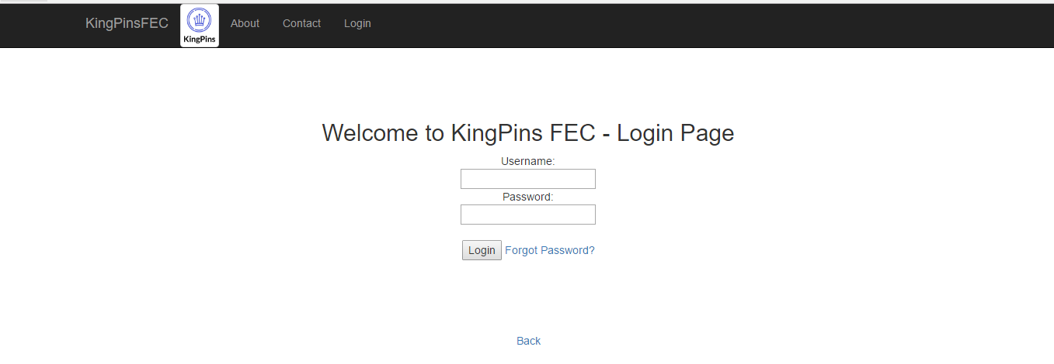

## 5.2 Descriptions of fields, content

Login Screen:

Required Fields: UserName, Password

Forgot Password:

Required Fields: email, UserName

Reset Password:

Required Fields: UserName, New Password, Confirm Password

## 5.3 Description of actions

Actions here are self-explanatory.

If user is an employee then Login takes the user to Employee screen with menu’s that the Employee is allowed to use.

If user is a manager then Login takes the user to Manager screen with menu’s that the Manager is allowed to use.

## 5.4 Sequence of screens

Login -> Employee Home -> Logout

Login -> Manager Home -> Logout

# 6 Function Component / Screen Employee Manager

The application allows two views:

* employee
* manager

businessman2_onEmployee view allows the employee to edit his profile. The employee can edit their username, email address and phone number. However he is not allowed to edit their first nam, last name and join date. These fields are editable on the manager view.

policeman_usa_onManager view is similar to the employee view where they can edit their own profile.

Manager view allows the manage to

1. create a new employee
2. search for an employee
3. edit an employee’s details - including marking them as inactive (delete)
4. along with the ability to list and print all the employees.

## 6.1 Screenshot

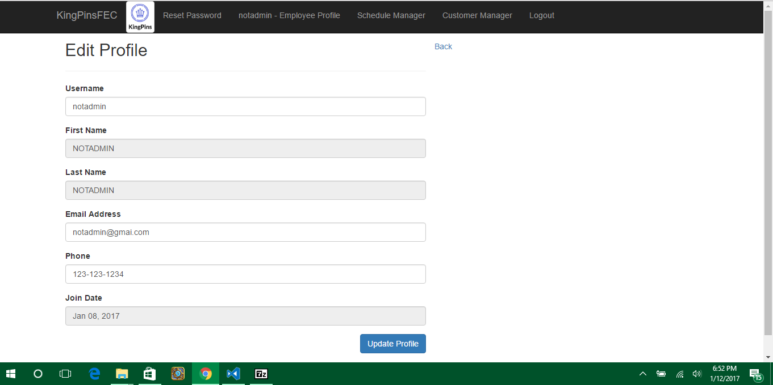

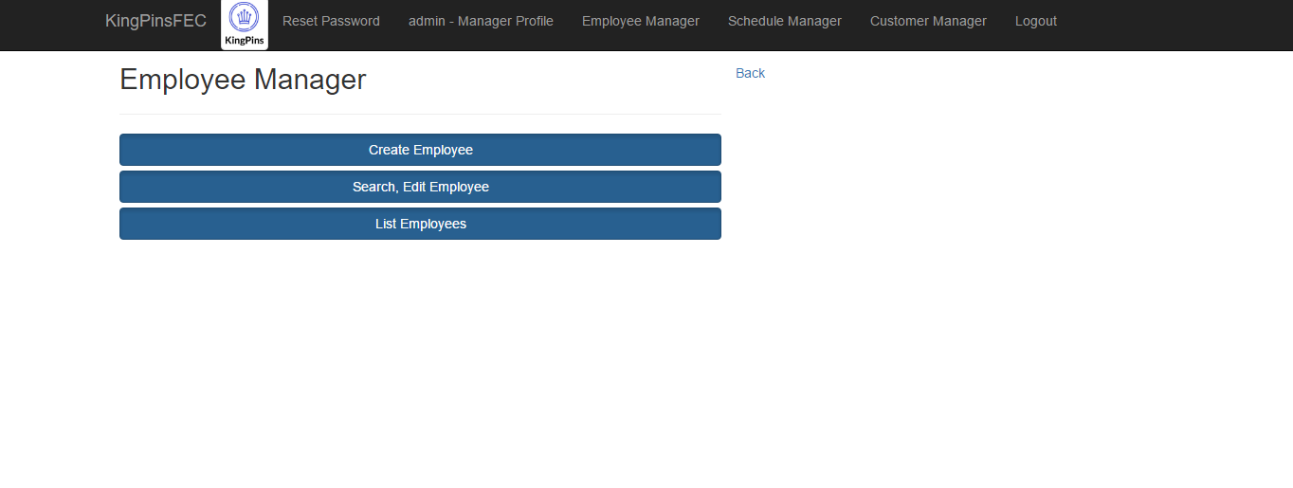

## 6.2 Descriptions of fields, content

Employee Edit Profile is auto populated based on the user login.

Create Employee is a blank form that allows for new employee creation.

Search Employee:

Required Fields:

Either one of the following:UserName, First Name, Last Name, Email

Or a combination of First Name and Last Name.

(They have to be exact matches)

## 6.3 Description of actions

* + Employee:
    - Click on Edit Profile to make changes and save them.
  + Manager
    - Click on Edit Profile to edit their own profile
    - Click Employee Manager
      * Click on Create Employee to create a new employee
      * Create Search and Edit Employee to search for an employee and edit their profile information.
      * In the Search screen the manager can get a list of all employees and print it from the screen.

## 6.4 Sequence of screens

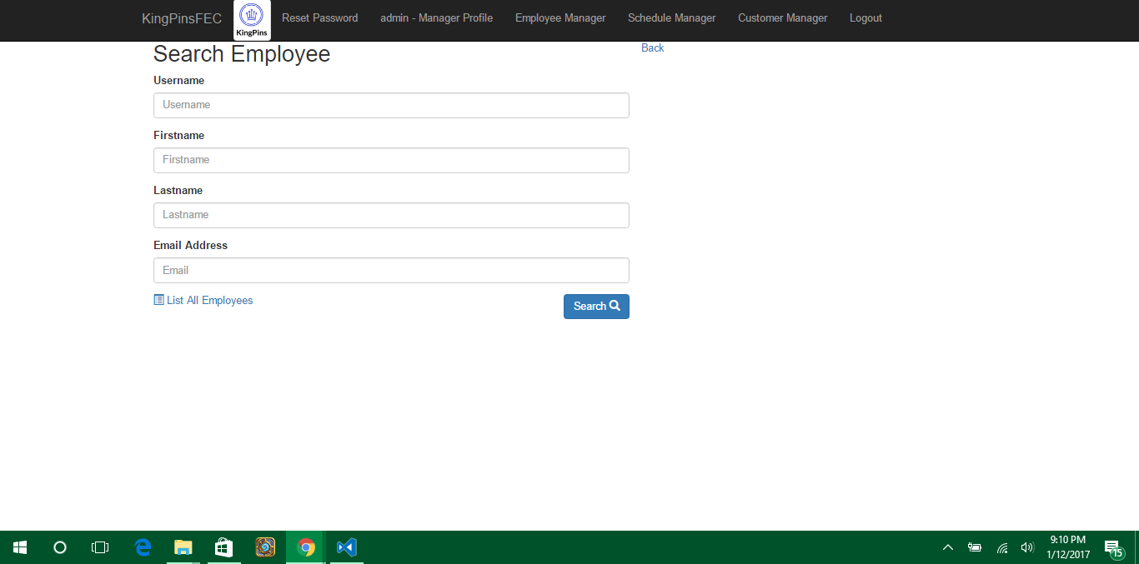

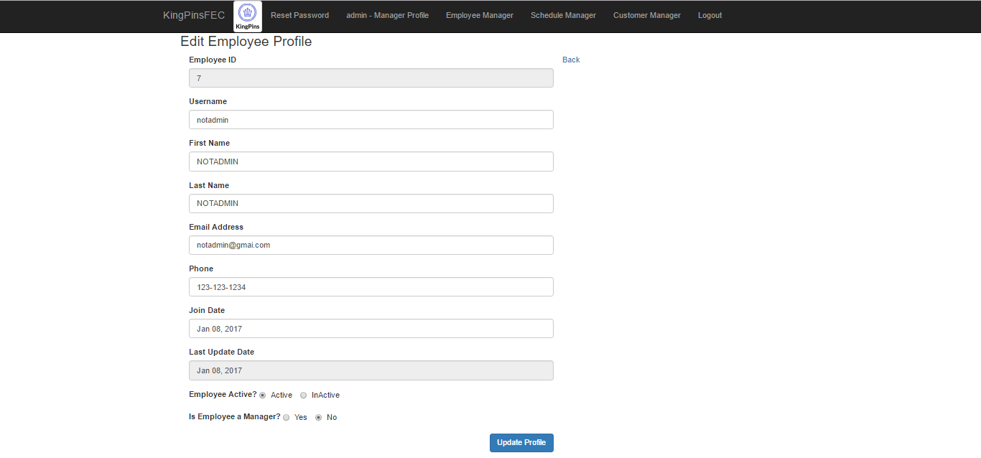

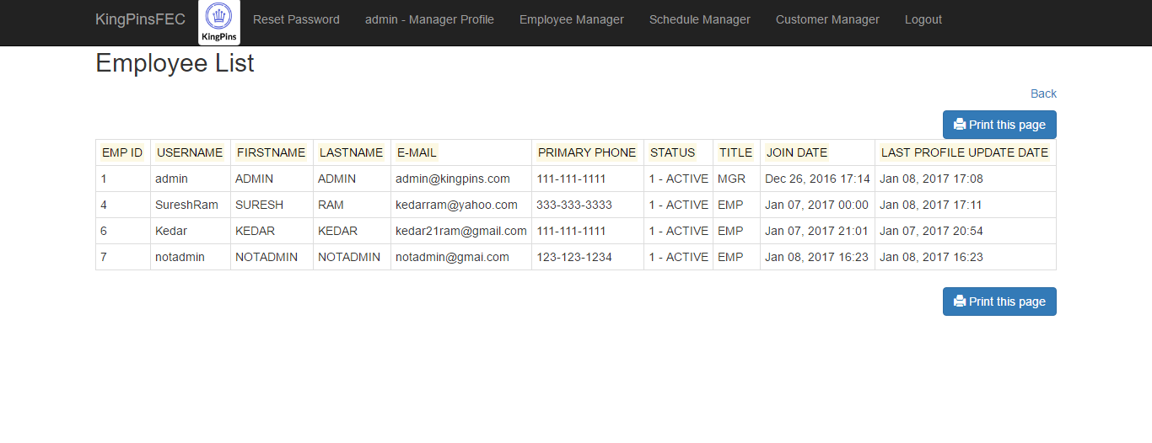

# 7 Function Component / Screen Customer Manager

Both Employee and Manager have the same view for a customer

They can

create a new customer

search and close the customer

get a list of all customers that are in the center

generate a report based on date on number of customers within a certain window of time.

## 7.1 Screenshot

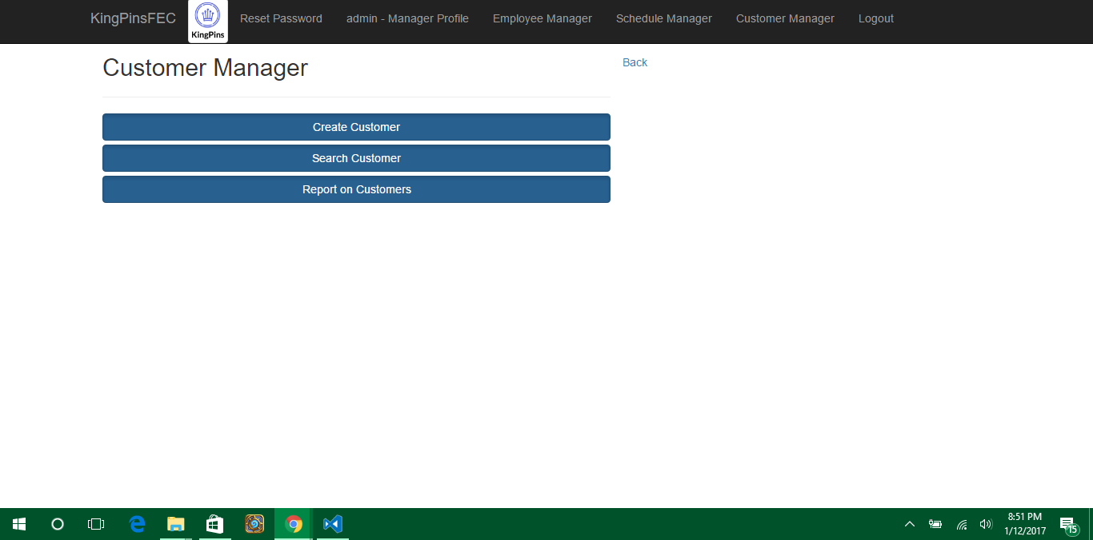

## 7.2 Descriptions of fields, content

Create customer:

Customer phone number

Customer First Name

Customer Last Name

Number of people in the customer party

Enter time is auto populated from current time.

Employee ID who created the customer is auto populated.

Search customer:

Customer phone number

Customer First Name

Customer Last Name

Report customer:

Date: default today

Start Time for Report: default 00:00

End Time for Report: default 23:59

option to include active customers is also available.

## 7.3 Description of actions

Actions are self explanatory.

## 7.4 Sequence of screens

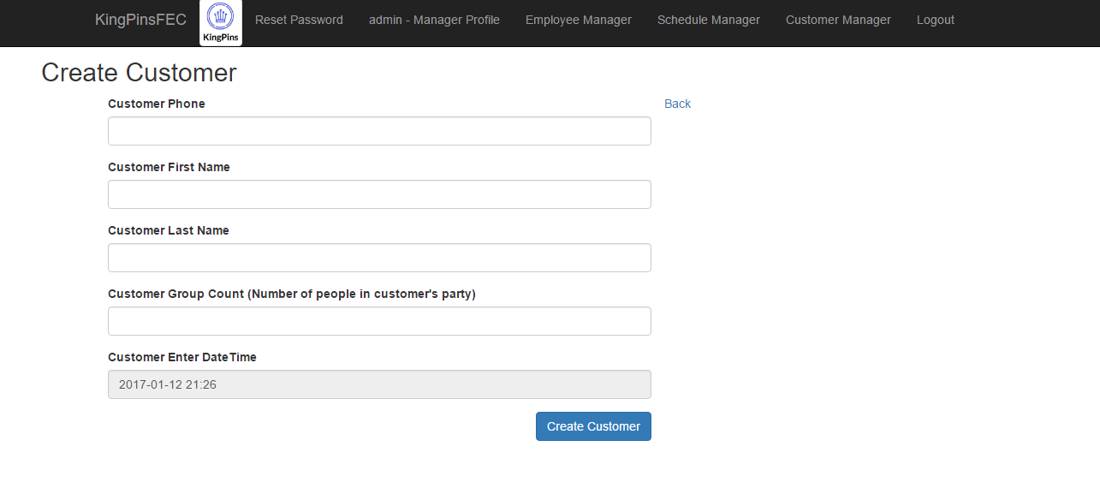

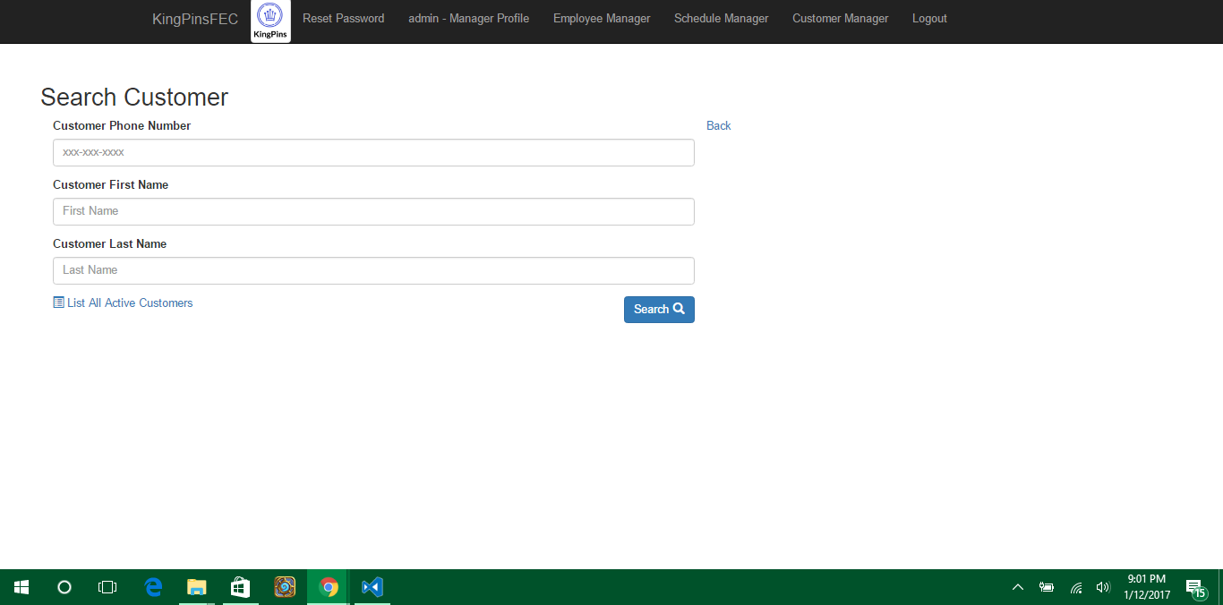

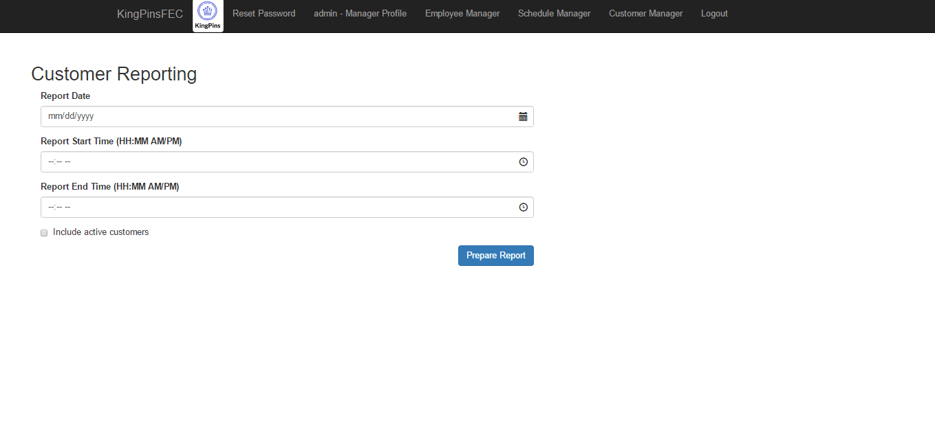

# 8 Function Component / Screen Schedule Manager

Employee/Manager gets to view their schedule for current week and upcoming week.

They both can request a schedule change for a week at a time.

They also have the option to delete their request.

policeman_usa_onManager has a menu of options to

1. approve employee request
2. add new group change to ensure there are enough employees per group.
3. lookup schedule and movement based on change request.

## 8.1 Screenshot

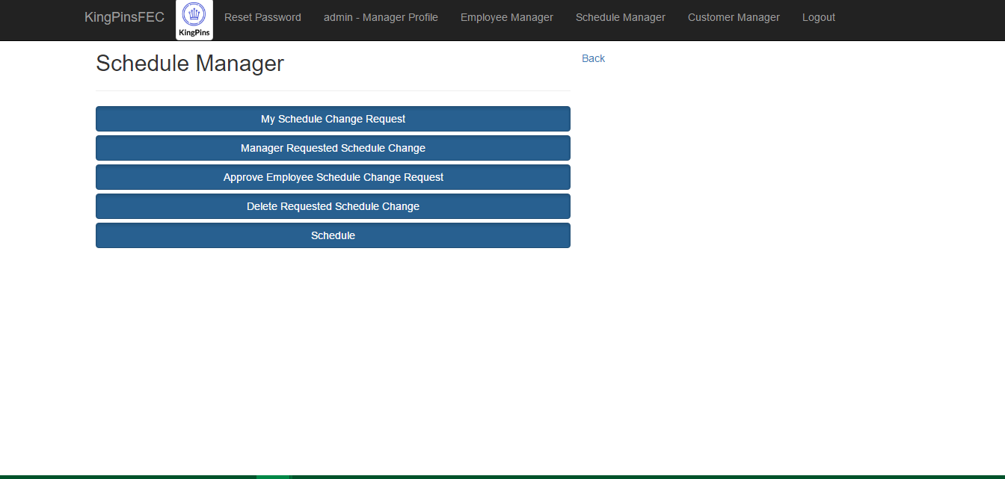

## 8.2 Descriptions of fields, content

Schedule Change Request:

Pick from next 3 week starting Sunday’s from the drop down list.

Pick from one of 4 group choices: 0 - vacation, Group1, Group2 or Group3

The options include specific schedule for the Group.

Manager Requested Schedule Change:

Similar to Schedule Change Request, but manager can choose an employee and change their schedule for the week.

Approve Change Request:

Manager can search for an employee’s search request and approve it individually or Approve all requests with a single bulk update.

Delete Change Request:

Manager or Employee can delete a change request they made or was made on their behalf by the Manager.

General Schedule:

Lists default group and highlights Group that the use is part of for this week and next week.

Schedule:

Allows the manager to see all the employee requests and default to determine approvals of change request.

## 8.3 Description of actions

An Employee makes a schedule request for upcoming week.

Manager looks up schedule to determine if there is enough coverage in each group ( default vs all requested group changes).

If the Manager agrees to the schedule, he can bulk approve ( currently it approves all not just for the upcoming week )

If the Manager agrees only to specific employee, he can search by Employee and approve their specific change request.

## 8.4 Sequence of screens

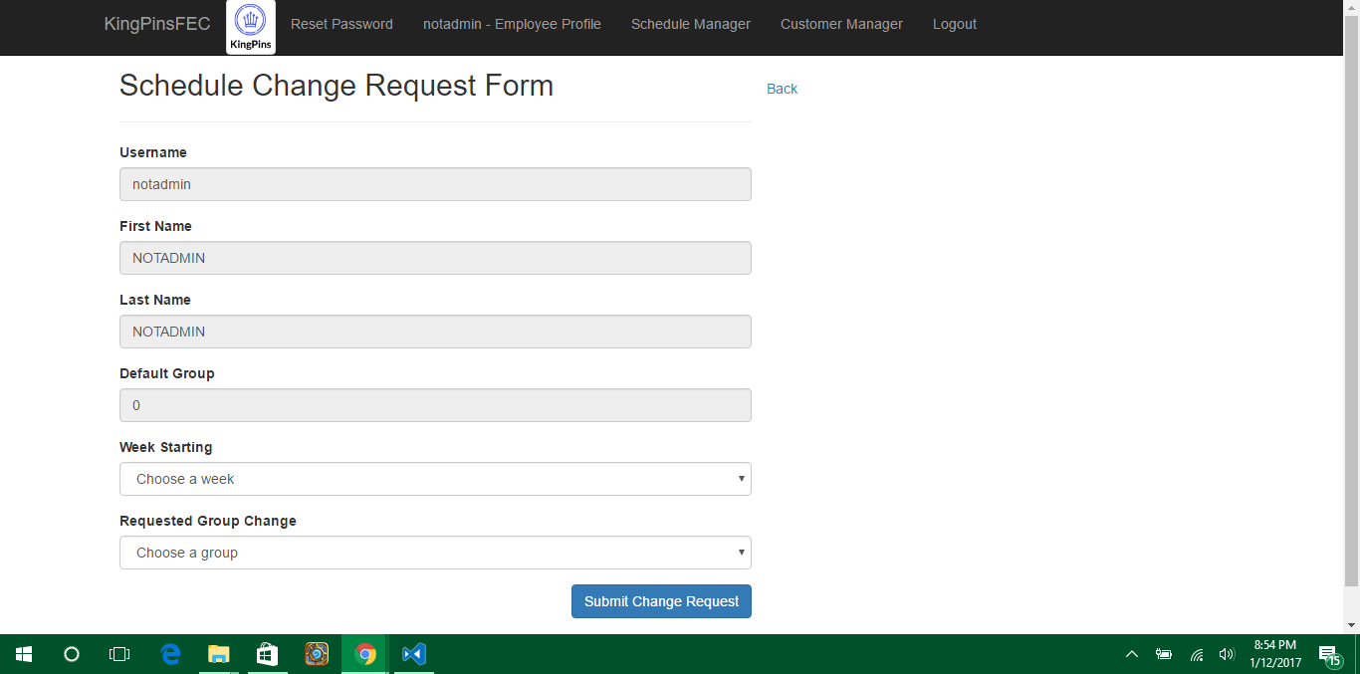

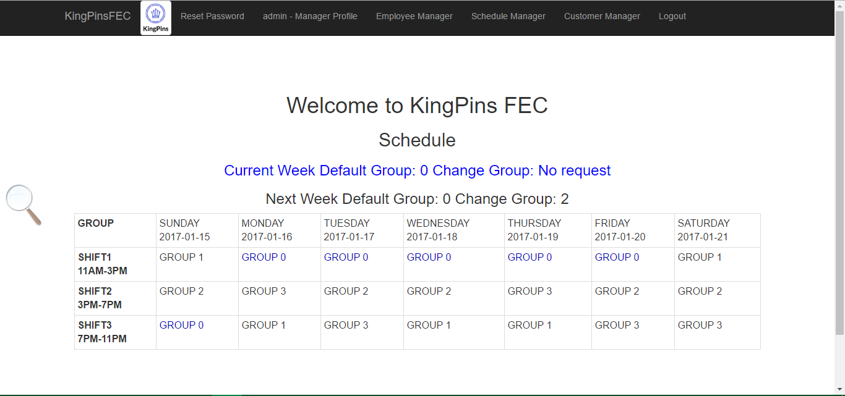

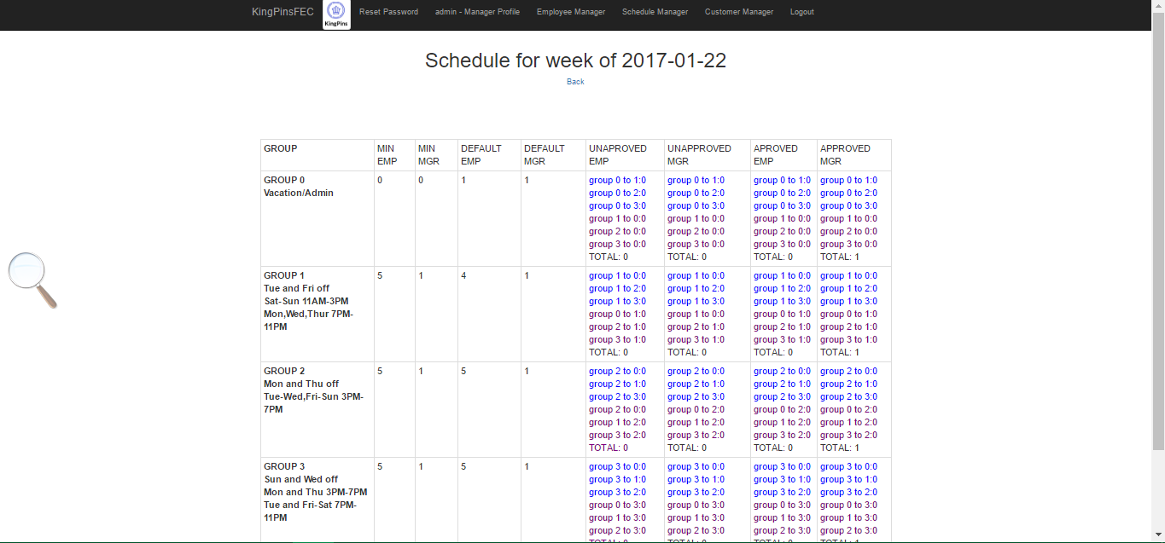

# 9 Appendices

## 9.1 Appendix 1

DEPLOYMENT STEPS

1. Download and Install WAMPSERVER x64 into C:wamp64 (copy of it can be found in KingPins/WAMPSERVER-Download/ )
2. Copy code and folders from KingPins folder in C:wamp64/www
3. Start Wampserver – icon will turn Green
4. Check Apache workings to ensure wampserver info come on when you go to <http://localhost> on the browser you set up.(You need internet connection.)
5. <http://localhost/KingPins> should take you to the login page.
6. Before you can login, need to setup mysql database and tables, follow instructions below to set up tables and load data.

a.Go to <http://localhost>

b.Click phpadmin under tools

c. In phpadmin, login as root, (no password)

d. Click new

e. Click Import, and load C:\wamp64\www\KingPins\db\kingpinsdb.sql

f.leave the utf-8 char set as is and click go to populate the database.

1. Test the login using employee (userid: notadmin) and password: notadmin)
2. Test the login using manager (userid: admin and password: admin)

**End of document**