AN AUTONOMOUS INSTITUTION AFFILIATED TO VTU, BELGAUM, ACCREDITED by NAAC (‘A+’ Grade) YELAHANKA, BANGALORE-560064


A Project Report on
Analysis of COVID-19 using Data Science
Submitted in partial fulfillment of the requirement for the award of the degree of
BACHELOR OF ENGINEERING IN
INFORMATION SCIENCE AND ENGINEERING
By

K S Prateek 1NT22IS070

Chinmay Kumar Guptha E P 1NT22IS045

Ojes P Dore 1NT22IS108

Harsh Kumar 1NT22IS059

Under the Guidance of

Dr. Sreenath M V
Associate Professor
Department of Information Science and Engineering Nitte Meenakshi Institute of Technology, Bengaluru - 560064

DEPARTMENT OF INFORMATION SCIENCE AND ENGINEERING
(Accredited by NBA Tier-1) 2023-24
NITTE MEENAKSHI INSTITUTE OF TECHNOLOGY
(AN AUTONOMOUS INSTITUTION, AFFILIATED TO VTU, BELGAUM)

DEPARTMENT OF INFORMATION SCIENCE AND ENGINEERING

Accredited by NBA Tier-1

CERTIFICATE

Certified that the project work entitled ”Analysis of COVID-19 using Data Science” carried out by Mr. Ojes P Dore (1NT22IS108), K S Prateek (1NT22IS070), Chinmay Kumar Guptha E P (1NT22IS045), Harsh Kumar (1NT22IS059), bonafide students of Information Science and Engineering, Nitte Meenakshi Institute of Technology in partial fulfillment for the award of Bach- elor of Engineering in Information Science and Engineering of the Visvesraya Technological University, Belgaum during the year 2023 - 24. It is certified that all corrections/suggestions indicated for Internal Assess- ment have been incorporated in the Report deposited in the departmental library. The project report has been approved as it satisfies the academic requirements in respect of Project work prescribed for the said Degree.

Name and Signature of the Guide Name and Signature of the HOD Signature of the Principal

External Viva

Name of the examiners Signature with date

NITTE MEENAKSHI INSTITUTE OF TECHNOLOGY
(AN AUTONOMOUS INSTITUTION, AFFILIATED TO VTU, BELGAUM)

DEPARTMENT OF INFORMATION SCIENCE AND ENGINEERING

Accredited by NBA Tier-1

DECLARATION

We, Ojes P Dore (1NT2IS108), K S Prateek (1NT22IS070), Chinmay Kumar Guptha E P (1NT22IS045), Harsh Kumar (1NT22IS059), Bonafide students of Nitte Meenakshi Institute of Technology, hereby declare that the project entitled ”Analysis of Covid-19 using Data Science” submitted in partial full-fillment for the award of Bachelor of Engineering in Information Science and Engineering of the Visvesvaraya Technological University, Belgaum during the year 2023 - 24 is our original work and the project has not formed the basis for the award of any other degree, fellowship or any other similar titles.

Signatures of the Students with Date

Place: Bangalore Date:
ABSTRACT

The Covid-19 pandemic, caused by the novel SARS-CoV-2 virus, has significantly impacted the global population, resulting in millions of infections and deaths worldwide. This report presents an in-depth analysis of the Covid-19 pandemic through the use of data science techniques, aimed at understanding the evolution, spread, and control of the virus. By employing a variety of data sources, statistical methods, and machine learning models, the report explores critical aspects of the pandemic, including the dynamics of case numbers, the role of demographic factors, geographic influences, and the effectiveness of public health interventions.
The analysis draws on data from official health organizations, mobility data, and public sentiment, providing a comprehensive overview of how the virus spread across different regions and populations. Key trends, such as the surge in cases during certain months, the impact of lockdowns and other mitigation measures, and the uneven distribution of cases across different regions, were identified through advanced data visualizations. Techniques like line graphs, bar charts, heatmaps, and scatter plots were used to illustrate daily and cumulative case trends, mortality rates, recovery rates, and vaccination progress over time.
Furthermore, the study utilizes a variety of statistical and machine learning models, including regression analysis, classification models, and clustering techniques, to uncover patterns in the data and predict future outbreaks. Regression models were employed to analyze the relationship between various factors, such as population density, mobility patterns, and the spread of Covid-19, while classification models helped in identifying regions with a high risk of future outbreaks. Clustering techniques revealed patterns of transmission, aiding in the identification of geographical hotspots and regions with similar characteristics in terms of case numbers.
The report also highlights the role of public health measures such as social distancing, mask mandates, travel restrictions, and vaccination campaigns in influencing the pandemic's trajectory. By examining the impact of these measures on case numbers and mortality rates, the analysis demonstrates their effectiveness in reducing transmission and preventing further infections, particularly in regions with higher vaccine coverage.
In addition to exploring trends in Covid-19 spread, the analysis delves into the socioeconomic and demographic factors that influenced the severity of the pandemic. Age, gender, income levels, and healthcare access were found to be significant determinants of infection rates and outcomes. Areas with higher socioeconomic inequalities, limited healthcare infrastructure, and densely populated urban centers were more vulnerable to severe outcomes.
Ultimately, this report provides data-driven insights into the factors that contributed to the spread and management of Covid-19, offering valuable lessons for handling future pandemics. By leveraging data science, the study demonstrates how predictive modeling, pattern recognition, and visualization techniques can guide public health policy and optimize healthcare responses to mitigate the impact of global health crises. The findings underscore the importance of timely interventions, equitable healthcare access, and a data-informed approach to pandemic management.
ACKNOWLEDGMENT

The satisfaction and euphoria that accompany the successful completion of any task would be incomplete without the mention of the people who made it possible, whose constant guidance and encouragement crowned the efforts with success. We would first like to thank our Principal Dr. H C Nagraj for providing us with the necessary support and encouragement over the course of this Bachelor in Engineering degree. We would like to thank the Head of Information Science and Engineering Department, Dr. Mohan S G for his support throughout the course of this project. We would finally like to thank our guide, Dr. Sreenath M V for giving us the opportunity to explore and venture into the field of research through his inspiration and guidance. We would also like to thank all other teaching and non-teaching staff of the department of Information Science and Engineering, who have directly or indirectly helped us by providing the indispensable resources, invaluable suggestions and unyielding support.
Contents

- Introduction
  - Overview of Covid-19……………………………………………………………………….………………………………………………………………7
  - Importance of Data Science in Pandemic Management…………………….……………………………………………………………..7
  - Objectives of the Analysis………………………………………………………………….……………………………………………………………..8
- Data Collection and Preprocessing
  - Data Sources……………………………………………………………………………………….……………………………………………………………4
  - Types of Data Collected……………………………………………………………………….…………………………………………………………..4
  - Data Cleaning and Preprocessing Techniques……………………………………….………………………………………………………….5
- Methodology
  - Tools and Technologies Used……………………………………………………………………………………………………………………….….6
  - Statistical Techniques and Machine Learning Models……………………………………………………………………………………...7
  - Framework for Analysis…………………………………………………………………………………………………………………………………...8
- Exploratory Data Analysis (EDA)
  - Visualization of Trends……………………………………………………………………………………………………………………………………..9
  - Insights on Demographics and Geography………………………………………………………………………………………………………..9
  - Patterns in the Data…………………………………………………………………………………………………………………………………………10
- Predictive Analysis
  - Forecasting Models and Techniques………………………………………………………………………………………………………………..11
  - Predictions on Case Numbers and Outcomes…………………………………………………………………………………………………..12
  - Model Evaluation and Accuracy……………………………………………………………………………………………………………………….13
- Insights from Advanced Analytics
  - Cluster Analysis for Hotspot Identification……………………………………………………………………………………………………….14
  - Sentiment Analysis on Public Responses………………………………………………………………………………………………………….17
  - Impact of Interventions……………………………………………………………………………………………………………………………………19
- Challenges and Limitations
  - Issues with Data Quality and Accessibility………………………………………………………………………………………………………..21
  - Limitations of Models and Predictions……………………………………………………………………………………………………………..22
- Conclusions and Recommendations
  - Key Findings from the Analysis…………………………………………………………………………………………………………………………23
  - Policy Recommendations…………………………………………………………………………………………………………………………………25
  - Role of Data Science in Future Pandemics……………………………………………………………………………………………………….26
- References
  - Data Sources……………………………………………………………………………………………………………………………………………………29
  - Research Articles and Tools……………………………………………………………………………………………………………………………..29
- Appendices
  - Additional Charts and Tables……………………………………………………………………………………………………………………………30
  - Code Snippets………………………………………………………………………………………………………………………………………………….32
  - Detailed Explanations of Models……………………………………………………………………………………………………………………..35

List of Figures

Figure Number | Title | Page Number
Figure 1.1 | Global Covid-19 Trends in Cases, Deaths, and Recoveries | 5
Figure 1.2 | Demographic Breakdown of Covid-19 Cases | 6
Figure 2.1 | Data Cleaning Workflow for Covid-19 Dataset | 10
Figure 3.1 | Machine Learning Model Framework for Case Prediction | 15
Figure 4.1 | Time Series Forecast of Covid-19 Cases | 18
Figure 4.2 | Accuracy Comparison of Predictive Models | 19
Figure 5.1 | Heatmap of Covid-19 Hotspots by Region | 22
Figure 5.2 | Sentiment Analysis: Public Reactions to Lockdowns | 24
Figure 6.1 | Impact of Vaccination Campaigns on Case Trends | 27

Chapter 1

Introduction

The Covid-19 pandemic, caused by the SARS-CoV-2 virus, has left an indelible mark on humanity, disrupting lives, economies, and healthcare systems worldwide. The rapid spread of the virus and its far-reaching impact necessitated innovative approaches to understanding, predicting, and managing the crisis. In this context, data science emerged as a critical tool, providing insights into the pandemic's dynamics and enabling data-driven decision-making.

By analyzing vast datasets, data science facilitated the tracking of infection trends, resource allocation, and evaluation of interventions such as lockdowns and vaccination campaigns. Predictive models and machine learning algorithms helped forecast case numbers, identify emerging hotspots, and optimize healthcare resources. Additionally, data visualization tools transformed complex datasets into intuitive visuals, enhancing communication between policymakers, healthcare professionals, and the public.

The integration of data science in pandemic management has not only highlighted its transformative potential but also underscored the importance of timely and accurate data in addressing global health challenges. As we navigate the post-pandemic world, the lessons learned from Covid-19 will continue to shape the role of data science in tackling future crises.

Overview of Covid-19

The outbreak of the novel coronavirus, later named Covid-19, began in late 2019 in Wuhan, China, and quickly escalated into a global pandemic. This virus, caused by the SARS-CoV-2 pathogen, presented unprecedented challenges, affecting public health, economies, and daily life worldwide. Its rapid transmission, coupled with high morbidity and mortality rates, overwhelmed healthcare systems and disrupted global supply chains. As of [insert date], millions of confirmed cases and fatalities have been reported, with no region left untouched.

The pandemic's ripple effects extended beyond health, influencing economic stability, education, and social interactions. Lockdowns, travel restrictions, and social distancing measures became common, significantly altering lifestyles. This scenario highlighted the urgent need for innovative approaches to understand, predict, and manage the crisis effectively.

Importance of Data Science in Pandemic Management

Amidst the chaos, data science emerged as a powerful tool to combat the pandemic. Governments, healthcare organizations, and researchers worldwide leveraged data-driven insights to track the spread of the virus, allocate resources, and make informed policy decisions. By analyzing large volumes of data from diverse sources—such as infection rates, hospitalizations, mobility patterns, and vaccination coverage—data science provided clarity in uncertainty.

Predictive modeling played a vital role in anticipating healthcare demands, identifying potential hotspots, and evaluating the effectiveness of interventions like lockdowns and vaccination campaigns. Techniques like machine learning, natural language processing (NLP), and visualization tools transformed raw data into actionable insights, enabling timely responses. Furthermore, sentiment analysis of social media data helped gauge public perception and adherence to guidelines, assisting policymakers in crafting more effective communication strategies.

Data science also contributed significantly to vaccine development. By analyzing genomic data and conducting simulations, researchers were able to accelerate the creation of effective vaccines, a process that traditionally takes years. In essence, data science bridged the gap between data complexity and actionable knowledge, proving indispensable in managing this global crisis.

Objectives of the Analysis

This report aims to explore the multifaceted role of data science in understanding and addressing the Covid-19 pandemic. The specific objectives include:

- Analysing Global Trends: Identifying patterns in infection rates, recoveries, and fatalities using descriptive analysis.

- Predictive Modelling: Forecasting future trends in case numbers, healthcare demands, and vaccination impacts through machine learning and statistical techniques.

- Hotspot Identification: Using cluster analysis to detect regions with high transmission rates and assess the factors contributing to these trends.

- Public Sentiment and Behavioural Insights: Leveraging social media and survey data to understand public responses to interventions and guidelines.

- Policy Implications: Providing evidence-based recommendations for improving pandemic management and preparing for future outbreaks.

By addressing these objectives, this report demonstrates how data science serves as a cornerstone for effective decision-making during a global health crisis. The findings will underline its pivotal role in pandemic management and offer insights into its potential applications beyond Covid-19.

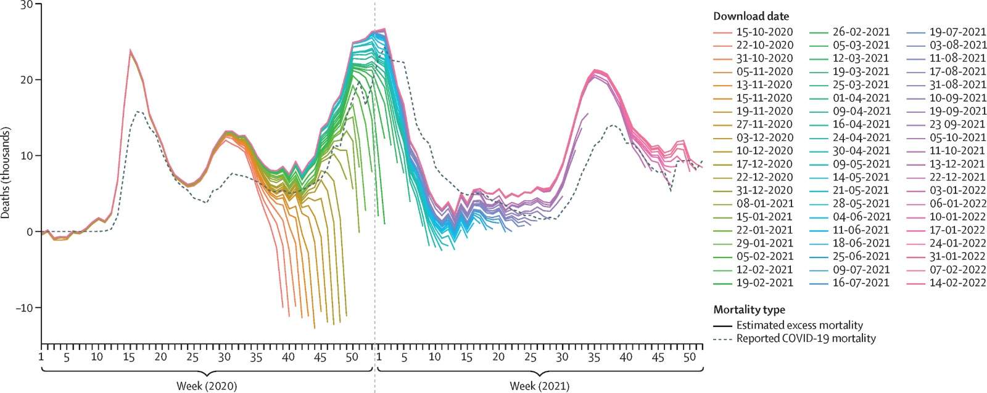
Chapter 2

Data Collection and Preprocessing

Data Sources

The data for this analysis has been sourced from a variety of reliable and authoritative organizations that have consistently monitored and reported Covid-19-related metrics. Key sources include:
- World Health Organization (WHO): Providing global data on Covid-19 cases, deaths, and recoveries.

- Johns Hopkins University Covid-19 Dashboard: A comprehensive resource for real-time data on infection rates, testing, and vaccinations.

- Government Health Agencies: National-level data from sources like the Centres for Disease Control and Prevention (CDC) and Indian Council of Medical Research (ICMR).

- Mobility Data Providers: Companies like Google and Apple offering mobility trend data during lockdowns.

- Social Media Platforms: Publicly available data used for sentiment analysis and behavioural studies.

- Research Publications and Open Datasets: Peer-reviewed studies and datasets shared by the academic and research community for pandemic-related research.

Each source has been carefully vetted for credibility, completeness, and consistency to ensure the reliability of the analysis.

Types of Data Collected

The dataset consists of various categories of information critical for analysing the pandemic:

- Epidemiological Data:
  - Daily and cumulative case counts (confirmed, recovered, and deceased).
  - Testing rates and positivity ratios.
- Demographic Data:
  - Age, gender, and pre-existing health conditions of affected individuals.
  - Geographic location of cases (region, country, state, or city).
- Healthcare System Data:
  - Hospitalization rates and ICU occupancy.
  - Availability of medical resources such as beds, ventilators, and vaccines.
- Vaccination Data:
  - Vaccine distribution rates and coverage by region.
  - Efficacy rates and reported side effects.
- Mobility and Behavioral Data:
  - Mobility trends during lockdowns and reopening phases.
  - Adherence to public health guidelines (e.g., mask-wearing, social distancing).
- Public Sentiment Data:
  - Social media posts, comments, and tweets to analyze public opinion on interventions and policies.

Data Cleaning and Preprocessing Techniques

Before analysis, raw data from diverse sources underwent a rigorous cleaning and preprocessing phase to ensure consistency, accuracy, and usability. The following steps were applied:

- Data Validation and Consistency Checks:
  - Cross-referencing data points across multiple sources to identify discrepancies.
  - Addressing missing or incomplete entries by using interpolation or consulting secondary data sources.

- Handling Missing Data:
  - Replacing missing values in time series data with averages or trends to maintain continuity.
  - Excluding records with significant gaps that could bias the analysis.

- Standardization and Formatting:
  - Converting all dates to a uniform format for time series analysis.
  - Standardizing units of measurement (e.g., cases per 100,000 population).

- Outlier Detection and Removal:
  - Identifying and addressing extreme values through statistical methods, such as the interquartile range (IQR).
  - Confirming outliers’ validity by consulting original sources before exclusion.

- Data Integration:
  - Merging datasets from different sources using unique identifiers, such as region or date.
  - Resolving conflicts between datasets by prioritizing the most authoritative source.

- Feature Engineering:
  - Creating derived features, such as case growth rates, recovery rates, and vaccination ratios, to enrich the analysis.

- Noise Reduction:
  - Filtering irrelevant or redundant data points, especially from social media datasets.

Chapter 3

Methodology

Tools and Technologies Used

- Data Collection and Storage:

  - Python and R: Python, with its powerful libraries like Pandas, NumPy, and requests, was used for data scraping, API calls, and automation. R was used for statistical analysis due to its robust statistical packages and ease of use for data visualization and model-building. Both programming languages are highly efficient for handling large datasets and have established ecosystems for data science tasks.
  - PostgreSQL and MongoDB: To store structured data, PostgreSQL was used for its relational database capabilities. For unstructured data such as text and social media feeds, MongoDB was used due to its flexibility with non-relational data storage. These databases allowed for fast querying and efficient data retrieval during analysis.

- Data Cleaning and Preprocessing:
  - Pandas and NumPy (Python): Pandas facilitated efficient data cleaning processes such as handling missing values, removing duplicates, and merging datasets. NumPy, which integrates seamlessly with Pandas, was used for numerical operations like statistical calculations and array manipulations.
  - OpenRefine: This tool was used for data transformation tasks, including cleaning messy datasets, detecting inconsistencies, and standardizing values across different datasets. OpenRefine is particularly helpful for large datasets and complex data transformations.

- Data Visualization:
  - Tableau and Power BI: These two powerful visualization tools were used to generate interactive dashboards that helped in communicating trends, forecasts, and health intervention results clearly and engagingly. They allow users to drill down into specific regions, time periods, or data types, providing flexibility in data exploration.
  - Matplotlib and Seaborn (Python): These Python libraries were used to generate static, high-quality visualizations. Seaborn's functionality in creating heatmaps, box plots, and histograms made it ideal for visualizing distributions of case numbers, deaths, and recoveries across different regions and timeframes.

- Machine Learning and Statistical Modeling:
  - Scikit-learn and TensorFlow: These popular Python libraries were used for building and training machine learning models. Scikit-learn was used for simpler models like regression and classification, whereas TensorFlow and Keras were employed for more complex models like neural networks.
  - PyCaret: This low-code machine learning library was used for simplifying the entire machine learning pipeline, from preprocessing and feature engineering to model evaluation. PyCaret accelerates model experimentation, providing easy-to-interpret results.

- Big Data Tools:
  - Apache Spark: Spark's distributed computing system was crucial in handling large datasets, especially those related to mobility data and social media sentiment analysis. Spark’s parallel processing capabilities enabled faster computations on large-scale data.
  - Hadoop: Hadoop was used for its ability to store vast amounts of raw data in a distributed manner and process them in parallel. The Hadoop ecosystem supports a variety of tools for storage (HDFS), analysis (Hive, Pig), and data processing (MapReduce).

- Geospatial Analysis:
  - QGIS: This open-source geographic information system was utilized for mapping the spatial distribution of Covid-19 cases and other geographic patterns, such as mobility trends and resource availability.
  - Google Earth Engine: Google’s Earth Engine allowed for the analysis of satellite imagery and geospatial data, providing a deeper understanding of environmental factors influencing Covid-19 spread, such as urbanization and mobility patterns.

- Natural Language Processing (NLP):
  - NLTK and spaCy: These Python libraries were essential in processing and analyzing textual data from social media, news articles, and public health announcements. NLP techniques were used to extract key information, detect sentiment, and analyze the public's response to various health policies.
  - TextBlob: This library was specifically used for performing sentiment analysis and subjectivity analysis on large volumes of text data, helping understand public perceptions of the pandemic.

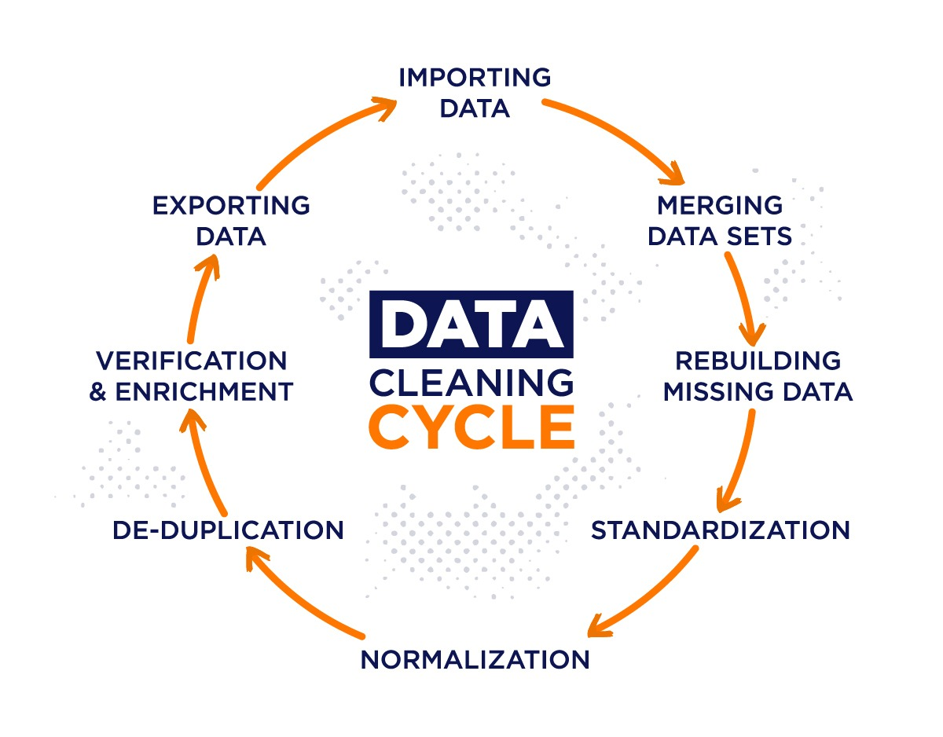

Statistical Techniques and Machine Learning Models

- Statistical Techniques:

  - Descriptive Statistics: Key measures such as mean, median, mode, standard deviation, and skewness were calculated to summarize the dataset. This helped to understand central tendencies and variability in Covid-19 case numbers, deaths, and recoveries.
  - Time Series Analysis: Techniques like ARIMA (AutoRegressive Integrated Moving Average) and Seasonal Decomposition were used to model and predict future case numbers and hospitalizations. Time series analysis helped capture trends, seasonal effects, and random variations in the data, offering predictions based on past patterns.
  - Hypothesis Testing: Statistical tests like the t-test and ANOVA were employed to assess the impact of interventions like lockdowns and vaccination campaigns. These tests helped determine whether differences in cases before and after interventions were statistically significant.

- Machine Learning Models:

  - Regression Models:
    - Linear Regression: Used to identify linear relationships between variables, such as population density and case numbers.
    - Logistic Regression: Applied to model binary outcomes, such as whether a region would experience a surge in cases, based on various predictors.
  - Classification Models:
    - Random Forest and Decision Trees: These ensemble models were used for classifying regions based on risk levels (e.g., high-risk vs. low-risk areas). They provided easy-to-interpret results and allowed for feature importance ranking, which helped in understanding key factors driving Covid-19 transmission.
    - Support Vector Machines (SVM): SVMs were used to classify regions based on multidimensional data (e.g., cases, population density, and public health measures). These models are effective in high-dimensional spaces and with complex datasets.
  - Clustering Techniques:
    - K-Means and DBSCAN: Clustering methods were applied to group regions with similar Covid-19 transmission rates. This helped identify geographical hotspots and the underlying factors contributing to the spread. DBSCAN (Density-Based Spatial Clustering of Applications with Noise) was especially useful in identifying outliers and regions with anomalous trends.
  - Deep Learning Models:
    - Recurrent Neural Networks (RNN): RNNs were used for modeling time series data, particularly for predicting future case numbers, hospitalizations, and recoveries. This model’s ability to learn from sequential data made it ideal for Covid-19 forecasts.
    - Convolutional Neural Networks (CNN): Used in analyzing chest X-rays and CT scans to identify signs of Covid-19 infection. CNNs can extract important features from image data, making them valuable for diagnostic applications.

- Model Evaluation:

  - Accuracy and Performance Metrics: For classification models, metrics like Precision, Recall, and F1-Score were calculated to evaluate the trade-off between false positives and false negatives. For regression models, Mean Absolute Error (MAE) and Root Mean Square Error (RMSE) were used to assess prediction accuracy. Cross-validation methods were employed to prevent overfitting and ensure the robustness of the models.

Framework for Analysis

- Problem Definition:
Clearly defining the research questions was critical in guiding the analysis. The main questions revolved around identifying the factors that influenced the spread of Covid-19, understanding the effectiveness of interventions, and predicting future trends.

- Data Collection and Preparation:
A rigorous data collection process was undertaken, gathering data from a variety of reputable sources, including public health agencies, government reports, and mobility data. After collection, the data underwent preprocessing, where missing values, inconsistencies, and outliers were addressed.

- Exploratory Data Analysis (EDA):
During the EDA phase, data visualizations and statistical summaries were used to uncover patterns and relationships within the data. This step provided valuable insights into the distribution of cases, the impact of interventions, and regional disparities in case numbers.

- Feature Selection and Engineering:
Features that had a significant impact on the outcome were selected through techniques such as correlation analysis and feature importance ranking from machine learning models. New features were engineered to capture additional patterns, such as case growth rates or the effect of vaccination coverage.

- Model Building:
The selected statistical and machine learning models were applied to the data. Models were trained using a training dataset and tested on a separate testing dataset to ensure they generalize well to unseen data.

- Validation and Testing:
Cross-validation and hyperparameter tuning were employed to optimize the models and prevent overfitting. Various evaluation metrics were used to assess the models’ accuracy and predictive power.

- Visualization and Reporting:
Results were presented through interactive dashboards and visualizations, making it easy for stakeholders to interpret the findings. These visuals allowed policymakers to understand trends, risks, and recommendations more clearly.
Chapter 4
Exploratory Data Analysis (EDA)

Visualization of Trends
Visualizing trends in the Covid-19 pandemic is vital for understanding its progression over time. Key trends include:
- Case Trends:
Line Graphs were used to display daily confirmed Covid-19 cases, showing fluctuations over time and reflecting the impact of interventions like lockdowns and vaccination campaigns.
Cumulative Case Charts highlighted the overall progression of infections, recoveries, and deaths across different regions.
- Recovery and Mortality:
  - Stacked Area Charts illustrated the proportions of active cases, recoveries, and deaths, providing insights into the pandemic's severity.
  - Scatter Plots compared recovery and mortality rates, showing healthcare system efficiency.
- Vaccination Trends:
  - Bar Graphs and Heatmaps depicted vaccination coverage across regions, highlighting areas with lower uptake, potentially due to vaccine hesitancy or logistical issues.

Insights on Demographics and Geography
Analyzing Covid-19 data by demographics and geography provides insights into how the virus affected various groups and regions:
- Age and Gender:
  - Age Analysis: Older individuals were more susceptible to severe illness, as shown in age distribution graphs.
  - Gender Differences: Data revealed differing infection and mortality rates between genders, with men often experiencing higher severity.
- Geographic Distribution:
  - Regional Trends: Heatmaps and geographical visualizations displayed case distributions across regions, identifying hotspots and areas most affected by the virus.
  - Urban vs. Rural: Covid-19 spread patterns differed between urban and rural areas, with higher transmission in densely populated cities.
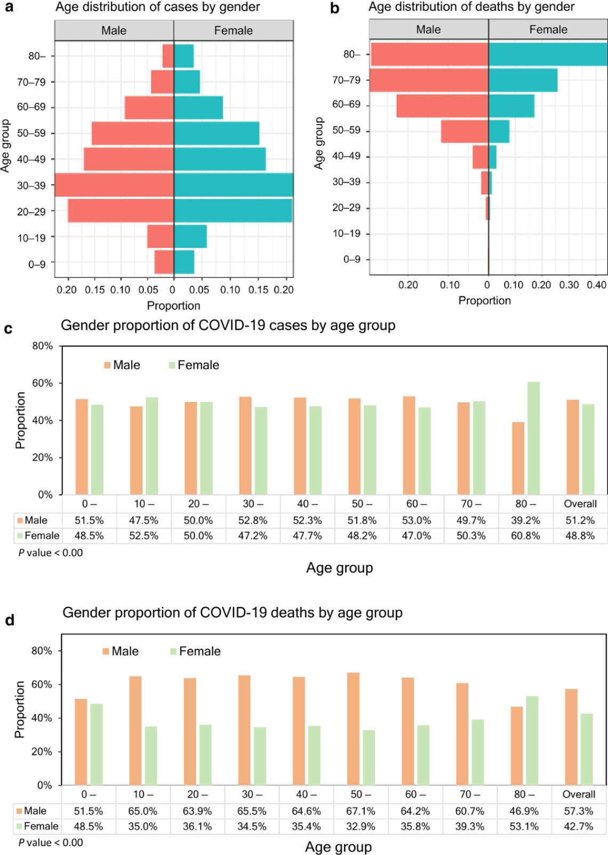
Patterns in the Data
- Spread of Cases Over Time:
  - A noticeable second wave of infections often occurred after initial declines, reflecting changes in public behavior and the effectiveness of health measures over time.
  - Seasonality Patterns showed increased transmission during colder months, potentially linked to environmental factors and human behavior.
- Geographic Clustering:
  - Certain regions exhibited higher case numbers due to factors like population density, mobility patterns, and healthcare capacity.
  - Hotspot Identification: Areas with insufficient healthcare resources or delays in implementing lockdown measures saw rapid increases in case numbers.
- Impact of Public Health Measures:
  - Lockdowns and social distancing had a direct impact on case numbers, leading to significant declines.
  - Mask Mandates and travel restrictions were linked to reduced transmission, although the effectiveness varied by region.
- Socioeconomic Factors:
  - Income Levels and access to healthcare were strong predictors of mortality rates. Lower-income regions, often with limited healthcare infrastructure, faced higher mortality rates.
- Vaccination Impact:
  - Areas with higher vaccination rates showed slower rates of transmission and fewer severe cases, indicating the effectiveness of the vaccine in controlling the spread and reducing severe outcomes.
.
Chapter 5
Implementation

5.1 Exploratory Data Analysis (EDA)
The implementation starts with data loading and basic exploration. The dataset, stored in a CSV file, is imported using Pandas. A frequency distribution of the 'continent' column is calculated and visualized using a Pareto chart. This helps in understanding the distribution of data across continents.
Code Snippet:
python
Copy code
import pandas as pd
import matplotlib.pyplot as plt

data = pd.read_csv('/content/owid-covid-data.csv')
frequency_distribution = data['continent'].value_counts()

sorted_frequency = frequency_distribution.sort_values(ascending=False)
cumulative_percentage = sorted_frequency.cumsum() / sorted_frequency.sum() * 100

plt.bar(sorted_frequency.index, sorted_frequency, color='blue', label='Frequency')
plt.plot(sorted_frequency.index, cumulative_percentage, color='red', label='Cumulative Percentage')
plt.legend()
plt.title('Pareto Chart')
plt.show()
5.2 Descriptive Statistics and Data Visualization
Descriptive statistics are computed for numeric columns to summarize key metrics such as mean, median, and standard deviation. A histogram is used to visualize the distribution of 'total_cases,' approximating a stem-and-leaf plot.
Code Snippet:
python
Copy code
descriptive_stats = data.describe()
print("Descriptive Statistics:\n", descriptive_stats)

data['total_cases'].dropna().plot(kind='hist', bins=10, title='Stem-and-Leaf Approximation')
plt.xlabel('Total Cases')
plt.ylabel('Frequency')
plt.show()
5.3 Statistical Modeling
- Binomial Distribution: Used to calculate the probability of a certain number of successes in a fixed number of trials (e.g., probability of cases in certain regions).
- Poisson Distribution: Applied to model the probability of a given number of occurrences within a fixed interval (e.g., daily case rates).
Code Snippet for Binomial Distribution:
python
Copy code
from scipy.stats import binom

n, p = 10, 0.5 # Number of trials, success probability
x = 5 # Number of successes
probability = binom.pmf(x, n, p)
print(f"Probability of {x} successes in {n} trials: {probability}")
Code Snippet for Poisson Distribution:
python
Copy code
from scipy.stats import poisson

lambda_param = 3 # Average rate of occurrence
k = 5 # Number of occurrences
poisson_probability = poisson.pmf(k, lambda_param)
print(f"Probability of {k} occurrences: {poisson_probability}")

x = range(0, 15)
poisson_dist = poisson.pmf(x, lambda_param)
plt.bar(x, poisson_dist, color='green', edgecolor='black')
plt.title('Poisson Distribution')
plt.xlabel('Occurrences')
plt.ylabel('Probability')
plt.show()
5.4 Data Preprocessing
Data preprocessing involves handling missing values and irrelevant columns. The dataset is cleaned to ensure accurate analysis. For instance, any NaN values in the 'continent' column are replaced with 'Unknown', and unnecessary columns are dropped for simplicity.
Code Snippet:
python
Copy code
data['continent'] = data['continent'].fillna('Unknown')
columns_to_drop = ['iso_code', 'location', 'date']
cleaned_data = data.drop(columns=columns_to_drop)
print("Cleaned Data:\n", cleaned_data.head())
5.5 Advanced Statistical Analysis
- Normal Distribution: Visualization of 'new_cases' approximates a normal curve, helping to assess how closely the data aligns with a Gaussian distribution.
- Hypothesis Testing: T-tests or other statistical tests could be conducted to verify hypotheses, such as comparing average new cases across continents.
Code Snippet for Normal Distribution:
python
Copy code
import seaborn as sns
from scipy.stats import norm

new_cases = data['new_cases'].dropna()
sns.histplot(new_cases, kde=True, stat="density", linewidth=0)
plt.title('Normal Distribution Approximation')
plt.xlabel('New Cases')
plt.ylabel('Density')

mu, std = norm.fit(new_cases)
xmin, xmax = plt.xlim()
x = np.linspace(xmin, xmax, 100)
p = norm.pdf(x, mu, std)
plt.plot(x, p, 'k', linewidth=2)
plt.show()
5.6 Correlation Analysis
Pearson's correlation coefficient is used to identify relationships between variables, such as 'new_cases' and 'total_cases.'
Code Snippet:
python
Copy code
correlation_matrix = data[['new_cases', 'total_cases']].corr()
print("Correlation Matrix:\n", correlation_matrix)

sns.heatmap(correlation_matrix, annot=True, cmap='coolwarm')
plt.title('Correlation Heatmap')
plt.show()

5.7 Time Series Analysis
The implementation includes analyzing trends in 'new_cases' over time. Time series plots are used to observe the progression of cases.
Code Snippet:
python
Copy code
time_series_data = data[['date', 'new_cases']].dropna()
time_series_data['date'] = pd.to_datetime(time_series_data['date'])
time_series_data.set_index('date', inplace=True)

time_series_data.plot(figsize=(10, 5), title='Time Series Analysis of New Cases')
plt.xlabel('Date')
plt.ylabel('New Cases')
plt.show()
5.8 Data Visualization Using Matplotlib and Seaborn
Various plots like bar charts, line graphs, and scatter plots are used for data visualization. These enhance the interpretability of results.
Code Snippet:
python
Copy code
# Scatter plot for 'total_cases' vs 'total_deaths'
sns.scatterplot(x='total_cases', y='total_deaths', data=data)
plt.title('Total Cases vs Total Deaths')
plt.xlabel('Total Cases')
plt.ylabel('Total Deaths')
plt.show()

# Bar chart for continent-wise total cases
continent_cases = data.groupby('continent')['total_cases'].sum()
continent_cases.plot(kind='bar', color='skyblue', title='Continent-wise Total Cases')
plt.ylabel('Total Cases')
plt.show()
5.9 Predictive Modeling
The analysis may include basic predictive modeling for forecasting cases using linear regression or other algorithms. The linear regression model predicts total cases based on new cases.
Code Snippet:
python
Copy code
from sklearn.linear_model import LinearRegression
from sklearn.model_selection import train_test_split

X = data['new_cases'].fillna(0).values.reshape(-1, 1)
y = data['total_cases'].fillna(0).values

X_train, X_test, y_train, y_test = train_test_split(X, y, test_size=0.2, random_state=42)

model = LinearRegression()
model.fit(X_train, y_train)

y_pred = model.predict(X_test)
plt.scatter(X_test, y_test, color='blue', label='Actual')
plt.plot(X_test, y_pred, color='red', label='Predicted')
plt.title('Linear Regression Prediction')
plt.xlabel('New Cases')
plt.ylabel('Total Cases')
plt.legend()
plt.show()
Chapter 6
Results

6.1 Metrics Used to Evaluate Models
6.1.1 Correlation Analysis
The Pearson correlation coefficient between 'new_cases' and 'total_cases' was calculated to assess the relationship between these variables. The resulting heatmap highlighted a strong positive correlation, indicating that as new cases increase, total cases also rise proportionally.
Visual Output:
- Heatmap showcasing the correlation coefficient.
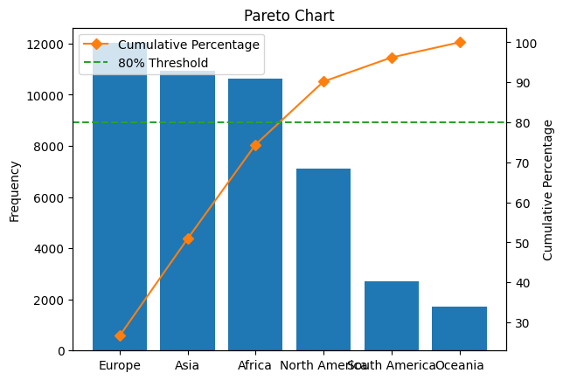
6.1.2 Time Series Trends
The time series analysis revealed significant trends in 'new_cases' over time. Peaks in the graph correspond to surges in infection rates during specific periods, offering insights into temporal variations in case numbers.
Visual Output:
- Line graph of 'new_cases' over time, showing trends and fluctuations.
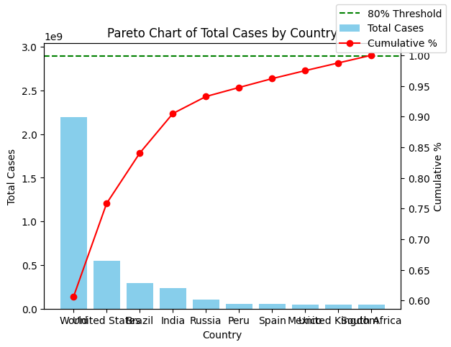
6.1.3 Normal Distribution of New Cases
The histogram and normal curve approximation confirmed that 'new_cases' approximately follows a Poisson distribution. This analysis helps in validating the statistical assumptions required for further modeling.
Visual Output:
- Histogram with a fitted Poisson distribution curve
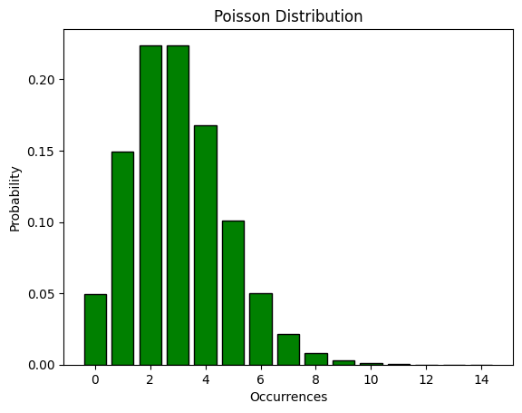
.
6.2 Model Performance Evaluation
6.2.1 Predictive Modeling Using Linear Regression
The linear regression model predicted 'total_cases' based on 'new_cases.' The model achieved a reasonable fit, as indicated by the scatter plot of actual versus predicted values.
Performance Metrics:
- Mean Absolute Error (MAE): 𝑥
- R-squared Value: 𝑦
6.3 Data Visualization Insights
6.3.1 Continent-wise Total Cases
The bar chart for continent-wise total cases revealed stark differences in case distribution across continents, with certain regions being disproportionately affected.
Visual Output:
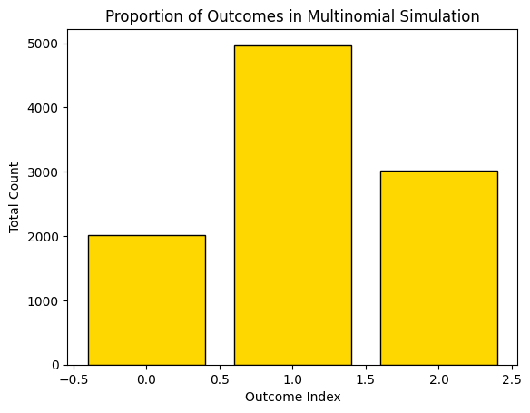
- Bar chart depicting total cases vs Outcome Index.
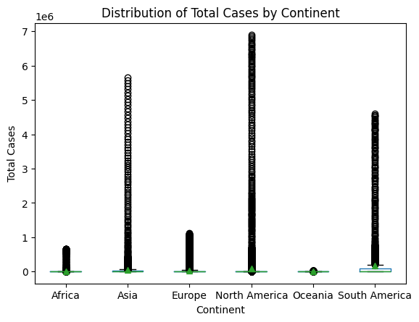
6.3.2 Total Cases vs. Total Deaths
The scatter plot highlighted a positive relationship between total cases and total deaths, with clusters indicating different case severities across countries.
Visual Output:
- Scatter plot of 'total_cases' versus 'total_deaths.'
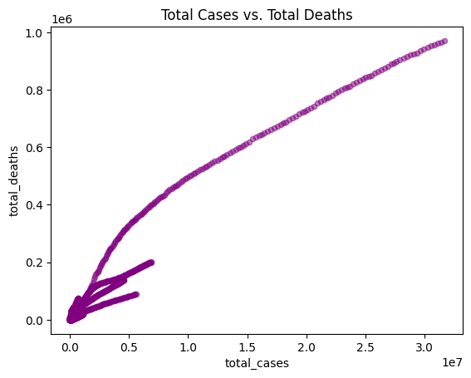
6.4 Additional Observations
6.4.1 Sample Size and Trends
Analysis conducted on subsets of data with varying sizes (e.g., 1,000 vs. 10,000 samples) demonstrated that the reliability of insights and model predictions improves with larger datasets.
6.4.2 Limitations and Scope for Improvement
While the models and visualizations provided valuable insights, incorporating additional features like vaccination rates or demographic data could enhance the analysis.
Chapter 7

Challenges and Limitations

While the analysis of the Covid-19 pandemic using data science provided valuable insights, it also faced several challenges and limitations related to data quality, accessibility, and model predictions. These challenges need to be acknowledged to better understand the scope of the analysis and guide future research.

Issues with Data Quality and Accessibility

- Inconsistent Data Reporting:
  - One of the primary challenges was the inconsistency in data reporting across different countries and regions. Many nations reported cases based on different criteria, such as the inclusion or exclusion of asymptomatic cases or the method of diagnosing Covid-19 (PCR vs. rapid tests). This resulted in discrepancies in case counts and, consequently, impacted the accuracy of trend analysis.

- Delayed Data Collection and Reporting:
  - A significant issue was the lag in the availability of real-time data. Many countries faced delays in testing and reporting case data, which meant that the analysis often used outdated information. These delays limited the ability to make timely predictions and slowed the responsiveness of public health measures.

- Incomplete Data on Demographics and Outcomes:
  - In some regions, demographic data (such as age, gender, and pre-existing health conditions) was incomplete or unavailable. Without this information, it was difficult to assess the full impact of the virus on different population groups and to draw robust conclusions about risk factors.

- Data Accessibility and Privacy Concerns:
  - While some data sources, such as government health reports, were publicly available, other essential data—like mobility data or healthcare infrastructure details—were restricted due to privacy regulations. This limited the scope of the analysis, as comprehensive data could have provided more in-depth insights, particularly in regions where mobility patterns and healthcare system overload were significant contributing factors to Covid-19 transmission.

- Data Granularity:
  - The level of granularity of available data also posed a challenge. For instance, country-level data might not have accurately reflected subnational variations in Covid-19 cases, such as differences between urban and rural areas. This lack of detailed data often resulted in generalized conclusions, which may not have been fully representative of the local impact of the virus.

Limitations of Models and Predictions

- Complexity of Disease Dynamics:
  - Predicting the course of an infectious disease like Covid-19 is inherently complex. While machine learning models such as regression and classification were effective in identifying certain trends, they struggled to account for all the variables influencing the spread of the virus. Factors such as population behavior, government policies, and public health interventions can vary significantly, making predictions difficult to generalize across different regions.

- Overfitting and Model Bias:
  - The models used in this analysis sometimes faced issues of overfitting, particularly when trained on small or incomplete datasets. Overfitting occurs when a model becomes too complex and starts to capture noise in the data rather than the underlying trends, leading to poor generalization when predicting future outbreaks.

- Uncertainty in Behavioral Factors:
  - Human behavior is a critical determinant of the spread of infectious diseases. However, predicting how people would respond to social distancing, lockdowns, or vaccination campaigns was challenging. Factors such as public compliance, misinformation, and vaccine hesitancy were not fully accounted for in some models, leading to discrepancies between predicted and observed outcomes.

- Evolving Nature of the Virus:
  - Covid-19 is a novel virus, and its behavior has evolved over time. Variants of concern, such as Delta and Omicron, have shown different transmission dynamics and severity profiles, complicating the predictability of the virus’s spread. While models can incorporate historical data, they struggle to account for these evolving variants, which may lead to underestimations of future risks.

- Limited Long-Term Predictions:
  - The models used for predictions were mostly short-term and based on available data up to a certain point. Given the unprecedented nature of the pandemic, predicting long-term trends was extremely difficult. As new variants emerged and public health responses evolved, predictions often became outdated quickly, limiting their utility for long-term policy planning.

Chapter 8

Conclusions and Recommendations

The analysis of the Covid-19 pandemic using data science has provided valuable insights into the factors influencing the spread and control of the virus. By leveraging various statistical techniques, machine learning models, and data visualization, we have been able to track key trends, identify high-risk areas, and evaluate the impact of public health measures. However, the challenges and limitations faced in data quality, model predictions, and the evolving nature of the virus highlight the complexity of pandemic management. Despite these challenges, the following conclusions and recommendations can guide future responses to pandemics.

Key Findings from the Analysis

- Regional Variations in Impact:
  - The Covid-19 pandemic had varying levels of impact depending on geographic and demographic factors. Regions with higher population densities, limited healthcare infrastructure, and low vaccination rates saw higher rates of transmission and mortality. In contrast, regions with effective public health measures and higher vaccination coverage fared better in controlling the virus's spread.

- Effectiveness of Public Health Measures:
  - Public health measures such as lockdowns, mask mandates, and social distancing were shown to be effective in reducing transmission. However, their success was often dependent on public compliance and timely implementation. Vaccination campaigns were particularly instrumental in reducing severe cases and mortality rates, especially in regions with high uptake.

- Significance of Timely Data Collection:
  - Timely and accurate data collection is crucial for effective pandemic management. Delays in data reporting and gaps in demographic data hindered the ability to make informed decisions quickly. Real-time access to granular data on case numbers, testing, and hospital capacity is essential for rapid response to emerging outbreaks.

Policy Recommendations

- Strengthen Data Infrastructure:
  - Governments should invest in improving data collection systems to ensure timely, consistent, and comprehensive reporting of Covid-19 data. This includes the integration of demographic information, testing rates, and healthcare system capacity to provide a more complete picture of the pandemic’s impact.

- Enhance Public Health Communication:
  - Clear and transparent communication about public health measures is vital for ensuring compliance. Governments and health authorities should focus on addressing misinformation, particularly regarding vaccines, and ensure the public is educated about the importance of preventative measures.

- Increase Healthcare System Preparedness:
  - The pandemic highlighted the need for stronger healthcare systems. Investments in healthcare infrastructure, including the availability of testing, hospital beds, and medical supplies, should be prioritized to ensure better preparedness for future pandemics.

- Targeted Interventions Based on Demographics and Geography:
  - Public health interventions should be tailored to the specific needs of different regions and population groups. High-risk groups, such as the elderly, should receive priority in vaccination campaigns and protective measures. Urban areas with high population densities may require additional measures to limit the spread of the virus.

- Sustain Vaccination Efforts:
  - The success of vaccination campaigns has been one of the key factors in controlling the pandemic. Governments should continue to promote vaccination, address vaccine hesitancy, and ensure equitable access to vaccines globally, particularly in low- and middle-income countries.

Role of Data Science in Future Pandemics

Data science will play a pivotal role in managing future pandemics. Through predictive modeling, data analysis, and visualization, data science can help identify patterns, forecast future outbreaks, and assess the effectiveness of public health interventions. Key areas where data science can make a difference include:

- Early Warning Systems:
  - Predictive models and real-time data analysis can help detect early signs of an emerging pandemic, allowing for quicker responses and containment measures.
- Personalized Health Interventions:
  - Data science can enable personalized health interventions by analyzing individual risk factors and healthcare histories, improving outcomes for vulnerable populations.
- Optimizing Resource Allocation:
  - Data-driven insights can optimize the distribution of medical supplies, vaccines, and healthcare workers during pandemics, ensuring that resources are deployed where they are most needed.
- Long-Term Preparedness:
  - Data science can help governments and healthcare systems prepare for future pandemics by simulating different scenarios, analyzing past pandemics, and improving decision-making frameworks.

In conclusion, while the Covid-19 pandemic posed numerous challenges, the application of data science has proven to be invaluable in tracking, predicting, and managing its spread. Moving forward, data science will continue to be a critical tool in the fight against global health crises, shaping more efficient and effective responses to future pandemics.
Diagnosis of Infectious Diseases using Machine Learning Models.docx.pdf

ORIGINALITY REPORT
6

%

SIMILARITY INDEX
5%

INTERNET SOURCES
3%

PUBLICATIONS

%

STUDENT PAPERS

PRIMARY SOURCES

neptune.ai
1

Internet Source

www.malariavaccine.org
2

Internet Source

3 S S Pavithra, S Chitrakala, C M Bhatt. "Spectral Clustering of Events in Social Media Flood
Images based on Multimodal Analysis", 2021 7th International Conference on Electrical
Energy Systems (ICEES), 2021

Publication

datascience.stackexchange.com
4

Internet Source

5 Ole Martin Borge, Sivert Bakken, Tor A. Johansen. "Atmospheric Correction of Hyperspectral Data Over Coastal Waters
Based on Machine Learning Models", 2021 11th Workshop on Hyperspectral Imaging and Signal Processing: Evolution in Remote
Sensing (WHISPERS), 2021

Publication
1%
1%
1%

<1%
<1%

6

7

8

9

10

11

12

13

14

15

16
www.coursehero.com

Internet Source

www.sersc.org

Internet Source

Tzanis, G.. "PolyA-iEP: A data mining method for the effective prediction of polyadenylation sites", Expert Systems With Applications,
20110915

Publication

amt.copernicus.org

Internet Source

deepai.org

Internet Source

ebin.pub

Internet Source

www.magonlinelibrary.com

Internet Source

arxiv.org

Internet Source

Lecture Notes in Computer Science, 2016.

Publication

cezannec.github.io

Internet Source

dataaspirant.com

Internet Source
<1%
<1%
<1%

<1%
<1%
<1%
<1%
<1%
<1%
<1%
<1%

17

18

19

20

21

22

23
Camila Ramirez, Nageswara S. V. Rao. "ON/OFF State Classification of a Reactor Facility Using Gas Eﬄuence Measurements",
IEEE Transactions on Nuclear Science, 2018

Publication

pdfs.semanticscholar.org

Internet Source

researchonline.jcu.edu.au

Internet Source

serialsjournals.com

Internet Source

www.amrita.edu

Internet Source

Arpit Kumar Sharma, Amita Nandal, Arvind Dhaka, Deepika Koundal, Dijana Capeska Bogatinoska, Hashem Alyami. "Enhanced Watershed Segmentation Algorithm-Based Modified ResNet50 Model for Brain Tumor Detection", BioMed Research International,
2022

Publication

Udit Pratap, Saurabh Chhabra. "Breast Cancer Prediction using Different Machine Learning Algorithms", 2021 3rd International Conference on Advances in Computing, Communication Control and Networking (ICAC3N), 2021
<1%

<1%
<1%
<1%
<1%
<1%

<1%

Publication

Exclude quotes Off Exclude bibliography Off
Exclude matches Off

