1. Caesar Cipher
Problem 1:
Encrypt the plaintext “MEET AT NOON” using a Caesar Cipher with a shift of +4. Show all steps.
Problem 2:
The ciphertext “QEB NRFZH YOLTK” was encrypted using a Caesar Cipher.
Find the plaintext if the shift key is 23.

2. Monoalphabetic Cipher
Problem 1:
Using the substitution key:
Plain: ABCDEFGHIJKLMNOPQRSTUVWXYZ
Cipher: QWERTYUIOPASDFGHJKLZXCVBNM
Encrypt the message “HELLO WORLD”.
Problem 2:
If “ZEBRAS” is the keyword for a monoalphabetic cipher, construct the key mapping and encrypt “SECURITY”.

3. Playfair Cipher
Problem 1:
Generate a 5×5 matrix using the keyword “NETWORK” and encrypt the plaintext “HELLO WORLD”.
Problem 2:
Decrypt the ciphertext “GATLMZCLQTX” using the Playfair Cipher with the keyword “MONARCHY”.
Show digraph formation and substitution steps.

4. Hill Cipher
Problem 1:
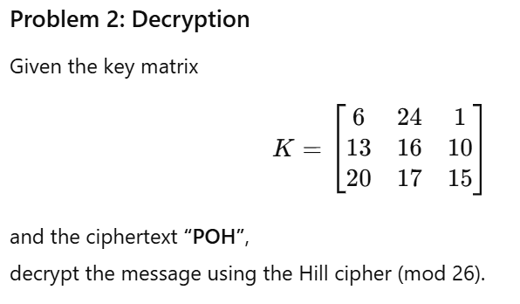
Problem 2:
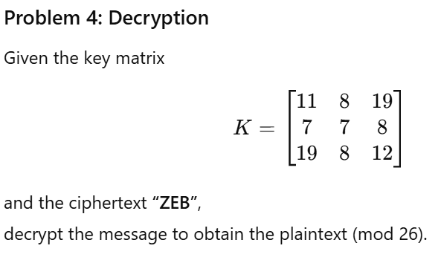

5. Polyalphabetic Cipher (Vigenère Cipher)
Problem 1:
Encrypt “ATTACK AT DAWN” using the Vigenère Cipher with the keyword “LEMON”.
Problem 2:
Decrypt the ciphertext “RIJVS UYVJN” using the same keyword “LEMON”.

6. One-Time Pad
Problem 1:
Given plaintext “HELLO” and random key “XMCKL”, encrypt using the One-Time Pad technique (A=0 to Z=25).
Problem 2:
Ciphertext: “EQNVZ”, Key: “XMCKL”.
Decrypt to obtain the original plaintext.

7. Transposition Techniques
Problem 1:
Encrypt “DEFEND THE EAST WALL” using a columnar transposition cipher with key “FORT”.
Problem 2:
Decrypt the ciphertext “TEITELHDVLSNHDTISEIIEA” using columnar transposition with key “GERMAN”.

8. RSA Algorithm
Problem 1:
Let ( p = 7 ), ( q = 13 ). Compute the public and private keys and encrypt the plaintext P = 5 using RSA.
Problem 2:
Given RSA public key ( e = 7, n = 33 ) and ciphertext C = 4, find the plaintext by computing the private key ( d ) and decrypting.

9. Diffie–Hellman Key Exchange
Problem 1:
Let ( p = 23 ), ( g = 5 ).
User A chooses ( a = 6 ), User B chooses ( b = 15 ).
Find the public keys and the shared secret key.
Problem 2:
If ( p = 11, g = 2, a = 8, b = 10 ), compute the shared key between A and B.

Al should be solved on paper and then uploaded
Last date to submit is 30th of October

