**Name: Sajja Kedarish Email: kedarishsajja@gmail.com Mobile Number: +91 7799304008**

*A high energy driven professional targeting assignments in* ***Cloud and******Infrastructure Management*** *with a reputed organization preferably in* ***Hyderabad***

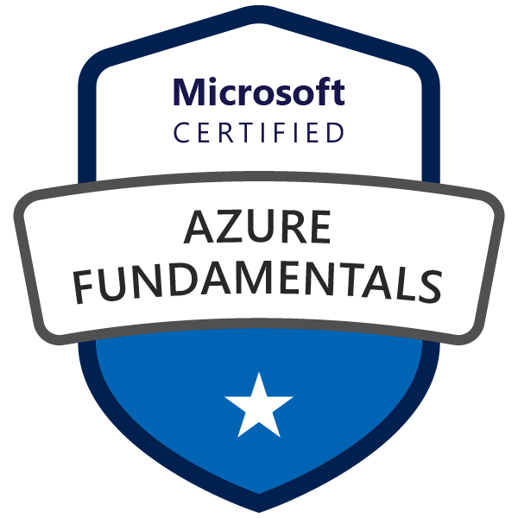

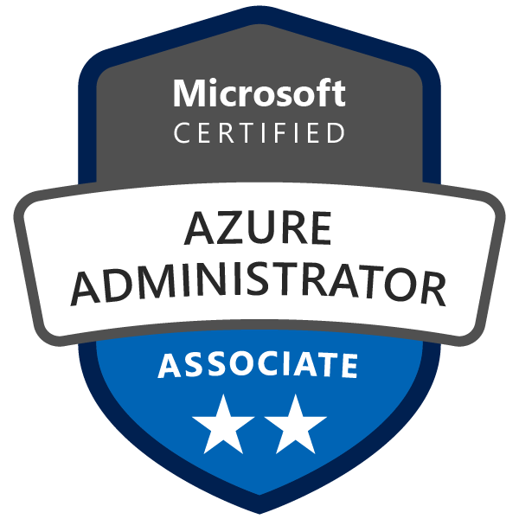

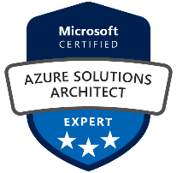

* *Dedicated and hardworking professional having around 2.6 Years of IT industry experience in the field of Microsoft Azure Administration (IAAS), Amazon EC2, Windows Server Administration, Citrix Xen Administration.*
* *Having around 2.2 years of experience on Microsoft Azure Administration with hands-on experience in administering Azure, along with a strong understanding of core Azure services, Azure workloads, security, and governance.*
* *Will be able to work on rotational shifts if needed by the project client.*
* *Experience in deploying and managing Windows & Linux Servers and securing the environment from vulnerabilities with troubleshooting capabilities.*
* *Good at managing Infra hosted on Azure platform and has experience working on Azure Disaster recovery, Scaling, Storage Accounts, Virtual Machines.*
* *Good knowledge in migration of on-premises workloads to cloud environment Azure.*
* *Experience and knowledge of IT operations, including networking, virtualization, identity, security, business continuity and disaster recovery, data platform, budgeting, and governance*
* *Knowledge on PowerShell Scripts and Azure CLI to deploy and manage Azure Resources, Hands-on experience in ARM Templates in Azure.*

----------------------------------------------------------------------------------------------------------------------------------------------------------------

# Proficiency Matrix:

# Operating Systems : Windows Server OS (2003 to 2019), Linux RHEL, ESXi.

# Cloud Knowledge : Microsoft Azure (IAAS), Amazon AWS EC2 Administration

# Domain Knowledge : Windows Server Administration, Active Directory, Patch Management (WSUS,

# SCCM), Performance Management, VMWare Data Center Virtualization (vSphere,

# vCenter, ESXi, Computing, Networking, Storage, Configuration and Management), Citrix Xen Environment Administration.

# Additional Knowledge: CISCO UCS Blade Administration (Basic), HPE Rack Mounted and Blade

# Server Management, ILO5, Systems Utility, BIOS, RAID Configuration etc.

# Organizational Experience:

# Infosys Limited! (January 19 – Till Date)

# Role: Wintel, Azure and VMWare Administrator (shared support) for client Kellogg Limited

# Azure Environment:

* *Monitoring all the AZURE Infrastructure as per the approved design and build covering - VM, Storage, Networking, OS (Alerts & Logs), network security groups*
* *VM Management: Provisioning, de-allocation, load balancing, configure availability sets. Scaling up & down, Image creation of VMs and virtual machine scale sets (VMSS)*
* *Patch management (System updates assessment and updates) for VM update management*
* *Configure VM with Azure Disk encryption and manage VM sizes by PowerShell and CLI*
* *Identity & Access management - Add/remove users, groups to Azure Active Directory and worked in RBAC access provisioning.*
* *Manage Subscriptions and governance by configuring Azure policy, Resource locks and management groups*
* *Endpoint Management, Load-Balancer, NSG, IP address Management, management of virtual networks*
* *Backup, Configure and Restore Azure Virtual Machine using Azure Backup with Recovery Service Vault*
* *Create, configure and manage Storage services like Azure Blob Storage and Azure File shares with secure way of Azure AD authentication*
* *Create and configure Azure App Service with scaling options in App service Plans*
* *Hands on experience on deploying resources by using Azure portal, PowerShell, Azure CLI*
* *Hands on experience on Azure Resource Manager (ARM) Templates in Azure.*
* *Create and configure Virtual Networks including peering and on premises connectivity though VPN gateway and Expressroute*
* *Experience in configuring Azure load balancer and Application gateway*

# Windows, VMWare and Citrix Environment:

# Managed Windows Server Administration: Server Performance Issues, maintaining server uptime efficiently, immediate response to server downs and its troubleshooting, C Drive clean up, Disk Partitioning, setting up Virtual Memory & Paging Memory, troubleshooting performance issues using Microsoft Sys Internal Tools.

# Active Directory Administration: Creating AD user accounts, groups, organizational units, password policies across domain, AD replication and its troubleshooting, AD Restore. Have enough knowledge on Sites, Trusts, Forests, AD Schema, AD Authentication i.e. Kerberos Authentication.

# Citrix Administration: XenApps, Storefront Configuration, XenCenter Compute, Networking and Storage, Citrix Director, Licensing Management, Citrix Studio Tool, Troubleshooting ICA Issues etc.

# DHCP Management: Creating DHCP Scopes, Reservations and profound knowledge in DNS Technology and its troubleshooting.

# VMWare Administration and Management: Creating VM’s from Templates, creating templates, Resource Pools, Deploying VM’s, Allocation resources, Snapshot Consolidation, Monitoring Management in the Data Stores, Creating Data Stores, Worked on VMWare Certificates, STS Certificates, Good Knowledge in the VMWare CLI.

# ESXi Patching, Firmware Upgrades via GUI, CLI, VMWare. Upgrading the vCenter from 5.5 and 6.5 to 7.0, Updating VMWare Tools.

# P2V Migration, v2v Migration, Patching Management through WSUS and SCCM, Upgrading Windows Server operating system from 2008, 2012 to 2016 and 2019.

# Job profile included maintaining and supporting the server infrastructure, patch management and AD domain services. Ensuring that the incident management, end user requirements are being delivered efficiently within the SLAs, and publishing/maintaining the necessary technical documentation. Worked on Automation projects which required gathering requirement from the client, working with different stakeholders, plan and execution of the changes ensuring minimal impact to the end users.

# Ensured data protection and high system availability in coordination with strategic engineering team.

# Coordinating with the Site teams, Hardware vendors to troubleshoot any hardware issues and facilitate part replacements.

# Working with HP ProLiant, Dell and IBM servers and Blade servers, working with hardware team to add/ replace, Azure and AWS EC2 Administration and Hosting platform.

# Event Log Monitoring, Created Power Shell Scripts for Automatic C Drive Cleanup, AD Replication Errors, VMWare Aged Snapshots Report, Up time report of all servers across domain.

***Certifications:***

* *Microsoft certified Azure Fundamentals, Azure Administrator, Azure Architect Expert.*
* *Infosys Certified Windows Active Directory Engineer*
* *Infosys Certified VMWare Data Center Virtualization Administrator*

# Academic Qualifications:

|  |  |  |  |  |  |
| --- | --- | --- | --- | --- | --- |
| **S:NO** | **COURSE** | **NAME OF BOARD/UNIVERSITY** | **YEAR OF PASSING** | **PERCENTAGE SECURED (%)** | **SPECIALIZATION** |
| 1 | B-Tech | ***JNTUK***  ***CHIRALA ENGG. COLLEGE*** | 2018 | 75 | E.C.E |
| 2 | Intermediate | ***BHASHYAM IIT-JEE JUNIOR COLLEGE*** | 2014 | 90.5 | M.P.C |
| 3 | S.S.C | ***BHASHYAM HIGH SCHOOL*** | 2012 | 88 | --- |

***Personal Details:***

*Name: Sajja Kedarish*

*Fathers Name: Sajja Basava Punna Rao*

*Date of Birth: 24th April 1996*

*Hobbies: Playing Online Games, Gardening (I feel it is food for the soul) & Cooking (Gives me art of feeding)*

***Declaration:***

*The above statements are true to the best of my knowledge and belief.*

*Place: Anantapur Date: 28 July 2021 (Sajja Kedarish)*