**Global Terrorism Analysis**

**Kedar Vasantrao Patil,**

**Rohit Rajendra Pawar**

**Data Science Trainee,**

**AlmaBetter**

**Abstract:**

The objective of this work is to analyze the region and country of a terrorist attack using exploratory data analysis, in order to acquire valuable information about the predicted attacks and attackers.

The work has been carried out upon the Global Terrorism Database (GTD), which is an open database containing list of terrorist activities from 1970 to 2017.

***Keywords:exploratory data anyalysis,terrorist activities,terrorist groups,attack region.***

**1.Problem Statement**

The GTD includes systematic data on domestic as well as international terrorist incidents that have occurred during this time period and now includes more than 180,000 attacks. The database is maintained by researchers at the National Consortium for the Study of Terrorism and Responses to Terrorism (START), headquartered at the University of Maryland.

Terrorism is the biggest hurdle to world peace. People believe in their own safety and most people do not want to be bothered by these problems. In this project, I focus on terrorism by analyzing the dataset provided by START (Study of Terrorism and Response to Terrorism) to explore meaningful patterns and statistics.

* Target_type: Type of target involved in the attack. It consists of categorical values like private citizens, military, police, government officials, transportation, education, religious institutions, airports, etc.
* AttackType: The type of attack happened. it consists of categories like explosion, armed assault, assassination, kidnapping, unarmed assaults.
* Killed: Number of people killed in any event
* Wounded: Number of people wounded in any event Organization that claimed responsibility of an attack.
* Weapon_type: Type of weapon used in the attack. Weapon_type contains values like firearms, explosives, melee, vehicles etc.
* Region: Name of the region where the attack happened. Region consists values like East Asia, South Asia, Western Europe, etc
* Latitude: latitude of the location.
* Longitude: longitude of the location.
* Group: Name of group involved in terrorist attacks.
* Country: Name of country where attack was done.
* Day, Month, Year: Calendar details of the events.

**2. Introduction**

### In simple words, terrorism is an act of violence carried out to intimidate & create fear & pain amongst the people. The agenda behind terrorism can be anything like political, religious, revenge, regional, ideological & sometimes mindless violence.

### Terrorist attacks have a significant threat to the safety and security of the international community and have become one of the greatest obstacles to the sustainable development of global social security.

In this analysis, analyses the changes in

terrorism over the last year and highlights the countries most impacted by terrorism, explores the individual characteristics of terrorists and terrorist groups in order to shed a light on the drivers of terrorism, analyses the major terrorist groups, including a historical analysis of how groups have ended in the past.

## **3. Misunderstanding About Terrorism**

Terrorism is widespread and inconsistent with time and nature. Because of these characteristics, International terrorism is difficult to summarize all aspects as a single conclusive solution and make this information available to be easily understood by most people.

Exploring this dataset can provide an insight into how different parameters are correlated with each other, which can help identify unknown hidden patterns.

First misunderstanding is that if we provide more military then we can suppress and control terrorism, but studies shows that more military is not enough to suppress terrorism it also depends on other factors like economy and politics.

Another popular misunderstanding is that terrorism only affects the individuals directly involved in any terrorist event. Terrorism adversely impact on countries financially associated with international terrorism. Studies shown that the effect of terrorism concerning the attack types.

## **4. Factors Affecting Terrorism**

Identifying dependent factors of terrorism is one of the goals of this project. There are parameters like religion or nationalism which are not defined in the dataset but have a major influence on contemporary terrorism.

Religion has been a very disputable topic among researchers about whether religion influences terrorism or not and if it does, up to what extent. Religious belief can shape and transform terrorism. Hence religion’s contribution in terrorism is an interesting subject to explore.

# **5. GTD Dataset**

# The dataset used in this project is called START (Study Terrorism and Response to Terrorism) dataset, which is a part of the Global Terrorism Database, compiled by the START consortium.

# The GTD incorporates in excess of 180,000 instances of terrorist events far and wide from 1970 to 2017. For every occurrence, data is accessible on the area and date of the comparing episode, summing up to 135 characteristics.

**6. Steps involved in Exploratory Data Analysis:**

1. **Project Structure**

Implementation of this project involves system design, backend design, visual design, and user interface. It includes the overall design plan of analysis which explains how each parameter is correlated with others.

1. **Data Cleaning**

Our dataset contains 135 columns in which there are a lot of missing values and more numbers of columns are irrelevant. I choose only those columns which are useful and rename those in proper name.

1. **Analysis**

This section consists of details regarding the visual results.

**7. Analysis**

* **Correlation Matrix**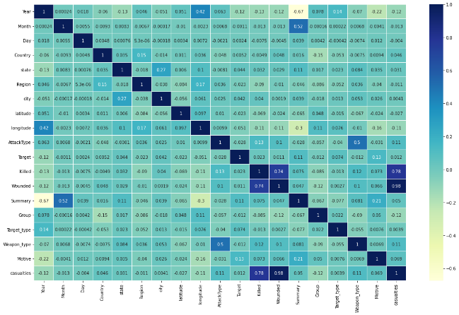

In our dataset there are more numbers of categorical features so I used a label encoding technique to convert features into numerical form to find correlation between them.

Attack type and weapon used in the attack also hold close ties with each other as attack type is defined based on the weapons used in that incident.

* **Terrorist Activities Each Year**

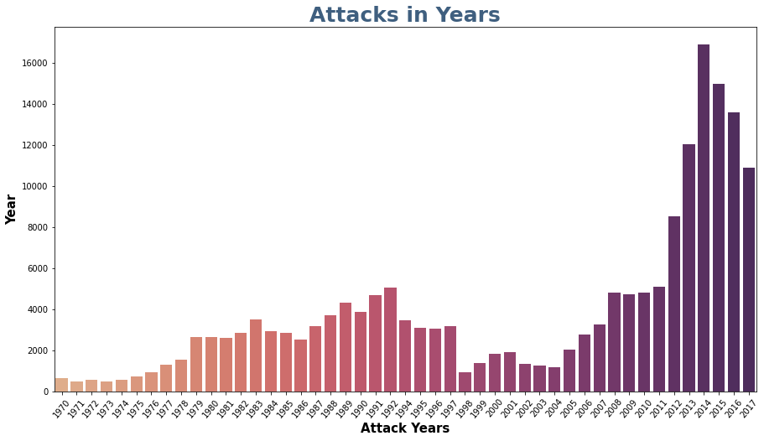

Summarizing all the terrorist attacks over the years can provide us an idea about how terrorism has evolved and what rate has it impacted the world each year.

Figure shows data from 1970 to 2017 for the total number of attacks that happen each year. Terrorist attacks were quite low in numbers in the decade of 1970.

Terrorism then had a fairly rise in the 1980s and early 1990s and was considerably low in the next decade but then terrorism rose from early the 2000s topping the charts like never before in the history.

* **Killings in Global Terrorism**

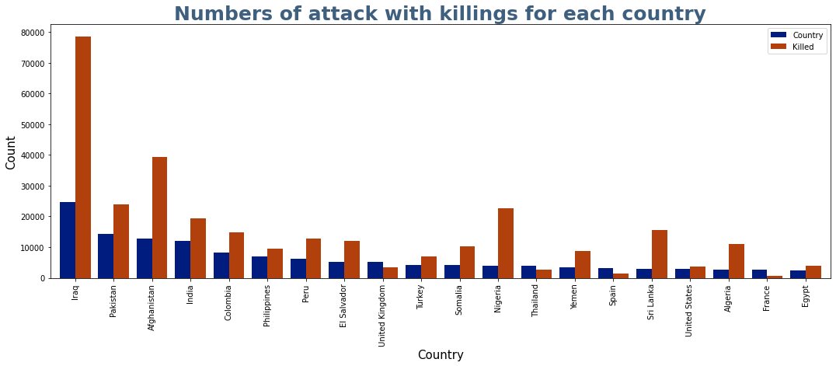

lists the most countries affected by terrorism based on the total number of attacks. Another bar along with each countries’ attack count is the number of total victims killed in those attacks combined for that country.

Iraq shows terrorist are very effective in getting what they wish for i.e. destruction in terms of lives and same can be said for top 5 countries. There are countries like Philippines, Peru and the United Kingdom which has faced an almost similar number of attacks but have a different number of kills. The United Kingdom has suffered significantly fewer casualties compared to the other 2 countries.

* **Terrorist Activities by region**

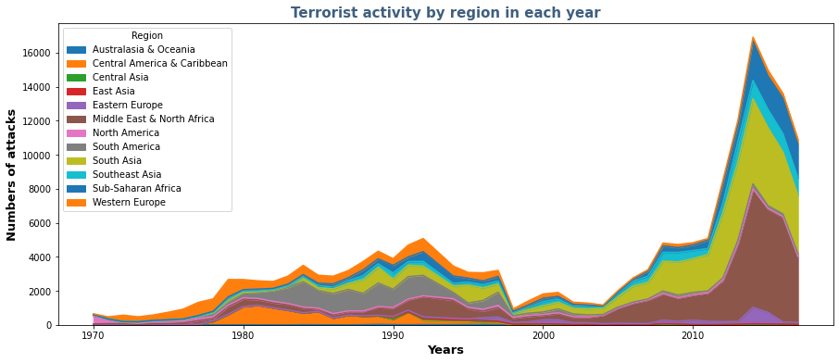

Based on the geographic location of countries, they have been subcategorized into twelve regions to compare the rate of terrorism in each one of them as shown. Middle east and north Africa have the highest number of attacks followed by South Asia and South America. Terrorism here does not show an equal distribution among all regions. As a result, based on the number of attacks, different levels of attention are required for each individual region.

The South America has been the third-highest affected region in the world after North Africa & the Middle East and South Asia. But from graph, see South America has no significant contribution to the current trending terrorism. South America was impacted by terrorism during the early 1980s to mid-1990s. Since then, terrorism has been relatively low.

Opposite of this is true for the Middle East and North Africa region. Middle East and North Africa has shown no noticeable rise in terrorism other than the early 2000s. This change in terrorism has been sudden and steep. But otherwise, there is no previous history of such high terrorist activities in the past.

* **Active Terrorist Groups**

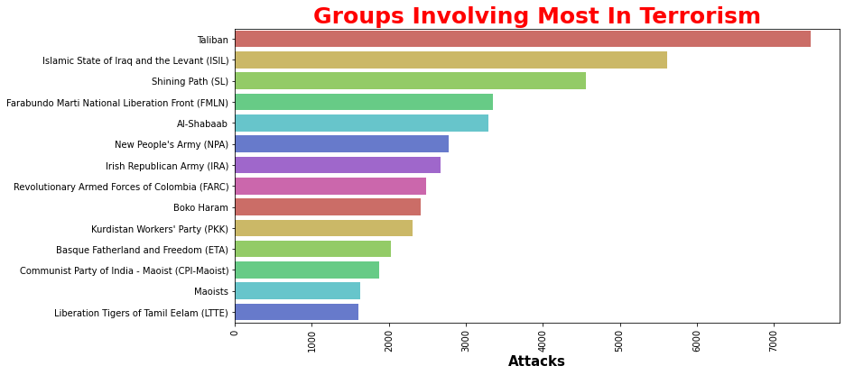

Taliban and ISIL are the major contributors in the recent rise in attacks, especially in North Africa and the Middle East regions. Today there are more active terrorist groups spreading violence and terror than ever before.

Almost all groups show multiple crests and troughs during their existence.

* **Attack Types**

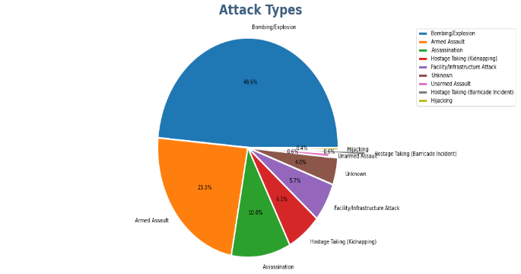

The above pie chart depicts the total attacks by type. It is evident that bombing and explosion followed by Armed Assault are the most preferred attack types with a total count of attacks from the year 1996-2017.

It seems that explosives were used in around 48.6% of the attacks, followed by Armed Assault accounted for 23.5% of the attacks. It can clearly be seen that Explosives are the most common weapon type.

Take a deep breath as these notorious groups still didn't possess weapons of mass destruction like Biological/Radiological as seen by data till now.

* **Target Types with number of Attacks**

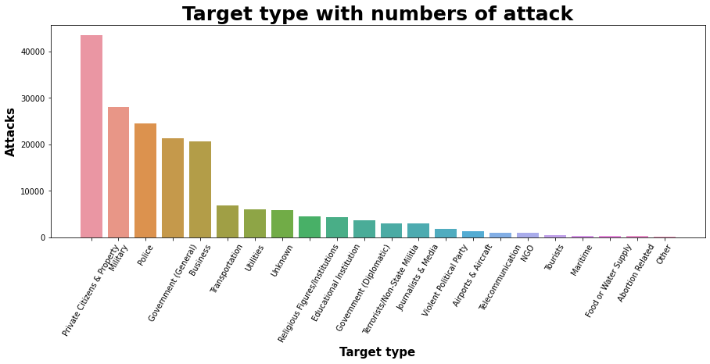

According to Figure, private citizens are only the modal target. Many of these attacks on private citizens are events in public spaces, such as marketplaces and sidewalk cafés.

The most common target after this is the government.

* **Most Attacked top 10 cities in the world.**

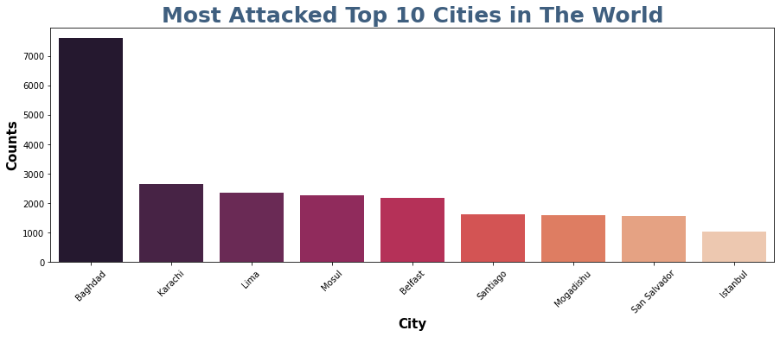

As expected Baghdad is the most affected city (and yes this is also called province).

However, the cities included here affected because either they are capital of state or densely populated areas in the respective countries i.e. easy target for terrorists.

* **Country wise Analysis**
  + **Country- Iraq:**

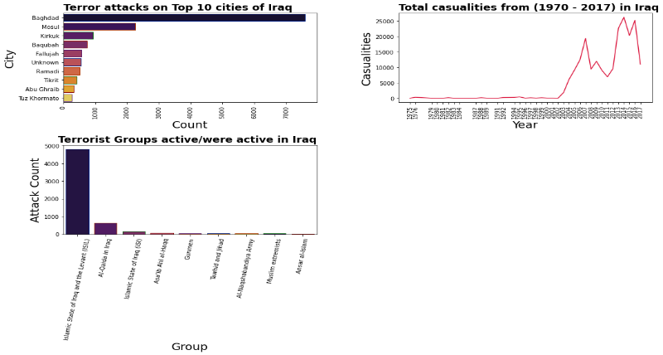

Level of terrorism in Iraq were very low prior to the 2003 invasion, for the last 13 years it has consistently been the country most impacted by terrorism. Most of the attacks are near the Capital of Iraq. This tells us how much these groups hate Government Organizations.

There have been two peak periods of terrorism in Iraq; the first occurred in 2007 and second commenced in 2011.

ISIL is the deadliest terrorist group in Iraq’s history and is responsible for over 18,000 deaths between 2013 and 2016.

* **Country- India:**

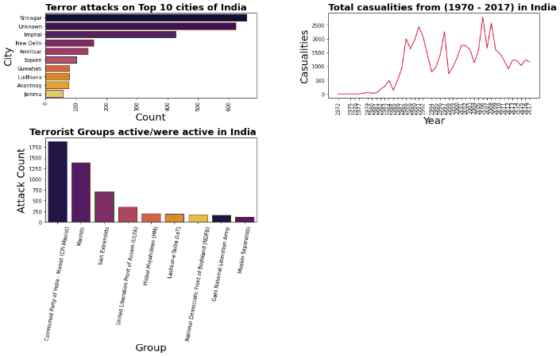

It seems like terror Attacks have been increased in India since 1985 and the main group responsible for these is Communist Party of India- Maoist.

India has the lowest rate of deaths per attack among the ten countries most affected by terrorism.

There is a large number of terrorist groups but many are seeking political recognition and so their attacks are not aimed at killing people.

* **Country- Pakistan:**

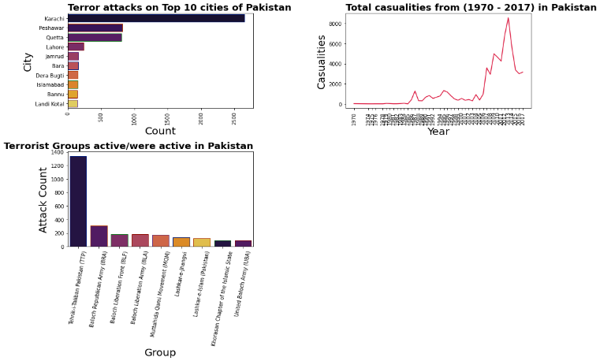

Pakistan has a long history of high levels of terrorism and the year 2014 result is the best in a decade.

It seems like terror Attacks have been increased in Pakistan since 1985 and the main group responsible for these is Tehrik-i-Taliban Pakistan.

Most of the attacks are in Pakistan in Karachi city.

* **Country- Syria**

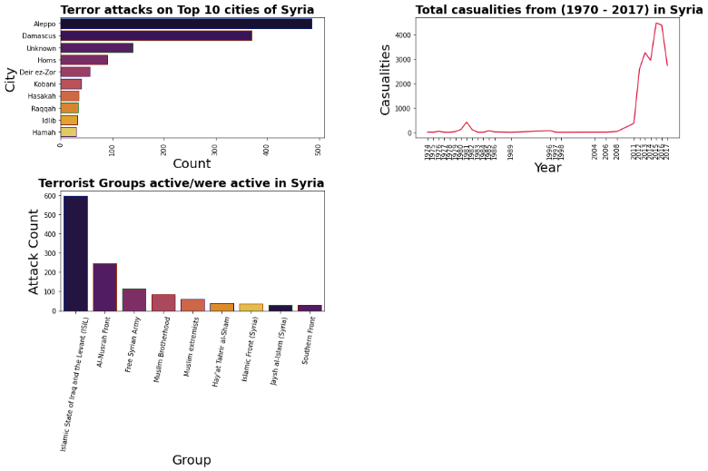

Terrorism in Syria is linked to the ongoing civil war which began in 2011.

There has been a proliferation of groups active in Syria that undertake terrorism.

Most attacks in Syria is in Aleppo.

**8. Conclusion:**

* Most of the attacks were done on year 2014.
* Taliban is the most active terrorist group in the world.
* Iraq is the most affected country from terrorism because most of the peoples killed in Iraq. In Iraq a maximum of 1570 people killed in a single attack.
* The Middle East and North Africa have the highest number of attacks followed by South Asia and South America. Terrorism here does not show an equal distribution among all regions.
* Private Citizens and property military is the most target type as per the dataset.
* It seems that explosives were used in around 48.6% of the attacks, followed by Armed Assault accounted for 23.5% of the attacks.

**References-**

1. Towardsdatascience
2. Global Terrorism Index 2017
3. Hindawi.com
4. START codebook