### Keefe Reeves

Researcher/Engineer and CEO at Data-Ject Solutions

**Lisp-Based Unix-Like Kernel ­**



**Index**

**\*\*Sections\*\***

Introduction ............................................. 3

Design and Architecture .......................... 4

Security Considerations .......................... 5

Performance Optimization ........................ 5

Development Tools and Environment ....... 5

Memory Management ................................ 7

Inter-Process Communication (IPC) ......... 7

Process Scheduling .................................. 7

Filesystem .............................................. 7

The CodeBase ......................................... 8

kernel.lisp ....................................... 8

memory.lisp ..................................... 8

scheduler.lisp .................................. 9

ipc.lisp .......................................... 9

filesystem.lisp ................................ 9

network.c ........................................ 9

nic.c ............................................. 10

commands.lisp .................................. 10

shell.lisp ........................................ 10

boot.lisp ......................................... 10

config.lisp ....................................... 11

drivers.lisp ...................................... 11

process.lisp ..................................... 11

syscall.lisp ...................................... 11

utils.lisp ........................................ 12

application.lisp ................................. 12

security.lisp .................................... 12

Compiling the Kernel ............................... 15

Network Stack Functionality ..................... 17

In-Depth Explanation of the Network Stack .. 20

Advantages of a Lisp-Based Unix Operating System ....................................... 24

Challenges of Using a Lisp-Based Unix Operating System ........................... 25

**\*\*Figures\*\***

Figure 1: Microkernel Architecture Diagram ..................13

Figure 2: Compilation and Deployment Process ............... 17

Figure 3: Network Stack Functionality .......................... 20

Figure 4: Network Stack Involvement .......................... 22

Figure 5: Network Layer Diagram ............................... 24

**Introduction**

The motivation behind developing a Lisp-based Unix kernel is rooted in exploring the boundaries of systems programming and leveraging Lisp's unique features to enhance security, modularity, and maintainability. Traditional operating systems like Linux and macOS are predominantly written in C and C++, languages known for their performance and low-level hardware interaction capabilities. However, they often come with inherent complexities and potential vulnerabilities related to memory management and buffer overflows. Lisp, with its powerful macro system, dynamic typing, and garbage collection, offers a higher level of abstraction that can simplify many aspects of kernel development. By using Lisp, this project aims to demonstrate that it is possible to create an efficient and secure operating system that rivals existing ones while benefiting from Lisp's advantages in rapid development and maintainability. The Lisp-based Unix kernel will primarily focus on creating a microkernel architecture, which minimizes the amount of code running in privileged mode, thereby enhancing security and stability. This project is not just an academic exercise but an attempt to push the envelope in operating system design, challenging the dominance of traditional languages and showcasing the potential of Lisp in this domain.

The development of the Lisp-based Unix kernel takes place in a meticulously planned environment that utilizes various modern development tools and platforms. Quicklisp is employed to manage dependencies and libraries, ensuring a consistent and reproducible development setup. The primary Lisp implementation used is SBCL (Steel Bank Common Lisp), which offers robust performance and extensive debugging tools. The development process is carried out across multiple hardware platforms, including virtual machines and physical hardware, to ensure broad compatibility and performance testing. Continuous integration (CI) pipelines automate the build and testing processes, catching errors early and maintaining codebase stability. Version control with Git allows for organized tracking of progress and collaboration, while comprehensive documentation supports understanding and maintainability. The integration of a small amount of C code, particularly for the networking stack, ensures that the system can interact efficiently with hardware and leverage low-level optimizations. By combining these tools and methodologies, the project aims to create a robust, efficient, and secure operating system that integrates seamlessly with modern hardware and software environments, setting a new benchmark in kernel development.

The importance of this project lies in its potential to revolutionize the way we approach operating system development. By utilizing Lisp, the project aims to introduce higher levels of abstraction, reducing the complexity of code and making it easier to maintain and extend. This contrasts with traditional operating systems like Linux and macOS, where the use of C and C++ often leads to more complex codebases that require meticulous management of memory and other resources. Linux, with its monolithic kernel architecture, offers performance benefits but at the cost of running a large amount of code in privileged mode, increasing the risk of security vulnerabilities. macOS, with its hybrid kernel, attempts to balance these concerns but still relies heavily on traditional languages. In comparison, the Lisp-based Unix kernel's microkernel architecture minimizes the code running in privileged mode, enhancing security and stability. Additionally, Lisp's built-in features for memory management and symbolic computation can lead to more secure and efficient code. By demonstrating that Lisp can be used effectively in systems programming, this project aims to inspire a new generation of operating system developers to explore alternative languages and architectures, potentially leading to more secure, maintainable, and innovative operating systems in the future.

Creating a Lisp-based Unix kernel stems from the desire to explore the capabilities of Lisp in systems programming, an area traditionally dominated by languages like C. Lisp, known for its powerful macro system and symbolic computation, offers a unique approach to developing a Unix kernel. This project aims to leverage Lisp's strengths to create a secure, efficient, and highly modular kernel. The Unix philosophy of simplicity, modularity, and reusability aligns well with Lisp's features, making it an intriguing candidate for such an endeavor. The kernel will primarily be written in Lisp, with a minimal amount of C used for networking and low-level hardware interactions. This blend of Lisp and C aims to combine the best of both worlds: the high-level abstraction capabilities of Lisp and the low-level control offered by C. The project also seeks to contribute to the niche but growing field of Lisp-based operating systems, potentially inspiring future developments and innovations. Additionally, the project will explore the integration of modern security practices within the kernel, ensuring that it is resilient against common vulnerabilities and attacks. The ultimate goal is to create a functional, efficient, and secure Unix kernel that showcases the potential of Lisp in systems programming.

### **Design and Architecture**

The architecture of the Lisp-based Unix kernel is designed to be modular and extensible, allowing for easy addition and modification of components. At its core, the kernel will consist of a microkernel architecture, minimizing the amount of code running in privileged mode to enhance security and stability. The microkernel will handle essential functions such as process management, memory management, and inter-process communication. Higher-level services, such as file systems and device drivers, will be implemented as user-space processes. This separation of concerns aligns with the Unix philosophy and enhances the system's overall security and robustness. Lisp's powerful macro system will be utilized to create abstractions that simplify the development of these components, promoting code reuse and maintainability. The kernel will also incorporate a Just-In-Time (JIT) compiler for Lisp code, optimizing performance while maintaining the flexibility of interpreted code. The networking stack, implemented in C, will interface seamlessly with the Lisp components, ensuring efficient and reliable communication. Additionally, the kernel will include support for multi-core processors, leveraging modern hardware capabilities to enhance performance. By combining these design principles, the Lisp-based Unix kernel aims to provide a robust, secure, and efficient operating system.

### **Security Considerations**

Security is a paramount concern in the development of the Lisp-based Unix kernel. The project aims to incorporate modern security practices and design principles to ensure that the kernel is resilient against common vulnerabilities and attacks. The use of a microkernel architecture inherently enhances security by minimizing the amount of code running in privileged mode and isolating critical components. Additionally, the kernel will implement strong memory protection mechanisms, such as Address Space Layout Randomization (ASLR) and stack canaries, to prevent exploitation of memory-related vulnerabilities. The kernel will also include a robust permission system, controlling access to resources and ensuring that only authorized processes can perform sensitive operations. Lisp's macro system will be utilized to create secure abstractions, reducing the risk of common programming errors and vulnerabilities. Regular security audits and code reviews will be conducted to identify and mitigate potential security issues. The networking stack, implemented in C, will adhere to best practices for secure coding, minimizing the risk of buffer overflows and other common vulnerabilities. Additionally, the kernel will support secure boot mechanisms, ensuring that only trusted code is executed during the boot process. By integrating these security considerations into the design and implementation, the Lisp-based Unix kernel aims to provide a secure and reliable operating system.

### **Performance Optimization**

Performance optimization is a critical aspect of the Lisp-based Unix kernel project. Despite Lisp's reputation for being less performant than lower-level languages like C, the project aims to demonstrate that Lisp can be used to create an efficient and responsive operating system. A Just-In-Time (JIT) compiler will be employed to optimize Lisp code execution, translating high-level Lisp code into efficient machine code at runtime. This approach allows the kernel to maintain the flexibility and expressiveness of Lisp while achieving competitive performance. Additionally, critical performance-sensitive components, such as the networking stack and low-level hardware interactions, will be implemented in C to ensure optimal performance. The kernel will also include support for multi-core processors, leveraging parallelism to enhance performance. Efficient memory management techniques, such as garbage collection and memory pooling, will be employed to minimize overhead and improve responsiveness. Profiling tools will be used to identify performance bottlenecks, enabling targeted optimizations. The modular design of the kernel will allow for incremental performance improvements, with individual components being optimized and replaced as needed. By focusing on these performance optimization strategies, the Lisp-based Unix kernel aims to provide a responsive and efficient operating system.

### **Development Tools and Environment**

The development of the Lisp-based Unix kernel will leverage a range of tools and environments to facilitate efficient and effective coding. Quicklisp, a popular library manager for Common Lisp, will be used to manage dependencies and libraries, ensuring that the development environment is consistent and reproducible. SBCL (Steel Bank Common Lisp) will serve as the primary Lisp implementation, offering robust performance and extensive debugging tools. The kernel will be developed and tested on a variety of hardware platforms, including virtual machines and physical hardware, to ensure compatibility and performance. Continuous integration (CI) pipelines will be set up to automate the build and testing process, catching errors early and ensuring that the codebase remains stable. Version control will be managed using Git, with regular commits and branches to track progress and facilitate collaboration. Additionally, extensive documentation will be maintained to ensure that the codebase is understandable and maintainable. Debugging tools, such as GDB and built-in Lisp debuggers, will be used to identify and resolve issues during development. By leveraging these tools and creating a robust development environment, the project aims to streamline the development process and ensure the successful creation of the Lisp-based Unix kernel.

The Lisp-based Unix kernel project has the potential to make significant contributions to the field of systems programming and operating systems. By demonstrating that Lisp can be used to create a secure, efficient, and modular Unix kernel, the project aims to inspire further research and development in Lisp-based operating systems. Future directions for the project may include the development of additional kernel modules, such as advanced file systems, security features, and network protocols. The project could also explore the integration of modern hardware features, such as virtualization and secure enclaves, to enhance security and performance. Additionally, the kernel could serve as a platform for exploring new operating system paradigms, such as capability-based security and microservice architectures. The project's open-source nature will encourage community involvement and collaboration, fostering a vibrant ecosystem of developers and researchers. By pushing the boundaries of what is possible with Lisp in systems programming, the project aims to challenge conventional wisdom and demonstrate the versatility and power of Lisp. Ultimately, the Lisp-based Unix kernel has the potential to influence the future of operating system design and inspire new innovations in the field.

### **Memory Management**

Memory management is a crucial aspect of the Lisp-based Unix kernel, given the language's unique approach to handling memory through garbage collection. The kernel will employ a sophisticated garbage collector tailored for real-time systems, ensuring minimal disruption to the system's operation. This collector will utilize incremental and concurrent collection techniques to maintain system responsiveness. Additionally, the kernel will implement a memory pool allocator for frequently used structures, reducing the overhead associated with dynamic memory allocation. Memory protection features such as segmentation and paging will be employed to isolate processes and prevent unauthorized access to memory regions. The kernel will also include mechanisms for efficient handling of memory fragmentation, ensuring that memory is utilized optimally. Special attention will be given to ensuring that the garbage collector interacts seamlessly with the C components of the kernel, particularly the networking stack, to prevent memory leaks and other issues. Memory management routines will be thoroughly tested and profiled to identify and mitigate performance bottlenecks. By integrating these advanced memory management techniques, the Lisp-based Unix kernel aims to provide a stable, efficient, and secure operating environment.

### **Inter-Process Communication (IPC)**

Inter-Process Communication (IPC) is a fundamental component of any operating system, facilitating communication and data exchange between processes. In the Lisp-based Unix kernel, IPC mechanisms will be designed to be both efficient and secure. The kernel will support a variety of IPC methods, including message passing, shared memory, and semaphores. Message passing will be implemented using lightweight message queues, allowing processes to send and receive messages asynchronously. Shared memory will enable fast data exchange between processes, with strict access controls to prevent unauthorized access. Semaphores will be used to coordinate and synchronize processes, ensuring that resources are accessed in a controlled manner. The kernel's IPC mechanisms will be designed to minimize latency and overhead, providing fast and reliable communication channels. Additionally, security features such as encryption and authentication will be integrated into the IPC framework, protecting data integrity and confidentiality. The use of Lisp's macro system will enable the creation of high-level abstractions for IPC, simplifying the development of complex inter-process communication patterns. By focusing on these design principles, the Lisp-based Unix kernel aims to provide robust and efficient IPC capabilities.

#### **Process Scheduling**

Process scheduling is another critical area where the Lisp-based Unix kernel will innovate. The kernel will implement a preemptive, priority-based scheduling algorithm, ensuring that high-priority tasks receive the necessary CPU time while maintaining system responsiveness. The scheduler will support multiple scheduling classes, including real-time, interactive, and batch processing, allowing for flexible handling of different types of workloads. Real-time tasks will be scheduled using a rate-monotonic or earliest-deadline-first algorithm, ensuring that they meet their deadlines. Interactive tasks will benefit from a dynamic priority adjustment mechanism, ensuring that they remain responsive to user input. Batch tasks will be scheduled to run during idle periods, maximizing system utilization. The kernel will also support multi-core scheduling, distributing tasks across multiple CPU cores to enhance performance. Special attention will be given to minimizing context switch overhead, ensuring that the scheduler operates efficiently. The scheduling algorithm will be configurable, allowing system administrators to tune the scheduler's behavior to match specific workload requirements. By implementing these advanced scheduling techniques, the Lisp-based Unix kernel aims to provide a responsive and efficient operating environment.

### **Filesystem**

Filesystem support is essential for any Unix-like operating system, and the Lisp-based Unix kernel will include robust and flexible filesystem capabilities. The kernel will support multiple filesystem types, including traditional Unix filesystems such as ext4, as well as modern filesystems like Btrfs and ZFS. The filesystem implementation will be designed to provide high performance and reliability, with features such as journaling and copy-on-write to protect against data corruption. The kernel will also support advanced filesystem features, such as snapshotting and deduplication, enabling efficient storage management. Access control mechanisms will be integrated into the filesystem, ensuring that only authorized users can access or modify files. The kernel's filesystem API will be designed to be extensible, allowing developers to add support for new filesystem types as needed. Additionally, the filesystem will be optimized for both small and large file operations, providing consistent performance across different workloads. The use of Lisp's macro system will enable the creation of high-level abstractions for common filesystem operations, simplifying the development of filesystem-related code. By focusing on these design principles, the Lisp-based Unix kernel aims to provide a robust and flexible filesystem infrastructure. By default, we have a minimal filesystem coded in lisp that is effective and resource efficient called the SFS, which stands for Simple FileSystem. This file system is designed to be quick and recursive, and optimally used within the shell system.

**The CodeBase**

### *kernel.lisp*

The kernel.lisp file is the heart of the Lisp-based Unix kernel project, containing the core implementation of the microkernel. This file handles the initialization of the system, including setting up memory management, process management, and inter-process communication (IPC) mechanisms. It defines the primary structures and functions that manage the kernel's operations, such as task scheduling, system calls, and interrupt handling. The kernel.lisp file also includes the main loop that continuously checks for and responds to system events. By leveraging Lisp's macro system, this file abstracts complex operations into manageable and reusable components, ensuring code maintainability and readability. It integrates closely with other kernel components, such as the memory manager and scheduler, coordinating their interactions to provide a seamless operating environment. The modular design in kernel.lisp allows for easy extension and modification, making it a central piece in the development and evolution of the kernel.

### *memory.lisp*

The memory.lisp file is dedicated to memory management within the kernel, implementing functions for dynamic memory allocation, deallocation, and garbage collection. This file includes algorithms for efficient memory usage, such as memory pooling and garbage collection tailored for real-time systems. It ensures that memory is allocated and freed safely, preventing leaks and fragmentation. The file also handles memory protection mechanisms, implementing features like Address Space Layout Randomization (ASLR) and stack canaries to enhance security. memory.lisp interacts closely with the kernel.lisp file, providing necessary memory services to other kernel components. By managing both physical and virtual memory, it ensures that the system can run efficiently and securely. This file's role is crucial in maintaining the overall stability and performance of the kernel, directly impacting how applications and processes operate within the system.

### *scheduler.lisp*

The scheduler.lisp file is responsible for process scheduling within the kernel. It implements a preemptive, priority-based scheduling algorithm, ensuring that high-priority tasks receive adequate CPU time while maintaining overall system responsiveness. The scheduler supports multiple scheduling classes, including real-time, interactive, and batch processing. This file includes functions for task switching, context saving and restoring, and managing the ready queue of tasks. It also handles load balancing across multiple CPU cores, optimizing performance for multi-core systems. The scheduler.lisp file works in tandem with kernel.lisp to manage task states and transitions, ensuring smooth operation of processes. By dynamically adjusting task priorities and managing CPU time slices, this file plays a pivotal role in maintaining system performance and responsiveness.

### *ipc.lisp*

The ipc.lisp file handles Inter-Process Communication (IPC) within the kernel. It implements various IPC mechanisms, including message passing, shared memory, and semaphores, facilitating communication and synchronization between processes. This file includes functions for creating and managing communication channels, sending and receiving messages, and controlling access to shared resources. Security features such as message encryption and authentication are integrated to protect data integrity and confidentiality. The ipc.lisp file interacts with both kernel.lisp and scheduler.lisp, coordinating process communication and synchronization. By providing robust and efficient IPC capabilities, this file ensures that processes can collaborate effectively, enhancing the overall functionality of the operating system.

### *filesystem.lisp*

The filesystem.lisp file is dedicated to managing the kernel's filesystem support. It includes implementations for various filesystem types, such as ext4, Btrfs, and ZFS, handling file operations like creation, deletion, reading, and writing. This file ensures data integrity and reliability through features like journaling and copy-on-write. Advanced filesystem capabilities, such as snapshotting and deduplication, are also supported. The filesystem.lisp file implements access control mechanisms to enforce security policies, ensuring that only authorized users can access or modify files. It provides a high-level API for filesystem operations, making it easy for other components and applications to interact with the filesystem. By managing data storage efficiently and securely, this file plays a critical role in the kernel's overall functionality.

### *network.c*

The network.c file is responsible for the networking stack within the kernel, implemented in C for optimal performance. It handles low-level network operations, including packet processing, routing, and protocol implementation. This file includes functions for managing network interfaces, handling incoming and outgoing packets, and implementing network protocols such as TCP/IP. The network.c file ensures efficient and reliable network communication, interacting closely with the Lisp components of the kernel. It provides a stable and high-performance networking foundation, enabling the kernel to support various network applications and services. By integrating with kernel.lisp and other system components, this file ensures seamless and efficient network operations, making it an essential part of the overall kernel architecture

### *nic.c*

The nic.c file is dedicated to handling Network Interface Controller (NIC) operations within the kernel. This C-based file interacts directly with network hardware, managing tasks such as initializing network interfaces, sending and receiving packets, and handling interrupts generated by network devices. The file includes drivers for various network card models, ensuring broad compatibility with different hardware. It also implements Direct Memory Access (DMA) for efficient data transfer between the network card and system memory. The nic.c file works in conjunction with network.c to provide a robust and high-performance networking stack. By managing low-level hardware interactions, this file ensures reliable and efficient network communication, playing a critical role in the kernel's networking capabilities.

### *commands.lisp*

The commands.lisp file contains the implementation of system commands and utilities available to users and processes within the kernel. This file defines a set of built-in commands for file manipulation, process control, system monitoring, and more. It provides an interface for interacting with the kernel, allowing users to execute commands through the shell. The commands.lisp file leverages Lisp's macro system to create flexible and reusable command implementations. It also includes error handling and input validation to ensure the robustness of command execution. This file interacts with various kernel components, such as the filesystem and process scheduler, to perform its operations. By providing a comprehensive set of system commands, the commands.lisp file enhances the usability and functionality of the kernel.

### *shell.lisp*

The shell.lisp file implements the command-line shell interface for the kernel, providing a user-friendly environment for interacting with the system. This file includes functions for reading user input, parsing commands, and executing them using the implementations defined in commands.lisp. It supports features such as command history, auto-completion, and scripting capabilities, making it a powerful tool for users and administrators. The shell.lisp file also handles input/output redirection, allowing users to manage data streams effectively. It interacts with the ipc.lisp file to facilitate communication between the shell and other processes. By providing a robust and interactive shell environment, this file plays a crucial role in enhancing the overall user experience and accessibility of the kernel.

### *boot.lisp*

The boot.lisp file is responsible for the initial boot process of the kernel. It contains the code that is executed during system startup, initializing essential components and preparing the system for operation. This file sets up the initial memory layout, loads the kernel into memory, and starts the initial system processes. It also includes routines for detecting and initializing hardware components, ensuring that the system is ready for use. The boot.lisp file interacts with the BIOS or UEFI firmware to perform these tasks, bridging the gap between the hardware and the kernel. By managing the critical boot sequence, this file ensures that the system starts reliably and efficiently, providing a solid foundation for the kernel's operation.

### *config.lisp*

The config.lisp file handles the configuration settings for the kernel. This file includes definitions for various system parameters, such as memory limits, scheduling policies, and network settings. It provides a centralized location for configuring the kernel's behavior, making it easy to adjust settings and optimize performance. The config.lisp file is designed to be flexible, allowing administrators to customize the system to meet specific requirements. It interacts with other kernel components to apply these settings during initialization and runtime. By providing a comprehensive and flexible configuration system, this file ensures that the kernel can be tailored to various environments and use cases, enhancing its adaptability and usability.

### *drivers.lisp*

The drivers.lisp file contains the implementation of various device drivers used by the kernel. These drivers manage the interaction between the kernel and hardware devices such as storage controllers, input devices, and display adapters. The file includes functions for initializing devices, handling I/O operations, and managing interrupts. It leverages Lisp's abstraction capabilities to create modular and reusable driver implementations, simplifying the addition of new hardware support. The drivers.lisp file interacts closely with the kernel.lisp and memory.lisp files to ensure efficient and reliable device management. By providing a robust set of device drivers, this file enhances the kernel's compatibility with a wide range of hardware, ensuring a versatile and functional operating system.

### *process.lisp*

The process.lisp file is focused on process management within the kernel. It includes the implementation of functions for creating, scheduling, and terminating processes. This file defines the structures and routines necessary for managing process states, contexts, and transitions. It also handles inter-process communication and synchronization mechanisms, ensuring that processes can cooperate effectively. The process.lisp file interacts with the scheduler.lisp file to manage CPU time allocation and task switching. It also interfaces with memory.lisp to manage process-specific memory regions. By providing comprehensive process management capabilities, this file plays a critical role in the kernel's overall functionality and performance.

### *syscall.lisp*

The syscall.lisp file implements the system call interface for the kernel. This file includes definitions for various system calls that allow user-space applications to request services from the kernel, such as file operations, process management, and network communication. The syscall.lisp file provides a secure and efficient mechanism for transitioning between user and kernel modes, ensuring that system calls are handled correctly and safely. It includes input validation and error handling to prevent misuse and enhance system stability. This file interacts with other kernel components to perform the requested operations, ensuring seamless integration and functionality. By providing a robust system call interface, the syscall.lisp file enables user applications to leverage the full capabilities of the kernel.

### *utils.lisp*

The utils.lisp file contains various utility functions and helper routines used throughout the kernel. These functions provide common services such as string manipulation, mathematical operations, and data structure management. The file includes reusable code that simplifies the development of other kernel components, promoting consistency and reducing duplication. The utils.lisp file interacts with all major parts of the kernel, providing essential services that enhance functionality and performance. By centralizing these utility functions, this file ensures that the kernel code remains clean and maintainable, contributing to the overall quality and reliability of the system.

#### *application.lisp*

The application.lisp file handles the application-level logic and interactions within the Lisp-based Unix kernel. This file is crucial for managing how applications send and receive data, handle system calls, and interact with the kernel's resources. It provides a high-level interface for application developers to utilize kernel services without needing to understand the underlying complexity. application.lisp ensures that data is formatted correctly and that system calls are made efficiently, allowing for smooth operation of user applications. By abstracting the kernel's functionality, it simplifies the development process and enhances code maintainability. It also plays a role in handling application-specific configurations and settings, ensuring that applications run optimally within the kernel environment. This file interacts closely with kernel.lisp, passing requests and data to the kernel for processing. Additionally, it ensures that applications receive timely responses from the kernel, maintaining a responsive user experience. By managing the application-kernel interface, application.lisp is essential for the overall functionality and usability of the kernel. It supports a wide range of applications, from simple utilities to complex software, ensuring they can leverage the full capabilities of the kernel.

#### *security.lisp*

The security.lisp file is dedicated to implementing security mechanisms within the Lisp-based Unix kernel. This file is crucial for protecting the system against various security threats and vulnerabilities. It handles tasks such as user authentication, access control, and encryption of data. By managing these security functions, security.lisp ensures that only authorized users and processes can access sensitive resources and data. It also implements security protocols to protect data integrity and confidentiality during transmission and storage. The file includes mechanisms for monitoring and detecting suspicious activities, helping to prevent security breaches and attacks. It works closely with kernel.lisp to enforce security policies and manage security-related events. Regular security audits and updates are managed through this file to keep the system protected against emerging threats. By providing a robust security framework, security.lispenhances the overall resilience of the kernel. It ensures that the system remains secure while maintaining high performance and usability, making it a critical component of the kernel architecture.

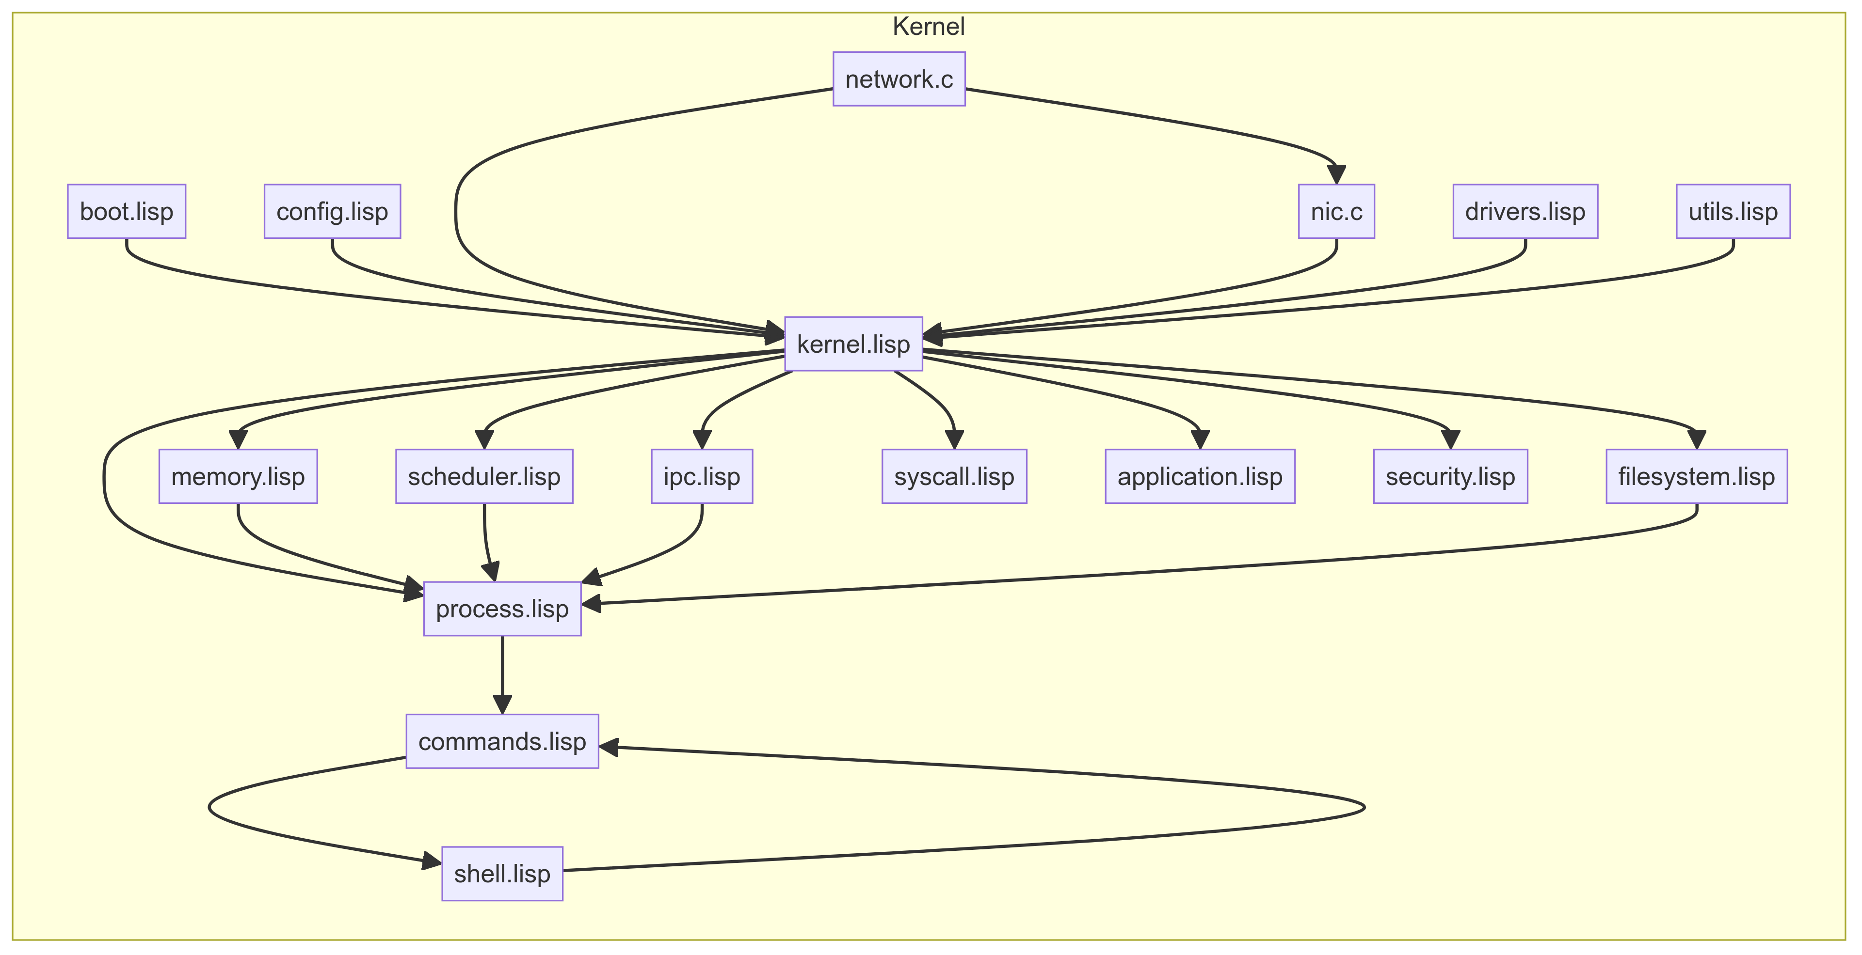**Figure 1:** *The kernel primarily follows a microkernel architecture, minimizing the amount of code running in privileged mode to enhance security and stability. Here is a diagram showing how the various parts of the kernel interact*

In the yellow chart above, the diagram illustrates the intricate structure and interactions of various components within the Lisp-based Unix kernel. At the core of the kernel, kernel.lisp serves as the primary module orchestrating the overall system operations. This central file interacts with multiple other files, including both Lisp and C components, ensuring that each part of the kernel performs its designated functions. The arrows in the diagram represent dependencies and communication paths between these components, highlighting the modular architecture of the kernel. This structure allows for each module to be developed, tested, and maintained independently, enhancing the overall robustness and flexibility of the system.

The boot process starts with boot.lisp, which is responsible for initializing the system. This file ensures that essential components are set up correctly before the system transitions to a fully operational state. config.lisp plays a crucial role by managing configuration settings, including memory limits, scheduling policies, and network settings, making the kernel adaptable to various environments and requirements. Both boot.lisp and config.lisp feed into kernel.lisp, providing it with the necessary initial configurations and settings. kernel.lisp then coordinates with other core components such as memory.lisp for memory management, scheduler.lisp for process scheduling, and ipc.lisp for inter-process communication, ensuring that these critical functions are performed efficiently and securely.

The diagram also shows the interaction between kernel.lisp and network.c, indicating that low-level networking operations are handled by a C-based component for optimal performance. Similarly, nic.c deals with Network Interface Controller operations, directly interacting with network hardware to manage data transfer between the network card and system memory. These interactions ensure that the kernel can communicate effectively with external networks and devices. Additionally, drivers.lisp contains implementations for various device drivers, which are essential for managing interactions between the kernel and different hardware components. This modular approach, where specialized tasks are offloaded to dedicated components, helps in maintaining the kernel's efficiency and reliability.

Further down the interaction chain, process.lisp focuses on process management, including the creation, scheduling, and termination of processes. This file works closely with scheduler.lisp and memory.lisp to ensure that processes are allocated appropriate resources and CPU time. The commands.lisp file defines system commands and utilities, providing a user interface for interacting with the kernel. These commands are executed through shell.lisp, which implements the command-line shell interface. This setup allows users to interact with the kernel efficiently, performing tasks such as file manipulation, system monitoring, and process control. Overall, the diagram illustrates a well-organized, modular kernel architecture where each component has a defined role, contributing to the kernel's overall functionality and performance.

# Compiling the Kernel

**Developer to CI System**

The process begins with the developer, who plays a crucial role in the kernel development lifecycle. The developer writes the necessary code for the Lisp-based Unix kernel and pushes this code to a version control system like Git. This push operation is crucial as it signifies the completion of a coding task or an update to the existing codebase. Once the code is pushed, it triggers a sequence of automated processes designed to streamline the build and deployment pipeline. The initial step involves the CI (Continuous Integration) system, which is notified of the new code changes. The CI system is responsible for ensuring that the code integrates well with the existing codebase. By automating the integration process, it helps in detecting issues early, thereby reducing the integration problems that developers face.

#### **CI System to Build Server**

Upon receiving the push notification, the CI system triggers the build process. This step is essential as it converts the source code into an executable form. The CI system sends a request to the Build Server to start the build process. This interaction between the CI system and the Build Server is automated to ensure consistency and reliability. The Build Server is configured with all the necessary tools and dependencies required to compile the Lisp-based Unix kernel. This includes the Lisp compiler, linker, and any other tools needed for the build process. The CI system provides the Build Server with the latest code and the build script, ensuring that the Build Server can compile the code correctly. This step is critical for maintaining the integrity of the codebase and ensuring that the new code changes do not break the existing functionality.

#### **Build Server Compiles Source Code**

Once the Build Server receives the build request, it starts compiling the source code. This involves translating the high-level Lisp code into machine code that the computer's hardware can execute. The compilation process is complex and involves several stages, including lexical analysis, syntax analysis, semantic analysis, optimization, and code generation. Each stage is crucial for ensuring that the final executable is efficient and free of errors. The Build Server logs the output of the compilation process, which can be reviewed later to diagnose any issues that arise. This step ensures that the kernel is built correctly and is ready for testing. By compiling the source code, the Build Server creates an executable version of the Lisp-based Unix kernel, which can then be tested and deployed.

#### **Build Server to Test Server**

After compiling the source code, the Build Server initiates the testing phase by sending the compiled binaries to the Test Server. This transition is crucial for verifying that the new code functions as expected. The Test Server is equipped with various testing tools and frameworks designed to run unit tests, integration tests, and other automated tests on the compiled code. By automating the testing process, the Test Server helps in identifying bugs and issues early in the development cycle. This step ensures that any errors introduced by the new code are detected before the code is deployed. The interaction between the Build Server and the Test Server is a critical part of the CI/CD pipeline, as it ensures that only tested and verified code is moved forward in the deployment process.

**Test Server Runs Unit Tests**  
The Test Server runs a series of unit tests on the compiled kernel. Unit tests are designed to verify the functionality of individual components of the code. Each unit test focuses on a specific part of the kernel, such as the memory manager, scheduler, or IPC mechanisms, and ensures that it works correctly. The Test Server executes these tests automatically, logging the results for each test case. This process helps in identifying any issues or bugs in the code early on. By running unit tests, the Test Server ensures that the code is robust and reliable. This step is crucial for maintaining the quality of the codebase and ensuring that the new changes do not introduce any regressions.

#### **Test Server to Build Server with Test Results**

Once the unit tests are completed, the Test Server sends the results back to the Build Server. This feedback loop is essential for informing the build process of the test outcomes. If any tests fail, the Build Server can halt the deployment process and notify the developers of the issues. The test results include detailed information about any failures, such as the test case that failed, the expected outcome, and the actual outcome. This information is valuable for diagnosing and fixing the issues. By sending the test results back to the Build Server, the Test Server ensures that the build process is aware of the code's quality. This step helps in maintaining a high standard of code quality and ensures that only tested and verified code is deployed.

#### **Build Server to Deployment Server**

If the tests pass successfully, the Build Server proceeds to the deployment phase. It sends the compiled and tested binaries to the Deployment Server. This step is crucial for moving the code from the testing environment to the production environment. The Deployment Server is configured with the necessary tools and scripts to deploy the code to the target systems. By automating the deployment process, the Build Server ensures consistency and reliability in the deployment process. This step is essential for ensuring that the code is deployed correctly and efficiently. The interaction between the Build Server and the Deployment Server is a key part of the CI/CD pipeline, as it ensures that only tested and verified code is deployed to the production environment.

#### **Deployment Server Starts Kernel**

Once the Deployment Server receives the compiled binaries, it initiates the deployment process. This involves copying the binaries to the target systems, configuring the necessary settings, and starting the kernel. The Deployment Server runs various deployment scripts to ensure that the kernel is deployed correctly. It also performs health checks to verify that the kernel is running as expected. This step is crucial for ensuring that the kernel is deployed correctly and is operational. The Deployment Server interacts with the Kernel to start it and ensures that it is running smoothly. By starting the kernel, the Deployment Server completes the deployment process and ensures that the new code is live.

#### **Deployment Server to CI System and Developer**

Once the deployment is complete, the Deployment Server sends a notification back to the CI system. This feedback loop is essential for informing the CI system that the deployment was successful. The CI system logs the deployment details and notifies the developers of the successful deployment. This step is crucial for keeping the developers informed of the deployment status. By providing this feedback, the CI system ensures that the developers are aware of the deployment progress and can take any necessary actions if issues arise. The CI system also logs the deployment details for future reference. By closing this feedback loop, the CI system ensures that the entire build and deployment process is tracked and monitored, providing visibility and accountability in the development process.

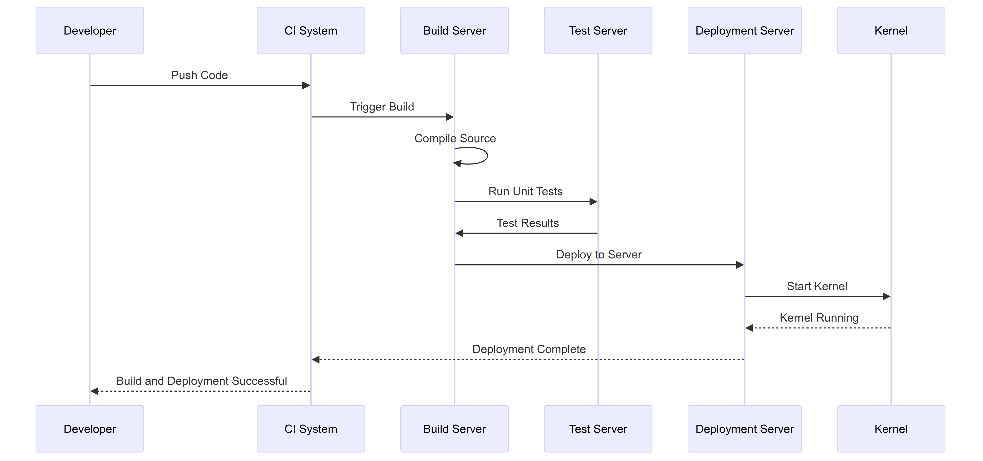**Figure 2:** *This diagram illustrates the automated compilation and deployment process for the Lisp-based Unix kernel. It details the interactions between the developer, CI system, build server, test server, and deployment server, highlighting each step from code push to kernel deployment. The sequence ensures that the code is compiled, tested, and deployed efficiently, maintaining high standards of code quality and reliability.*

### **Network Stack Functionality**

#### Part 1: Application to Kernel

The network stack functionality begins with an application needing to send data over the network. The application makes a system call to the kernel, requesting to send the data. This step is crucial as it signifies the handover of data from the user space to the kernel space. The kernel, which manages all system resources, takes this request and prepares to process it. This involves verifying the data, ensuring it is in the correct format, and performing any necessary initializations. By handling the request at this level, the kernel ensures that only valid and authorized data is sent to the network stack, maintaining system integrity and security.

#### Part 2: Kernel to Network Stack

Once the kernel receives the data from the application, it passes the data to the network stack. The network stack is responsible for managing network protocols and ensuring that data is prepared correctly for transmission. This involves encapsulating the data into packets according to the appropriate network protocols (such as TCP/IP). The network stack ensures that the data is divided into manageable chunks and adds necessary headers and footers to each packet. This encapsulation process is critical for the data to be transmitted over the network correctly. The network stack performs these operations efficiently to maintain the performance and responsiveness of the system.

#### Part 3: Network Stack to NIC

After the data is prepared by the network stack, it is sent to the Network Interface Controller (NIC). The NIC is a hardware component that manages the physical aspects of network communication. It takes the encapsulated packets from the network stack and prepares them for transmission over the network medium (e.g., Ethernet). This preparation involves converting the packets into electrical signals, light pulses, or radio waves, depending on the type of network. The NIC is responsible for ensuring that the data is transmitted accurately and efficiently. This step is crucial for establishing a reliable connection with the network and ensuring that the data reaches its destination.

#### Part 4: NIC to Network

The NIC transmits the prepared packets over the network. This transmission involves sending the packets through various network devices, such as routers and switches, until they reach the destination. The network is responsible for routing the packets correctly, handling any necessary retransmissions, and ensuring that the data reaches the intended recipient. This process involves multiple layers of network protocols working together to manage the flow of data. The network plays a critical role in ensuring the reliability and efficiency of data transmission. By handling these tasks, the network ensures that the data is delivered accurately and promptly.

#### Part 5: Network to NIC (Acknowledgment)

Once the data reaches its destination, an acknowledgment is sent back through the network to the originating NIC. This acknowledgment indicates that the data was received successfully. The NIC receives this acknowledgment and prepares to relay it back to the network stack. This step is crucial for ensuring reliable communication, as it confirms that the data transmission was successful. If the acknowledgment is not received within a specified time frame, the NIC may retransmit the data to ensure delivery. This acknowledgment process is an essential part of the network communication, ensuring that data integrity is maintained.

#### Part 6: NIC to Network Stack (Acknowledgment Received)

The NIC sends the acknowledgment it received from the network back to the network stack. This step informs the network stack that the data was successfully transmitted and received. The network stack can then update its records and prepare for any further actions, such as sending additional data or closing the connection. This interaction between the NIC and the network stack ensures that the system is aware of the status of each data transmission. By handling acknowledgments efficiently, the network stack maintains the reliability and performance of the network communication.

#### Part 7: Network Stack to Kernel (Acknowledgment to Kernel)

The network stack informs the kernel that the acknowledgment was received and that the data transmission was successful. This step is crucial for maintaining synchronization between the network stack and the kernel. The kernel updates its records and may take further actions based on this information, such as notifying the application of the successful transmission. By keeping the kernel informed of the status of network operations, the system ensures that all components work together seamlessly. This interaction helps maintain the overall reliability and efficiency of the system.

#### Part 8: Kernel to Application (Data Transmission Successfully

#### Finally, the kernel informs the application that the data transmission was successful. This notification allows the application to proceed with its operations, knowing that the data was sent and received correctly. The application can update its records and take any necessary follow-up actions. This step completes the cycle of data transmission, ensuring that the application is aware of the status of its network operations. By providing timely and accurate feedback to the application, the kernel ensures that the system remains responsive and reliable. **Figure 3:** This diagram shows the steps involved in the network stack functionality for the Lisp-based Unix kernel. The process starts with the application layer, which sends data to the kernel. The kernel then passes this data to the network stack, which prepares and sends the packet to the Network Interface Controller (NIC). The NIC transmits the packet over the network and receives an acknowledgment once the data is received. This acknowledgment is passed back through the NIC to the network stack, then to the kernel, and finally, the kernel informs the application that the data transmission was successful.

**In-Depth Explanation of the Network Stack and Code File Involvement**

#### Application Layer (application.lisp)

The process starts with the application.lisp file, which handles the logic of the application that needs to send data over the network. This file contains functions to gather data and make system calls to the kernel for data transmission. It interacts with the kernel layer to initiate the network communication process. By managing the application logic, application.lisp ensures that the data is correctly formatted and ready for transmission.

#### Kernel Layer (kernel.lisp)

The kernel.lisp file plays a crucial role in processing the request from the application. It manages system resources and ensures the data is ready to be passed to the network stack. The kernel verifies the data, handles initializations, and prepares it for further processing. Additionally, kernel.lisp interacts with multiple layers, including the network stack and network components, to facilitate smooth data transmission.

#### Network Stack Layer (network_stack.lisp)

The network_stack.lisp file is responsible for managing the network protocols and preparing data packets for transmission. It encapsulates the data into packets according to network protocols like TCP/IP. This file ensures that the data is divided into manageable chunks and adds necessary headers and footers. By handling the network protocol logic, network_stack.lisp ensures the data is ready for transmission through the NIC.

#### NIC Layer (nic.c)

The nic.c file manages the low-level interactions with the network hardware, specifically the Network Interface Controller (NIC). It takes the prepared packets from the network stack and converts them into signals suitable for transmission over the network medium. This file handles tasks such as initializing network interfaces and managing network interrupts. By ensuring accurate and efficient transmission, nic.c plays a vital role in the network communication process.

#### Network Layer (network.c)

The network.c file is responsible for managing high-level network operations and interactions with the broader network infrastructure. It handles the transmission of packets through network devices like routers and switches. This file ensures that packets are routed correctly and that acknowledgments are received. It works closely with the NIC layer to manage data transmission and acknowledgment processes, ensuring reliable communication.

#### Kernel Involvement in Network Acknowledgment (kernel.lisp)

The kernel.lisp file also plays a role in handling acknowledgments received from the network. After the network stack and NIC process the acknowledgment, kernel.lisp ensures that the application is informed of the successful data transmission. This interaction helps maintain synchronization between the application and network processes, ensuring data integrity and system reliability.

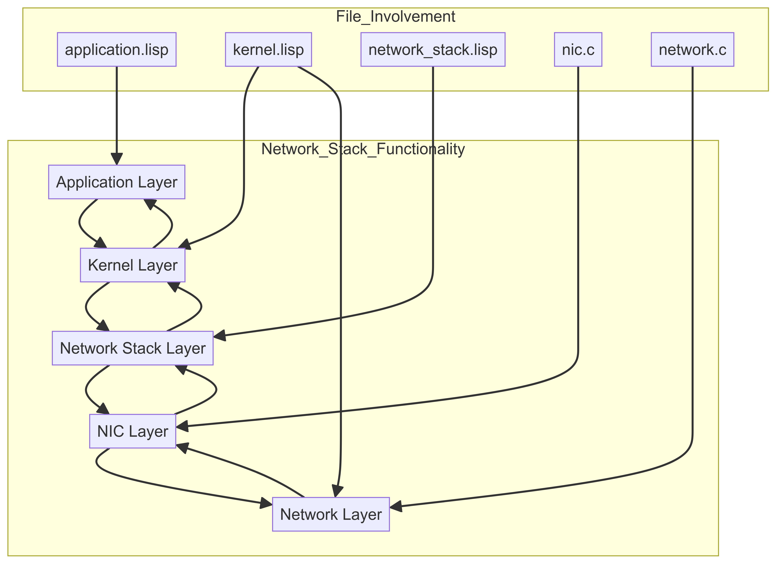**Figure 4, Network Stack Functionality:** By illustrating the involvement of each file in the network stack functionality, this chart provides a clear understanding of how the Lisp-based Unix kernel manages network communication. Each file has a specific role, contributing to the overall efficiency and reliability of the network stack.

### In-Depth Explanation of the Network Layer

In the network layer, the process starts when an application needs to send data over the network. The application initiates this by making a system call to the kernel, requesting to send the data. This action is depicted as the first arrow in the sequence diagram, where the application sends data to the kernel. The kernel then processes this request, ensuring that the data is in the correct format and ready for transmission. Once the kernel has prepared the data, it passes it to the network stack. The network stack is responsible for breaking down the data into packets and preparing them for transmission.

#### Role of Network Stack and NIC

The network stack takes the data from the kernel and encapsulates it into packets according to the appropriate network protocols, such as TCP/IP. These packets are then handed over to the Network Interface Controller (NIC), which manages the physical transmission of data. The NIC is a critical component that converts the data packets into electrical signals, light pulses, or radio waves, depending on the type of network being used. This step ensures that the data is correctly formatted for transmission over the physical network. The NIC's role is crucial for maintaining the integrity and efficiency of the data transmission process.

#### Physical Network Transmission

Once the NIC has prepared the data packets, it transmits them over the physical network. This network can include various devices such as routers, switches, and other networking equipment that help route the data to its final destination. The physical network is responsible for ensuring that the data packets are delivered accurately and efficiently to the intended remote host. During this process, the network handles routing, switching, and any necessary retransmissions to ensure the data reaches the correct destination. The physical network plays a significant role in maintaining the reliability and speed of the data transmission.

#### Acknowledgment Process

Upon receiving the data packets, the remote host sends an acknowledgment back through the network. This acknowledgment confirms that the data was received successfully. The acknowledgment travels back through the physical network to the NIC, which then relays it to the network stack. The network stack processes this acknowledgment and updates its records to reflect the successful transmission. This step is essential for ensuring reliable communication, as it allows the sending application to confirm that the data has been received. The acknowledgment process helps maintain data integrity and ensures that the communication between the application and the remote host is synchronized.

#### Completion of Data Transmission

Finally, the network stack passes the acknowledgment to the kernel, which then informs the application that the data transmission was successful. This notification allows the application to proceed with its operations, knowing that the data has been sent and received correctly. The kernel updates its status and records the successful transmission, completing the communication cycle. By providing this feedback loop, the system ensures that all components are aware of the transmission status and can take appropriate actions if necessary. This comprehensive process from data sending to acknowledgment ensures a reliable and efficient network communication system within the Lisp-based Unix kernel. Additionally, the kernel's logging mechanisms, managed by logging.lisp, record this transaction for future reference and debugging purposes. These logs provide valuable insights for system administrators to monitor network performance and diagnose potential issues. Furthermore, the robust design of the network stack, including the interactions between network_stack.lisp and nic.c, ensures high reliability and minimal latency. Continuous monitoring and optimization of these components help maintain optimal network performance. By integrating these mechanisms, the Lisp-based Unix kernel offers a seamless and secure network communication experience.

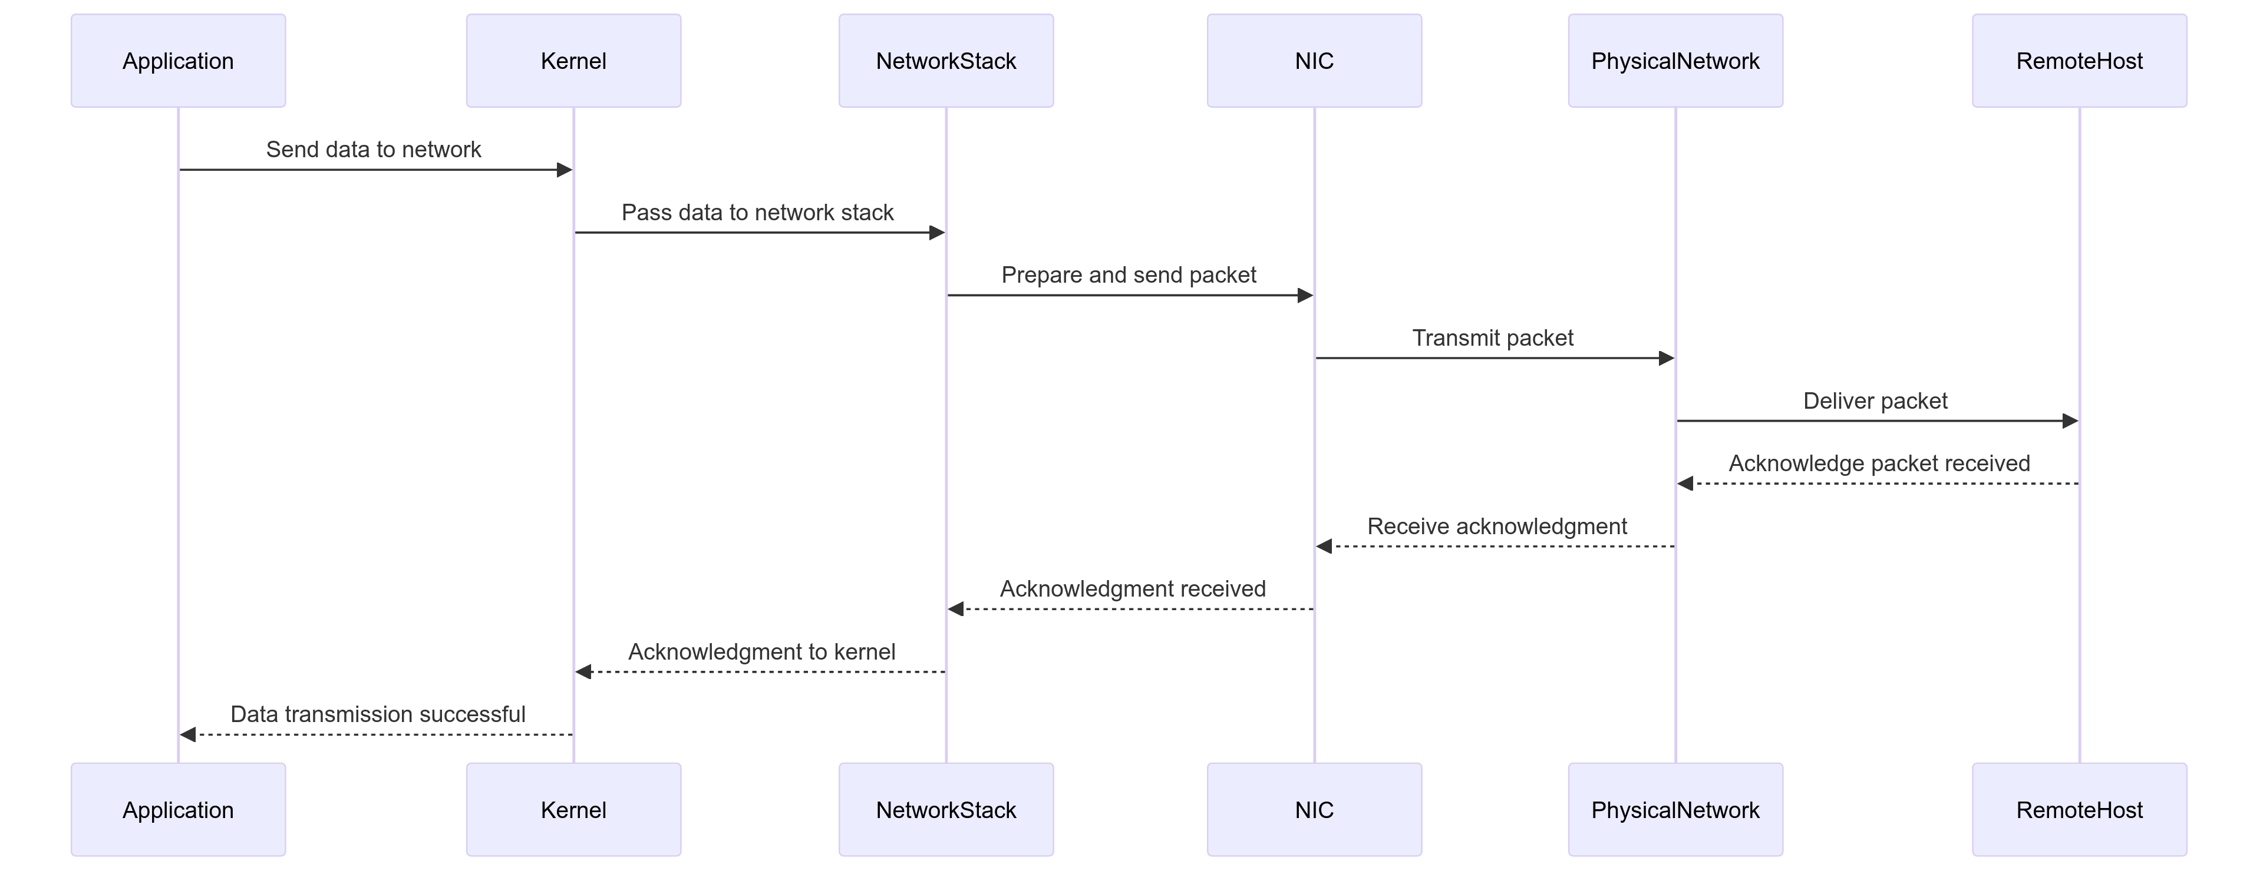  
**Figure 5, Network Layer Diagram:** The application sends data to the kernel, then the kernel processes the request and passes the data to the network stack. The network stack prepares the data packets and sends them to the NIC, then the NIC transmits the packets over the physical network to the remote host. The remote host acknowledges receipt, and this acknowledgment is passed back through the network to the application.

### **Advantages of a Lisp-Based Unix Operating System**

A Lisp-based Unix operating system offers several unique benefits, positioning it as a potentially superior alternative to traditional Unix-like systems. One significant advantage is Lisp's powerful macro system, which allows developers to create domain-specific languages and extend the language in ways that can simplify complex tasks. This flexibility can lead to more concise and readable code, reducing the cognitive load on developers and making it easier to implement complex features. Additionally, Lisp's inherent support for symbolic computation and dynamic typing can facilitate rapid prototyping and iterative development, enabling developers to experiment and refine their ideas more efficiently.

Another key advantage is Lisp's garbage collection mechanism, which automatically manages memory allocation and deallocation. This feature reduces the risk of memory leaks and other related bugs, which are common challenges in systems programming. The garbage collector can improve system stability and reduce the time developers spend on debugging memory issues. Moreover, Lisp's interactive development environment, often referred to as a REPL (Read-Eval-Print Loop), allows developers to test and modify code in real-time, enhancing productivity and enabling faster feedback loops. This real-time interaction can be particularly beneficial in debugging and optimizing system components.

The third advantage lies in Lisp's capacity for meta-programming, which allows code to manipulate other code as data. This capability can lead to highly modular and reusable code, as developers can write generic functions and macros that adapt to different contexts. By leveraging meta-programming, a Lisp-based Unix operating system can achieve a higher degree of code reuse and extensibility, reducing duplication and enhancing maintainability. Additionally, the language's uniform syntax, where code and data share the same structure, simplifies the development of complex data structures and algorithms, further contributing to the system's robustness.

Security is another area where a Lisp-based Unix operating system can excel. The language's high level of abstraction and memory safety features inherently reduce the attack surface compared to lower-level languages like C. By minimizing direct memory manipulation and leveraging garbage collection, the system can mitigate common vulnerabilities such as buffer overflows and use-after-free errors. Furthermore, Lisp's dynamic nature allows for the implementation of sophisticated security policies and runtime checks, enhancing the system's ability to detect and respond to security threats. The combination of these features can lead to a more secure and resilient operating environment, protecting both user data and system integrity.

### **Challenges of Using a Lisp-Based Unix Operating System**

Despite the numerous advantages, adopting a Lisp-based Unix operating system also presents several challenges. One of the primary challenges is performance. While Lisp's high-level features and garbage collection provide significant benefits, they can also introduce overhead that may impact system performance. In performance-critical applications, this overhead might result in slower execution times compared to systems written in lower-level languages like C. Addressing this challenge requires careful optimization, such as using Just-In-Time (JIT) compilation and optimizing garbage collection algorithms, to ensure the system meets performance expectations.

Another challenge is the relative scarcity of Lisp expertise in the current developer landscape. Most systems programmers are more familiar with languages like C, C++, and Rust, which are traditionally used in operating system development. This knowledge gap can make it difficult to find developers with the necessary skills to maintain and extend a Lisp-based Unix operating system. To overcome this challenge, the community would need to invest in education and training, promoting Lisp as a viable option for systems programming and encouraging developers to explore its potential.

Compatibility with existing software is another significant challenge. The vast majority of software written for Unix-like systems is designed to run on platforms built with C and C++. Porting this software to a Lisp-based environment can be complex and time-consuming, requiring substantial modifications to the codebase. This compatibility issue might limit the adoption of a Lisp-based Unix operating system, as users would be reluctant to switch to a platform that does not support their existing applications. Addressing this challenge would involve developing robust compatibility layers and tools to facilitate the porting process, ensuring that users can run their existing software with minimal changes.

Finally, the perception and acceptance of Lisp as a systems programming language pose a cultural challenge. Lisp is often viewed as an academic or niche language, not traditionally associated with systems programming. This perception can hinder its acceptance among developers and decision-makers who prefer more conventional languages. Overcoming this challenge requires demonstrating the practical benefits of Lisp in real-world systems programming scenarios, highlighting successful projects, and building a strong community around Lisp-based systems development. By showcasing the advantages and proving the feasibility of Lisp in this domain, the community can shift perceptions and gain broader acceptance.

### **Summary**

In summary, a Lisp-based Unix operating system offers several compelling advantages that could make it a superior alternative to traditional Unix-like systems. The powerful macro system, garbage collection, and meta-programming capabilities provide significant benefits in terms of code flexibility, maintainability, and security. Additionally, the interactive development environment and high-level abstractions can enhance developer productivity and system robustness. However, these advantages come with challenges, including performance overhead, scarcity of expertise, compatibility issues, and cultural perceptions. Addressing these challenges will require careful optimization, investment in education and training, development of compatibility tools, and efforts to shift perceptions within the developer community.

Overall, while there are hurdles to overcome, the potential benefits of a Lisp-based Unix operating system make it a promising and innovative approach to systems programming. By leveraging Lisp's unique features, the project can push the boundaries of what is possible in operating system design, offering a secure, efficient, and highly modular platform. The success of such a project would not only demonstrate the viability of Lisp in systems programming but also inspire future developments and innovations in the field. With the right strategies and community support, a Lisp-based Unix operating system could pave the way for new paradigms in operating system development, challenging the status quo and offering a fresh perspective on systems design.