PRISM Hybrid Vision
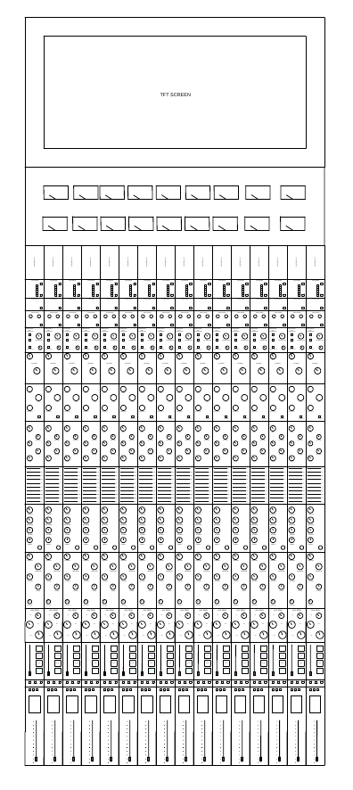
Prototype 1A Plan

Main Plan
- Getting Sponsorship(s)
- Get materials
- Find/build place to build the console
- Finish building place
- Get machines
- Get components on BOM
- Build PCB
- Test
- Revise/Edit
- Begin Manufacturing

Test Plan

- Purpose: The prototype testing proves whether the console is ready for manufacturing and details what should be revised before. This makes the quality check easier to execute and easier to prove what should be revised further
- Prototype Revision: Prototype 1A
- Hardware Revision: 1.3
- Software revision: 0.0.1
- Test instructor: Keegan

Equipment | Use
Oscilloscope | Waveforms, oscillation, noise, power rails
Multi-meter | Voltage, resistance, current, continuity
Audio signal/function generator | Injecting known sine waves and test signals
Audio analyzer | THD+N, Frequency Response, SNR, noise, dynamic range
Bench Power Supply | Safely powering individual circuits
Electronic Load | Testing Power supplies
Frequency Counter | Clock/frequency verification
Logic Analyzer | MCU, SPI, I²C, UART, control communications
Dummy Loads | Safely testing outputs without speaker
DI/re-amp/test interface | Connecting audio equipment to prototype safely

Test Areas | Pass Criteria
Power supplies | All rails specified voltage tolerance, acceptable ripple/noise, stable under rated load
Mic Preamp | Gain, noise, THD+N, frequency response, headroom, phantom power, and impedance meet all specifications
EQ | Frequency, boost/cut, Q, bypass, and response remain within design tolerances
Compressor | Threshold, ratio, attack, release, gain reduction, and recall operate within specified tolerances
Analog signal path | Frequency response, THD+N, noise, dynamic range, crosstalk, and headroom meet specifications
Digital Control | Commands execute correctly, parameters recall correctly, and communication remains reliable
Motorized Faders | Reach commanded position within positional tolerance
DAW | Correct channel mapping, sample rates, synchronization, recording/playback, and stable operation within specification
Mix bus | Correct summing, stereo operation, headroom, noise, distortion, and output level meet specification
9.2.6 Routing | Every intended channel routes to the correct destination without unintended cross routing; all meet specification
Safety | No unsafe voltage, overheating, destructive fault behavior, or uncontrolled output occurs
Integration | Complete signal chain functions from input through processing, mix bus, conversation, DAW, and monitoring
---- | ----
---- | ----

Safety
- Electrical Safety
  - Disconnect power before modifying
  - Never work on exposed energized circuitry unless measurement specifically requires it
  - Use current-limited bench supplies during development.
  - Verify supply polarity and voltage before connecting a board
  - Install appropriate fuses/current protection in power-input paths
  - Do not bypass fuses
  - Inspect wiring and connections for shorts, damaged insulation, loose connections, or exposed conductors
  - Use insulated tools where appropriate
  - Use insulated tools where appropriate.
  - Keep conductive objects away from energized circuits
  - Use proper grounding and protective earth practices where applicable
- Phantom Power
  - Phantom power shou8ld be switched off before connecting or disconnecting microphones
  - Check output voltage with no load before connecting prototype
  - Verify phantom power voltage before connecting equipment
  - Protect input circuits against shorts
  - Never apply phantom power to equipment not designed for it
  - Clearly identify phantom power status
  - Test phantom power with current limiting during prototype development
- Power-supply testing
  - Bring new power supplies up using current limiting
  - Increase load gradually during intital testing
  - Monitor temperature and current or voltage compontents
  - DO NOT exceed the rated current of voltage of components
  - Discharge capacitors before handling circuitry
- High voltage warning
  - Mains wiring must be isolated from SELV/low-voltage circuitry
  - Appropriate fusing and protection must be used
  - AC wiring must be enclosed and mechanically secured
  - Protective earth must be implemented where required
  - Mains circuits must not be exposed during operation
  - Testing of mains circuits should only be performed by someone qualified/supervised
- Audio output safety
  - Connect outputs to appropriate loads
  - Start monitoring Levels at minimum volume
  - Increase level gradually
  - Never connect an unknown load to an output during initial testing
  - Use dummy loads when testing maximum output
  - Avoid feeding excessive levels into headphones, monitors, amplifiers, or other connected equipment
  - Mute outputs before changing signal path connections
- Thermal Safety
  - Voltage regulators
  - Power amplifiers/output drivers
  - Transformers
  - Phantom power circuitry
  - CPUs/MCUs
  - High-current components
  - Power supplies
- Prototype fault safety
  - Immediately stop testing if you observe:
    - Smoke
    - Sparks
    - Arching
    - Unexpected Heating
    - Burning odor
    - Melting insulation
    - Rapidly increasing current-limited/Unstable power rails
    - Unexpected Oscillation
    - Component deformation
    - Unexpected output voltage
    - Repeated resets
  - Then:
    - Disconnect power if safe
    - Allow system to discharge
    - Identify the fault
    - Correct the design/wiring
    - Re-test from a controlled starting condition.
- ESD protection
  - Use an ESD-safe work surface
  - Use an appropriate wrist strap
  - Store sensitive IC’s in ESD safe packaging
  - Avoid touching IC pins
  - Ground before handling sensitive boards
- Measurement equipment safety
  - Verify the grounding configuration of measurement before connecting probes to energized circuitry
- Documentation and labeling
  - High voltage/main areas
  - +48V phantom power
  - Power inputs
  - Power outputs
  - Dangerous or hot surfaces
  - Test points
  - Ground Points
  - Fuse locations

