Auction Proposal

{{seller_label}}: {{seller_line}}
Subject Property: {{erf_legal}}
Better known as:
{{erf_known_as}}

Title deed: {{erf_title_deed}}

Auction Date: {{auction_date_line}}

Auction Venue: {{auction_venue_line}}

Administrator: {{administrator}}
Subject Property Deeds Enquiry
{{image:deeds}}
Draft Proposed Advert
{{image:advert}}
Digital Marketing Examples
***Examples from previous marketing campaigns. They are displayed on websites, social media, Google etc.

Google Ad Campaigns

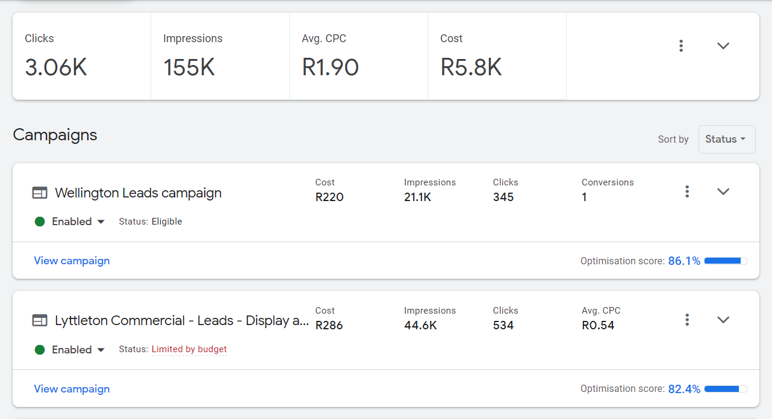
Social media campaigns Facebook and Instagram


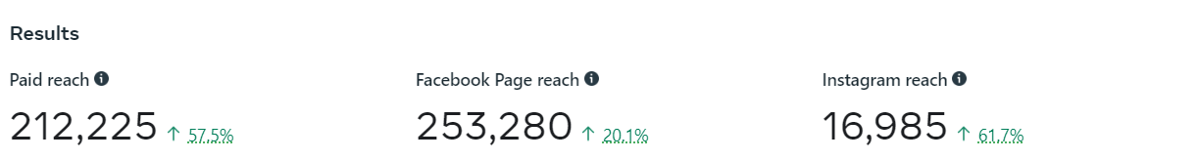
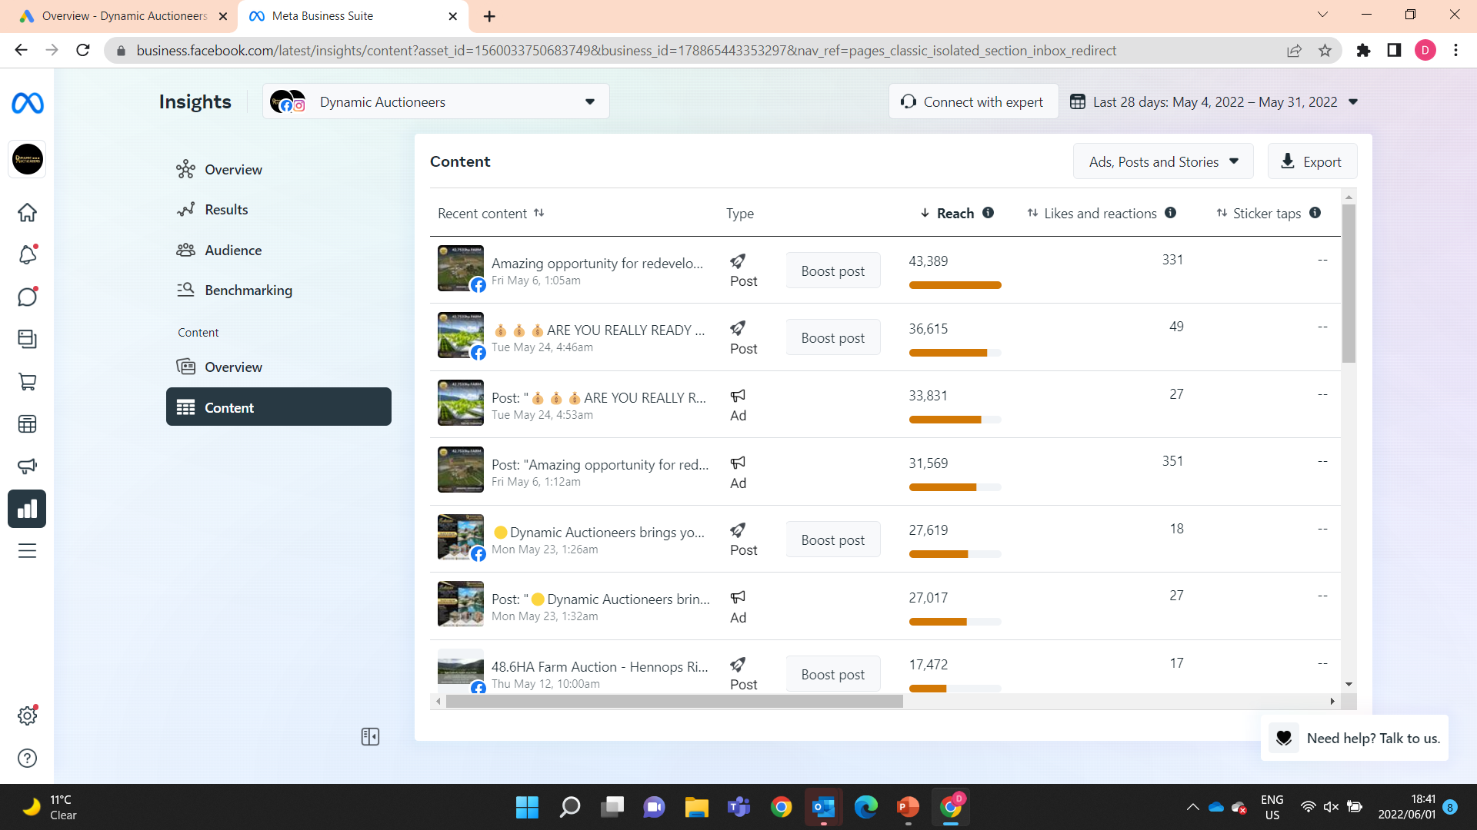
LinkedIn Campaigns
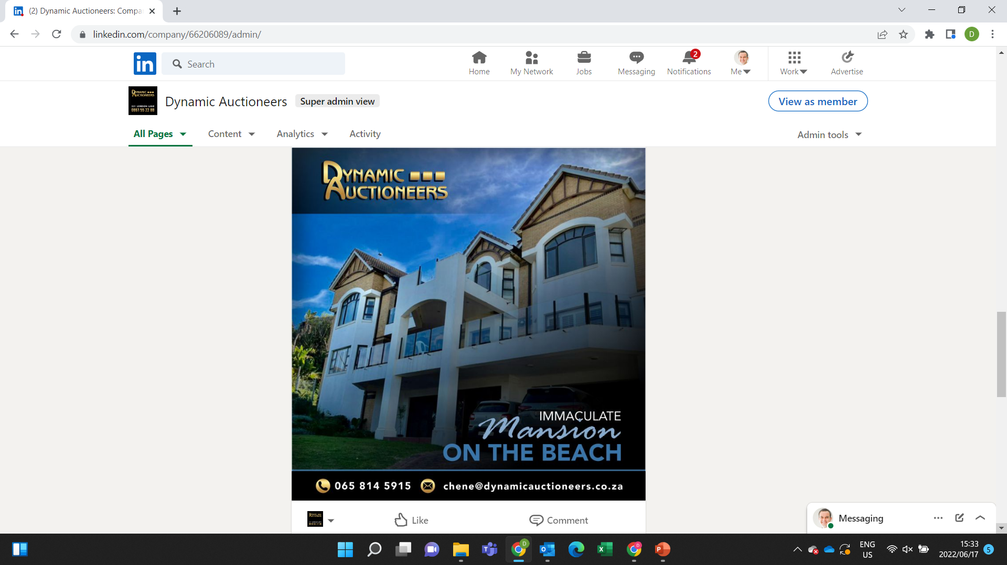

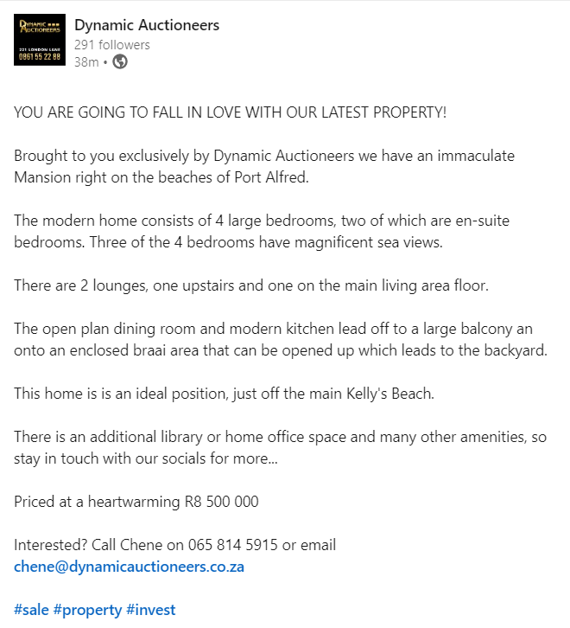
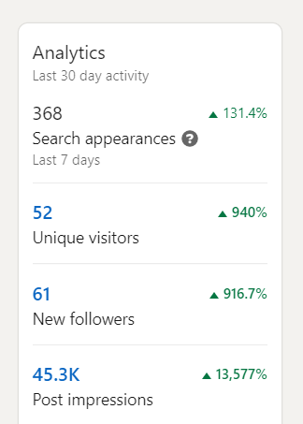

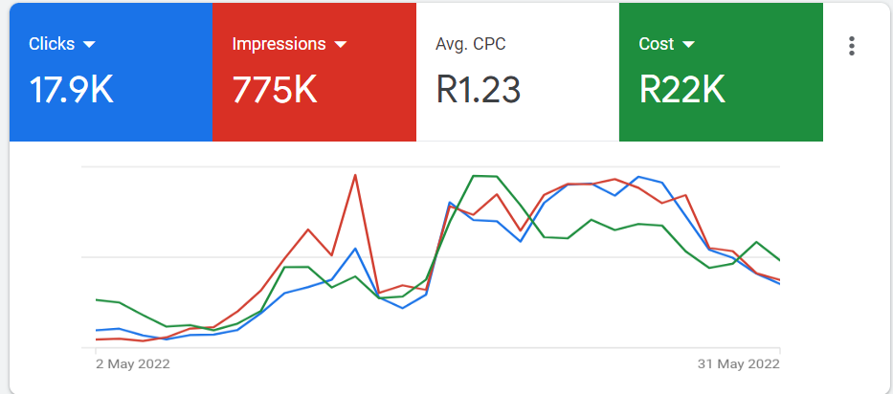
Dynamic Auctioneers website
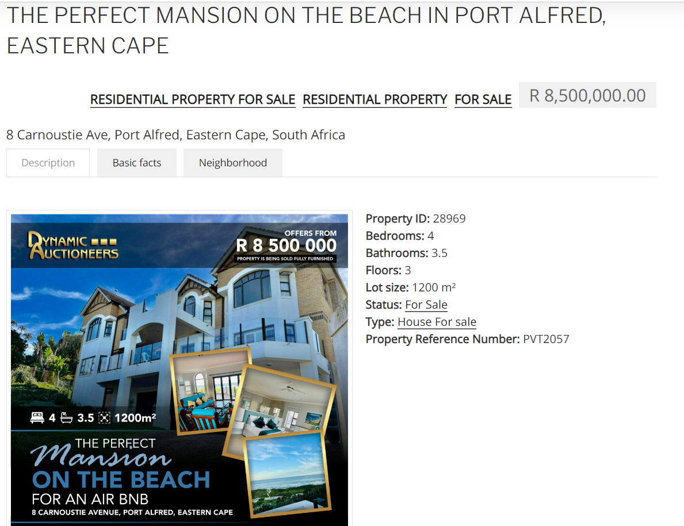

Listings on Property Portals
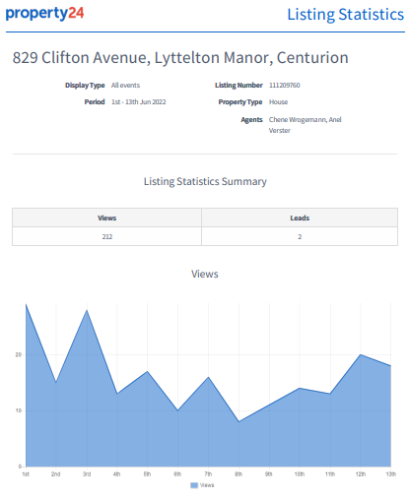
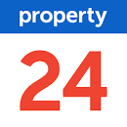
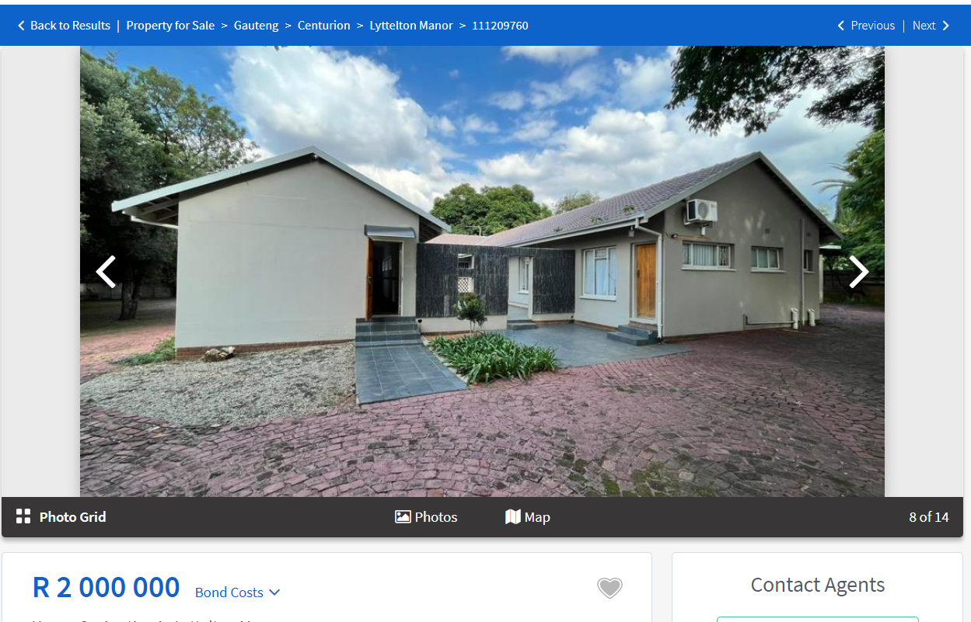

Listings on other platforms
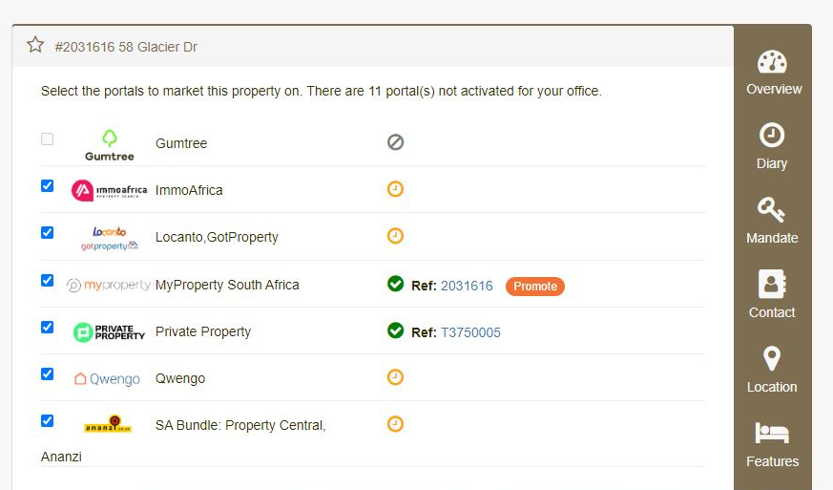

Proposed Budget and Schedule
AUCTION STARTING DATE:
{{auction_starting_line}}

MEDIA | DESCRIPTION | PLACEMENT DATE | COST
{{line_media}} | {{line_description}} | {{line_placement}} | {{line_cost}}
 |  | TOTAL: | {{total}}
 |  | VAT: | {{vat}}
 |  | TOTAL INCLUDING VAT: | {{total_incl}}

DEADLINE ({{deadline}})

