# Business requirements document

**Name:** Keelan Duddy

**Module:** Software Testing

**Website Tested:** Git-hub

**Main Features:**

* Sign up
* Sign in
* Create project
* Upload Files
* Update Profile
* Search functions
* Follow users
* Private/ public repo
* Repo search function

## Introduction

In recent years in this course there has been one website in which we have used a lot of and that would be the website [www.github.com](http://www.github.com). We’ve been uploading a lot to this website, and I think it is a good pick to design tests around. It has a lot of features and functionality to design tests around. GitHub is a US-based global company that provides hosting for software development version control using Git. It oﬀers the distributed version control and source code management functionality of Git, plus its own features.

**Features to test (i) Language English**

**Test Case 1.0 Launch** [**www.github.com**](http://www.github.com)

- below is a screenshot of the website Git-hub with the English language presented.

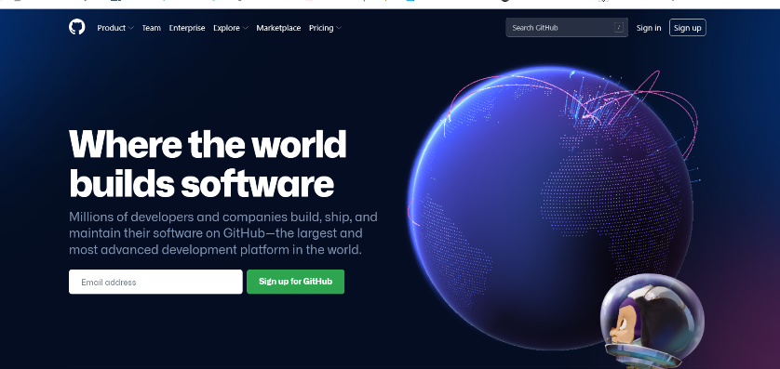

**Features to test (ii) Sign Up**

**Test case 2.0**

1. Launch www.github.com

2. press the sign-up button on the navigation panel

3. Enter a valid username, email, no for updates and password

4. Verify the anti-bot puzzle and select free plan

5. enter the digits for email confirmation

6. choose just me and student on next page.

7. just press the blue continue on the tools page.

8. Click continue as free button on payment page.



- Screenshot of the sign-Up button on the Home Page (1)

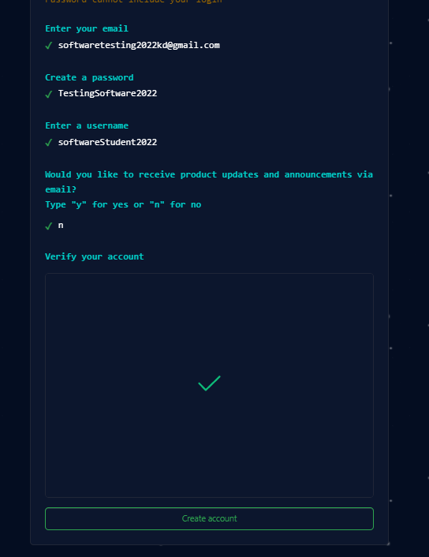

- The Sign-Up Page on GitHub where the user must enter all their details. (2)

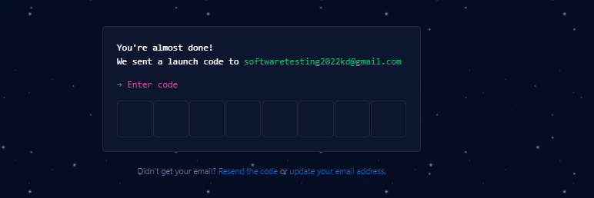



- enter the digits for email confirmation (3)

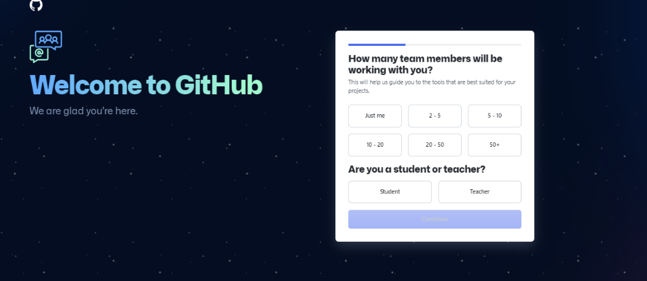

-Press “just me” and “Student” then the blue continue button (4)

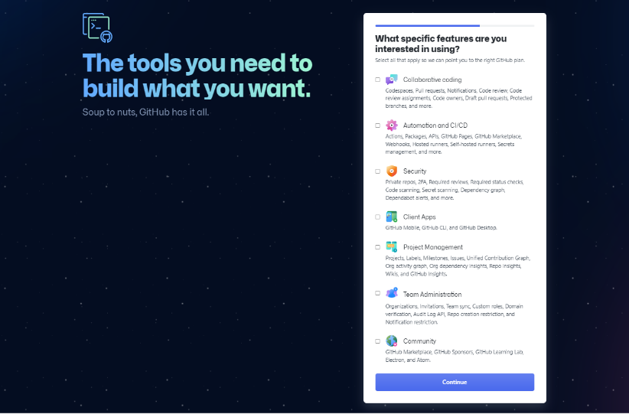

* Only press the blue continue button when on tool page (5)

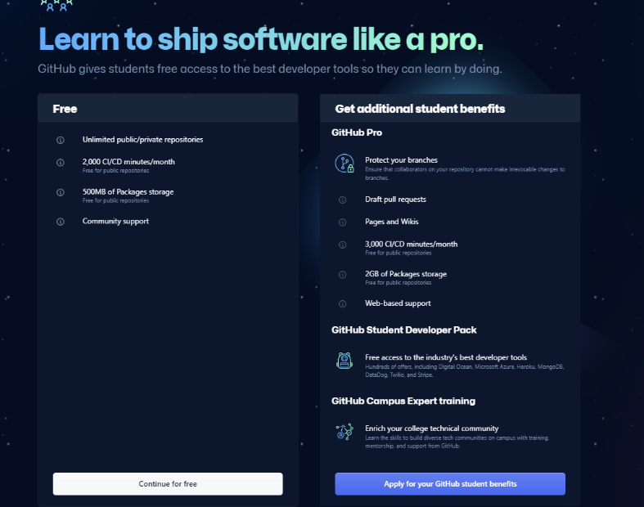

* Click the continue as free button on the payment page (6)

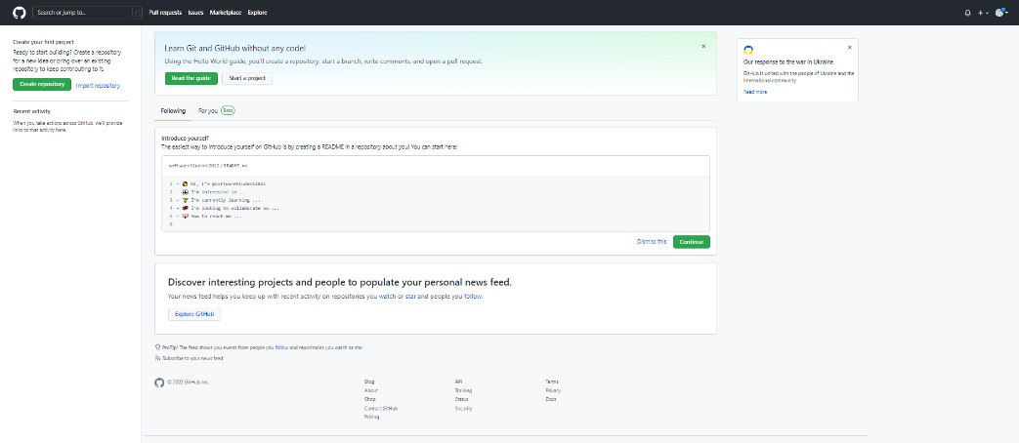

* User successfully signs up (7)

**Features to test (iii) Sign Up with existing username**

**Test case 3.0**

1.Launch www.github.com

2. Enter your existing username "Keelan1996" with your email and password

3. Click the sign-up button

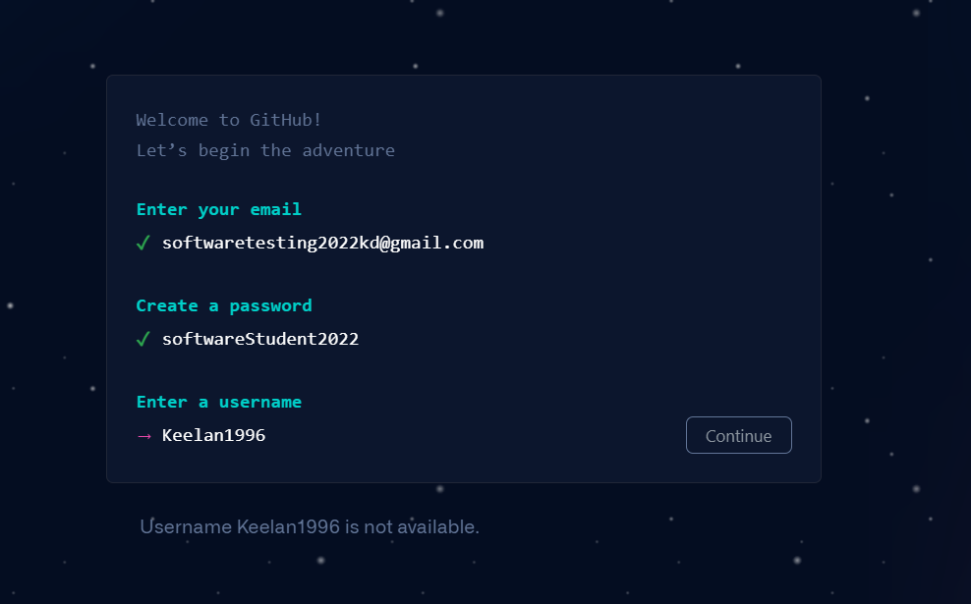

* Can’t continue because that username already exists

**Features to test (iv) Sign up with illegal credentials**

**Test case 4.0**

1. Launch www.github.com and press the sign-up button.

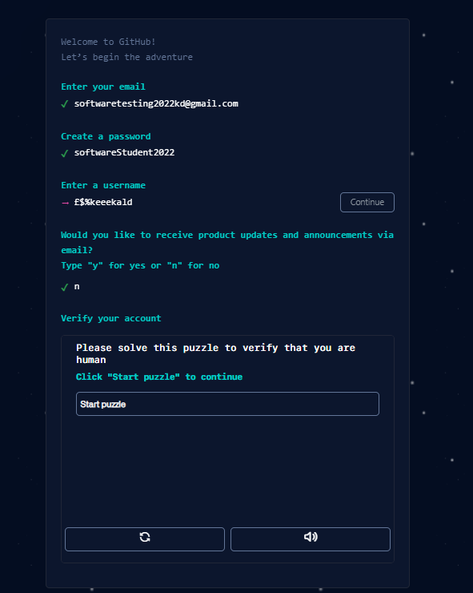2. Enter a username with illegal characters like £ @ " etc, email and password.

* Can’t continue when there are illegal characters

**Features to test (v) Sign in displays**

**Test case 5.0**

1. Launch www.github.com

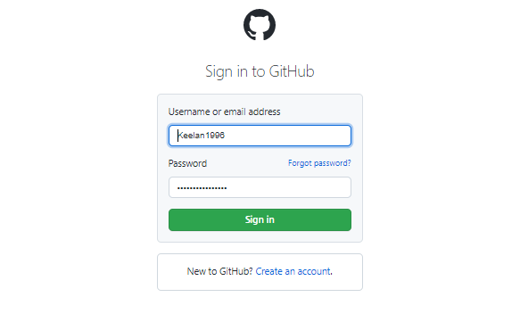2. click Sign in section

* Sign in displays when clicked

**Features to test (vi) Sign in credentials**

**Test case 6.0**

1. Launch www.github.com.

2. Click the sign in button.

3. Enter an existing username, email, password and click sign in.

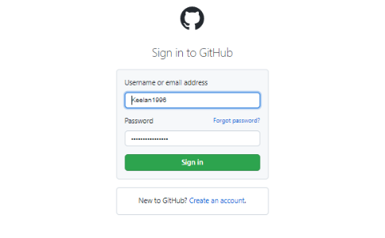

* Successfully signs in

**Features to test (vii) Sign in with wrong password**

**Test case 7.0**

1. launch www.github.com

2. click the sign in button top right.

3. In the login screen enter your username and a WRONG password.

4. Click Sign in button.

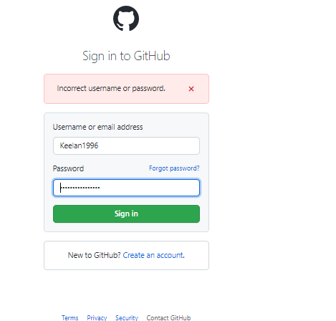

* Get error message

**Features to test (viii) Sign in with no entered password**

**Test case 8.0**

1. Launch www.github.com and click the sign in button top right.

2. Enter your username and leave the password empty.

3. click the sign in button.

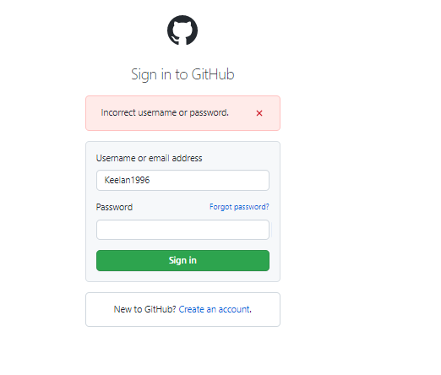

* Error message shown

**Features to test (ix) Password reset**

**Test case 9.0**

1. Launch www.github.com

2. Press the sign in button

3.Enter your username and press the "forgot password" button

4. Enter your email address into the text box, solve the puzzle, and press the send password reset email button.

5. Go to the email you entered in a separate tab and click the email from Git-hub to reset your password.

6.Follow the instructions inside the email and enter a new legal password and press the reset password button.

7.launch www.github.com and press the sign in button.

8. enter your username and the new password you created.

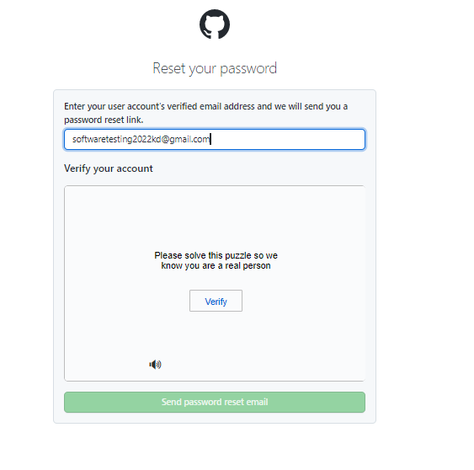

* After clicking the “forgot password” button, enter email and solve puzzle

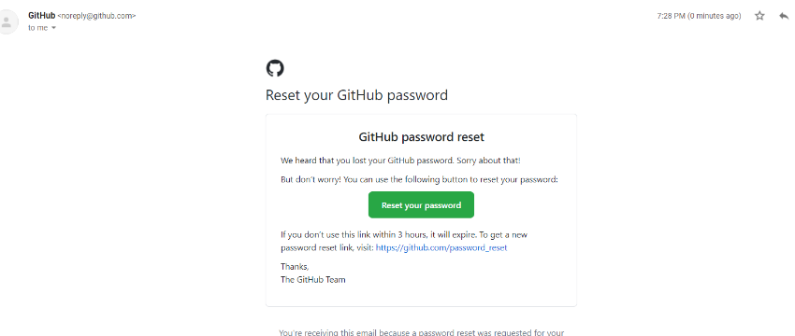

* Email sent by Git-hub to you email, follow its instructions

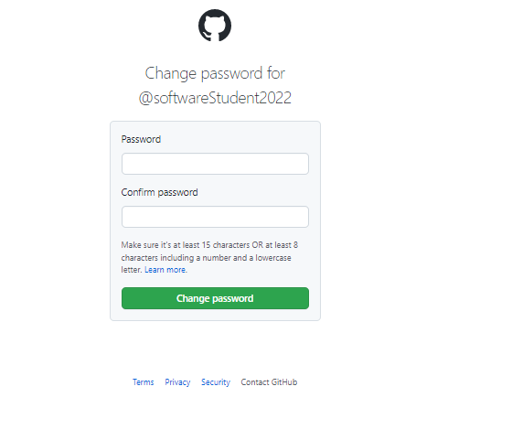

* Change password

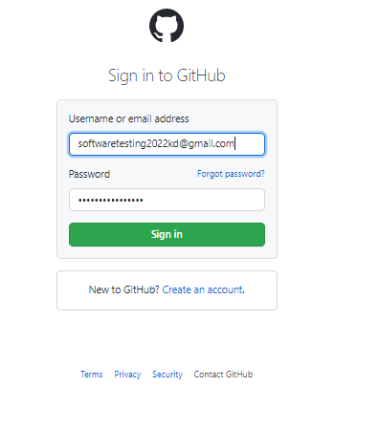

* Sign in with your new password

**Features to test (X) Password reset: enter old password you changed**

**Test case 10.0**

1. Launch www.github.com
2. Press the sign in button located at the top right-hand corner of the screen
3. Enter your username and your previous old password before you changed the password
4. Click Sign in button at bottom of password text box.

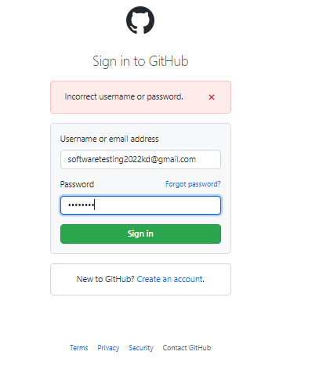

* Old password doesn’t work and given error message.

**Features to test (XI) create a repository**

**Test case 11.0**

1. Launch www.github.com.

2. Click the sign in button.

3. Enter an existing username, email, password and click sign in.

4.On the homepage click the button "+" on the top right.

5. scroll through the mini menu and click option that says new repo

6.on the repo page add text to the name and description, leave the buttons at default and then click the green button at the bottom of the page named "Create Repository".



* Click the + top right

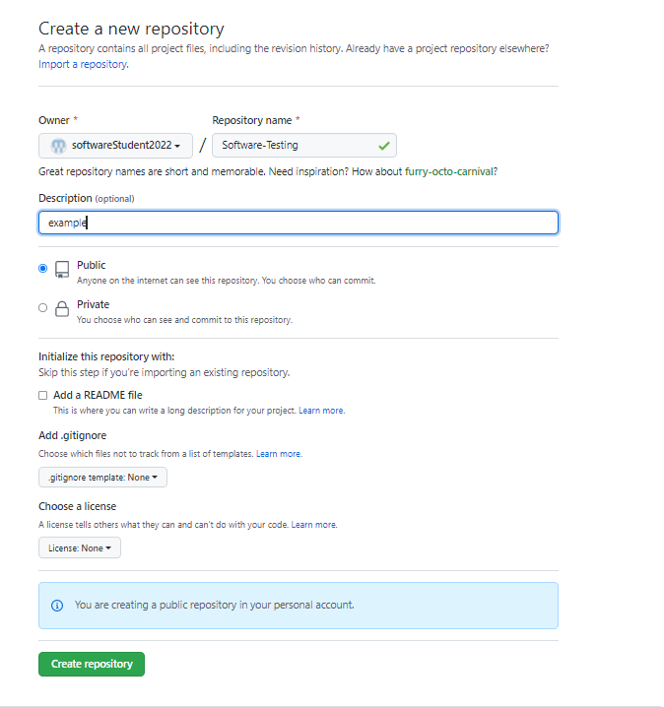

* Fill in repo details

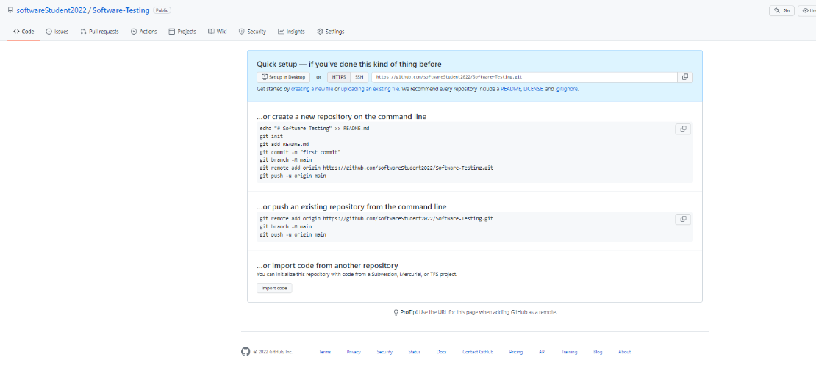

* Repository successfully created

**Features to test (XII) upload file**

**Test case 12.0**

1. launch www.github.com
2. click the sign in button.
3. Enter your username, password and click sign in.
4. click the repo you want to upload a file too.
5. click the file upload button
6. Navigate file explorer and select a test.txt file to upload.
7. 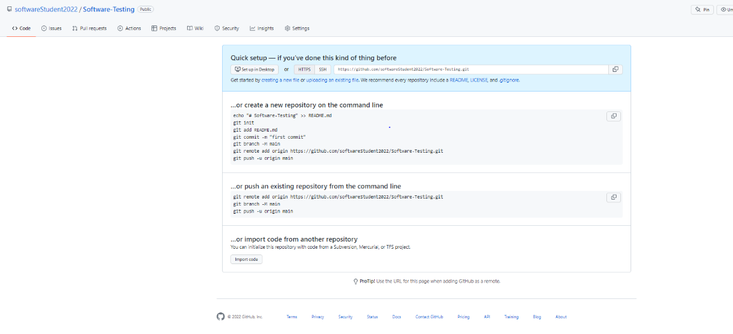Click the green button named Commit changes

* Click the button at the top that says “upload an existing file”

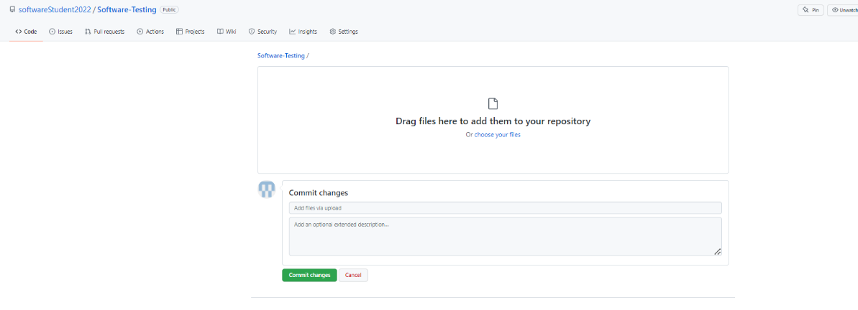

-click “choose your files”, find the test.txt file in your file explorer and upload it, then press the green commit changes button

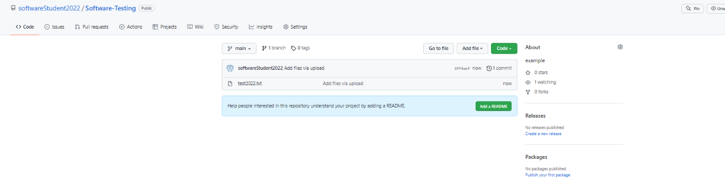

* File successfully uploaded to repo

**Features to test (XIII) update profile**

**Test case 13.0**

1. Launch www.github.com.

2.Sign-in to your profile.

3.click the user icon on the top right and then click the "your profile" button.

4.Click the edit profile button under your username.

5. Add new name, bio, URL, company, location as "Test" and click the green button that says save profile.

6. Look at your profile to see the changes.

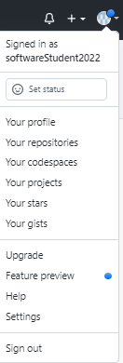

-click “your profile”

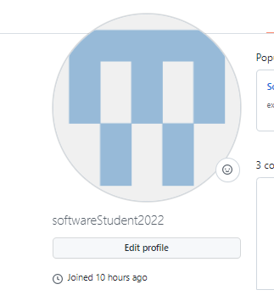

* Press Edit profile button

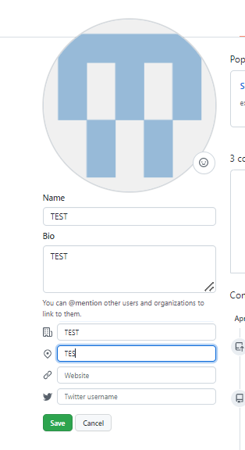

* Write in test to the boxes then press save

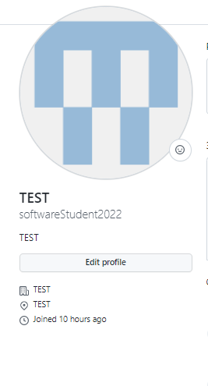

- update to the profile is saved successfully

**Features to test (XIV) search user**

**Test case 14.0**

1.Launch www.github.com

2. Sign into your account.

3.Go to the top left corner and click the search bar.

4. Enter "Keelan1996" to the search bar and press enter.

5. Click the section where it says user.

6. click on the name Keelan1996.

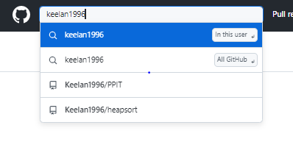

* Search the user and click on the result profile

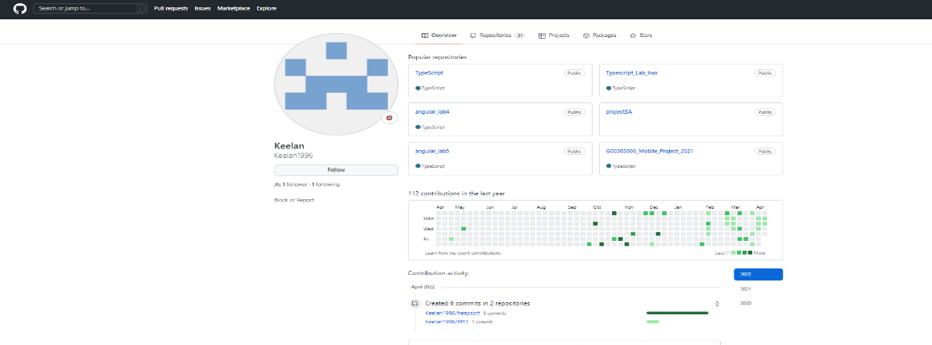

* User is successfully found

**Features to test (XV) search user from the search engine**

**Test case 15.0**

1. Launch the web engine www.google.com and type the Git-hub 'Keelan1996' and click enter.

2.Click first Result ' Keelan1996' to see the page.

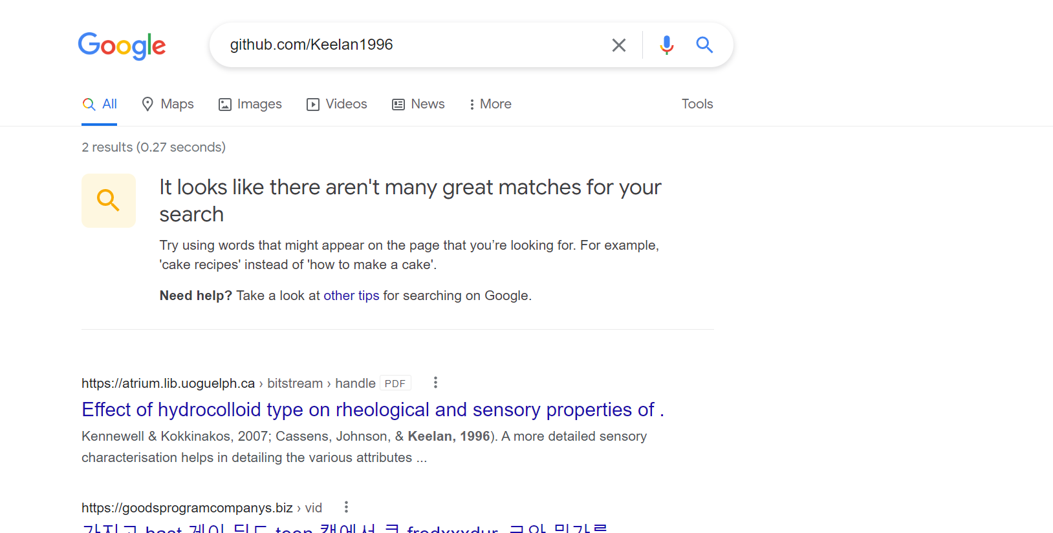

* Search for an existing user and no results came up. So, this test failed

**Features to test (XVI) follow a user**

**Test case 16.0**

1.Launch www.github.com

2.Sign in with existing details

3. On homepage click the search bar and type 'Keelan1996'

4.Click Users section

5.Click follow button highlighted blue

6.Click profile

7.Navigate to 'Following' found above repositories

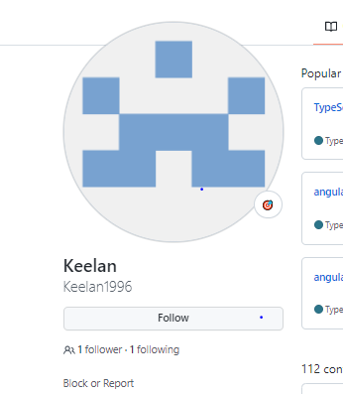

* 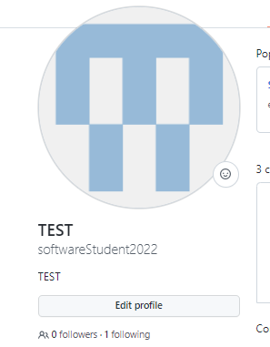Click the follow button to follow the user

-the user’s following count has gone up

**Features to test (XVII) unfollow a user**

**Test case 17.0**

1.Launch www.github.com

2.Sign in with existing details

3. On homepage click the search bar and type 'Keelan1996'

4.Click Users section

5.Click unfollow button highlighted blue

6.Click profile

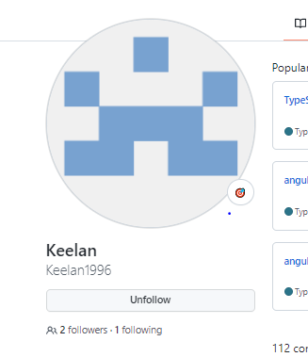

* Press the unfollow button and the users follow count goes down by 1

**Features to test (XVIII) change repository to private**

**Test case 18.0**

1. Launch www.github.com

2.Press the sign in button located at the top of the homepage.

3.Enter your existing username and password.

4.Click an existing public repo on your profile.

5.Click Settings button

6.In general scroll down to the bottom until you hit the danger zone section

7.press the **Change repository visibility**

8.Click the private button and confirm it

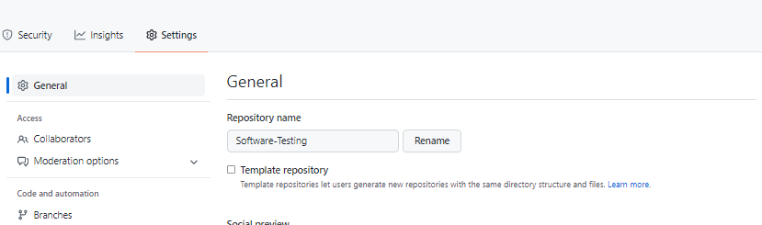

* Settings area of repo

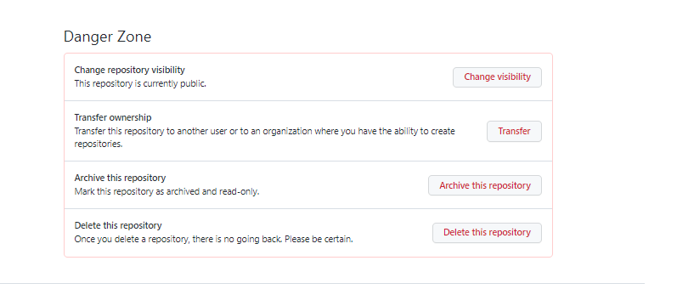

* The section to change visibility

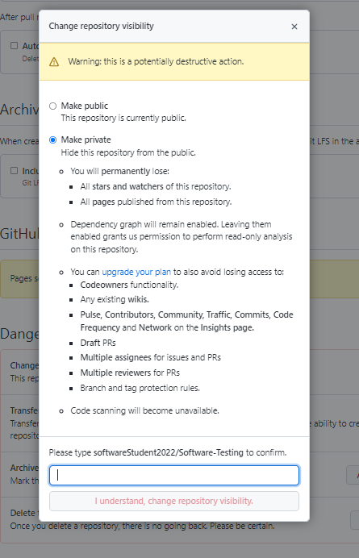

* Select private and confirm the action

**Features to test (XIX) Email confirmation**

**Test case 19.0**

1. Create valid email account with a username.

2. Go to Sign up page for the first time.

3. Enter a valid username and e-mail.

4.Check email box for an email from GitHub stating your account has been created

5. Enter the code from your email on GitHub to confirm the email

* Email from GitHub with a code to confirm your email

**Features to test (XX) Search Repo**

**Test case 20.0**

1. Launch Github and sign into your account.

2. have test case 11 "Create a project repo" previously done.

3. click on the repo search bar at the left side of screen of home page.

4. Type in the repo's name you've already created.

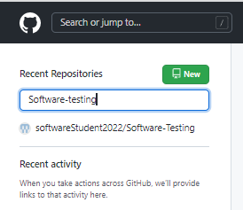

* Searching a repo that exists and the result shows up

**Features to test (XXI) Search Repo that doesn’t exist**

**Test case 21.0**

1. Launch GitHub and sign into your account.

2. click on the repo search bar at the left side of screen.

3. Type in a name of a repo that doesn't exist within your profile.

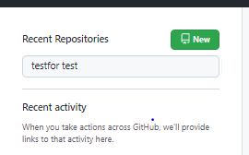

* No results because that repo name doesn’t exist