AEM 428/528 Midterm Project Report
Keelan O'Doherty
AEM 428/528

Nomenclature
Symbol | Definition
A_e | nozzle exit area, m^2
A_t | nozzle throat area, m^2
A_ref | reference area for drag, m^2
C_D | drag coefficient
D | aerodynamic drag force, N
g | gravitational acceleration, m/s^2
M_e | nozzle exit Mach number
mdot | propellant mass flow rate, kg/s
P_0 | chamber stagnation pressure, Pa
p_a | ambient pressure, Pa
p_e | exit pressure, Pa
R | gas constant, J/(kg K)
T | thrust, N
T_0 | chamber stagnation temperature, K
T_e | exit temperature, K
t | time, s
v_e | nozzle exit velocity, m/s
v_x, v_y | velocity components, m/s
x, y | horizontal and vertical coordinates, m
gamma | specific heat ratio
gamma_p | flight-path angle
rho | atmospheric density, kg/m^3

I. Problem Statement
This report presents a Python solution for the unguided gravity-turn attack and defense missile midterm project. The attack missile is launched from ground level and must strike a target 50 km away while accounting for altitude-dependent atmospheric properties. The defense missile is launched from the target location and must intercept the attack missile at x = 49 km with a vertical miss distance no greater than 0.5 m while minimizing flight time to the intercept point.

II. Requested Results
Quantity | Value
Attack throat area | 0.044102 m^2
Attack mass flow rate | 62.6939 kg/s
Attack exit temperature | 1201.92 K
Attack exit velocity | 2166.73 m/s
Attack launch angle | 79.8149 deg
Attack time of flight | 117.1297 s
Defense final mass | 35.00 kg
Defense launch angle | 74.0254 deg above -x
Defense exit Mach number | 2.00
Defense intercept time | 4.0237 s
Defense vertical miss distance | 0.1673 m
Required defense launch delay | 105.0175 s

III. Methodology
A two-dimensional point-mass gravity-turn model was used. The thrust vector was aligned with the instantaneous velocity direction, gravity was fixed at 9.80665 m/s^2, and drag was evaluated with the standard quadratic form using the altitude-dependent atmospheric density from the specified two-layer atmosphere. The attack launch angle was found by matching the impact range to 50 km, and the defense solution was refined to satisfy the intercept tolerance at x = 49 km.

IV. Governing Equations
A_e/A_t = (1/M_e) * [ (2/(gamma+1)) * (1 + ((gamma-1)/2) * M_e^2) ]^((gamma+1)/(2*(gamma-1)))
mdot = A_t * P_0 / sqrt(T_0) * sqrt(gamma/R) * (2/(gamma+1))^((gamma+1)/(2*(gamma-1)))
T_e = T_0 / (1 + ((gamma-1)/2) * M_e^2)
v_e = M_e * sqrt(gamma * R * T_e)
D = 0.5 * rho * V^2 * C_D * A_ref
x_dot = v_x
y_dot = v_y
v_x_dot = ((T - D) * cos(gamma_p)) / m
v_y_dot = ((T - D) * sin(gamma_p)) / m - g

V. Attack-Missile Results and Figures

Figure 1. Attack Missile Path Angle vs. Time
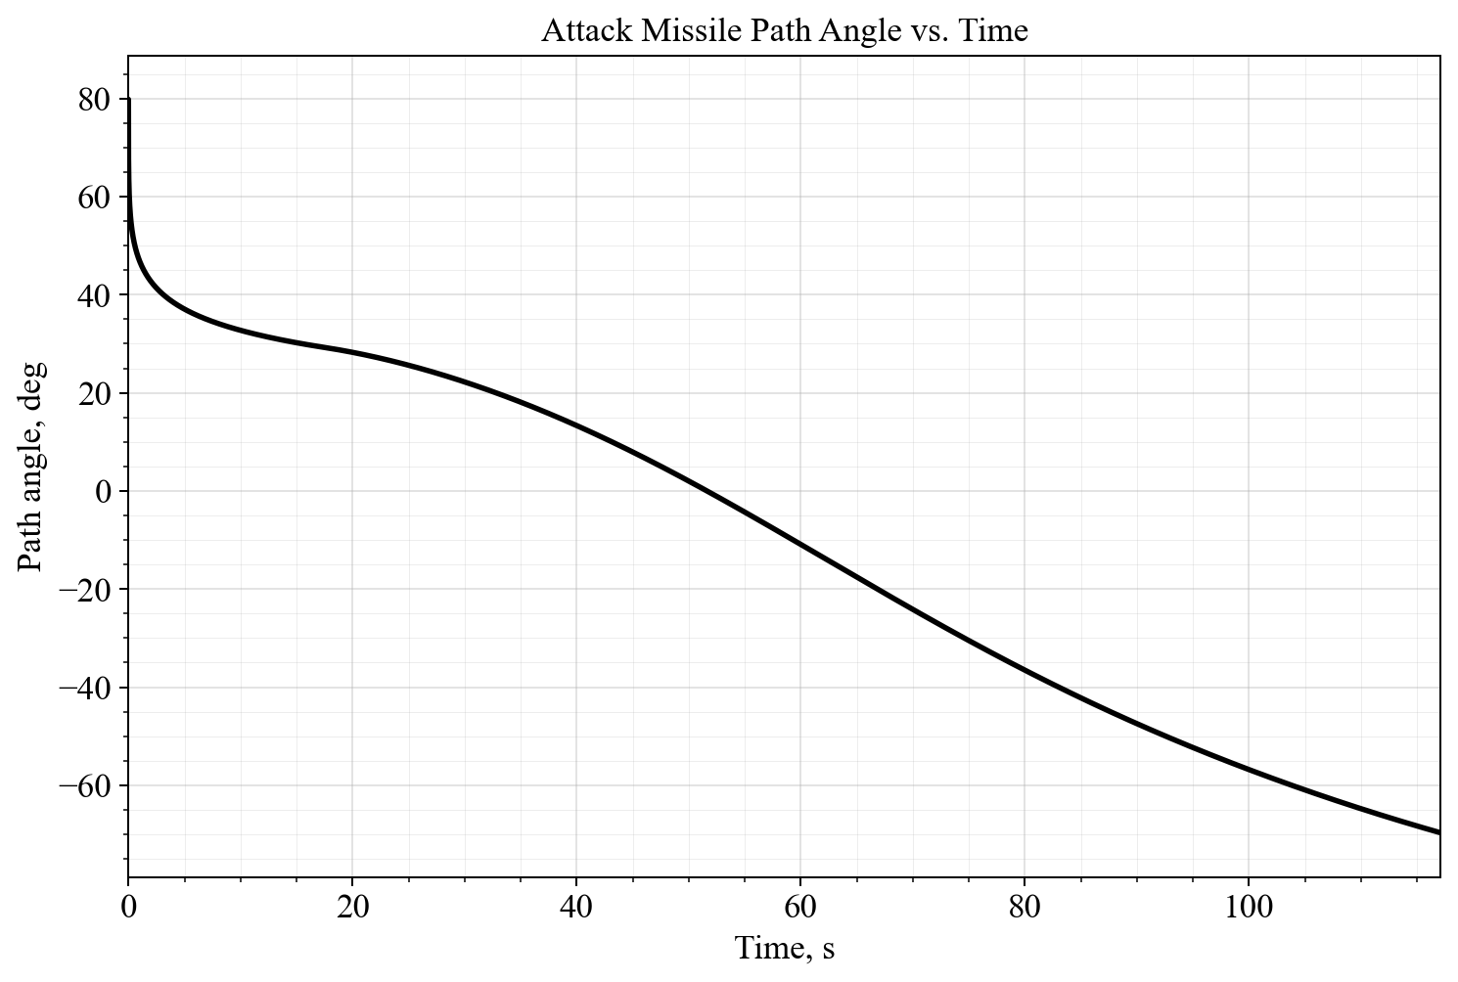
The flight-path angle starts at the launch value and then evolves under gravity-turn motion as thrust and drag reshape the trajectory.

Figure 2. Attack Missile Elevation vs. Time
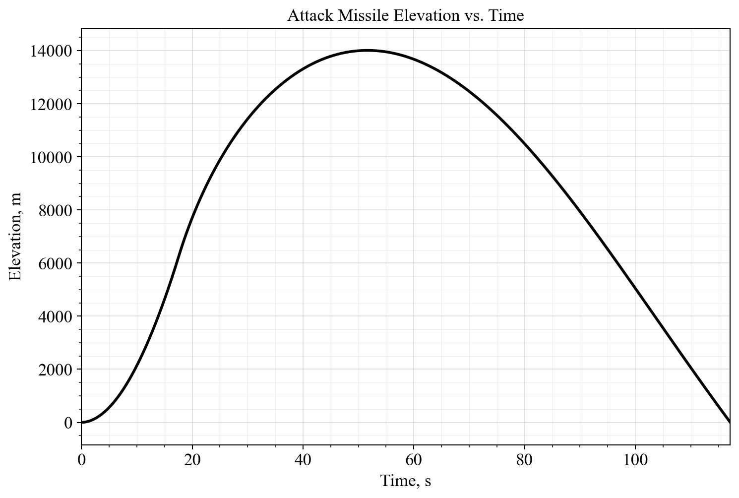
The altitude history shows the missile climbing rapidly during powered flight and then descending back to the ground at the required range.

Figure 3. Attack Missile Horizontal Velocity vs. Time
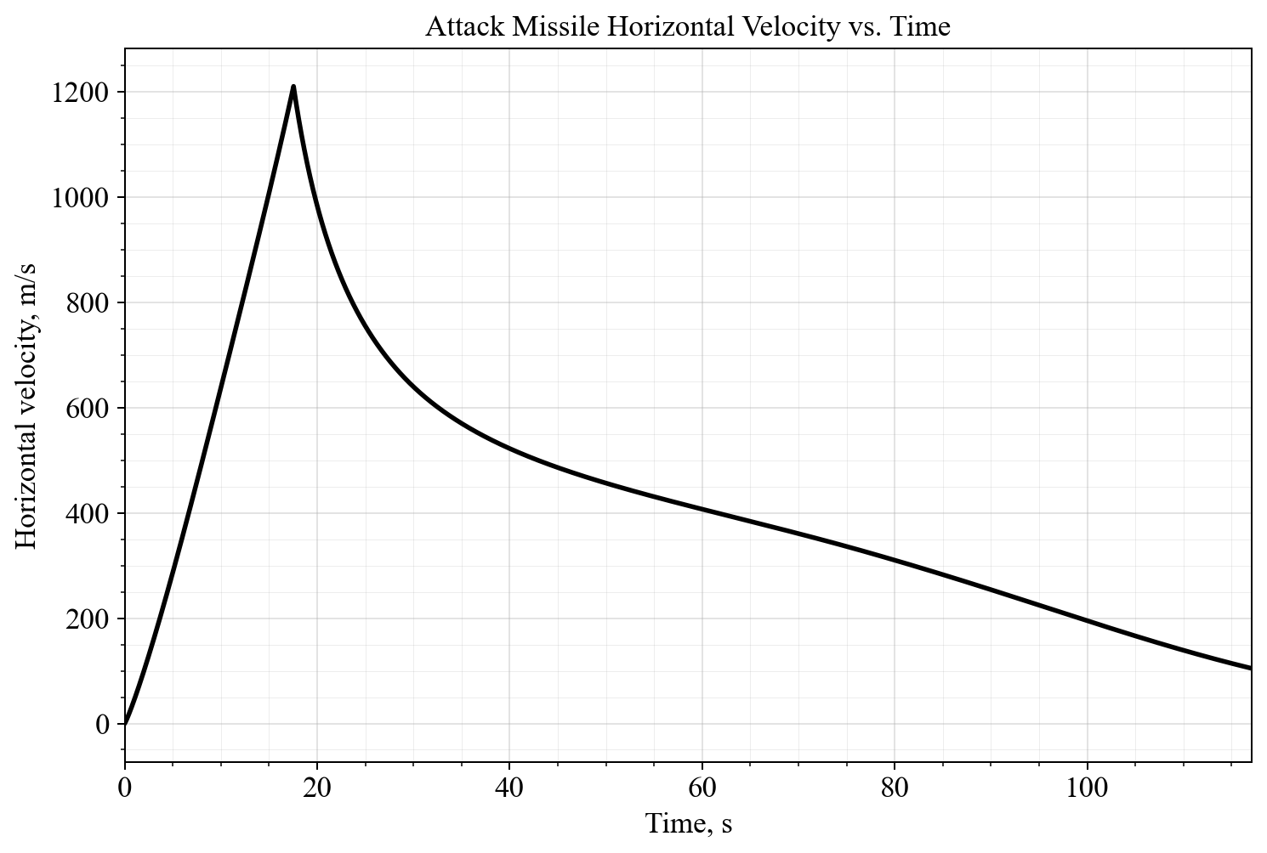
The horizontal velocity grows strongly during the burn and then decays gradually during coast because of aerodynamic drag.

Figure 4. Attack Missile Vertical Velocity vs. Time
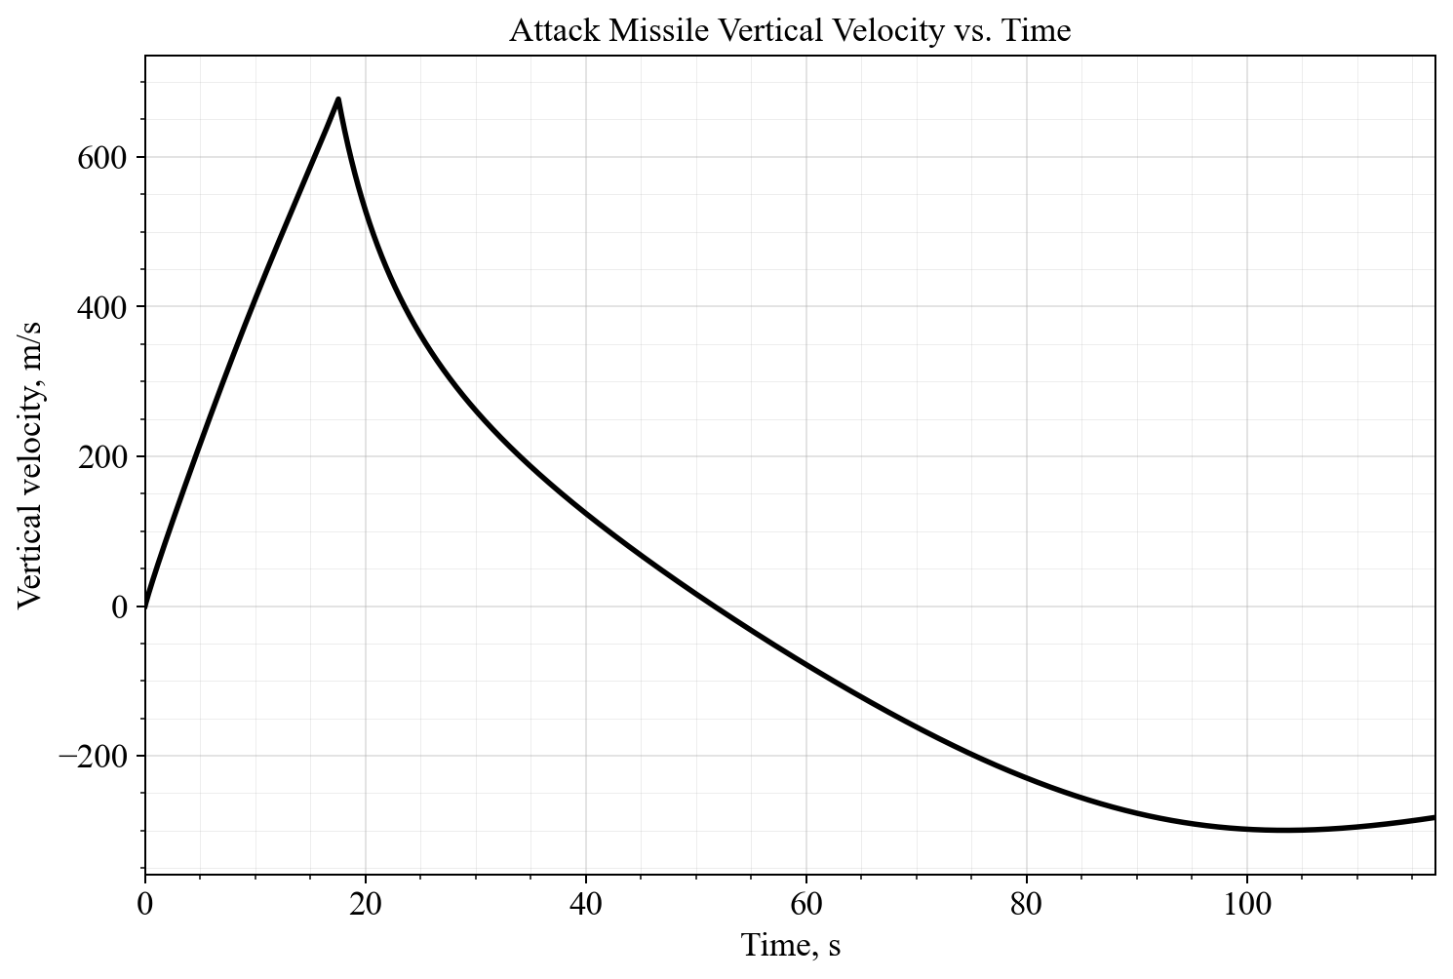
The vertical velocity rises during ascent, crosses through zero near apogee, and becomes negative during descent toward the target.

Figure 5. Attack Missile Acceleration Magnitude vs. Time
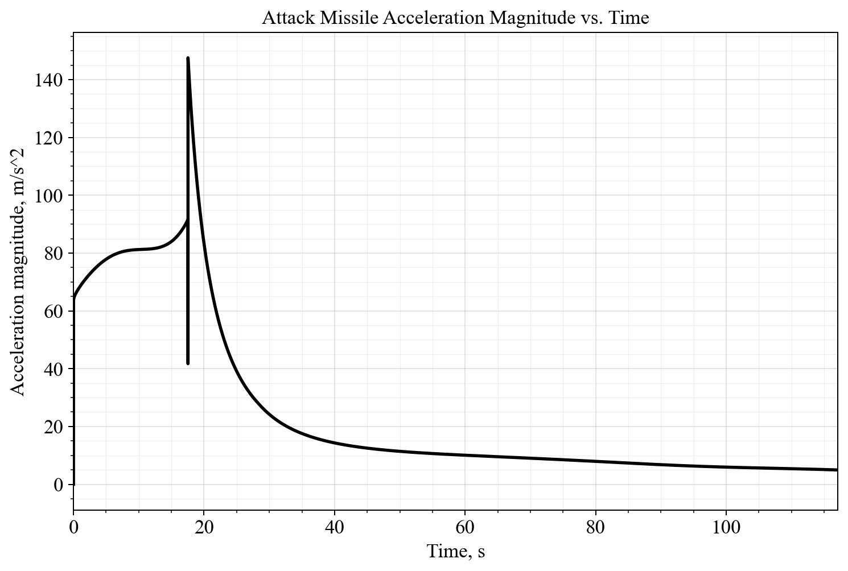
The acceleration is highest early in powered flight and drops sharply after burnout when thrust goes to zero and only gravity and drag remain.

Figure 6. Attack Missile Thrust vs. Time
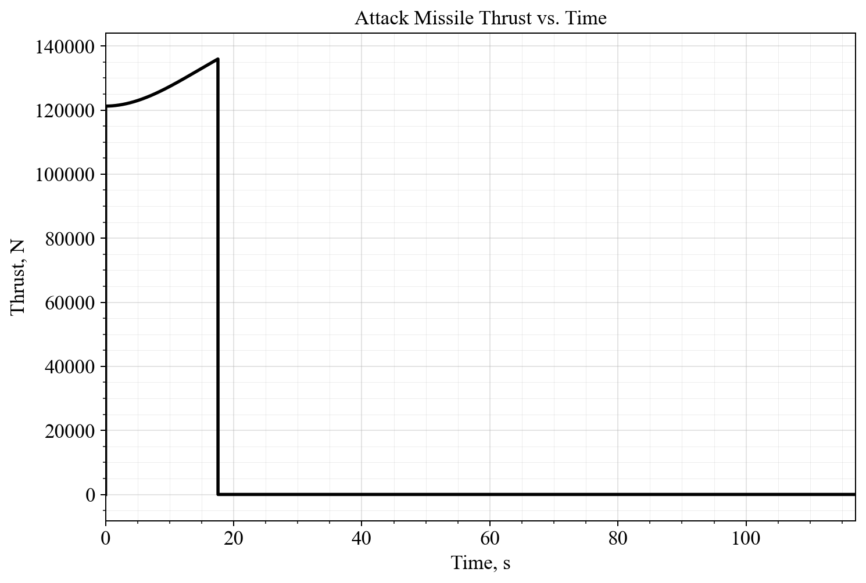
Thrust remains approximately constant during the burn and then collapses to zero at burnout, clearly identifying the powered-flight interval.

VI. Defense-Missile Intercept Result

Figure 7. Attack and defense missile trajectories
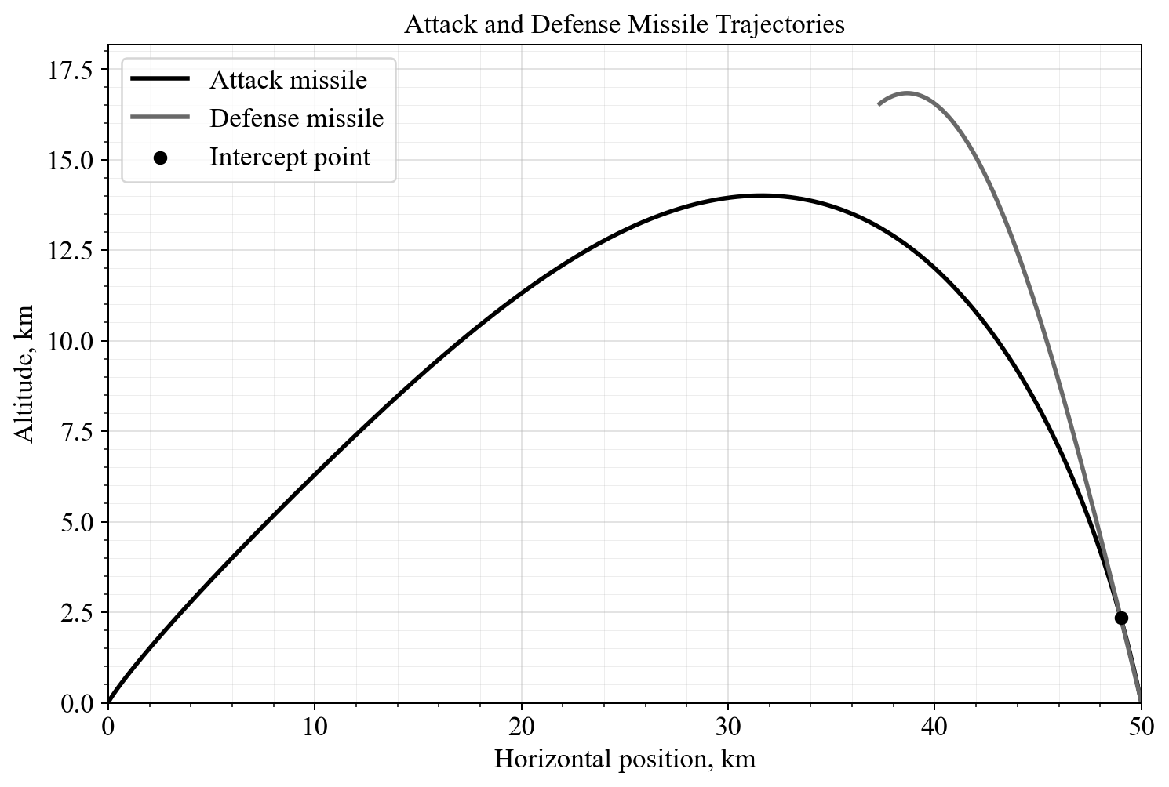
The defense missile launches from x = 50 km and flies back toward x = 49 km, intercepting the attack missile at an altitude of 2345.218 m with a vertical miss distance of 0.1673 m. The required defense launch delay is 105.0175 s after the attack missile is fired.

VII. Discussion
The selected defense solution corresponds to the lowest tested final mass and lowest tested exit Mach number in the feasible neighborhood. Because the defense missile only travels 1 km horizontally but must climb to roughly 2.35 km altitude, the dominant benefit is a high thrust-to-weight ratio and rapid ascent rather than long-range efficiency.

VIII. Submitted Files
- AEM428_Midterm_Report.docx
- AEM428_Midterm_Report.md
- AEM428_Midterm_Report.html
- AEM428_Midterm_Notebook.ipynb
- midterm_helpers.py
- results_summary.json
- attack_path_angle_vs_time.png
- attack_elevation_vs_time.png
- attack_vx_vs_time.png
- attack_vy_vs_time.png
- attack_acceleration_vs_time.png
- attack_thrust_vs_time.png
- attack_defense_trajectories.png

IX. Note on Code Submission
The assignment reminder mentions MATLAB code, but this solution was developed in Python. The notebook and helper script included with the submission provide the full computational workflow used to generate the numerical results and figures.

