**Text Emotion detection**

**Cosmos:** Priyanshu Tanwar, Samyak Jain, Saurabh Shetty, Tarika Gupta

**Motivation and About the Project**

**Emotion analysis** plays a crucial part in understanding the feelings of human beings. People convey a variety of sentiments, behavior, and emotions via their speech, which can have significant impacts. In most of the previous work, nearly all projects have focused on analyzing the expression based on only positive, negative and neutral classification while our project analyzes the proposed system by categorizing the text into emotion classes called *joy, sadness, anger, fear, love and surprise.*

While the solution is an ordinary classification model in NLP, we plan to experiment with using a pretrained model like **BERT** and other approaches such as **LSTMs** to benchmark and draw conclusions from it, along with model explainability taught in DS1.

In this project we have worked on the **entire lifecycle** of an NLP task - Preprocessing and EDA, Model Training and Benchmarking and Model Explainability using lime.

**Model Explainability Dashboard**

We have also implemented a model explainability dashboard working on all 3 models to help us visualize the results & see which word is contributing the most to the classification.

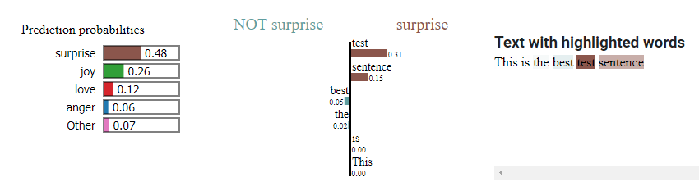

**Model**

We’ve implemented **three** models:

https://meet.google.com/jzd-xhzs-cvd

**Conclusion and Future Work**

We tried different models but found that **Custom trained LSTM/BiLSTM** Model worked the best with a marginally better score than LSTM with Pre trained ELMo embeddings.

The trained model can be used in different applications - a very good example can be ChatBot, where different approaches can be taken according to the mood. Customers can be redirected to human customer support if they are found to be irritated or angry.

In the future:

- Capitalization can be supported, as different cases represent different intensity of emotions.

- New pre trained models can be tried: XLNET, GoogleT5, GPT3, and the likes

- Data augmentation, using different techniques such as SMOTE. Another creative way to augment text data is using Google Translate.

**References**

**[1]** Acheampong, FA, Wenyu, C, Nunoo-Mensah, H. Text-based emotion detection: Advances, challenges, and opportunities. *Engineering Reports*. 2020; 2:e12189. <https://doi.org/10.1002/eng2.12189>

**[2]** V. S. Kodiyala and R. E. Mercer, "Emotion Recognition and Sentiment Classification using BERT with Data Augmentation and Emotion Lexicon Enrichment."

**Data and Labels**

The name of the data set is [**Emotions dataset for NLP**](https://www.kaggle.com/code/die9origephit/sentiment-prediction-bert-stopword-lemmatizer/data) which is an open-source data set that was made publicly available on Kaggle. It contains **20000** entries which are split into test, train and validation sets. There are **seven emotions** ('joy', 'sadness', 'anger', 'fear', 'love', 'surprise') present in the data. The dataframe contains two columns that are **text** and **emotion**.

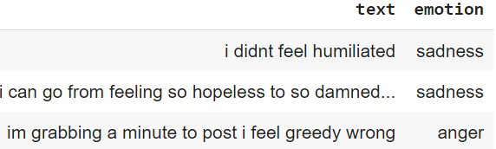

**Results**

|  |  |  |  |
| --- | --- | --- | --- |
| Model | Train Accuracy | Validation Accuracy | Test Accuracy |
| BiLSTM: random embeddings | 99% | 95% | 91.3% |
| BiLSTM: pretrained elmo embeddings | 99% | 95% | 91.25% |
| Finetuned BERT | 59% | 62% | 60.65% |

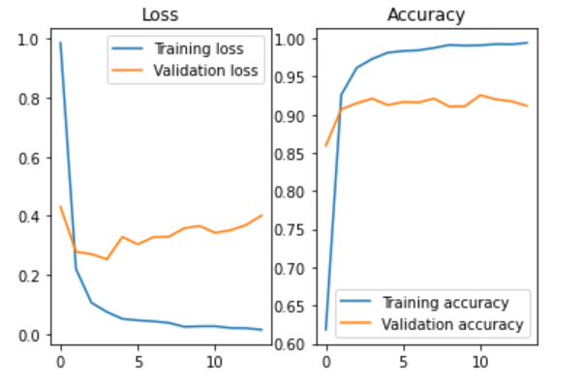 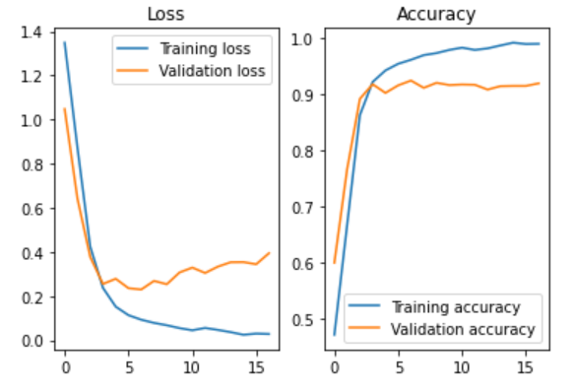

BiLSTM Model with random embeddings BiLSTM Model with pretrained elmo embeddings

**Fine tuned lightweight BERT Model (DistilBERT)**

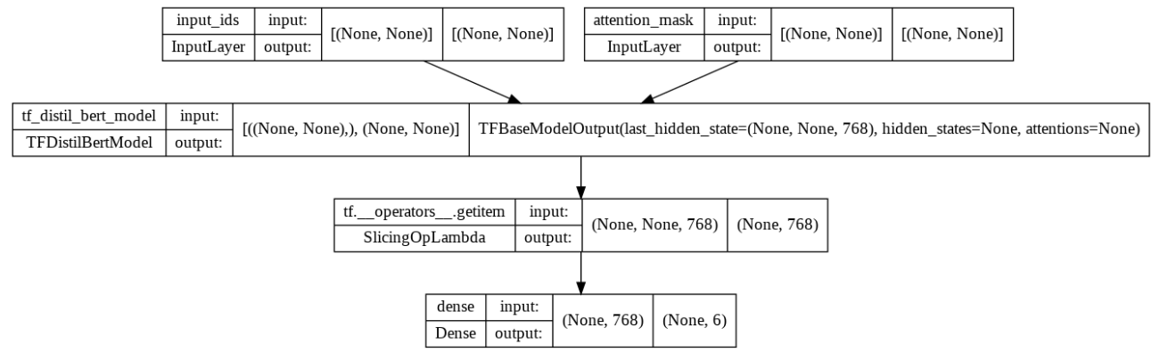

**BiLSTM model with pretrained elmo embeddings.**

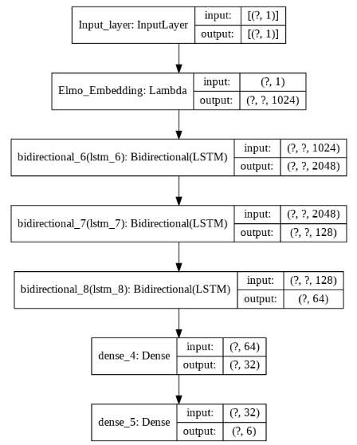

**Baseline model: BiLSTM Model with random word embeddings.**

