Configure aws access key:

1. Install aws cli on your terminal  
   $ sudo snap install aws-cli --classic # version 1.15.58
2. Goto aws console create access key  
   Can download csv version of the access key and secret key pair to copy paste aws credential config later.
3. On your terminal,   
   $ aws configure
4. Confirm credentials in your terminal,  
   $ cat ~/.aws/credentials

In VS code, create Terraform > exercise1 folders  
main.tf

# file: main.tf

resource "aws_s3_bucket" "lambda_bucket" {

bucket = "ce9-roger-s3bucket"

force_destroy = true

}

provider.tf

# file: provider.tf

terraform {

required_providers {

aws = {

source = "hashicorp/aws"

version = "5.83.1"

}

}

}

provider "aws" {

region = "

Run the following terraform commands:

$ terraform init

$ terraform plan  
$ terraform apply

Enter a value: yes  
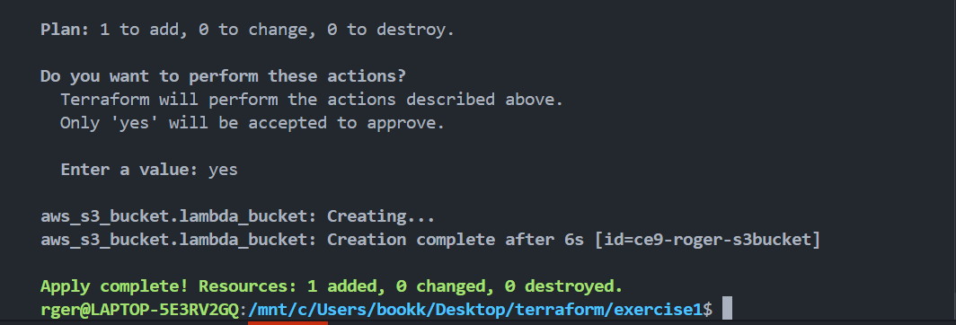

Screenshot s3 bucket from aws console  
