### Github repo <https://github.com/KeenGWatanabe/terraform-vpc>

### <https://github.com/KeenGWatanabe/terraform-module-sns>

### Activity: Use Community VPC Module

My output nat_gateway_id

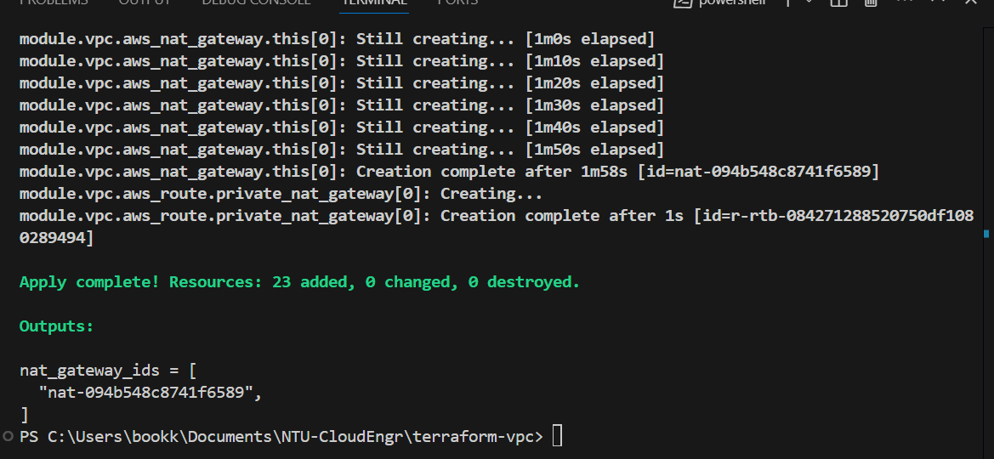

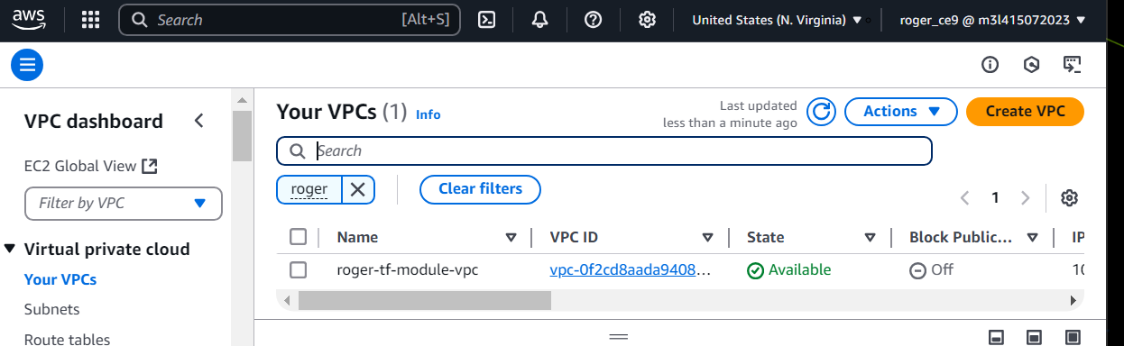

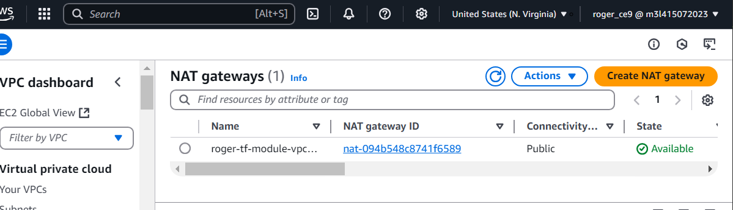

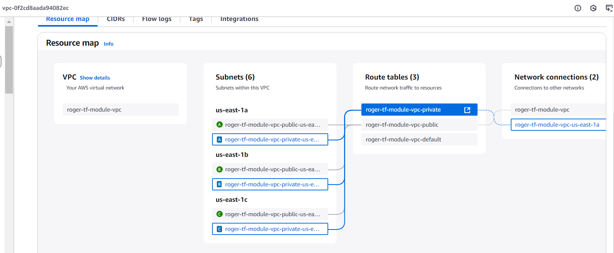

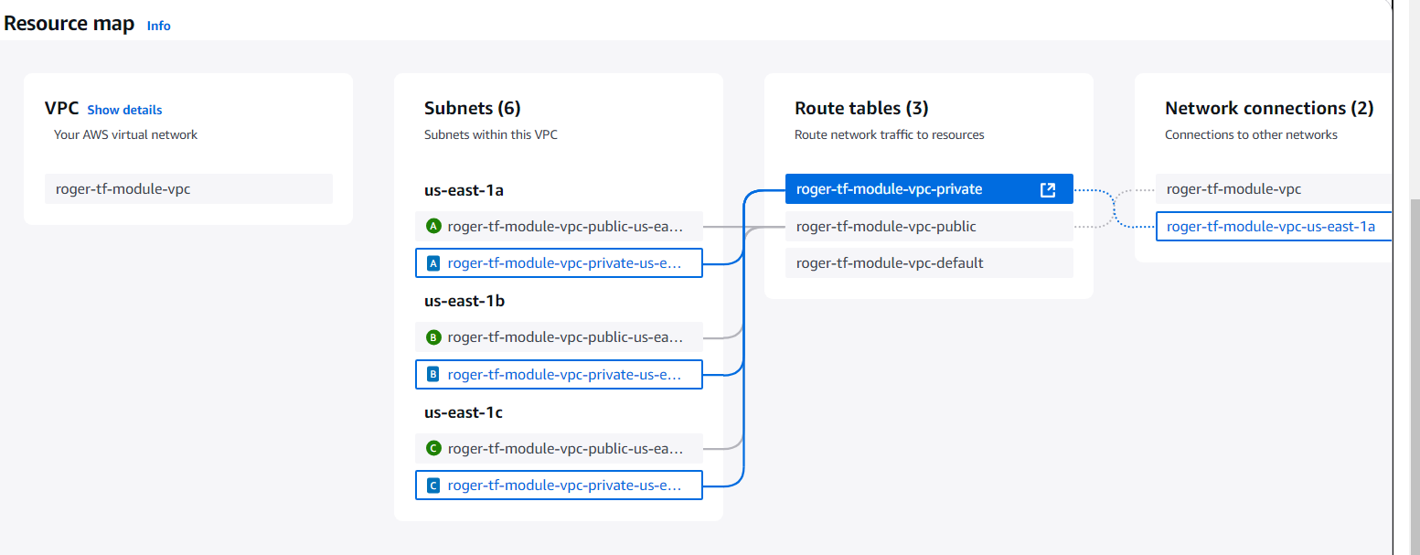

### Activity: Create Custom Module

My output:  


 

 

