Github repo activity 1: <https://github.com/KeenGWatanabe/terraform-rds.git>

Github repo activity 2: <https://github.com/KeenGWatanabe/tf-dynamodb.git>  
Readme.md: create key_pair in project folder for easy access. Key_pairs are not push to git repo, stated in gitignore

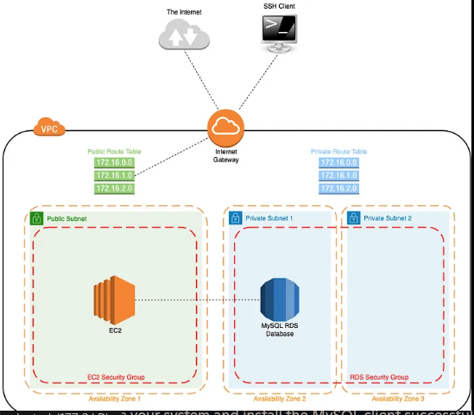  
Terraform apply:  
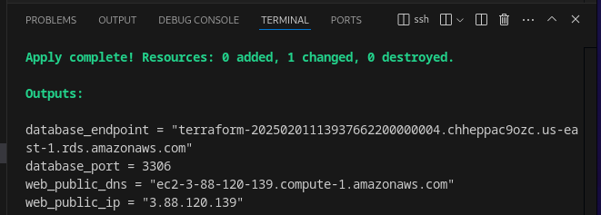

Ssh to Linux:  
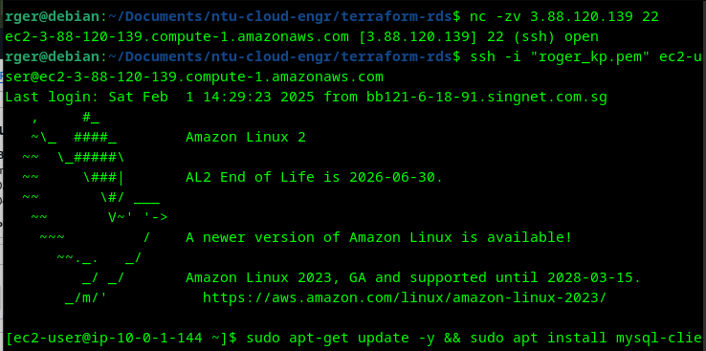

Install and MySQL access:  
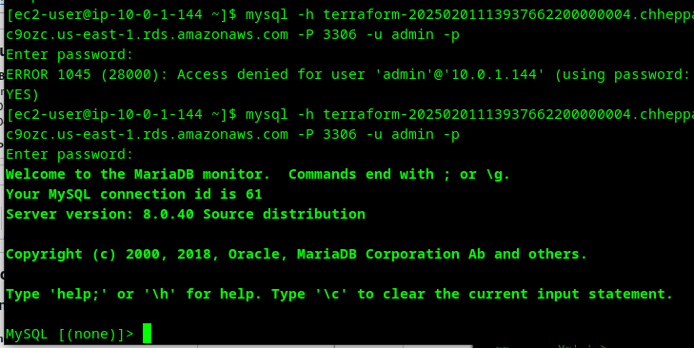

ec2 : roger_web_0

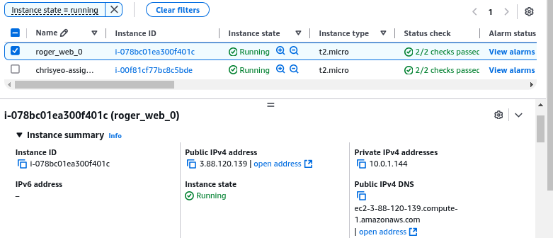

Rds: MySQL

