Github repo activity 1: <https://github.com/KeenGWatanabe/tf-dynamodb-iam.git>  
Readme.md: create key_pair in project folder for easy access. Key_pairs are not push to git repo, stated in gitignore

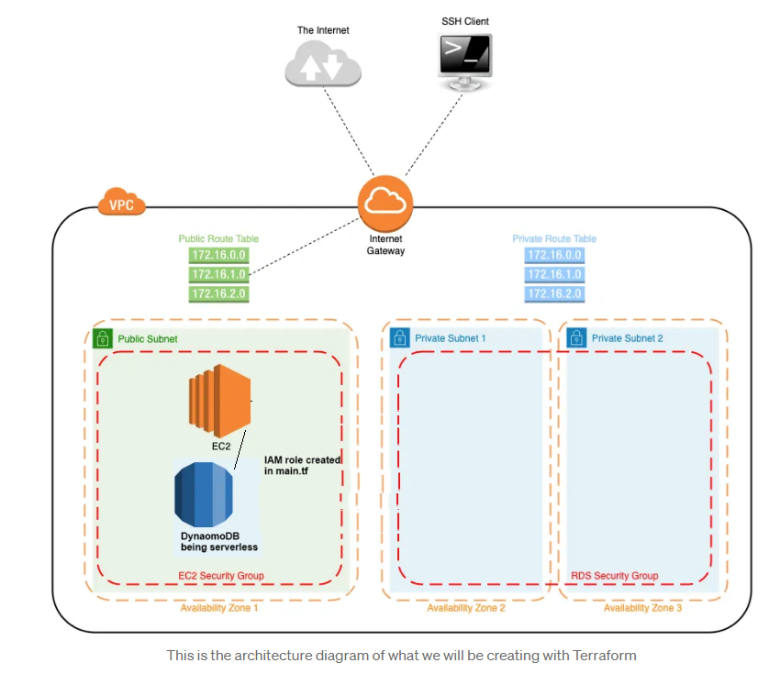

IAM role created for EC2 access to DynamoDB:

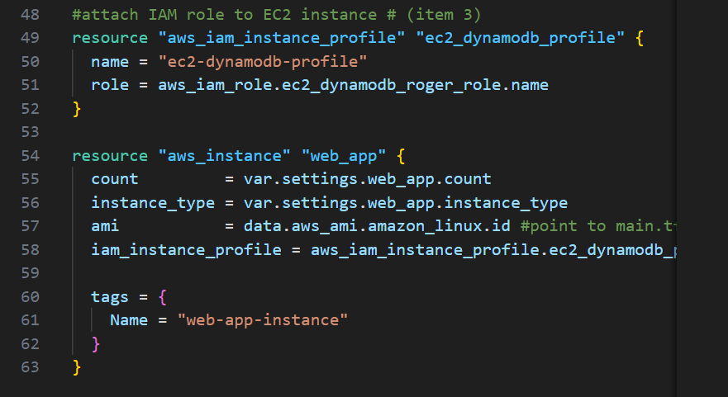

Terraform apply:

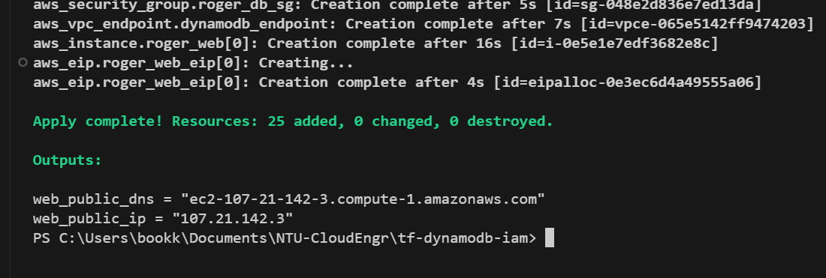

EC2 created:

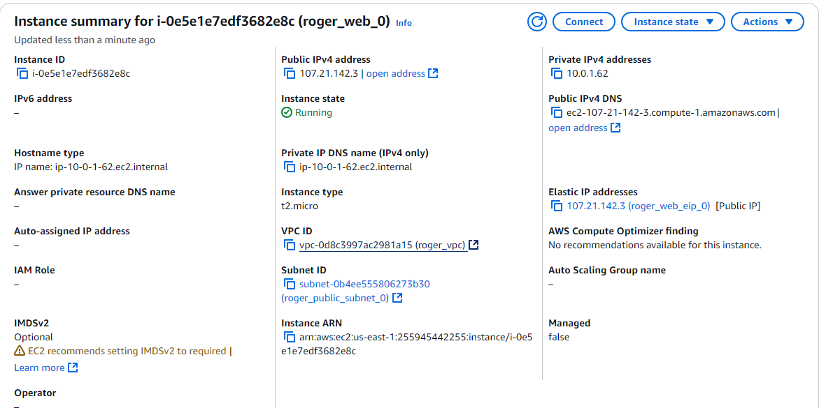

Ssh to EC2:  
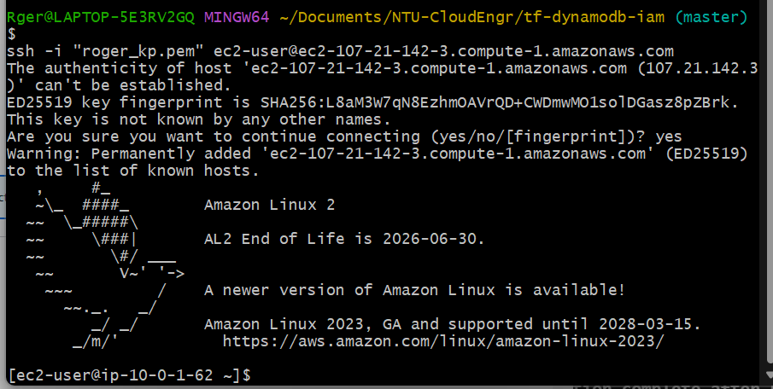

DynamoDB:  
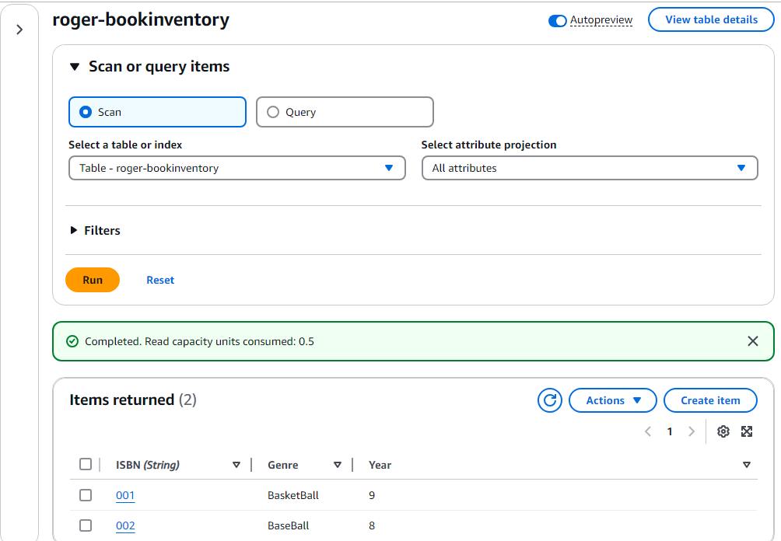

IAM role:  
