Github repo activity 1: <https://github.com/KeenGWatanabe/tf-ebs-ec2.git>  
Assignment: Using terraform attach a 1 GB EBS volume onto a EC2 instance.

The EBS volume must be in the same AZ as your EC2’s subnet

You don’t have to format / mount the EBS volume

Submission is the url to your public git repository with the working code.

Readme.md: create key_pair in project folder for easy access. Key_pairs are not push to git repo, stated in gitignore, but for study purpose, comment *.tfvars to show data inputs for the project.

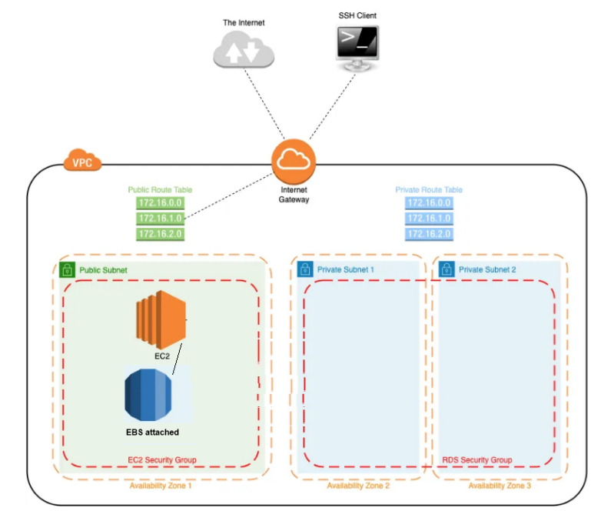

EBS and attachment from terraform apply:

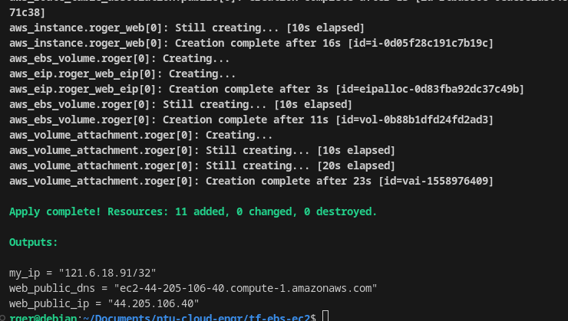

EC2 created:

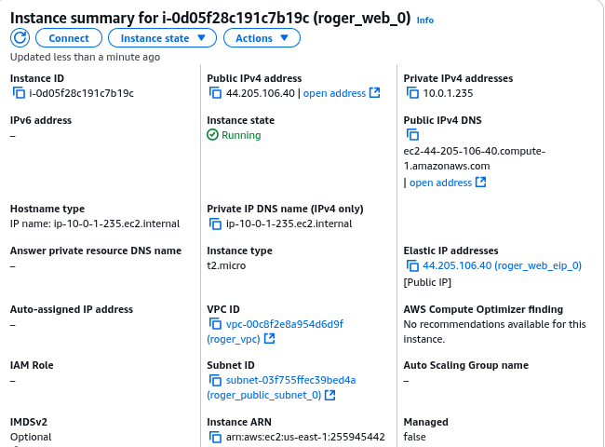

Ssh to EC2:  
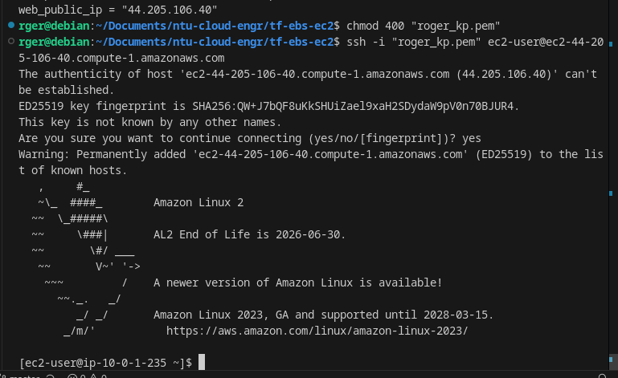

EBS:  
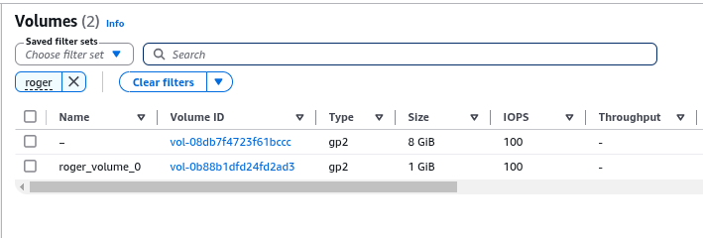

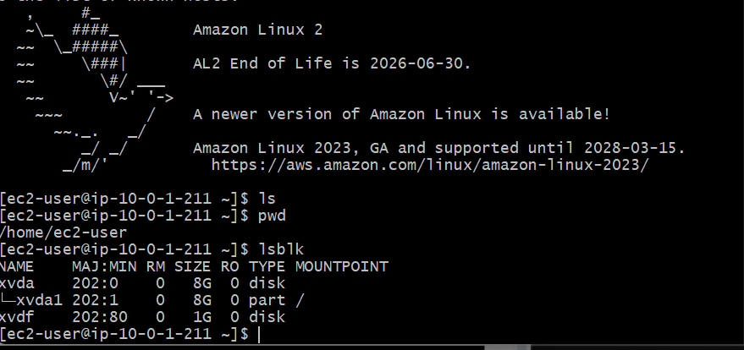

EBS attached to EC2:

