daNETWORK INFRASTRUCTURE PRACTICAL MANUAL
Module: Network Infrastructure
Programme: Information Technology / Networking Support
Practical Assessments: 9
Total Marks: 100
Lab Size: 10 Student Workstations

1. MODULE OVERVIEW
This practical module equips students with the knowledge and skills required to design, install, configure, manage, test, and troubleshoot network infrastructure in a modern enterprise environment.
The practical exercises progress from basic cabling and hardware installation to Cisco router and switch configuration, VLAN implementation, network services, and troubleshooting.

2. AVAILABLE EQUIPMENT

Structured Cabling Equipment
Item | Quantity
Crimping Tools | 4
Punchdown Tools | 4
Patch Panels | 4
Network Patch Boxes | 13
0.5m Fly Leads | 13
1m Fly Leads | 13
Network Cable (500m) | 4 Rolls

Cisco Equipment
Item | Quantity
Cisco Console Cables | 4
Cisco 1941 Routers | 2
Cisco ISR 4331 Routers | 2
Cisco Catalyst 3560 Switches | 2

Network Infrastructure Equipment
Item | Quantity
24-Port Switches | 4
24-Port Patch Panels | 4
4U Switch Cabinets | 4

Computer Equipment
Item | Quantity
Lenovo Desktop PCs | 10
LG Screens | 10
Keyboard & Mouse Sets | 10

Printing Equipment
Item | Quantity
HP LaserJet 600 M602 Printer | 1
HP Color LaserJet 5500DN Duplex Printer | 1
HP Colour LaserJet Professional CP5225N Printer | 1

Toolkits
Item | Quantity
SPROTEK 58-Piece Computer Technician Toolkit | 2
SPROTEK 10-Piece Network Installation Toolkit | 2

Classroom Equipment
Item | Quantity
Projector | 1
Projector Mounting | 1
Whiteboard | 1

3. LEARNING OUTCOMES
Upon successful completion of this module, students will be able to:
- Safely use networking tools and equipment.
- Construct Ethernet cables using industry standards.
- Install and terminate patch boxes and patch panels.
- Build structured cabling systems.
- Install and manage switch cabinets.
- Access and configure Cisco IOS devices.
- Configure Cisco switches and routers.
- Implement VLANs and network segmentation.
- Configure shared network resources.
- Troubleshoot enterprise network faults.
- Document network installations professionally.

PRACTICAL 1: NETWORK TOOLS AND SAFETY

Objective
Identify networking tools and apply safe working procedures.

Activities
- Identify networking tools.
- Explain the use of each tool.
- Demonstrate safe handling.
- Complete a tool inventory sheet.
- Apply health and safety procedures.

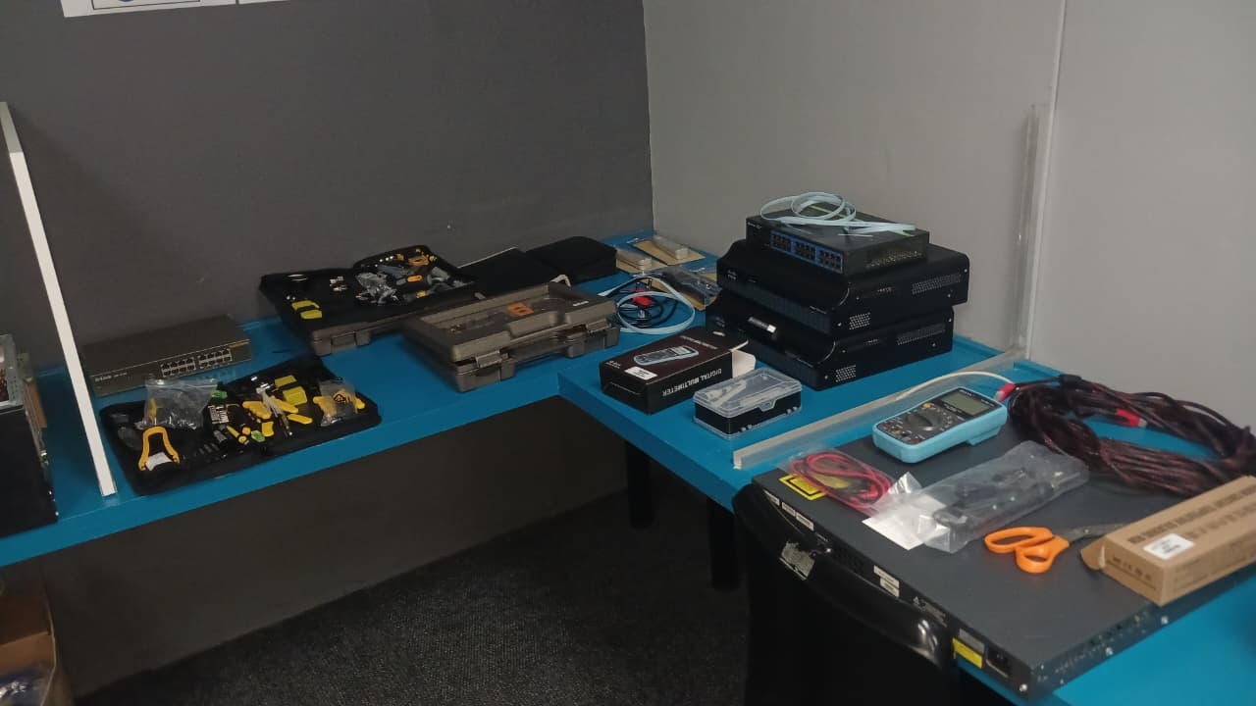

Figure 1 Crimping Tool and Punch Down Tool
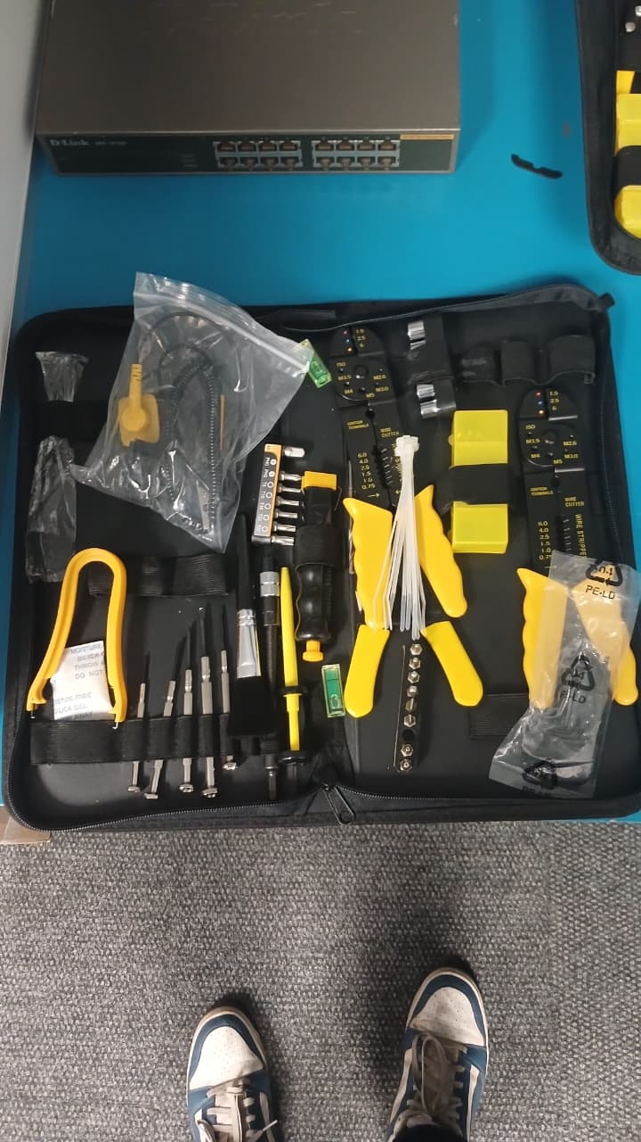
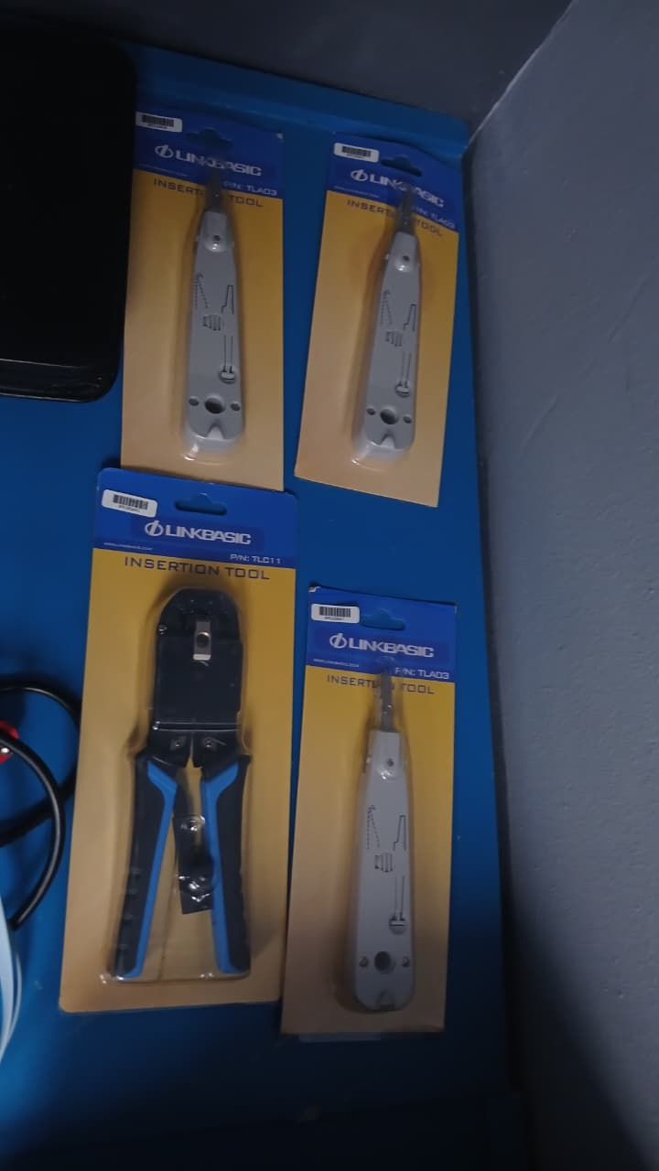

Figure 2 Tools including Crimping Tool,Wire Stripper and Punch Down tool

Deliverable
Completed Tool Identification Worksheet.

Assessment Rubric (10 Marks)
Criteria | Marks
Tool identification | 4
Understanding tool functions | 2
Safe tool usage | 2
Worksheet completion | 2
Total | 10

PRACTICAL 2: ETHERNET CABLE CONSTRUCTION

Objective
Construct and test Ethernet patch cables using T568B.

Activities
- Measure and cut cable.
- Strip cable jacket.
- Arrange conductors according to T568B.
- Crimp RJ45 connectors.
- Test completed cables.

T568B Wiring Standard
- White/Orange
- Orange
- White/Green
- Blue
- White/Blue
- Green
- White/Brown
- Brown

Deliverable
Three tested Ethernet cables.

Assessment Rubric (10 Marks)
Criteria | Marks
Correct cable sequence | 4
Cable preparation | 2
Crimp quality | 2
Connectivity testing | 2
Total | 10

PRACTICAL 3: PATCH BOX INSTALLATION

Objective
Install and terminate network outlets.

Activities
- Install patch boxes.
- Terminate using T568B.
- Label outlets.
- Test connectivity.

Deliverable
Fully functional network outlet.

Assessment Rubric (10 Marks)
Criteria | Marks
Correct termination | 4
Use of punchdown tool | 2
Cable management | 2
Labelling | 2
Total | 10

PRACTICAL 4: PATCH PANEL INSTALLATION

Objective
Install and document a patch panel.

Activities
- Mount patch panel.
- Terminate network runs.
- Label ports.
- Create port schedule.
- Test all ports.

Deliverable
Completed patch panel installation.

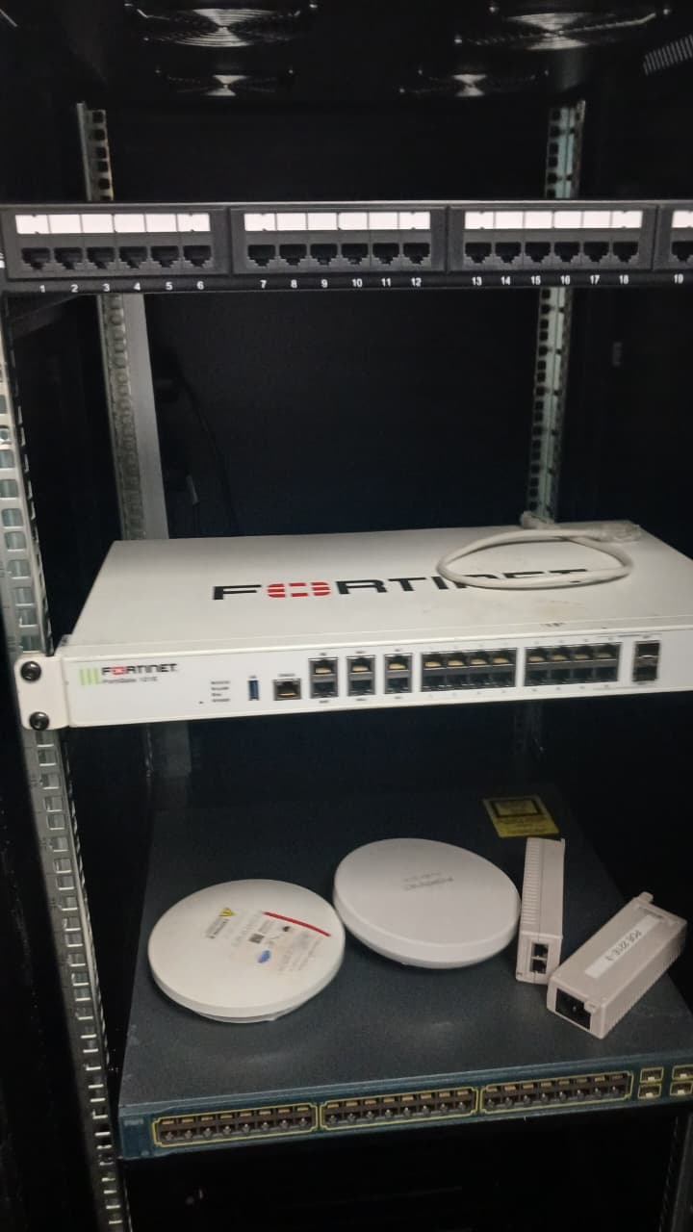
Figure 3Patch Panel With switches installed

Assessment Rubric (10 Marks)
Criteria | Marks
Correct patch panel termination | 4
Port numbering | 2
Documentation | 2
Testing verification | 2
Total | 10

PRACTICAL 5: CISCO DEVICE ACCESS AND BASIC CONFIGURATION

Objective
Access Cisco IOS and perform basic device configuration.

Equipment
- Console Cables
- Cisco 1941 Router
- Cisco ISR4331 Router
- Cisco Catalyst 3560 Switch

Activities
- Access Cisco devices using console cables.
- Configure hostname.
- Configure passwords.
- Configure login banner.
- Save configurations.

Example Configuration
1 enable
2 configure terminal
3
4 hostname POTCH-R1
5
6 enable secret Cisco123
7
8 line console 0
9 password Cisco123
10 login
11
12 banner motd # Unauthorized Access Prohibited #
13
14 end
15 copy running-config startup-config

Deliverable
Configuration screenshots and configuration file.
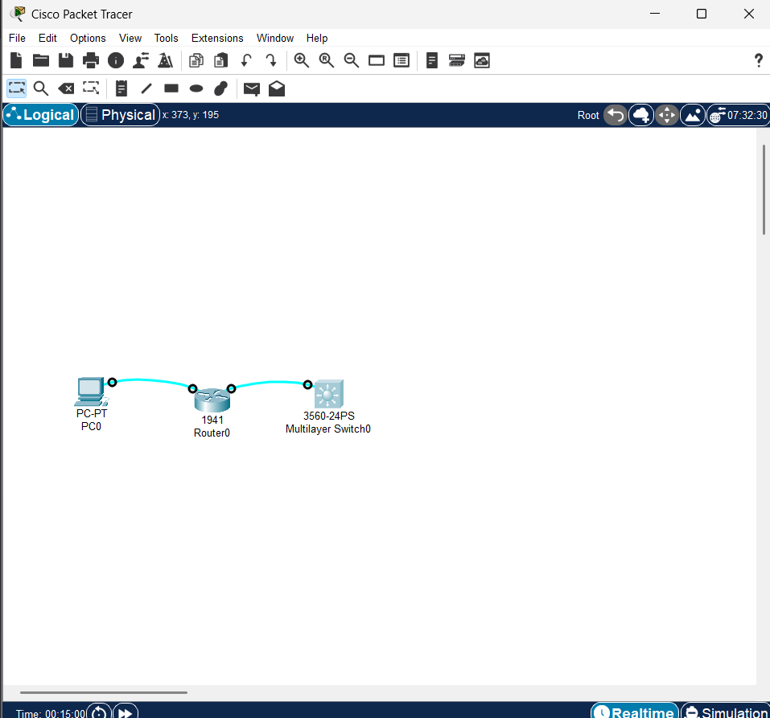
Figure: 1Overview of network
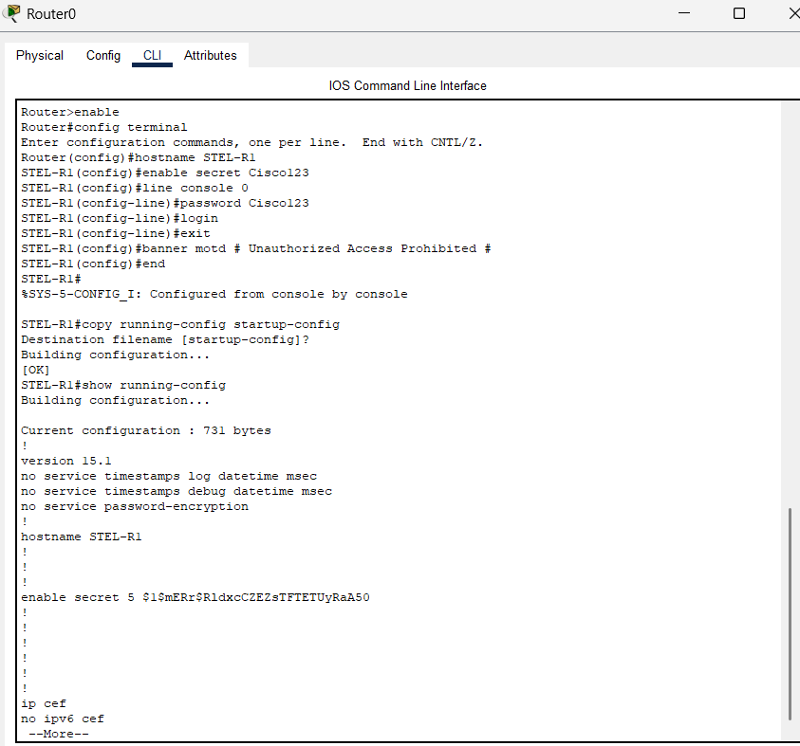
Figure: 2 Configuration of router
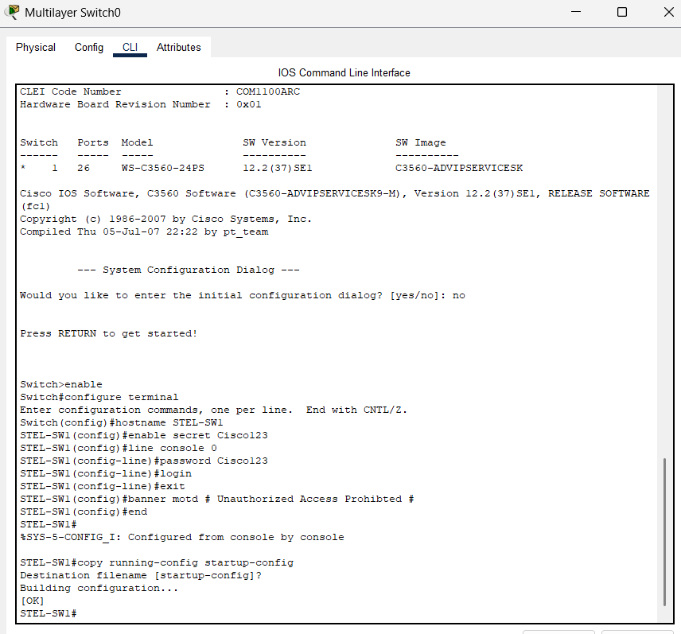
Figure: 3 Configuration of switch
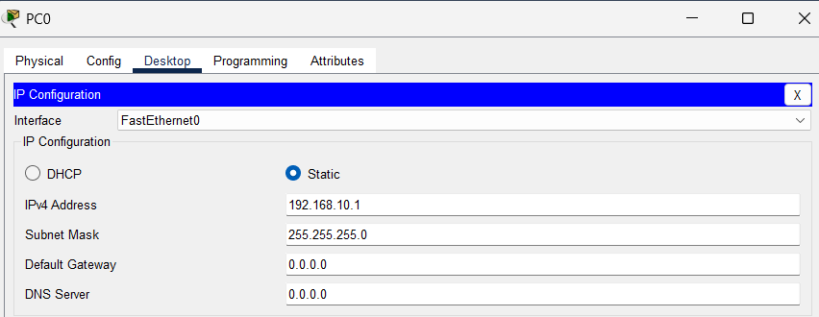
Figure: 4 Configuration of pc ip-address

Assessment Rubric (10 Marks)
Criteria | Marks
Console connectivity | 2
IOS navigation | 3
Device configuration | 3
Save and verify configuration | 2
Total | 10

PRACTICAL 6: LAN CONSTRUCTION AND SWITCH CONFIGURATION

Objective
Build a LAN using a Cisco Catalyst switch.

Equipment
- 10 PCs
- Cisco Catalyst 3560 Switch
- Patch Panel
- Fly Leads

Activities
- Connect all 10 PCs.
- Configure static IP addresses.
- Configure switch management interface.
- Verify connectivity.
- Create a network diagram.

IP Addressing Scheme
Device | IP Address
PC1 | 192.168.10.1
PC2 | 192.168.10.2
PC3 | 192.168.10.3
PC4 | 192.168.10.4
PC5 | 192.168.10.5
PC6 | 192.168.10.6
PC7 | 192.168.10.7
PC8 | 192.168.10.8
PC9 | 192.168.10.9
PC10 | 192.168.10.10
Switch VLAN 1 | 192.168.10.254
Subnet Mask: 255.255.255.0

Verification Commands
1 show running-config
2 show vlan brief
3 show mac address-table

Deliverable
Operational LAN and topology diagram.
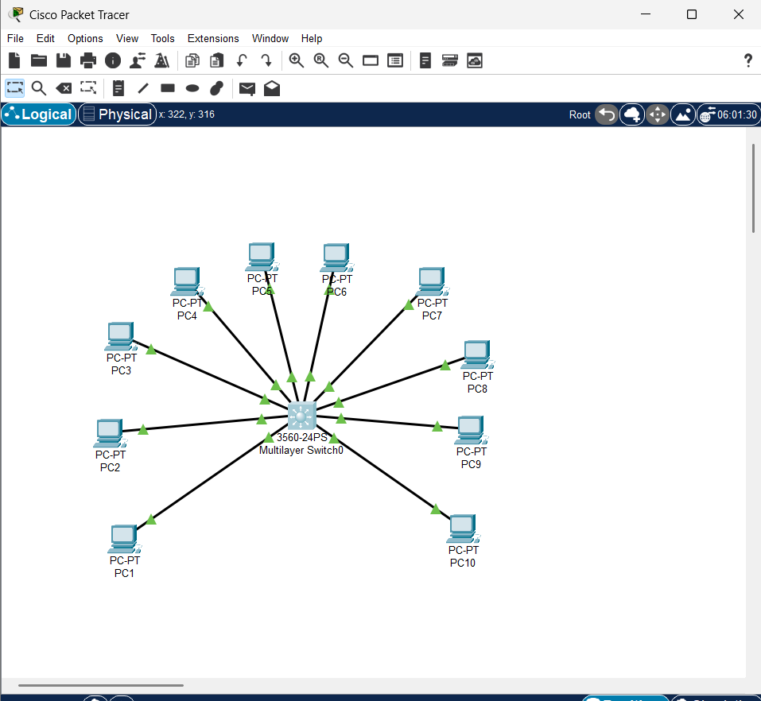
Figure: 5 Network overview
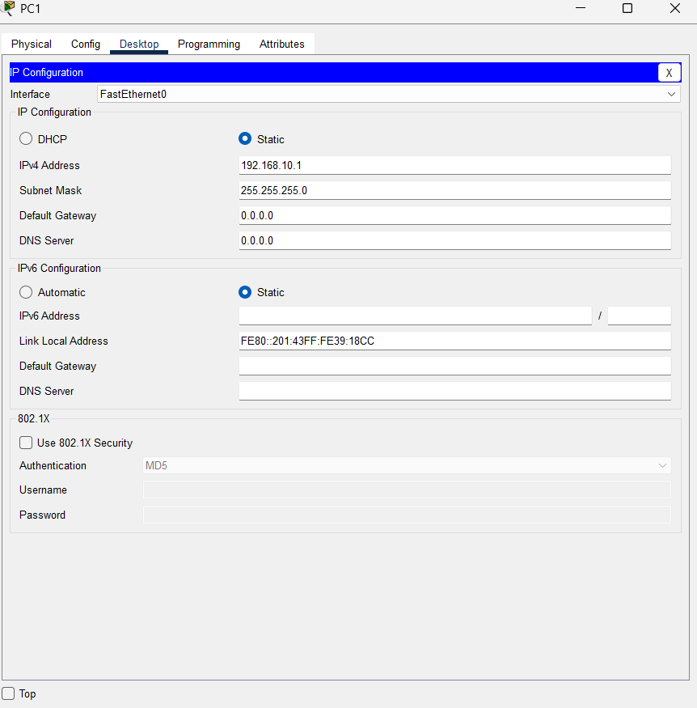
Figure: 6 Configuration of pc1 ip-address
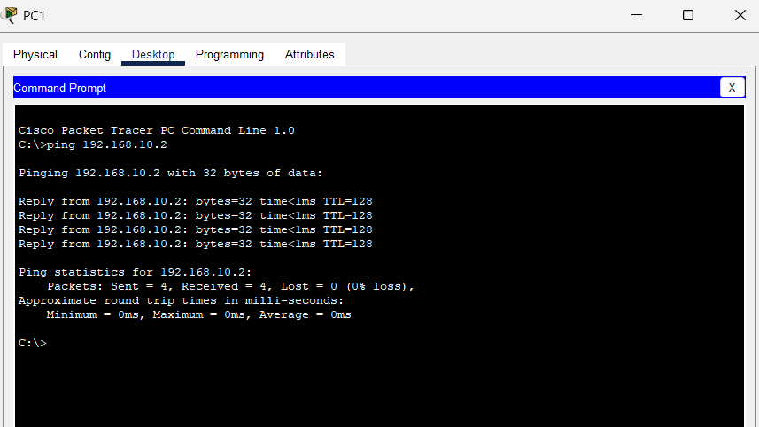
Figure: 7 Pinging of pc2 from pc1

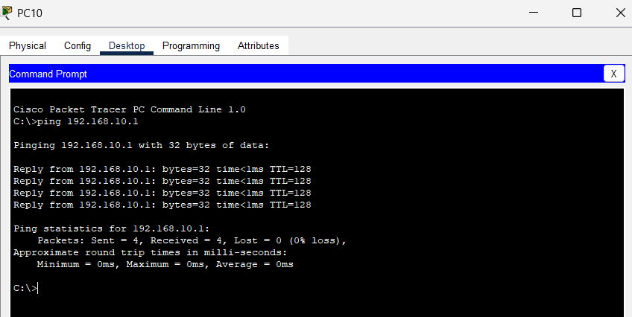
Figure: 8 Pinging of pc1 from pc10
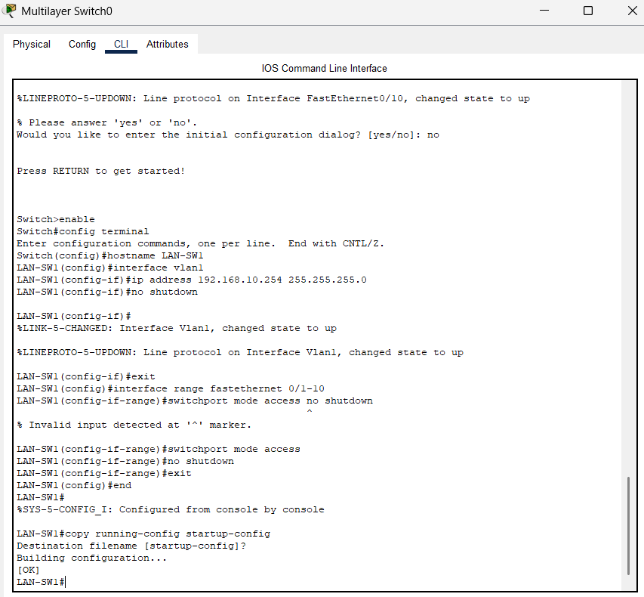
Figure: 9 Configuration of switch
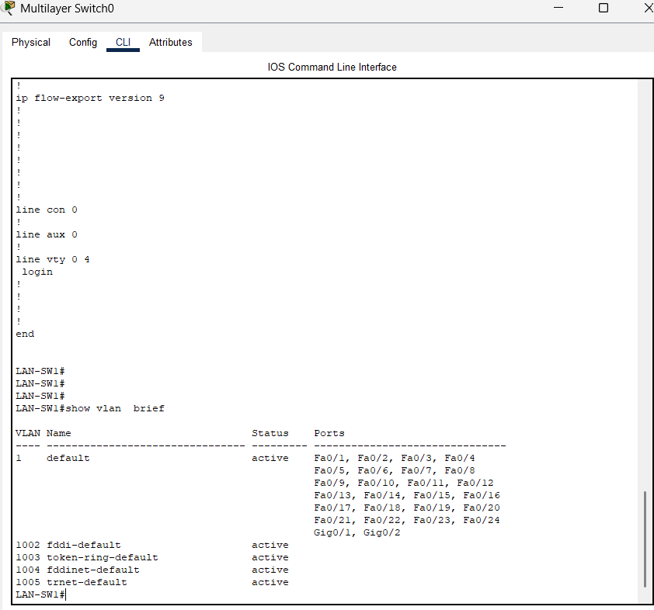
Figure: 10 Show Vlan Brief Command
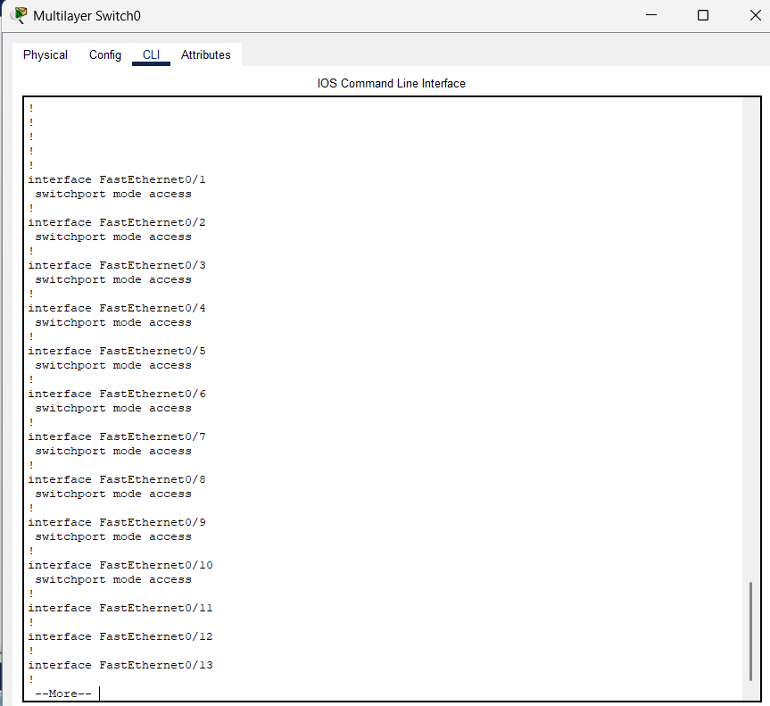
Figure: 11 Show Running-Config Command

Assessment Rubric (15 Marks)
Criteria | Marks
Physical installation | 3
Switch configuration | 4
IP configuration | 4
Connectivity testing | 4
Total | 15

PRACTICAL 7: ROUTER CONFIGURATION AND INTER-NETWORK COMMUNICATION

Objective
Configure routers and establish communication between networks.

Equipment
- Cisco 1941 Router
- Cisco ISR4331 Router
- Cisco Switches
- PCs

Activities
Create two networks:

Network A
1 192.168.10.0/24

Network B
1 192.168.20.0/24
Configure router interfaces.

Example Configuration
1 interface g0/0
2 ip address 192.168.10.1 255.255.255.0
3 no shutdown
4
5 interface g0/1
6 ip address 192.168.20.1 255.255.255.0
7 no shutdown

Verification Commands
1 show ip interface brief
2 ping
3 tracert

Deliverable
Successful communication between both networks.
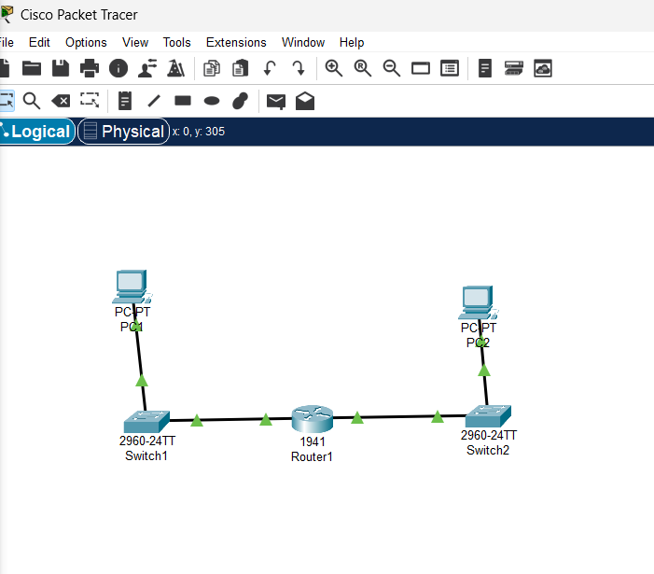
Figure: 12 Network Overview

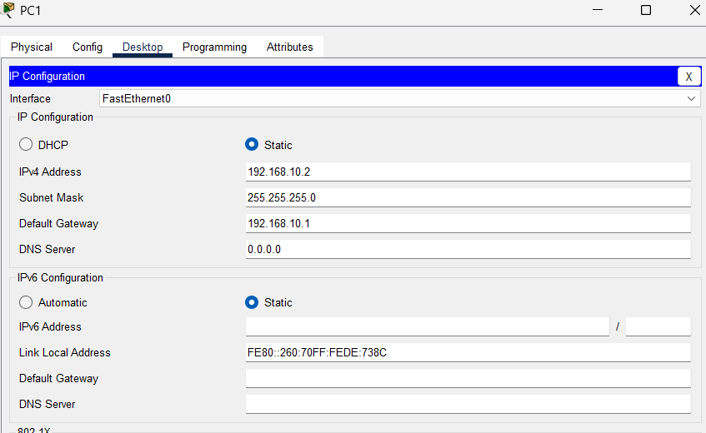
Figure: 13 PC1 ip-address configuration

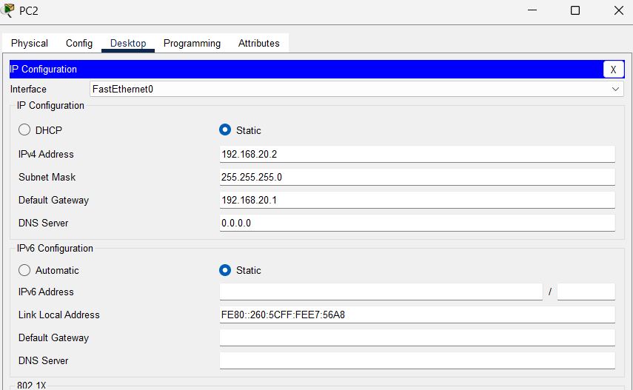
Figure: 14 PC2 ip-address Configuration
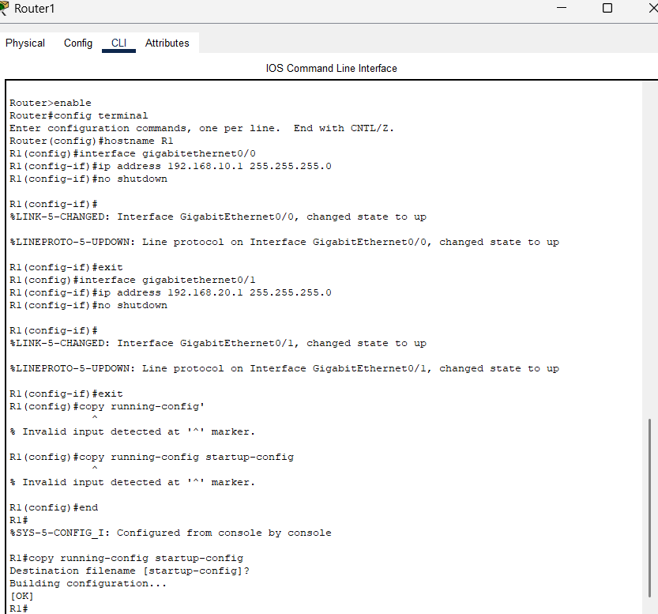
Figure: 15 Router Configuration & Running-Config Command

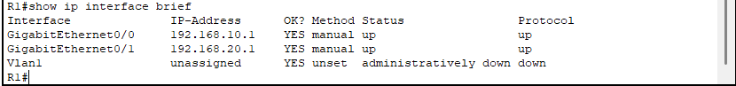
Figure: 16 Show ip interface bief
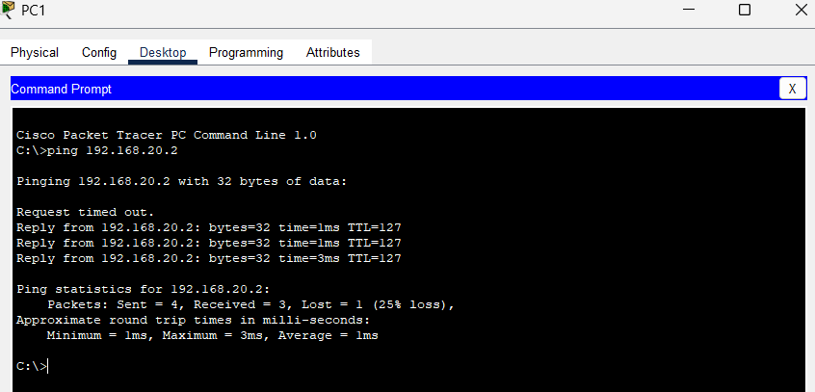
Figure: 17 Pinging of PC2 from PC1

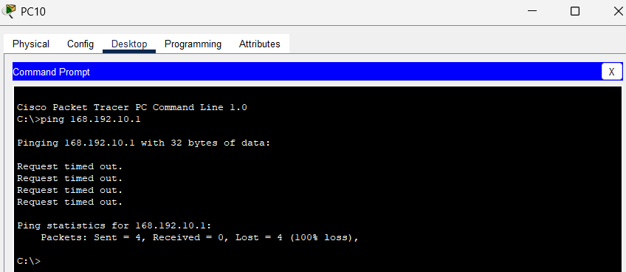
Figure: 18 Pinging of PC1 from PC10

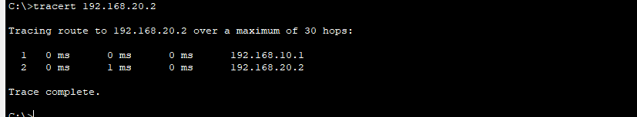
Figure: 19 Tracert Comman(Tracing Route)

Assessment Rubric (10 Marks)
Criteria | Marks
Router configuration | 4
Interface addressing | 2
Connectivity testing | 2
Documentation | 2
Total | 10

PRACTICAL 8: VLAN IMPLEMENTATION AND NETWORK SEGMENTATION

Objective
Create VLANs and segment network traffic.

Equipment
- Cisco Catalyst 3560 Switches
- 10 PCs

VLAN Design
VLAN | Department | Devices
VLAN 10 | Administration | PC1-PC3
VLAN 20 | Lecturers | PC4-PC6
VLAN 30 | Students | PC7-PC10

Activities
- Create VLANs.
- Assign ports to VLANs.
- Verify VLAN membership.
- Test communication.
- Document VLAN design.

Example Commands
1 vlan 10
2 name ADMIN
3
4 vlan 20
5 name LECTURERS
6
7 vlan 30
8 name STUDENTS

Verification
1 show vlan brief

Deliverable
Working segmented network.
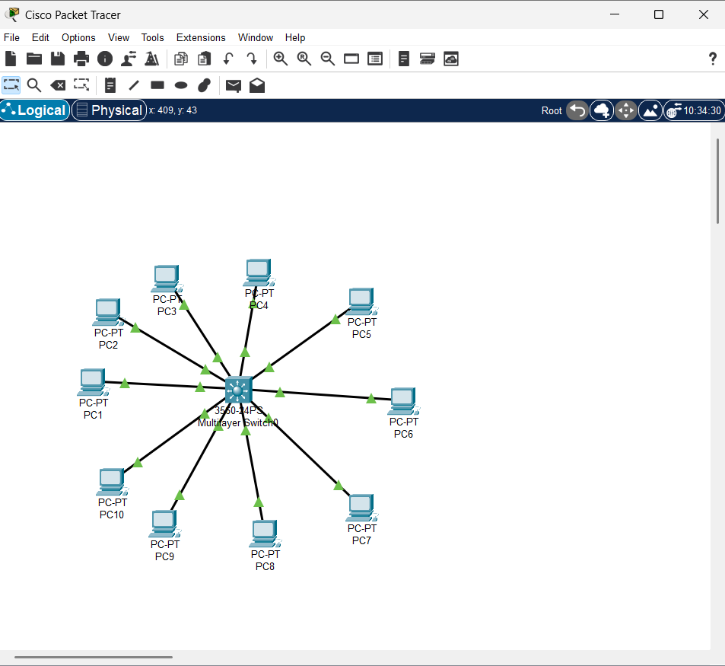
Figure: 20 Network Overview

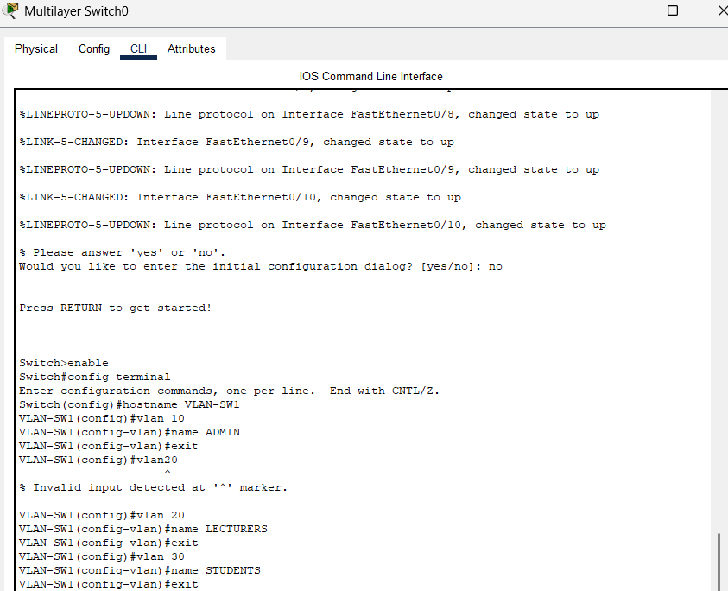
Figure: 21 Configuration of switch

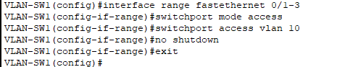
Figure: 22 Config of Vlan10
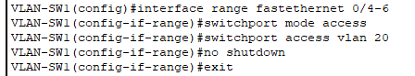
Figure: 23 Config of Vlan20
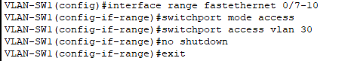
Figure: 24 Config of Vlan30

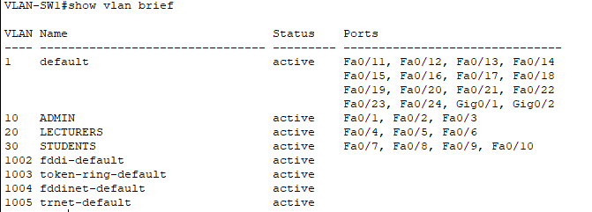
Figure: 25 Show vlan brief

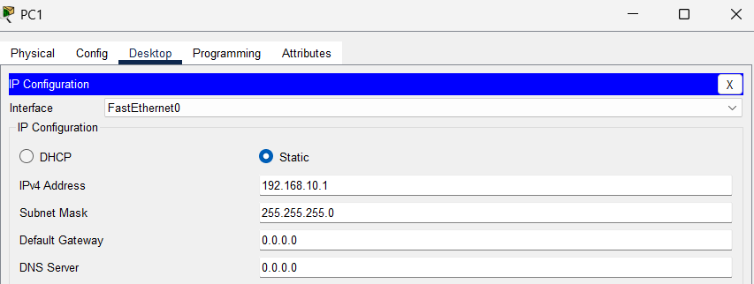
Figure: 26 PC1 Configuration
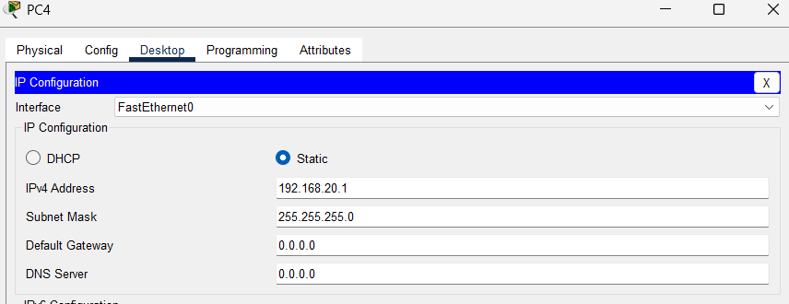
Figure: 27 PC4 Configuration

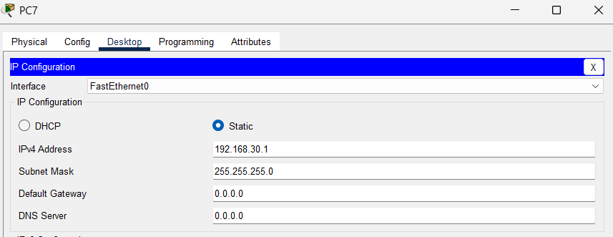
Figure: 28 PC7 Configuration

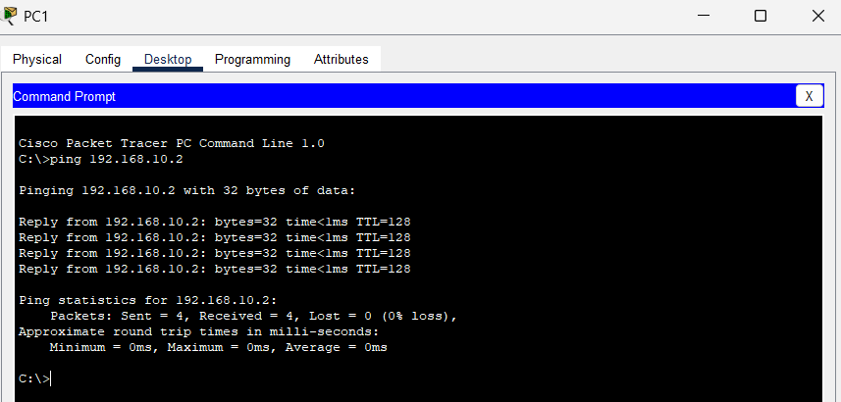
Figure: 29 Pinging of PC2 form PC1

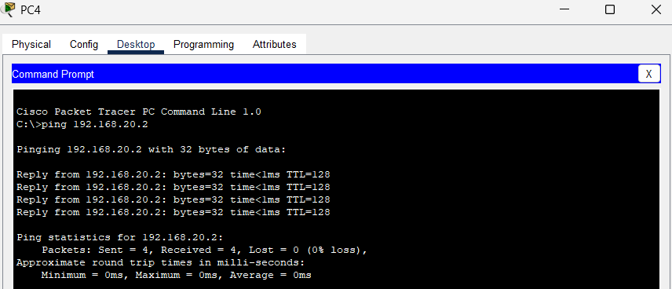
Figure: 30 Pinging of PC5 from PC4
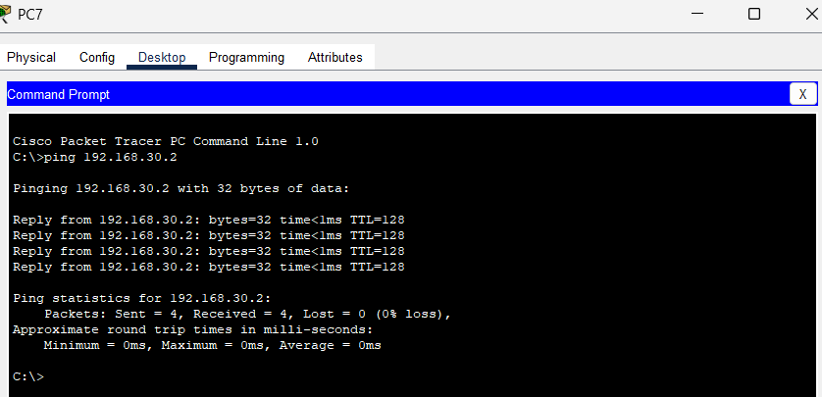
Figure: 31 Pingin of PC8 from PC7

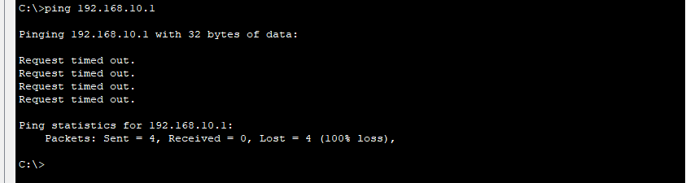
Figure: 32 Pinging of PC1 from PC10

Assessment Rubric (15 Marks)
Criteria | Marks
VLAN creation | 4
Port assignment | 4
Connectivity verification | 4
Documentation | 3
Total | 15

PRACTICAL 9: ENTERPRISE NETWORK DEPLOYMENT AND TROUBLESHOOTING

Objective
Deploy and troubleshoot a complete Cisco-based enterprise network.

Equipment
- Cisco Routers
- Cisco Switches
- Switch Cabinets
- Patch Panels
- Printers
- 10 PCs

Activities
- Install switch cabinet.
- Install patch panels.
- Configure switches.
- Configure routers.
- Implement VLANs.
- Configure printers.
- Test and troubleshoot the network.

Introduced Faults
- Incorrect VLAN assignment
- Incorrect subnet mask
- Incorrect default gateway
- Duplicate IP address
- Faulty patch lead
- Disabled switch port
- Router interface shutdown
- Missing route

Troubleshooting Commands
1 show running-config
2 show vlan brief
3 show interfaces
4 show ip route
5 show ip interface brief
6 show mac address-table
7 ping
8 tracert

Deliverable
Completed troubleshooting report.
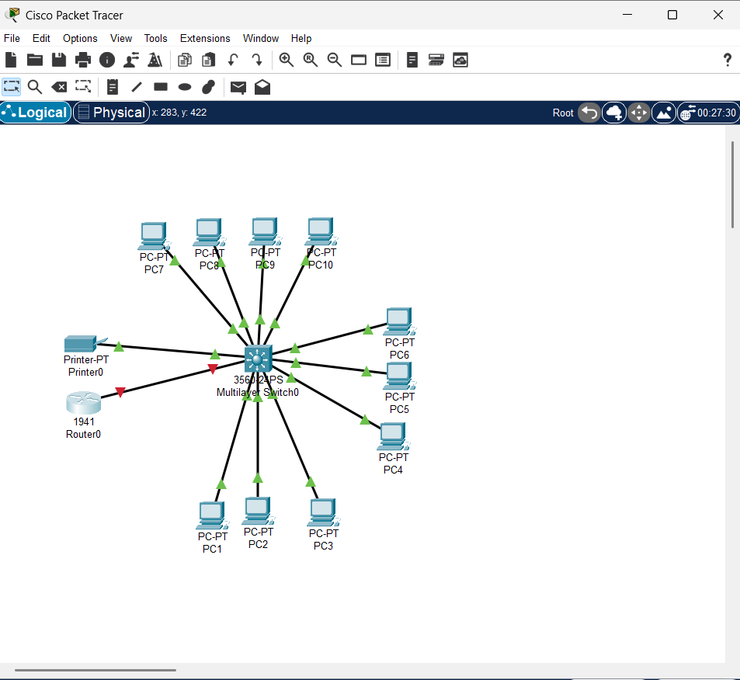
Figure:33 Network Overview
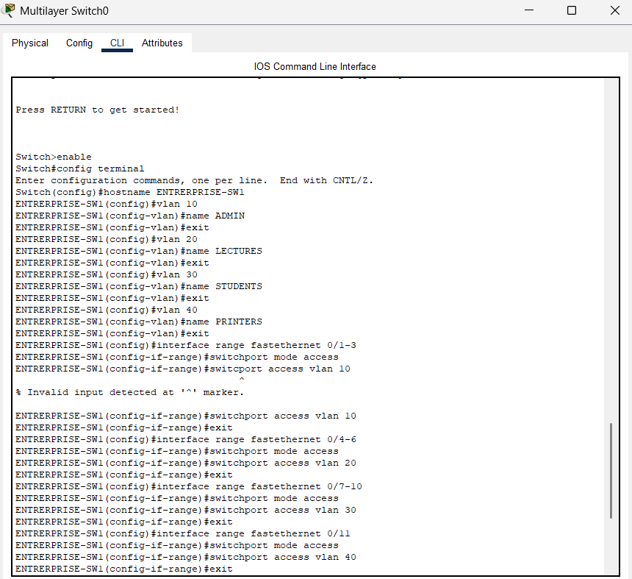
Figure: 33 Switch Configuration & Configuration of Vlanports 10-40
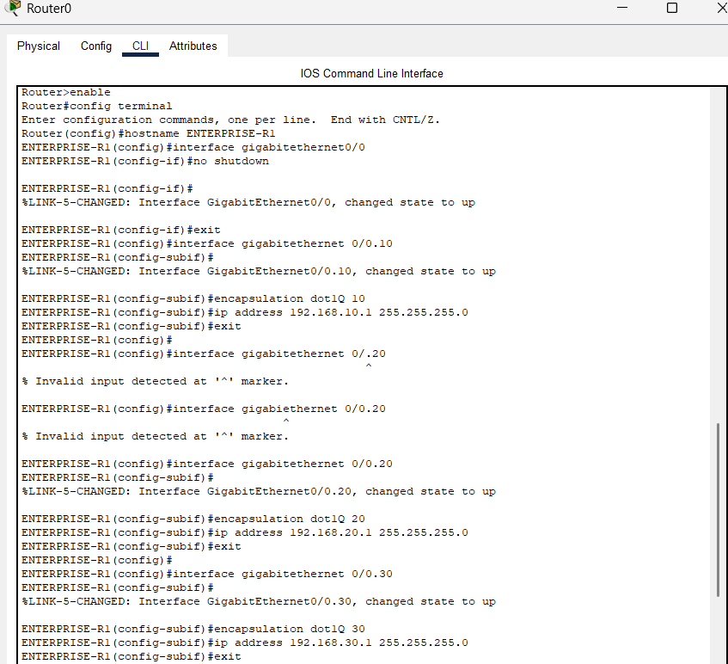
Figure: 34 Router Configuration & Configuration of DOT1Q

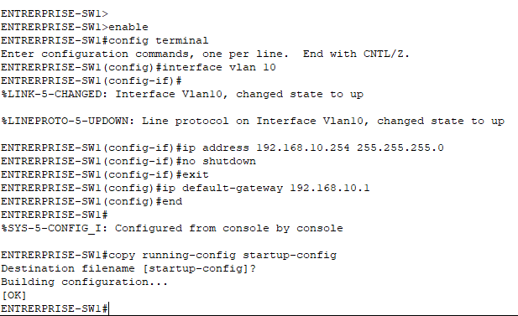

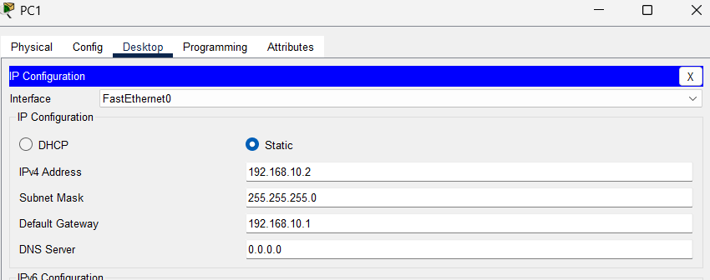
Figure: 35 Configuration of PC1
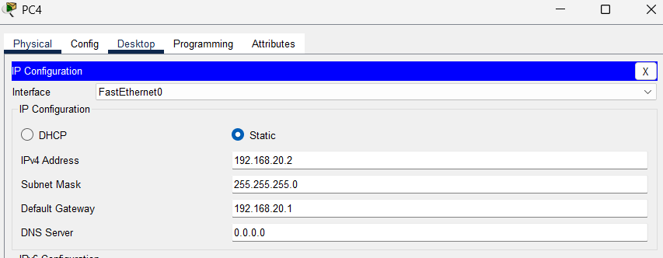
Figure: 36 Configuration of PC4
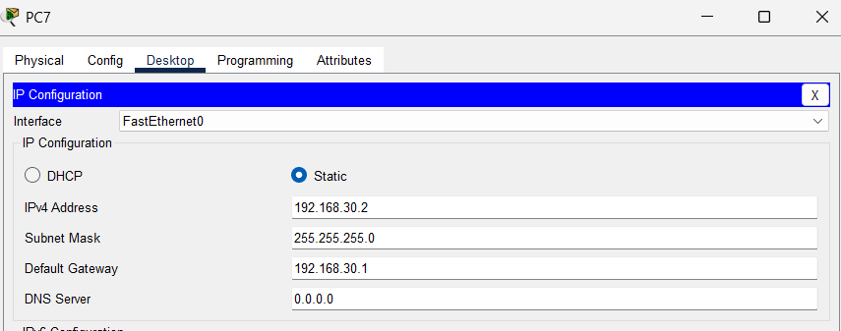
Figure: 37 Configuration of PC7
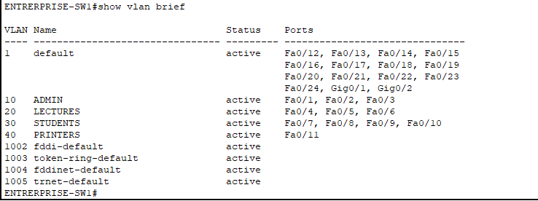
Figure: 38 Show vlan brief
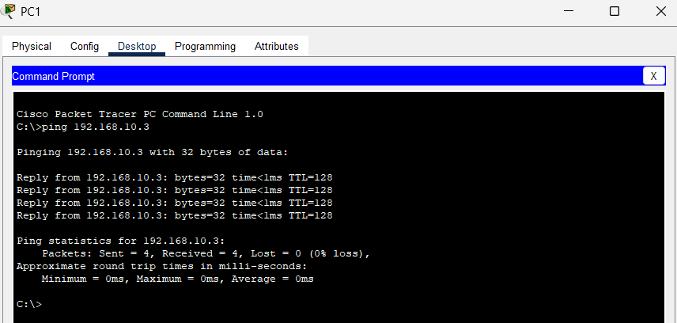
Figure: 39 Pinging of PC2 From PC1
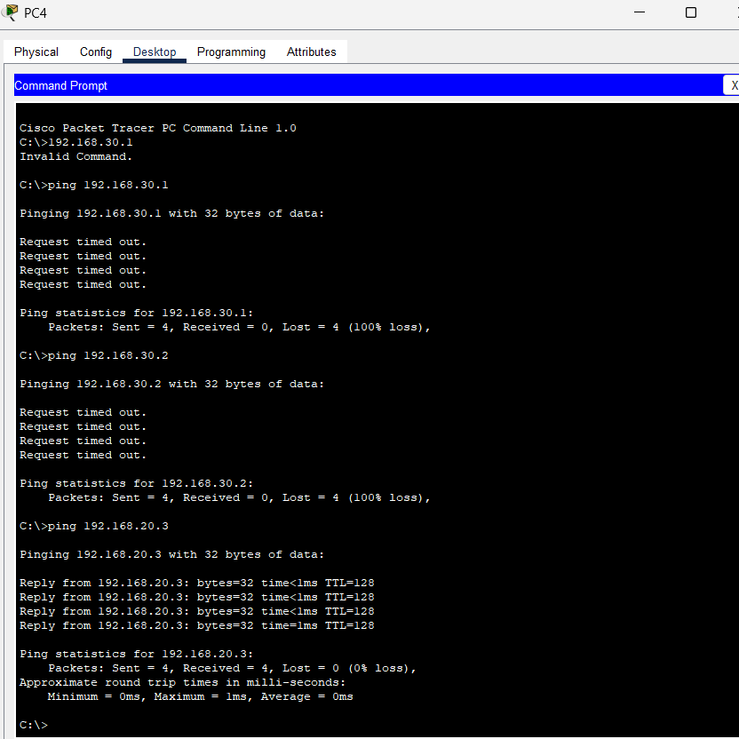

Assessment Rubric (10 Marks)
Criteria | Marks
Fault identification | 3
Troubleshooting methodology | 3
Correct resolution | 2
Professional report | 2
Total | 10

PRACTICAL OBSERVATION CHECKLIST
Competency | Yes | No
Uses tools safely | ☐ | ☐
Uses crimping tools correctly | ☐ | ☐
Uses punchdown tools correctly | ☐ | ☐
Applies T568B correctly | ☐ | ☐
Configures Cisco devices correctly | ☐ | ☐
Demonstrates troubleshooting skills | ☐ | ☐
Maintains clean workstation | ☐ | ☐
Demonstrates teamwork | ☐ | ☐
Produces accurate documentation | ☐ | ☐

FINAL CAPSTONE PROJECT

Scenario
Potchefstroom Campus requires a fully operational networking laboratory for 10 workstations. Student teams must design, install, configure, test, secure, document, and troubleshoot the complete network infrastructure.

Infrastructure Requirements

End User Devices
- 10 Desktop PCs
- 10 Monitors
- 10 Keyboard and Mouse Sets

Cisco Equipment
- 2 Cisco Catalyst 3560 Switches
- 2 Cisco 1941 Routers
- 2 Cisco ISR 4331 Routers
- 4 Cisco Console Cables

Infrastructure Equipment
- 4 Patch Panels
- 4 Switch Cabinets
- 13 Network Outlets
- Structured Cabling System
- Fly Leads

Shared Resources
- 3 Network Printers
- Projector
- Whiteboard

Project Tasks

Phase 1: Planning
- Produce physical topology
- Produce logical topology
- Create IP addressing plan
- Design VLAN structure

Phase 2: Infrastructure Installation
- Install switch cabinets
- Install patch panels
- Terminate outlets
- Test cabling

Phase 3: Cisco Switch Configuration
- Configure hostnames
- Configure passwords
- Configure management interfaces
- Configure VLANs

Phase 4: Cisco Router Configuration
- Configure interfaces
- Configure routing
- Verify routing tables
- Test communication

Phase 5: Shared Resource Configuration
- Configure network printers
- Verify access from all VLANs

Phase 6: Testing and Troubleshooting
- Verify connectivity
- Verify VLAN functionality
- Verify routing
- Resolve instructor-introduced faults

Phase 7: Documentation
Submit:
- Network topology diagram
- IP addressing table
- VLAN allocation table
- Switch configurations
- Router configurations
- Connectivity test results
- Troubleshooting report

CAPSTONE PROJECT RUBRIC (20 MARKS)
Assessment Area | Marks
Network Design and Planning | 4
Structured Cabling Installation | 3
Patch Panel and Cabinet Configuration | 2
Cisco Switch Configuration | 3
Cisco Router Configuration | 3
VLAN Configuration | 2
Testing and Troubleshooting | 2
Documentation and Professionalism | 1
Total | 20

ASSESSMENT SUMMARY
Assessment | Marks
Practical 1 | 10
Practical 2 | 10
Practical 3 | 10
Practical 4 | 10
Practical 5 | 10
Practical 6 | 15
Practical 7 | 10
Practical 8 | 15
Practical 9 | 10
Total Continuous Assessment | 100

ACHIEVEMENT LEVELS
Percentage | Achievement
80 - 100% | Excellent
70 - 79% | Competent
60 - 69% | Satisfactory
50 - 59% | Basic Competence
Below 50% | Not Yet Competent

Expected Graduate Competencies
Students who successfully complete this practical programme will be able to:
- Install structured cabling systems.
- Configure patch panels and switch cabinets.
- Configure Cisco Catalyst switches.
- Configure Cisco 1941 and ISR4331 routers.
- Implement VLANs and network segmentation.
- Configure network printers and shared resources.
- Troubleshoot physical and logical network issues.
- Deploy and document a small enterprise network consisting of 10 workstations using industry-standard networking practices.

