219114/115 Programming I

**Week 11: OOP programming laboratory**

You will need to access files from the following link:

[week11_oop_lab](https://drive.google.com/drive/folders/1R8fcQnNpm7c7315sk4T_b60I7yAbxtCl?usp=sharing)

**Task 1:**

* Make a Git repository called oop_lesson
* Copy the bank_account.py file to this directory
* Make a first commit for this file with a message like ‘Procedural programming for bank account simulation’
* Push it to your Github remote public repository
* Modify the bank_account.py file so that it is written in OOP-style. You can follow the example given in the example file in the link above
* Make a second commit and write a meaningful message to go with it
* Push it to your Github remote public repository
* Modify the bank_account.py file again:
  + Add the delete method to AccountDB
  + Provide a test code for this method
  + Make sure that it works correctly
* Make a third commit and write a meaningful message to go with it
* Push it to your Github remote public repository
* Go to your TAs to show your commit history in your Github repository so that they can check you off for this first task

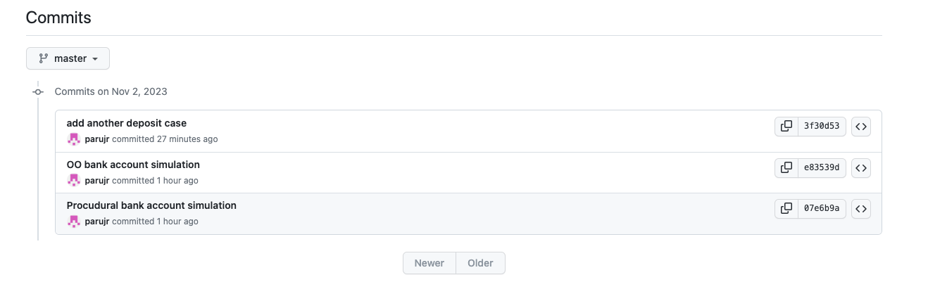

**An example of a commit history (not exactly aligned with the asking for Task 1)**

**Task 2:**

* Copy the following files to the oop_lesson directory:
  + data_processing.py
  + Cities.csv
  + Countries.csv
* Run data_processing.py and observe the outcome
* Commit these three files to your local and remote repository with a message like ‘Add another set of lesson files for data processing’
* Modify your data_processing.py so that it is written in a procedural style; see the file data_processing_procedural.py for a guideline
* Make another commit with a meaningful message to go with it
* Modify your data_processing.py so that it is written in an OOP style
* Make another commit with a meaningful message to go with it
* Add test cases to
  + Print the min and max temperatures for cities in EU that do not have coastlines
  + Print the min and max latitude for cities in every country
* Once you are done, make a final commit with a meaningful message to go with it
* Go to your TAs to show your commit history in your Github repository so that they can check you off for this second task